

Eduard Stefan

2024

Cloud computing administration
ACCA6025

Lecturer: Renuga Jayakumar
University of Wales
Contents

1. Introduction. 3
2. Cost analyse 3
3. Azure file storage 7
4. Azure Database 12
5. Backup and retention policies 16
6. Azure site recovery. 19

Introduction.

There is IT infrastructure in every organization. A server beneath a person's desk, widely dispersed datacenters the size of several football fields, or anything in between could be the configuration. Several important fabric (physical infrastructure) components are contained in that infrastructure:

Compute Capacity.
The several servers in the datacenter, each of which has processors, memory, and additional hardware (such as a motherboard, power supply, and so forth), can be thought of as having compute capacity. When I talk about server capacity.
Storage.
Data must be persistently stored, from the operating system (OS) and programs to pure data like files and databases. Storage can be found in external devices like a storage area network (SAN) or within a server. Enterprise-level performance and capabilities are offered by SANs, however modern storage architectures in datacenters are increasingly utilizing local storage to copy data. [1]

Network
These elements facilitate communication between client devices and hosted services by connecting the various components of the datacenter. The network architecture may also include connections to other datacenters. Typical options include Internet connectivity via a DMZ, Multiprotocol Label Switching (MPLS), and dedicated fiber connections. [1]
Datancenter
.The supporting infrastructure of datacenters is an important but frequently disregarded component. It is necessary to take into account things like generators, air conditioning, the actual building, and uninterruptible power supplies (UPSs). Every element contributes to the datacenter's efficiency and power consumption effectiveness (PUE), a metric that indicates how much energy a datacenter needs for computer equipment relative to the other factors. A datacenter is considered more efficient if its PUE is lower, meaning that more power is allocated to processing tasks. [1]

Cost analyse

To optimize IT infrastructure and drive cost reductions, I have used the Azure Total Cost of Ownership (TCO) Calculator to do a thorough analysis. The purpose of this research is to give GLI a thorough understanding of the financial and strategic benefits of moving from on-premises services to Azure cloud solutions.
Transferring servers, databases, storage, and network resources to the cloud can result in significant cost savings and operational advantages that can be measured with the help of the Azure TCO Calculator. We can obtain information on the financial effects of moving to Azure by entering data that reflects our present infrastructure configuration and operational trends.

In pursuit of optimizing our IT infrastructure and driving cost efficiencies, I have conducted an in-depth analysis utilizing the Azure Total Cost of Ownership (TCO) Calculator. This report aims to provide GLI with a comprehensive understanding of the financial implications and strategic advantages associated with migrating our on-premises services to Azure cloud solutions.

Total on-premises cost breakdown:
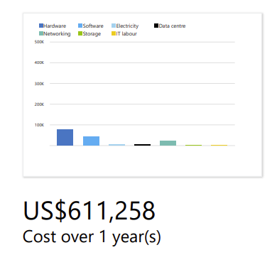
Figure 1 - On prem costs

Total Azure cost breakdown: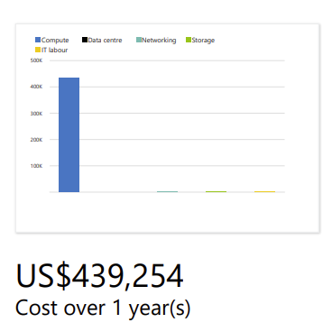
Figure 2 - Azure costs

Computer costs.
On-premises: US$580,027.04
Azure: US$435,282.96
Compute costs could be significantly reduced by switching to Azure. When compared to keeping hardware on-premises, Azure's flexible pricing models—such as pay-as-you-go and reserved instances—can frequently be more economical.

Hardware:
On-premises: US$76,809.60
Azure: No hardware cost
By switching to Azure, you can avoid future capital expenditures for hardware upgrades and save money right away by doing away with the need to buy and maintain physical gear.

Software:
On-premises: US$43,085.00
Azure: Costs may vary based on the services you use, but often included in Azure subscription or offered at a lower cost compared to on-premises software licenses.
Compared to buying individual software licenses, Azure offers a variety of software services, such as Windows Server, SQL Server, and other Microsoft products, at a lower cost.

Electricity:
On-premises: US$3,940.44
Azure: No electricity cost
By switching to Azure, you may save even more money and lessen the environmental impact of the company by removing the need for electricity for running on-premises infrastructure.

Database:
On-premises: US$456,192.00
Azure: Costs may vary based on database usage, but Azure offers scalable and cost-effective database services such as Azure SQL Database and Azure Cosmos DB.
When compared to running databases on-premises, Azure's managed database services can offer improved performance, scalability, and less operational overhead.

Data Centre:
On-premises: US$5,743.13
Azure: No data center cost
By switching to Azure, you may further reduce costs and free up resources to concentrate on your core business operations by doing away with the necessity of managing and maintaining a physical data center.

Networking:
On-premises: US$21,581.82
Azure: US$297.00
When compared to the maintenance of networking infrastructure on-premises, Azure's networking costs are often lower. Azure provides services for securely and effectively connecting your resources, like Azure ExpressRoute and Virtual Network (VNet).

Storage:
On-premises: US$1,606.40
Azure: US$2,524.09
Even though this breakdown makes Azure storage seem more expensive, it's important to weigh the scalability, durability, and other capabilities that Azure Storage services provide over more conventional on-premises storage options.

IT Labour:
On-premises: US$2,300.00
Azure: Labour costs may vary based on your organization's needs, but moving to Azure can potentially reduce the need for dedicated IT personnel to manage and maintain on-premises infrastructure.

100
K
K
200
300
K
400
K
500
K
600
K
0
1
Year
On-premises cost
Microsoft Azure cost
Figure 3 - Cost comparison.

A total savings of US$172,004.00 with Microsoft Azure.

GLI stands to gain greatly from moving workloads to Azure, Microsoft's cloud platform. First off, GLI is able to adjust resources in response to changing business requirements because to Azure's scalability and flexibility, which guarantees efficient resource allocation and agility. As a result, the limitations of conventional infrastructure are removed, allowing GLI to quickly respond to market demands and effectively provide new services.

Cost effectiveness is yet another strong benefit. With Azure's pay-as-you-go pricing structure, GLI can maximize IT expenditure by only paying for the resources that are really used. In the long term, this results in significant cost savings because it eliminates the need for upfront capital investments in hardware, lowering total cost of ownership (TCO), and matching expenses to actual utilization.

Azure file storage

Azure File Storage has many capabilities and security controls that can help GLI manage its data more efficiently and safely. This section provides GLI with a critical examination of how Azure File Storage and its related capabilities can help, as well as an example of how to set up an Azure Storage account for GLI.

Microsoft's first cloud storage solution is called Azure Storage. It offers other specialized kinds, including as queues, blobs, tables, and file sharing, which are basically key/value stores. Data is stored in a flat hierarchy using key/value pairs. Simple or complex data can be stored in the value, and the key is utilized for lookup. File shares and blob storage have a value that is especially high and a key that resembles a file path. Standard key/value stores are tables. Queues hold text fields and IDs. Virtual machine (VM) disk backup is also offered by Azure Storage for Azure VMs. [2]

- Blob Storage stores files as byte collection blobs, with a programmatic command interface.
- Files service stores files, with a Server Message Block (SMB) protocol interface. Use this service for network shares.
- Queue service stores messages in a queue for sequential programmatic retrieval.
- Tables service stores collections of key/value pairs, with unique IDs. [2]
Azure provides a number of ways to create new resources, such as the Azure portal, Azure PowerShell, and Resource Manager (ARM) templates. While you can automate tasks on Azure more simply with PowerShell and ARM templates, the Azure portal has a lower entry barrier.
Setting up an Azure Storage account requires a few pieces of information common to all Azure services, including a subscription, name, location, and resource group.
- A subscription groups services together for access control and billing.
- A resource group groups related services together for management.
- A location assigns services to a regional data center.
- Names are globally unique identifiers within the specific service.
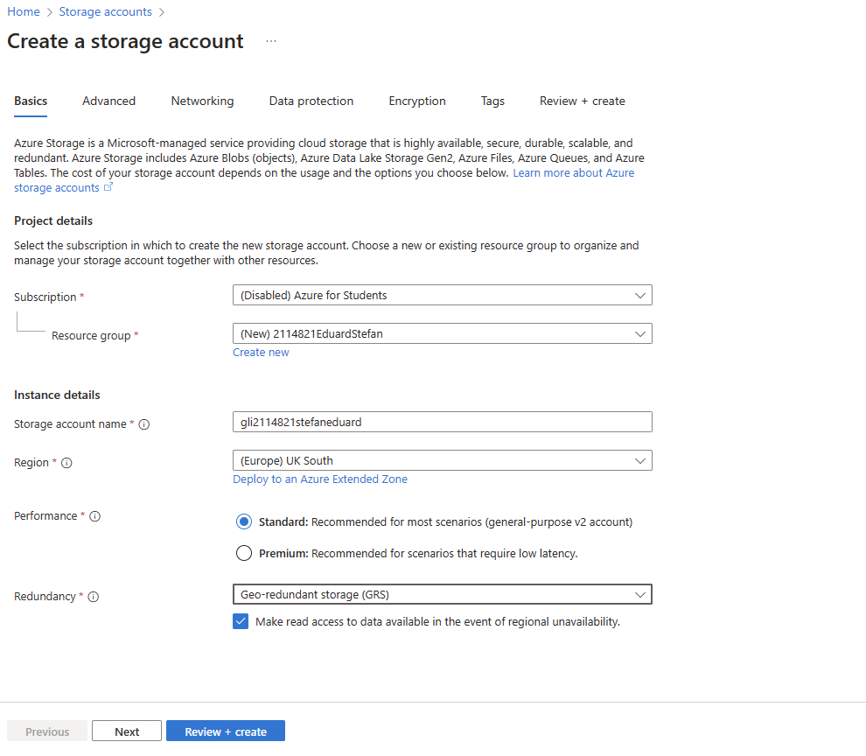
Figure 4 -Create storage account.
In cloud storage solutions, redundancy is essential for guaranteeing data availability, robustness, and durability. When it comes to Azure Storage Accounts, Azure provides a variety of redundancy solutions to satisfy various business needs and lessen the chance of data loss or outages. Let's examine the redundancy choices that Azure Storage Accounts offer and how businesses like GLI might profit from them.

1. LRS, or locally redundant storage
Overview: To provide high availability and redundancy, LRS duplicates data within a single Azure datacentre.
Analysis: For businesses in need of a bare minimum of defence against datacentre outages or hardware malfunctions, LRS offers affordable redundancy. But since data replication takes place inside the same datacentre, it might not be able to withstand catastrophic catastrophes or breakdowns that affect the entire region.
2. GRS, or Geo-Redundant Storage:
Overview: To increase resilience against regional outages, GRS replicates data asynchronously to a secondary Azure region.
Analysis: By keeping a copy of the data at a backup location, GRS provides better data availability and durability than LRS. This improves data protection against local disasters or data center outages. Businesses that place a high priority on data resilience and business continuity should consider this redundancy option.

3. ZRS, or Zone-Redundant Storage:
Overview: To provide improved availability and fault tolerance, ZRS replicates data throughout several availability zones inside a single Azure region.
Analysis: In the event of a breakdown inside a single availability zone, ZRS's zone-level redundancy ensures data availability. Applications with strict availability requirements or those spread over several zones within a region are best suited for this redundancy option.

4. Geo-Redundant Storage with Read-Access (GZRS):
Overview: Read-only access to data in the secondary region is made possible by RA-GRS, which offers the same redundancy as GRS in addition to read access to the secondary area.
Analysis: RA-GRS is appropriate for scenarios like disaster recovery testing, data analytics, or providing read-heavy workloads from the secondary region while retaining data redundancy. It combines the advantages of GRS with the capacity to perform read operations from the secondary region.
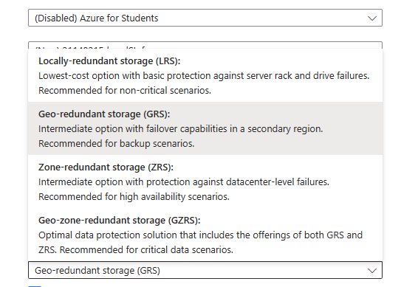
Figure 5 - Redundancy storage options

For businesses like Global Logistics Inc. (GLI), ensuring the security of data kept in Azure Storage Accounts is critical to safeguarding confidential data, adhering to legal requirements, and reducing the possibility of data breaches or unauthorized access. For the protection of data kept in Storage Accounts, Azure offers an extensive range of security tools and controls. Let's examine the advantages of these security features:

1. Encryption during transit and at rest:
Data may be encrypted using Azure Storage while it is in transit or at rest, guaranteeing data security all the way through its lifespan.
Organizations can improve data security and retain complete control over encryption keys by utilizing server-side encryption (SSE) with customer-managed keys (CMKs) to encrypt data while it is at rest. Furthermore, safe communication between clients and Azure Storage is ensured by encryption in transit via HTTPS, which guards against data interception and eavesdropping.

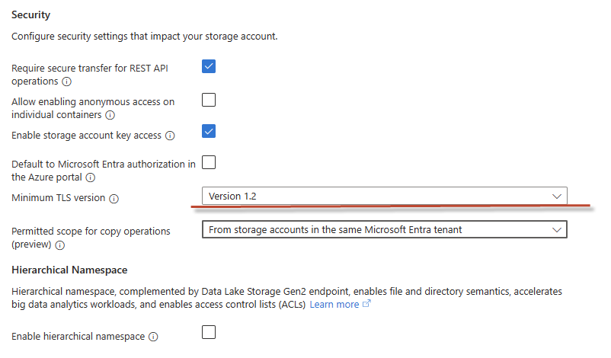
Figure 6 - Storage account security
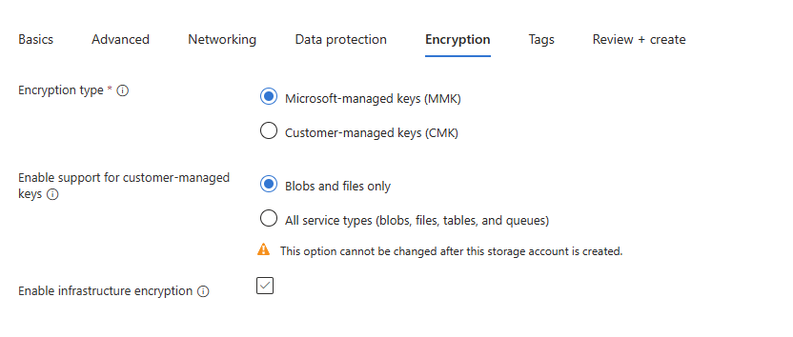
Role-Based Access Control (RBAC):
Role-based access control is made possible by the integration of Azure Storage with Azure Active Directory (AAD), which enables businesses to provide users and apps specific rights.
By allocating access permissions in accordance with users' roles and responsibilities, RBAC lessens the possibility of unlawful access and helps uphold the principle of least privilege. Granular access control and policy compliance are ensured by administrators who can create custom roles and assign permissions at the subscription, resource group, or Storage Account level.
Versioning and soft delete capabilities are supported by Azure Blob Storage, enabling businesses to keep several versions of items and retrieve erased data.
Versioning helps businesses keep track of object updates over time, giving them a historical record of data changes and making data recovery easier. Soft delete lowers the danger of irreversible data loss and ensures data integrity by enabling companies to retrieve mistakenly erased objects within a predetermined retention period.
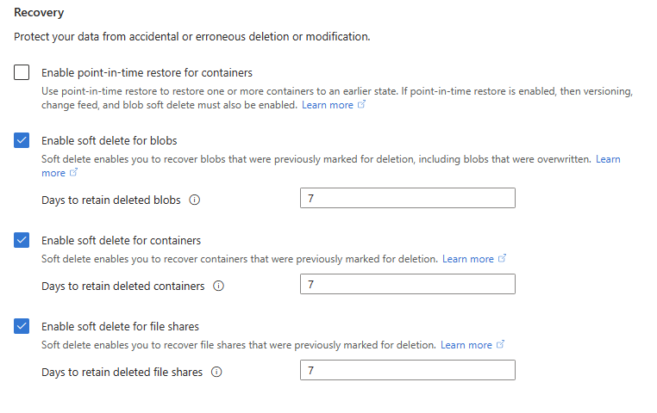

Azure Database
It's critical to evaluate aspects like scalability, performance, security, and compatibility with application requirements when evaluating Azure database alternatives for user profile storage. The most appropriate Azure database for storing user profiles will be suggested after a thorough analysis of three well-liked options: Azure SQL Database, Azure Database for MySQL, and Azure Database for PostgreSQL.

Azure SQL Database:
Built on the Microsoft SQL Server engine, Azure SQL Database is a fully managed relational database service.
Advantages:
Integrated automatic backups and scalability with high availability.
Advanced security features like row-level security, dynamic data masking, and transparent data encryption (TDE).
compatibility with current SQL Server tools and applications.
Cons:
Limited ability to use non-Microsoft tools and technologies.
more expensive than open-source substitutes.

MySQL on Azure Database:
Providing high availability, scalability, and performance, Azure Database for MySQL is a managed MySQL database service.
Advantages:
Interoperability with MySQL frameworks, tools, and applications.
support for widely used frameworks and programming languages, including PHP, Python, and Node.js.
Options for pay-as-you-go and reserved instances with flexible pricing.
Cons:
Limited support for sophisticated SQL Server capabilities and features.
less Microsoft ecosystem integration than with Azure SQL Database.

PostgreSQL Database on Azure:
Providing enterprise-grade functionality and compatibility, Azure Database for PostgreSQL is a managed PostgreSQL database service.
Advantages:
Interoperability with tools, extensions, and PostgreSQL apps.
support for advanced features like partitioning and full-text search, as well as JSON data types.
integration with Azure services, including authentication with Azure Active Directory.
Cons:
Limited interoperability with tools and functionality exclusive to SQL Server.
Costlier than PostgreSQL installs that are self-managed.
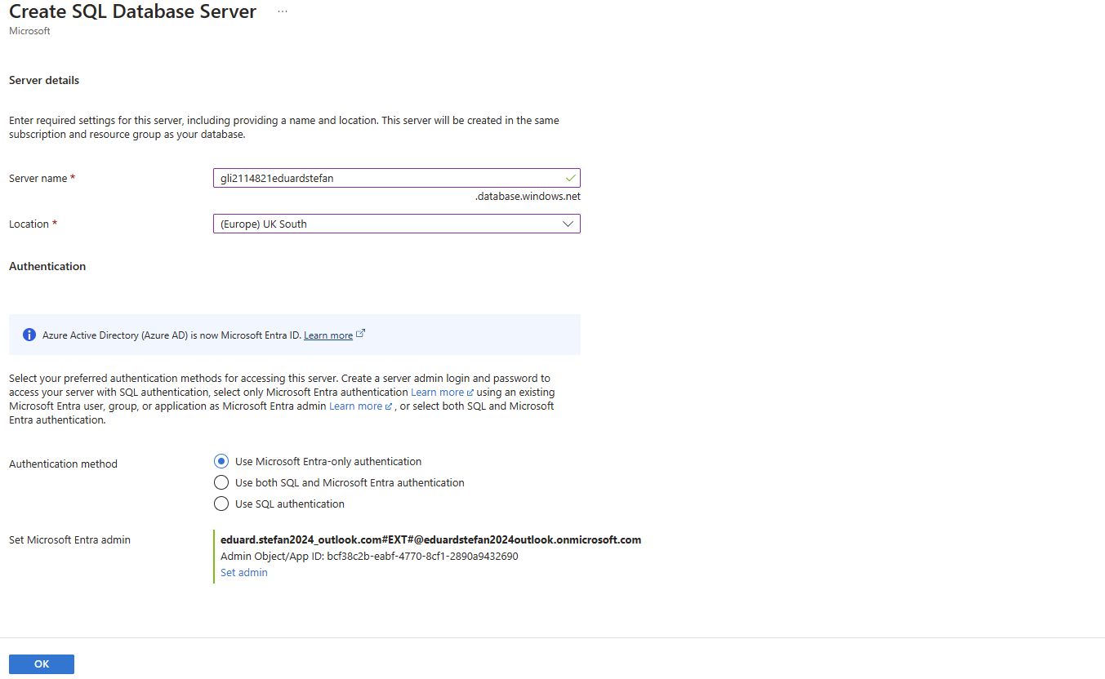

A fully managed relational database service built on the Microsoft SQL Server engine is called Azure SQL Database. It has security features, scalability, and high availability that are ideal for contemporary data management and application development. Based on its features, let's examine Azure SQL Database and why is the suggestion it for GLI:

Because Azure SQL Database has built-in scalability features, businesses can adjust their resource levels in response to demand without experiencing any downtime. Because of its adaptability, GLI can effectively handle varying workloads and business needs.
Azure SQL Database offers geo-redundancy options, point-in-time restore, and automatic backups to safeguard data from regional outages and hardware problems while maintaining high availability. GLI can count on Azure SQL Database to uphold availability and uptime service level agreements (SLAs) while preserving data integrity.
Advanced security capabilities including dynamic data masking, row-level security, and transparent data encryption (TDE) are available in Azure SQL Database to safeguard sensitive data. Centralized authentication and access control are made possible by integration with Azure Active Directory (AAD), guaranteeing that only authorized users are able to access the database.

Azure SQL Database is compatible with pre-existing SQL Server applications, tools, and frameworks because it is a fully managed relational database service. By taking advantage of its experience with SQL Server, GLI can quicken the development and migration process, cutting down on operational complexity and time to market.
For workloads that are crucial to the success of an organization, Azure SQL Database's features like intelligent query processing, automated tuning, and in-memory technology provide consistent performance and minimal latency. GLI can save expenses and resource usage while achieving optimal performance for its applications.
Creating a database in Azure portal:

- Sign in to the Azure Portal:
  - Navigate to portal.azure.com in your web browser.
  - Sign in with your Azure account credentials.
- Navigate to the Azure SQL Databases service:
  - In the Azure Portal, search for "SQL databases" in the search bar.
  - Select "SQL databases" from the search results to open the service.
- Click on "Create SQL database":
  - Once in the Azure SQL Databases service, click on the "+ Add" button to create a new SQL database.
- Configure basic settings:
  - Provide the basic details for the new SQL database, including:
    - Subscription: Choose the Azure subscription to use.
    - Resource group: Select an existing resource group or create a new one.
    - Database name: Enter a unique name for the database.
    - Select source: Choose the source for the database, such as Blank database, Sample, Backup, or Geo-restore.
    - Server: Create a new server or select an existing one. If creating a new server, provide a server name, server admin login, and password.
- Configure compute + storage:
  - Select the compute and storage configuration for the database, including:
    - Compute tier: Choose the desired performance level for the database (e.g., Basic, Standard, Premium).
    - Data max size: Specify the maximum size limit for the database.
    - Collation: Choose the collation settings for the database (optional).
- Configure additional settings:
  - Customize additional settings as needed, including:
    - Tags: Add tags to categorize and organize the resources.
    - Networking: Configure network settings to control access to the database (optional).
    - Advanced data security: Enable advanced data security features like threat detection and vulnerability assessment (optional).
    - Sample database: If selecting the Sample option, choose the sample database to deploy (optional).
- Review and create:
  - Review the configuration settings to ensure everything is correct.
  - Click on the "Review + create" button to proceed.
- Deployment validation:
  - Azure will validate the configuration settings for the database deployment.
  - Ensure that there are no errors or warnings before proceeding.
- Create the Azure database:
  - Once the validation is successful, click on the "Create" button to initiate the deployment process.
  - Azure will begin provisioning the new SQL database based on the provided configuration settings.
- Monitor deployment progress:
  - Monitor the deployment progress in the Azure Portal.
  - Once the deployment is complete, the new SQL database will be available for use.
- Access and manage the Azure database:
  - After the database is created, you can access and manage it from the Azure Portal.
  - Navigate to the SQL databases service and select the newly created database to view its details, configure settings, and perform management tasks. [3]

Recommendation:
Based on the analysis, Azure SQL Database is recommended for GLI's database needs. Its scalability, high availability, security, compatibility, and performance features align with GLI's requirements for a reliable, secure, and efficient database solution. By leveraging Azure SQL Database, GLI can streamline its data management processes, enhance application performance, and drive business innovation with confidence.
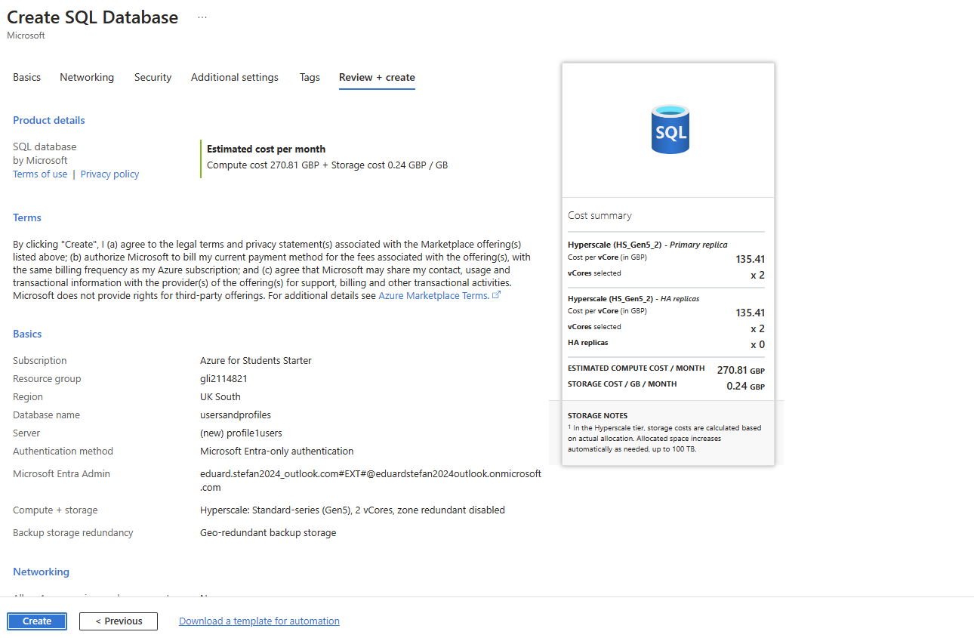

Backup and retention policies

To guarantee data resilience, compliance, and business continuity, GLI must configure backup schedules and retention policies utilizing Azure Backup options for both file shares and databases. Let's examine how GLI can accomplish this, taking into account the procedure of file and database restoration from backups.

File share
Scheduled Backups for File Sharing. Using Azure Backup, GLI can set up backup schedules for file sharing. Establishing the frequency and time of backups is necessary to guarantee consistent data protection.
Policies for Retention. To specify the duration for which backup data should be kept, GLI can establish retention policies. This involves deciding whether to save backups on a daily, weekly, or monthly basis as well as the duration of retention.

Database
Schedule of Backups. Using Azure Backup for databases like Azure SQL Database or the built-in backup features, GLI can plan backups for databases on Azure. Depending on what they need, they can plan differential, incremental, or complete backups.
Policies for Retention. Retention policies for database backups can be defined by GLI to regulate the duration of backup data retention. Full backups, differential backups, and transaction log backups can all have different retention durations specified.
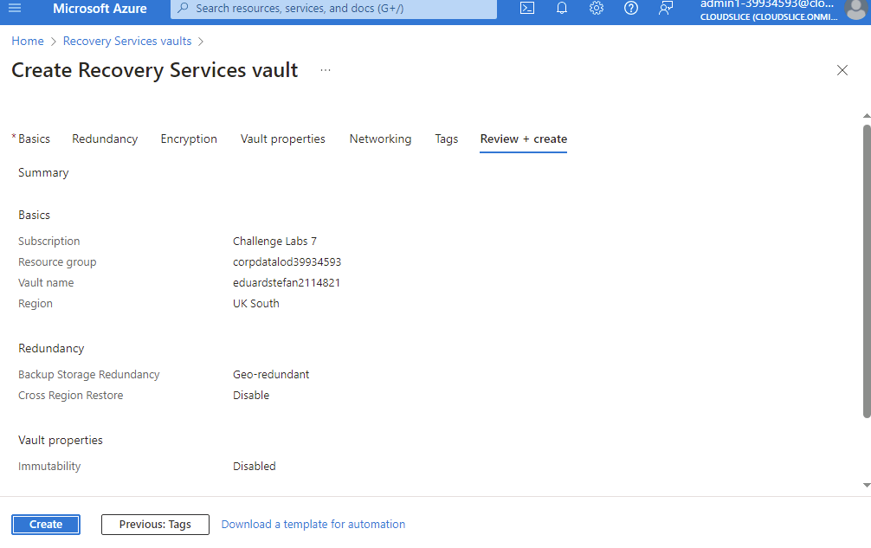

Backup schedule options:

Fixed Schedule: GLI has the option of a fixed backup schedule, in which backups take place on a daily, weekly, or monthly basis at predetermined intervals. Because of its simplicity and predictability, this approach is appropriate for environments with regular data usage patterns and backup needs.
Flexible Schedule: As an alternative, GLI can decide on a backup plan that is flexible enough to adjust to changing business needs and data consumption. With this option, backup frequencies can be dynamically adjusted in response to fluctuations in workload, enabling optimal resource usage and adaptability to changing requirements.

Event-Driven Schedule: In addition, GLI may take into account an event-driven backup schedule that is set off by particular circumstances or occurrences, including system events or data alterations. This approach reduces the risk of data loss from unanticipated disasters and delivers agility and reactivity, allowing backups to coincide with important business events.
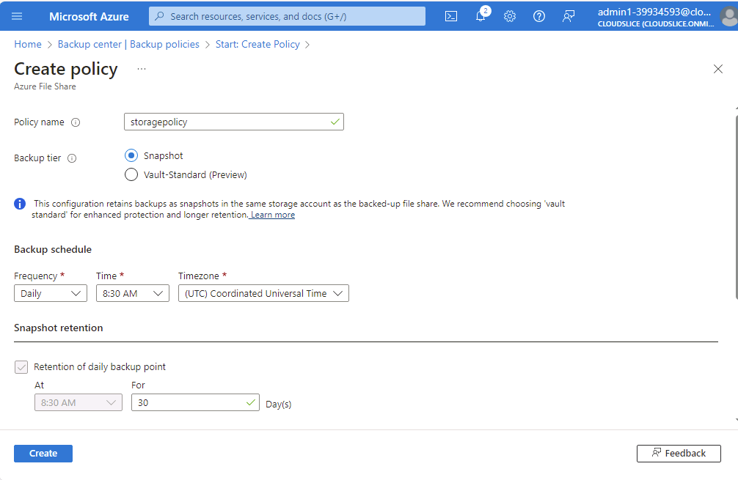

Choices for Retention Policies:
Long-Term Retention: To maintain backup data for protracted periods of time, guarantee regulatory compliance, and preserve historical data for analysis and auditing needs, GLI may give priority to long-term retention policies. This choice is appropriate for sectors requiring the preservation of historical data or those subject to strict data retention regulations.
Tiered Storage and Short-Term Retention: As an alternative, GLI may employ tiered storage and short-term retention policies to maximize performance and cost-efficiency. This approach strikes a balance between cost-effectiveness and accessibility by moving older backups to lower-cost storage tiers for archiving purposes while keeping recent copies on high-performance storage for quick recovery.

Customized Retention Policies: GLI may choose to implement retention strategies that are adapted to the needs of particular business divisions, data kinds, or regulatory frameworks. Granular control over retention durations is made possible by this option, which enables GLI to match retention policies to the various needs of the data lifecycle in various organizational units or data categories.

GLI can create a robust and compliant data security architecture that complies with regulations and its business goals by implementing flexible backup schedules and long-term retention rules. These choices guarantee the availability and integrity of vital business data while offering the adaptability and scalability required to meet GLI's changing demands for data management.

Storage restore from Backups:

Azure Portal Interface: GLI may start file restores from backups via the Azure Portal interface. Administrators can specify which files or folders to restore, choose the recovery point holding the necessary files, and browse to the relevant backup instance within the Azure Backup service. There are only a few easy phases in the process: deciding which data to restore, where to store the files, and which recovery point to use. Administrators may swiftly retrieve individual files or entire directories from backup archives thanks to this user-friendly interface, which also speeds up the file restoration process.

PowerShell Command Line: GLI may use the PowerShell cmdlets that Azure Backup provides to restore files programmatically in more complex circumstances or automated workflows. Administrators can automate automation workflows and recovery scripts, personalize restore choices, and script file restoration activities using PowerShell commands. Because of this approach's scalability and flexibility, GLI is able to automate file restoration duties and optimize recovery procedures throughout its IT infrastructure.

Restoring Databases from Backups:

Azure Portal Interface: GLI can use the Azure Portal interface for Azure SQL Database or other database services to start database restores from backups. Administrators can choose the preferred recovery point and customize the restore parameters, such as the target server and database name, by navigating to the "Backup & restore" section of the Azure SQL Database service. Administrators can take comparable actions to start database restores from backup archives for other database providers, like Azure Database for MySQL or PostgreSQL. Administrators' restoration procedure is made simpler by the Azure Portal's user-friendly interface for managing database backups and recoveries.

Commands for Transact-SQL (T-SQL): As an alternative, GLI can use T-SQL (Transact-SQL) instructions to programmatically restore databases, providing more flexibility and control over the procedure. Using well-known SQL syntax, T-SQL commands let administrators automate restoration procedures, define recovery parameters, and script database recovery tasks. Advanced recovery scenarios, batch processes, and integration with pre-existing database management scripts and procedures are good fits for this methodology.

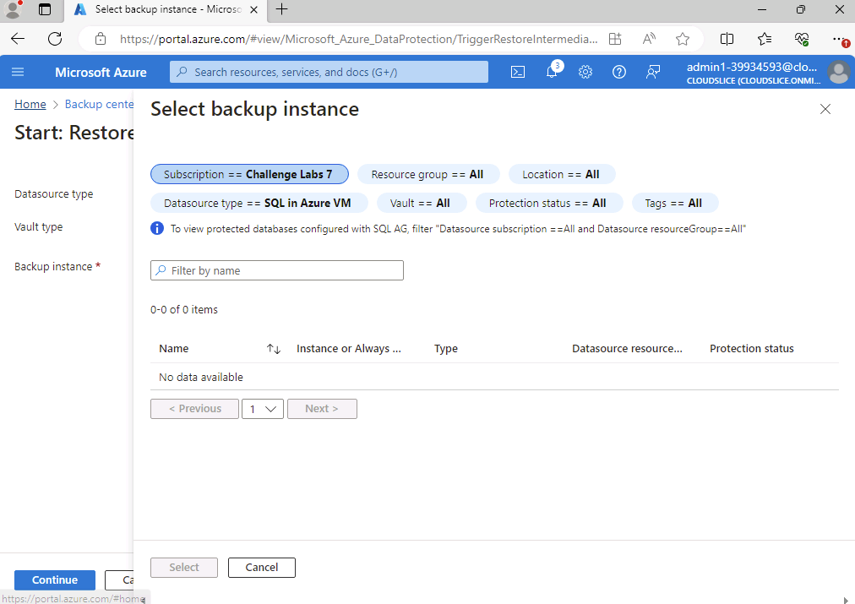
It is advised to employ a combination of programmed automation tools and user-friendly interfaces when recovering files and databases from backups due to GLI's varied backup and recovery requirements:
Azure Portal Interface: The Azure Portal interface provides an intuitive and user-friendly experience for ad hoc or manual file and database restores. It allows administrators to swiftly start recovery operations and retrieve particular data assets from backup archives with little effort.
T-SQL commands and the PowerShell command line: PowerShell cmdlets and T-SQL commands offer the flexibility and scalability required to automate recovery workflows, modify restore settings, and integrate restoration operations into pre-existing automation frameworks or recovery scripts for automated or scripted file and database restores. This method improves recovery operations' uniformity and efficiency, allowing GLI to expedite data restoration processes throughout its IT infrastructure.ort.

In the event of data loss or system failures, GLI can efficiently restore files and databases from backups by utilizing a combination of user-friendly interfaces and programmable automation tools. This guarantees quick recovery and little downtime. With the help of this hybrid approach, which blends flexibility and customization with ease of use, GLI is able to address a wide range of recovery demands while preserving data integrity and operational resilience.

Azure site recovery.

Azure Site Recovery (ASR) offers a robust solution for GLI to ensure business continuity and minimize downtime in the face of unexpected outages or disasters. Here's a detailed analysis of how ASR can assist GLI in disaster recovery, along with the steps to set up and the associated costs
Continuous Replication and Failover: Using an on-premises site or a backup Azure region, ASR offers continuous replication of virtual machines (VMs), including databases and storage. Configuring recovery plans, replication frequency, and VM replication parameters are all part of the setup process. The number of virtual machines (VMs), the frequency of replication, and the speed at which data is transferred between regions all affect the cost of continuous replication. For instance, a natural disaster caused a data center outage for a manufacturing company. They were able to ensure continuous operations and avoid financial losses by using ASR to quickly failover essential workloads to Azure.

Application-Aware Recovery: For supported databases, including Azure SQL Database and SQL Server operating on virtual machines, ASR provides application-aware recovery features. Configuring replication settings unique to databases and guaranteeing consistency during failover are part of setting up application-aware recovery. The quantity of databases and degree of automation needed for recovery may have an impact on costs. A financial organization had a service disruption due to a database corruption issue in a real-world scenario. They were able to promptly restore service availability and minimize data loss by restoring the database to a consistent state thanks to ASR's application-aware recovery functionality.

Cost-effectiveness and scalability: By doing away with the requirement for pricey secondary data centers or specialized disaster recovery infrastructure, ASR lowers both capital and running costs. Furthermore, GLI may grow resources according to demand thanks to ASR's pay-as-you-go pricing mechanism, which optimizes costs while guaranteeing strong DR capabilities. ASR expenses include storage costs for virtual machines that have been replicated, charges for data movement between regions via network egress, and ASR service fees that are determined by the quantity of protected instances and recovery strategies. For example, a healthcare company used ASR to relocate its disaster recovery infrastructure to Azure, which saved a lot of money over keeping DR sites on-site. Through the pay-as-you-go pricing model, they were able to scale resources effectively and lower total cost of ownership.

Testing and Validation: GLI may simulate failover scenarios and validate recovery methods without affecting production workloads because to ASR's non-disruptive testing capabilities. In order to ensure readiness, test failover plans must be created and regular testing must be carried out. The only expenses related to testing are network egress fees and test virtual machine (VM) storage costs. An online retailer used ASR to simulate several disaster scenarios for regular DR exercises, validating recovery protocols and pinpointing areas for improvement. Their preparedness to handle emergencies in the actual world was improved by this proactive strategy.

Compliance and Security: By offering encryption, identity and access management (IAM), and audit logs for DR operations, ASR assists GLI in meeting regulatory compliance standards. Customers and stakeholders will feel more confident knowing that data is protected and regulations are being followed. Configuring encryption for data replication, establishing access limits, and turning on logging for auditing are all part of setting up compliance and security measures. For instance, a government organization used ASR to safeguard confidential information and software while adhering to legal requirements. Access controls and encryption, two of ASR's security features, enabled them to comply with strict data protection laws.

Azure's emphasis on operational efficiency and agility enables GLI to automate processes, streamline workflows, and accelerate application development and deployment cycles. By leveraging Azure's integrated development tools, APIs, and services, GLI can achieve faster time-to-market for their products and services, driving innovation and competitive advantage.

Moreover, Azure's data analytics and AI services empower GLI to unlock valuable insights from their data, enabling predictive analytics, optimization, and informed decision-making. With Azure's rich ecosystem of data analytics and AI tools, GLI can gain actionable insights, identify trends, and innovate new business models, enhancing operational efficiency and driving business growth.

Finally, Azure's robust disaster recovery solutions, including Azure Site Recovery (ASR) and Azure Backup, ensure business continuity and data resilience in the face of disasters or cyber threats. GLI can replicate and recover workloads across geographically dispersed regions, minimizing downtime and maintaining operational resilience, thereby safeguarding their business operations and reputation.

Bibliography

[1] | J. Savill, Mastering Microsoft Azure Infrastructure Services, Sybex, 2015.
[2] | R. Nuckolls, Azure Storage, Streaming, and Batch Analytics: Guide for Data Engineers, Manning Publications, 2020.
[3] | “Microsoft learn,” Microsoft, 2024. [Online]. Available: https://learn.microsoft.com/en-us/training/azure/. [Accessed 2024].

