

Assessment 1 – Reading Task Template
PART 1: Upload your photo of your A3 in-class notes here:
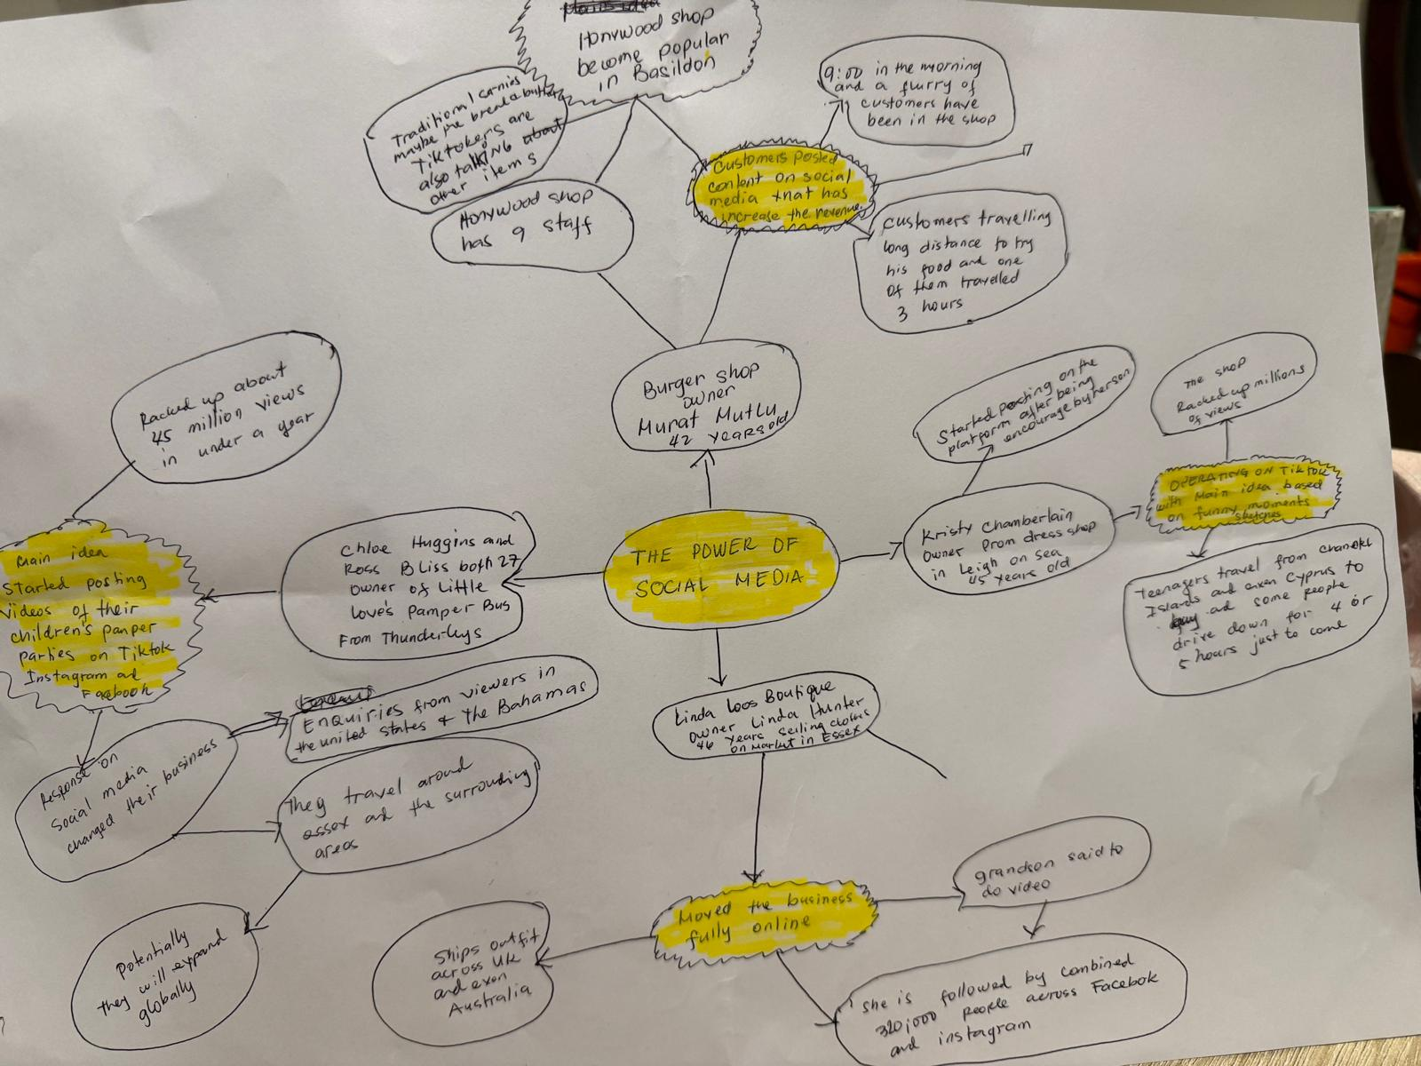

PART 2:
- Answer every question below in 1-3 full sentences.
- Use your own words. Do not use generative AI to answer these questions.
- Include a specific detail from the text when asked.
REMINDER
- The main idea is the overall message of the whole text.
- A key point helps to explain the main idea.
- A specific detail or example from the text shows that the key point is true.

- What is the main idea of the whole text?
Social media provides a massive influence and enormous help for smaller as well as big businesses because it reaches a huge number of people.
Not only in one’s own locality but also in different parts of the world.

- What is one key point that supports the main idea, and which specific example from the text shows this?
HONYWOOD SANDWICH SHOP-CUSTOMERS POSTED ITS CONTENT IN TIKTOK THAT HAS BECAME WELL KNOWN OR POPULAR.
Specific example- Murat the owner of the business says customers travelled for 3 hours just to try his chicken sandwich.
- What is a different key point that supports the main idea, and which specific example from the text shows this?
The shop has become very busy both regular customers and also customers visiting from far places.
Specific example - the flurry of customers have already been through the door at just 9:00 in the morning.
- Which part of the text do you think is most important, and why?
The most important part is the shops started booming when some customers posted the content in social media.
Where people started to come and try their food even if they are travelling for few hours.

Reflection:
- What did you find difficult in this task (including in-class components), and why was it difficult?
It was quiet difficult for me because I couldn’t express myself clearly.

- What helped you with this difficulty, and how did it help you?
How I manage to tackle this difficulty is I tried my best to write and explain it in my own language then I translated it in English.

