Introduction
The area of focus for this project is the previous Tesco Superstore and its adjacent car park. The site itself is to be demolished and to be developed into a hotel building in collaboration with Jarvis Hotels. The building is to be five storeys tall with a total of four hundred rooms, a bar, restaurant, and conference centre. It is our job to conduct a preliminary survey of the area, its history and geological make-up to determine the feasibility of the proposed project.

Details & History
The proposed site is located adjacent to the Swansea Arena and St. Philips Community Centre in Oystermouth Road. It currently functions as the Tesco Superstore with its own car park, which is to be demolished for our hotel project to move forward. The total area of the site is around 24637.1m², or 6.1 acres of land. Located nearby is the former South Dock, which was reopened as a marina in 1982, where their light industrial units were repurposed for companies to provide services for local boat owners in Fishmarket Quay (). The site itself is situated close to the former North Dock, where a large gasworks once stood, which had been in service since March 1842 when the Dyfatty Gasworks proved no longer sufficient when the town expanded west at a lower elevation. In 1890, the gasworks would be further expanded, with two more gasholders being constructed over the area of the former timber yards. Arrangements were made in the 1910’s to move the gasworks to Morriston, though plans saw major delays due to the beginning of World War 1. The first gasholder and the retort houses would be demolished in 1936, with the other three gasholders surviving until Nationalisation and the Wales Gas Era.() It can be presumed that the demolition of the gasworks was done as late as the early 2000’s as the available historical maps show the gasholders being present as late as the 1990’s.
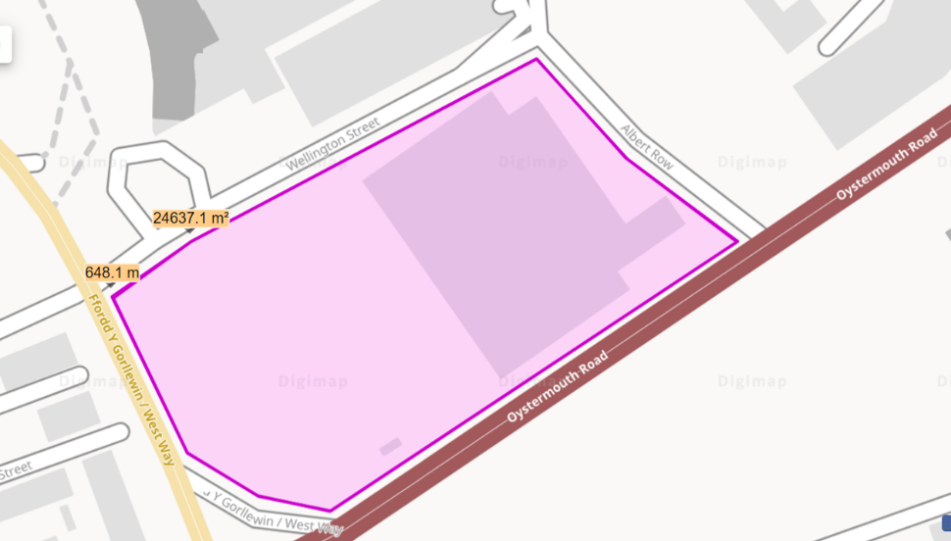
()[Ordnance Survey Map of Oystermouth Road, recorded as early as the late 2000’s]
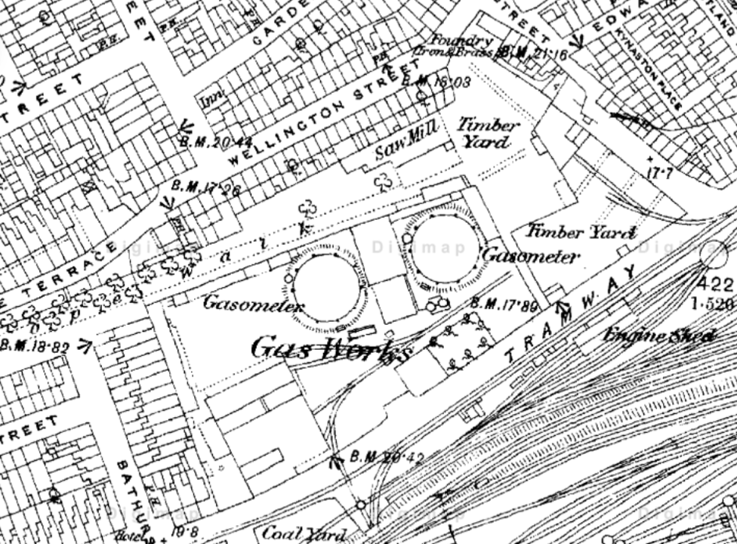
() [A Historical Map of the Swansea Marina in the 1870’s, showing the earliest stages of the gasworks with its first two gasholders and the nearby timber yards. Closer to the marina is the local tramway, which passes through Swansea, and terminating at Mumbles.]

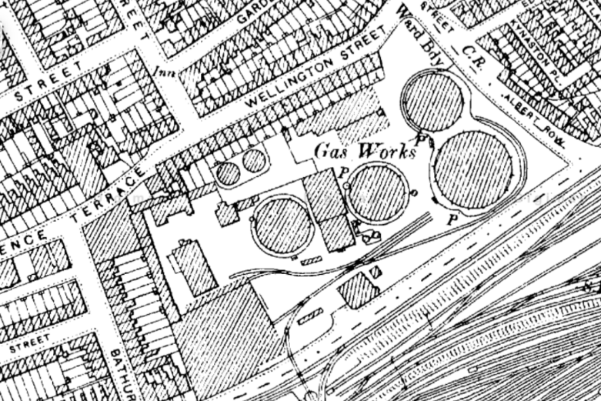
() [Historic Map of the Swansea Marina in the 1890’s seeing its most substantial expansion of two larger gasholders, in the place of the former timber yards. The No.1 gasholder and the retort houses would be demolished in 1936]
Geology
According to public geological records sourced from British Geological Survey (BGS), the data shown indicates that our site has a formation that contains mudstone, siltstone and sandstone, with sedimentary bedrock that formed during the Carboniferous period, which got its name from when many natural coal beds started forming. It can be gathered that mining work was done in the area to harvest the coal spoils, indicating the presence of mining infrastructure. ()

Here we have publicly accessable borehole records and site layout plans of the gasworks site before it was repurposed as the Tesco superstore in 1999, sourced from the British Geological Survey website. The records will be summarised through the stratification found in the borehole, as well as the presence of groundwater and other substantial details. I will be covering records 585 to 590 in this report.

[Record 585, borehole dug in 1997, BGS ID: 370486]
- This borehole is 10m deep and accquired through cable percussion, with water added 5m deep to assist in drilling the stiffer cobble. Made Ground composed of compacted stone/ashes/bricks until 0.3m depth, followed by more made ground composed of ashes/bricks/stones and clay until 1.5m depth. Sand present until 2.25m depth. Peat present until 2.85m depth. Peaty clay present until 3.2m depth. Peaty/sandy clay present until 4.3m depth. Peaty clay and some gravel present until 4.9m depth. Sandy gravel present until 5.6m depth. Gravel/cobble/boulders present until 8.9m depth. Clay bound cobbles/ boulders present until 10m depth. Gas levels were recorded every 2m of digging the borehole, no indication of gas underground.

[Record 586, borehole dug in 1999, BGS ID: 370487]
- This borehole is 10m deep and accquired through cable percussion. Hardcore Made Ground until 0.3m depth, followed by Made Ground composed of stiff/sandy/silty clay with abundent rootlets and gravel made from clinker and bricks until 1.3m depth. Then followed by more Made Ground consisting of soft/gravelly/clayey sand with occasional cobbles until 2.5m depth. Firm silty clay is present with trace amounts of coarse sand until 3m depth. Soft to firm/clayey peat is present with visible organic debris in abundance until 4.6m depth (Possible fossil or animal remains). Soft/slightly sandy silt present until 5.5m depth. Soft/sandy silt is present with plentiful fine to coarse gravel until 9m depth. Dense to very dense/fine to coarse sandy gravel with boulders and cobble until 10m depth. Recorded compositions after 2.5m depth are recorded as Alluvium, concluding with an Alluvial Fan Deposit after 9m depth. Groundwater present from 0.7m to 8.1m depth.

[Record 587, borehole dug in 1999, BGS ID: 370488]
- This borehole is 8m deep and accquired through cable percussion. Hardcore Made Ground until 0.3m depth, followed by Made Ground composed of mottled clayey sand with abundent gravel and brick/cobble fragments until 2m depth. Then followed by more Made Ground consisting of gravel sand with occasional cobble and shell fragments until 3.5m depth. Sandy silt is present with an abundance of organic debris and rootlets until 4m depth. Spongey peat is present until 7m depth. Soft to firm slit is p-resent with occasional organic debris (Possible fossil or animal remains). Recorded compositions after 3.5m depth are recorded as Alluvium until 8m depth. Groundwater present from 1.5m to 7.3m depth.

[Record 588, borehole dug in 1999, BGS ID: 370489]
- This borehole is 9.7m deep and accquired through auger drilling, with water added at 4.2m until 6.6m depth, presumably to test the grounds ability to retain water. Hardcore Made Ground until 0.4m depth, followed by mottled silty clay until 3.8m depth. Mottled/silty clay is present with large rounded cobbles until 4.2m depth. Cobbly gravel with coarse sand is present until 6.3m depth, with only cobbly gravel present until 9.7m depth. No indication of groundwater is present in this borehole.

[Record 589, borehole dug in 1999, BGS ID: 370490]
- This borehole is 10m deep and accquired through auger drilling, with water added at 7.1m until 10m depth, presumably to test the grounds ability to retain water. Hardcore Made Ground until 0.4m depth, folllowed by Made Ground composed of red brick/concrete/ash until 1.8m depth. Made Ground composed of wood/concrete/rubble is present until 3.9m depth. Soft silt is present until 4.2m depth. Brown peat is present until 5.9m depth. Alluvium deposit is present until 7.1m depth. Alluvium deposit embedded with rubble until 8.4m depth. Large cobbles are present until 8.7m depth. Gravel with coarse sand until 10m depth. No indication of groundwater is present in this borehole.

[Record 590, borehole dug in 1999, BGS ID: 370491]
- This borehole is 8m deep and accquired through auger drilling, with water added at 3.7m until 8m depth, presumably to assist in drilling the denser cobbles deeper into the borehole. Hardcore Made Ground until 0.4m depth, followed by Made Ground composed of cobbly clay until 0.7m depth, then followed by Made Ground composed of boulders until 1.1m depth, finishing with Hard Ground composd of silty clay embedded with boulders until 3.7m depth. Gravel with coarse sand present until 4.6m depth. Large cobbles are present until 8m depth. No indication of groundwater is present in this borehole.

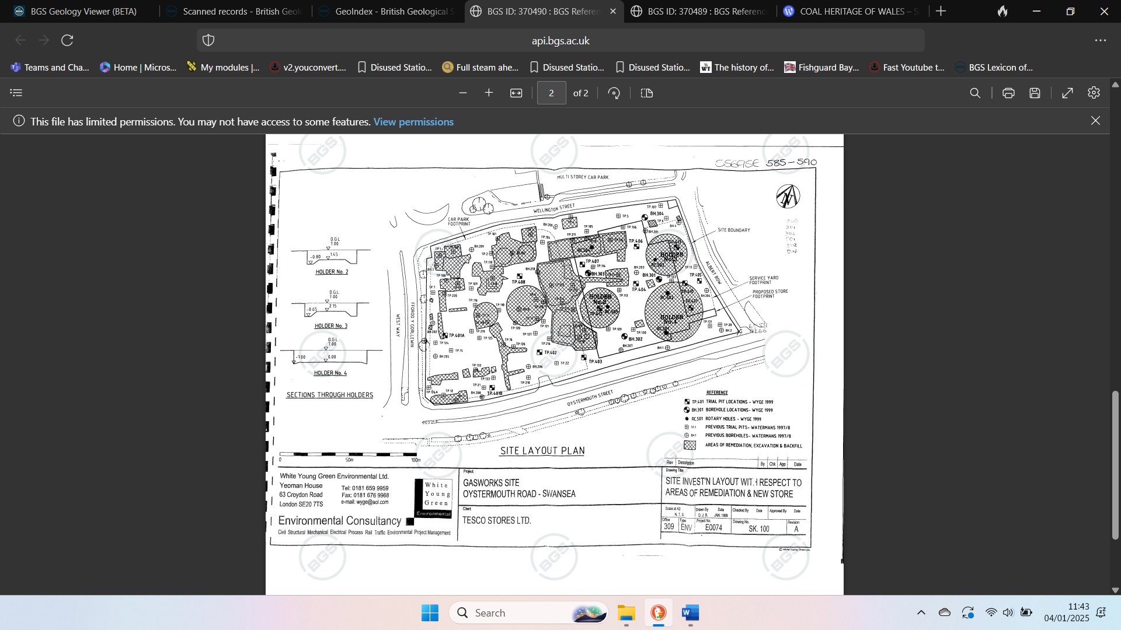

() [Site Layout Plan of the gasworks in Oystermouth Road, writing in the top-right corner indicates all borehole reports recorded, from 585 to 590]

Environmental
() Given the previous usage of the site, its safe to assume the contamination is present due to the former gasworks having stood for over a century as well as the adjacent tramway. The borehole reports suggest coal spoils dating back centuries which were dug up from established mining tunnels close to the site, being used as fuel for the gasworks to redistribute elsewhere. The waste produced from the gasworks and the mining of the coal to fuel it poses a large health risk that may contaminate the drinking water supplied to the city’s inhabitants, as well as the surrounding soil which could degrade the quality of its load-bearing capacity, which will in turn create the need for more remedial work to accommodate the foundation for this new high-rise hotel.
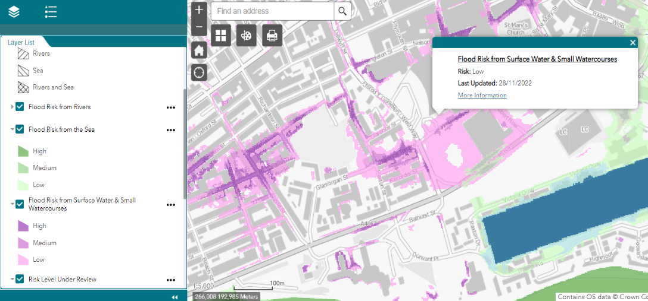

() [Data gathered from the National Resources Wales website on potential flood risks in the area surrounding the Swansea Marina]
Concerning flood risks, the Tesco car park is shown to have a risk of flooding from surface water and small water courses, though it is shown to be small risk it does have a wide coverage with a noticeable gap in the centre. If it can be assumed that the website does not have a graphical defect it could indicate signs that the ground has began to slope. This poses a plausible safety hazard due to the data only being a few years off and that whether such a change as been remedied or gone unchanged is not known. It is of the upmost importance that a proper time is arranged that optimises down time for businesses as well as being out of harms way to the natural elements.

Conceptual Model
In terms of accessing the site into the car park, there is only the single entrance turning in from Wellington Street, which may prove difficult for any larger machinery hired to conduct the site preparation or excavation of the foundations. Another thing to consider is the onsite services that are still present and functioning for surrounding home and business owners, so it is of absolute importance that all inhabitants are properly informed of the disabling of local utilities for given periods as work is conducted. It is also important to exercise proper codes of practise when disabling and removing utilities for further ground-working, such codes of practise include HSG47 () or PAS 128 ().
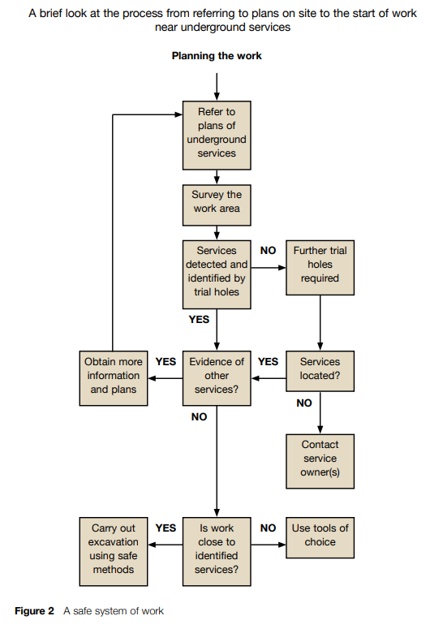
() [A graph taken directly from HSG47 demonstrating the proper planning to be taken when managing underground services, Figure 2, Page 9 out of 40]
Applying what is shown here to our own scenario, we start by going off a point of reference, through the usage of pre-existing site plans. We then dig trial holes to help map out the locations of services underground, depending on whether the trial pits are sufficient, we either gather evidence and plans of the services or drill more holes to locate them. Proper caution must be exercised depending on the proximity of these services to the work site, as alternative methods need to be employed depending on the acceptable distance of these services.
Foundation of choice
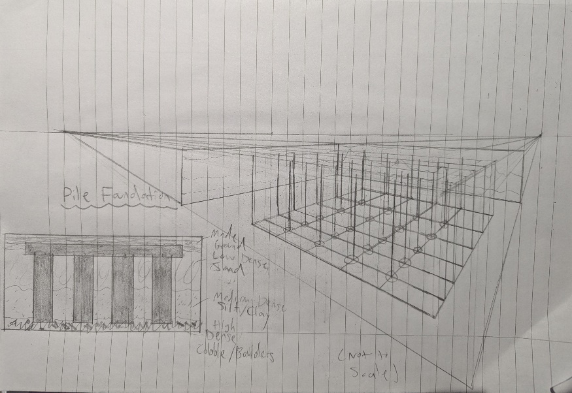
Considering the geological and environmental conditions presented in this reported I have settled on the best foundation for the new hotel. My choice of foundation is a pile foundation, since there’s lesser dense sand and silt closer to the surface with more dense cobbles and boulders deeper down, the pile foundation can reach those denser rocks to support our hotel. Below is an illustration of how the foundation may constructed, considering the stratification of the ground of our site.

Summary
A new hotel is being built at Oystermouth Road on the site of a previous Tesco Superstore. The site has had a history of being a long-standing gasworks since the late 19th century. The gasworks would be demolished in the late 1990’s and a Tesco would be built, now the Tesco has been demolished, and we will be constructing a 400-bedroom hotel. Borehole records have indicated various levels of sandy, silty, or peaty clay, with a wide coverage of Alluvium and some unspecified organic debris. Due to previously being a gasworks, the site may be contaminated with harmful waste that could degrade the load bearing capacity of the soil, as well as being at a minimal risk of surface water flooding.
Proper safety measures need to be in place to manage the deactivation of service mains before work can begin, local businesses and homeowners must be notified of power-cuts so the older utilities can safely be removed for the new property. The best choice of foundation for the hotel has been decided as a Pile Foundation, as the soil does not reach the denser clays for at least 8-10m deep.

References
- historypoints.org (2022), Waterfront: Swansea marina, [Online] Available at: https://historypoints.org/index.php?page=swansea-marina [Accessed: 03/01 2025]
- Coflein (2021) “Swansea Gas Works Depot, William Street, Swansea”, [Online] Available at: https://coflein.gov.uk/en/site/85432 [Accessed: 04/01/2025]
- Digimaps (1951), National Grid Number SS6592, [Online] Available at: https://digimap.edina.ac.uk/roam/map/historic [Accessed: 04/01/2025]ss
- Digimaps (1979), County Sheet Glamorgan, [Online] Available at: https://digimap.edina.ac.uk/roam/map/historic [Accessed: 04/01/2025]
- Digimaps (1899), County Sheet Glamorgan, [Online] Available at: https://digimap.edina.ac.uk/roam/map/historic [Accessed: 04/01/2025]
- British Geological Survey (2020), “The BGS Lexicon of Named Rock Units”, [Online], {Keyworth, Nottingham}, Available at: https://www.bgs.ac.uk/technologies/the-bgs-lexicon-of-named-rock-units/ [Accessed: 04/01/2025]
- British Geological Survey (2020), “Borehole records”, [Online] Available at: https://www.bgs.ac.uk/information-hub/borehole-records/ [Accessed: 07/01/2025]
- Natural Resources Wales (2023), “Land contamination”, [Online] Accessed at: https://naturalresourceswales.gov.uk/guidance-and-advice/business-sectors/planning-and-development/advice-for-developers/land-contamination/?lang=en [Accessed: 08/01/2025]
- Natural Resources Wales (2022), “Flood Risk from Surface Water & Water courses”, [Online] Accessed at: https://flood-risk-maps.naturalresources.wales/?locale=en [Accessed: 08/01/2025]
- Health and Safety Executive (2014), “Avoiding danger from underground services”, third ed, Norwich: TSO
- British Standards Institution (2014), “Specification for underground utility detection, verification and location”, [Online] Accessed at: https://geotechnicaldesign.info/download/pas128-2014.pdf [Accessed: 08/01/2025]
- Health and Safety Executive (2014), “Avoiding danger from underground services”, third ed, Norwich: TSO, [Page 9 of 40]

https://historypoints.org/index.php?page=swansea-marina
https://coflein.gov.uk/en/site/85432/
https://digimap.edina.ac.uk/roam/map/historic
https://digimap.edina.ac.uk/roam/map/historic
https://digimap.edina.ac.uk/roam/map/historic
https://webapps.bgs.ac.uk/lexicon/lexicon.cfm?pub=SWMCM
https://api.bgs.ac.uk/sobi-scans/v1/borehole/scans/items/370490
https://naturalresourceswales.gov.uk/guidance-and-advice/business-sectors/planning-and-development/advice-for-developers/land-contamination/?lang=en
https://flood-risk-maps.naturalresources.wales/?locale=en
https://www.hse.gov.uk/pubns/priced/hsg47.pdf
https://geotechnicaldesign.info/download/pas128-2014.pdf
https://www.hse.gov.uk/pubns/priced/hsg47.pdf

