

LEVEL 4

SEMESTER 2

MODULE CODE: SHSS4078
Adventure: A Risk worth Taking

aSSESSMENT TYPE: aSSIGNMENT
Assessment/Component: 1 (Part A)
COMPONENT WEIGHTING: 55 %
WORD COUNT: 2000 WORDS
MODULE TUTOR: Denise leonard

Assignment:

With reference to a critical incident case study that we have examined, identify one key contributing hazard. Evaluate your own personal logged experiences in different activities, of risk management in relation to this identified hazard.

You should include a logbook recording every activity session you complete during this module and a synopsis of the critical incident case study as appendices to this submission.

SUBMISSION DETAILS:

Deadline:
Date: 19th April 2019
Time: 3.00pm
Portal: Turnitin

School of Sport, Health & Outdoor Education

Assessment Feedback Sheet

Student No./Name:
Module: SHSS4078
Module Code: Adventure: A Risk Worth Taking

Personal Evaluation – to support your academic progress please complete the section below BEFORE submitting your work.
What do you consider to be the best aspects of this work?
Which aspects do you consider could have been improved in this piece of work?
What have you found most satisfying whilst undertaking this submission?
ASSESSMENT CRITERIA | Learning  Outcomes |  | GRADE
ASSESSMENT CRITERIA |  |  | Poor  0 – 25% | Unsatisfactory  26-39% |  | Satisfactory  40 – 49% | Good  50 – 59% | Very Good  60 – 69% | Excellent  70 – 85% |  | Exceptional  86– 100% | %
Complete logbook for each session | All |  |  |  |  |  |  |  |  |  |  | 15%
Provide a synopsis of a critical incident case study | All |  |  |  |  |  |  |  |  |  |  | 15%
Identify a specific significant hazard and the risk it poses to undertaking adventurous outdoor activities | 1,2,3,5 |  |  |  |  |  |  |  |  |  |  | 30%
Discuss a range of appropriate measures that might effectively control the identified hazard and consequent risks. | 1,2,3,5 |  |  |  |  |  |  |  |  |  |  | 30%
Appropriate references used and correctly formatted | All |  |  |  |  |  |  |  |  |  |  | 10%
It is expected that students will present work that is proof read, correctly referenced and adheres to the Assessment Checklist. Therefore a range of 0 – 10 marks will be deducted for non-completion of any of the points on the checklist below.
TUTOR COMMENTS:

Submission date:  via Turnitin |  | Return date:  (at least within 4 weeks) |  |  | Tutor: Denise Leonard |  |  |  |  | Mark:

Assignment Checklist

- Please complete the Personal Evaluation section of the Assessment Feedback sheet, add your name and details, and paste the whole of this assignment document into the front of your assignment

- Submission is a single word file, clearly labelled with your name and module code
- Font style - Times New Roman, size -12 for text and 14 for headings
- Ink colour – black only
- Line spacing – 1.5 line spacing and 2cm- 2.5cm page margins
- Quotations more than three lines to be indented 1 line spacing
- One line space between paragraphs, paragraphs must be left aligned
- Pagination (your assignment should have page numbers)
- All tables and figures are internally referenced and have a title
- Word count checked and written at end of text (before references and any appendix)
- Assignment is within 10% of the word limit (excluding references and any appendices)
- All references in the text are included in the reference list
- Correct referencing following the Harvard style, as described in the Palgrave study skills book ‘Cite them Right’.
- Correct spelling using UK English
- Correct use of punctuation
- Grammar and syntax correct- double check anything that has a green line under it
- I have read my assignment out loud to myself and it makes sense and is easy to read
- Somebody else has read my work and it makes sense to him or her!
- I have checked and I have not plagiarised
Failure to follow these guidelines will cost you marks!
With reference to a critical incident case study that we have examined, identify one key contributing hazard. Evaluate your own personal logged experiences in different activities, of risk management in relation to this identified hazard.

Introduction
The hazard I will be identifying throughout this piece of work is the effect of the weather on outdoor adventure activities. Definition of hazard is “When we refer to hazards in relation to occupational safety and health the most commonly used definition is A Hazard is a potential source of harm or adverse health effect on a person or people.” (Hsa.ie, 2019). A definition of weather is “the state of the atmosphere at a particular place and time as regards heat, cloudiness, dryness, sunshine, wind, rain, etc.” (Google.co.uk, 2019). The definition of outdoor adventure activities is “Adventure recreation involves recreational activities that contain inherent elements of physical, emotional, or psychological risk and potential danger, often with an uncertain outcome and typically involving a close interaction with the natural environment”. (Google.co.uk, 2019).

I will be concentrating on the influences that weather conditions have on outdoor adventure activities in this section of my essay. I think deciding if your participants should go through with a certain activity due to the conditions of the weather throughout that activity day is vital and requires good and efficient decision-making skills by all the leaders/teachers in charge of that activity. Examining apex 1 it is easy to point out the common mistakes that are involved with not considering the weather conditions and the general outcomes of the activity on that day. Factors from the Lyme bay case study include rafting some of the pupils together having the initial thought that they’d be safer tied together instead ended in the pupils drifting away due to the winds on that day and not being in a sheltered part of the water. This creating more issues such losing the use of CLAP, which means Communication, Line of site, Avoidance, Position of maximum usefulness. This is a very important list of instructions to unsure participants are safe as can be when taking part in any activity. Based on my personal experiences of how the weather conditions has affected an activity would be for example using appendix 2 would be when I participated in a kayaking activity day where there was lightly raining and slightly raining this was affecting my eye sight, concentration level as you’d have to move your body away from the instructor when we was giving demonstrations and instructions and my hearing because of the wind. The appropriate risk management undertaken during this activity day was factors such as the instructors leading this session would move all participants to more of a convenient and sheltered area like the equipment shed at the side of the pond at Llandysul when explaining key information regarding the session, this insuring that all participants could hear and see him/her clearly and have a better understanding of the task given to them.

Another personal experience of how the weather conditions has affected an activity would be for example using appendix 2 would be when I participated in walking up the black mountain in weather conditions that we did not account for as it was snow, windy and then sunny towrds the end of the day. Before we went out for this session we spent an hour in the calssroom discussing the weather issuses we might face looking at diffirent weather channels, apps and others. We did not acess the information on any of these cites that there would be snow on the ground at this location, therefore we were equipped with the food and enugh colthes for this day. This was a learning experience for everyone that took part that day to carry extra clothers and kit that we might need in all sucomstances in relation to the weather as it’s so unpordictable.

Some may question that the weather and temperature on the day of the activity influences individual participants and the overall mood of the group. If it alters our moods it can also influence our behaviour. “Serotonin, the brain hormone associated with mood elevation, rises with exposure to bright light and falls with decreased sun exposure.” (Mercola.com, 2019). Others would argue that no matter the weather the benefits of being outside outweigh the conquests. Just a few minutes a day has been proven to improve both our moods and our physical health, leading to reduced stress and increased self-esteem. (The Student Conservation Association, 2019). Reading apex 1 it does not say exactly what the weather was like on that day and the pupils feelings but due to research I have found that the weather on that day was meant to be “winter showers” across the whole UK this winter shower included more “sleet, snow and hail” in the north and rain in the south of the UK. (YouTube, 2012). As these pupils were completely new to the sport, I can imagine that they would have been nerves and excited but cold and wet due to the weather conditions. Based on my personal experiences of taking part in outdoor adventure activities based on the weather of that activity day is part of the experience, the challenge of kayaking on a rainy day or walking up the black mountain in the heavy snow and winds. On the other hand, other participants won’t get involved or show up on some activity days because the weather conditions would be too bad or it’s a hot day and they’d rather do something else. On activity days in the winter when we’d be taking part in mountain walking participants would complain that they are too cold, ill, complain throughout the session that they can’t feel their hands and so on, they also kept asking how long we had left of the session so they could go in the warm. When we went kayaking again in April at New Quay it was a beautiful sunny and hot day, but participants also complain that they had headaches and their eyes were hurting form squinting but wanted to spend longer doing the activity. Therefore, as you can see the participants complained in each session about different things but the duration, they wanted to spend taking part in that activities changed. The management of risk for this would be simply observing others more when the weather is extreme in the group taking part in the activity, seeing how they react to being asked to take part in certain tasks within that activity and question if these participants feel comfortable doing so, if not letting the participants know they can talk to the activity leaders and have the option of “challenge by choice”. Making sure everyone is happy taking part will make the group and the activity overall a positive experience.

Making sure you have the correct equipment not only for the weather, the outdoor adventure activity your taking part in but also others in your group just in case of an emergency could potentially be the difference between life and death in some circumstances when out in dangerous environments. Another vital factor of equipment is that participants must check that all equipment is fit for the activity, no damages done to the equipment before using it in person as it wouldn’t be reliable and could cause a huge error when that participant during the activity. Examining apex 1 it mentions that the pupils had life jackets and the instructors wore buoyancy aids. My thoughts are why couldn’t the participants have worn buoyancy aids as well as they offer more movement to people who participate in water activities than life jackets. There also factors such as the instructors did not carry any flares with them, and the pupils were not provided with any spray decks for their craft. I have also researched that “this wasn’t a ‘canoeing’ tragedy at all but one involving kayaks with potentially covered/sealed cockpits.” (DirtyWetDog, 2017). This article also goes on to say that the spray-decks weren’t used due to the participants not being trained to use them by the instructors. This issue also means that the cockpit of the kayaks used would have easily flooded.Based on my personal experiences of taking part in outdoor adventure activities it has become clear to me how important having the right kit also having enough equipment depending on what activities I was to take part in. Using apex 2 It is clear to see that some of the equipment changes due to where were doing the activity and the weather/temperature. The following is what I wrote in one of my portfolios after my first kayaking session of this semester at llandysul. “I was happy with all the PPE given to me before I began the session. This included wet suite, helmet, buoyancy aid, cag jacket, paddle and a sit in kayak.” PPE meaning personal protective equipment. In another session where the activity was the same but in a different environment as we were sea kayaking therefore some of the equipment has changed. “I was happy with all the PPE given to me before I began the session. This included wet suite, helmet, buoyancy aid, cag jacket, paddle and sit on top kayak.” The kayaks we used were different this is because of safety reasons as sit on top kayaks are much easier to get out of in a panic as the sea can be unpredictable and there’s less chance of entrapment. I also put in my portfolio for this session that I took a cag jacket just in case as the weather could have changed once we got to the location. The management of risk for this is to check that you have enough kit for yourself and others, the correct equipment such as the right paddles for the chosen paddle sport, all the kit that you check out is suitable for use and doesn’t need to be in quarantine, make sure that the leaders in charge have a repair kit with them so that if anything does break accidently then we have the material to fix it and get on with the activity as safely as possible.

In conclusion my key contributing hazard, weather has an enormous effect on taking part in any outdoor adventure activities on the land and in water. Weather not only effects the outdoor adventure activity its self but has the power to determine how dangerous that activity can be as it can be unpredictable. For example if you plan to go walking on a sunny day which the forecast tell you are a clear day but get to the location and half way through the day it starts raining you not only have the worry of if the participants have the correct equipment to carry on with the activity this being waterproofs, extra clothes, warm drink but also the factors that if some don’t how much risk are they exposed to and what’s the likelihood of participants developing illnesses, colds, flues and even hypothermia due to not being dressed appropriately. In my opinion the responsibility of carrying the correct equipment lays on the participant as much as the leader of the activity. This factor will then snowball into the rest of the day as if the participants are cold due to pure kit, the mood and atmosphere of the group will become negative and give them a bad experience walking.
Word count: 1901

References
DirtyWetDog, V. (2017). The dark side.. [online] Dirty wet dog , boats and sailing. Available at: https://dirtywetdog.co.uk/2017/11/30/the-dark-side/ [Accessed 17 Apr. 2019].
Google.co.uk. (2019). Dictionary - Google Search. [online] Available at: https://www.google.co.uk/search?safe=strict&q=Dictionary [Accessed 15 Apr. 2019].
Google.co.uk. (2019). ewert and sibthorp definition of outdoor adventure ed - Google Search. [online] Available at:
https://www.google.co.uk/search?safe=strict&biw=1366&bih=657&ei=_1C0XJ5HO2I1fAPwLm88A0&q=ewert+and+sibthorp+definition+of+outdoor+adventure+ed+&oq=ewert+and+sibthorp+definition+of+outdoor+adventure+ed+&gs_l=psyab.3..33i160.4143.10939..11423...1.0..3.723.5330.2j12j3j1j1j2j1......0....1..gws-wiz.......35i39j33i21.wJTYj5-fVpo [Accessed 15 Apr. 2019].
Hsa.ie. (2019). Hazards - Health and Safety Authority. [online] Available at: https://www.hsa.ie/eng/Topics/Hazards/ [Accessed 15 Apr. 2019].
Mercola.com. (2019). How the Weather Can Affect Your Mood. [online] Available at: https://articles.mercola.com/sites/articles/archive/2016/03/31/weather-affects-mood.aspx [Accessed 16 Apr. 2019].
Rospa.com. (2019). Watersports Safety - RoSPA. [online] Available at: https://www.rospa.com/leisure-safety/water/advice/watersports/ [Accessed 12 Apr. 2019].
The Student Conservation Association. (2019). How Going Outside Improves Our Mood and Health Even in Winter. [online] Available at: https://www.thesca.org/connect/blog/how-going-outside-improves-our-mood-and-health-even-winter [Accessed 16 Apr. 2019].
Thebmc.co.uk. (2019). Risk, freedom and the law. [online] Available at: https://www.thebmc.co.uk/risk-freedom-and-the-law [Accessed 12 Apr. 2019].
YouTube. (2012). BBC Weather 22nd March 1993. [online] Available at: https://www.youtube.com/watch?v=DTKgBQqqtww&list=PLF19CA1AB15449205&index=23 [Accessed 17 Apr. 2019].

Appendix 1: Case study - Lyme Bay Tragedy 1993
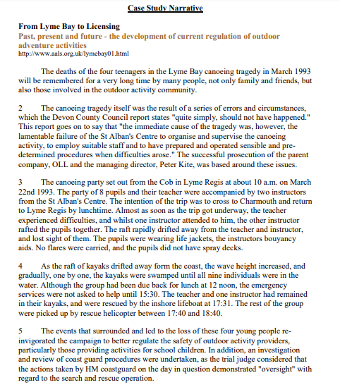

Appendix 2: Portfolios

Portfolios
Activity- Llandysul/ kayaking
Before the activity | Generic risk assessment | 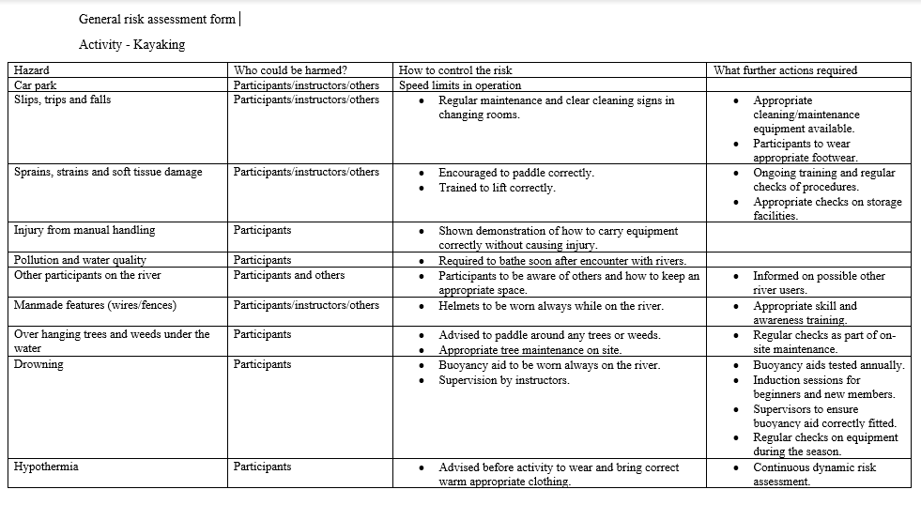
 | Be familiar with relevant legislation | “The Health and Safety at Work etc Act 1974 applies to water sports activities which are commercial in their nature. In addition, the Adventure Activities Licensing Authority (AALA) has a remit to inspect and ultimately license centres providing adventure activities to young people of 17 years old and under.” (Rospa.com, 2019)
 | National governing body | British Canoe Union are the national governing body for paddle sports in the UK.
 | Have understood key technical terms | 1.CLAP- Communication, Line of site, Avoidance, Position of maximum usefulness.  2. KISS- Keep, It, Simple, Safe  3. Eddy- A circular movement of water causing a small whirlpool.
 | Have identified key activity specific skills to be developed | Using throw lines  Good standing position and arm movement when throwing the line.
 | Be able to outline the potential benefits of each session | The potential benefit for this session was to generally risk asses this activity. Benefits of kayaking in an educational group.
 | Weather | There was light rain and winds of 5 mph on this day.
During the activity | Inspect relevant kit in accordance with the guidelines provided | I was happy with all the PPE given to me before I began the session. This included wet suite, helmet, buoyancy aid, cag jacket, paddle and a sit in kayak.
 | Keep a record of events and relevant observations throughout the day | There was a patch of weeds at the bottom half of the lake at Llandysul. The current was also a lot quicker by a pile of rocks towards the left of the lake.
 | Reflect on their own and others’ preparation for the activity | I think I prepared for this session well as I had the correct PPE. This included wet suite, helmet, buoyancy aid, cag jacket, paddle a kayak and took a hot drink and food. Others in the group were well prepared too.
After the activity | Record any near misses or accidents | There were no accidents during this activity as it was in a small lake and a controlled environment.

Activity- Llandysul/ kayaking
Before the activity | Generic risk assessment
 | Be familiar with relevant legislation | “The Health and Safety at Work etc Act 1974 applies to water sports activities which are commercial in their nature. In addition, the Adventure Activities Licensing Authority (AALA) has a remit to inspect and ultimately license centres providing adventure activities to young people of 17 years old and under.” (Rospa.com, 2019)
 | National governing body | British Canoe Union are the national governing body for paddle sports in the UK.
 | Have understood key technical terms | 1.CLAP- Communication, Line of site, Avoidance, Position of maximum usefulness.  2. KISS- Keep, It, Simple, Safe  3. Catchment Area- The area from which rainfall flows into a river, lake, or reservoir.  4. confluence- when two rivers join.
 | Have identified key activity specific skills to be developed | Using throw lines  Good standing position when throwing the line.
 | Be able to outline the potential benefits of each session | The potential benefit for this session was to do a site spesific risk asses on this activity.  Benefits of kayaking in an educational group.
 | Weather | It was sunny with no winds on this activity day.
During the activity | Inspect relevant kit in accordance with the guidelines provided | I was happy with all the PPE given to me before I began the session. This included wet suite, helmet, buoyancy aid, cag jacket, paddle and sit on top kayak.
 | Keep a record of events and relevant observations throughout the day | All the participants including our lecturers had different ways oh putting the throwing back into the bag and other useful tips and tricks to speed this process along.
 | Reflect on their own and others’ preparation for the activity | I think I need to have more patience when learning a new skill as I was getting annoyed at myself for not using the throw line correctly at the beginning of the session.
After the activity | Record any near misses or accidents | One of the participants stepped into the trailer and it toppled over before leaving cynefin.  Some of the participants in the river didn’t catch the throw lines meaning our lectures had to step in to prevent any near misses.

Activity- Three cliffs bay/ rock climbing
Before the activity | Generic risk assessment | 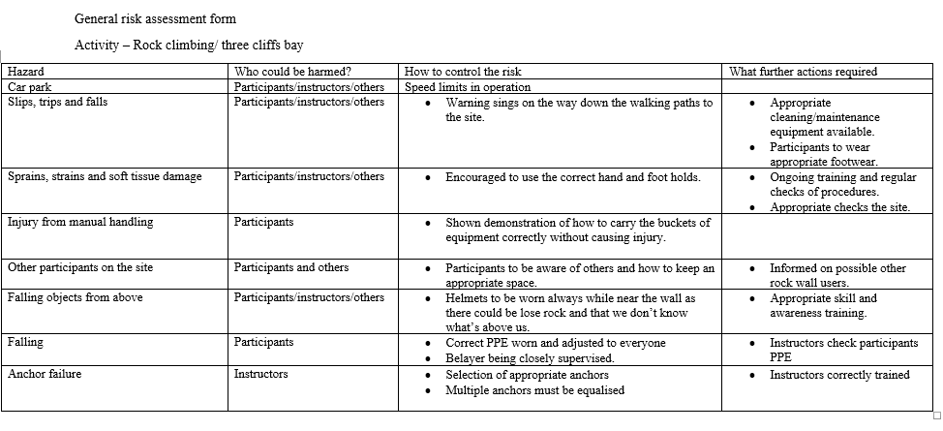
 | Be familiar with relevant legislation | The standard of care owed to a novice is obviously higher than to an experienced participant. Hence, it is wise to ensure that a novice has been made fully aware of the relevant risks involved. Climbing walls, outdoor centres and ski slopes might achieve this by an introductory session outlining the specific risks involved.  ‘volenti non fit injuria’ literally a willing man cannot be injured – this is a very old common law principle. It was ‘passed’ as a defence by the Occupiers Liability Act (1957) which does not impose any obligation on a landowner or occupier to a visitor who willingly accepts risks.  The chain of causation means that the loss or injury has been caused by the act or omission in question, rather than by something else.  Contributory negligence is another factor that can reduce the liability. This concept is fairly simple, an example of which might be a member of a novice walking group forgetting to pack essential supplies despite being informed that they were required. (Thebmc.co.uk, 2019)
 | National governing body | The British Mountaineering Council is the national representative body for England and Wales that exists to protect the freedoms and promote the interests of climbers, hill walkers and mountaineers, including ski-mountaineers.
 | Have understood key technical terms (words and phrases) when given | 1.CLAP- Communication, Line of site, Avoidance, Position of maximum usefulness.  2. Rule of the 12th's- Rule of thumb for estimating the height of the tide at any given time.  3. Lock-off- The act of pulling on a hold until your arm is in a bent position, then holding that position using body tension in order to reach the next hold with your free hand.  4. Belay- Fix (a running rope) round a cleat, rock, pin, or other object, to secure it.
 | Have identified key activity specific skills to be developed | Tying the figure of eight knot and body placement on the cliffs when rock climbing.
 | Be able to outline the potential benefits of each session | The potential benefit for this session was to do a site spesific risk asses on this activity.
 | Weather | Wind was south west, 12mph, aditionla information: low water 0.6 at 12:06pm and high water at 6:23pm.
During the activity | Inspect relevant kit in accordance with the guidelines provided | I was happy with all the PPE given to me before I began the session. This included a helmet, harness and appropriate shoes.
 | Keep a record of events and relevant observations throughout the day | Cerian has a fear of heights therefor felt nervous and upset when we had to work as a group to get across the cliffs towards the end of the session. There were a selected few participants that had to check the distance of the tide from the cliffs, so we knew how long we had left to climb safely.
 | Reflect on their own and others’ preparation for the activity | During this session I was pleased with my preparation as I wore trainers which gave me the advantage against others when climbing as they all wore walking boots which are bulky and not ideal for climbing.
After the activity | Record any near misses or accidents | During this activity there were no accidents according to my regulations.

Activity- The black mountain/ walking
Before the activity | Generic risk assessment
  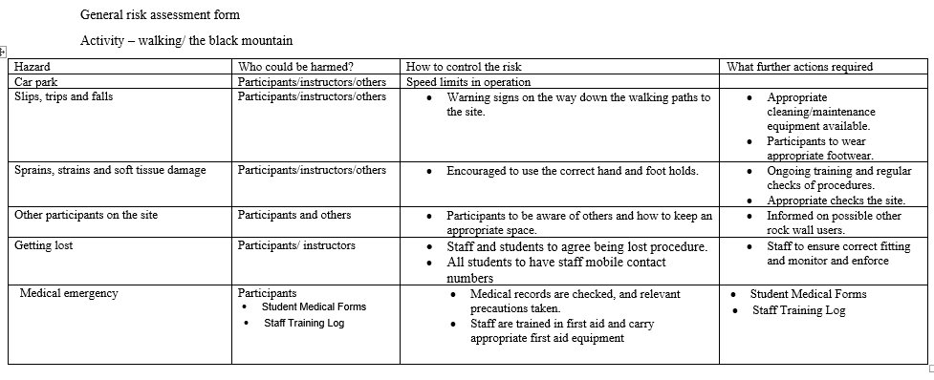
 | Be familiar with relevant legislation | The standard of care owed to a novice is obviously higher than to an experienced participant. Hence, it is wise to ensure that a novice has been made fully aware of the relevant risks involved. Climbing walls, outdoor centres and ski slopes might achieve this by an introductory session outlining the specific risks involved.  ‘volenti non fit injuria’ literally a willing man cannot be injured – this is a very old common law principle. It was ‘passed’ as a defence by the Occupiers Liability Act (1957) which does not impose any obligation on a landowner or occupier to a visitor who willingly accepts risks.  The chain of causation means that the loss or injury has been caused by the act or omission in question, rather than by something else.  Contributory negligence is another factor that can reduce the liability. This concept is fairly simple, an example of which might be a member of a novice walking group forgetting to pack essential supplies despite being informed that they were required. (Thebmc.co.uk, 2019)
 | National governing body | The British Mountaineering Council is the national representative body for England and Wales that exists to protect the freedoms and promote the interests of climbers, hill walkers and mountaineers, including ski-mountaineers.
 | Have understood key technical terms (words and phrases) when given | 1. CLAP- Communication, Line of site, Avoidance, Position of maximum usefulness.  2. Contour Line- A line on a map joining points of equal height above or below sea level.  3. Trig point- A reference point on high ground used in surveying, typically marked by a small pillar.
 | Have identified key activity specific skills to be developed | Map reading, reading a compass, learning how to lead a group walking from one point to the next and learning how to take a bearing.
 | Be able to outline the potential benefits of each session | The potential benefit for this session was to do a site spesific risk asses on this activity.
 | Weather | Heavy snow, wind and then sunny towrds the end of the day.
During the activity | Inspect relevant kit in accordance with the guidelines provided | I was happy with all the PPE given to me before I began the session.
 | Keep a record of events and relevant observations throughout the day | One of the participants didn’t have waterproofs with them.  One of the lecturers had knee problems.  Several participants didn’t have the correct kit for example gloves.
 | Reflect on their own and others’ preparation for the activity | I felt disappointed in myself this session as I didn’t come prepared as well as others I my group taking part in this activity.
After the activity | Record any near misses or accidents | There were several slips/trips and falls as it was snowing and icy on the ground.

Activity- Sit on top kayaking the coast/ New Quay
Before the activity | Generic risk assessment
 | Be familiar with relevant legislation | “The Health and Safety at Work etc Act 1974 applies to water sports activities which are commercial in their nature. In addition, the Adventure Activities Licensing Authority (AALA) has a remit to inspect and ultimately license centres providing adventure activities to young people of 17 years old and under.” (Rospa.com, 2019)
 | National governing body | British Canoe Union are the national governing body for paddle sports in the UK.
 | Have understood key technical terms | 1.CLAP- Communication, Line of site, Avoidance, Position of maximum usefulness.  2. The rule of 12th - Rule of thumb for estimating the height of the tide at any given time.
 | Have identified key activity specific skills to be developed | Identifying what route to take  Decision making
 | Be able to outline the potential benefits of each session | The session will focus on dynamic risk assessment, considering the ongoing decision-making process considering both group and environmental factors. Another benefit of this activitie was to have experience kayaking on a diffirent body of water.
 | Weather | Sunny and hot, it was 12 degrees on this activity day.
During the activity | Inspect relevant kit in accordance with the guidelines provided | I was happy with all the PPE given to me before I began the session. This included wet suite, helmet, buoyancy aid, cag jacket, paddle and sit on top kayak.
 | Keep a record of events and relevant observations throughout the day | Some of the participants felt nauseous paddling back from the activity.
 | Reflect on their own and others’ preparation for the activity | I felt like I had prepared for this activity as I picked up a cag jacket even though it was sunny just in case the weather changed suddenly. Others in my activity group prepared also by bringing sun cream, sunglasses, water, hats and other kit needed to participate.
After the activity | Record any near misses or accidents | There was some difficulty transporting the equipment e.g. the kayaks and paddles from the beach to the bus as there were small busy roads and the equipment was heavy, so participants needed to stop and rest in between. This could have caused accidents with cars and others walking around in the area.

