

Decarbonising Tata Steel: Marketing-Environment Analysis, Strategic Growth and Critical Reflection on AI

Student name: Tarjan Bhandari
Student ID number: 2542504
Programme: Master of Business Administration
Module: Marketing Management
Module code: LCMB7024
Lecturer: Sinan He
Assignment Title: Marketing Environment Analysis
Word count: 2628
Submission deadline: 7/24/2026

Table of Contents
Introduction 1
Task 1: Marketing Environment Analysis 1
1.1 Company and Analytical Context 1
1.2 Natural Environment Actor 2
1.3 Government and Regulatory Actor 4
1.4 Critical Synthesis 5
Task 2: Strategic Growth and Competitive Positioning 5
2.1 Critical Evaluation of Ansoff Alternatives 5
2.2 Recommended Product-Development Strategy 6
2.3 Competitive Positioning and Marketing Contribution 7
2.4 Implementation, Risk and Performance Control 8
2.5 Strategic Judgement 8
Task 3: Critical Reflection on AI Usage 9
3.1 Tool Disclosure 9
3.2 Critical Evaluation and Verification 9
3.3 Contribution Analysis 9
3.4 Ethical and Professional Reflection 10
Conclusion 10
References: 11

Introduction
The report critically reflects on Tata Steel's decarbonisation strategy, which involves conducting a marketing environment analysis, strategically evaluating growth and reflecting with the support of AI. It delves into the impact of natural environmental challenges and government policies on green-steel opportunities, examines the product development using Ansoff's matrix and the potential of responsible use of AI for evidence-based strategic decision-making.

Task 1: Marketing Environment Analysis

1.1 Company and Analytical Context
Tata Steel is an Indian multinational steel group which functions worldwide, primarily in India, the United Kingdom and the Netherlands. The lower-carbon transition is needed as the blast-furnace method needs coke that emits substantial amounts. Tata has proclaimed that it has set a goal of achieving a net-zero footprint by 2045, but in FY2024/25 its emissions intensity was 2.22 tonnes of CO2 per tonne of crude steel, while FY2020/21 had an emissions intensity of 2.19 tonnes of CO2 per tonne of crude steel (SUCURI, 2026). This is in opposition to its environmental objectives. Based on the expansion of the Indian grid, which will predominantly be on the coal side, India may have 40-50 MT of capacity on the grid by mid 2020s, according to Carbon Tracker (2025) and CREA (2026).
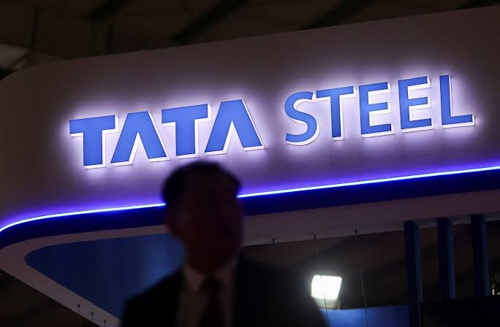
Source: (Reuters, 2025)

1.2 Natural Environment Actor
Tata is affected by the natural world by climate change, resource scarcity, pollution, circularity and the new definitions of value by customers. Kotler et al. (2024) claim that environmental forces are constraints and sources of innovation (Oluwatosin Yetunde Abdul-Azeez et al., 2024). The bottom line is that for Tata, climate change is not just a reputational issue; it's a threat to their coal assets because they generate carbon costs and are an issue that will become irrelevant and unattractive to automotive and construction customers seeking credible Scope 3 reductions. Strategically, this is significant as it is becoming a more critical factor for Tata's selection of suppliers, access to investment and strengthening brand legitimacy and long-term resilience of their customer relationships in international markets and regions. In 2024, production of steel was around 1,886 million tonnes, producing around 4.1 billion tonnes of CO2-equivalent, which accounted for 7–8% of anthropogenic greenhouse-gas emissions (BBC, 2025). The intensity is slightly more than the sectoral average of 2.18 tonnes. This is only an illustrative example of the lack of differentiation that can only be obtained by using an independent set of baselines for the products. What is very important is that the marketing communicates the performance of the product/service - not as sustainability stories. The largest, immediate opportunity for Tata is the electric-arc-furnace production based on scrap. The capacity of Ludhiana EAF was less than 0.3 tonnes of steel, with an emission level of CO2 of less than 750 kg/tonne of steel (Bolton, 2025). The expected emissions at the proposed £1.25bn Port Talbot EAF are expected to be approximately 90% less than the emissions that it will replace – five million tonnes per year. The EAFs are reducing the consumption of coke and increasing circularity with the reuse of scrap. If all the near-zero carbon technologies are considered, only scrap-EAF can be recognised as a low-cost near-zero carbon technology when the electricity is low carbon, which is highlighted by Wu et al. (2025) , (Steel-Technology, 2026). The carbon intensity of the electricity, transport, alloy inputs and quality are important to performance. The presence of copper will prevent scrap from being used in automotive applications. With just energy and cost in mind, Devlin et al. (2023) demonstrate that the higher the percentage of scrap, the lower the energy and cost, but Johnson et al. (2025) illustrate, particularly in terms of quantity and quality, that this is not a viable option to replace all primary steel with scrap (Wang et al., 2021). Then to hydrogen direct reduced iron (DRI) for high-quality primary steel, high-grade sorting and closed-loop collection, and finally, on to renewable fuel EAFs for Tata. This is a rejection of the notion that there is some new technological fix to the problem of the environment. This is not all the pressure carbon. The land use for iron-ore and coal mining affects land, biodiversity and water, and the production of steel has an impact on particulates, sulphur oxides, slag and wastewater. Increased focus on life-cycle impacts, as there is growing interest from buyers in the negative impacts. Tata's environmental product declarations (EPDs) for slabs, cold-rolled steel (CRS) and galvanised steel make life more transparent. But statements are not a decrease in impacts (Kausher et al., 2023). Absorbing change, rather than making absolute cuts, and marketing can be ways to greenwash. A business opportunity has some factors that contribute to it. Lower Carbon steel assists automotive and construction customers to reduce their embedded emissions, satisfy procurement needs and plan for future regulations. But just 10% or less of the materials surveyed customers reported taking premiums of approximately 10%. The segments that Tata will be looking for to extract value from customers based on their carbon exposure and prove total value will cover lower compliance risk, tender eligibility, traceability and Scope 3 evidence (Aflaki and Nordberg, 2026).
Figure 1: Greenhouse Gas Emissions by Economic Sector
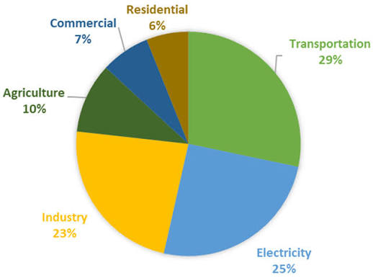
Source: (Lufrano-Jardine and Sanchez, 2025)

1.3 Government and Regulatory Actor
Government can influence green-steel economics through subsidies, carbon pricing, standards, and procurement and is decisive. Public risk sharing (as provided for in the UK government's support for the EAF in Port Talbot, which has been funded to the tune of £1.25bn) can facilitate commercially unwanted but highly desirable decarbonisation. An intervention keeps the domestic capacity and about 5,000 jobs, but if the blast furnace is closed, there are redundancies and disruptions to the region (Climatecatalyst, 2026). The Regulation also provides for the use of verified emissions data as market access. EU Carbon Border Adjustment Mechanism (CBAM) will enter its definitive phase on 1 January 2026 and will require importers of goods subject to the CBAM to report embedded emissions and to purchase carbon certificates (Zacharia, 2026). CBAM will offer incentives for cost reduction of imports containing more carbon and incentivise Tata's lower carbon product to become competitive.

1.4 Critical Synthesis
Subsidies, carbon costs and disclosure requirements reflect the physical and market imperative to decarbonise, which is driven by the natural environment, and are then imposed by government. Their relationship is also an established alternative to low-carbon steel, which has some drawbacks, such as electricity, quality of steel scrap, capital, employment and customers' willingness to pay. Hence, Tata should be looking to shift towards specific products as more negative carbon products and even to be mentioning the absolute emissions of the portfolios, which is backed by independent certification. This was an evidence-based approach which would be complementary to the marketing transformation and provide a basis for defensible Ansoff product development.

Task 2: Strategic Growth and Competitive Positioning

2.1 Critical Evaluation of Ansoff Alternatives
Ansoff's (1957) matrix categorises products and markets into four quadrants – market penetration, market development, product development and diversification – to help determine if the product or market is existing or new (Oliveira and Marques, 2024). Certainly, penetration would further stimulate conventional steel sales but would also add to the environmental/regulatory demands on Task 1. While the current level of grades can be transferred to new export markets once the EU Carbon Border Adjustment Mechanism (CBAM) comes into effect, it can help to reduce emissions-intensive exports.
The top risk mitigation: Tata should make sure there is independent testing of low-carbon grades for current customers from automotive, construction, engineering and packaging. The move reflects the current partnerships and technical expertise, as well as distribution channels, and will address the Scope 3, regulatory and procurement challenges of customers (Kouloukoui, de Marcellis-Warin and Warin, 2025).

Figure 2: Ansoff Matrix—Strategic Growth Alternatives
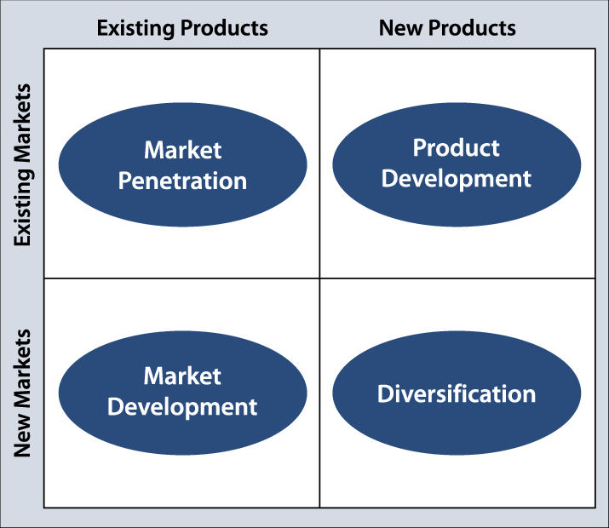
Source: (Finney and Joseph, 2009)

2.2 Recommended Product-Development Strategy
A collection of green labels should be developed instead of one ‘Tata Verified Low-Carbon Steel '. Cradle-to-gate emissions, production route, recycled content, renewable-electricity share and baseline are all things that should be included in an assured environmental product declaration. There are three grades of circular scrap-EAF steel: transition grades, which are less but contain known amounts of scrap; and future near-zero primary steel, achieved using renewable hydrogen-DRI-EAF (Andreotti et al., 2023). The products in a transition are not regarded as near zero in a tiering system and can have various requirements for product quality. Existing customers in target countries requiring carbon reporting, those customers who require to purchase carbon and those who have customers in their supply chain in target countries should be targeted first. Automotive companies can achieve a verified decrease in vehicle embedded emissions, and construction companies can benefit in their tender performance. It is necessary for marketing to realise the carbon exposure and willingness to contract and then translate the reductions to the value per application (Xue et al., 2025). The benefits of pre-investment offtake agreements are that they would eliminate uncertainty of demand, co-development (strength, formability, recyclability) and then scaling up. Production is made in Port Talbot and Ludhiana, but product development is not confined to just 'relabelling showcase output'. Agreements should encourage the closed-loop recycling of customer offcuts and end-of-life (EoL) steel (Zhang et al., 2023). Sensors would enhance the sorting process, help to limit contamination and ensure that the feedstock is safe. The digital product passports could link to batch data to enable the carbon data to be available for the buyers' Scope 3 reporting. What would happen if a commodity was transformed into a solution with a service and had physical circularity and information transparency, but there are lots of varieties of scrap and not all of these are able to cover all the needs for metallurgy? Tata needs to monitor primary production innovations related to low carbon, for instance, hydrogen DRI (Antony Jose et al., 2024). As the European climate policy is tightening up, the possibility of low-emission primary steel can be achieved, but the viability depends on the price of renewable electricity, hydrogen quality, quality of the ore, etc. Good pilots, based on cost/demand thresholds, are better than big irreversible bets.

2.3 Competitive Positioning and Marketing Contribution
According to Porter (1985), superiority should be based on a sustaining cost or a differentiation basis. In the early stages, it's not feasible to be a cost leader when these activities bring costs to the EAF construction, renewable power, certification and hydrogen projects. There is no doubt that customers must be differentiated with a more focused approach where emission verifications reduce the tender value or compliance risk (Antony Jose et al., 2024). Differentiation is not by image of the environment; it's by measurable performance. Product-level traceability, closed-loop partnerships for the use of scrap, co-development of lower carbon and application-specific quality, and geographic learning transfer – adapting learning to local energy systems are the four capabilities that guarantee defensibility. Securing datasets, contractual agreements, and creating a customer-specific grade is harder and costs more than competitors to duplicate for EAF or green brand. Marketing is more than simply promotion. It should conduct research on WTP, limit regulatory exposure, co-develop value proposition, ensure coordination of requirements with operation, procurement & research (Guerreiro et al., 2023). There may be a moderate premium available through multi-year contracts and may be tied to any of these costs of electricity, scrap and carbon.

2.4 Implementation, Risk and Performance Control
Staging a change is a good idea. In 2026-2027, Tata needs to pay attention to product footprints, renewable power and scrap deals and test customer offtakes. Investment thresholds should be met with technical performance and contracted demand, and the economics of energy should be met before taking primary grade based on hydrogen. The biggest danger is lack of credibility. The idea of encouraging use of EAF products and building Indian capacity with coal might sound paradoxical (Growth, 2026). Carbon Tracker (2025) will help plan geography-specific reduction pathways and disclosure of absolute emissions; while the efficiency may reduce absolute emissions, growth can lead to an increase in absolute emissions. These should be scrapped and collected, sorted and low carbon direct reduced iron. Volumes of this type are required due to weak willingness to pay, and due to high volatility of electricity prices, there is a need for renewable power-purchase agreements (IEA, 2025). Control measures could involve environmental measures, commercial measures and social measures, such as product and absolute emissions, proportion of renewable electricity and recycled inputs, guaranteed lower carbon volume and revenue, offtake and keeping the lower carbon inputs, closed-loop input volumes and reskilling of workers and their results (Ajeigbe and Ganda, 2024). Without these linkages to absolute decarbonisation, management incentives would otherwise be based on reducing costs and increasing growth, at the expense of the credibility of the transition.

2.5 Strategic Judgement
The product development offers a better risk–return ratio with the value to the environment and Tata's existing customers and capabilities. If there is demonstrated reduction in circular feedstock, quality and integration with customers, then sustainable-focused differentiation is possible. Investments need to be based on evidence of assurance and demand that shows commercial long-term growth that is environmentally adding; evidence is what must be sold, not aspirations.

Task 3: Critical Reflection on AI Usage

3.1 Tool Disclosure
This was then translated into OpenAI's ChatGPT, checked with other companies, headings/evidence location, put together with other evidence, and an initial draft of the brief was formed. It introduced the idea of the natural environment and its segmentation, made it clear that the Government should be involved in the Ansoff product development and focused differentiation. That's why it wasn't only proofreading, but research assistant, organiser and language builder. This involvement will be rewarded with the appropriate AI-use (Haque, 2023). I have yet to have any claims, citations or judgments dismissed.

3.2 Critical Evaluation and Verification
The word ‘provisional' is the one that I hadn't heard in my speech on AI content before, and ‘fluency' does not equal ‘accuracy'. Claims that had a time sensitivity were linked to the primary sources: emissions intensity from Tata (FY2024/25 reporting); funding from European Commission guidance (CBAM); funding from UK Government material (Port Talbot). Quality of electric-arc furnace and scrap were compared to peer-reviewed studies, as were the claims for hydrogen direct reduction (Evenly, 2026). Analysis was also performed independently, and cross-checking was used, as the companies tend to over-emphasise improvement. Their statements were not only conceivable, but they realised that they had the conceptual risk. When ChatGPT believed that it was everything was “green” (electricity carbon intensity, contamination of scrap, transport), I had to put it right (Dumiter and Schebesch, 2025). It also showcased how much Tata has done to move towards his dream of creating a zero-emission company.

3.3 Contribution Analysis
Initial composition and verbiage, source leads and potential strategies were assisted with the use of AI. My role was to now "read all the evidence" and decide what is important, challenge and question all the conflicts and then, based on the evidence assembled, the key argument is that investment in AI for Europe to be a leader is required (AI assisted to synthesise). Well supported ideas for focus, generalisations and marketing which are finished. This is not relevant - think linguistic editing is about the ownership of ideas and I don't think that I should be interpreting something that I haven't verified.

3.4 Ethical and Professional Reflection
AI can accelerate the process of environmental scanning but can also provide spurious references, biases and make some projections without hesitation. They lack the important information to develop in marketing, which can have a negative impact on the stakeholders and/or trust of the organisation (greenwashing process). Also, if sensitive or protected customer and/or business data is uploaded, then it would be a privacy and governance issue. The aspects of responsible use are Disclosure, Source verification, Data minimisation, independent assurance and Accountable human judgement. The best part is that the AI can assist in research and drafting but isn't claiming "to be an authority(Costa, Crupi and Cesaroni, 2025). That proficiency allows me to have the efficiency needed to fulfil my professional duties with respect to third parties in the evaluation of evidence, in expressing uncertainty, and in maintaining an accurate, appropriate and professionally defensible environmental claim.

Conclusion
Tata Steel must take a sustainable path, make sustainability an imperative, but must also do more in the way of differentiation and responsibly deal with customers if it is to move towards a verified low carbon footprint. Product development is a strategic pathway to be followed and is a balancing of sustainability, regulation and market. AI can help streamline and improve research, but it is essential that it still be conducted by humans to ensure accuracy and ethical considerations.

References:
Aflaki, L. and Nordberg, H. (2026) “The Green Steel Market : Evaluating the OEM Business Case and the Role of Decarbonisation Targets as Strategic Drivers in the Automotive Sector,” (May). Available at: https://lup.lub.lu.se/luur/download?func=downloadFile&recordOId=9228595&fileOId=9228966.
Ajeigbe, K.B. and Ganda, F. (2024) “The Impact of Pollution and Carbon Emission Control on Financial Development, Environmental Quality, and Economic Growth: A Global Analysis,” Sustainability, 16(20), p. 8748. Available at: https://www.mdpi.com/2071-1050/16/20/8748.
Andreotti, M. et al. (2023) “SDGs in the EU Steel Sector: A Critical Review of Sustainability Initiatives and Approaches,” Sustainability, 15(9), p. 7521. Available at: https://www.researchgate.net/publication/370568967_SDGs_in_the_EU_Steel_Sector_A_Critical_Review_of_Sustainability_Initiatives_and_Approaches.
Antony Jose, S. et al. (2024) “Promoting a Circular Economy in Mining Practices,” Sustainability, 16(24), p. 11016. Available at: https://www.davidpublisher.com/Public/uploads/Contribute/5563f0411247b.pdf.
BBC (2025) Climate experts criticise handling of Tata changes. Available at: https://www.bbc.co.uk/news/articles/c79ezrvd9neo.
Bolton (2025) “SUSTAINABILITY REPORT 2025,” RTU Sustainability Report 2025 [Preprint]. Available at: https://www.bolton.com/sites/default/files/2026-04/bolton-sustainability-report-2025.pdf.
Climatecatalyst (2026) “Catalysing Demand for Green Steel through Public Procurement in India.” Available at: https://climatecatalyst.org/wp-content/uploads/2026/02/Catalysing-Demand-for-Green-Steel-through-Public-Procurement-in-India-Report.pdf.
Costa, A., Crupi, A. and Cesaroni, F. (2025) “Exploring the role of artificial intelligence in addressing sustainable development. A semantic analysis of AI patents.” Available at: https://www.sciencedirect.com/science/article/pii/S0166497225001671.
CREA (2026) India power sector review 2025: Record clean energy deployment drives historic decline in coal generation. Available at: https://energyandcleanair.org/publication/india-power-sector-review-2025/.
Dumiter, F.C. and Schebesch, K.B. (2025) “Using Artificial Intelligence to Determine the Impact of E-Commerce on the Digital Economy,” Journal of Theoretical and Applied Electronic Commerce Research, 20(3), p. 219. Available at: https://www.mdpi.com/0718-1876/20/3/219.
Evenly (2026) What Voice AI Needs: Trust or Fluency? Available at: https://evenly.care/wp-content/uploads/2026/05/Evenly-WhitePaper-Trust-or-Fluency.pdf.
Finney, A. and Joseph, M. (2009) “The Forecasting Mantra: A Holistic Approach to Forecasting and Planning.” Available at: https://www.researchgate.net/publication/23961314_The_Forecasting_Mantra_A_Holistic_Approach_to_Forecasting_and_Planning.
Growth, S. (2026) “Anchored in the Tata Group ’ s legacy of responsible and,” (June). Available at: https://tataprojects.com/web/sites/default/files/ESG_Charter_26-05-2026.pdf.
Guerreiro, J. et al. (2023) “How to earn a premium price: the effect of green marketing and brand coolness,” Journal of Communication Management, 27(1), pp. 35–63. Available at: https://www.researchgate.net/publication/366849261_How_to_earn_a_premium_price_the_effect_of_green_marketing_and_brand_coolness.
Haque, M.A. (2023) “A Brief Analysis of ‘ChatGPT’ – A Revolutionary Tool Designed by OpenAI,” EAI Endorsed Transactions on AI and Robotics, 1(1), p. e15. Available at: https://www.researchgate.net/publication/369620426_A_Brief_Analysis_of_ChatGPT_-_A_Revolutionary_Tool_Designed_by_OpenAI.
IEA (2025) IEA Energy and Carbon Tracker 2025. Available at: https://www.iea.org/data-and-statistics/data-product/iea-energy-and-carbon-tracker-2025.
Kausher, R. et al. (2023) “Assessing Impacts of Mining-Induced Land Use Changes on Groundwater and Surface Water Quality Using Isotopic and Hydrogeochemical Signatures,” Sustainability, 15(14), p. 11041. Available at: https://www.mdpi.com/2071-1050/15/14/11041.
Kouloukoui, D., de Marcellis-Warin, N. and Warin, T. (2025) “Barriers, Opportunities, and Best Practices for Corporate Climate Transition Plans: A Literature Review,” Climate, 13(5), p. 88. Available at: https://www.mdpi.com/2225-1154/13/5/88.
Lufrano-Jardine, S. and Sanchez, J.E. (2025) “Environmental Sustainability as a Core Value in a Company with a High Carbon Footprint,” Sustainability, 17(18), p. 8392. Available at: https://www.mdpi.com/2071-1050/17/18/8392.
Oliveira, A.F. and Marques, M.B. (2024) The Importance of the Ansoff Matrix for the Study of the Information Services Market. Available at: https://www.researchgate.net/publication/382141729_The_Importance_of_the_Ansoff_Matrix_for_the_Study_of_the_Information_Services_Market.
Oluwatosin Yetunde Abdul-Azeez et al. (2024) “Sustainability in product life cycle management: A review of best practices and innovations,” International Journal of Applied Research in Social Sciences, 6(9), pp. 2018–2043. Available at: https://www.researchgate.net/publication/383848031_Sustainability_in_product_life_cycle_management_A_review_of_best_practices_and_innovations.
Reuters (2025) India’s Tata Steel beats quarterly profit estimates on lower expenses. Available at: https://www.reuters.com/world/india/indias-tata-steel-beats-quarterly-profit-estimates-lower-expenses-2025-05-12/.
Steel-Technology (2026) Electric Arc Furnaces and Scrap Steel: Moving towards the Low-Carbon Steelmaking. Available at: https://www.steel-technology.com/articles/moving-towards-the-low-carbon-steelmaking.
SUCURI (2026) Access Denied - Sucuri Website Firewall. Available at: https://eurometal.net/tata-steel-adopts-differing-european-indian-decarbonisation-strategy/.
Wang, T. et al. (2021) “Copper Recycling Flow Model for the United States Economy: Impact of Scrap Quality on Potential Energy Benefit,” Environmental Science & Technology, 55(8), pp. 5485–5495. Available at: https://pmc.ncbi.nlm.nih.gov/articles/PMC8154355/.
Xue, F. et al. (2025) Impact of Carbon Transfer and Low Carbon Preferences on Firm Decision Making Under Two Power Structures. Available at: https://www.mdpi.com/2071-1050/17/11/4956.
Zacharia, M. (2026) CBAM: A guide to Carbon Border Adjustment Mechanism. Available at:%20https:/oneclicklca.com/en/resources/articles/cbam-a-guide-to-carbon-border-adjustment-mechanism.
Zhang, X. et al. (2023) “The Impact of Green Technology Investment Levels on Competitive Supply Chain Integration Decisions,” Sustainability, 15(13), p. 10386. Available at: https://www.mdpi.com/2071-1050/15/13/10386.

