

Computer Networks and Cyber Security
Level 7
2020/2021
Security Protection and mechanism of A small to Medium Size Network

Lecturer: Dr. Carlene Campbell
Author: Ezzulddin Alakkar
Student ID:2010845
INTRODUCTION ……………………………………………………………………………………………………………………….5
Part one

- What is network security?...........................................................................................................................................5
  - Threats and Attacks……………….……………………………………………………………………………………………5
1.1.1 Types of Attacks:………………………………..………………………………………………………………………………..7
1.1.2 Passive attacks……………………………………………………………………………………………………………………7
1.1.3 Active attacks……………………………………………………………………………………………………………………..7
1.1.4 Phishing attacks:…………………………………………………………………………………………………………………7
1.1.5 Close in attacks…………………………………….…………………………………………………………………………….7
1.1.6 Viruses, Worms and Trojans……………………………………………………………………………………………………7
2. SECURITY MEASURES …………………………………………………………………………………………………….………..8
2.1 Firewall………………………………………………………………………………………….……………………………………..8
2.2 Antivirus System.................................................................................................................................................................8
2.3 Intrusion detection systems …………………..……………………………………………………………………………………8
3. Fundamental principles of securing a network: …………………………………………………………………………………..8
3.1 Strong password……………………………………………………………………………………………………………….……….9
3.2 Secure the Virtual Private Network (VPN) …………………………………………………………………………………………9
3.3 Actively manage user privileges: …….………………………………………………………………………………………..……9
3.4 Delete inactive accounts………………………………………………………………………………………………………,,,……9
4. How to mitigate the effects of common network attacks? ………….……………………………………………………………9
4.1 Authentication, Authorisation, and Accounting or known as “triple A” AAA…………………….…………………………10
4.2 Cisco ACLs: ….………………………………………………………………………………………………………………………….10
4.3 Cisco Internetwork Operation System (IOS) Secure management Features:………………………………………………..10
4.4 Encryption Protocols: ………………………………………………………………………………………………………………….10
4.5 SSH protocol………………………………………………………………………………………………………………………………10
4.6 Internet Protocol Security (IPsec): ……….………………………………………………………………………………………….10
4.7 Secure Socket Layer (SSL) protocol:…….………………………………………………………………………………………..…10
5. Security Appliances and Applications: ……………………………………………………………………………………………….10
5.1 How Cisco Network Foundation Protection (NFP) framework functions ……………………………………………………..11
5.1.1 The management………………………………………………………………………………………………………………………11
5.1.2 The control plane……………………………………………………………………………………………………………………...11
6. How to mitigate the effects of Viruses, Worms, and Trojan Horses in a small to medium business……………..………11
6.1 How to Mitigate Worm Attacks: ………………..…………………………………………………………………………………….11
6.2 Viruses Trojan Horse……….…………………………………………………………………………………………………..………12
6.3 Endpoint vulnerabilities and protection method………….…………………………………………………………….…………12
6.4 Some Protection methods ……………………………………….……………………………………………………………………12

The practical session:
7.1 Authentication without AAA: …………………………………………………………………………………………………………14
7.2 ACLs: ……………………………………………………………………………………………………………………..…………….15
7.3 Classic Firewall………………………………………………………………………………………………………………………..15
7.4 Mitigating Attacks with ACLs: ……………………………………………………………………………………………………..15
7.5 Implement secure network design, management, and reporting. …………………………….……………………………17
7.6 Description of the various techniques and tools used for network security testing………………………………….17
7.7 The vulnerabilities of and mitigation techniques for securing the Layer 2 infrastructure:……………………………18
7. 8 How network-based Intrusion Prevention Systems are used to help secure a network and how signatures are used to detect
malicious network traffic,……….…………………………………………………………………………………………………….19
7.9The purpose of VPNs………………………………………………………………………………………………………………19
7.10 How IPsec operates……………………………………………………………………………………………………………….20
7.11 Hash Functions………………………...……………………………….……………………………………………………….20
7.12 Authenticated Encryption…………………………………………………………………………………………….………….21
7.13 Digital Signature………………………………………………………………………………………………………………..21
7.14 Encryption and Digital Signature Operation………………………………………………………………………………22
7.15 How ASA operates………………………………………………………………………………………………………………23
Part two
8. Building the network………………………………………………………………………………………………………..……..25
8.1 The cost: ….………….……………………………………………………………………………………………………………25
8.2 The plan timeline: ……………………………………………………………………………………………………………….25

8.3 Three possible attacks…………………………………………………………………………………………………………26
8.4 There are several tests to be run on the network regularly. ……………………………………………………………26
The conclusion: ………………………..……………………………………………………………………………………………..27
References…………………..…………………………………………………………………………………………………………28

INTRODUCTION
The terms of information security, computer security, and information assurance are used interchangeably to describe the process of protecting information and data from unauthorised access. The goal of information security mainly deals with confidentiality, integrity, and availability of data regardless of its sources. (Kadry, S & Hassan, W., 2008.)
Electronic computers are used these days to collect, store, process, and transmit information through networks to other computers. Therefore, confidentiality of business customers, finances, army, or any other fields must be considered. This information can fall in the hands of hackers and such a security breach could lead to lawsuits, business loss or even business bankruptcy. Protecting data and confidentiality is required by law. Information security is important for protecting data and privacy of individuals as well as organisations. The information security subject has been growing significantly recently.
The subject of this paper is information security, and it has been covered in two parts. The first part covers the definition of network security, tools, and procedures of securing a network and mitigating attacks. This part is also covering the security techniques, security tools, and security configurations using hardware and software tools such as AAA, ACLs, VPN, IPsec, ACLS, and ASA.
The second part on the other hand is to implement the theory of part one in a practical case study of establishing a virtual network and securing it.

Keywords: Network security, threats, attacks mitigation, Encryption, VPN, IPsec, ACLs, SAS.

Part one
- What is network security?
Security Network is a wide concept that includes several techniques, hardware, and software. Simply put, the integrity, confidentiality, and accessibility of computer networks and data is protected by a group of rules and configurations, which are applied on both hardware and software systems. Due to the wide spread of cyber threats, different levels of network security are required for each institution. Computer networks are always facing threats by attackers who try to find vulnerabilities. These can be found in a different part of a network such as hardware, data, software, clients, and locations. Therefore, numerous network security devices and applications have been built and designed to determine and avoid individual threats, and to mitigate attacks. (Forcepoint. 2021). According to (Khan and Hasan. 2017) “A successful organisation needs to implement six kinds of layers of securities namely physical, personal, operational, communication, network and information”.

1.1 Threats and Attacks
Different types of threats and attacks are always present trying to penetrate a network ’s security. Sensitive and confidential data can be exposed by attackers. However, the concept of an attack and a threat is different, a threat is the continuous danger to the integrity of data. The sources of a threat can be an accident, environment (natural disaster), human mistake or failure. On the other hand, an attack is the actual unauthorised action of breaking the network security. Therefore, an attack is always malicious, intentional, and initiated by a system or user from outside the network. (Khan and Hasan. 2017) and (GeeksforGeeks, 2020). However, there are different types of threats and attacks, and the following figure illustrates some of the more common ones (Khan and Hasan. 2017).
Potentially, greater damage can be caused by internal threats because employees for example can access the devices directly. Specific tools must be implemented by network security professionals to mitigate external and internal threats. (Cisco Networking Academy, 1.1.1.4)

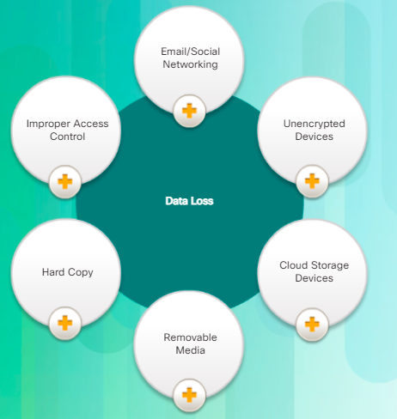
Figure Vectors of data lose
Threats | Description | Solutions
Malicious HTML emails | An attacker can link a user email to a malicious website and steal data. | Implementing a web proxy server to monitor all the websites.
Insider attack | Can be a member of the inside network who has full access and authorisation. This member can be a malicious or accidental attacker. | Restrict and control the login credentials, by implementing more than one person to control login institution’s servers.
Lack with emergency plans | Bad or lack planning by institutions can lead to data failure or lose it. | Planning firm methodologies to help developing personalised policies benchmark from other institutions.
Poor configuration | Poor quality or unskilled network managing staff due to lack of funding. | Check and scan the entire network devices regularly and automatically by using a method of vulnerability audit scanning.
Inconsiderate use of Wi-Fi hotspots | Attackers try to capture employees’ secured information such as usernames and passwords without they notice the threats. | Encrypted connections are highly recommended, for instance using VPNs and encrypt the wireless connections prevent attackers to listen or steal the data wirelessly.
Loosing portable data storages | It is a common issue that users forget or accidently leave their portable storage devices such as mobile phones, USB memory sticks, and others in public transports, hotels, and other places which easily enables attackers to retrieve sensitive and valuable data | Enterprise services such as Amazon, Google, and others provide remote storages as cloud. This facility enables users and organisations to store their data and information safely and retrieve them easily
irresponsible web surfing by employees | Different Trojans, spams, and viruses breach into the institution’s network systems when the employees surf websites other than related to their business. As a result, they end up getting victimized by pool of malware. | Keep maintaining and updating URL of blocked websites by using web filtering such as WatchGuard’sWeb Blocker

Figure Types of threats and solutions

1.1.1 Types of Attacks
Security attacks can be classified into two groups: passive and active.
    - Passive attacks: with this group, the data transmitted can be monitored and eavesdropped on by the attacker to find the content of data transmitted or to analyse the type of communication. It is difficult to detect this type of attacks due to no loss or alteration of data. However, in this situation attackers try to analyse traffics, monitor unprotected communications, decrypt weakly encrypted data and catch authentication information such as passwords (Cisco Networking Academy, 1.1.1.4) Therefore, it is necessary to implement different encryption technologies to prevent these types of attacks rather than invent new technologies to detect them.

    - Active attacks: Attackers in active attacks intend to penetrate protected systems in the on-going communications networks. This sort of attacking involves breaching secure features, injecting a malicious code, and stealing or editing sensitive data. Active attacks can be detected but they are hard to prevent. Network security professionals must apply different error detection and correction technologies on different network layers to obtain a safe data transferring. According to (Roozbahani, F and Azad, R. 2015), “Active attacks can take place in four ways: Masquerading, Replay, and Modification of message and Denial of Service”. The security of global networks has been damaged by some attacks such as: e-mails containing virus, attacks on the server, server rejection attacks, network user attacks, and network viruses. (Roozbahani, F and Azad, R. 2015) also mentioned some other types of network attacks which cause serious damage to the confidentiality of institutions such as:

    - Phishing attacks: Attackers pretend to be trustworthy people with a hidden intention of capturing sensitive data through fake emails.
    - Close in attacks: Commonly called “Bugs”, this attack involves physical interaction with the network system, and hardware to get unauthorised access to the data.

    - Viruses, Worms and Trojans: Viruses are pieces of code which are written to alter the working of the victim’s computer without its permission and authorisation.

- SECURITY MEASURES
Categorising networks attacks to Reconnaissance attacks, Access Attacks, Denial of Service (DoS), and Data theft attacks makes it easier to mitigate the attacks by determining kinds of attacks rather than individual attacks. (Cisco Networking Academy, 1.1.4.2)
The previous section and table illustrated the attacks and some of the solutions. In this section, however, several security measures will be mentioned with explanations.
  - Firewall:
A firewall is a hardware device which could either be a computer or a router, it should be allocated between the institution network and the internet. Its performance is based on filtering packets, only the ones that fulfill an institution’s internal network parameters can pass through. These parameters are configured by the firewall administrator to permit some packets and deny others. A firewall works at three of TCP/IP layers, network, transport, and application layers. Furthermore, Filtering packets happens at network and transport layers, whereas proxy firewall acts on the application layer. A firewall can be configured with specific rules to allow or filter the traffics. Attackers, however, can allow harmful data to have parameters which a firewall finds safe to allow through.
2.2 Antivirus Systems:
An antivirus system detects and eliminates malware from our systems. Regular updates must be applied on the antivirus program. Updating enables the system to scan the latest virus signatures. Some infected encrypted or zipped files cannot be detected by the firewall systems.
2.3 Intrusion detection systems:
The detection technique in this system is based on monitoring, it keeps track of any malicious actions and policy violations. This system reports any intrusion to the network administrator immediately. Anomaly intrusion detection system and Misuse detection (Signature Based IDS) are two types of intrusion detection system. They help to detect intrusions and protect the network from attacks. The Anomaly system has neutral networks and prediction pattern generation, whereas the Misuse has state transition tables, pattern matching, genetic algorithms, fuzzy logic. (Asif, M; Khan, T; Taj, T; Umar, and N; Sufyan, Y 2013).
- Fundamental principles of securing a network:
The IT organisation highly recommends updating computers, mobile devices, and network hardware on a regular basis. Furthermore, it emphasises that automatic updating must always be enabled on Windows and Apple computers. The organisation claims that cyber criminals use any vulnerabilities in operating systems, software applications, programs, and web browsers when patches and updates are not applied. It was confirmed that all office computers should have current versions of the most usable programs such as Adobe flash, Oracle java, Adobe Acrobat and Reader, etc (Berry, M, 2021).

3.1 Strong password:
A strong password is defined by PC (PC, 2021) as “a password that is hard to detect both by humans and the computer. Two things make a password stronger: (1) a larger number of characters, and (2) mixing numeric digits-, upper- and lower-case letters, and special characters ($, #, etc.)”. Furthermore, passwords must always be kept out of plain sight and changed regularly. For example, looking over users’ shoulders while they are typing their password is a simple way to hack their accounts.
3.2 Secure the Virtual Private Network (VPN):
Identity authentication and date encryptions are particularly vital in securing VPNs. Hackers exploit any vulnerability to breach any open network connection. Furthermore, the internet paths of travelling data are always targeted. Using strong encryptions and authentication protocols is a great technique to secure a VPN software and server. (Berry, M, 2021).
Barry Megan says that users on a network should be required to use a personal identification number (PIN) beside the password. It is also a good technique to separate the VPN from the rest of the network by using a firewall.

3.3 Actively manage user privileges:
A significant security threat can be caused by inappropriate user-access privileges, as Berry’s experienced (Berry, M, 2021). Managing employee access to sensitive data should not be overlooked. For example, the IT departments must always be notified when an employee’s job or position changes, so the department can modify the access privileges.

3.4 Delete inactive accounts:
Inactive former employees’ accounts can be used by hackers to gain access and track the activities. Therefore, these sorts of accounts must be removed.

- How to mitigate the effects of common network attacks?

So far, several attacks have been explained as well as some common mitigation methods such as password integrity and encryption. However, this section goes over the required action to reduce the impact of an attack on a network in more detail. The main discussed mitigation techniques are:
Authentication, Authorisation, and accounting (AAA)
Cisco access control lists (ACLs)
Cisco Interwork Operation System (IOS) secure management features
Encryption protocols
Security appliances and applications.

4.1 Authentication, Authorisation, and Accounting or known as “triple A” AAA: -

- Authentication: It is used to identify each user by login and password.
- Authorisation: It is used to specify what each user can do on the network
- Accounting: It is used to gather and report usage information such as logging.
To provide a secure network connection with a record of user actions, there are two protocols (TACACS & RADIUS) which work in conjunction with triple A.

4.2 Cisco ACLs:
Pearson defines an access list as a sequence of “permit” and “deny” statements which can be applied on a Cisco router to give a permission for some packets and deny others depending on the configuration and requirements of the network. A well configured access list can stop most attacks. Such as IP spoofing, TCP SYN attacks, ICMP and traceroute. (Pearson, 2021)

4.3 Cisco Internetwork Operation System (IOS) Secure management Features

The network administrator is responsible for configuring a new password for the network devices before deployment. In the meantime, the password step can be taken further by implementing some extra measures to secure Cisco devices within the IOS. Some extra Cisco features such as SSH, Syslog, Network Time Protocol (NTP), and Simple Network Management Protocol (SNMP) can result in more a secured network.

4.5 Encryption Protocols:
It is important to encode data to prevent attacks, otherwise it can be easily read and captured by attackers. These are the three key encryption protocols:

4.6 SSH protocol:
According to CISCO, SSH is “Secure Shell (SSH) is a protocol which provides a secure remote access connection to network devices. Communication between the client and server, Cisco SSH version 2 has a more enhanced security algorithm. protocol” (CISCO, 2021).

  - Internet Protocol Security (IPsec):
Is a group of protocols that were enhanced to secure transferred packets above the IOS model’s layer 3 (The network layer).

  - Secure Socket Layer (SSL) protocol:
A secure channel between two devices at layer 7 of IOS model can be provided by using this protocol, for example HTTPS is an SSL secure transaction.

- Security Appliances and Applications:
There is some security equipment used to mitigate vulnerabilities such as: Firewall, Intrusion prevention System (IPS), and Intrusion Detection System (IDS).
Both the software and hardware of a firewall help to mitigate attacks by separating a trusted network from a less trusted one, such as the internet. Whereas IPS is a device that listens to all incoming traffic to catch any attacks. It works in parallel with a firewall to block traffic from attacker addresses while the actual attack is in progress. IDS on the other hand, also listens to incoming traffic, however, it records, and issues alerts and TCP resets if needed.

5.1 How Cisco Network Foundation Protection (NFP) framework functions
Functions that happen on a network can be logically grouped by using Cisco NFP. The NFP as a framework combines several security methods to secure routers and switches. NFP also ensure the availability of the network even when attacks happen. The protocol is divided into three sections, Management plane, Control plane, and Data plane. (Geek University, 2021).

5.1.1 The management plane is based on the protocols and traffic used by a network administrator to configure network equipment from his/her computer. For instance, when the network administrator manages the network devices remotely using SSH and telnet. Any failure in the management plane can affect the ability to access and manage the network devices remotely.
5.1.2 The control plane consists of the protocols and travelled traffic between the network devices where the network administrator is not involved. ARP routing or messaging protocol updates are examples of a control plane. Lastly, Data plane deals with the end-user traffic. In other words, the traffic that goes through the network, but to a device out of the network’s scope. A user on a network is browsing a website is an example of Data plane. The user might be prevented from finishing the browsing if a failure happens.

- How to mitigate the effects of Viruses, Worms, and Trojan Horses in a small to medium business
With over 20+ years of experience in Cisco devices, Certificate Kits company describes some procedures to mitigate the effects of Worm attacks, Viruses, and Trojan Horses.

6.1 How to Mitigate Worm Attacks:
Worm attacks are based on self-spreading. Therefore, significant intelligent efforts are required to mitigate them. The company says that various departments within the network are needed to coordinate to achieve the task. There is a real difficulty to control and respond to warm attacks. (Certificate kits, 2021). A good technique is to set a mitigation plan of a few steps; in step one the Worm attack should be contaminated by dividing the network into infected and not infected sections. This can help to contain the propagation of the attack. At the following level, the system must be inoculated which involves scanning and patching the vulnerable system. Moving forward to the third step where all the infected devices are determined, they should be disconnected and removed from the network. Lastly, clean up and patch the entire system. Generally, the response methodology consists of, preparation, identification, classification, tracing back, reaction, and documenting and analysing the entire taken procedures to insure how to deal with the attacks in the future. (Certification Kits, 2021

6.2Viruses Trojan Horse
Computer viruses can destruct systems by connecting to normal programs and modifying their actions. Unlike Worm attacks, viruses cannot automatically transfer themselves over a network. Trojan Horses on the other hand are the programs which come across as interesting and real but have malicious hidden code inside them. The code might be a virus, a worm or both. To mitigate the effect of viruses and Trojan horses, proper precautions are required. For example, install and update antivirus software programs or applications, the network administrators should always update their knowledge with the latest attacks’ techniques, and deploying a suitable intrusion detection and preventing systems to eliminate such threats.
6.3 Endpoint vulnerabilities and protection methods
Nowadays, it would be impossible to count every internet connected device. For example, but not limited to, computers, laptops, phones, and tablets. Each of them is subject to be attacked. (Slate, S. 2018)
Slate gives an example of reasons behind the endpoint vulnerabilities in the health sector. He says “the most common vulnerability of endpoints in the healthcare sector is improperly configured devices and default admin credentials. Poor password security is a problem that haunts every company and continues to deliver exploit after exploit”. Introducing polices and accountability for password security to be followed by employees can be a solution. Furthermore, companies need to integrate security procedures for the employees, such as two-steps authentication. Endpoints, on the other hand, require more security measurements, such as updating and patching of software to avoid phishing attacks. They are, however, more vulnerable than other devices because they interact directly with users. Firewalls can be used to mitigate the effect of endpoints’ attacks also.
6.4 Some Protection methods
- A security policy must be written to include the security rules to follow.
- Employees need to be educated about the risks of social engineering, and develop techniques to validate identities over phone, email or in person.
- Manage and monitor physical access to systems.
- Strong passwords should be required and changed regularly.
- Sensitive data needs to be encrypted and protected with strong passwords.
- Implementing security hardware and software.
- Applying backups and testing the backups files regularly.
- All unused ports and services should be shutdown.
- Update all patches by installing them weekly or daily to prevent buffer overflow and privilege escalation attacks.
- Test the network by performing security audits.
- The practical session:
In addition to the basic configuration for all topology devices, the routers have been secured with the following: OSPF, OSPF MD5, TACACS, RADIUS
The command “Enable secret” has been chosen as the first step security step instead of the old one “Enable password”, as the “enable secret” command uses a stronger encryption algorithm (Cisco, 2021). However, the passwords follow a specific guideline. In the configuration, no guideline has been considered as to make them easier to remember and for training purposes only. Furthermore, the “service password-encryption” command has been applied globally on the three routers to prevent all the passwords from being observed by individuals when looking at the screen.
OSPF protocol has been configured on all routers, and a static route on R1 to direct all the unknown traffic towards R2.
OSPF MD5 has been configured on all routers. Although, MD5 has known vulnerabilities, it used here since it is the strongest encryption supported by a packet tracer. However, organisations’ security requirements must be considered when a security algorithm is chosen.
By turning to more security basic procedures, messages logging, and time synchronising should be implemented. However, the given diagram has one server which has been configured as a multiple server to include Syslog, NTP, Tacacs, Radius…. etc
On the other hand, SSH has been applied on all routers and switches. The traffic sent to Cisco IOS devices is managed at the management plane. This traffic is made up of applications and protocols such as SSH. SSH remote access tests have been tested from the external computer, and it was successful.
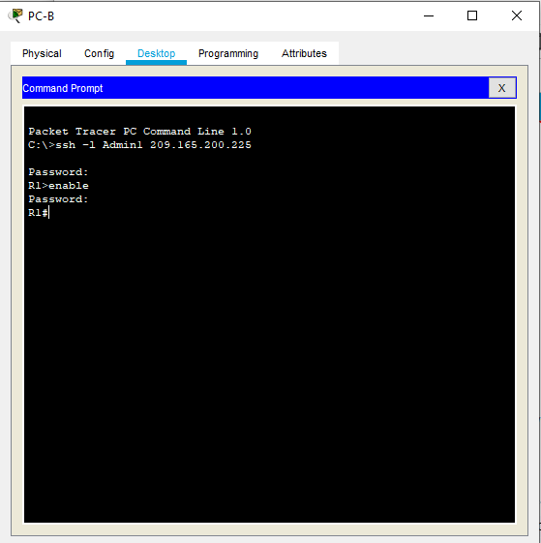
Figure SSH Local AAA authentication

The control plane has been configured with OSPF and OSPF MD5. It is responsible for processing the functions of the network’s infrastructure. The applications and protocols between network devices are included in this plane, such as EIGRP, OSPF, IGPs, and BGP. However, OSPF specifically has been used in this network.
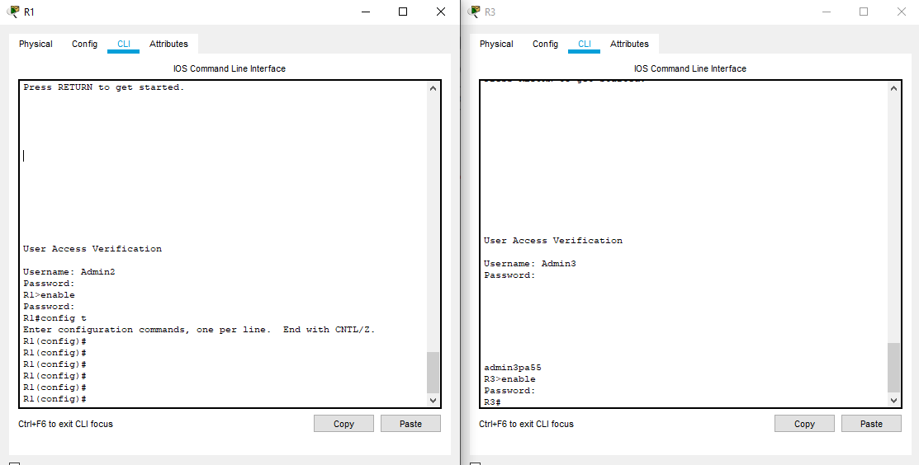
Figure TACACS & RADIUS on R1 & R3 respectively
7.1 Authentication without AAA:
Different ways of authentication can be applied on Cisco equipment and each way has different levels of security. Starting from the simplest method of remote access authentication by applying credentials on console, vty, and aux ports. However, these methods are not as reliable as Authentication, Authorisation, and Accounting (AAA method). So, what is AAA and how does it work?
“AAA network security services provide the primary framework to set up access control on a network device. AAA is a way to control who is permitted to access a network (authenticate), what they can do while they are there (authorize), and to audit what actions they performed while accessing the network (accounting)”. (Cisco, 2021)
With AAA, the database of usernames and passwords of all network devices can be kept on one central server. Users can be authenticated to access the network remotely or administrate it by using AAA, which provides two services: local AAA and server-based authentication. The difference is the username and passwords are kept locally within the router in the local AAA, while they should be allocated to a server with the server-based AAA. Therefore, the server has been set as TACACS and RADIUS with the required settings.

7.2 ACLs: In the access lists (ACLs), the routers R1, R2, and R3 can only be accessed by the external host (PC-C) for management. However, ACLs have been applied on edge routers to mitigate threats based on source and destination IP address. A standard access list has been created on the VTY line of all routers to enable the external host to SSH all of them. The numbered ACL 120 has been applied on R1 to allow any outside host to access the services DNS, SMTP, FTP, and deny any outside host access to HTTPS on the server. R3, on the other hand, has been configured with 2 numbered access-lists, 100 and 110. ACL 100 has blocked all the RFC 1918 private addresses, and any IP multicast address. However, it permits SSH traffic from the 10.0.0.0/8 network to return to the host. ACL 110 has denied all outbound packets with source address outside the range of internal IP addresses on R3.
However, when a user is authenticated successfully, then that user is authorised for a specific resource. The authorisation level should be determined through the configuration, a user can be restricted to achieve certain functions and access to certain services after authentication successfully.
By turning to Accounting which reports user activities, for example, the start and stop connection time, the number of packets, etc. can be gathered by accounting. It is also useful for troubleshooting.
7.3 Classic Firewall
Cisco IOS classic firewall inspects and filters traffic, detects intrusion, and generates audits and alerts. However, Access Control Lists have been configured to control some of traffic and the Zone-Based-Policy Firewall (ZPF) has also been applied on R3 to allow internal hosts access to external resources and to block external hosts from accessing internal resources.

7.4 Mitigating Attacks with ACLs:
ACLs can be used to filter traffic and mitigate many network threats, such as IP address spoofing and denial of service (DoS) attacks. (Cisco Networking Academy, 4.1.2.1)
However, a few ACLs have been configured on the routers to prevent the most popular access of IP addresses which should not ever enter an organization’s network. Two ACLs have been configured on R1, two on R3, and one on R2. On R1 it is used to prevent all coming zeros addresses, broadcast, local host addresses, all reserved private addresses, and IP multicast addresses. However, the PC-C Ip address was permitted for managing.

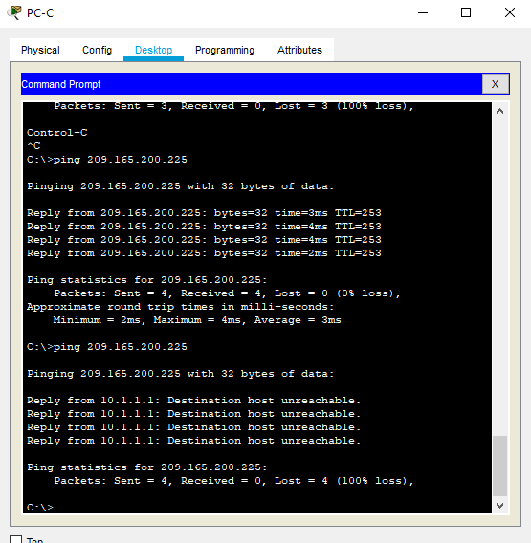
Figure Pinging from PC_C to R1 before and after ACLs modification

For mitigating attacks, only certain types of traffic through a firewall were permitted such as Domian name System (DNS), Simple Mail Transfer protocol (SMTP), and FTP. Remote access should be allowed for managing purposes such as SSH, Syslog, and SNMP.

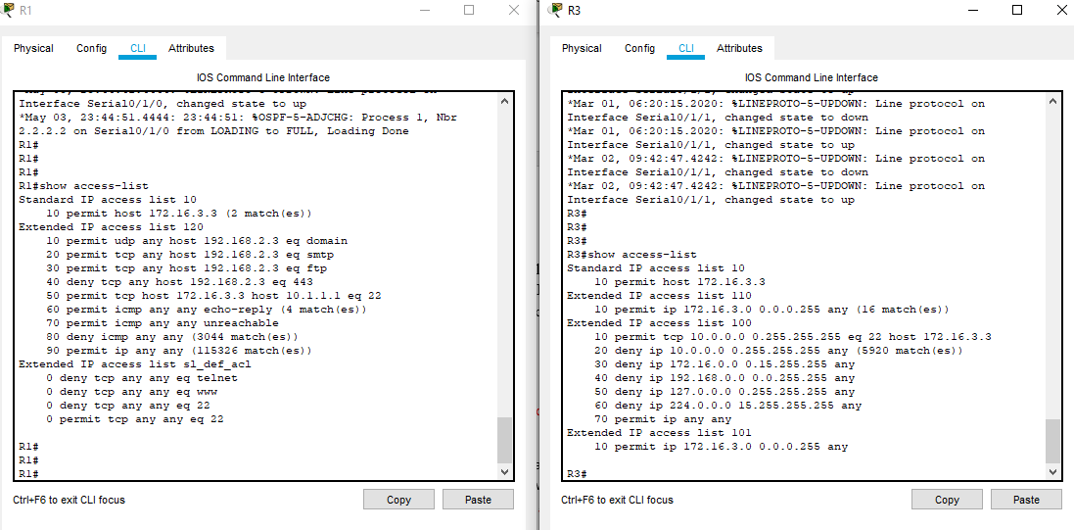
Figure ACLs R1&R3

7.5 Implement secure network design, management, and reporting.
As it is illustrated in the figure, the governing policy is necessary for organisations. It controls all departments security. In other words, the governing policy would determine who is responsible for network equipment (routers, switches, etc.), computers, who can give permissions to use the network resources, what to access should be given, determine the activities that could damage the network and computers.
Technical policies, on the other hand, are used by the security staff members. These policies are more specific than the governing policy. They can answer the “What”, the “Who”, the “When”, and the “Where” security policy questions. End-user policies are another part of the hierarchy of the corporate policy structure. (Cisco certificate Expert., 2021)
7.6 description of various techniques and tools used for network security testing.
The network testing includes testing network equipment, servers and DNS for vulnerabilities or threats. It is beneficial for companies in terms of retention of customers and cost saving. However, testing tools involve.
- penetration testing the servers, endpoints, web application, wireless devices, mobile devices, and network equipment.
- Password cracking is used to crack weak passwords. This technique is useful to enforce a password policy to create strong passwords that are hard to crack.
- Ethical Hacking to determine potential threats to a system or network. It helps to identify if unauthorised access or malicious attacks are possible.
- Vulnerability scanning to identify a weakness of the system or network to improve the network.
- Network scanning is important to determine all network connected devices. It also scans network services such as HTTP and FTP. Furthermore, it helps to insure whether ports are configured to allow only the secured network services. [Software Testing Help, 2021]

7.6 The vulnerabilities of and mitigation techniques for securing the Layer 2 infrastructure:

Layer 2 security is critical and can be hacked potentially because any ethernet port can be accessed by users. (TegTarget, 2021). According to Network PC World, the types of layer 2 attacks can be classified into four groups (Network PC World 2021); MAC layer attacks, VLAN attacks, Spoofing attacks, and Attacks on switch devices. The following figure illustrates the layer 2 attacks and mitigations. Therefore, to prevent spanning-tree manipulation attacks, the STP parameters have been secured. To stop CAM table overflow attacks, port security has been configured to limit the number of MAC addresses each switch port can learn. If the number of MAC addresses exceeds the set limit, the port will be shutdown.

Attack types | explanation | Mitigations
MAC address flooding | Frames with unique, invalid source MAC address flood the switch | Secure the ports and MAC address access maps.
VLAN attacks | An attacking device sends or receives packets on various VLANs, bypassing layer 3 security measures | Restricting trunk configurations and the negotiation of unused ports and implementing private VLANs
Spoofing attacks | DHCP starvation and DHCP spoofing can exhaust the address space available to the DHCP servers, spanning-tree compromises, MAC spoofing, and ARP spoofing | Using DHCP snooping,  Configure and enable root guard, and using port security.
Switch device attacks | CDP manipulation, and SSH and telnet attacks, | Disable CDP on all ports that are not in use and Using SSH v2
Figure Layer 2 attacks and mitigation

7.8 How network-based Intrusion Prevention Systems are used to help secure a network and how signatures are used to detect malicious network traffic:
“An intrusion detection system (IDS) is a system that monitors network traffic for suspicious activity and alerts when such activity is discovered” (TegTarget, 2021)
The main functions of IDS are to detect and report any anomaly. However, IDS also can take actions in some cases. Therefore, IDS can stop hackers before a real damage to the network occurs. IDSs are either a host-based intrusion detection system which is installed on the user computer, or a network-based intrusion detection which resides on a network. The following figure shows IDS
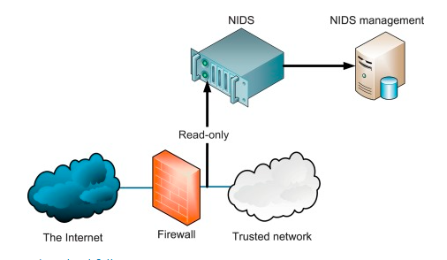
Figure IDS

“Intrusion detection systems work by either looking for signatures of known attacks or deviations from normal activity. These deviations or anomalies are pushed up the stack and examined at the protocol and application layer. They can effectively detect events such as Christmas tree scans and domain name system (DNS) poisonings”. (TegTarget, 2021)
IDS, however, can be implemented as a software or hardware. There are a few types of IDS such as network intrusion detection system, host intrusion detection system, signature-based intrusion detection system, and anomaly-based intrusion detection system. A signature-based detection system monitors all the packets travelling through the network and compares them against database of attack signature or attributes of known malicious threats.

7.9 The purpose of VPNs
According to Steve Symanovich “A virtual private network (VPN) gives you online privacy and anonymity by creating a private network from a public internet connection. VPNs mask your internet protocol (IP) address, so your online actions are virtually untraceable. Most important, VPN services establish secure and encrypted connections to provide greater privacy than even a secured Wi-Fi hotspot”. (Symanovich, S 2021)
Sensitive and private data can be exposed on unsecured Wi-Fi networks. Therefore, VPNs is necessarily for anyone concerned about their online security and privacy. Unless a private Wi-Fi network that requires a password is used, any information transmitted through the online session could be vulnerable to eavesdropping by hackers using the same network. VPNs provide encryption and anonymity that protect the online activities such as sending emails, shopping online, dealing with bills. VPNs also help to keep users’ web browsing anonymous.

7.10 How IPsec operates
IP Security (IPsec) is one of two popular protocols or group of standards used to establish a VPN connection, according to Calyptix website. (Calyptix 2016).
IPsec works on layer 3, and used to allow secure, remote access to an entire network, not just to a single device. However, there are two types of IPsec VPNs: tunnel mode and transport mode.
IPsec Tunnel Mode VPN functions by encrypting all outgoing packets, wrapping the old packet in a new, secure one, and adding a new packet header and ESP trailer. IPsec VPNs also authenticate the receiving site using an authentication header in the packet. The tunnel model is typically applied on a secure gateway for instance: a firewall or a router port which acts as a proxy for the two communicating sites. Unlike IPsec tunnel mode, IPsec Transport Mode VPN only encrypts the IP payload and ESP trailer being sent between two sites. It is used in end-to-end communication between sites, transport mode does not notify the IP header of the outgoing packet.

7.11 Hash Functions
Cryptographic hash functions are a type of cryptographic algorithm (Altili. E. 2018). The input with Hash represents a message of any length, and the output to a short, fixed length hash. Some mathematical algorithms such as MD5, SHA..etc maps data of random size to a bit string of a constant size (a hash) and designed to be a one-way function, which is impossible to invert. There is something called hash or digest which is a thumbprint of the information to validate the integrity. An algorithm that creates a shorter bit string from the information also creates the thumbprint. However, the information is checked by integrity checking mechanism to see if there is a change on the information.

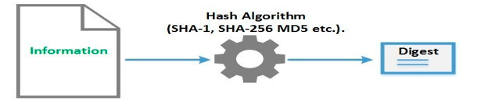
Figure Hash algorithm

7.12 Authenticated Encryption
According to Eray ALTILI “Authenticated encryption provides confidentiality, data integrity, and authenticity assurances on encrypted data. Authenticated encryption can be generically constructed by combining an encryption scheme and a message authentication code (MAC)” (Altili, E. 2018)

7.13 Digital Signature
“Digital signature is a mathematical scheme for demonstrating the authenticity of digital messages or documents.” (Altili, E. 2018)
Information integrity (using a hash algorithm) is enabled by using a valid digital signature. The authenticity and integrity of information can be verified if the digital signature is authenticated, unfalsifiable, non-reusable, and irrevocable. The signature function is based on asymmetric cryptography. First a digest of the main information is created, and then the output is encrypted with the private key. This operation is called the signature. The recipient, on the other hand, extracts the encrypted digest from the message and use the public key to encrypt it, and this operation validates the signature. The process of the signature checking includes a digest from the received information. It would be created by the receiver and compared with the previously unencrypted digest.
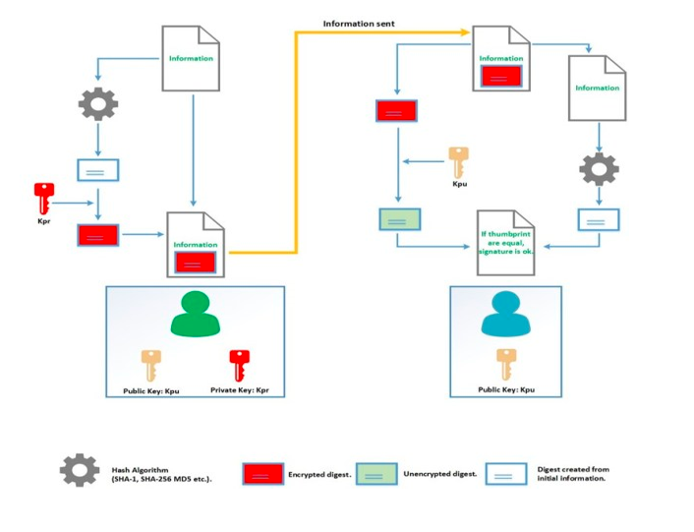
Figure digital signature

7.14 Encryption and Digital Signature Operation
Encryption, hash algorithm, and signature work together to make transferred information confidential, authentic, and honest. The signing process is done first when the signature and encryption work together. The following steps illustrate the process:
- A digest is generated from the original information.
- The thumbprint is encrypted with the private key, and then added to the initial information (within the same file).
- A temporary session key is created to be used to encrypt initial information.
- The session key is encrypted with the public key of the receiver.
- The encrypted session key is added to the encrypted information file. The file will have the encrypted information, the encrypted session key, and the signature.

When the receiver receives the file from the sender, the process begins by the encrypted file and then verifying the signature as follow:
- The encrypted session key is extracted by the receiver, this key is unencrypted with the private key to gain a session key.
- The session key is used to unencrypt information.
- The encrypted thumbprint is extracted by the receiver.
- The thumbprint will be unencrypted by using the public key.
- In the meanwhile, a digest is created by the receiver using the previously unencrypted information.
- To finish the process, the generated digest from the unencrypted information will be compared with the unencrypted thumbprint by the receiver, the signature would be verified only if they match.

7.15 How ASA operates
According to Cisco website, the ASA firewall has two modes of operation (CCNA Security, 9.1.1.6). Routed and transparent modes. With the routed mode, ASA has two or more interfaces separate the network layer. In the following figure, ASA works as a routed hop in the network and act as NAT between the connected networks. Multiple interfaces are supported by the routed mode. Each interface is on a different subnet and an IP address is required on each subnet. The policy is applied by ASA as the flows transit the firewall.
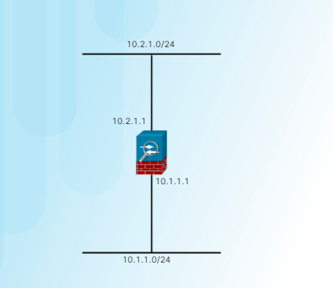
Figure ASA routed mode.

On the other hand, Transparent mode or as it is called “bump in the wire” or “stealth firewall” functions on the data link layer and is not considered as a router hop. The following figure shows the transparent mode. The Adaptive Security Appliance (ASA) is assigned an IP address on the local network for management reasons only. This mode is useful to simplify a network configuration or when the existing IP addressing cannot be altered. This mode does not support the dynamic routing protocols, VPNs, QoS, and DHCP relay.
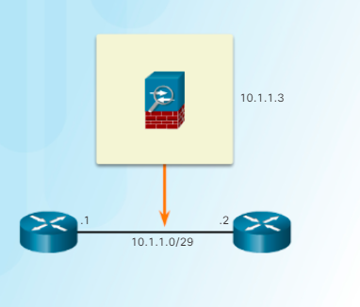
Figure ASA transparent mode

Part two
- Building the network
As the company requires, a simulation design has been set using a packet tracer. The design includes 4 routers to represent the main office in Swansea, the manufacturing in Cardiff, the ISP and the external router which represent the users working from home. Moreover, a Cisco ASA has been placed in the Swansea site where all departments are. The ASA is to connect the inside network where all departments (Represented by All Departments PC) are connected, and DMZ to the outside network (represented by Swansea router). An IPsec tunnel, on the other hand, has been allocated in between the external route which represents the employees work from home to secure the connection. The configuration should include the security measurements of AAA, ACLs, Zone-based-policy, IPsec VPN, and ASA. The diagram also includes the cloud services as the company adopts.
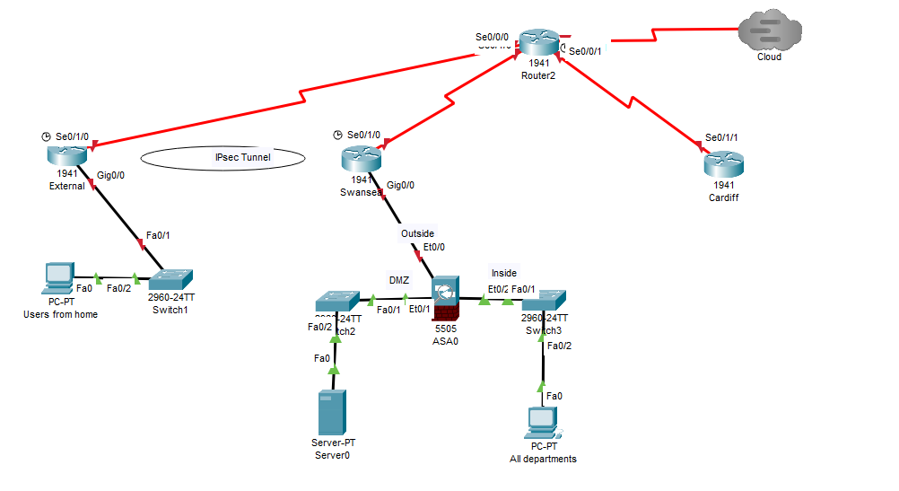
Figure A2Z Network

8.1 The cost:
The cost includes the hardware equipment and software. In addition to the cost of network devices such as the routers, switches, PCs, and wires, the cost of security devices such as firewalls, ASA, etc. must be added. Software, on the other hand, includes the cost of establishing VPN, antiviruses for endpoint devices and the entire network.

8.2 The plan timeline:
A plan of three months has been set to configure, implement, and secure the network. With this project, I would give more time for configuration and defending the network as follow:
- One week for the hardware and software tools to be prepared and connected.
- 3 weeks for configuration and testing connectivity between devices within the same site and the other sites.
- 2 months for applying security software and hardware and test them.
8.3 Three possible attacks:
There are at least seven types of network attacks.
- Spoofing.
- Sniffing.
- Mapping.
- Hijacking.
- Trojans.
- DoS and DDoS.
- Social engineering.

- Trojans: They are programs that look like normal software but make malicious actions behind the scenes.
- Spoofing (Identity spoofing or IP Address Spoofing): This attack happens when a hacker controls the running software on a network device. They can then easily modify the device’s source address field. This case is known as IP spoofing.
- Sniffing: it happens when data packets traversing a network are intercepted. A sniffer program works at the ethernet layer in combination with NIC to capture all traffic moving to and from the internet host site.
8.4 The several tests to be run on the network regularly.
- Internal/External Infrastructure Penetration testing: Includes firewalls, system hosts and devices (routers and switches). This test can be either internal to focus on inside the corporate network, or external to deal with internet-facing infrastructure.
- Web Application Testing: this test covers the websites and custom applications delivered through the web. It investigates malicious exploited uncover coding, design, and development flaws.
- Wireless Penetration testing: This test focuses on WLAN and wireless protocols (ZigBee, Bluetooth, and Z-wave). The reason for this test is to determine rogue access points, weaknesses in encryption and WPA vulnerabilities.

The conclusion:
This paper covers the topic of information security and studying the threats, attacks and how to mitigate them on a network. There are always potential threats and attacks by hackers and viruses. The reason of security is to protect networks from threats and attacks, and provide availability, integrity, and confidentiality. However, some of the configuration worked perfectly on Packet tracer while some did not. The IPsec, for example, is to prevent hackers from interfering with the sent messages among hosts in the network. I have applied the security protocols and tools in this project to avoid the potential threats and attacks, but to secure a network in real world more consideration needs to be applied, such as using proper passwords of at least 10 characters as an example. Moreover, I found that dealing with virtual platform, such as packet tracer is not as easy and productive as physical labs. Furthermore, diagnosing problems and troubleshooting in physical labs are much easier to solve than packet tracer. Lastly, I have encountered some problems and mistakes which affected the connection and SSH, for example, I had an issue with pinging and SSH remote access because I declared the right network address but wrong mask address. However, some issues were easy to solve by modification, while others needed re-configuration.

References:
- Forcepoint., (2021)., Network Security defined [online]. Available from What is Network Security? Defined, Explained, and Explored | Forcepoint.
- Khan, R, Hasan, M. (2017). NETWORK Threats and Security Measures: A review. International Journal of Advanced Research in Computer Science. 8(8), p 116-119.
- GeeksforGeeks., (2020), Difference between Threats and Attacks [online]., GeeksforGeeks [20/03/2021]. Available from Difference between Threat and Attack - GeeksforGeeks
- Roozbahani, F and Azad, R., (2015)., Security Solutions against Computer Networks Threats. International journal of advanced networking and applications., 7 (1), p.2576
- Asif, M; Khan, T; Taj, T; Umar, and N; Sufyan, Y 2013, ‘Network intrusion Detection and its Strategic importance’, IEEE Business Engineering and Industrial Applications Colloquium (BEIAC), Langkawi, Malaysia, 7-9 April 2013
- Berry, M., 2021.Network Security: Top 5 Fundamentals [online]. IT Manager Daily(31/03/2021)., available from http://www.itmanagerdaily.com/network-security-fundamentals/
- PC., 2021., Strong Password [online]. PC (32/03/2021., available from https://www.pcmag.com/encyclopedia/term/strong-password
- Pearson., 2008., CCNT Exam prep: General Network Security [online]., Pearson (31/03/2021). Available from Mitigating Network Threats | CCENT Exam Prep: General Network Security | Pearson IT Certification
- CISCO., 2021., Configuration Secure Shell on Routers and Switches Running Cisco IOS [online., CISCO (1/4/2021]., Available from https://www.cisco.com/c/en/us/support/docs/security-vpn/secure-shell-ssh/4145-ssh.html
- Geek University 2021., Cisco Network Foundation Protection (NFP framework) [online]., Geek University (1/4/2021). Available from https://geek-university.com/ccna-security/cisco-network-foundation-protection-nfp-framework/
- CertificationKits., 2021., CCNA Security:Woem, Virus and Trojan Horse attacks [online]. CertificationKits(1/4/2021) Available from https://www.certificationkits.com/cisco-certification/ccna-security-certification-topics/ccna-security-describe-security-threats/ccna-security-worm-virus-and-trojan-horse-attacks/
- Slate.S., (2018)., Endpoint Security: An Overview and a Look into the Future [online]., available from http://www.cs.tufts.edu/comp/116/archive/spring2018/sslate.pdf.
- Cisco., 2021., Cisco Guide to harden Cisco IOS Devices [online].,Cisco (3/4/2021). Available from https://www.cisco.com/c/en/us/support/docs/ip/access-lists/13608-21.html#anc0
- Cisco., 2021., Cisco Guide to harden Cisco IOS Devices [online]., Cisco (3/4/2021). Available from: https://www.cisco.com/c/en/us/support/docs/ip/access-lists/13608-21.html#anc47
- Codebots 2018. Application Security. What is AAA security? An introduction to authentication, authorisation, and accounting [online]. Codebots (28/4/2021). Available from: https://codebots.com/application-security/aaa-security-an-introduction-to-authentication-authorisation-accounting#:~:text=AAA%20intelligently%20controls%20access%20to,restricted%20to%20specific%2C%20legitimate%20users.&text=Historically%20AAA%20security%20has%20set%20the%20benchmark.
- Cisco Networking Academy 2021. CCNA Security: Implementing Network Security 2.01[online]. Cisco Networking Academy 928/4/20210). Available From: https://static-course-assets.s3.amazonaws.com/CCNAS2/en/index.html#1.2.4.1
- Cisco Networking Academy 2021. CCNA Security: Implementing Network Security 2.01[online]. Cisco Networking Academy 928/4/20210). Available From: https://static-course-assets.s3.amazonaws.com/CCNAS2/en/index.html#1.1.1.4
- Cisco Networking Academy 2021. CCNA Security: Implementing Network Security 2.01[online]. Cisco Networking Academy 928/4/20210). Available From: https://static-course-assets.s3.amazonaws.com/CCNAS2/en/index.html#1.3.5.4
- Cisco certificate Expert., 2021. Components of a Comprehensive Security Policy [online], 24/4/2021. Available from: https://www.ccexpert.us/scnd/components-of-a-comprehensive-security-policy.html
- Software Testing Help, 2021. Network Security Testing and Best Network Security Tools[online]. Software Testing Help Available (24/4/2021) from: https://www.softwaretestinghelp.com/network-security-testing-and-tools/
- TegTarget, 2021. Preventing Layer 2 Security Threats[online]. TegTarget (24/4/2021). Available from: Preventing Layer 2 security threats (techtarget.com)
- Network PC World 2021. Types of Layer 2/Switch Security Attacks, and Mitigation steps in brief [online]. Network PC world (24/4/2021). Available from: Network PC World: Types of Layer 2/Switch Security Attacks, and Mitigation steps in Brief
- TegTarget, 2021. Intrusion Detection System (IDS) [online]. TegTarget (24/4/2021). Available from: https://searchsecurity.techtarget.com/definition/intrusion-detection-system
- Symanovich, S 2021.What is a VPN? [online]. Norton (25/4/2020). Available from: https://us.norton.com/internetsecurity-privacy-what-is-a-vpn.html
- Calyptix 2016., SSL VPN and IPsec VPN: How they work [online]. Calyptix security (25/4/2021). Available from: https://www.calyptix.com/research-2/ssl-vpn-and-ipsec-vpn-how-they-work/#:~:text=IPsec%20VPNs%20that%20work%20in,packet%20header%20and%20ESP%20trailer.&text=Tunnel%20mode%20IPsec%20VPN%20is,for%20the%20two%20communicating%20sites
- Kadry, S & Hassan, W., 2008. DESIGN AND IMPLEMENTATION OF SYSTEM AND NETWORK SECURITY FOR AN ENTERPRISE WITH WORLDWIDE BRANCHES. Journal of Theoretical and Applied Information Technology.
- Altili, E. 2018. Cryptography, Encryption, Hash Functions and Digital Signature [online]. Data Driven Investor (25/4/2021). Available from: https://medium.datadriveninvestor.com/cryptography-encryption-hash-functions-and-digital-signature-101-298a03eb9462
- Cisco Networking Academy. 2021. Antispoofing with ACLs [online].Cisco Networking Academy(29/4/2021) Available from: https://static-course-assets.s3.amazonaws.com/CCNAS2/en/index.html#4.1.2.1
- Cisco Networking Academy. 2021. ASA Firewall Modes of Operation[online].Cisco Networking Academy(29/4/2021) Available from: https://static-course-assets.s3.amazonaws.com/CCNAS2/en/index.html#9.1.1.6
R1 configuration
R1#show run
Building configuration...

Current configuration : 3044 bytes
!
version 15.1
service timestamps log datetime msec
no service timestamps debug datetime msec
no service password-encryption
!
hostname R1
!
login block-for 60 attempts 2 within 30
login on-failure log
!
!
enable secret 5 $1$mERr$TfFTxE.mmb5O5BVC56ndL0
!
!
!
!
!
aaa new-model
!
aaa authentication login default group radius local
!
!
aaa authorization exec default group tacacs+
aaa authorization network default group tacacs+
!
!
!
!
!
no ip cef
no ipv6 cef
!
!
!
username Admin1 secret 5 $1$mERr$yqLDyfDDWkZGJ9y568Vjq0
username Admin2 secret 5 $1$mERr$lfxtLKoTWhTjn9wJx3u4s.
username SSHadmin privilege 15 secret 5 $1$mERr$OBJ1/J.XbT5.JhwNHVc7p/
!
!
license udi pid CISCO1941/K9 sn FTX1524OKS6-
!
!
!
!
!
!
!
!
!
ip ssh version 2
ip ssh authentication-retries 2
ip ssh time-out 90
no ip domain-lookup
ip domain-name ccnsecurity.com
!
!
spanning-tree mode pvst
!
!
!
!
!
!
interface Loopback1
ip address 172.20.1.1 255.255.255.0
!
interface GigabitEthernet0/0
description connection to ASA
ip address 209.165.200.225 255.255.255.248
duplex auto
speed auto
!
interface GigabitEthernet0/1
no ip address
duplex auto
speed auto
shutdown
!
interface Serial0/1/0
description connection to R2
ip address 10.1.1.1 255.255.255.252
ip ospf message-digest-key 1 md5 MD5pa55
ip access-group 120 in
clock rate 128000
!
interface Serial0/1/1
no ip address
clock rate 2000000
shutdown
!
interface Vlan1
no ip address
shutdown
!
router ospf 1
router-id 1.1.1.1
log-adjacency-changes
area 0 authentication message-digest
passive-interface GigabitEthernet0/0
network 209.165.200.224 0.0.0.7 area 0
network 10.1.1.0 0.0.0.3 area 0
network 172.20.1.0 0.0.0.255 area 0
network 192.168.2.0 0.0.0.255 area 0
network 192.168.1.0 0.0.0.255 area 0
network 172.16.3.0 0.0.0.255 area 0
default-information originate
!
ip classless
ip route 0.0.0.0 0.0.0.0 Serial0/1/0
!
ip flow-export version 9
!
!
access-list 10 permit host 172.16.3.3
access-list 120 permit udp any host 192.168.2.3 eq domain
access-list 120 permit tcp any host 192.168.2.3 eq smtp
access-list 120 permit tcp any host 192.168.2.3 eq ftp
access-list 120 deny tcp any host 192.168.2.3 eq 443
access-list 120 permit tcp host 172.16.3.3 host 10.1.1.1 eq 22
access-list 120 permit icmp any any echo-reply
access-list 120 permit icmp any any unreachable
access-list 120 deny icmp any any
access-list 120 permit ip any any
ip access-list extended sl_def_acl
deny tcp any any eq telnet
deny tcp any any eq www
deny tcp any any eq 22
permit tcp any any eq 22
!
!
tacacs-server host 192.168.2.3
tacacs-server key tacacspa55
radius-server host 192.168.2.3 auth-port 1645
radius-server key radiuspa55
!
!
!
!
logging 192.168.2.3
line con 0
exec-timeout 0 0
password ciscocopa55
login authentication default
!
line aux 0
!
line vty 0 4
access-class 10 in
password cisco vtypa55
login authentication SSH-LOGIN
transport input ssh
!
!
ntp authentication-key 1 md5 080F787E1918160405041E00 7
ntp authenticate
ntp trusted-key 1
ntp server 10.1.1.2
ntp update-calendar
!
End

R2
R2#show run
Building configuration...

Current configuration : 1978 bytes
!
version 15.1
service timestamps log datetime msec
no service timestamps debug datetime msec
no service password-encryption
!
hostname R2
!
!
!
enable secret 5 $1$mERr$TfFTxE.mmb5O5BVC56ndL0
!
!
!
!
!
aaa new-model
!
aaa authentication login SSH-LOGIN local
aaa authentication login SSH_LOGIN local
aaa authentication login default group tacacs+ local
!
!
!
!
!
!
!
no ip cef
no ipv6 cef
!
!
!
username Admin1 password 0 admin1pa55
username Admin2 secret 5 $1$mERr$lfxtLKoTWhTjn9wJx3u4s.
username SSHadmin privilege 15 secret 5 $1$mERr$OBJ1/J.XbT5.JhwNHVc7p/
!
!
license udi pid CISCO1941/K9 sn FTX152435AX-
!
!
!
!
!
!
!
!
!
ip ssh version 2
ip ssh authentication-retries 2
ip ssh time-out 90
no ip domain-lookup
ip domain-name ccnsecurity.com
!
!
spanning-tree mode pvst
!
!
!
!
!
!
interface GigabitEthernet0/0
no ip address
duplex auto
speed auto
shutdown
!
interface GigabitEthernet0/1
no ip address
duplex auto
speed auto
shutdown
!
interface Serial0/1/0
description connection to R2
ip address 10.1.1.2 255.255.255.252
ip ospf message-digest-key 1 md5 MD5pa55
!
interface Serial0/1/1
description connection to R3
ip address 10.2.2.2 255.255.255.252
ip ospf message-digest-key 1 md5 MD5pa55
clock rate 128000
!
interface Vlan1
no ip address
shutdown
!
router ospf 1
router-id 2.2.2.2
log-adjacency-changes
area 0 authentication message-digest
network 10.1.1.0 0.0.0.3 area 0
network 10.2.2.0 0.0.0.3 area 0
!
ip classless
!
ip flow-export version 9
!
!
access-list 10 permit host 172.16.3.3
!
!
tacacs-server host 192.168.2.3
tacacs-server key tacacspa55
!
!
!
!
logging 192.168.2.3
line con 0
exec-timeout 0 0
password ciscocopa55
login authentication default
!
line aux 0
!
line vty 0 4
access-class 10 in
password ciscovtypa55
login authentication SSH-LOGIN
transport input ssh
!
!
ntp authentication-key 1 md5 080F787E1918160405041E00 7
ntp authenticate
ntp trusted-key 1
ntp server 192.168.2.3
ntp master 3
ntp update-calendar
!
End
R3
R3#show run
Building configuration...

Current configuration : 3141 bytes
!
version 15.1
service timestamps log datetime msec
no service timestamps debug datetime msec
no service password-encryption
!
hostname R3
!
!
!
enable secret 5 $1$mERr$TfFTxE.mmb5O5BVC56ndL0
!
!
!
!
!
aaa new-model
!
aaa authentication login SSH-LOGIN local
aaa authentication login default group tacacs+ local
!
!
aaa authorization exec default group radius
aaa authorization network default group radius
!
!
!
!
!
no ip cef
no ipv6 cef
!
!
!
username Admin1 secret 5 $1$mERr$Ty/EkWXcSXEwIckISrps8/
username Admin2 secret 5 $1$mERr$lfxtLKoTWhTjn9wJx3u4s.
username SSHadmin privilege 15 secret 5 $1$mERr$OBJ1/J.XbT5.JhwNHVc7p/
!
!
license udi pid CISCO1941/K9 sn FTX152430Y6-
license boot module c1900 technology-package securityk9
!
!
!
!
!
!
!
!
!
ip ssh version 2
ip ssh authentication-retries 2
ip ssh time-out 90
no ip domain-lookup
ip domain-name ccnsecurity.com
!
!
spanning-tree mode pvst
!
ip ips name IOSIPS
ip ips signature-category
category all
retired true
category ios_ips basic
retired false
class-map type inspect match-all IN-NET-CLASS-MAP
match access-group 101
!
policy-map type inspect IN-2-OUT-PMAP
class type inspect IN-NET-CLASS-MAP
inspect
!
!
!
zone security IN-ZONE
zone security OUT-ZONE
zone-pair security IN-2-OUT-ZPAIR source IN-ZONE destination OUT-ZONE
service-policy type inspect IN-2-OUT-PMAP
!
!
interface GigabitEthernet0/0
no ip address
duplex auto
speed auto
shutdown
!
interface GigabitEthernet0/1
description connection to S2
ip address 172.16.3.1 255.255.255.0
zone-member security IN-ZONE
ip access-group 110 in
duplex auto
speed auto
!
interface Serial0/1/0
no ip address
clock rate 2000000
shutdown
!
interface Serial0/1/1
description connection to R2
ip address 10.2.2.1 255.255.255.252
ip ips IOSIPS in
zone-member security OUT-ZONE
ip ospf message-digest-key 1 md5 MD5pa55
ip access-group 100 in
!
interface Vlan1
no ip address
shutdown
!
router ospf 1
router-id 3.3.3.3
log-adjacency-changes
area 0 authentication message-digest
network 10.2.2.0 0.0.0.3 area 0
network 172.16.3.0 0.0.0.255 area 0
default-information originate
!
ip classless
ip route 0.0.0.0 0.0.0.0 Serial0/1/1
!
ip flow-export version 9
!
!
access-list 10 permit host 172.16.3.3
access-list 110 permit ip 172.16.3.0 0.0.0.255 any
access-list 100 permit tcp 10.0.0.0 0.255.255.255 eq 22 host 172.16.3.3
access-list 100 deny ip 10.0.0.0 0.255.255.255 any
access-list 100 deny ip 172.16.0.0 0.15.255.255 any
access-list 100 deny ip 192.168.0.0 0.0.255.255 any
access-list 100 deny ip 127.0.0.0 0.255.255.255 any
access-list 100 deny ip 224.0.0.0 15.255.255.255 any
access-list 100 permit ip any any
access-list 101 permit ip 172.16.3.0 0.0.0.255 any
!
!
tacacs-server host 192.168.2.3
tacacs-server key tacacspa55
!
!
!
!
logging 192.168.2.3
line con 0
exec-timeout 0 0
password ciscocopa55
login authentication default
!
line aux 0
!
line vty 0 4
access-class 10 in
password ciscovtypa55
login authentication SSH-LOGIN
transport input ssh
!
!
ntp authentication-key 1 md5 080F787E19185042 7
ntp authenticate
ntp trusted-key 1
ntp server 10.2.2.2
ntp update-calendar
!
End
S1
Username: Admin01
Password:

S1#config t
Enter configuration commands, one per line. End with CNTL/Z.
S1(config)#
S1(config)#
S1(config)#
S1(config)#
S1(config)#
S1(config)#
S1(config)#do show run
Building configuration...

Current configuration : 2169 bytes
!
version 12.2
no service timestamps log datetime msec
no service timestamps debug datetime msec
no service password-encryption
!
hostname S1
!
!
!
ip ssh version 2
ip ssh authentication-retries 2
ip ssh time-out 90
no ip domain-lookup
ip domain-name ccnasecurity.com
!
username Admin01 secret 5 $1$mERr$Jj7To5G9RItlZ3jcQt1WO1
username admin secret 5 $1$mERr$WvpW0n5HghRrqnrwXCUUl.
!
!
!
spanning-tree mode pvst
spanning-tree extend system-id
spanning-tree vlan 1 priority 0
!
interface FastEthernet0/1
shutdown
!
interface FastEthernet0/2
shutdown
!
interface FastEthernet0/3
shutdown
!
interface FastEthernet0/4
shutdown
!
interface FastEthernet0/5
shutdown
!
interface FastEthernet0/6
switchport mode access
switchport port-security
switchport port-security mac-address sticky
switchport port-security mac-address sticky 0030.A3E9.2DD3
spanning-tree portfast
spanning-tree bpduguard enable
!
interface FastEthernet0/7
shutdown
!
interface FastEthernet0/8
shutdown
!
interface FastEthernet0/9
shutdown
!
interface FastEthernet0/10
shutdown
!
interface FastEthernet0/11
shutdown
!
interface FastEthernet0/12
shutdown
!
interface FastEthernet0/13
shutdown
!
interface FastEthernet0/14
shutdown
!
interface FastEthernet0/15
shutdown
!
interface FastEthernet0/16
shutdown
!
interface FastEthernet0/17
shutdown
!
interface FastEthernet0/18
shutdown
!
interface FastEthernet0/19
shutdown
!
interface FastEthernet0/20
shutdown
!
interface FastEthernet0/21
shutdown
!
interface FastEthernet0/22
shutdown
!
interface FastEthernet0/23
shutdown
!
interface FastEthernet0/24
switchport mode access
spanning-tree portfast
!
interface GigabitEthernet0/1
shutdown
!
interface GigabitEthernet0/2
shutdown
!
interface Vlan1
ip address 192.168.2.11 255.255.255.0
!
ip default-gateway 192.168.2.1
!
banner motd ^CUnauthorized access strictly prohibited!^C
!
!
!
line con 0
password ciscoconpa55
logging synchronous
login local
exec-timeout 5 0
privilege level 15
!
line vty 0 4
exec-timeout 5 0
login local
transport input ssh
privilege level 15
line vty 5 15
exec-timeout 5 0
login local
transport input ssh
privilege level 15
!
!
!
!
End
S2
S2#show run
Building configuration...

Current configuration : 1911 bytes
!
version 12.2
no service timestamps log datetime msec
no service timestamps debug datetime msec
no service password-encryption
!
hostname S2
!
!
!
ip ssh version 2
ip ssh authentication-retries 2
ip ssh time-out 90
no ip domain-lookup
ip domain-name ccnasecurity.com
!
username admin secret 5 $1$mERr$WvpW0n5HghRrqnrwXCUUl.
!
!
!
spanning-tree mode pvst
spanning-tree extend system-id
spanning-tree vlan 1 priority 0
!
interface FastEthernet0/1
shutdown
!
interface FastEthernet0/2
shutdown
!
interface FastEthernet0/3
shutdown
!
interface FastEthernet0/4
shutdown
!
interface FastEthernet0/5
shutdown
!
interface FastEthernet0/6
shutdown
!
interface FastEthernet0/7
shutdown
!
interface FastEthernet0/8
shutdown
!
interface FastEthernet0/9
shutdown
!
interface FastEthernet0/10
shutdown
!
interface FastEthernet0/11
shutdown
!
interface FastEthernet0/12
shutdown
!
interface FastEthernet0/13
shutdown
!
interface FastEthernet0/14
shutdown
!
interface FastEthernet0/15
shutdown
!
interface FastEthernet0/16
shutdown
!
interface FastEthernet0/17
shutdown
!
interface FastEthernet0/18
switchport mode access
spanning-tree portfast
spanning-tree bpduguard enable
!
interface FastEthernet0/19
shutdown
!
interface FastEthernet0/20
shutdown
!
interface FastEthernet0/21
shutdown
!
interface FastEthernet0/22
shutdown
!
interface FastEthernet0/23
shutdown
!
interface FastEthernet0/24
switchport mode access
spanning-tree portfast
!
interface GigabitEthernet0/1
shutdown
!
interface GigabitEthernet0/2
shutdown
!
interface Vlan1
ip address 192.168.1.11 255.255.255.0
!
ip default-gateway 192.168.1.1
!
banner motd ^CUnauthorized access strictly prohibited!^C
!
!
!
line con 0
password ciscoconpa55
logging synchronous
login
exec-timeout 0 0
!
line vty 0 4
exec-timeout 5 0
login local
transport input ssh
privilege level 15
line vty 5 15
login
transport input none
!
!
!
!
End
S3
S3#show run
Building configuration...

Current configuration : 2044 bytes
!
version 12.2
no service timestamps log datetime msec
no service timestamps debug datetime msec
no service password-encryption
!
hostname S3
!
!
!
ip ssh version 2
ip ssh authentication-retries 2
ip ssh time-out 90
no ip domain-lookup
ip domain-name ccnasecurity.com
!
username admin secret 5 $1$mERr$WvpW0n5HghRrqnrwXCUUl.
!
!
!
spanning-tree mode pvst
spanning-tree extend system-id
spanning-tree vlan 1 priority 0
!
interface FastEthernet0/1
shutdown
!
interface FastEthernet0/2
shutdown
!
interface FastEthernet0/3
shutdown
!
interface FastEthernet0/4
shutdown
!
interface FastEthernet0/5
switchport mode trunk
switchport port-security
switchport port-security mac-address 0001.4241.8002
!
interface FastEthernet0/6
shutdown
!
interface FastEthernet0/7
shutdown
!
interface FastEthernet0/8
shutdown
!
interface FastEthernet0/9
shutdown
!
interface FastEthernet0/10
shutdown
!
interface FastEthernet0/11
shutdown
!
interface FastEthernet0/12
shutdown
!
interface FastEthernet0/13
shutdown
!
interface FastEthernet0/14
shutdown
!
interface FastEthernet0/15
shutdown
!
interface FastEthernet0/16
shutdown
!
interface FastEthernet0/17
shutdown
!
interface FastEthernet0/18
switchport mode access
switchport port-security
switchport port-security maximum 3
switchport port-security aging time 120
spanning-tree portfast
spanning-tree bpduguard enable
!
interface FastEthernet0/19
shutdown
!
interface FastEthernet0/20
shutdown
!
interface FastEthernet0/21
shutdown
!
interface FastEthernet0/22
shutdown
!
interface FastEthernet0/23
shutdown
!
interface FastEthernet0/24
shutdown
!
interface GigabitEthernet0/1
shutdown
!
interface GigabitEthernet0/2
shutdown
!
interface Vlan1
ip address 172.16.3.11 255.255.255.0
!
ip default-gateway 172.30.3.1
!
banner motd ^CUnauthorized access strictly prohibited!^C
!
!
!
line con 0
password ciscoconpa55
logging synchronous
login
exec-timeout 0 0
!
line vty 0 4
exec-timeout 5 0
login local
transport input ssh
privilege level 15
line vty 5 15
login
!
!
!
!
End
ASA
CCNAS-ASA(config)#show run
: Saved
:
ASA Version 8.4(2)
!
hostname CCNAS-ASA
domain-name ccnasecurity.com
enable password Qa8ENuiyPgE/u.0d encrypted
passwd 4IncP7vTjpaba2aF encrypted
names
!
interface Ethernet0/0
switchport access vlan 2
!
interface Ethernet0/1
!
interface Ethernet0/2
switchport access vlan 3
!
interface Ethernet0/3
!
interface Ethernet0/4
!
interface Ethernet0/5
!
interface Ethernet0/6
!
interface Ethernet0/7
!
interface Vlan1
nameif inside
security-level 100
ip address 192.168.1.1 255.255.255.0
!
interface Vlan2
nameif outside
security-level 0
ip address 209.165.200.226 255.255.255.248
!
interface Vlan3
no forward interface Vlan1
nameif dmz
security-level 70
ip address 192.168.2.1 255.255.255.0
!
object network INSIDE-NET
subnet 192.168.1.0 255.255.255.0
object network dmz-server
host 192.168.2.3
!
route outside 0.0.0.0 0.0.0.0 209.165.200.225 1
!
access-list OUTSIDE-DMZ extended permit ip any host 192.168.2.3
!
!
access-group OUTSIDE-DMZ in interface outside
object network INSIDE-NET
nat (inside,outside) dynamic interface
object network dmz-server
nat (dmz,outside) static 209.165.200.227
!
aaa authentication ssh console LOCAL
!
!
username admin password qDkcg3XLw7CT08wq encrypted
!
class-map default
!
policy-map global_policy
!
!
telnet timeout 5
ssh 192.168.1.0 255.255.255.0 inside
ssh 172.16.3.3 255.255.255.255 outside
ssh timeout 10
!
dhcpd dns 209.165.201.2
dhcpd option 3 ip 192.168.1.1
!
dhcpd address 192.168.1.5-192.168.1.36 inside
dhcpd enable inside

marking criteria and Student FEEDBACK

This section details the assessment criteria. The extent to which these are demonstrated by you determines your mark. The marks available for each criterion are shown. Lecturers will use the space provided to comment on the achievement of the task(s), including those areas in which you have performed well and areas that would benefit from development/improvement.

Common Assessment Criteria Applied (Assignment 1) | Marks available | Marks  awarded
1. Engagement with Literature Skills
Extent of research and/or own reading, selection of credible sources, application of appropriate referencing conventions.
You have research on security threats facing modern network infrastructures and other areas to aid solutions to part 1 and 2. However, more peer-reviewed articles could have been used to aid your discussions. Try to reduce the use of websites. See report comment on the referencing you have used. (Grade mark: 67.00%) | 10 | 6.7
2. Knowledge and Understanding Skills
Extent of knowledge and understanding of concepts and underlying principles associated with the discipline.
You have demonstrated understanding of the research. However, you could show more critical awareness of current problems and insight. (Grade mark: 67.00%) | 10 | 6.7
3. Cognitive and Intellectual Skills
Analysis, evaluation and synthesis; logic, argument and judgement; analytical reflection; organisation of ideas and evidence
See comments in report to improve conclusion.  You have Use the knowledge and understanding gain from part 1 to propose and implementation solution for A2Z:  • You have wrote the proposal explaining your choices and security measures, but lacking indepth discussion.  • You have not done a proposed cost analysis for implementing the solution(s); which include software, hard-ware, etc.  • You have not done the timeline for the implementation, e.g. a Gantt chart  • You have explained to A2Z at least three attacks that will plagues the organisations network infrastructure  • You have explained three types of test to be conducted after the implementation to ensure the network infrastructure is secure.  • You have not provided an invoice for the professional/consultancy service as a Network Security Engineer. (Grade mark: 72.00%) | 25 | 18
4. Practical Application Skills
Deployment of methods, materials, tools and techniques; application of concepts; formulation of innovative and creative solutions to solve problems.
You have not submitted a fully working Cisco Packet Tracer file along with the routers and ASA configuration txt files of the design (figure and table) laboratory task given in part 1. However, relevant screenshots of the configurations for most of the devices given in the tasks were explained and included in your written report. The configurations for the devices were included at the end of the report; next time use an Appendix heading for these or upload as additional file. Also you should refer to all figures in your discussions/explanations.  The knowledge and understanding gain from part 1 packet tracer implementation was used to:  • Construct and label the blueprint design, using Cisco Packet Tracer for the given case study.  (Grade mark: 74.00%) | 50 | 37
5. Transferable Skills for Life and Professional Practice
Attributes in professional practice: individual and collaborative working; deployment of appropriate media; presentation and organisation.
A presentable work. Be consistent with your formatting. There are typo and grammatical errors. (Grade mark: 60.00%) | 5 | 3

Assignment Mark (Assessment marks are subject to ratification at the Exam Board. These comments and marks are to give feedback on module work and are for guidance only until they are confirmed. ) | Late Submission Penalties (tick if appropriate) |  | 71%
 | Up to four weeks late |  | 71%
 | First Attempt? |  | 71%

