Session 11 booklet – The Jewish and Christian Traditions
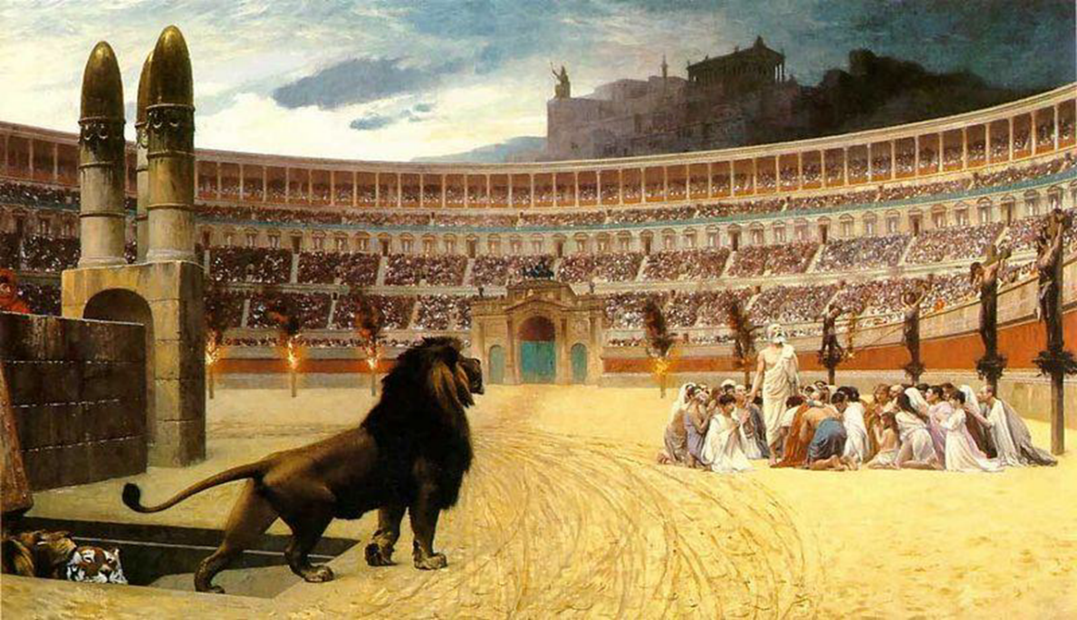
The Last Prayer by J.-L. Gérôme (1824-1904).

In the first part of this session we will examine Nero’s representation in Jewish and Christian historical / ecclesiastical traditions in Antiquity (particularly Late Antiquity), and how this contributes to the negative image we have of him. I have given some extracts from a number of these sources below, which you should read through these and consider the connecting questions. In the second part of this workshop session, we will specifically consider the artistic tradition connected to Simon, Magus, Nero and the apostles Peter and Paul in the medieval, renaissance and early modern periods.

Modern Scholarship (optional reading):
Crake, J. E. A. (1965) ‘Early Christians and Roman Law’, Phoenix 19 (1): 61-70.
Maier, H. O. (2013) ‘Nero in Jewish and Christian Tradition from the First Century to the Reformation’, in A Companion to the Neronian Age, Buckley, E. and Dinter, M. T. (eds.), Oxford: Wiley-Blackwell: 385-404.

Extracts from Judeo-Christian Texts

Sibylline Oracles Books 4 and 5
(translation from http://www.sacred-texts.com/cla/sib/sib.pdf )

Book 4
155
A mighty king
shall like a runaway slave
Flee over the Euphrates' stream unseen,
Unknown, who shall some time dare loathsome guilt
Of matricide, and many other things,
Having confidence in his most wicked hands.
160
And many for the throne with blood
Rome's soil while he flees over Parthian land.
And out of Syria shall come Rome's foremost man
Who having burned the temple of Solyma,
And having slaughtered many of the Jews,
165
Shall destruction on their great broad land.
And then too shall an earthquake overthrow
Both Salamis and Paphos
when dark water
Shall dash o'er Cyprus washed by many a wave.
But when from deep cleft of Italian land
170
Fire shall come flashing forth in the broad
heaven,

Book 5 [28-34]
One who has fifty as an initial will be commander (N = 50),
a terrible snake, breathing out grievous war, who one day
will lay hands on his own family and slay them…,
athlete, charioteer, murderer, one who dares ten thousand things.
He will also cut the mountain between two seas and defile it with gore.
But even when he disappears he will be destructive. Then he will return
declaring himself equal to God. But he [i.e., God] will prove that he [i.e., Nero] is not.

Book 5 [488-533]
And
from the limits of the earth shall come
Fleeing and pondering sharp things in his mind,
490
A matricidal man who every land
Shall overpower and over all things rule,
And see all things more wisely than all men;
And
that for whose sake he himself was slain
Shall he seize forthwith. And he shall destroy
495
Many men and great tyrants and shall burn
All of them, as none other ever did,
And he shall raise up them that are afraid
For emulation's sake. And from the West
Much war shall come to men, and blood shall flow
500
Down hill till it becomes deep-eddying streams.
And
in the plains of Macedonia
Shall wrath distil and give help from the West,
But to the king destruction. And a wind
Of winter then shall blow upon the earth,

Ye matricides
leave off your impudence
And evil-working boldness, who of old
520
provided lawlessly lewd couch with boys,
And placed as harlots maidens pure before
In brothels by assault and punishment
And by much-laboring indecency.
For in thee mother with her child did hold
525
Unlawful intercourse, and daughter was
With her own father wedded as a bride;
And in thee kings have their ill-fated mouth
Polluted, and in thee have wicked men
Found couch with cattle. Be in silence hushed,
530
Thou wicked city all-bewailed, possessed
Of revelry; for by thee virgin maids
Shall care no longer for the fire divine.

Questions:
- Why might (at least some) Jewish tradition have been hostile to Nero? What great crime (against the Jewish faith) would they associate him with?
- What are these “Sibylline Oracles” predicting?

Revelation 13 (Translation from: https://www.biblegateway.com/passage/?search=Revelation%2013&version=NIV )
“The dragon stood on the shore of the sea. And I saw a beast coming out of the sea. It had ten horns and seven heads, with ten crowns on its horns, and on each head a blasphemous name. The beast I saw resembled a leopard, but had feet like those of a bear and a mouth like that of a lion. The dragon gave the beast his power and his throne and great authority. One of the heads of the beast seemed to have had a fatal wound, but the fatal wound had been healed. The whole world was filled with wonder and followed the beast. … “This calls for wisdom. Let the person who has insight calculate the number of the beast, for it is the number of a man. That number is 666.” [In some Latin other Latin witness manuscripts this is 616]

Questions:
- What do you think the fatal wound that had been healed is an allusion to?
- What is the significance of 666?

Eusebius Ecclesiastical History 2.25: (translation from McGiffert, A. C: 1890).
1. When the government of Nero was now firmly established, he began to plunge into unholy pursuits, and armed himself even against the religion of the God of the universe.
2. To describe the greatness of his depravity does not lie within the plan of the present work. As there are many indeed that have recorded his history in most accurate narratives, every one may at his pleasure learn from them the coarseness of the man's extraordinary madness, under the influence of which, after he had accomplished the destruction of so many myriads without any reason, he ran into such blood-guiltiness that he did not spare even his nearest relatives and dearest friends, but destroyed his mother and his brothers and his wife, with very many others of his own family as he would private and public enemies, with various kinds of deaths.
3. But with all these things this particular in the catalogue of his crimes was still wanting, that he was the first of the emperors who showed himself an enemy of the divine religion.
4. The Roman Tertullian is likewise a witness of this. He writes as follows: "Examine your records. There you will find that Nero was the first that persecuted this doctrine, particularly then when after subduing all the east, he exercised his cruelty against all at Rome. We glory in having such a man the leader in our punishment. For whoever knows him can understand that nothing was condemned by Nero unless it was something of great excellence."
5. Thus publicly announcing himself as the first among God's chief enemies, he was led on to the slaughter of the apostles. It is, therefore, recorded that Paul was beheaded in Rome itself, and that Peter likewise was crucified under Nero. This account of Peter and Paul is substantiated by the fact that their names are preserved in the cemeteries of that place even to the present day.
6. It is confirmed likewise by Gaius, a member of the Church, who arose under Zephyrinus, bishop of Rome. He, in a published disputation with Proclus, the leader of the Phrygian heresy, speaks as follows concerning the places where the sacred corpses of the aforesaid apostles are laid:
7. "But I can show the trophies of the apostles. For if you will go to the Vatican or to the Ostian way, you will find the trophies of those who laid the foundations of this church."
8. And that they both suffered martyrdom at the same time is stated by Dionysius, bishop of Corinth, in his epistle to the Romans, in the following words: "You have thus by such an admonition bound together the planting of Peter and of Paul at Rome and Corinth. For both of them planted and likewise taught us in our Corinth. And they taught together in like manner in Italy, and suffered martyrdom at the same time." I have quoted these things in order that the truth of the history might be still more confirmed.

Questions to consider:
- What seems to be the gravest of Nero’s crimes that Eusebius emphasises?
- Why do you think it might have made sense of Eusebius and other Christian writers to have emphasised Nero as the first to persecute the Christians?

Lactantius Of the Manner in which the Persecuted Died 2: (translation from the Library of Nicene and Post Nicine Fathers, emended by Vanderspoel, J. the university of Calgary).
His apostles were at that time eleven in number, to whom were added Matthias, in the place of the traitor Judas, and afterwards Paul. Then were they dispersed throughout all the earth to preach the Gospel, as the Lord their Master had commanded them; and during twenty-five years, and until the beginning of the reign of the Emperor Nero, they occupied themselves in laying the foundations of the Church in every province and city. And while Nero reigned, the Apostle Peter came to Rome, and, through the power of God committed unto him, wrought certain miracles, and, by turning many to the true religion, built up a faithful and steadfast temple unto the Lord. When Nero heard of those things, and observed that not only in Rome, but in every other place, a great multitude revolted daily from the worship of idols, and, condemning their old ways, went over to the new religion, he, an execrable and pernicious tyrant, sprung forward to raze the heavenly temple and destroy the true faith. He it was who first persecuted the servants of God; he crucified Peter, and slew Paul: nor did he escape with impunity; for God looked on the affliction of His people; and therefore the tyrant, bereaved of authority, and precipitated from the height of empire, suddenly disappeared, and even the burial-place of that noxious wild beast was nowhere to be seen. This has led some persons of extravagant imagination to suppose that, having been conveyed to a distant region, he is still reserved alive; and to him they apply the Sibylline verses concerning: “The fugitive, who slew his own mother, being to come from the uttermost boundaries of the earth” – as if he who was the first should also be the last persecutor, and thus prove the forerunner of Antichrist! But we ought not to believe those who, affirming that the two prophets Enoch and Elias have been translated into some remote place that they might attend our Lord when He shall come to judgment, also fancy that Nero is to appear hereafter as the forerunner of the devil, when he shall come to lay waste the earth and overthrow mankind.

Questions to consider:
- What can we understand from Lactantius’ account about the popularity of the idea that Nero would be the forerunner of the Anti-Christ?
- What influence might the Sibylline verses have? What about Revelations?
- What symbolism does Lactantius note about Nero returning as a persecutor?

Sulpicius Severus Chronicle 2.28 (translation from http://www.preteristarchive.com/StudyArchive/s/severus-sulpicius.html)
"As to Nero, I shall not say that he was the worst of kings, but that he was worthily held the basest of all men, and even of wild beasts. It was he who first began a persecution; and I am not sure but he will be the last also to carry it on, if, indeed, we admit, as many are inclined to believe, that he will yet appear immediately before the coming of Antichrist. Our subject would induce me to set forth his vices at some length, if it were not inconsistent with the purpose of this work to enter upon so vast a topic. I content myself with the remark, that he showed himself in every way most abominable and cruel, and at length even went so far as to be the murderer of his own mother. After this, he also married a certain Pythagoras in the style of solemn alliances, the bridal veil being put upon the emperor, while the usual dowry, and the marriage couch, and wedding torches, and, in short, all the other observances were forthcoming--things which even in the ease of women, are not looked upon without some feeling of modesty. But as to his other actions, I doubt whether the description of them would excite greater shame or sorrow. He first attempted to abolish the name of Christian, in accordance with the fact that vices are always inimical to virtues, and that all good men are ever regarded by the wicked as casting reproach upon them. For, at that time, our divine religion had obtained a wide prevalence in the city. Peter was there executing the office of bishop, and Paul, too, after he had been brought to Rome, on appealing to Caesar from the unjust judgment of the governor. Multitudes then came together to hear Paul, and these, influenced by the truth which they were given to know, and by the miracles of the apostles, which they then so frequently performed, turned to the worship of God. For then took place the well-known and celebrated encounter of Peter and Paul with Simon. He, after he had flown up into the air by his magical arts, and supported by two demons (with the view of proving that he was a god), the demons being put to flight by the prayers of the apostles, fell to the earth in the sight of all the people, and was dashed to pieces."

Questions:
- Who is this Simon Magus figure and why might he be important to Christian narratives about Nero?

The Acts of Saint Peter: The Apocryphal New Testament: (trans. from James, M. R: 1924).
But Nero, learning thereafter that Peter was departed out of this life, blamed the prefect Agrippa, because he had been put to death without his knowledge; for he desired to punish him more sorely and with greater torment, because Peter had made disciples of certain of them that served him, and had caused them to depart from him: so that he was very wrathful and for a long season spoke not unto Agrippa: for he sought to destroy all them that had been made disciples by Peter. And he beheld by night one that scourged him and said unto him: Nero, thou canst not now persecute nor destroy the servants of Christ: refrain therefore thine hands from them. And so Nero, being greatly terrified by such a vision, abstained from harming the disciples at that time when Peter also departed this life.
And thenceforth the brethren were rejoicing with one mind and exulting in the Lord, glorifying the God and Saviour (Father?) of our Lord Jesus Christ with the Holy Ghost, unto whom be glory, world without end. Amen.

Questions
- Is it possible to prove or disprove this narrative of servants of Nero being converted to Christianity?
- Is this a stock narrative we might see elsewhere?

Augustine City of God 20.19: (translation from Dods, M: 1890).
Some think that the Apostle Paul referred to the Roman empire, and that he was unwilling to
use language more explicit, lest he should incur the calumnious charge of wishing ill to the empire which it was hoped would be eternal; so that in saying, “For the mystery of iniquity doth already work,” he alluded to Nero, whose deeds already seemed to be as the deeds of Antichrist. And hence some suppose that he shall rise again and be Antichrist. Others, again, suppose that he is not even dead, but that he was concealed that he might be supposed to have been killed, and that he now lives in concealment in the vigor of that same age which he had reached when he was believed to have perished, and will live until he is revealed in his own time and restored to his kingdom.
But I wonder that men can be so audacious in their conjectures. However, it is not absurd to believe that these words of the apostle, “Only he who now holdeth, let him hold until he be taken out of the way,” refer to the Roman Empire, as if it were said, “Only he who now reigneth, let him reign until he be taken out of the way.” “And then shall the wicked be revealed:” no one doubts that this means Antichrist. But others think that the words, “Ye know what withholdeth,” and “The mystery of iniquity worketh,” refer only to the wicked and the hypocrites who are in the Church…

Questions:
- What can we take away from Augustine’s quite sceptical tone regarding to allusions to Nero as the Anti-Christ and other related theories?

Part 2: Simon Magus, the apostles and Nero in medieval, Renaissance and Early Modern Art

Questions:
1) What key representational elements appear in the following images?
2) How do you think the specific context (both chronologically and in terms of medium) might affect how “Roman” or not the images look?
3) How effectively do these images convey a narrative?

Images
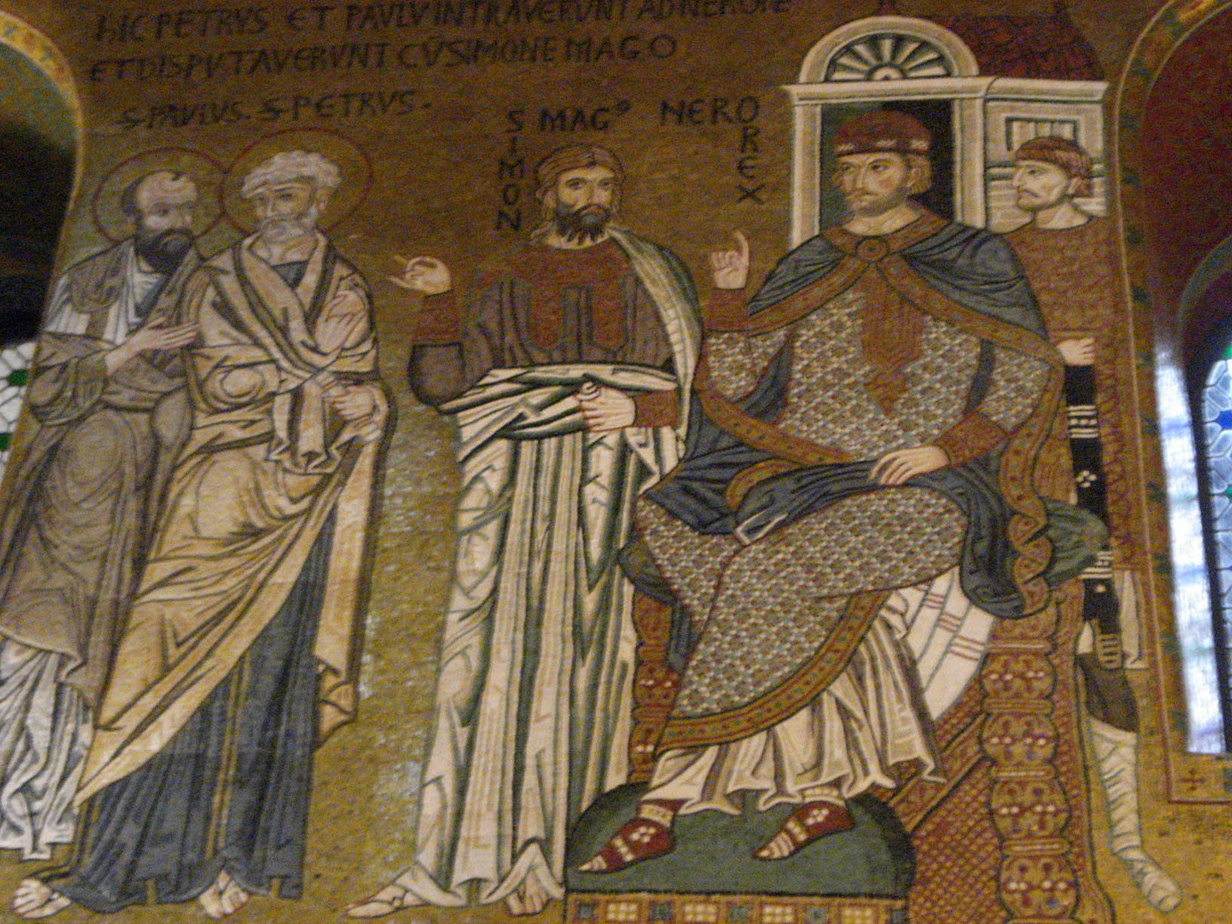
Peter, Paul, Simon Magus and Nero, Palatine chapel of Palermo (Sicily), 12th century

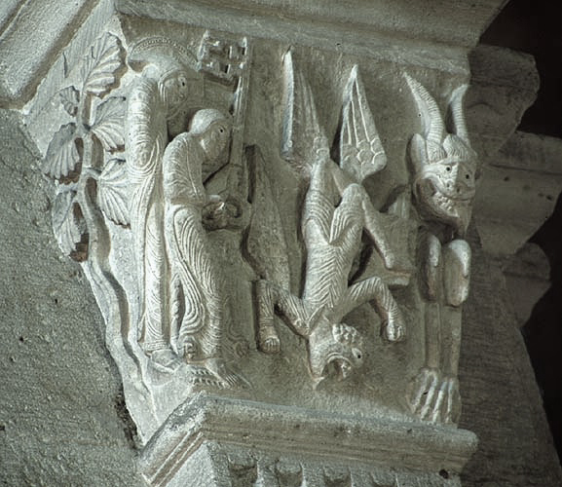
Fall of Simon Magus, pillar capital in the Cathedral of St. Lazare (Burgandy), 12th century
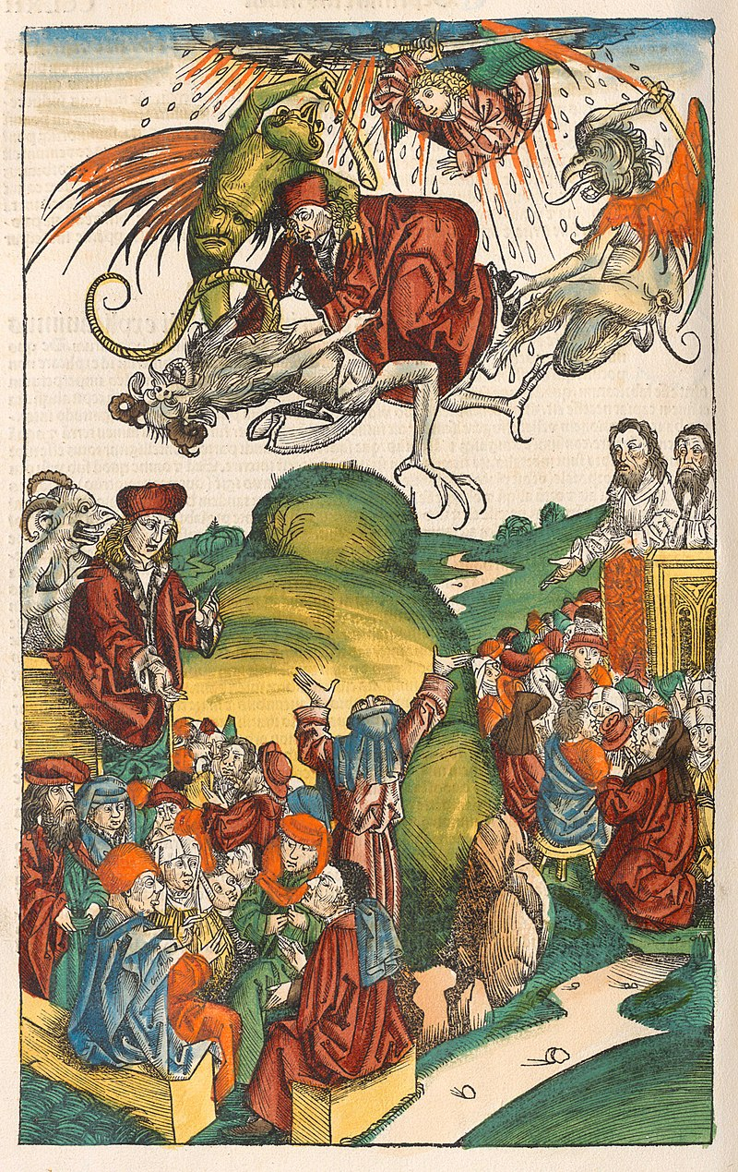
Simon Magus, the Nuremburg Chronicle, 1493

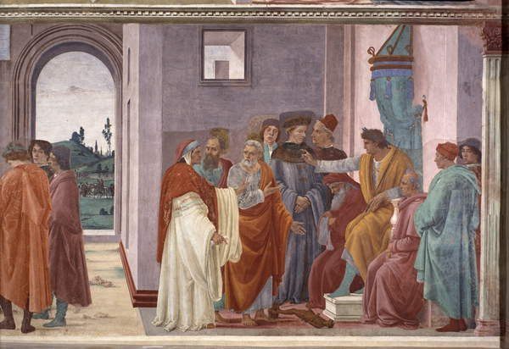
Disputation with Simon Magus and Crucifixion of Peter, 1482-1513 (fresco), Lippi, Filippino (c.1457-1504) / Brancacci Chapel, Santa Maria del Carmine, Florence, Italy / Bridgeman Images

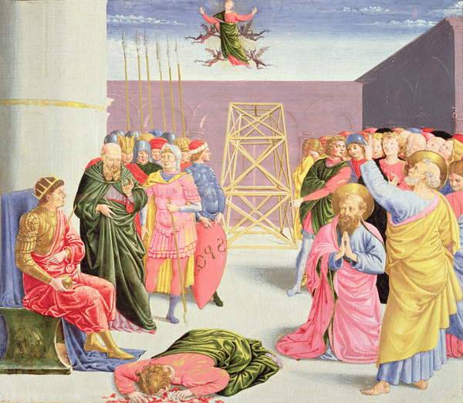
St. Peter and Simon Magus, 15th century (tempura on wood), Gozzoli, Benozzo di Lese di Sandro (1420-97) / Metropolitan Museum of Art, New York, USA / Bridgeman Images

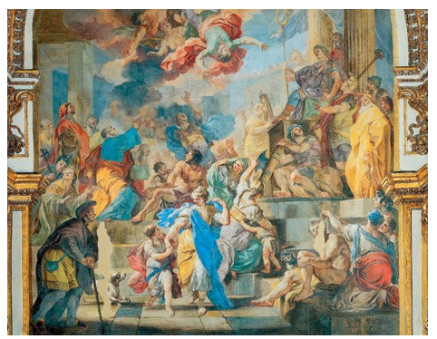
Simon Magus falls to his death before Emperor Nero, 18th-century, church of San Paolo Maggiore (Naples), by Francesco Solimena

