Designing Learning that Sticks
Designing, Delivering and Evaluating Learning and Development Provision

Hannah Botes Assoc CIPD
Student no.: 0652311

Executive summary
This report provides an analysis and evaluation of the current and prospective learning provision for the Leadership Team of Chwarae Teg. Methods of analysis include :-
- current learning provision
- learning gaps identified through the ‘Achieve’ system
- feedback gathered through the employee survey
- review of learning design methods
- learning theories to support evidence-based interventions to support the strategic direction of Chwarae Teg.
The report finds there is no formal management induction in place resulting in inequalities of management of the business and employee experience. . The major areas of weakness require further investigation and remedial action by management. Recommendations discussed include:
- Producing a range of interventions to support the Leadership Team
- Involving the Leadership Team in the design of the learning intervention
- Investigating Gamification technologies to support participant experience in training. This will involve an financial investment from the company.

The report recognises the importance of investing now in this level of the organisation to ensure its future readiness post-Brexit and post-pandemic

CONTENTS
Executive summary 2
Introduction 4
aim OF REPORT 5
Literature review 6
Contextual Factors 6
Learning Theories 8
Evaluation 11
Conclusion 12
Recommendations 13
References 14
Appendices 17
Appendix A PESTEL Analysis: External influences on L&D at chwarae teg 17
APPENDIX B SWOT ANALYSIS of Chwarae Teg 19
Appendix C - Action plan to design and create a Management Induction at Chwarae Teg. 20

Figure 1 Factors considered in a PESTLE analysis
Figure 2 Multiple generations at work – adapted (Ibid)

Introduction
Chwarae Teg ( CT) commenced trading in 1992. The business has been working to ensure that women in Wales can enter the workplace, develop their skills and build rewarding careers. (www.chwaraeteg.com/about/mission). This is achieved via two funded programmes; a women's ILM programme and an SME Business Programme. There is also a policy research team that works at the Government level. Internally, there are a variety of roles including, managers, trainers, consultants and Administrators.
Due to the global pandemic and a business restore in 2020, Chwarae Teg has now closed three of their four offices and all operations have moved online. Although the decision has been made to move all staff to home working, there is no formal provision in place to support managers during this significant change to traditional working practice.. As it stands, ‘the work from home if you can’ guidance is still in place at the time of writing this report (May 2021).
The current learning provision for staff is focused on self-directed learning opportunities identified by managers – often as part of the personal review process. Individual members of staff can ask for guidance on issues through their line manager, attend free webinars that run ‘off the shelf’ or seek advice via the in-house People Manager. Off the shelf, learning programs do not fulfil the current gaps that the management level of the organisations are faced with. Griffiths and Inman (2017) found that greater awareness of multi learning contexts will improve the operationalism of learning in the real world.
Nick Shakleton-Jones (2014) touches on the importance of learning interventions and refers to their significance when people join an organisation. Similar analogies can be made for when someone commences a new role through internal recruitment. He refers to a ‘Cultural Drift’ where people develop a host of workarounds to the set standards and these become’ norms’ within the team. This is the scenario at Chwarae Teg where different managers bring different ways of managing teams into play. CIPD research also refers to joining up talent management strategies and formalising skills and development at the management level. If businesses fail to do this they will have additional recruitment costs as well as losing valuable skills and experience (CIPD)
Revised corporate values are now in place and are linked to the new 2021-2023 Strategic Plan of the organisation. The Leadership Team now needs to receive a learning intervention that provides the individuals with the tools, skills and application to support the company culture. According to Barlett and Kang (2004) investing in your employees with L&D should positively impact and improve their commitment to the organisation. In addition to employee development is linked to improved competitive advantage. Leitch (2006).
Through evidence gathered via HR metrics, the Employee Survey, the Employee Forum and Chwarae Teg’s formal review system, the Senior Leadership Team (SLT including the Board) have now acknowledged a learning intervention is required. The leadership tier of the business has received no management induction. This has led to gaps in knowledge in management principles and mental health training as well as a lack of development of their management skills and experience. The key areas where gaps have become apparent are within discipline and grievance training, supporting mental health at work, and managing a remote team. Failure to provide adequate training in these areas could lead to discrimination claims, unfair dismissal claims due to poor investigations, increased absence as well as staff turnover. The business needs to embrace a new and robust, forward-thinking way of working with a trained and competent team leading the business.
This report has been compiled to review and recommend the best way to implement a management induction programme to Chwarae Teg. This report will be presented to the Senior Leadership Team and Board members and will form part of the Strategic Plan for Chwarae Teg,

aim OF REPORT
- Review the internal and external contextual factors that may impact the design, delivery and assessment of introducing a management induction programme to Chwarae Teg.
- Design learning plans and interventions to meet identified needs in a timely, feasible and cost-effective way
- Design and implement appropriate evaluation methods to assess the success and effectiveness of e-learning plans and interventions.
- Stimulate discussion on the best ways to improve on the current arrangements

Literature review

Contextual Factors

PESTEL AND SWOT
Context is a driver for learning design and if not considered, a learning intervention will be incomplete and not fit the learning needs of the business. (Hattie & Yates, 2014).
Using the PESTEL model, broader environmental factors can be examined (Turner 2002), Figure 1 shows the factors considered and a completed PESTEL analysis is available in Appendix A. The interpretation of the environmental influences is detailed in the SWOT analysis in Appendix B (Johnson et al 2003).

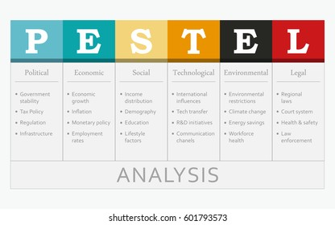

Figure 1: Factors to Consider in PESTEL
Source: pestel-analysis-concept-table-main-260nw-601793573.jpg (416×280) (shutterstock.com)

Workforce Demographic Considerations
One one of the key, stated values of Chwarae Teg is “we embrace and respect individuality and are united by difference”. This must be considered in the designing of learning to ensure we stay true to Chwarae Teg’s values.
At Chwarae Teg there is a diverse demographic of employees - particularly within the management team. Within the management level of the business, there are multi-generations and this has to be considered when investigating the best learning options for this group. Generational differences are often oversimplified, with millennials being referred to as ‘Tech savvy’ and other generations perceived to struggle more with innovations and technology albeit this is not always the case in reality.
Millennials are change drivers in organisational learning. They make up 50% of the workforce with this increasing to 75% by 2025. These ‘digital natives’ are learning constantly and have evolved to embrace new ways of communicating, collaborating, teaching, gathering information and utilising technology, Morgan (2014) . “Older workers have been more reluctant in taking up training due to fear and lack of confidence” (Gutherie and Shwoerer 1996) (Age Diversity). However, these are stereotypes and not every individual conforms as laid out in figure 2. (King, Finkelstein, Thomas, Corrington 2019)

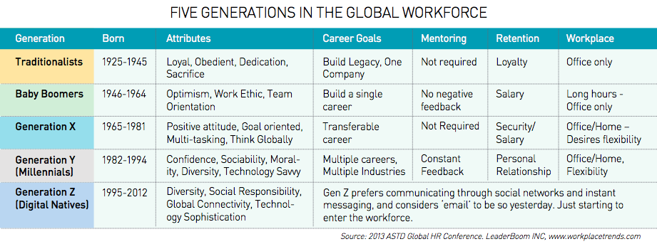
Source: https://res.cloudinary.com/people-matters/image/upload/v1490598317/Screen_Shot_2017-03-27_at_12.27.32_pm_uc1ddb.png
Figure 2: Generational Differences in the Workplace
The modern workplace has a diverse workforce where cultural differences are also apparent. It is, therefore, useful to consider any ‘tweaks’ required to the learning experiences to ensure all employees have a successful learning experience. ( Stewart and Cureton, 2014, p.93)
It is important to also consider diversity and inclusion for all when designing new learning and ensuring no group is disadvantaged or not considered. “Structured processes contain similar biases. The use of competencies is considered best practice in selection yet there is increasing concern about their impact on diversity. By focusing exclusively on the behaviours found in many competency frameworks, an organisation is being extremely prescriptive about the type of people they employ. They are ignoring those who may have a different approach to a problem but who are still effective worker” (Pearn kandola 2013)

Learning Theories
A Learning Needs Analysis (LNA) needs to be carried out to gain a clear understanding of what the leadership tier of the organisation requires and to enable any learning to be relevant and targeted.
Data sources for the LNA should include the Organisational Strategic Plan, Human Resources Plan, HR metrics such as turnover, feedback through the performance management system (called ‘Achieve’ in Chware Teg) Iqbal and Khan (2011). The LNA needs to be included as part of the organisational wide Human Resources Development Strategy. The LNA allows for critical examination and identification of employee knowledge, behaviour and skills gaps Harrison (2009).
Individual, team and organisational learning needs should be identified and addressed for the induction of managers as different managers will be starting from different levels of experience and knowledge and will require different interventions.
Outlined in Figure 3, is the consideration for both traditional and contemporary theories of individual learning. Mullins (1993) reminds us that the research carried out by Pavlou (1928) was with animals, not humans and, therefore, the results are not conclusive for humans.
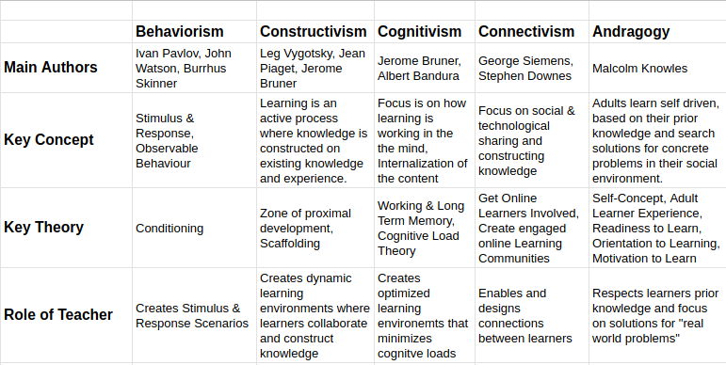
Source: https://griffl.org/comparing-le 1
Figure 3 Traditional and Contemporary Theories of Individual Learning
Adult Learning Theory also known as andragogy (Knowles, et al., 2011) identified four key principles with a strong emphasis on theory and practice and believes that design principles are relevant in Physical and Digital environments for adult learning.
- Adults must be involved in the planning and evaluation of their learning
- Experience (good and bad) are essential components
- Adults are mostly interested in immediately relevant learning
- Learning is problem-centred rather than content orientated.
In recent years, critics have claimed that formal training does not prepare managers to keep pace with the constant change that occurs in today’s workplace Hartley (2000). Knowles’ four stages of development take time to be realised so looking at the use of mentors for individuals may be a way of supporting managers in the short term.

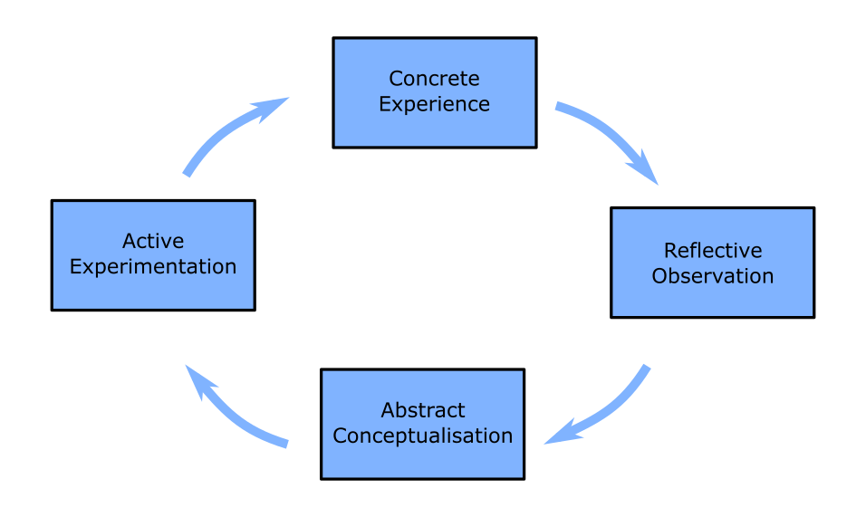
Source: https://deparkes.co.uk/2015/12/21/kolb-learning-cycle/
Figure 4 Kolb’s Experimental Learning Cycle
Experimental Learning maintains that learning is individual in content and direction. “Learning is the process whereby knowledge is created through the transformation of experience” (Kolb, 1984, p. 38). Whilst simplistic in its approach Harrison (1998), it still highlights the importance of reflection Mullins (2013).
Team Learning theory categorised by Senge (1990) states there are five disciplines needed to achieve a true learning organisation :-
- A shared Vision
- Mental Models
- Team Learning
- Personal Mastery
- System Thinking
Although criticised, it is not possible for an organisation to match all these catagories, but his model has been the basis for further research and academic works such as that produced by Slater and Narver (1995). The creation of a learning climate and culture also has to be flexible so that businesses can adapt to the external environment. The cultural web (Johnson and Scholes 1993) is a useful tool to analyse assumption regarding company culture. It helps identify practices and belief systems and looks to align them with the company’s business strategy and culture. One of the core values of Chwarae Tegs is ‘ We are empowering change makers’ We believe in giving people the belief, respect and tools they need to succeed. ( Chwarae Teg values, 2021).
We must not disregard informal learning behaviours, Informal learning behaviours take place every time a person decides to take action with the deliberate intention of developing new skills or knowledge, Cerasoli (2017)
Nick Shackelton-Jones (2014) describes that when designing learning plans or programs, they should aim to create an experience that will cause a reaction in an individual. The ‘push and pull’ theory affects the drivers for individual’s learning motivations. ‘Push’ approaches look at designing experiences, storytelling, action learning, observation and simulation. Technology might be able to support the simulation experience through Artificial Intelligence platforms that can create real-life situations. The ‘Pull’ approach to learning seeks to provide a point of need of resources including video/dvd, checklists, template documents, case studies, flow charts, infographics.
Moving further into design technology, gamification could be one of the solutions to support the induction programme and future company-wide training. Gamification is applying game design to practical or real life business situations Collins (1996). The Aberdeen Group (2013) reported better outcomes in performance, engagement and retention when using gamification. The game element can encourage learning and make the process much more interactive and fun Simpson and Jenkins (2015). Examples of learning and training that are already very successfully using concepts of gamification include Health and Safety training, leadership development (e.g. Deloitte Leadership Academy). Some academics believe gamification is just ‘hype’ and novelty Burke (2014).). However, Moreno-Ger et al (2009) suggest that gamification can produce a more individualised environment resulting in a more inclusive training programme.

Evaluation
Evaluation of the learning intervention is key to understanding if learning outcomes have been met and where improvements can be fed back. Kirkpatrick's model (Figure 5) is still a relevant model to use for evaluation and looks at the full impact and effectiveness of the learning. The business should explore making use of questionnaires, appraisals and analysis of employee surveys. These should provide both quantitative and qualitative data to demonstrate that the company has had a return on its investment. Peak Kearns (2006) highlights the importance of evaluating the return on investment.
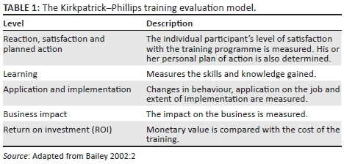

Figure 5 Kirkpatrick’s Four Levels Model

Conclusion
Chwarae Teg should actively consider creating an innovative and forward-thinking solution to the skills gaps within the leadership team especially the challenges highlighted with the new ‘work from home’ implementation. Developments in technology, internally, ( pushed forward due to the pandemic) will allow the business to ensure a robust system of training is implemented.
A full Learning Needs Analysis will identify exactly what the learning outcomes should be for the design of the management induction. Utilising this information - along with the creation of a working group - should result in a robust induction that would support all current and future managers embedding in their role.
As per Knowles et al 2011, people need to be involved in their learning. Involvement from the management team will be a key part of the process and they should be engaged as soon as possible and before the learning program is developed.
The socio-cultural factors ( Appendix A) state that a mental health crisis may be on the horizon for staff (People Management). Mental Health First Aid (MHFA) England revealed a quarter (25%) of workers had not received a single mental health check since March 2020. Ensuring managers have empathy and soft skills they can call upon, will help support employees through the easing of lockdowns and revised methods of working within a post-pandemic world. By addressing these issues and with a strong management team, the business will be in a better position to take advantage of new opportunities and ensure business continuity post-2023.
The research has highlighted the importance of recognising demographic diversity within the organisation This may impact the range of resources that need to be developed and, at all points, accessibility should be checked and any issues or barriers to accessibility need to be addressed. If ‘high tech’ learning platforms are to be used, additional support for those with less technical knowledge and confidence should be put in place.
The management team has had to support and deliver on funded project targets during an unprecedented time. Old paradigms of work have been broken and now is the opportunity to forge new ways of working, with a supported and involved leadership team. The social changes in the economy now demand more transparency, more ethical approaches to leadership with fairness and inclusion at the centre ( CIPD May Edition Peter Cheese Editor pg 5).
Using technology that is already in place would be advantageous as there would be a minimal cost involved in terms of investment in programmes and individuals will already be familiar and comfortable with the systems. Costs that will incur will be the actual cost to the company for the time of individuals, and, potentially, where targets may have to be relaxed during the development phase, the cost of time and hourly rate of individuals supporting the development of the program. There will be capital investment if gamification platforms are the preferred method to use. Using experimental learning - linked with reflections - should make the experience exciting and transformative for staff.
To gauge if the learning is a success, an evaluation of the resources will need to take place. Any feedback collated will need to be analysed and acted upon to ensure the company's intervention has resulted in a return on investment and an improvement in management capabilities. The management induction is something that will evolve and continue to support managers within their continuous professional development Hyde and Phillipson. (2014).

Recommendations
Following the research and conclusions, it is recommended that a range of resources is developed to ensure all the leadership team received a formal induction to their roles. The resources developed should be inclusive and support all learning styles of managers and teams. This will enable Chwarae Teg to achieve the same outcome of a well supported and managed team regardless of location.
Additional considerations in the development of this learning intervention are the cost of time and resource. Time must be reallocated to allow for the manager to participate in the process. The cost of their hourly rate will be reallocated from their existing salary, so there may be no additional costs to the business. Re-priroitisation of work will be required to accommodate this.
Utilising internal resources such as trainers and management ILM assessors will support the recommendations outlines in this report.
Gamification technologies will give the business not only a competitive edge within the recruitment market but will ensure an immersive experience with real-life application to gain experience. This investment will be transformational for employees and can be utilised in other learning and development activities. The commercial side of the business would also be able to develop other learning experiences using this technology investment. There are higher costs associated with the development of new software. However, the cost-benefit to the organisations learning and development, along with the opportunity to increase revenues through commercial offerings should offset the initial outlay.

The full Action Plan can be found in Appendix B of this report. Some of the key actions would be:-
- Create a ‘Focus Group’ from the management team to gain knowledge on the actual skills and support they are requiring to support their teams effectively.
- Carry out a learning needs analysis- particularly looking at Discipline and grievance, managing a remote team and wellbeing.
- Research gamification technologies to support an immersive experience.
- Introduce to all existing managers and, particularly, those who are newly appointed
- Evaluate the impact of intervention and training at 6 and 12-month points.

References
Blaschke, M. L., Hase, S. (2016) Heutagogy: A holistic framework for creating twenty-first century self-determined learners. In: Gross, B., Maina, M. (eds) The future of ubiquitous learning, New York: Springer, pp. 25–40.
Burke, B. (2014b) Gamify: How Gamification Motivates People to Do Extraordinary Things.Brookline, Ma: Bibliomotion, Inc.
Cerasoli, C. P., Alliger, G. M., Donsbach, J. S., Mathieu, J. E., Tannenbaum, S. I., & Orvis, K. A. (2018). Antecedents and outcomes of informal learning behaviours: A meta-analysis. Journal of Business and Psychology, 33(2), 203-230.
Chi, M. T. (2008). Three types of conceptual change: Belief revision, mental model transformation, and categorical shift. International handbook of research on conceptual change (pp. 61–82).
CIPD (2012) “From e-learning to 'gameful' employment” April 2012, Sustainable Organisation Performance Research programme, London: Chartered Institute of Personnel and Development.
Collins, A. (1996) Design issues for learning environments. In: Vosniadou, S., De Corte, E., Glaser, R., Mandl, H. (eds) International perspectives on the psychological foundations of technology-based learning environments, Mahwah, NJ: Lawrence Erlbaum Associates, pp. 347–361.
Dalziel, J., Conole, G., Wills, S., Walker, S., Bennett, S., Dobozy, E., … Bower, M. (2016). The Larnaca declaration on learning design. Journal of Interactive Media in Education, 2016(1), 7.
David Yakobovitch (2020) The Commandments of Workplace Reskilling and Upskilling in 2020 Towards Data Science Accessed 31.01.2021
de Jong, T. (2010) Cognitive load theory, educational research and instructional design: Some food for thought. Instructional Science 38: 105–134.
FIGURE Mayes, T., de Freitas, S. (2004) Review of e-learning theories, frameworks and models, London: Joint Information Systems CommitteeRetrieved from www.jisc.ac.uk/whatwedo/programmes/elearningpedagogy/outcomes.aspx. (accessed 12.05.2021)
Gagne, R. (1985) The conditions of learning, New York: Holt, Rinehart & Winston.
Green, J. G., Collins, A. M., Resnick, L. (1996) Cognition and learning. In: Berliner, D. C., Calf, R. C. (eds) Handbook of educational psychology, New York: Simon & Schuster, pp. 15–46.
King. E, Finkleton.L, Thomas.C and Corrington.(2019) Review Generational Differences At Work Are Small. Thinking They’re Big Affects Our Behavior. Harvard Business Review . https://hbr.org/2019/08/generational-differences-at-work-are-small-thinking-theyre-big-affects-our-behavior (Accessed 12.05.2021)
https://chwaraeteg.com/about/mission (Accessed 12.05.2021)
https://gov.wales/taking-all-reasonable-measures-minimise-risk-exposure-coronavirus-workplaces-and-premises-open Accessed 31.01.2021
https://pearnkandola.cDm/app/uploads/2013/03/Organisational-Prejudice-1.pdf ( Accesed 12.05.2021)
https://www.agediversity.org/course/older-workers-outdated-skills-and-resistance-to-retraining/
Iqbal, M.a and Khan, R.A (2011) The growing concept of training needs analysis asessement a review with oroposed model, Journal of European Industrial Training, Vol 35, No 5. Pp 439-466
Kearns, Paul 2006 Evaluating the ROI from Learning: How to Develop Value-based Training Paul Kearns Human Resource Management International Digest ISSN: 0967-0734 Article publication date: 1 January 2006
Knowles, M., Holton, E. F., Swanson, R. A. (2015) The adult learner, 8th ed. Burlington, MA: Elsevier.
Moreno-Ger, P., Burgos, D. and Torrente, J. (2009) Digital games in e-learning environments. Simulation and Gaming. Vol 40, No 3. pp 669–687
Morgan, J (2014) THE FIVE TRENDS SHAPING THE FUTURE OF WORK The Five Trends Shaping the Future of Work | Jacob Morgan (thefutureorganization.com) accessed 14th April 2021
Online Resource Link: https://gov.wales/sites/default/files/publications/2019-08/eu-funds-2014-2020-eligibility-rules-and-conditions-guidance 0.pdf Accessed 31.01.2021
Patton, M. Q. (2002) Qualitative research and evaluation methods, 3rd ed. Thousand Oaks, CA: Sage Publications.
Penny Simpson and Pete Jenkins (2015) Gamification and Human Resources: an overview, Gamification-and-HR-Overview-January-2015 (iwantaspeaker.com)
pestel-analysis-concept-table-main-260nw-601793573.jpg (416×280) (shutterstock.com)
Senge, P.M., 1990, The Fifth Discipline – The Art & Practice of a Learning Organization, New York: Doubleday
Shackleton Jones, Nick ( 2019) How People Learn: Designing Education and Training that Works to Improve Performance. London: Kogan Page Limited, pages 109-117
Slater, S.F and Narver, J.C (1995) Market orientation and the learning organisation, Journal of marketing. Vol 59,No3, pp63-74
Snowden, D. J., Boone, M. E. (2007) A leader’s framework for decision making. Harvard Business Review 85: 68–76.
Stewart, Jim; Cureton,Peter (2014) Designing, delivering and evaluating learning and development: Essentials in practice; London, CIPD, Pages 79-99
Turner ( 2002) Turner, J. C., Midgley, C., Meyer, D. K., Gheen, M., Anderman, E., Kang, Y., & Patrick, H. (2002). The classroom environment and students’ reports of avoidance behaviors in mathematics: A multi-method study. Journal of Educational Psychology, 94, 88–106
WEF. (2016). The future of jobs: Employment, skills and workforce strategy for the fourth industrial revolution. In Global challenge insight report, Geneva: World Economic Forum, January, 2016
Welsh European Funding Office (2019). Eligibility Rules and Conditions for Support from the European Structural Funds 2014-2020.
www.gov.uk/transition Accessed 31.01.2021

Appendices

Appendix A PESTEL Analysis: External influences on L&D at chwarae teg
 | External Factors to Consider | Factors affecting my industry and organisation
Political | - Government policy  - Political stability  - Tax Industry regulations  - Global trade agreements and or restrictions | Devolved Welsh government and Uk national government policy influences decisions on Welsh economy and business. Brexit implications on funding and Employment Law New funding replacing EU funding is unknown Covid 19 regulations and restrictions for wales
Economic | - Exchange rates  - Globalisation  - Economic growth/ decline  - Inflation Interest rates  - Cost of living  - Labour costs  - Consumer spending habits | Economy shrinking and recession potentially looming which will affect fundraising generation and income to the business. This will impact Learning budgets for staff developments Gender pay gap not decreasing as fast as expected Staff pay increasing to staff competitively. However, costs decrease due to closing offices.
Social | - Consumer trends/ tastes, Fashions  - Consumer buying habits  - Lifestyle factors  - Career attitudes  - Work-life balance  - Population demographics | Increasing demand for flexibility in learning and working from the millenial generation. People what an intersectional approach to diversity and inclusion. Influenced heavily by the news and social media.  Mental Health crisis potential
Technology | - Automation Innovation  - Disruptive technologies  - Social networking  - Upgrades Robotics  - Artificial Intelligence  - Security | Infrastructure for the business to deliver Upskilling employees with each update ( this can be frequent with Microsoft packages such as MS Teams) AI for training Ensuring staff are experienced innovative ways of learning Technology can support social learning experiences
Legal | - Employment law  - Common law  - Local labour law  - Health and safety regulations | Legal restrictions in place for Covid-19 lockdowns ( e.g no travel) H&S of staff working from home including lone working, and those with disabilities and requiring reasonable adjustments. Data protection and GDPR for home workers
Environmental | - Environmental restrictions imposed by in-country governments  - Sustainable resources  - CSR (Corporate social responsibility)  - Ethical sourcing  - Transportation  - Procurement  - Supply chain management  - Future pandemics | Reduced travel  Paperless systems  E&D added into the procurement process  Increased home heating, water, electricity

APPENDIX B SWOT ANALYSIS of Chwarae Teg
Strengths | Weaknesses
- Complete Office 365 package already in place, with additional office apps, integrated.  - In house ILM level 5 Management trainers.  - In house HR professionals and business team trainers.  - Prestigious and respected organization when it comes to policy and gender equality.  - Allocated L&D budget for next 2 years ( this was calculated into the EU funding proposal)  - The majority of the management team have been in the post for several years and have a wealth of experience.  - ROWE – results-only work environment allowing for flexibility of work-life balance for all staff.  - Already have online learning platforms to design and deliver training for Chwarae Teg staff.  - Supportive and involved Board with a People Organisation Development Subcommittee.  - Robust recruitment system, so managers to do have transferrable skills for the roles.  - Up to date job descriptions | - The quick pace at which business had to switch to online, leaving some employees with skills gaps.  - Targets still had to be met even when redesigning learning quickly to allow for online continuation. – huge pressure o staff  - Experiencing access issues with virtual classroom currently in situ  - Not all staff trained in the use of virtual classroom  - L&D processes internally are not transparent or have a formalized structure.  - Lack of promotional opportunities due to a flat structure  - Do not fund professional memberships for employees.
Opportunities | Threats
- Using more of the Microsoft 365 package such as task management (planner)  - Look at gamification, AI and virtual reality technologies to support Internal and external training programmed  - Automation of processes to free time up to develop new offerings and projects  - Welsh Government and private contracts to bid for and grow the commercial arm of the business  - Ensure businesses are aware we are not a ‘women only’ charity.  - More branding on Social media | - No secured budgets after 2023, short term spending and uncertainty for long term planning for the business as a whole and L&D.  - Turnover of staff due to project end date and fixed-term contracts concluding  - Competition with other diversity and inclusion charities and companies taking an intersectional approach to resolving inequalities in society.  - Competitors bidding for similar contracts with Welsh Government and fundraising opportunities.  - Mental Health crisis leading to increased absence costs

Appendix C - Action plan to design and create a Management Induction at Chwarae Teg.
Action | Details | People | Expected date | Notes
Set up a management ‘Focus Group’ | - To include a range of managers from different departments.  - This Focus Group will be responsible for gathering information from other managers and sharing experiences of induction and how they would like to see CTs new induction be embedded. | Range of senior and junior managers | 31.05.2021
Set up coggle | - Set up a coggle mind mapping tool for collaborative learning and set out ideas. | Hannah Botes | 30.06.2021 | Free resource
Leaner session on coggle | - Provide stream video on using coggle ( Visual) | Hannah Botes | 07.07.2021
Set up new task teams on Microsoft Planner. | - This will allow allocation of tasks, reminders of deadline and follow-ups for the team | Hannah Botes | 31.05.2021
Carry out a Learning Needs analysis of the Leadership Group | - Multi-level for all leadership team ( incudes senior, lead and director grades).  - Utilising information for the strategic plan, HR metrics and feedback through Achieve Performance Management system | People Team | 30.06.2021
Research content to meet learning outcomes | - Research latest trends and readings on management induction and linking this to organizational values, managing remote teams | Hannah Botes | 31.07.2021
Research Learning platforms | - Research digital platforms to support the learning experience, such as gamification for bringing scenarios to life | ICT team | 31.07.2021
Identify resources to meet learners needs | - Online presentation for all management levels inducting them in the CT management framework.  - Follow up handout  - Creation of gamification platforms | People Team  Training and Qualifications Team  Hannah Botes  Hannah Botes | 30.09.2021 | Cost Analysis required and approval with finance
Set up of MS Teams Channel for the leadership team | - Setup of private teams Chanel for the leadership team, where resources can be shared and allow for the shared social learning experience. | ICT Team | 31.05.2021
Feedback on resources and make any amendments | - Feedback gathered from the Leadership team through questionnaire and via achieving documentation.  - This will take place at 6 and 12 months intervals  - Following on from the feedback make any amendments | Hannah Botes Leadership Team  Training and Qualifications Team | 6months and 12 months after training launched
Revision dates of resources scheduled in | - Resources are checked for relevance and accuracy | People Team | Annually

