

BMHP5015
Changemakers: Building your Personal Brand for Sustainable Employment

Component 1: Online Portfolio of Set Exercise

Student Name: Andreea Talmaciu
Student ID: 2409581
Table of Contents
Task 1 – Personal Brand 3
Task 2 – Network Map and Rationale 4
Task 3 – Blog 6
Task 4 – NHS Equality, Diversity and Inclusion (EDI) Quiz 7
Task 5 – A Letter to Yourself 9
Task 6 – Gantt Chart 10
Task 7 – Making Changes Report: Introducing Digital Care Planning in a Care Home 12
References 14

Task 1 – Personal Brand
Personal branding is the way a person markets his or her capabilities, values and professional image to others, especially to prospective employers. By showcasing their strengths and unique qualifications, a strong personal brand can make an individual more attractive to employers and improve their chances of success in their career (Ghaltakhchyan, 2025; Cai et al., 2025). I want to project a professional and trustworthy image that will demonstrate my dedication to assisting people and communities.
The customer-focused focus of my work experience has formed my personal brand. Worked at Lidl UK for 7 years from 2018 to 2025, learning to communicate, teamwork and problem solve in a busy environment. I have been running my own business, C&C Emerald Lashes, since 2025, developing my own leadership, organisational and interpersonal skills. Being self-employed has also helped develop my relationship-building skills, knowledge of what my clients want and professional demeanour. I know I need to build on my understanding of social care legislation, safeguarding and social work practice. I will be extending my professional network by joining LinkedIn, attending university events and interacting with social care professionals. These will help to reinforce myself as a professional and to enhance my employability.
My personal brand is communication, resilience and professionalism. I will be able to gain more skills and knowledge in my future, so that I can move towards my aim to become a successful Social Worker.

Task 2 – Network Map and Rationale
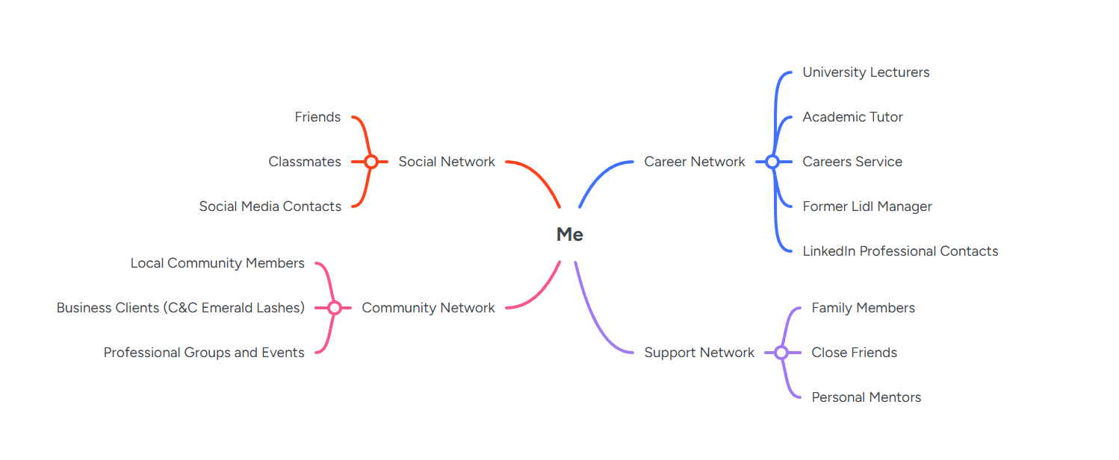
Supporting Rationale
My network is a hybrid network as it includes personal, professional, social and community networks. A variety of networks are available to access valuable information, support and opportunities that can enhance career development and employability (Healy, Hammer, and McIlveen, 2022).
I have the strongest social area of social capital – close relationships with friends and family, which I consider to be trusted friends (Tuominen et al., 2023). These are the links that give me emotional support, motivation and direction in my educational and career path. Their assistance has been much appreciated in meeting the challenge of balancing University studies, work and running my own business.
I also enjoy social capital along the way from my university classmates, lecturers and professional contacts. These relationships help me to experience new ideas, experiences and opportunities that can help me in my future career as a Social Worker. There are opportunities to create more robust links through increased involvement in the health and social care professions.
The one area where I struggle is in my social capital, that is, the connections I have with people who have power and influence (Portes, 2024). Although I can access lecturers and former managers, I do not have as much direct access to qualified social workers and local authority persons at present. To overcome this, I will go to networking events, talk to social care organisations and improve my LinkedIn profile.
In conclusion, I have a solid network of support, and I believe that I can continue to build my professional network and improve my employability and job outlook.

Task 3 – Blog
Mental Health Support for Young Adults in the UK: Why Action Is Needed
Target Audience: Young Adults Aged 18–25
The mental health challenges of young people aged 18 to 34 years are a major concern in the UK (McCloud et al., 2023). While there has been an increase in awareness of mental health in the past ten years, there is a question about how well the existing support services are addressing the mental health needs of young people. Anxiety and depression, stress-related disorders and other negative conditions remain prevalent, especially among emerging adults.
Life-changing experiences such as relationships, finances, employment, and higher education are common in young adulthood. Such transitions may bring up feelings of stress and anxiety. Social media has also been a factor in mental health issues. Online platforms offer support and connection, but too much use can lead to social comparison, decreased self-esteem and anxiety (Beyari, 2023). Thus, social, economic and psychological factors play a role in mental health issues of young adults rather than a single factor (Khalaf et al., 2023; World Health Organization, 2022).
NHS and other charities have increased mental health support and campaigns. Access to support has been enhanced through initiatives like NHS Talking Therapies and university wellbeing services (Verbist et al., 2024). But many young adults continue to experience challenges accessing help. Treatment delays and diminished effectiveness of services may result from long waiting times, limited resources and regional disparities.
Another issue is that mental health policies tend to be treatment-driven instead of prevention-driven. While professional help can be significant, the concerns of financial worry, housing need and academic pressure could be just as vital. Mental health services alone might not be sufficient to respond to rising demands unless they address the underlying causes.
But it is not just the health care provider's responsibility. There are roles for all universities, employers, families, and communities to play in the promotion of positive mental well-being. Providing environments and facilitating open dialogue will help to minimise stigma and prompt timely action.
Overall, although there has been some progress in awareness and support, the provision of mental health care continues to be inadequate for young adults' needs. Building a more comprehensive service and prevention agenda and wider social support will provide a more effective long-term mental health response in the UK.

Task 4 – NHS Equality, Diversity and Inclusion (EDI) Quiz
1. What is the primary goal of the NHS Equality, Diversity, and Inclusion Improvement Plan?
The overall purpose of the NHS EDI Improvement Plan is to build a workforce that is fair, inclusive and diverse, with all staff members valued, treated respectfully and given equal opportunities to succeed based on their background or personal characteristics.
2. How does the NHS EDI Improvement Plan propose to tackle the gender pay gap?
The plan is designed to tackle gender pay inequalities, enhance transparency with respect to pay, and provide equal opportunities to promote women's career progression and to remove obstacles that may stand in the way of women reaching leadership roles.
3. What is meant by the term ‘intersectionality’ as used in the NHS EDI Improvement Plan?
Intersectionality acknowledges that people can fall into one or more categories of discrimination or disadvantage because of the combination of characteristics they have – e.g. gender, ethnicity, disability, age or sexual orientation.
4. Why is it important for the NHS to create a psychologically safe work environment?
A psychologically safe environment encourages staff to speak openly about concerns, mistakes and ideas without fear of blame or discrimination, leading to improved wellbeing, learning and patient care.
5. How does the NHS EDI Improvement Plan suggest improving the experience of internationally recruited staff?
The plan supports internationally recruited staff through better induction programmes, career development opportunities, mentoring schemes and measures that promote inclusion and reduce discrimination.
6. What role does leadership play in advancing EDI objectives according to the NHS Improvement Plan?
Leaders are responsible for promoting inclusive workplace cultures, challenging discrimination, modelling positive behaviours and ensuring that equality, diversity and inclusion are embedded within organisational practices.
7. Identify one way the NHS EDI Improvement Plan aims to reduce health inequalities within the workforce.
One strategy is improving access to career development, training and progression opportunities for underrepresented groups to ensure fair treatment and equal opportunities across the workforce.
8. Why does the NHS EDI Improvement Plan emphasise the importance of collecting and analysing data on protected characteristics?
Collecting and analysing workforce data helps identify inequalities, monitor progress and inform evidence-based actions that support greater equality and inclusion.
9. Explain how flexible working policies can contribute to equality and inclusion in the NHS workforce.
Flexible working allows employees to better balance work and personal responsibilities, making employment more accessible for individuals with caring responsibilities, disabilities or other personal circumstances.
10. What is one strategy mentioned in the NHS EDI Improvement Plan to combat bullying and harassment in the workplace?
A strategy is to establish clear reporting procedures, and to respond quickly to any inappropriate behaviour, as well as fostering an organisational culture of dignity, respect and accountability.

Task 5 – A Letter to Yourself
Dear Younger Me,
I understand that sometimes life is too much, and sometimes it is too much to think about. You're under a great deal of pressure to excel at work, as well as at home and school. It can seem as though you must do everything yourself, and during these more challenging times, you may feel stressed and emotionally exhausted. I do want you to understand, however, that these are challenges that will lead to strength and resiliency in the future.
The one thing I have learned the most is the importance of emotional intelligence. You were preoccupied with solving problems and not aware of how your emotions impacted your well-being. Emotional intelligence is the ability to identify and control one's emotions, as well as understand the feelings of others (Igbokwe et al., 2023). This skill would have helped you manage stress better, to communicate your concerns and seek support when you needed it, if you had developed it earlier.
I have also learnt that resilience is not about trying to avoid problems, but about being able to adapt and get on with it. Things will get tough, you'll get doubtful, but these are not you. Rather, they offer chances to learn, develop and gain confidence. In retrospect, it would have been helpful if I had been kinder to myself and allowed myself to make mistakes as a step to improvement.
On the way, try to keep in mind that it's not a sign of weakness to ask for assistance. Support and guidance from family, friends and mentors can be helpful. Believe in yourself, concentrate on your objectives and value your successes, regardless of their size.
What you can do within a system today will affect the person you are the next day. Be patient, gain confidence in yourself and keep on going; determination and hard work will get you there.
Yours sincerely,
Your Future Self

Task 6 – Gantt Chart
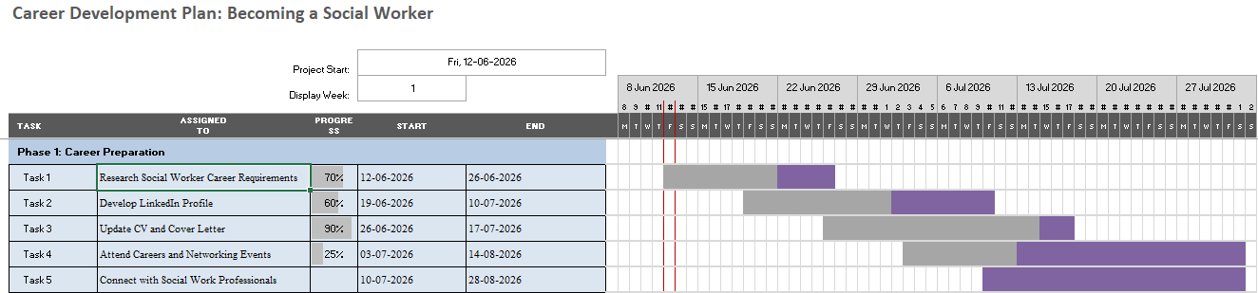
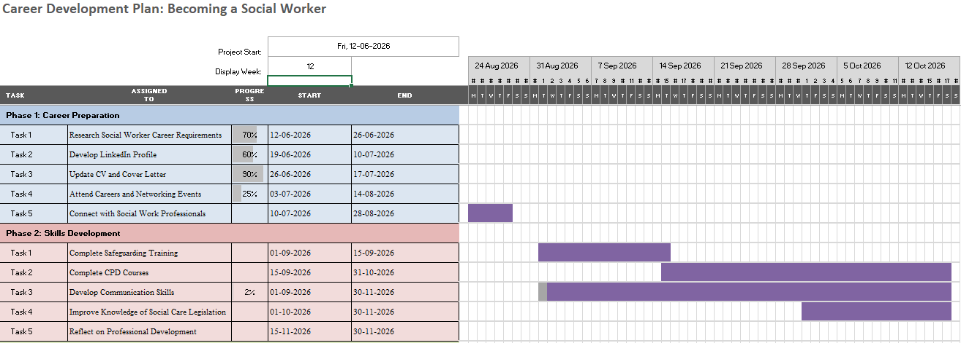
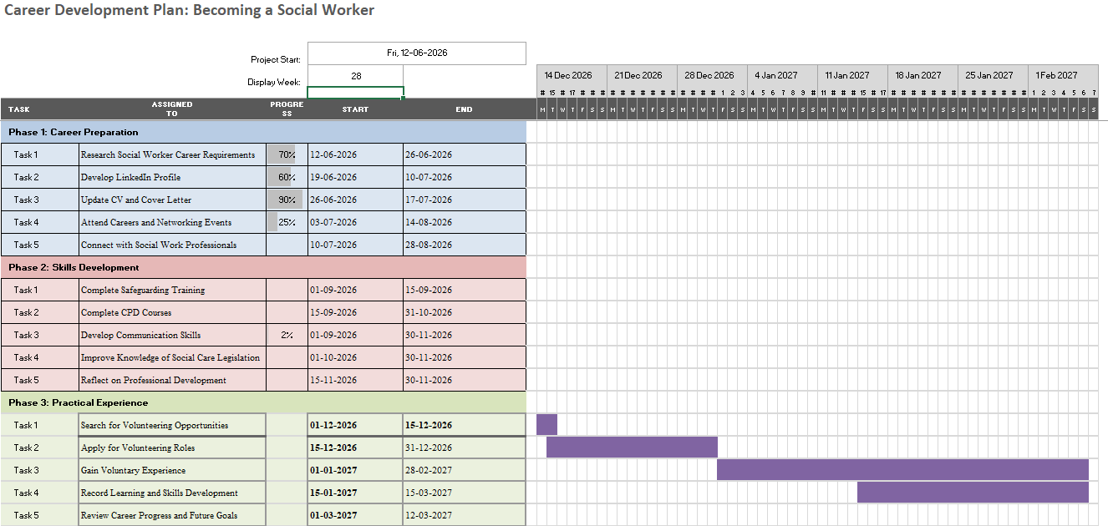
Explanation
This Gantt Chart outlines the key activities I plan to undertake over the next several months. The following Gantt Chart shows the tasks and activities I will be doing in the coming months to accomplish my long-term goal to become a Social Worker. The plan has four levels: career preparation, skills development, practical experience, and employment preparation. First, I will look at researching the social work profession, building my LinkedIn profile and optimising my CV to strengthen my professional profile. The second phase focuses on learning key knowledge and skills through safeguarding training, CPD courses and in-depth knowledge of social care legislation. The third phase involves hands-on experience and reflection on skills learned, achieved through volunteering experiences. Lastly, the job preparation component is to build my professional portfolio, enhance my interview abilities and prepare job applications. This is a structured plan which will enable me to acquire the knowledge, experiences and professional skills needed in the health and social care industry. Through these activities, I will gain greater employability and progress towards becoming a qualified Social Worker as my ambition is to become a qualified Social Worker.

Task 7 – Making Changes Report: Introducing Digital Care Planning in a Care Home
Introduction
As a care home manager, I would be implementing a digital care planning system that would replace the paper-based system. Digital care planning can help with the accuracy of records and aid in communication while supporting person-centred care (Lydahl et al., 2022). This adjustment is significant as it helps promote informed decision-making and facilitates better resident outcomes.
Planning the Change
The model that I'm going to use to successfully implement this change is Kotter's Eight-Step Change Model. The first step would be to raise awareness among staff on the value of digital care planning. Employees would be trained and given demonstrations to help them understand how the new system can help improve efficiencies and resident outcomes. Staff will be engaged during the process of implementation to foster engagement and minimise resistance. The change would be phased in over time so that staff can adapt before the change is rolled out.
Skills Required
Good leadership, communication, time management and problem-solving are needed for successful implementation. Communication drives the understanding of the "why" and "how" of the new system, and leadership is required to motivate staff and guide the change process. Time management ensures that training and implementation are done effectively; problem-solving skills are used to solve any problems encountered.
Barriers and Solutions
Staff resistance is one of the possible obstacles, because staff are afraid of technology or changing the routine. This can be minimised through training, support and active participation in decision-making by members of staff. Limited resources or a lack of technology skills among staff are another obstacle. Training and technical support can provide help to overcome these challenges. There may also be technical issues when implementing; access to IT support will be vital.
Conclusion
Digital care planning can enhance efficiency, quality and accuracy in the delivery of care. While obstacles like staff resistance and low digital literacy can arise, good leadership, communication and training can help with successful implementation and benefit both residents and staff.

References
Beyari, H., (2023). The relationship between social media and the increase in mental health problems. International journal of environmental research and public health, 20(3), p.2383.
Cai, W., El Baroudi, S., Gorbatov, S., Khapova, S.N. and Fan, X., (2025). How proactively building personal brand equity can help employees’ marketability. The International Journal of Human Resource Management, pp.1-31.
Ghaltakhchyan, S., (2025). PERSONAL BRANDING: SHAPING AND MAINTAINING A SUCCESSFUL PERSONAL BRAND. Armenian Folia Anglistika, 21(1 (31)), pp.125-142.
Healy, M., Hammer, S. and McIlveen, P., (2022). Mapping graduate employability and career development in higher education research: A citation network analysis. Studies in Higher Education, 47(4), pp.799-811.
Igbokwe, I.C., Egboka, P.N., Thompson, C.C., Etele, A.V., Anyanwu, A.N., Okeke-James, N.J. and Uzoekwe, H.E., (2023). Emotional intelligence: practices to manage and develop it. European Journal of Theoretical and Applied Sciences, 1(4), pp.42-48.
Khalaf, A.M., Alubied, A.A., Khalaf, A.M., Rifaey, A.A., Alubied, A. and Rifaey, A., (2023). The impact of social media on the mental health of adolescents and young adults: a systematic review. Cureus, 15(8).
Lydahl, D., Britten, N., Wolf, A., Naldemirci, Ö., Lloyd, H. and Heckemann, B., (2022). Exploring documentation in person‐centred care: a content analysis of care plans. International journal of older people nursing, 17(5), p.e12461.
McCloud, T., Kamenov, S., Callender, C., Lewis, G. and Lewis, G., (2023). The association between higher education attendance and common mental health problems among young people in England: evidence from two population-based cohorts. The Lancet Public Health, 8(10), pp.e811-e819.
Orben, A., Meier, A., Dalgleish, T. and Blakemore, S.J., (2024). Mechanisms linking social media use to adolescent mental health vulnerability. Nature Reviews Psychology, 3(6), pp.407-423.
Portes, A., (2024). Social capital: Its origins and applications in modern sociology. New critical writings in political sociology, pp.53-76.
Tuominen, M., Kilpi-Jakonen, E., García Velázquez, R., Castaneda, A. and Kuusio, H., (2023). Building social capital in a new home country. A closer look into the predictors of bonding and bridging relationships of migrant populations at different education levels. Migration Studies, 11(4), pp.598-630.
Verbist, I.L., Fabian, H., Huey, D., Brooks, H. and Blakemore, A., (2024). An evaluation of patient and public involvement (PPI) experience in NHS Talking Therapies for anxiety and depression services: A framework analysis and practical recommendations. Counselling and Psychotherapy Research, 24(4), pp.1503-1515.
World Health Organization, (2022). World mental health report: Transforming mental health for all. World Health Organization.

