Business Plan
Students & Name:

Catalina Bucataru - 1918854

Dan Dumitru – 2025728

George Giuliano Mihai: 2027230

Sorin Stoleru: 2026787

Module Code: BMSW4006 Lecturer Name: Yohan Mendis

Introduction. 2
Business Plan / Overview. 4
Products and Services. 4
Market audit - Competitor’s Analysis. 4
￼Market Audit-SWOT Analysis. 6
Market Audit-Pestle analysis. 7
Target Market. 7
The marketing and sales plan. 8
Team management structure. 8
Forecast Cash flow 9
Forecast Profit and Lose. 10
Reference list. 10

Introduction.
At this point we are going to discuss in detail about the business plan and its structure. The business plan it will include the legal structure and an executive summary also the products and services. The Market Audit Competitor Analysis and Pestle and SOWT Analysis, Target Market, Marketing and Sales Plan are areas which we are going to cover them too. In the and we will present the Team management structure, Forecast Cash Flow and Forecast Profit and Loss Account.
Executive Summary Business Overview.
Quality.
Our quality might be better than our competitors, because we offer the quality game place which no one of them are having now.
We came with the idea to reproduce a map from a well know pc game (counter strike) the map name “fy_iceworld”. We also offer a resting place with bar facility and the escape room near to it.
Price’s.
Our prices it will depend on the package the costumer will choose. We have individual price’s (37£pp with 1 free drink included) and group prices based on the event costumers have (birthday parties, team buildings or simple game) for those packages we will set up a timer of the game (those price’s applicable for airsoft). We charge 5£pp 30 minutes time for escape room.
Location.
We are located in the city centre of Birmingham are also planning to find a location where the costumers can benefit from free parking and other facilities such as MacDonald's, KFC, or Burger king (Lesure park) for the new location where we are planning to open the second point of the business as part of Francise.
Selection.
We have 2 big options that the costumers can chouse from, airsoft place and escape room, we have the bar area where the costumes can rest and have a drink and the party area for the birthday parties.
Service.
Our staff will train the costumers promptly and accurately the staff will also provide help the costumes to get fully equipped in time we assure the safety of costumers.
Speed/Turnaround.
We offer 10 minutes intense training and 10 minutes to get equipment on to get ready for the game, the rest of the time can be use by the costumer for the game itself (Susan Ward, 2020)

Business Plan / Overview.
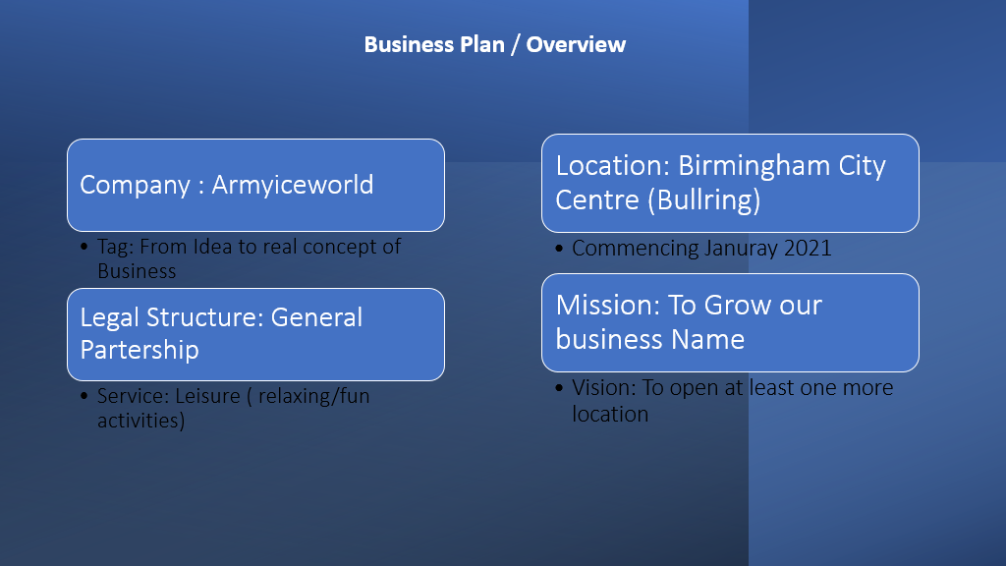
(Page Grossman, 2020)

Products and Services.

Our company Army –Iceworld we will welcome individuals, groups of friends, work groups, birthday parties, schools and people, male and female of all ages, 16 to 99

In our Escape room everyone can improve their interpersonal skills:
Teamwork Problem, deficiency of team personality, lack of contribution, struggle making choices, weak communication, lack of ability to resolve tensions, social abilities, motor abilities, memory abilities,
We also have a Free parking for our customers, bar and rest room where you can relax during break time.

Market audit - Competitor’s Analysis.
In competition and merger lawsuits, market definition has long been a contentious subject. In the last two decades, new methods of defining markets have appeared that are better suited to the demands of competition analysis than those previously employed by economists. Methods of directly assessing market power have also got attention, obviating the need to set up markets in some cases. The current study examines recent improvements in market definition and measurement approaches (P.Massey 2000).
FACTORS
Product and services: our company has is that we have a good group packages price and individual price in respect to our competitors A and B that have only individual price.
Key success factors: our company has fast environment, and our staff are trained very well in respect to our competitors A: a reliable source of finance at the start and B: good, detailed business plan in detail.
Past strategies and current strategies: our company had offered decent price at the start in the past and current is coming with innovation ideas of games itself. Our competitor A had small prices in the past and raised it currently. Competitor B had individual prices in the past and currently the prices stayed the same.
Advertising front: our company is using google and has an Instagram account. Our competitors A and B are using only Google.
Strengths and weaknesses: as strengths we have experience as an organizer but also as an airsoft player, decent prices and excellent location. As a weakness it can be short number of equipment (16), the time maintenance of the guns, the import of products.
Our competitor A as a strength has that is found in good area and his weakness is that has limited strategies of playing.
Our competitor B as a strength has long time in business and his weakness is that is has old equipment.

A successful marketing audit should include the following elements:
-Comprehensive, in that it considers all aspects of a company's marketing strategy
-Systematic, in that it follows a set of steps in a logical order -Independent, in that it is not influenced by those who created and implement the marketing strategy
-Periodic, in that it is conducted on a regular basis A recommended frequency is once a year or twice a year.

Market Audit-SWOT Analysis.

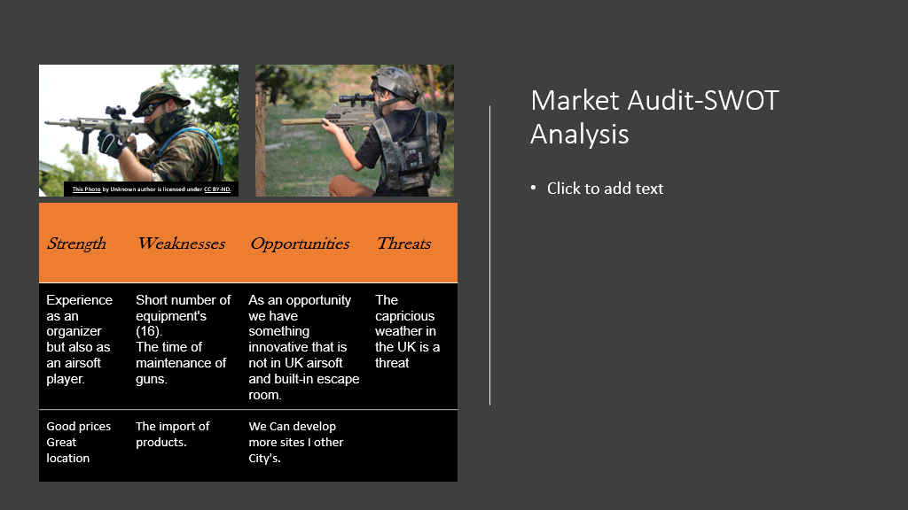
(researchgate, 2022)

Strength and weakness
“We have enough strength to be able to get what we really want, as well as with this we are also aware of our weaknesses too (ed, 2022) Some of our strengths are, staying focused in order to achieve the furnished services or products, work really well in teamwork, we stay aware and alert. (idpublications.org, 2022). We keep ourselves motivated and also practice many acts that make us motivated or help us in building our self-esteem positively. we get fully engaged in doing our own thing so that nobody can break our concentration. With strengths, there are also some of our weaknesses in which we must be working, like, we cannot work in a team with not experienced people from outside. Working in a team result in better results compared to working individually. Another is, we get fully engaged with our work and results sometimes breaking connections with our near ones”.

Market Audit-Pestle analysis.
The business related to the escape room and airsoft does not have any political barrier.
These activities have many effects on the economy.
It has increased the socio-cultural gap between the employer and the employee.
Escape rooms have the option of using varieties of hi-technologies.
the escape room must have some legal factors, which will enable them to protect the business from losses.
more sustainable and are thinking about the environmental factors as well

Target Market.
Target market is a group of people with some shared characteristics that a company has
identified as potential customers, the people who are going to buying the products and
services. Identifying the target market in an essential step in the development and products,
services and marketing efforts used to promote them.
It can be divided into smaller segments, typically grouped by age, location, income, and
lifestyle.
Armi-Iceworld are focusing on the target market of people between 16 and 99+ years, with at
least a minimum income.
At Army-Ice world are welcome to enjoy both male and female, who want to relax, have fun,
or even try something new.
Our location is in Birmingham City Centre Bullring Grand Central, a very populated area.
Our main goal in to reach out and cater to the needs of the people who came to enjoy at
Army-Iceworld.
Market and Sales Plan
The marketing and sales plan on any business play a pivotal role in the business overall
success. One of their most important tasks is developing practical, structured, and detailed
marketing and sales plans. Even is small or large, the business needs to have a plan for
enjoying of success. Marketing and sales plan play a significant role in keeping the business
relevant and staying on track with. The result from marketing and sales plan should be
closely and monitored so that the entire team is aware when the certain goals have been
achived.

The marketing and sales plan.
The marketing and sales plan details the strategies that you will use to reach your target
market. Our products and prices depend on numbers of players and events like birthdays or
team buildings, and we also have individual prices.
• Individual price- 37£pp (airsoft) 250 shots 1h+1 free drink
• Group of 8 price- 250£ (airsoft) 250 shots 1h
• Individual price- 10£pp (escape room) 40 min
• Group price- 30£pp (escape room)
We are creating different scenarios of playing and we can create membership for the
customers which are interested on at reasonable prices.
We offer also discounts and deals to attract and retain targeted customers, like that we can
develop strong relationships with loyal customers who will remain loyal and return to Army-Ice world. We are expecting to attractant amount of people between 120 and 140 per month and 1440 and 1600 per year.

Team management structure.
We have a really easy structure of management, the staff members 1 and 2 must good communication between them, and they must follow manger indications and must report the any situation to the manager. Manager is having the responsibility supervision on the place to train and support the staff members because "he is the one which is having the knowledge of the business. In the peak time we do have one more member.
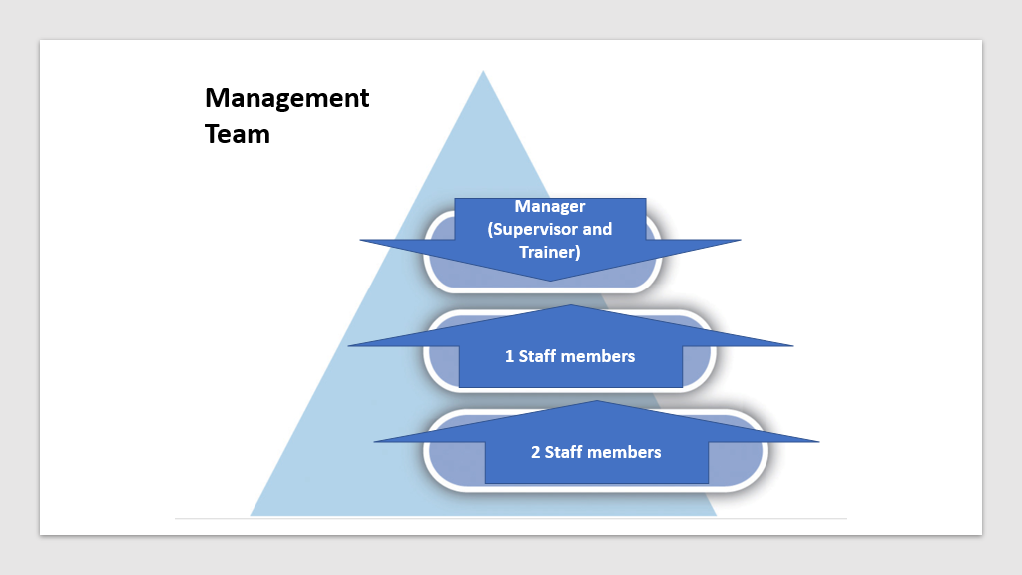

Forecast Cash flow.
We are expecting to have an amount of “money in” 139,440£ in there are included our initial Invesment and our loan of 3200£. The amount of 122,240£ is going to be just from the sales. We have fluctuations of monthly sales because of different reasons: In July and August we have the summer holidays which is impacting the sales in September most students are going back to schools or universities. With an “Total Outgoing” of 54,130£ money spent on business expenses we expect to close the year with 85,310£.
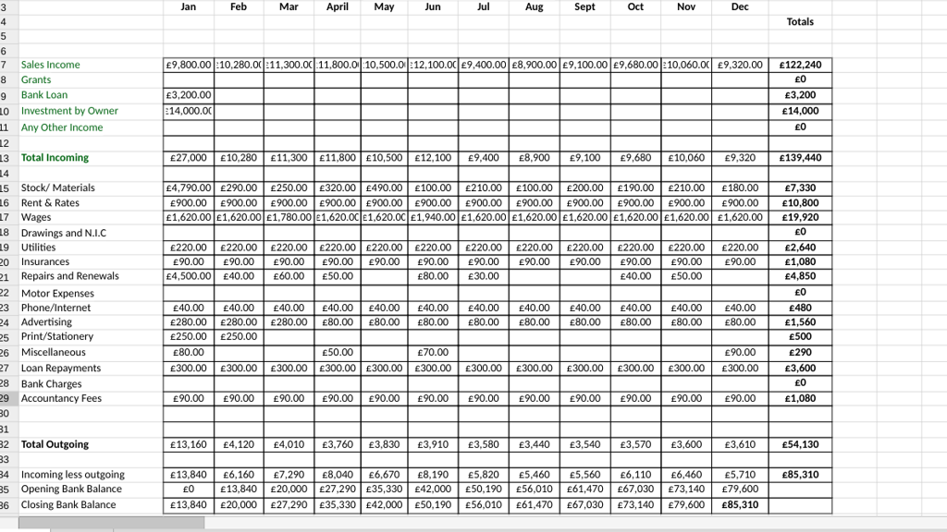

Forecast Profit and Lose.
We do have made some rectifications on this stage we modify the gross and net profit, as in the PP presentation they were wrong we tried to make the right adjustments.
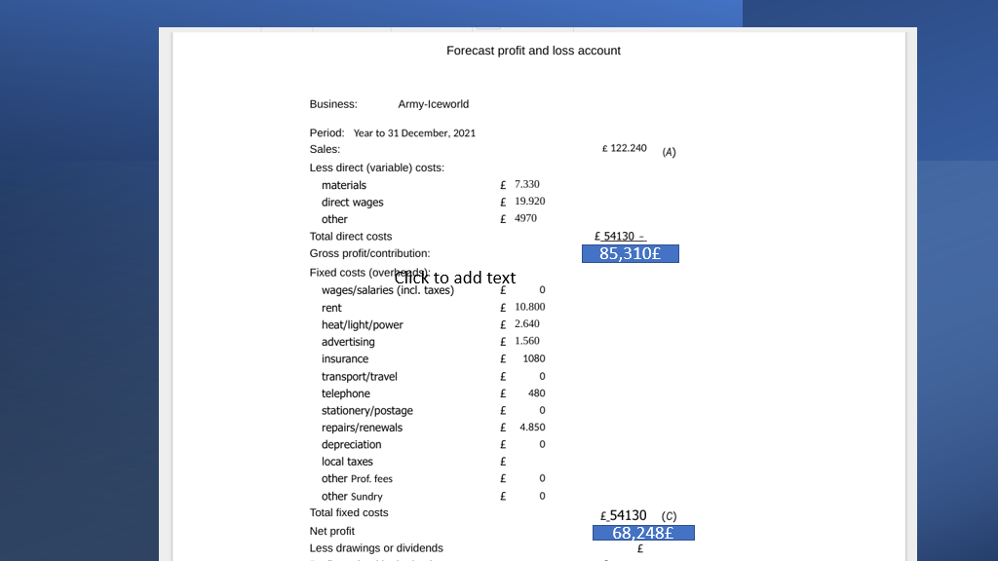

Reference list.
Kallapur, Sanjay and Sankaraguruswamy, Srinivasan and Zang, Yoonseok, Audit Market Concentration and Audit Quality (February 2, 2010). Available at SSRN: https://ssrn.com/abstract=1546356 or http://dx.doi.org/10.2139/ssrn.1546356

MASSEY, P., Market Definition and Market Power in Competition Analysis: Some Practical Issues(October 2000).Available at : https://www.esr.ie/ESR_papers/vol31_4/2Massey
ed.gov , 2022. Leggio, J.C. and Terras, K.L., 2019. An Investigation of the Qualities, Knowledge, and Skills of Effective Teachers for Students with Emotional/Behavioral Disorders: The Teacher Perspective. Journal of Special Education Apprenticeship, 8(1), p.n1. https://files.eric.ed.gov/fulltext/EJ1223988
idpublications.org , 2022. Alikulovich, M.K. and Yuldashevich, T.D., 2020. Development of physical training skills and formation of willpower qualities in extracurricular activities. European Journal of Research and Reflection in Educational Sciences Vol, 8(3). http://www.idpublications.org/wpcontent/uploads/2020/04/Full-Paper-DEVELOPMENT-OF-PHYSICALTRAINING-SKILLS-AND-FORMATION-OF-WILLPOWER-QUALITIES.pdf
researchgate.net , 2022. Wheelahan, L. and Moodie, G., 2017. Vocational education qualifications’ roles in pathways to work in liberal market economies. Journal of Vocational Education & Training, 69(1), pp.10-27. https://www.researchgate.net/profile/LeesaWheelahan/publication/315597064_Vocational_education_qualifications%27_role s_in_pathways_to_work_in_liberal_market_economies/links/5b030f310f7e9be94b dabb4f/Vocational-education-qualifications-roles-in-pathways-to-work-in-liberalmarket-economies.pdf

Kristina 12 nov 2021 Target market https://sixads.net/blog/target-market-examples/
Sebastian Duncan 19 July 2021 Marketing and sales plan https://realbusiness.co.uk/sales-marketing-plan
Ward, S. [ the balance small business] (2020) Executive Summary of the Business Plan [online] 20 May. Available at: https://www.thebalancesmb.com/executive-summary-of-the-business-plan (Accessed: 10/04/2022).

Grosman, P. [nerdwallet] (2020) How to Write a Company Overview for a Business Plan
[online] 22 October. Available at: https://www.nerdwallet.com/article/small-business/company-overview (Accessed: 10/04/2022).
Hello sir. We just have a problem with one of the members from our team (Marian Mihai).
Last time when we had a conversation with him, was after the presentation. We all were agreeing to meet in 2 days' time to finish the project. He didn't show up, we tried to get him involve but we couldn't reach him.
we thought that he doesn't want to participate anymore, and me Dan Dumitru I've been taking the decision to do his part of the project.
The main body of the project it was in my computer I had the responsibility to put all the bitts together.
We finished today 10/04/2022 the project has been uploaded in the final submission at 10:30pm and he came on our group at 10:40pm because he seen our conversation on the group, and he told us to wait him until tomorrow that he is not ready yet.
But the work was submitted already.
I hope this will not affect us.

