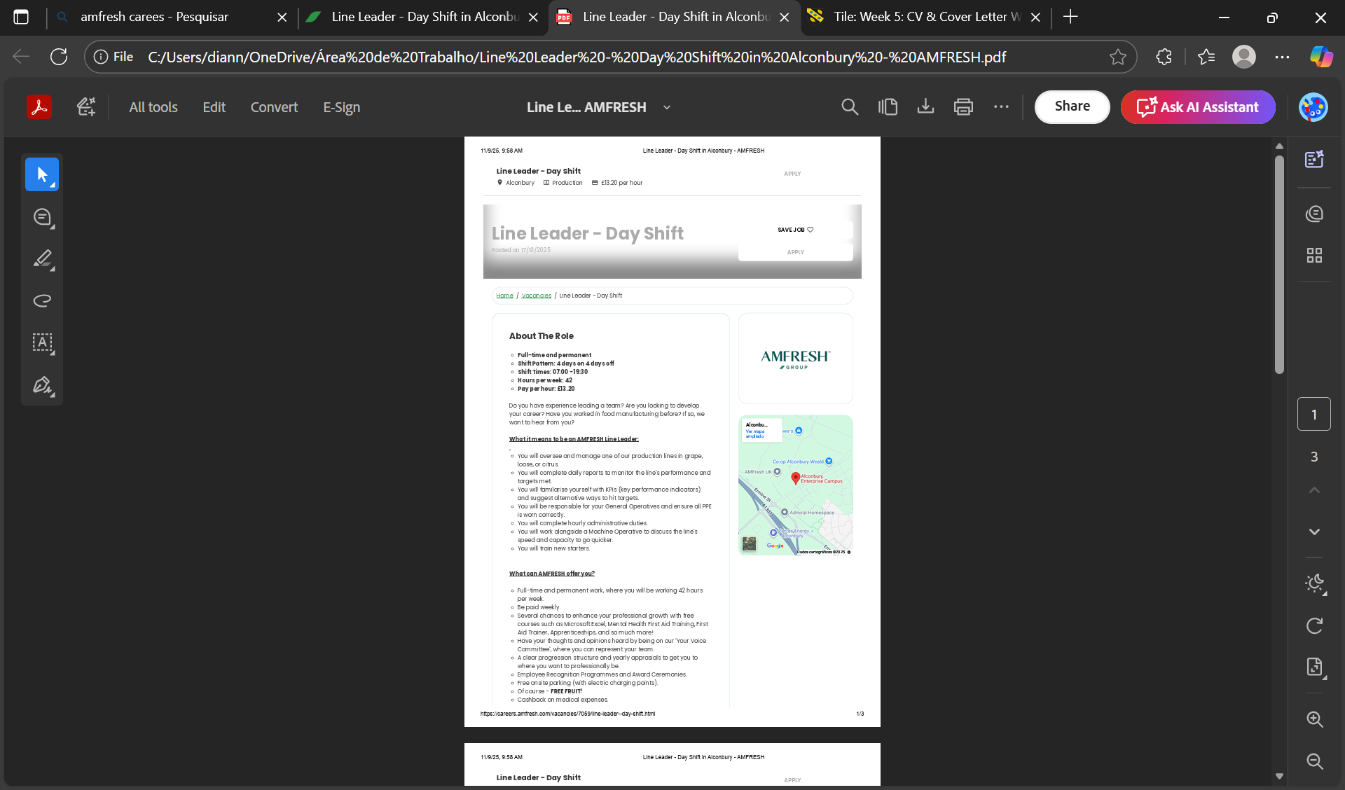
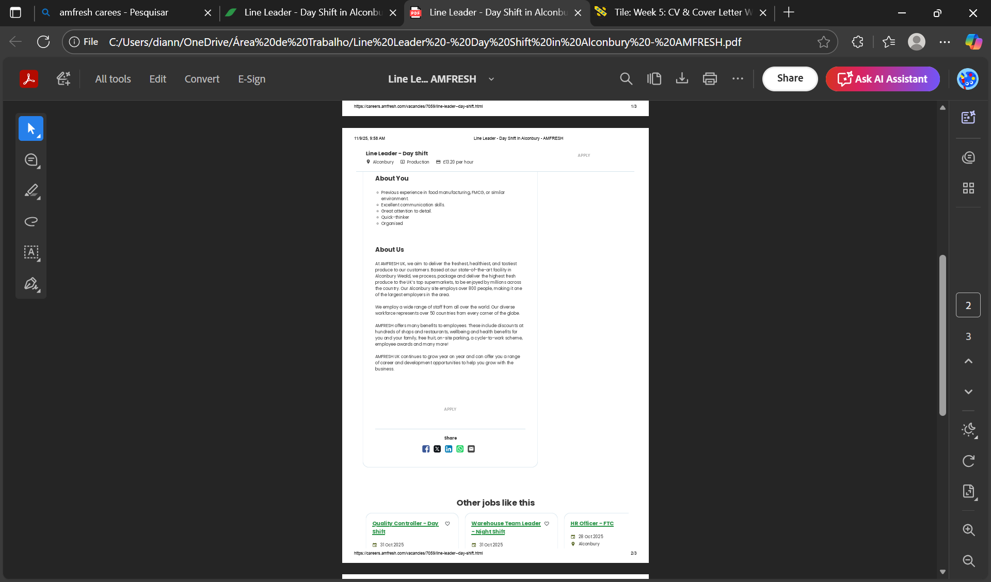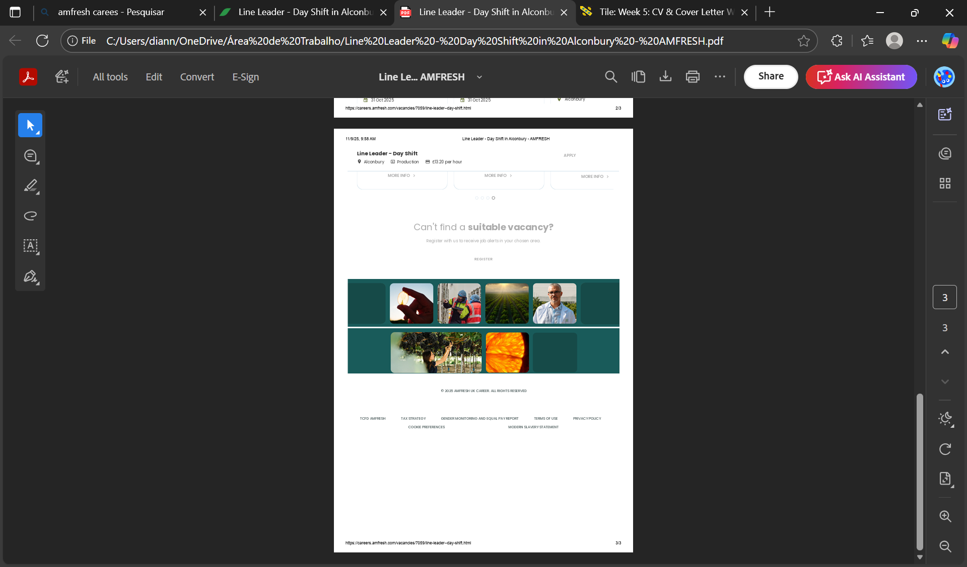

DMBB
70 Burmer Road
PE1 3H*

Hiring manager
AMFRESH GROUP
Lobelle Way, Huntingdon PE28 4
09/11/2025

Dear Mr/Mrs Hiring Manager
I wish to apply for the role of Line Leader - Day Shift, currently being advertised on Line Leader - Day Shift in Alconbury - AMFRESH. Please find enclosed my CV for your consideration.
As you can see from my attached CV, I have over 8 years of experience in the
BAKKAVOR GROUP plc industry, and I believe my experience and skills developed in the field during this time make me the right candidate for the role.
In my current role as a Line Leader at Bakkavor Group, I have been responsible for staff management, KPI targets and reports, administrative system operation, and production lines for citrus and delivery orders on time. Ease in learning and teaching new starters
All of this, coupled with my enthusiasm and dedication, good communication in English, Portuguese and Spanish, which can facilitate integration with the staff and the Food Safety (General Food Hygiene) certificate, working to high standards.
Further, with new projects and system implementation on the packhouse site, i am confident that I can bring this level of success with me to your organisation and help to add value as well as build upon their reputation as giving premium quality products & services to its customers, and that good reputation will be maintained by having me, which includes my previous experience and expertise. I believe my contribution will have a significant impact on the business value.

Thank you for your time and for giving me an opportunity. I look forward to hearing from you soon.

Yours sincerely,
DMBB
Signature DMBB

Resume-of Line Leader - Day Shift

DMBB
70, Burmer Road,
Peterborough PE1 3H*
07986 868686
Email: dmbb@gmail.com

I am currently working as Line leader level 2. I have 8 years of Professional experience in the packhouse citrus production activities of an organisation.

Objective:
- As a line leader, I want to coordinate and control all activities related to my role on the packhouse production site efficiently, helping the organisation achieve its objectives and goals with satisfied customers.

Education:
- Certificate in Higher Education – Business Skills for the Workplace, University of Wales Trinity Saint David- Campus London, 2025, from London, UK.

Professional Certifications:
- The Food Safety Certificate (General Food Hygiene), 2019, 2024 from Peterbough, UK

Skills:
- I have good staff management
- Have good, accurate KPIs targets and reports
- Have good multiple language skills in English, Portuguese and Spanish, verbal and written
- Capable of working under pressure and meeting deadlines as scheduled with quality in work
- Capable of taking care of quality service activities and front-line management.

Computer Skills:
Microsoft Office tools, Microsoft Word, Outlook, Excel, Teams, PowerPoint and usage of Google and other browsers

Key Strengths:

- Communication Skill:
I have good English-language skills. I am also fluent in Portuguese and Spanish.

- Organized:
I am very organised in my tasks and responsibilities assigned to me. This helps me to do my work effectively and efficiently. I have been appreciated and given letters from my senior managers for my organised and efficient work.

Work History:

Bakkavor Group plc- Line Leader level 2
Duration: Oct 2018 – Till date
Responsibilities:
As a line leader level 2 In my current role as a Line Leader at Bakkavor Group, I have been responsible for staff management, KPI targets and reports, administrative system operation, and production lines for citrus and delivery orders on time. Ease in learning and teaching new starters
All of this, coupled with my enthusiasm and dedication, the Food Safety (General Food Hygiene) certificate, and my commitment to working to high standards.
Further, with new projects and system implementation on the packhouse site, I am confident that I can bring this level of success with me to your organisation and help to add value as well as build upon your reputation for giving premium quality products & services to its customers. That good reputation will be maintained by having me, which includes my previous experience and expertise. I believe my contribution will have a significant impact on the business value.

Hobby’s:
swimming, Listening Music and dance.

Languages Known:
English, Portuguese, and Spanish.

