
Marketing Fundamentals assignment 2
January 2018


Marketing fundamentals
Matthews house
Jessica Rees
1703037


Table of Contents

- Main Body
- Conclusion
- References

List of Figures

Figure 1 – Marketing Mix
Figure 2 – Marketing Process

Main Body

In consonance with the Chartered Institute of Marketing, “Marketing is the management process responsible for identifying, anticipating and satisfying customer requirements profitably.” (CIM, 2018). In regards to the operations of the marketing criteria in businesses and companies, its daily activities is a deeper and more complex operation than what meets the eye. These important elements and factors include marketing fundamentals, market research and the ability to interact, identify and empathise with current and potential customers including target markets, management activities such as the processes and stages of the marketing mix and the engagement of stakeholders and how they impact the marketing activities of any organisation.
The marketing mix is a basic tool that organisations use to get their product out and known to their target market. The characterization of the marketing mix is simple. It is about putting the right product or a combination thereof in the right place, at the right time, and at the right price. (http://marketingmix.co.uk, 2015). An organisation is more likely to succeed using this tool other than not, but it requires knowing the organisation’s business plan perfectly to do well.

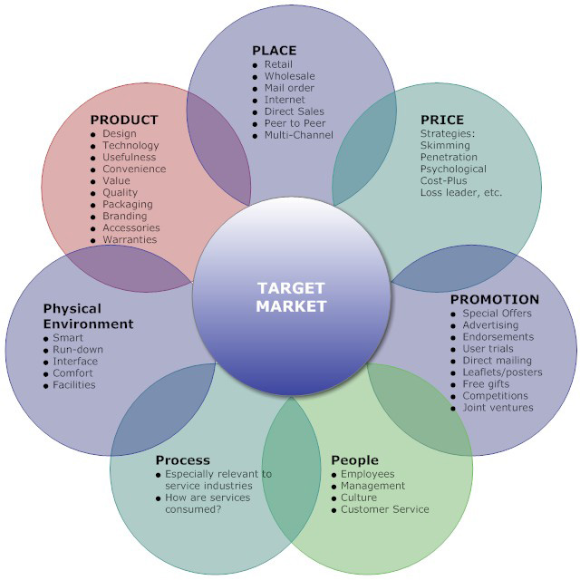

Figure 1.
Figure 1 above shows an example of the ‘7Ps Marketing Mix’ model which is generally used in service industries. Each factor to the marketing mix plays a significant role in the organisations success rate. The first and evidentially one of the most important factors to the mix is Product. The product is produced as a benefit in aim to target a specific target market and is then classed in regards to its being such as tangible or intangible. Tangible products refer to a physical object that can be perceived by touch, for example, a car. However, in recent day and age more intangible products are being developed such as digitised and online-delivered content like television shows, e-books and blog content. Products are classed this way as they come in the form of goods or services. It is very unlikely that a product will appeal to everyone, hence the reason for target markets. With knowledge of these target markets, the marketing team can focus their attention on getting the message out to that specific group in the most successful ways. To allow a product to be successful, the organisation must ensure the product being developed is in demand in the target market with a unique selling point to differentiate from competitors. Each product is known to have a life line as time goes on which makes it a wise decision for organisations to develop the product over time or expand the product line/mix.
Another paramount factor is Price. The reason for its importance, especially within the marketing plan is because it a ground for the organisation’s profit and survival. The pricing of a product shapes the way customers and potential customers perceive the product and the organisation itself. Price is a fairly flexible element of the mix, since it is relatively easy to change prices in response to demand fluctuations, but continually changing prices can lead to confusion and even suspicion on the part of the customers. (Blythe, 2009) Although, along with the price of the product or service, there is always the monetary costs. Monetary costs refer to how the customer thinks about purchasing the product and the factors that influence this, for example, cost of ownership of product, time and expense of owning it and so on. Monetary costs go hand in hand with money, price and value which is typically the three most important factors that a customer will think about during the purchasing process.
Place is also a very important component in the product mix and in some cases can have a detrimental effect on sales. This is regarding placement or distribution. Its location has to be suitable so that it is accessible to current and potential buyers but this can only be efficient with deep understanding of the target market being aimed for. Jobber (2007, pg.21) explains that distribution channels consist of organisations such as retailers or wholesalers through which goods pass on their way to customers.
For example, Amazon has been headlining newspapers regarding how Amazon is secretly building its superfast delivery empire. In its early days, Amazon only dealt with books but eventually diversified into a differentiation of product lines, such as toys, jewellery, DVDs and so on. This decision led the business to become today's $75 billion company with a diverse product portfolio. In the 1990's, Amazon developed its huge infrastructure and across the whole of the United States of America, had a general lead delivery time of 4-7 days. This idea led onto the mission of "Get Big Fast" meaning more diversification and geographic expansion of distribution centres to be able to get more products out faster to customers in various parts of the country.
Boosting brand recognition is very important, especially for sales which is why Promotion comes into practise. Organisations will try use any form of promotion to advertise themselves and the product or service they are selling. The organisation will ensure that the advertisement is placed anywhere their target market may see, of which recently, advertising companies have seen a bigger shift to the online world rather than offline. As an example, Matthew's House uses a range of platforms to promote what they do. Outside Matthew's House, you'll see a banner explaining who they are and what they do as a quick summary for people passing by. You'll also hear the organisation being mentioned on the radio where there is a large volume of listeners. This also applies to social media and online advertising. People refers to both the target market and the people related to the business. The employees are important in marketing because without them, there would be no one to deliver the service. A company is a legal fiction so there always needs to be a superior service to the clients so that if they have any enquiries or issues, there is someone within the business they can turn to.
The main component of the marketing mix which ensures everything is running at minimum costs is the Process. Having a well-tailored and productive process helps to minimise costs to save paying off for any issues or breakages and even enhancements to the process system can also minimise costs and maximise profits.
The last main component to the Marketing Mix is Physical Evidence. This refers to the type of reputation a business and its products have and how they are perceived in the marketplace. With any well-known brand such as Timberland shoes, we, from a consumer perspective, already know their presence in the industry and that they have physical evidence established from their marketing.
There are numerous interpretations of what is meant by customer value. The term may mean low price, receiving what is desired, receiving quality for what is paid, or receiving something in return for what is given (Zeithaml, 1988) Although, this definition suggests that there are two aspects to customer value: desired value and percieved value. Desired value refers to the types of desires customers have in a product or service. Percieved value is the benefit the customer believes they received after the purchase (Woodruff, 1997). When looking at creating value for customers (Kotler, 2017) puts it into marketing terms stating that marketing is engaging customers and managing profitable customer relationships. From an overall perspective on marketing, the goal is precisely focused on attracting new customers and growing current customer satisfaction by continually delivering high-calibre value and meeting customer needs. This is where the marketing process comes in.
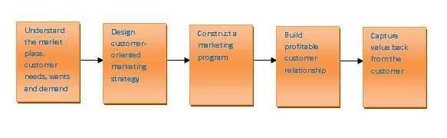Figure 2

The first four steps of the process require organisations to gather an understanding about their consumers and how to build strong relationships, which is mainly done via market research and the final stage to the organisation is the goal. This is because, by using the first four stages successfully, the organisation then benefits from more value from consumers in the form of profit, increasing sales and strong and long-term customer relationships. The market research used in the first four steps focuses on many elements but one important element in particular is understanding the market place and customer needs. (Kotler, 2017) backs up this statement by stating that organisations conduct consumer research, analyse customer data and observation of customers as they shop and interact, both online and offline. All customer value grows from customer satisfaction but marketers of the organisation must ensure that the expectations they set, is in reach so they know it is possible to achieve, rather than it being too low and not attracting enough customers or setting the mark too high and facing customer disappointment, which leads consumers to the competitors. This all links to customer behaviour. For example, if we look at both Tesco and Aldi, both of which are profitable businesses. From a customer perspective, I’d be more likely to shop at Tesco as I know that all product value is high and to standard but there is more variety. For example, there are food isles as well as beauty and health counters and clothing on the upper floor. There is also a pharmaceutical counter which makes customer's shopping experience easier if they need to pick up prescriptions. Although my preference, I would still shop at Aldi as I know they have the food I need at good prices and value but their product portfolio is not as wide as Tesco meaning that if customers need a product that they don't have, they would refer to stores such as Tesco who is a competitor. Studies conducted over the past few years as established by (Baines, Fill, Page, 2013) customer relationship management (CRM) is controlled through software systems with details and history of each customer, this also has a relation to customer retention.

A stakeholder is a person, group, or organisation that has direct or indirect stake in an organisation – because it can affect or be affected by the organisation's actions, objectives, and policies. (CIM, 2014) Stakeholders differentiate for the type of organisation. Typically, for a 'for-profit' organisations, stakeholders to the business would be employees, creditors, directors, local government and so forth. On the other hand, stakeholders to a 'not-for-profit- organisation includes donors, employees, volunteers, beneficiaries, individuals or groups that give grants, the local community, the local government and anyone else who has an interest in the organisation. Organisations such as Matthew's House relies on their stakeholders to be able to continue running and delivering the service they do. As (Farnham, 1999) summaries, that non-profit stakeholders typically fall into 3 legal categories. The first is Constitutional. Matthew's House has many constitutional stakeholders which are their trustees and the management team as it is their responsibility for managing and running the organisation on a daily basis. The next category is contractual stakeholders. Matthew’s House only has a couple of contractual stakeholders of which are the managers of the organisation. Another stakeholder of this kind that has a formal relationship with Matthew’s House is Tesco. Every week, Tesco donate food that has not been bought and only has a short period of shelf life left. This food donated is then used in Matt’s Café which is situated in Matthew’s House. Finally, there are third-party stakeholders. People such as you and I are accounted for as third-party stakeholders as we are the local community of which this organisation operates in. For example, if myself and friends decided to go to Matt’s Café for food, we are donating money for the food we are buying which is making use of the organisation and then the money we donated will then go towards feeding homeless people in the area. Without these stakeholders, organisations like Matthew’s House would find it difficult to continue. The stakeholder engagement previously mentioned all has an impact on the organisation, mainly regarding their marketing activities. For organisations like Matthew’s House, stakeholder engagement is imperative for the running of the business and to carry out their mission statement. Donors are needed for funding to feed the homeless and other facilities necessary, and visitors and trustees are needed to run the organisation and create as well as spreading more awareness.

To conclude, when looking at the different elements of the marketing mix and the marketing process, it is imperative to have stakeholder engagement for both for-profit and non-profit organisations especially for organisations like Matthew’s House. When exploring the elements of the marketing mix, commonly referred to as the 7P’s, it’s evident that there is a strong basic goal of creating strong customer value by building long-term relationships. (CIM, 2014) makes a statement about the flux of marketing describing it as both vender and customers are seeking the new and unexpected, while fresh consumer habits, needs and trends have changed the game. This gives all the more reason for any type of organisation to create a unique selling point. Matthew’s house unique selling point is the type of service they run and all the facilities they have on offer such as showers, café open to the public to fund food for homeless people, even their project to help vulnerable women on the street with personal hygiene.

Referencing

Anon, (2018). Internal Marketing. [online] Available at: http://www.thensmc.com/sites/default/files/CIM%207Ps%20Resource.PDF [Accessed 7 Jan. 2018].
Baines, P., Fill, C. and Page, K., 2013. Essentials of marketing. Oxford University Press.
Blythe, J., 2009. Principles & practice of marketing. Cengage Learning EMEA.
Farnham, David., 1999. Managing in Business Context
Figure one - http://marketingmix.co.uk/
Figure two - https://blogsforeveryone.wordpress.com/2013/05/10/marketing-and-the-marketing-process/
Freeman, R.E., Harrison, J.S. and Wicks, A.C., 2007. Managing for stakeholders: Survival, reputation, and success. Yale University Press.
Jobber, D., 2007. Principles and practice of marketing (No. 5th). McGraw-Hill Higher Education.
N. Craig Smith, Minette E. Drumwright, and Mary C. Gentile. The New Marketing Myopia
Sirgy, M.J., 2008. Ethics and public policy implications of research on consumer well-being. Journal of Public Policy & Marketing, 27(2)
Spreng, R.A., MacKenzie, S.B. and Olshavsky, R.W., 1996. A reexamination of the determinants of consumer satisfaction. The Journal of Marketing, pp.15-32.
The Marketing Mix. (2018). Marketing Mix Definition - 4Ps & 7Ps of the Marketing Mix. [online] Available at: http://marketingmix.co.uk/ [Accessed 7 Jan. 2018].
Zeithaml, V.A., 1988. Consumer perceptions of price, quality, and value: a means-end model and synthesis of evidence. The Journal of marketing, pp.2-22.

