Student Name: Yilan Men
P Number: 2006394
Programme of Study: Fine Art
Research in Context Lecturer’s Name: Gwenllian Beynon

Task: Explore how artists have expressed gender in art practice providing evidence from at least 2 artists and thinkers. = 2326 words

Gender in Art Practice

Introduction: an international issue – gender
According to the Cambridge Dictionary (Cambridge University Press, 2021), it can be referred to not only the physical but also the social condition of being male or female. Then on this basis, it is also a range of features concerning and distinguishing between femininity and masculinity in binary gender societies.

While most cultures are dominated by male power, this definition tends to lead to discrimination and exploitation. For example, as wage labourers and domestic labourers, women bear the ‘dual burden’ under the ‘dual role’ and are exploited by both capitalism and patriarchy. In this mechanism, most women become unpaid domestic workers, and the sex variable plays an inevitable and intrinsic role (Ueno, 2020). Therefore, for the purpose of this essay, I am considering gender in association with unequal rights.

Globalisation process has deeply influenced the already tense gender issues (DEMİR, 2021). Gender inequality has been more and more broadly considered worldwide in recent years. It is manifested in the MeToo Movement and the events of the same nature occurring in more places with increasing frequency. However, artists’ expressions and discussions of gender in their practices preceded such public awareness. Therefore, it is crucial to understand the significance of aesthetics to politics (Millner & Moore, 2022) under such circumstances. This importance was underlined by Jacques Rancière with his famous saying: ‘The real must be fictionalised in order to be thought’ (Rancière, 2006).

This essay will investigate how Louise Bourgeois, Martha Rosler, Joan Semmel, and Barbara Kruger, have conveyed gender in their art practices during the second-wave feminism movement.

I will explore the context and background in which these works were created and the basis of the rousing of feminist consciousness first. Then, the detailed analyses of the works and artists will be presented. Lastly, I will elaborate on the importance of feminist art and feminist art research through examples and the mutually supporting theories of different theorists.

Context: consciousness-raising
The four pieces of artwork span the period from 1968 to 1981, which coincided with the second-wave feminism movement. In the United States in the 1940s, there were attempts to rebind women by arguing that the pursuit of career achievement and higher education made them masculine and unfeminine (Li, 2018). Thus, in the second-wave feminist movement, which began in the 1960s and continued to the 1980s, the main purposes were to criticise sexism, gender discrimination, and male power (Li, 2018), which can also be found in the artworks.

Such awakening of feminist consciousness was established on storytelling; it provided a space for the female perspective and granted the interconnection of knowledge with power (Millner & Moore, 2021). There was small-group organising – women gathered together in small groups and shared their stories uninterrupted on a particular topic, to discover how the topics discussed connected to their own lives. An awareness of concerted suppression between women emerged in this way (Gosling, Robinson & Tobin, 2018).

It is important to note that artmaking was impacted by consciousness-raising and the storytelling bedrock, too (Gosling, Robinson & Tobin, 2018). New artistic perspectives on art are contributed by feminism with the act of challenging the gendered view within the thought of femininity (Millner & Moore, 2021).

In the works to be explored below, we can also see the artists’ telling of the individual or collective stories. These stories are an indictment of the exploitation of women under the rule of patriarchy.

Artworks & Artists: rebelling against the conventional canon
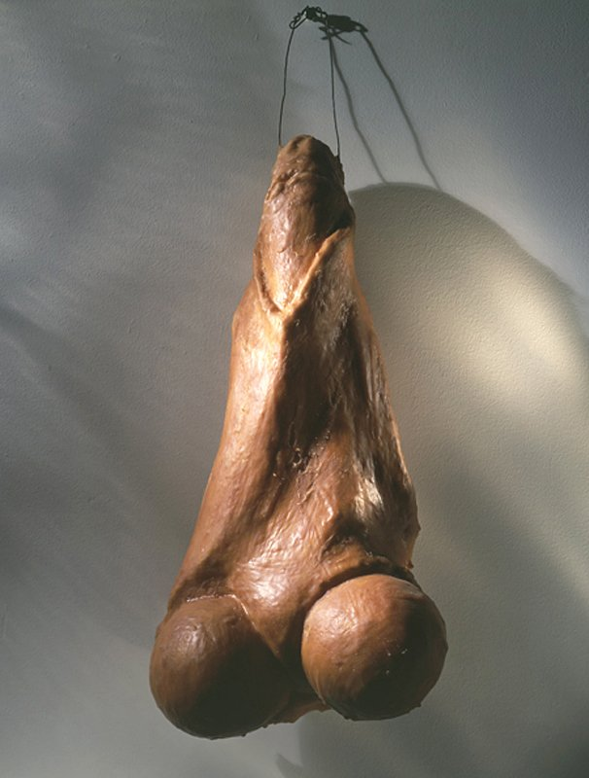
The first work is titled ‘Fillette’. It is produced by Louise Bourgeois, an artist who had experience in her parent's tapestry restoration workshop in her early years，which allows her to work with fabric and sewing deftly (Frigeri, 2019).
Fig 1. Fillette, Louise Bourgeois, 1968

She attained authentic shape and texture in this hanging sculpture by the use of plaster and latex (MoMa, 2012). The appearance of the work shows the potency of masculinity, however, the title of this phallic means ‘little girl’ giving the audience a disturbing sense of disconnection (Tate, 2020). This sarcastic title suggests that the work can also be seen as a female torso, and it also lends ambiguity to the work as Bourgeois created dual qualities of potency and vulnerability (MoMA, 2012). Such complexity in this piece is in relation to her life as a wife and a mother which prompted her to see the truth that masculinity is considerably more fragile than she had envisaged, ‘From a sexual point of view I consider the masculine attributes to be extremely delicate’ explained the artist (Tate, 2020).

While the work is 2ft-long, which is at a monumental scale, it is comic and diminishing rather than authoritative (Showalter, 2019). Hence, it can be considered as a resurfacing of the disturbance of her dictatorial father in her childhood, and as a challenge or a vengeance to it as well.

In this piece of sculpture, she explored the multiple facets of masculinity and confronted gender stereotypes. Given that there is a one-way relation in which the ‘penetrator’ is the subject of sex and the ‘penetrated’ is the object of sex. To be penetrated, to become a sexual object, in the words, to be feminised, is what men fear the most in a patriarchal society (Ueno, 2015). This work can also be seen as an attempt to subvert the subject-object relationship between male and female in sex.

The role of the male as a sexual subject is overturned into a sexual object, but the work still recognised that women are the object of sex, so it fails to break away from the core of misogyny. Despite the fact that Bourgeois resolutely refused the feminist label, her work still engaged with femininity and its investigations (Frigeri, 2019). Nevertheless, her endeavour in overturning the entrenched relation between two sexes in the gender binary system can be perceived as an unintentional act of the subconscious mind.


The second is the iconic Body Beautiful, or Beauty Knows No Pain by Martha Rosler. Her work is centred around the continuing concerns of feminism, her art and her engagement with feminism are incessantly inseparable (Frigeri, 2019).
Fig 2. Body Beautiful, or Beauty Knows No Pain, Martha Rosler, 1966-1972

While the popular media deliberately draw attention to the way women are modelled, packaged like productions for men’s usage (Rosler, no date), the artist takes a similar approach, turning photomontage into a means of accentuating the contemporary feminist issues (Frigeri, 2019).

The work consists of a group of 32 photomontages and abstracts the portrayals of women’s bodies from mainstream media sources. A lot of the photos are from the mass production of monthly porn magazines, for instance, Playboy, in which the nudes are made expendable with each new issue. She made the profusion of female flesh absurd by creating new contexts in which decontextualising the bodies from the media-created environments they supposed to be staged (Stokic, 2013).

There is a dual-level interpretation of the media shown in such action, and it is a play on the aesthetics and meanings transmitted by the media. She is clearly unsatisfied with the way the popular media portrays women and female bodies, so she takes these images from the media and uses them out of the set context. However, these new contexts are still relatively situated within the aesthetics of the media. Some critics claimed that the collage failed to ‘de-fetishize’ the object trait of nude models photographed (Stokic, 2013). For instance, the image selected to insert in this essay, which is very much situated in the style of a magazine spread – the composition of the bodies and their posing.

Despite the collection’s debatable meanings – which I believe to be a sign of a ‘good’ piece of work, in that, it has the ability to create discourse, the work still demonstrates Rosler’s worries about the objectification of women, which can be the external burden, behest, and imagination projected on women (Rosler, no date). In a less forthright but not subtle way, it expresses dissatisfaction with the oppression that men have imposed on women.

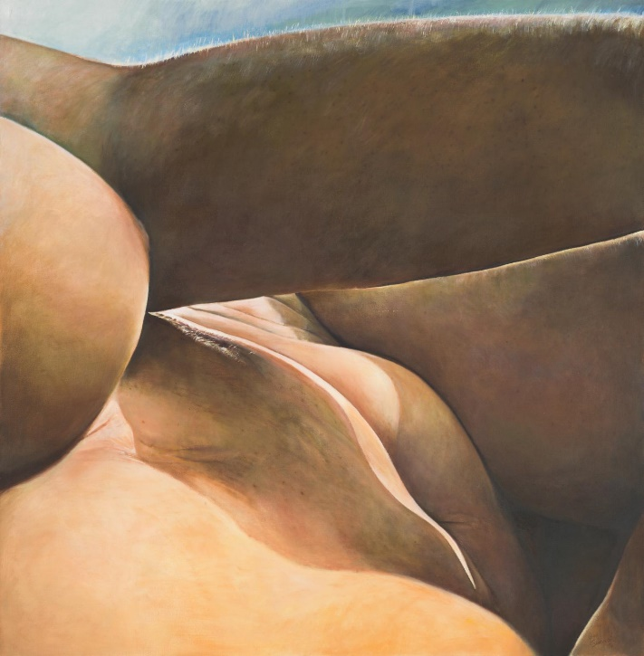
The next piece is Secret Spaces by Joan Semmel. It is produced based on a photograph of the artist’s body taken by herself (Johnston, 2016). The work delineates a real woman’s body as she sees it from a first-person view, without being objectifying, sexualising, or fantasising by the male gaze.
Fig 3. Secret Spaces, Joan Semmel, 1976.

The artist excluded any other possible perspective by cropping the composition of this work into a close-range self-looking. Moreover, the linear outline, delicate brushwork, and mild colours not only represent the real female body, but also give it a scenic feature. Through these techniques of expression, the artist turns the reality, which the male aesthetic may not appreciate, into an experience of female self-appreciation.

Semmel considered that subjecting her nakedness can be a way in which to dissolve the fact that women were passively being looked at (Johnston, 2016), and this painting presents the most authentic female body, not projected by male fantasy, in a completely female angle and straightforward way.

It can be seen as clearer defiance compared to the work of Martha Rosler’s discussed above, because Rosler only puts forward the irony of male projection, while Joan Semmel expresses for women to have the freedom to show their true selves by the showcase of her naked body in its natural state.

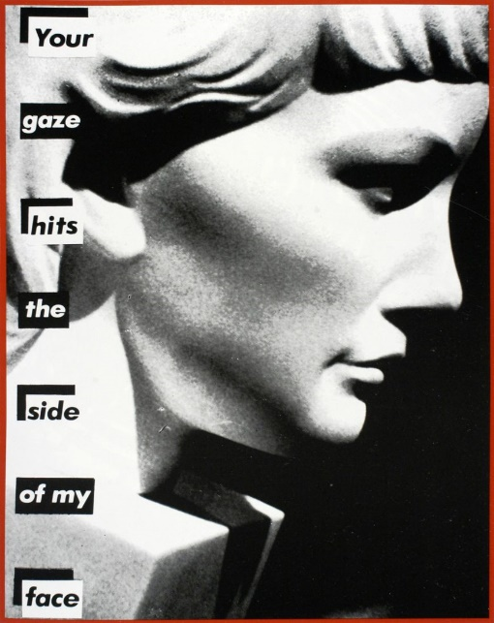
The last one is Barbara Kruger’s Untitled (Your gaze hits the side of my face), a photo-collage produced in 1981, coalesces an image of a bust in sidelight with text overlaid: ‘Your gaze hits the side of my face’ (Gosling, Robinson & Tobin, 2018).
Fig 4. Your gaze hits the side of my face, Barbara Kruger, 1981

The text appears to speak to the audience or voicing the bust, the term ‘gaze’ here correlates to the male gaze – a contemporary discourse around the gendered dynamics of seeing and being seen (Gosling, Robinson & Tobin, 2018), and the sculpture can be comprehended as women as a collective under this ‘gaze’. It was in 1981 the notion of the male gaze explicated the crucial problem of such objectification implied in this act of being looked at (Folland, 2020).

Masculine, inquisitive gaze is confronted by the artist’s phrase, and she sarcastically suggests that only a stone could rebound from such scrutiny (Gosling, Robinson & Tobin, 2018). In addition, the patriarchal fantasy of the submissive female object is facilely conformed by the portrait bust, and with the neck of the bust disappearing into a block of stone, Kruger’s insinuation here is that in the act of being looked at, women are portrayed inert (Folland, 2020).

It made visible the default presumption of visual traditions that women are gazed at; men do the gazing. Kruger intervened in this negative definition of women's lack of subjective initiative, and it is in such a manner her work is taken into account as a feminist canon (Folland, 2020).

The work goes further than Semmel’s, because it is not only an implicit indictment of the male gaze, but also an explicit rejection of it by the sharp use of words and a certain level of rage is shown.

Conclusion: why do we need to research feminist art
From the artworks studied above, we can see that the expression of gender is multifaceted. The attitude of the artists towards gender issues and the way they conveyed gender in their works, has shifted from ambiguity to clarity: from individual to collective, from the subconscious to conscious, gradually increased sharpness and anger, and most importantly, getting rid of the patriarchal context. Female artists reform their works and refine their ideas on the basis of what has been done before, assisting by feminist thinking welcoming the contingency, and aspiring the remain open and incomplete (Millner & Moore, 2021).

On the other hand, these works have their limitations for different reasons, nevertheless, such limitations should not prevent the work from being worthy of study, because to be a woman means to accept the historic misogyny within the definition of 'women', and to be a feminist means to wrestle with misogyny (Ueno, 2015).

As the definition of private and public spheres is ideologically propelled to root and eternalise exploitative power relations, feminist thinking has been essential to the rethinking of public discourse (Millner & Moore, 2021), meanwhile, art plays another key role in that artworks assist to form the social world (Rancière, 2006). Jacques Rancière (2006) claims that the way art is created – with symbols and pictures which outline ways of being, seeing, and doing – is profoundly bound up with underlying formations of comprehensibility, and this quality of art governs whichever social order.

Rancière’s theory is supported by Michael Biggs and Henrik Karlsson (2011): ‘Artistic knowledge seems to have more potential in relation to the human individual, their experience, their emotions and their embodied relationship with the world.’

The necessity of art-based research is that it might possibly discover new ways of researching and deliver perceptions and apprehensions beyond the art itself (Biggs & Karlsson, 2011). Suzanne Lacy’s early public participatory works that broke the social quietness on sexual violence (Gosling, Robinson & Tobin, 2018) are a solid example. Furthermore, feminist art practices re-imagine the public re-inhabit places and spaces to catechize ingrained narratives and amplify muted voices (Millner & Moore, 2021).

Borrowing from the Marxist term, feminist artists helped to forge ‘use value’ to speak to gendered relations in power and envisage non-exploitive societies (Millner & Moore, 2021).

The representations of gender and sexuality in mainstream culture and art history are probed by feminist artists, and they declared that female subjectivity has more fluid and diverse experiences (Millner & Moore, 2021). It proves that survey in feminist art has its irreplaceable value, and it should continue until the patriarchal dominance over women is eliminated.

This goal of elimination cannot be attained only by changing men's mind-sets and awareness, but only by converting the material foundation of reality, namely the social order and power structure (Ueno, 2020). Combined with Rancière’s viewpoint above, the study of feminist art is indispensable to the new art history, contemporary theory, and cultural studies (Millner & Moore, 2021).

Bibliography
Biggs, M. & Karlsson, H., 2011. The Routledge Companion to Research in the Arts. New York: Routledge.
Cambridge University Press, 2021. Cambridge English Dictionary. Cambridge: Cambridge University Press. Available from: https://dictionary.cambridge.org/dictionary/english/gender?q=Gender [Accessed on 2nd December 2021]
DEMİR, Ö., 2021. ‘Gender Inequality in the Labour Market: Comparison of Turkey and OECD Countries by Multidimensional Scaling Method’, Journal of Management & Economics, 28(2), pp. 377–397. doi: 10.18657/yonveek.868465.
Folland, T., 2020. Barbara Kruger, Untitled (Your gaze hits the side of my face). Smarthistory, 27th June. Available from: https://smarthistory.org/barbara-kruger-untitled-your-gaze-hits-side-face/ [Accessed on 15th November 2021]
Frigeri, F., 2019. Women Artists. London: Thames & Hudson Ltd.
Gosling, L., Robinson, H. & Tobin, A., 2018. The Art of Feminism. San Francisco: Chronicle Books.
Johnston, H., 2016. ‘Secret Spaces’, Joan Semmel, 1976. Tate. Available from: https://www.tate.org.uk/art/artworks/semmel-secret-spaces-t15716 [Accessed on 9th November 2021]
Li, Y., 2018. Feminism(女性主义). Shanghai: Shanghai Culture Publishing House.
Millner, J. & Moore, C., 2021. Contemporary Art and Feminism. New York: Routledge.
Museum of Modern Art (MoMA), 2012. Louise Bourgeois. Fillette. 1968. Museum of Modern Art. Available from: https://www.moma.org/collection/works/81418# [Accessed on 13th October 2021]
Rancière, J., 2006. The Politics of Aesthetics: The Distribution of the Sensible, transl. Gabriel Rockhill with afterword by Slavoj Žižek, London; New York: Continuum.
Rosler, M. No Date. Body Beautiful, or Beauty Knows No Pain. Available from: https://www.martharosler.net/body-beautiful-or-beauty-knows-no-pain-carousel [Accessed on 8th November 2021]
Showalter, E. 2019. Lumps, bumps, bulbs, bubbles, bulges, slits, turds, coils, craters, wrinkles, and holes. Tate, 25th June. Available from: https://www.tate.org.uk/tate-etc/issue-11-autumn-2007/lumps-bumps-bulbs-bubbles-bulges-slits-turds-coils-craters-wrinkles [Accessed on 14th October 2021]
Stokic, J., 2013. Martha Rosler: The Body Beautiful by Jovana Stokic. Artcore Journal. Available from: https://artcorejournal.net/2013/07/21/martha-rosler-the-body-beautiful-by-jovana-stokic/ [Accessed on 8th November 2021]
Tate, 2020. Louise Bourgeois, ‘Fillette (Sweeter Version)’, 1968–99, cast 2001. Tate. Available from: https://www.tate.org.uk/art/artworks/bourgeois-fillette-sweeter-version-l02885 [Accessed on 13th October 2021]
Ueno, C., 2015. Misogyny (厌女). Shanghai: SDX Joint Publishing Company.
Ueno, C., 2020. Patriarchy and Capitalism(父权制与资本主义). Hangzhou: Zhejiang University Press.

List of Figures
Figure 1. Fillette, Louise Bourgeois, 1968. Accessed from: https://www.tate.org.uk/tate-etc/issue-11-autumn-2007/lumps-bumps-bulbs-bubbles-bulges-slits-turds-coils-craters-wrinkles [Accessed on 14th October 2021]
Figure 2. Body Beautiful, or Beauty Knows No Pain, Martha Rosler, 1966 – 1972. Accessed from: https://www.martharosler.net/body-beautiful-or-beauty-knows-no-pain-carousel [Accessed on 8th November 2021]
Figure 3. Secret Spaces, Joan Semmel, 1976. Accessed from: https://www.tate.org.uk/art/artworks/semmel-secret-spaces-t15716 [Accessed on 19th November 2021]
Figure 4. Untitled (Your gaze hits the side of my face), Barbara Kruger, 1981. Accessed from: https://smarthistory.org/barbara-kruger-untitled-your-gaze-hits-side-face/ [Accessed on 21st November 2021]

