Evaluate how the cost-of-living crisis has impacted government policies and organised crime

University of Trinity St David

Name: Ronan McCoach
Student number: 1901575
Supervisor: Jane Davies
Degree title: MA Criminal Justice and Policing

Acknowledgements

I would like to thank everybody who participated in my survey for this dissertation as without the 35 participants this study would not have been possible.
I would also like to express gratitude to my supervisor and the feedback that was given during this research project.

Declaration
This work has previously not been accepted in substance for any degree and is not being concurrently submitted in candidature for any degree
Signed Ronan McCoach
Date 13/12/2023
Statement 1
This dissertation is being submitted in partial fulfilment of the requirements for degree of MA
Signed Ronan McCoach
Date 13/12/2023
Statement 2
This dissertation is the result of my own independent work/investigation, except where otherwise stated.
Other sources are acknowledged by footnotes giving explicit references. A bibliography is appended.
Signed Ronan McCoach
Date 13/12/2023
Statement 3
I hereby give consent for my dissertation, if accepted, to be available for photocopying and for interlibrary loan, and for the title and summary to be made available to outside organisations.
Signed Ronan McCoach
Date 13/12/2023
Statement 4
I hereby give consent for my dissertation, if accepted, to be available on the universities’ IT system to those who have consent to use the system.
Signed Ronan McCoach
Date 13/12/2023
Abstract

The aim of this dissertation is to evaluate the potential impacts that the Beating Back Crime could have on society based on prior methods that have been employed by the police during the last 20 to 30 years. Key topics of the of the Beating Back Crime plan will be national police recruitment campaign, stop and search and a National Online Platform. The dissertation will also explore the Cost-of-Living Crises and its impacts on crime within communities within the United Kingdom.

Contents page

Abstract………………………………………………………………………………………………………………………….
Chapter 1………………………………………………………………………………………………………………………..
1.1 Background……………………………………………………………………………………………………………………….
1.2 Aims ………………………………………………………………………………………………………………………………….
1.3 Objectives………………………………………………………………………………………………………………………….
1.4 Research rationale…………………………………………………………………………………………………………………
1.5 Methodology…………………………………………………………………………………………………………………….
Chapter 2 literature review………………………………………………………………………………………………………
2.1 Introduction…………………………………………………………………………………………………………………………
2.2 What is the Beating Back Crime Plan…………………………………………………………………………………….
2.3 Changes within the Beating Back Crime Plan……………………………………………………………………….
2.4 Justifications for changing stop and search and why it may not prevent crime…………………………………………………………………………………………………………………………………………..
2.5 Risks of allowing police officers to conduct stop and search without probable cause…………………………………………………………………………………………………………………………………………….

2.6 Brief overview of the Beating Back Crime Plan and the current state of prisons within England and Wales………………………………………………………………………………………………………………………………………………
2.7 Digitising the police…………………………………………………………………………………………………………………….
2.8 What is the police uplift program does it solve the police retention crisis……………………………………
2.9 What is a cost-of-living crisis?.........................................................................................................
2.10 Events that have led to the cost-of-living crisis……………………………………………………………………
2.11 How the cost-of-living crises is impacting crime…………………………………………………………………..
2.12 Does the cost-of-living crises impact government policy?.......................................................
2.13 literature review conclusion……………………………………………………………………………………………..
Chapter 3 Methodology………………………………………………………………………………………………………………
3.1 Saunders Research Onion……………………………………………………………………………………………………..
3.2 Positivism………………………………………………………………………………………………………………………………….
3.3 Quantitative………………………………………………………………………………………………………………………………..
4.4 Deductive………………………………………………………………………………………………………………………………………
3.5 Ethical considerations……………………………………………………………………………………………………………….
5.6 Data collection……………………………………………………………………………………………………………………………
5.7 Data sampling ……………………………………………………………………………………………………………………………
3.8 Data Analysis………………………………………………………………………………………………………………………………
3.9 Limitations………………………………………………………………………………………………………………………………….
3.10 How will the survey be structured………………………………………………………………………………………
Chapter 4 Survey findings……………………………………………………………………………………………………………….
4.1 Introduction…………………………………………………………………………………………………………………………….
4.2 Participants views on the Beating Back Crime Plan…………………………………………………………………….
4.3 Participants thoughts on the cost of living crises and the impacts it has had on their local communities………………………………………………………………………………………………………………………………….
Chapter 5 Conclusion……………………………………………………………………………………………………………………
Introduction 5.1…………………………………………………………………………………………………………………………..
Aims 5.2……………………………………………………………………………………………………………………………………..
5.3 Objectives………………………………………………………………………………………………………………………..
5.3.2 Evaluate changes contained with the Beating Back Crime Plan and review whether it will prevent crime…………………………………………………………………………………………………………………………………
5.3.3 Analyse current economic conditions and how it has impacted county lines and discuss how the cost-of-living crises has impacted organised crime in low-income areas…………………………..
5.4 Survey findings Beating Back Crime Plan……………………………………………………………………
5.5 Survey findings cost of living crisis…………………………………………………………………………….
5.6 Recommendations………………………………………………………………………………………………..
5.7 Limitations……………………………………………………………………………………………………………..
5.7 reference sheet………………………………………………………………………………………………………..
5.8 Appendices………………………………………………………………………………………………………………..

Chapter 1: Introduction
1.1 Background
The United Kingdom is currently in the midst of a cost-of-living crises of which has had a major impact on local communities leaving many people worse off financially. This has led to increased crime rates in worse off communities due to inflation and the lack job opportunity (HM Treasury 2022). The reason behind the cost-of-living crises is primarily due to Brexit and Covid-19 both of which have had a major impact on the British economy leading to many businesses closing down or laying off staff (University of Surrey 2023). These changes to the British economy have had major impacts on crime prevention policy and this can be seen with the Beating Back Crime Plan which sets out to reduce crime in low-income areas by means of cooperation as well as increasing police presence on British streets (Seccombe 2021). The changes within the Beating Back Crime can be seen as controversial in relation to economic crime due to its changes in relation to stop and search, a strategy of which was made strict due to cultural and racial search biases leading to many instances of retaliation due to unfair search practices (Brown 2019). This is one of many controversial changes but the policy does bring some benefits to policing practices as well as community and police cohesion however, the Beating Back Crime Plans ability to reduce both organised and economic crime is a topic of discussion and debate within the United Kingdom due to some methods primarily bringing back older and controversial strategies of which do not appear to be correct older issues (Difford 2021). Investigating whether gangs have been impacted by the cost-of-living crises is very important due to criminal organisations primarily praying low-income areas due to the likelihood of finding and targeting vulnerable individuals of which can lead to increased victimization drug sales or gang recruitment all impacting crime within local communities (Heeks 2018). This is important because during times of economic deprivation crime is one of the first problems to grow due to desperation as well as opportunistic career criminals and radical extremists. “Poverty is the parent of revolution and crime”-Aristotle (Anon 2020)
1.2 Aims
The aim of this dissertation is to critically review the Beating Back Crime Plan and whether it will bring positive changes in terms of crime prevention and public trust. This will be done by comparing older strategies to the changes in the Beating Back Crime Plan as some of the changes within the Beating Back Crime Plan recycle older methods of which will likely contain some of the previous draw backs as well as some of the potential positives furthermore, newer methods will also be analysed to see if they address issues in relation to poverty based crime as well as organised crime and whether the plan seeks to reduce these forms of criminal activity or if it is likely to create a divide between the police and sub culture groups. Lasty, evaluating the cost-of-living crisis’s impact on crime will also be essential as the beating back crime plan may not be effective at crime prevention if the source of crime is financial desperation potentially leading to a more reactive approach to stopping crime as opposed to preventative. These will be the main aims due to their relevance in the modern day as well as how they may impact the United Kingdom in the near future, this is important as these topics may see changes in how Britian polices the nation and whether crime could increase as a result of inflated prices on basic goods and decreased job opportunities.

1.3 Objectives.
- Evaluate changes contained within the Beating Back Crime Plan.
- Critically review whether the Beating Back Crime Plan will prevent crime in the short to long term and the potential impacts it may have on the public and crime.
- Analyse current economic conditions and how it has impacted county lines.
- Discuss how the cost-of-living crises has impacted organised crime in low-income areas.

1.4 Research Rationale
There is a lack of available academic study on both the cost-of-living crises as well as the Beating Back Crime plan. This is primary due to both subjects being quite new in recent years with the cost-of-living crises beginning in 2021 and the Beating Back Crime Plan still being implemented, this means that both subjects will in some cases require comparable data based on past experiences. The main goal is the explore the possible outcomes of implementing the Beating Back Crime Plan based on strategies that were either implemented before or by improving upon current systems e.g., the effects of loosening stop and search restrictions and digitising the police service. Exploring the outcomes of the cost-of-living crises will also be important as it’s effects on financially disadvantaged communities have led to increases in organised crime across the United Kingdom.

1.5 Methodology
When collecting data, it is of the utmost importance that a researcher avoids biases whether it’s be their own or from sources that are collected (National Library of Medicine 2011). The reason for this is that biases are likely to contain inaccurate information that heavily favours one argument over the other leading a document that essentially shows the thoughts and feelings of the researcher on a particular subject rather than a conclusive study from multiple sources. This (Simundic 2013). furthermore, avoiding bias also ensures that all sides of an argument are shown which will allow the researcher to provide more data about through scrutiny rather than opinions, this also allows all sides of an argument to be shown allowing readers to gain a wider understanding into the subject that the researcher has prepared (Smith 2014). However, this research is likely to contain a small amount of bias from both the researcher as well as any sources that will be utilised in this project, biases cannot always be avoided but can be mitigated by ensuring that the researcher prioritizes data over opinions as well as avoiding any and all generalisations as to avoid confusion (Galdas 2017). The reason that it is important to avoid generalisation when writing a research paper is due to the likelihood of oversimplification of complicated subjects leading to either incorrect conclusions or information not lining up with the researchers points (Monarsh University (2022). This can be problematic when scrutinising subjects as the researcher may have gaps in their writing leading to either unanswered questions or answers that lack the detail that is necessary to be understood by people who are not familiar with the subject, it is also important to note that gaps in research are not always avoidable as certain topics contained within a literature review may not contain enough information to adequately conclude leading to gaps in research (Southern New Hampshire University 2023). The researcher can avoid this mistake by proofreading what they have already written as to correct any oversimplifications as well as correct any potential spelling mistakes, furthermore, having a close friend or family member read over the researchers work can aid in these corrections as the researcher is likely to miss simple mistakes when proofreading (University of Southern California 2023)

Chapter 2 Literature review

2.1 Introduction
This chapter will provide an overview on the changes contained within the Beating Back Crime Plan as well as the arguments based on the outcomes the changes may have on policing as well as community cohesion. This chapter will also go over the effects of the cost-of-living crises on financially disadvantaged communities and the how organised criminal gangs may have been effected.

2.2 What is the Beating Back Crime Plan
The Beating Back Crime Plan was announced in 2019 as a means to address state of crime within the United Kingdom. The addressing of this plan came with promises to reduce organised criminal activity such as drug trafficking, county lines operations as well as violent crime with a further promise to increase police presence on the streets via additional recruitment of police officers nationwide (Home Office 2021). The plan also seeks to increase co-operation between all public services as well as local communities e.g., neighbourhood watch all of which was primarily promised as a means to not only decrease crime rates but to also restore the public’s confidence within the criminal justice system (Johnson 2021).

2.3 Changes within the Beating Back Crime Plan
The Beating Back Crime Plan includes policy changes that would provide the police with additional powers and responsibilities and would also provide changes in how a police constable is able to utilise their powers to stop and search a suspect within local communities (Metropolitan Police 2022). This change involves permanently relaxing section 60 stop and search by allowing police officers to conduct stop and searches on suspects without probable cause (College of Policing 2021). This is being done with the thought that stop and search will decrease concealed articles such as knifes and drugs in order to decrease organised crime within London and throughout the United Kingdom furthermore, the relaxing of this policy is to also decrease the amount of drugs being sold within local communities as a means to weaken organised crime within Britian’s lower income communities (Nickolls 2022). The act centralising around the changes to stop and search is named the public order act of 2023 of which is also designed around changing laws surrounding protests and civil unrest due to the Black Lives Matter riots of 2020 and has passed though both the house of Commons and house of lords and has also received royal assent (Patel 2023). Furthermore, the act also includes changes to protests of which centres on obstruction as protesters who block essential infrastructure may now face arrests and harsher fines (Braveman 2023). The Beating Back Crime also aims to aims to increase police recruitment by 20,000 by March of 2023 of which has already passed and been successful and was done as a means to reinforce an already short-staffed police service to improve upon police response times and prevent crime (Philip 2023). Lastly, The Beating Back Crime Plan also aims to increase the presence of digital policing as a means to provide people within the United Kingdom more options to contact the police and find out information about their local area (College of Policing 2021).

2.4 Justifications for changing stop and search and why it may not prevent crime
The idea behind this change seems to be motivated by the police removing over 11,000 concealed weapons off the streets alongside 74,000 arrests of witch has been considered to be a remarkable achievement within the criminal justice sector as the Home Office mentioned that “every weapon seized, a potential life is saved” (Home Office). Further justifications can be seen with records showing that a further 100,000 weapons were sized from 2019 up to 2023 (Home Office 2023) However, this still brings questions as to how this reduces crime rates as this approach is primarily reactive not preventive the reason that preventative and reactive strategies are important is primarily due to how it impacts crime (Murray 2014). What exactly is a preventative method? A preventative method tries to ensure that crimes don’t happen to begin with of which can be seen with police patrols and CCTV cameras as people are far less likely to commit offences if there are high risks of being caught (College of Policing 2022). However, reactive strategies are similar to what the public order bill aims to do as the bill attempts to prevent crime by catching offenders who are concealing illegal accessories on their person leading to an arrest, this would be considered reactive as the method relies on finding people who are breaking the law leading to an arrest (Muhlhausen 2018). By comparison a preventative method would seek to avoid offences from ever happening by use of proactive methods to ensure community safety (Lum 2020).
Examples of preventive methods are education and security as education seeks to ensure that younger members of society avoid committing offences by making them aware of why it is wrong as well as the repercussions of doing so e.g., prison, community reputation and limited job prospects (Bell 2019). Security simply acts as a deterrent so that if someone was planning to commit a robbery offence they may avoid doing so if police, CCTV or security guards were stationed due to the high risk and low reward factor meaning that being caught is too much of a risk compared to the potential rewards of successfully completing a criminal act (Walter 2021). Cornish and Clark would create key principles behind this method, Increase the effort, increase the risk, reduce the reward, reducing provocation and remove excuses (College of Policing 2022). The key idea behind reactive methods is to catch an offender who is in the middle of committing an offence of which is primarily seen by police responses to ongoing offences as well as police investigations on gangs and homicides alongside stop and search (College of Policing 2021). To conclude, stop and search can be considered proactive in its uses as it does have the potential to disarm those with malicious intent however, the strategy would be considered more reactive with the changes to section 60 as it allows the police to use stop and search with no probable cause compared previous policy. The previous restrictions to stop and search allowed the police to search people who were either actively involved in a crime or matched the description of a known criminal furthermore, people who were acting suspiciously were also allowed to be stopped and searched provided that police constable could justify the need to stop and search the individual (Home Office 2023). Furthermore, it is unlikely that stop and search will have a major impact on knife crimes in London in relation to concealment as some people carry weapons due to concerns of safety and security as opposed to attacking bystanders or working with organised criminals meaning that the changes do not address safety concerns and may not have a big impact weapon offences within London (Bullock 2023).
Another main concern about the beating back crime plan is the easing on stop and search as stop and search has had a controversial record over the last 20 years primarily due to its inefficiency of reducing crime rates alongside the increased likelihood of cultural and racial profiling by officers within local urban areas. Profiling is of major concern within the police service as if many residents within the United Kingdom are being targeted out of bias they are less inclined to work with or trust the police furthermore, the likelihood of civil unrest is also likely to increase leading to potential riots and general increases in crime. with increases in social justice movement such as Black Lives Matter it could be argued that loosening such a method could see increased retaliation by the movement especially if racial profiling increases due to strict policies being lifted. A positive to this change is that it is likely to improve upon evidence gathering leading to more increased likelihood of investigative materials being found. An example of this being if a quantitative amount of illicit drugs were found on detained suspect it could potentially lead to more information being gathered on local drug gangs of which could be used to shut down criminal networks within specific areas however, considering stop and search is likely to lead to controversy within both the media and local communities it would likely be better to maintain the previous application of the section 60 stop and search act.
Furthermore, the loosening of the section 60 stop and search act is also attempting to reduce homicide rates within the London area alongside the rest of the United Kingdom. the issue with this is that crime is not always planned to mean that crimes such as grievous bodily harm and murder can be acted out either by motive or escalation meaning that stop and search is unlikely to reduce homicides significantly enough to outweigh community relation impacts. Examples of escalation can be seen with domestic abuse as well as drunken behaviour as in both circumstances the offender is unlikely to have planned killing and individual stop and search is also unlikely to have prevented such a criminal act as escalated crimes are more in the moment meaning that a police officer is very unlikely to prevent a homicide in this instance. Alongside if a gang had planned to murder someone stop and search is unlikely to be the reason that it was prevented as stop and searches require probable cause and if a gang wanted another offender murdered it is unlikely that the potential victim would contact the police for protection unless of course they were innocent and were aware of gang’s plan of which would still not require the use of stop and search.
2.5 Risks of allowing police officers to conduct stop and search without probable cause
The changes to stop and search are likely to harm community relations within the near future especially within lower income regions and amongst minority groups, this is primarily due to the fact that minority and subculture groups that reside within low-income areas are seven times more likely to be stop and searched by police officers within the United Kingdom as of 2023 (Independent Office for Police Conduct 2022). This can be seen in the years of 2011 up to 2015 as stop and search was considered controversial in this period due to police constables over utilisation of stop and search within urbanised locations (Keeling 2011). People associate with chav culture and ethnic minorities were most commonly searched over the average resident leading to many people to assume that many police constables were utilising the powers to engage in racist acts however, the key issue is that some officers were more likely to perceive people in a stereotypical manner leading to stop and searches being conducted without appropriate cause (Young 2023). An example of this is chav culture as people associated with this culture are very likely to wear sports styles clothing such as track suits and running shoes. The issue with this is that chav culture is not inherently aggressive but some members do behave in a criminal manner much like any other group however, this has still led to criminal stereotypes amongst the older generation and the police leading to a form of moral panic (Grand 2015). It is worth noting that not all people who dress this way are associated with chav culture as sports styled clothing is quite common as of 2023 especially among working class people and youths. This essentially means that stop and search can be problematic among individual constables as each constable is likely to perceive each group differently leading to potential misuse of stop and search on particular subcultures and races, essentially showing that stop and search should have strict rules based on its uses as to avoid constables utilising their personal biases to target different subgroups (Minhas 2021).
The Macpherson report would later show inefficiencies in stop and search in relation to community trust and cohesion. Firstly, Sir William Macpherson’s report suggested that community trust and cohesion of the police service would be crucial in preventing crime amongst minority groups as well as the general population and would be essential to preventing racial targeting amongst police constables (UK Parliament 2021). Secondly, stop and search has been problematic with community trust and cohesion amongst people within the black community due to feeling unsafe in the presence of police constables of which would be blamed on the fact that black people are 9 and half times more likely to be treated as suspects through the use of stop and search (College of Policing 2021). The report concluded that the use of stop and search has vital part to play in modern policing but should be made stricter due to the risks associated with alienation of minority groups, way in which stop and search is currently being used and the way in which it could be changed could have serious negative impacts on the police service that should ideally be viewed as a service to be trusted and as a service with integrity (UK Parliament 2021). Lastly, the Macpherson report would be created as a way to address racial issues that hampered investigations within the British police service with the hopes to correct issues relating to the current practices of the late 1990s as well as improve relations between minority groups and the police. This report would primarily utilise the case of a murder victim Steven Lawrence of which would be heavily criticised due to the incompetence of senior police officers as well as the institutional racism that severely hampered the investigation (Meade 2023).

2.6 Brief overview of the Beating Back Crime Plan and the current state of prisons within England and Wales
The Beating Back Crime Plan contains changes that claim to modernise prisons in order to make them more rehabilitative as to decrease recidivism rates within England and Wales however, this will take some time as many prisons are simply not designed around modern practices meaning those who arrested for organised criminal activities such may not receive adequate rehabilitative support in the near to mid future (Sinha 2023). This means recidivism rates are unlikely to reduce when combined with overpopulated prisons across the United Kingdom. A quick overview of why British prisons suffer from over population is due to the time period most of these prisons were built as many prisons across the United Kingdom as some prisons that are being utilised are built either just before the Victorian era 1833 to be exact and during the Victorian era of which began in 1837 (Moran 2021). The issue with this is that many of these older designed prisons including the ones built in the late 20th century do not account for rehabilitative practices meaning that accommodating space for vast numbers of prisoners and rehabilitate facilities can be quite difficult leading to further discontent due to overcrowded cells and lack of space for rehabilitative staff and equipment (Brown 2019). This would strongly go against the Beating Back Crime Plans goals as a prison that is not designed with space in mind is likely to become a place of high discontent and low social order, this of course would lead to increase in violence, gang activity, drug distribution and a place that essentially increases criminal activity when prisoners are released due to the hostile conditions that prisoners were placed in (Moran 2022). Lastly, one benefit of the Beating Back Crime Plan on prisons is the changes that are being made to sentencing as prison sentences will now reflect the severity of the offence that was committed. This could potentially mean that prisons could theoretically reduce overpopulation if lower end offenders spend less time within prisons reducing prisoner discontent (Home Office 2021).
2.7 Digitising the police
The Beating Back Crime Plan also includes plans to modernize the way in which the police interact their local communities. This has already been done through the creation of the digital police service of which allows people to email the police for non-emergency calls or inquire about their local communities and it’s crime rate. Further improvements are also planned by use of a national online platform in order to provide more seamless communication between people in their communities e.g., receiving notifications about differences in crime rates within their areas as well as being notified about any emergencies that may have happened or is happening near their location (College of Policing 2023).
The national online platform sounds like a new and original idea but idea behind platform has already been in use for many years as many people across the United Kingdom and most of the world have access to crime mapping through google allowing people to simply google their local area on the website providing detailed information about their local community’s criminal activities (Newbold 2015). The one unique aspect of this system is allowing people to ask questions and raise concerns to the police however, much of this is already available to the public as people are still able to contact the police by use of the 101 non-emergency call allowing the police to become aware of certain criminal acts that a resident may be concerned about (Swansea Council 2023). This change primarily adds further options but is unlikely to improve upon current crime mapping methods as most of the changes are simply founded on already existing methods however, this would improve upon community and police cooperation due to Its improvements in communication and ease of access. Lastly, this strategy would certainly be considered a crime prevention strategy due to its concentration on data gathering, as this strategy rellies on already existing systems that already prevent crime as can be seen with current crime mapping utilisation (NEC Software Solutions 2021). The reason that this strategy works is primarily because such data gathering allows the police to better understand what types of crime happens within a local community and how frequent they occur allowing the police to better organise patrol routs as a means to both stop and prevent criminal activity, this means that the changes are unlikely to have any real impact on the current methods aside from possibly improving upon the already existing hot spot policing method (College of Policing 2022).

2.8 What is the police uplift program does it solve the police retention crisis
The Beating Back Crime Plan also introduced an uplift program that increased police recruitment is by 20,000 as to ensure that there are enough police officers to both prevent and stop criminal activity. This being a much-needed improvement as 21,000 constables have either been laid off or left the service from 2010 up to 2020 leaving the police service dangerously understaffed (Johnson 2019). The key issue with this change is that it firstly doesn’t meet the original manpower of the police that being 21,000 secondly, it does not address why many constables leave the role in the first place as many constables leave the job due to the recent lack of guarantees relating to job security which can be seen in 2022 where job resignations rose by 72% compared to 2021(Charman 2022). For example, the police service within the United Kingdom still does not have access to a trade union of which is not out of the ordinary for state related organisations however, the British police does utilise the police federation as a way to provide incentives for job improvement (Police Federation 2010). The issue with the police federation is that it doesn’t provide the same workers’ rights as a traditional trade union which has led to many newer constables leaving their roles as they are unable to argue for pay rises and government actions (Police Federation 2022). This is a serious issue as recruitment drives are unlikely to be successful if officers feel unprotected and unsatisfied with their current roles meaning that they are likely to consider searching for other job opportunities instead of working as a police constable furthermore, this is likely to even decrease the chances of aspiring police constables from working within the services due to the lack of both job security and job amenities (Police Federation 2023). To conclude the 20,000 police recruitment is unlikely to assist in reducing criminal activity as it not only does improve upon prior police standards but does not improve the quality of life that constables desire working in their field leading to many constables to either leave their jobs due to unsatisfactory working conditions or reduce the chances of an aspiring constable from signing up for recruitment (Police Federation 2023).

2.9 What is a cost-of-living crisis?
A cost-of-living crisis is when prices relating to essential good become significantly more expensive compared to household income. This essentially means that inflation will increase the pricing of essential goods before household income leading to many households having ration what money they earn otherwise known as the rapid demolishing economic and social standards (National Library of Medicine 2023). This of course leading to many people buying significantly less when shopping as a means to maintain money for rent, gas and electricity prices. The impacts of the cost-of-living crises are currently having a major impact on the lives of British residents of which could see further difficulties for government organisations as well as residents across the United Kingdom at this current time and in near future (Hourston 2022).

2.10 Events that have led to the cost-of-living crisis
The cost-of-living crises has mainly been caused by Covid-19 of which was responsible for distributing both global and national trade of which would be responsible for most business closures from 2020 to 2023. The cost-of-living crises would also have further impacted on the United Kingdom due to Brexit as Brexit has led to increased tariff prices within EU nations leading to increased import prices between trade organisations furthermore, export prices are also less valuable as a result due to tariff prices leading to many businesses to strictly trade within the United Kingdom harming Britain’s GDP (Office for national statistics 2023). furthermore, the cost-of-living crises has also been impacted by the ongoing war in Ukraine further impacting economic with Eastern Europe also lend leases will also impact the British economy in future potentially harming or benefiting the British economy in the long term (Lawrence 2022).

2.11 How the cost-of-living crises is impacting crime
The United Kingdom is currently experiencing a cost-of-living crisis alongside many nations worldwide and with this crisis’s poverty has increased. The reason for this increase is primarily due to increased prices on essential goods and services of which has led to many businesses to either close down or cut staff as a means to reduce upkeep cost, this has had an impact on poverty rates within local communities across the United Kingdom but is primarily affecting communities that were already facing financial difficulties prior the cost-of-living crises (Thurik 2021). This is important to consider as the communities that are currently faced with poverty are likely to see increases in both general crime as well as organised crime furthermore, poverty is also likely to impact the social environment in these communities influence increasing the chances of people becoming victims or becoming criminals (London Assembly 2021).
The cost-of-living crises will have an impact on the Beating Back Crime Plan and this is primarily due to the fact that many people within the United Kingdom are struggling to maintain and find employment of which is straining pre-existing issues causing difficulties on the British economy (Avram 2022). One of these pre-existing issues is pricing as many stores within Britian are charging more for essential items leaving many people without much in terms of financial options leaving them with only the basic essentials meaning that people are more likely to become involved with organised crime in one way or another (Farrington 2023). One such way the financially vulnerable may become involved is through county lines which is employed by criminal gangs as a means to exploit those vulnerable enough to become involved in criminal activities either to support themselves and their families through financial gain or to avoid being targeted by the gang in terms of physical injury and theft (Public Health England 2021). The primary issue with county lines in terms of the Beating Back Crime Plan and the cost-of-living crises is that gangs will have an easier time targeting vulnerable people as they can offer payment to vulnerable people to entice them into committing acts of crime e.g., storing drugs in their home or selling drugs to people within their local areas both increasing drug crime and county lines operations within hotspot regions furthermore (Staffordshire Safeguarding Children Board 2023). This desperation can influence youths whose parents have fallen victim to a county lines operation. This is because county lines has traumatic influence on the parents of which is likely to have a serious impact on a child’s development of which is likely not intentional. This may happen as a result of the parent being witnessed meeting members of gangs or is simply seen with illegal narcotics potentially normalising such behaviour to the child leading them to be more likely influenced by criminal gangs at their age leading them to potentially become exploited by a county lines gang either at their current age or during adulthood (Ditcham 2022).
Furthermore, Dr Alex Chard supports the claims of crime and exploitation are far more likely amongst children who grow up in economically disadvantaged homes (. This can be seen with his writings about children who experience disadvantages such as poverty and social exclusion of which can lead to emotional outbursts and aggressive behaviour and trauma of which can define a child’s social characteristics during development leading to potentially aggressive, exploitive or exploitable personalities (West Midlands Police and Crime Commissioner 2021). This means that the effects of a child’s development when living in a financially unstable household are likely to affect how a child interacts with their environment e.g., aggressive with teachers and authority figures to partaking in anti-social behaviour all of which are likely to increase the likelihood of criminality into adulthood (Edinburgh Law School 2022). Furthermore, exploitability would primarily be due to the environment and community the child is brought up in potentially leading to negative social factors being viewed positively e.g., glamorization of a gangsters lifestyle of which can lead to exploitation by means of county lines and gang recruitment.

2.12 Does the cost-of-living crises impact government policy?
The cost-of-living crises has and will have an impact on policy that is being enacted such as the Beating Back Crime Plan. The reason that government policies will be impacted is due to multiple factors one such factor being funding as the government must ensure that adequate funding is spent on important services e.g., community development and government organisations such as the police, military and NHS (Sameen 2023). An example of defunding can be seen with care work of which received a 1.2% decrease in salaries 10% when accounting for inflation of which would impact leaving many to search for more financially stable working leaving a gap within the care departments of which can be problematic due to the role being critical for senior citizens health and comfort (Campion 2023). Other reasons involve careful planning as each policy must be planned around the current situation of both the nation and the world as if these are not considered controversy may begin to rise leading to discontent among the British residents increasing civil unrest and crime (Scott 2022). The reason that this is important to explain is due to the fact that the Beating Back Crime Plan doesn’t fully address the issues relating to the crises as well as already existing problems leading to potential inefficiencies and controversy. An example of pre-existing issues is county lines as the beating back crime plan doesn’t seem to find any real solutions behind this issue, this is very problematic when considering the cost-of-living Crisis as many younger and vulnerable people are becoming more likely to fall victim to these criminal strategies (Brown 2022). This could be rectified to include changes to the education system or instituting more benefits for desperate low-income family households potentially decreasing the chances of younger individuals falling victim to county lines due to their families’ financial struggles (National Crime Agency 2023).

2.13 literature review conclusion
in conclusion, the cost of living has and will have major impacts on local communities within the United Kingdom these effects are also likely to have major and severe impacts on plans and policies created by parliament in the coming years. One of the policies that will certainly be impacted will be the beating back crime plan of which can already be considered a flawed plan due to its implementations of older strategies and its lack of consideration to current modern issues. Examples of these can be seen with rehabilitation across the United Kingdom due to the use of both outdated practices and prisons of which severely Impact how rehabilitation facilities operate furthermore, the lack of attention put into prisoner support post -prison sentence is likely to only negate the positives of the plan. The changes to stop and search are also likely to have consequences on community support as stop and search has been established as a more relative strategy as opposed to preventative of which is likely to only worsen the already strained prisons complexes across the United Kingdom due to its reliance of finding people who are carrying illegal weapons and substances of which will lead to an arrest and possible jail time. Lastly, due to the cost-of-living crises creating greater difficulties for those in the lower to work class will create further divisions in terms of financial stability within local communities, this is likely to only increase gang growth within these communities subsequentially decreasing the efficiency of the beating back crime plan of which may also create further divides due to stop and search amendments.
Furthermore, the cost-of-living crises is also likely to bring about further challenges in the near future especially with the ongoing war in Ukraine which is likely to further impact prices within the food, fuel and industrial markets. The challenges of which could impact jobs as well as household incomes which could further increase organised criminal activity within local. The beating back crime plan does come with benefits of which can be seen with changes to crime mapping involving easier access to local communities through emails and increased contacts with local constabularies but is unfortunately fallen short of the mark due to controversial changes and the unprecedented cost of living crises both of which are likely to lead to great disruption in crime prevention. communities.

Chapter 3 Methodology

3.1 Saunders Research Onion
Saunders research onion is used as a means to identify what research methods a researcher is going to utilise when conducting a research project and has been described as peeling back an onion due to the researcher starting outwards with their philosophical understanding of their chosen topic whilst moving inwards to the centre where data collection methods are selected (Thesismind 2019).
The purpose of the research onion is to provide a researcher with a systematic approach to conducting research allowing a researcher to change methods when reaching certain milestones. An example of this can be seen with a literature review utilising a qualitive approach to research where the researcher will gather multiple sources containing highly detailed data that thoroughly explains the relevant topic (Tenny 2022). The researcher is likely to use multiple methods when collecting data e.g., quantitative and qualitative as this will allow the researcher to provide sources from multiple angles as both utilise different methods of data collection. This can be seen with qualitative data which relies more on statistics providing interpretive arguments to certain points whereas qualitative relies on data that has already been recorded and will likely be expanded on with further research on specific topics (Timans 2019).
Key benefits of the research onion is organisation and time management as the research onion simplifies this process by providing the researcher with a better understanding of how they can gather and analyse their research. this can be seen with how the research onion provides stages of which show the researcher when they should be using a specific form of data collection when writing a thesis e.g., starting with the research philosophy then moving to research approaches providing a more seamless form of research (Phair 2021).

3.2 Positivism
Positivism will be utilised due to its reliance on proven and verifiable data of which will be useful in the chosen topic due to much of the subject consisting of previously used strategies and past economic struggles allowing the researcher to use existing studies to aid in their research (Park 2020). This will have both positive and negative impacts on the researchers chosen topics as elements of the chosen topic are very well studied meaning that the researcher will have an adequate amount of information to use when writing about the certain parts of the subject however, elements of this research are also lacking in data meaning that the researcher may have to use additional time to find data that supports claims that are within the dissertation (The Open University 2018). Lastly, the researcher must ensure that they read the data carefully as to avoid misinterpreting what academic journals they use in their research as this could potentially harm any research that is sourced however, if the researcher avoids this they will have highly reliable data that they can use to in their research (Caylor 2020).

3.3 Quantitative
A quantitative approach will also be utilised when conducting research by the use of surveys. This is due to surveys primary providing a general idea of what people think and feel about a particular subject whilst simultaneously being both easy to create and distribute allowing the researcher to gather data in a timely manner (Jones 2013). This will also be useful due to time constraints as other research methods are likely to consume a large portion of the researchers time leading to potentially rushed research due to the length of time other approaches would likely require (Ponto 2015). Key downside to this approach is the likelihood of a participant not fully understanding the topic or questions, this could lead to participants either not answering questions are answering randomly leading to either inconsistent data harming validity or potentially the loss of a participant due to them opting out (Gaille 2020). Participant opting out should be unlikely to happen as the researcher will be asking questions in a simplified manner allowing the participants to gain a basic understanding of the questions they are being asked.

3.4 Deductive
A deductive research approach will be utilised in this thesis to ensure that the researcher uses well documented theories in the literature review. This will be especially useful in the beating back crime plan as some of the changes contained within the policy contain previously utilised policing practices (Kim 2021). This will also be useful in the beating back crime plan as economic studies can be utilised to support economic related criminal activity within financially worse of communities furthermore, aspects of the cost-of-living crises may also be supported by prior recession due to inflation and job losses being prevalent in both crises. The key aspect of deductive research is discussing key aspects of a chosen research subject whilst collecting data that tests whether the topic has any real basis e.g., proving whether the changes to stop and search will bring positive or negative outcomes based on prior utilisation of the strategy (Edgar and Manz 2017).

3.5 Ethical considerations
The questions within the surveys will primarily relate the beating back crime plan as well as the cost-of-living crises. These two topics can be distressing to individuals for multiple reasons as these topics could either bring memories of negative experiences or could potentially be seen as a form of political manipulation due to the nature of the topics primarily relating to government practices and outcomes (Cote 2021). It is essential that the layout of the survey avoids any distressing examples as well as maintained a completely apolitical stance when writing out questions and examples as to avoid any potential researcher bias as well as ensure that the participant does not feel as though they are being taken advantage of (UK Parliament 2018). Furthermore, it is also important to ensure that the survey is written in a way that the average person can understand as to ensure that they fully understand the question whilst also ensuring that the surveys examples remain purely factual as to avoid form of manipulation and bias (UK Statistics Authority 2022). Avoiding the use of real names, numbers and addresses will be utilised as to ensure the privacy and safety of participants, this is due to the possibility of the researcher possibly being hacked leading to potential breaches in the participants security of which will be negated if participants remain completely anonymous (Murdoch 2014). Remaining anonymous also ensures that participants feel safe when answering questions due to the average participant likely not wanting their names and personal data displayed on the researchers final submission. Any and all information of what they survey is used for will be displayed on the survey in plain view as to ensure that the participant understands the purpose of the survey whilst also understanding that they will remain anonymous once upon completion (Fox 2023). Lastly, the survey will contain a basic summary of what the survey will contain as to avoid distressing individuals who may find the topic sensitive allowing participant optionally to opt out before seeing any questions and examples (Bath University 2023).

3.6 Data collection
Data collection for the literature review will primarily utilise academic and government journals as they will provide the researcher with information relating to the beating back crime plan and the cost-of-living crises. Academic research will be very useful when conducting research as research papers are likely to scrutinise changes allowing the researcher to gain information that avoids one sided argument (Rallison 2015). This form of research also allows the researcher to gain an understanding of why people may support the policy or stand against it. Government data will be utilised as these changes are created and enforced by the British Government allowing the researcher to collect accurate data about the changes (Western Sydney University 2022). This will allow the researcher to avoid collecting data that could be written in such a way that purposefully or unintentionally exaggerates information about the beating back crime plan furthermore, this will also allow the researcher to avoid bias sources that could lead false data collection and conclusions (Florczad 2021). The literature review will primarily rely on secondary sources as opposed to primary, this is due to the nature of the literature review exploring the effects of the cost-of-living crises and the potential impacts of the Beating Back Crime Plan (Wickham 2019).
Information will also be gathered through survey of which will be distributed amongst the public either in person or by the use of social media pages allowing the researcher to gather quantitative amounts of data in a timely manner furthermore, the data collected in the surveys will also be utilised in the dissertation to see the publics viewpoints and understanding on the Beating Back Crime Plan to reach and appropriate conclusion (Phair and Warren 2022). Information within the survey will contain information about the beating back crime plan and whether people support the changes alongside the potential positives and negatives relating to the changes e.g., the changes to stop and search and its impacts on crime prevention. The survey will also contain questions about the cost-of-living crises primarily relating to their thoughts about growing criminal activity and whether they or anyone they know has personally been a victim of crime since the cost-of-living crises began. Lastly, the survey will provide a summary about each subject allowing the participants to gain a basic understanding of what they are being asked as well as gaining an understanding into the changes that the Beating Back Crime Plan will provide (Broadley 2023). This will be done as to avoid confusion with the added benefit of participants providing answers that are more genuine as opposed to random. This form of research is considered primary research due to the surveys being created and distributed by the researcher in order gather information about the cost-of-living crises and beating back crime plan (University of Wolverhampton 2018).

3.7 Data Sampling
The chosen participants will consist of the general British public in order to gain a general understanding of what the people within the United Kingdom think and feel about Beating Back Crime plan as well as the Cost-of-Living Crises. The Survey will not consist of people outside of the United Kingdom however, non-British citizens will be selected if they have lived within the United Kingdom. people outside of the United Kingdom will not be participating due to the differences in living conditions as well as differences in crime prevention of which are likely lead to inconsistencies in data due to differences in national values.
3.8 Data Analysis
The data will be analysed to understand what changes will be brought to the British police service alongside understanding arguments for and against changes within the Beating Back Crime plan alongside understanding the perception that the general public holds towards these changes. Most data will be analysed through government data as well as academic papers to ensure information is supported by reliable sources. Public opinion will be analysed through surveys that the researcher will both create and distribute to the British public, this data will be analysed to see what the public perception is on these changes and will primarily be analysed to see whether public confidence is either high or low in relation to these changes.
Analysis will also be conducted to see how the cost-of-living crises has impacted local communities in terms of organised crime and whether this economic crisis has led to increased growth and influence within working class areas. This data will also be analysed by use of academic and government websites to see how financial struggles caused by the crises could have led to increased gang activity. Surveys will primarily be analysed to understand if anyone has personally noticed any changes to criminal activity within local communities as well as understand their current perception of organised crime within the United Kingdom. lastly, will also analyse whether the participant feels personally affected by the crises in terms of external criminal activity and whether they feel safe when travelling both within and outside of their own community.
Lastly, data will be analysed by use of qualitative and quantitative approaches. The reason for the researcher will utilise these methods is due to the use of survey as and supported data as the surveys will primarily relate to general statistical data of which will both be qualitive and quantitative.

3.9 Limitations
As with any form of research limitations will always be a prominent part of data collection either due to personal issues or due to constraints faced by research opportunities. The first limitation will be the lack of qualitative data from the survey as most people who will be participating will likely not have a good understanding of the subject matter leading to a very generalised understanding of what people think and feel about current economic conditions and the Beating Back Crime Plan. secondly, the researcher also has a job that they must perform simultaneously alongside this research project meaning that the researcher must plan ahead allowing them to avoid falling behind on both endeavours. This can be considered a major limitation if not managed properly as the researcher risks missing crucial milestones on the project if they prioritise work over the research however, as long as the researcher organises their time appropriately both can be manged with minor difficulty. Lastly, the survey will require at least 30 participants that live in the United Kingdom of which can prove to be a potential limitation due to the researcher not being active on social media. This means that the researcher could face difficulties when finding survey participants likely taking longer than is ideal to gain enough participants for the survey.
3.10 How will the survey be structured
The survey will consist of yes and no styles questions with 10 overall questions, these questions will primarily relate to the opinions of the beating back crime plan and whether it will be an effective method at deterring crime. this survey will contain no written answers due to the survey primarily orientating around statistics of which don’t line up with descriptive answers. The survey will also contain questions about the cost-of-living crises and whether it has had an impact on their local community on a criminal level. These questions will not contain any descriptive crimes as to avoid making the participant uncomfortable however, the questions ask whether the participant feel confident that the situation will improve or further deteriorate in the near to mid future. Lastly, the survey will include a brief description of what will be on the survey as to allow the participants to back out of the survey if they feel uncomfortable with the questions would be answering. The survey will also contain information detailing what the survey will be used for whist also reassuring the participants of their anonymity in case of any security breaches on the research part.

Chapter 4 Survey findings

4.1 Introduction
This survey will primarily focus on how the general public feels about the changes contained within the beating back crime plan whilst also asking whether the cost-of-living crises has had an impact on their local community. This survey has a total of 35 participants who all consented to take part in this survey whilst also allowing the researcher to utilise any data that is collected to be used for academic purposes.
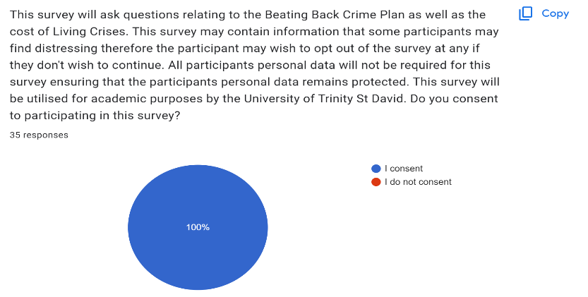

4.2 Participants views on the Beating Back Crime Plan
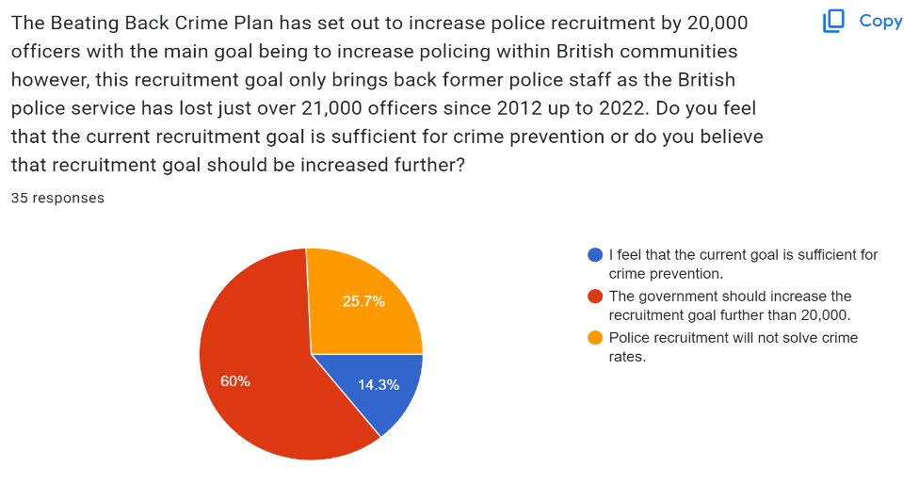
Question 1: Participants opinions on the recruitment plan to increase police recruitment by 20,000.

14.3% of participants felt that the current recruitment numbers were not sufficient for crime prevention instead largely favoured increasing the recruitment goal further of which 60% felt would increase crime prevention within local communities. 25.7% of the participants felt that police recruitment would not be effective at crime prevention meaning that these participants may instead feel that a different approach should be taken to prevent crime.
To conclude, the participants largely feel that the 20,000-recruitment goal is not a sufficient method for crime prevention largely believing that an increase to the recruitment goal would likely have a bigger impact whilst the 25.7% if the participants felt the recruitment goal simply would not have an impact on crime and would likely be a waste in terms of resources. The remaining 14.3% felt confident with the current recruitment goal of which could’ve been due to their location being relatively safe in term so of crime or due to having high confidence with the polices ability to prevent crime.

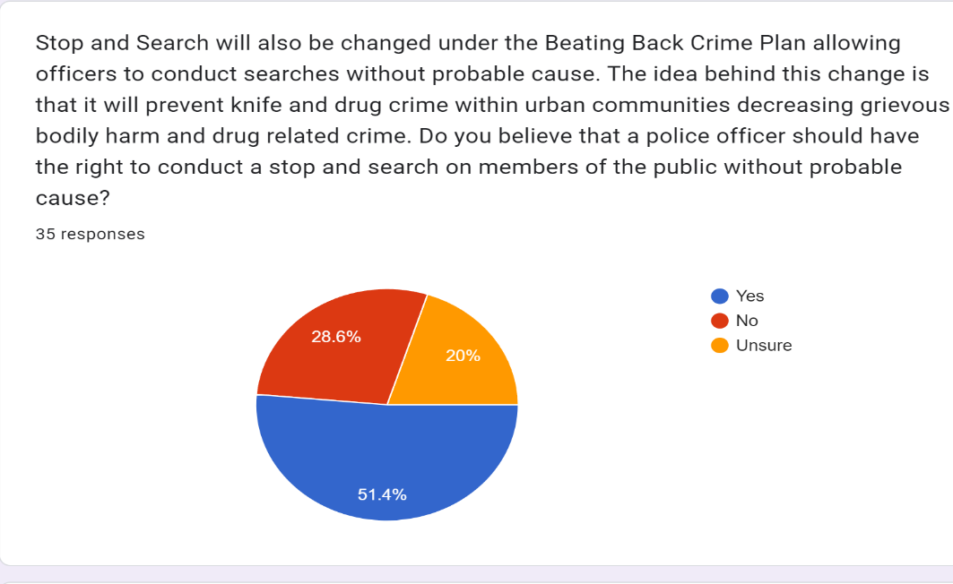
Question 2: How the participants felt about the police being able to conduct stop and search without probable cause.

The majority of the participants supported the idea of police constables being able to conduct stop and search without probable cause however, it is worth noting that whilst 51.4% supported this change 28.6% of participants felt that this should not be the case while the remaining 20% remained unsure.
Just over half of the participants who took part in this survey are in favour of the police having the right to conduct stop and searches on the public without probable cause. This could indicate that half of the participants feel that stop and search is an effective method or is simply necessary to prevent crime within local communities. This contradicts a similar survey created by the Office for Police Conduct where 49% of people who were surveyed largely felt that stop and search was utilised incorrectly as well as being unnecessary when it came to crime prevention. The survey created by the Office for Police Conduct also showed that people who supported stop and search were largely white and over the age of 55 whilst younger participants who were ethnic minority largely thought stop and search was unnecessary (Independent Office for Police Conduct 2021).
Question 3: Does the general public believe that stop and search could become further controversial if stop and search can be conducted without probable cause.

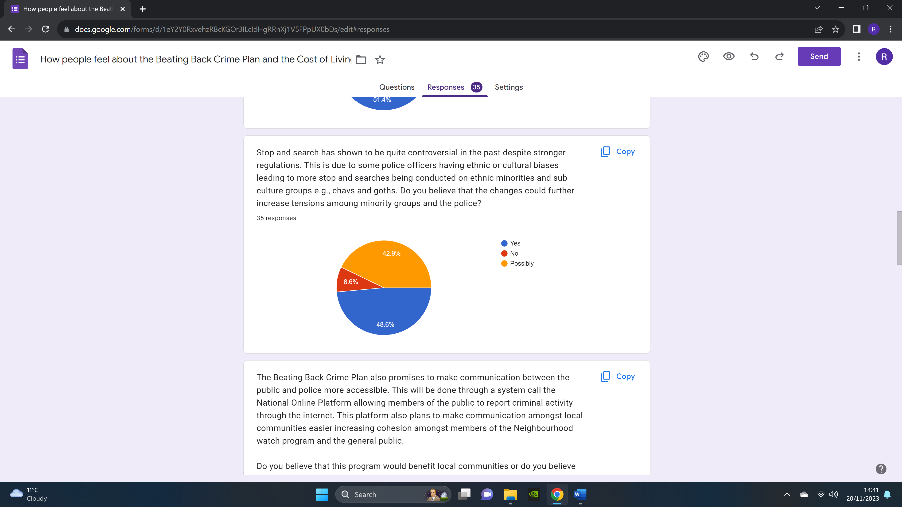
The participants largely acknowledge the risks of stop and search with 48.6% of participants answering yes to tensions increasing among minority groups and the police alongside 42.9% of participants believing that there is a possibility of tensions increasing. Interestingly only 8.6% of the participant believe that stop and search will not have any negative impacts on community relations possibility indicating that the participants have full confidence in individual police officers performing their duty with appropriate care, there is also the possibility that the 8.6% have never been stopped and search or witnessed any negative impacts of stop and search on social media.
This is somewhat consistent with research conducted by Criminal justice Inspectorate where participants were asked if they felt safe when being stopped and search. This is relevant to the current topic as if people do not feel safe tensions are likely to rise within specific communities within the United Kingdom. the research conducted by the Criminal Justice Inspectorate indicated that 31% felt no positive impact when police constables conduct stop and search furthermore, 48% felt confident that the police were carrying out stop and search to prevent criminal activity (Criminal Justice Inspectorate 2023).

Question 4: Does the public support the creation of the National Online Platform?
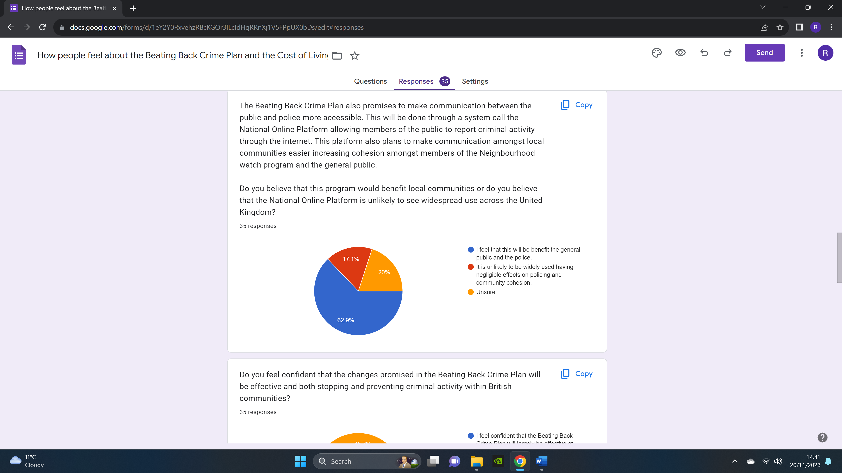
The majority of participants were in favour of the National Online Platform with 62.9% of participants answering that it would have a positive impact on the police service as well local communities. This support is likely due the National Online Platform expanding ways in which members of the public can interact with the police of which would allow more members of the public to become more involved in the neighbourhood watch program. This would prove to be successful in reality as the National Online Platform would be realised and named the Digital Police Service and would prove to be successful at increasing cohesion between local communities and the police service.
A small minority of participants felt that the National Online Platform simply would not receive widespread use across the United Kingdom of which only 17.9% felt its effects would be reliable when it comes to community and police cohesion. This is a reasonable assumption as more than three quarters of emergency 999 calls are non-emergencies showing that the majority of callers are either unaware of the non-emergency number or simply don’t want to use it. This logic can be applied to the Digital Police Service as most people are more likely to utilise the 999-emergency number before considering the Digital Police (Allen 2016).
This is very consistent with a survey conducted by the National Police Chief’s Council of which asked whether people supported the idea of police and community cohesion on social media. This survey indicated that 75% of participants wanted to be notified of incidents within their local community e.g., missing persons and road traffic collisions indicating that the participants believe in an increase in digital policing (National Police Chief’s council 2021).

Question 5: Do the participants support the changes contained within the Beating Back Crime Plan?
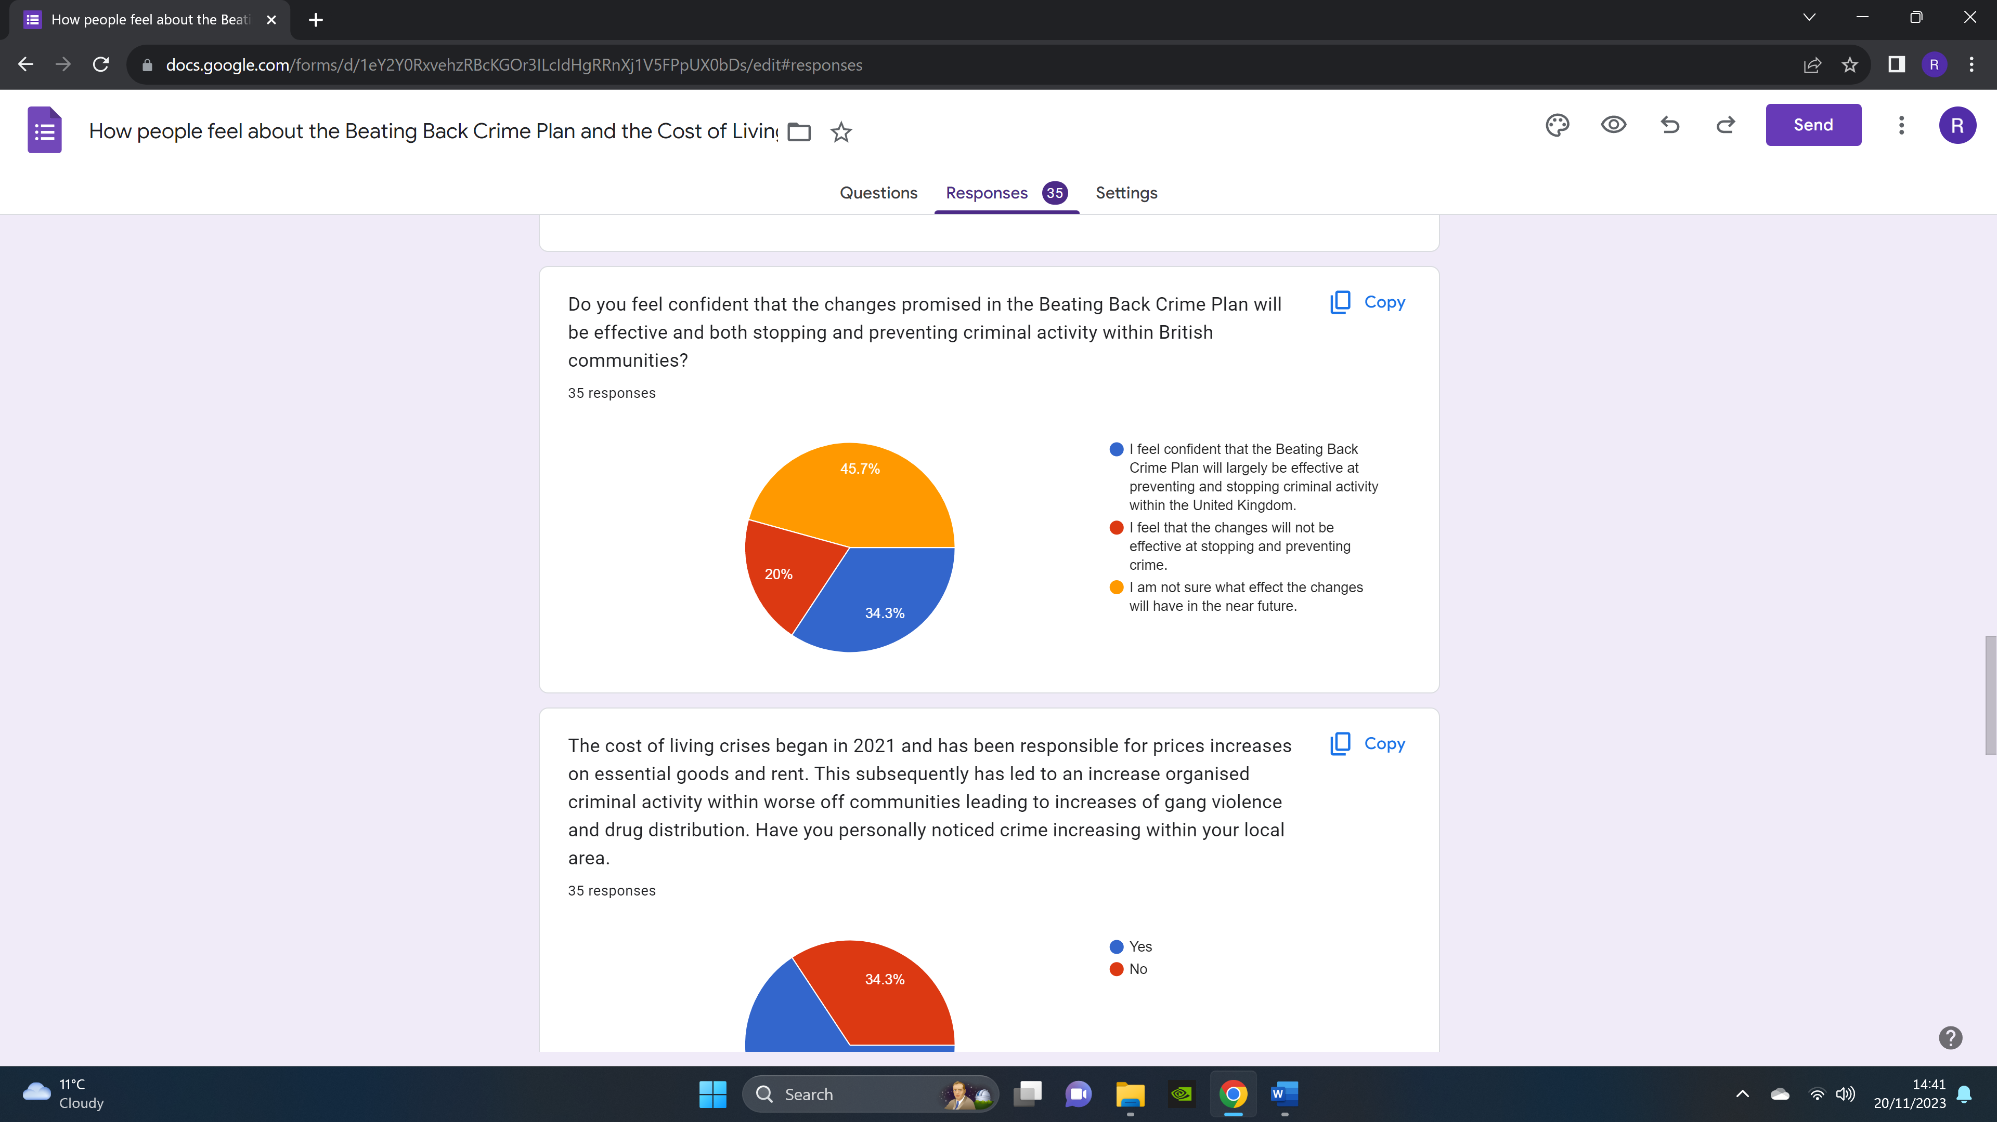
The majority of participants felt unsure whether the Back Crime Plan would be effective at both preventing and stopping criminal activity within the United Kingdom of which would make up 45.7% of the overall participants. Although the majorty of participants answered that they were unsure the majority of participants believed that it would either be effective or ineffective with 34.3% of participans answering that the Beating Back Crime Plan would be effective a detering and stopping crime across the United Kingdom with the remaining 20% answering that it would not be effective.
The answers given are somwhat consistent with a survey conducted by the Office for National Statistics where participans were asked if the public service operated poorly would any changes bring about positve outcomes of which answered that improvements would be likely if changes were made however, the key difference between the two surveys is that 49% of participants answered that the services would liekly not be improved upon if changes were made (Lelli 2022).

4.3 Participants thoughts on the cost of living crises and the impacts it has had on their local communities

Question 6: Have you personally noticed crime increasing in your local area

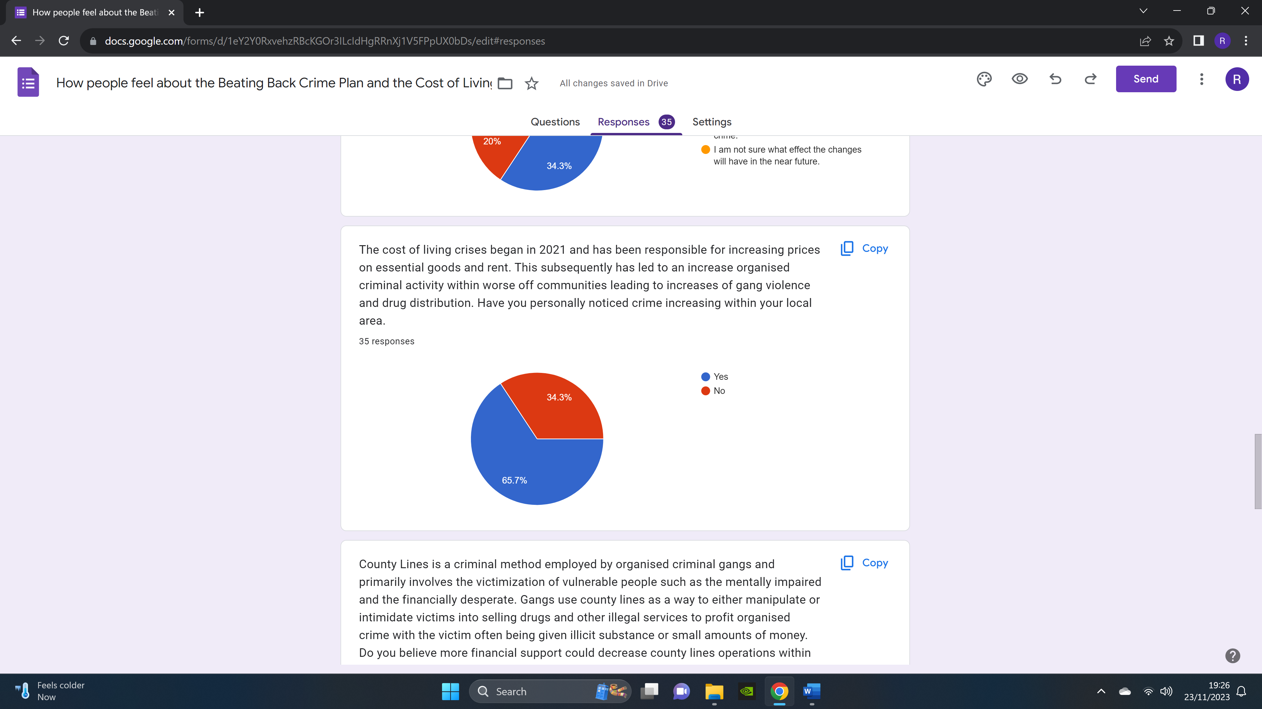
65.7% of the participants have noticed an increase in criminal activity within their local community since the cost-of-living crises began, this increase could of course be a general increase in crime e.g., thefts and violence however, the possibility of organised criminal activity could be a likely cause due to increases in county-lines and gang violence. 65.7% of participants answered yes to an increase in criminal activity.
34.3% of participants answered no to crime increasing within the United Kingdom of which still remains consistent with Halsey and White but is also an indication that some communities simply are not experiencing changes in criminal activity. This could be associated with the participants living conditions as organised criminal gangs are more likely to form in financially disadvantaged communities. This can be further supported by the fact that crimes against businesses had largely increased with shoplifting and fraud rising by 4% across the United Kingdom (Stripe 2023).
This is not consistent with a survey conducted by the Home Office where participants largely felt safe from criminal activity within their local communities. This can be seen with both ethnic minorities of which 63% answered yes to feeling safe within their communities furthermore, 80% of the white participants also answered yes to feeling safe within their local communities. Lastly, people living in economically deprived regions also had a majority yes with 62% of participants stating that they felt safe in their community (Home Office 2023).
Question 7 Do you believe that financial support could decrease county lines within financilly worse off communities
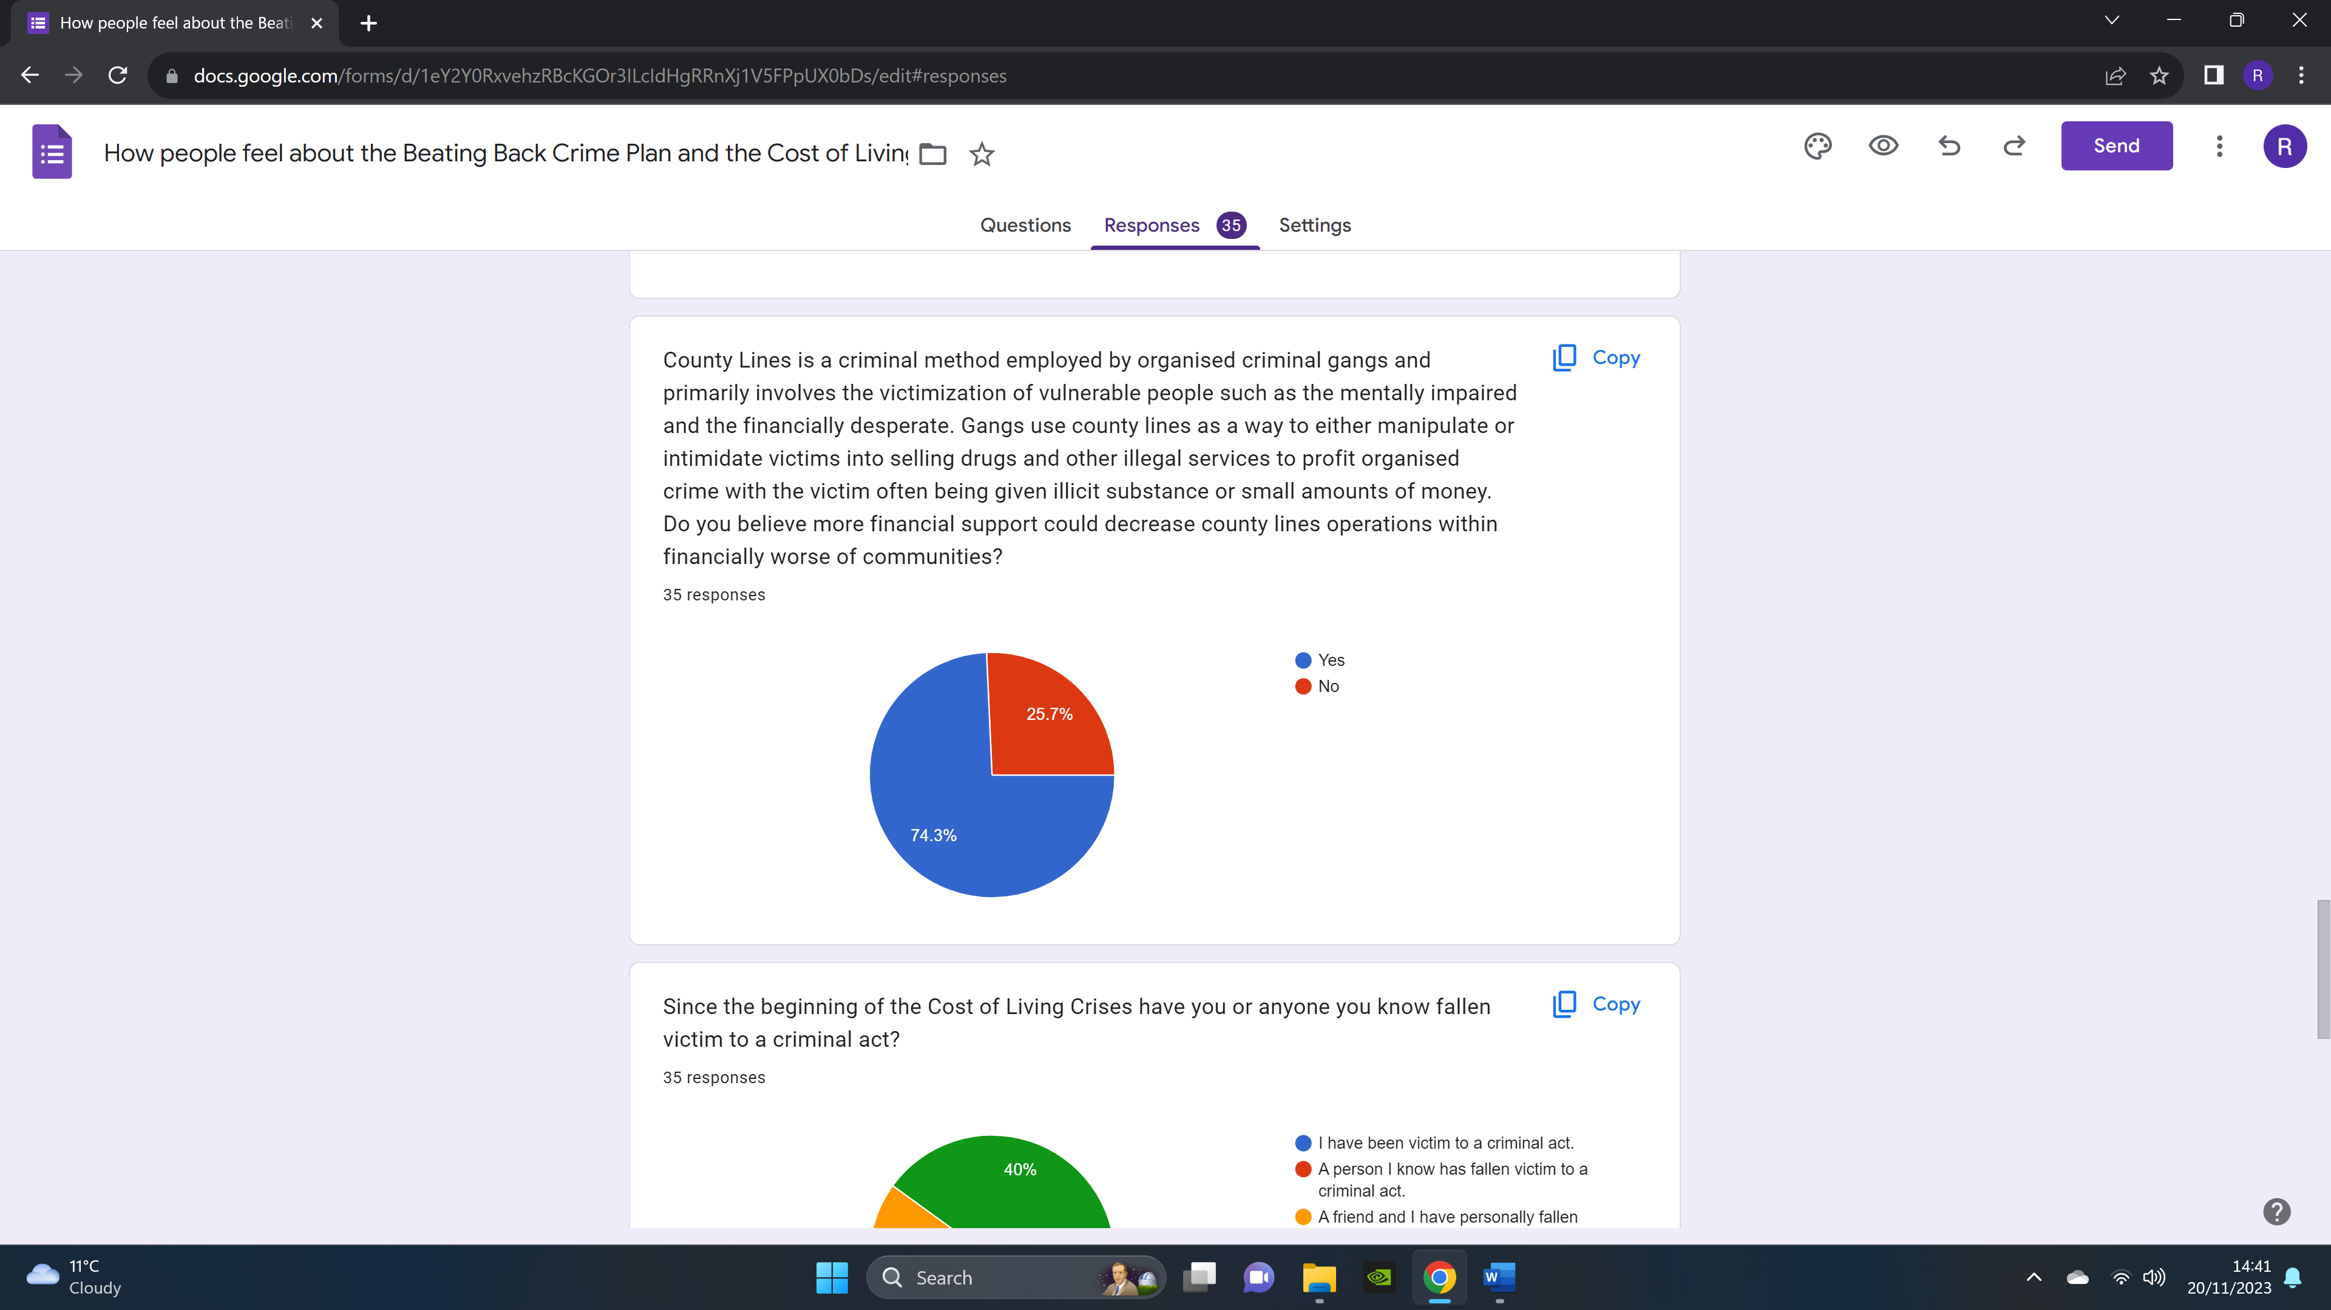
The overwhelming majority of participants felt that financial support would be effective at preventing county line operations within financially worse off areas with 74.3% of participants answering yes to financial support and 25.7% of participants feeling that financial support would not prevent county lines within financially worse off communities.
This survey has very similar results to a survey conducted by the charitable organization named the Revolving Doors which indicated that 76% of participants believed that crime would increase if poverty was to grow within local communities furthermore, 68% believed that instead of sending offenders who commit poverty-related crime to prison instead should be supported to reduce the likelihood of re-offending. The key similarities is that both survey participants believed that financial support would reduce criminal activity in local communities (Revolving Doors 2022).

Question 8: Since the Beginning of the Cost-of-Living Crises have you or anyone you know fallen victim to a criminal act.
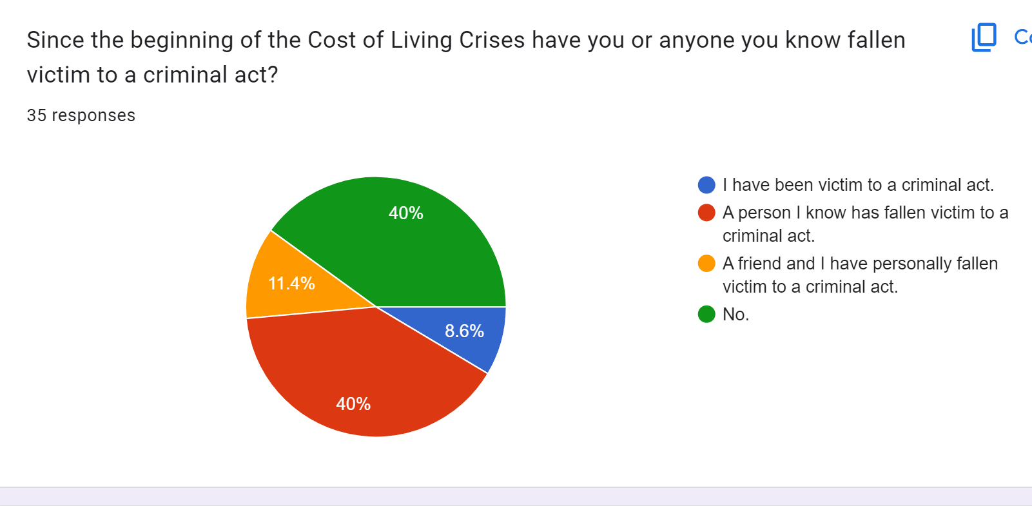
Most of the participants answered yes to crime being an issue within their lives during the cost-of-living crises with 40% answering that a person they know a person who has fallen victim to a criminal act, 11.4% of participants also that a friend and I have personally fallen victim to a criminal act alongside 8.6% of participants answering that they themselves have fallen victim to a criminal act since the cost-of-living crises began. Lastly, 40% of the participants answered no to this question meaning that no criminal acts have happened to anyone they know or to themselves.
This information does line up with crime statistics gathered by the Office for National Statistics which indicates that crimes against persons have risen in 2022 compared to 2020 which indicates that people are now far more likely to fall victim to criminal activities. This partially lines up with the with the researchers survey due to the majority of participants answering that someone they know or themselves have fallen victim to a criminal act since the Cost-of-Living Crises began (Jones 2023).

Question 9 Do you believe that organised crime will stagnate or rise once the UK leaves the cost-of-living crises
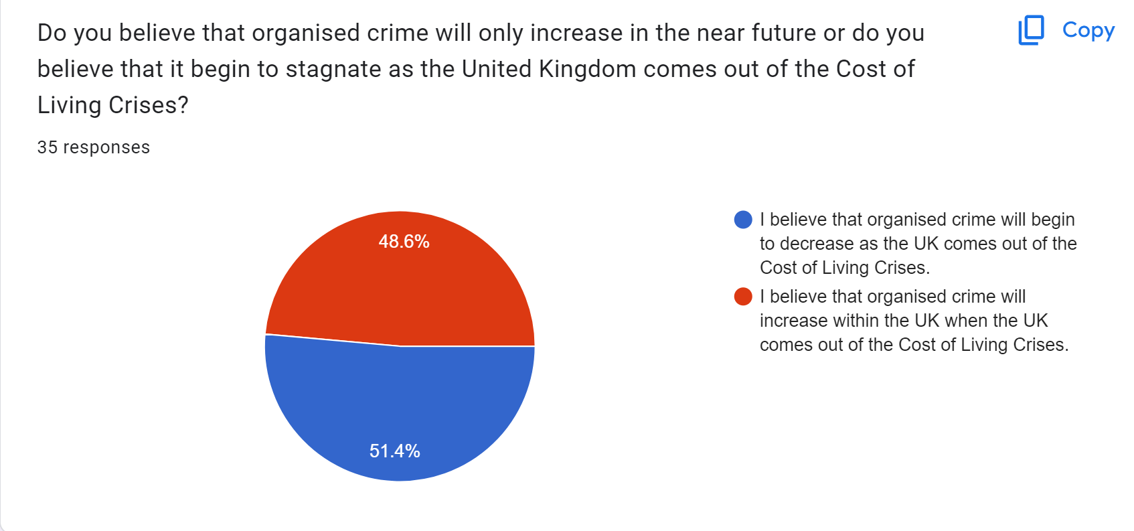
The results show that just over half of the participants believe that organised crime will decrease once the United Kingdom comes out of the cost-of-living crises however, these results are roughly even as just under half of the participants answered that organised crime will increase even after the cost-of-living crises has ended. The results show that 51.4% of participants believed that organised crime would decrease once the United Kingdom comes out of the cost-of-living crises whilst the remaining 48.6% of participants felt that organised crime would not decrease once the United Kingdome recovers from the cost-of-living crises.
It’s reasonable to assume that crime could either decrease or remain the same once the United Kingdom comes out of the Cost-of-Living Crises of which will mostly be determined with what policies the British Government approves of in the future as well as any unforeseeable events that may occur. There is truly not much information that can be compared to this question however it does indicate that the participants are largely split on whether the British Government and emergency services will be capable of improving crime rates within local communities during and after the Cost-of-Living Crises.

Question 10: Do you believe the British government is doing enough to tackle organised crime within the United Kingdom?

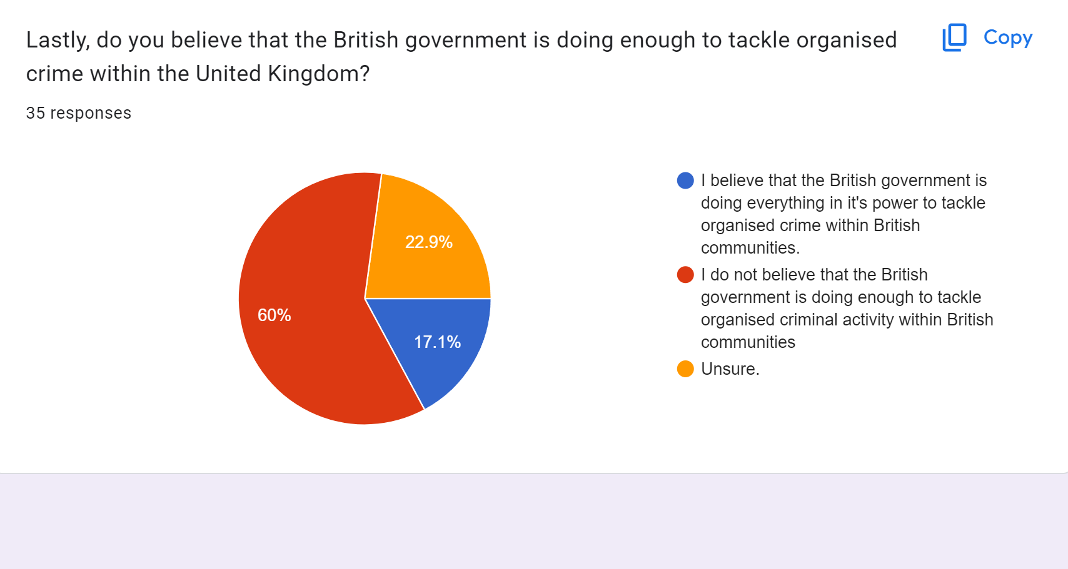
The overwhelming majority of participants do not feel that the British Government is not doing enough to tackle organised crime across the United Kingdom with only 17.1% of participants answering that the British Government is using all its available power to reduce organised crime within the United Kingdom and 60% answering that the British government is not doing enough. This is somewhat consistent with a survey conducted by the Mathew Lelii where only 35% of participants had full trust in the British government and its actions however this survey did indicate that local government as well as the public services had more trust by comparison.
The participants answers in Mathew Lelii and the researchers are quite similar when it comes to who the public trust, this can be seen with question two where 51.4% of the researchers participants answered that they trusted the police enough to have the right to stop and search people without probable cause of which would be the majority. By comparison only 17.1% of participants do not seem to believe that the government is doing enough indicating a lack of trust for the British government. Mathew Lelii’s survey also indicated a lack of trust in the British government by comparison to the public service of which can be seen with 80% of the participants answering that they trusted the public services compared to 35% of participants answering that they trust the British government (Lelii 2022).

Chapter 5 Conclusion

Introduction 5.1
The conclusion will contain a summary of the primary finding as well as the literature review.
The conclusion will also lay out the aims and objective that the researcher set at the beginning of this dissertation.

5.2 Aims
The aim of this dissertation is to critically review the Beating Back Crime Plan and whether it will bring positive changes in terms of crime prevention and public trust. This will be done by comparing older strategies to the changes in the Beating Back Crime Plan as some of the changes within the Beating Back Crime Plan recycle older methods of which will likely contain some of the previous draw backs as well as some of the potential positives furthermore, newer methods will also be analysed to see if they address issues in relation to poverty based crime as well as organised crime and whether the plan seeks to reduce these forms of criminal activity or if it is likely to create a divide between the police and sub culture groups. Lasty, evaluating the cost-of-living crisis’s impact on crime will also be essential as the beating back crime plan may not be effective at crime prevention if the source of crime is financial desperation potentially leading to a more reactive approach to stopping crime as opposed to preventative. These will be the main aims due to their relevance in the modern day as well as how they may impact the United Kingdom in the near future, this is important as these topics may see changes in how Britian polices the nation and whether crime could increase as a result of inflated prices on basic goods and decreased job opportunities.
5.3 Objectives
- Evaluate changes contained within the Beating Back Crime Plan.
- Critically review whether the Beating Back Crime Plan will prevent crime in the short to long term and the potential impacts it may have on the public and crime.
- Analyse current economic conditions and how it has impacted county lines.
- Discuss how the cost-of-living crises has impacted organised crime in low-income areas.

5.3.2 Evaluate changes contained with the Beating Back Crime Plan and review whether it will prevent crime
In conclusion, the Beating Back Crime plan was created by the Conservative government beginning with former Prime Minister Boris Johnson in 2021 and being carried over to Prime Minister Rishi Sunak in 2023 to 2024. The key idea behind the Beating Back Crime Plan is to “level up Britian” meaning modernise policing methods as well as the uses of technology. Once such change being an increase in policing staff of which would consist of 20,000 additional police officers in order to reinforce an understaffed police service. The key issues that was found with this recruitment scheme is that it does not actually increase how many officers are in the police instead it only just about brings back former police staff falling short by 1000.
This essentially means that the recruitment plans main goal is to bring back 20,000 of the former 21,000 police staff that have been lost since 2012 up to 2023. Furthermore, the issue with this plan is that it does not improve upon job quality of which has largely been considered responsible for most police officers leaving the service, this can have a negative effect on the service as many new recruits could leave for the same reason in the near future if job quality is not improved upon. The main concerns that have been stated by former police staff is the lack of pay of which was increased by 7% but the value of the British pound was also devalued as a result of inflation. A lack of protection as also been stated by former police staff of which claims that officers are dissatisfied officers lacking a voice when it comes to how the police are manged of which could be rectified if with an official workers union for the police service. These issues have led to a police retention as of 2023 with over 5000 officers leaving the service of which was predicted by the police federation claimed by Rich Cooke (West Midlands Police Federation 2023). Lastly, the researchers survey also indicated that 60% of the 35 participants largely believed that the recruitment plan should have been over the 20,000 recruitment gaol indicating that the majority of participants felt that there is a lack of police officers within their community furthermore, 25.7% of the participants also felt that changes to the service were more important that recruitment indicating that the participants feel that the police service needs to become more modernised if crime is to be prevented.
Additional changes to the Beating Back crime Plan is the way in which an officer is able to conduct stop and search without probable cause on members of the public. This is considered a radical change to the current practice of stop and search as the current usage requires that a police officer has probable cause to stop and search a suspect e.g., fitting the description of a known offender or due to suspicious actions that appear criminal in nature. This change being very controversial due the likelihood of this being abused by individual police officers leading to cultural and ethnic minority groups having increased chances of being stopped and search over the majority of the population. Another issue with this change is that it is not effective at crime prevention as stop and search relies on catching an offender with an illegal article rather than deterring the population from carrying these articles in the first place furthermore, it is more likely that stop and search could increase criminal activity due to the potential for the public to protest and riot when stop and search is conducted inappropriately of which could be increased if the police can stop and search without probable cause.
The National Online Platform also known as the Digital police is also a great idea due to it making heavy utilisation of modern technology that being the internet and has many great features that are useful to both the general public as well as the police service. The main benefits of the digital police service is the option to send non-emergency emails to the police providing another method of communication between the police and the public furthermore, people may search specific destinations within the United Kingdom to gain a general understanding of its criminal activities as well as the frequency of crime committed. The key downside with this idea is that it is unlikely to receive widespread use much like the 101 calls being overlooked by the general public in favour of the 999-emergency call however, this can still provide a more modern method for neighbourhood watch allowing more members of the public to assist each other in safeguarding their communities. The survey also indicated that 62.9% of participants were favour of the digital police service indicating that the vast majority of participants believe that there should be more cohesion between members of the public and the police.

5.3.3 Analyse current economic conditions and how it has impacted county lines and discuss how the cost-of-living crises has impacted organised crime in low-income areas.
The cost-of-living crises has had a major impact on the financial well-being of many people across the United Kingdom due to increasing prices on consumer goods and services. The cost-of-living crises was largely started due to Brexit and Covid-19 both of which would have a major impact on market growth within the United Kingdom due to changes in market regulations and open trade. This has left many people with less disposable income due to the late responses to inflation as many jobs and professions had not adjusted workers’ salaries based on current market prices. This means that people who may have been financially stable initially may instead be financially struggling of which has been responsible for increases on criminal activity due to financial desperation as well as different social environments.
One aspect of crime that has been impacted is county-lines of which primary targets vulnerable individuals as a means of financial exploitation, this exploitation can be conducted through multiple methods e.g., drug running or sexual service both of which focus on a victim being either forced or manipulated into conducting illegal services for a criminal organisation. The reason this is important is due to the cost of living’s impact on people financial wellbeing or which is likely to have a mental impact on both adults as well as children making them potential victims to county lines. The reason this increases the risk of county lines involves both financial desperation as well as mental health firstly, a gang may offer small amounts of money or illicit substances to financially desperate individuals as a means of cooperation of which the gang may use violence or threats to ensure cooperation continues. Vulnerable individuals such as the mentally handy capped, children and people with mental health conditions are far more likely to be targeted by county line gangs due to their impaired judgment. This impaired judgment means that vulnerable people are more likely to view criminal organisations in a more positive way making them more susceptible being manipulated by a criminal organisation alternatively, mental vulnerability can be the reason a victim does not seek help from their friends, family or the police keeping them in a helpless cycle of exploitation. This is relevant to the cost-of-living crises as people who are financially struggling are more likely to either become involved in county lines out of desperation or due to a declining mental state of which has impacted both children and adults creating further difficulties with county lines prevention.

5.4 Survey findings Beating Back Crime Plan

Survey findings on the uplift program
The participants largely had mixed opinions on the survey showing both support and disapproval of aspect of the Beating Back Crime Plan. This can be seen with the police uplift program as most participants did not feel that the Beating Back Crime Plan was increasing the police service to a standard that befits modern times. This could primary be due to the fact that the government is only bringing back 20,000 of the original 21,000 police officers however, it is likely that the participants have noticed that there is a lack of a police presence within their local communities due to the retention crisis.

Survey findings on stop and search
The researchers survey also concluded that 51.4% of the participants were in favour of stop and search without probable cause of which indicates that the public may either have confidence in how the police conduct themselves when on duty or believe that stop and search works well as a deterrent on offenders who carry weapons or illicit drugs furthermore, 48.6% answered that stop and search would increase tensions among minority groups if the police were allowed to stop and search people without probable cause whilst 42.9% answered that it was possible that tensions would increase showing that despite the participants approval of easing stop and search regulations that the participants are mostly aware of its negative impacts on minority groups. Interestingly most of the participants acknowledged that the changes to stop and search would likely increase tensions amongst minority groups and the police. This indicates that most of the participants are aware of the dangers that stop and search could bring but believe that the changes could be necessary to prevent crime.

Survey finding on the National Online Platform
62.9% of the participants were in favour of the National Online Platform this indicates that the majority of participants agree that the police service should become more involve with digital technology furthermore, this also indicates that most of the participants agree that local communities should have more options when communicating with the police service further increasing cohesion with crime prevention.

Do participants agree that the Beating Back Crime Plan will prevent crime if implemented
Interestingly most of the participants were unsure about how effective the Beating Back Crime Plan would be if implemented. This could primary be due to the fact that most of the participants do not feel qualified to answer this question however, it is also possible to assume that the participants simply believe that elements of the Beating Back Crime Plan will be effective whilst other will not e.g., most participants being I favour of the National Online Platform over the uplift program. Lastly, more people did in fact believe that the Beating Back Crime Plan would be effective vs those who did not indicating that they likely support the changes contained within the policy.

5.5 Survey findings cost of living crisis

Did the participants feel as though crime had increased since the cost-of-living crisis began
The overwhelming majority of participants felt as though crime had increased in their local community of which indicates multiple possibilities. Firstly, the participants may live in a community that has been negatively impacted by the cost-of-living crisis increasing criminal activity. Secondly, it is also possible that the participants fear in crime has risen since the cost-of-living crisis began indicating a worry about personal safety. Both of these reasons are reasonable for the participants as crime has risen due to crime increases and desperation.

Did the participants believe that financial support would decrease county lines
The overwhelming majority of participants did in fact believe that financially supporting those who are either financially desperate would decrease the amount of county lines activity within worse off communities. This is a reasonable assumption as people who are struggling financially are more likely to fall victim to county lines. This can either be due to the stress this can bring onto a person making them mentally vulnerable or due to desperation of which can lead a person to person falling victim to county lines in exchange for money. The opposition also have a reasonable claim as financial support has not always reduced criminal activity which can be seen with job seekers allowance which does not always prevent people from committing crimes.

Have the participants or anyone they know fallen victim to crime since the cost-of-living crises began
The results were largely mixed showing that 40% had not been victims of crime whilst another 40% had answered that a person they know has fallen victim to a crime. it is worth adding that a further 11% had in fact become a victim of crime alongside someone they know since the cost-of-living crises began, with the remaining 8% stating that they had been a victim of crime. This question largely indicated that crime has had some level of impact on the majority of participants whether it be themselves or someone they know showing that to some extent the cost-of-living crises is having an impact on crime.

Did the participants believe that crime would stagnate once the UK leave the cost-of-living crisis
Half of the participants thought that crime would stagnate whilst the other half thought crime would continue to rise. This is a reasonable belief as unforeseeable events could further impact the British economy much like the Ukraine war, Isreal-Palastain conflict and Covid-19.

Lastly, Do the participants believe that the Government is doing enough to tackle organised crime within the United Kingdom
60% of the overall participants did not believe that the Government was doing enough to tackle organised crime within the United Kingdom. This is a reasonable belief as the Government has not addressed many of the current issues that the police have addressed e.g., job quality and pay both of which have led to a job retention within the police service. Furthermore, the Government has also been known for defunding the public sector of which has led to decrease in crime prevention and reactive strategies.

5.6 Recommendations

- A larger amount of participants is recommended if further studies are taken this would provide the researcher with more variety when it comes to participants in terms of education, religion and economic status. This would provide more representation amongst participants as a smaller sample size is less likely to be similar to the larger societies views.

- It would also be more beneficial if research is conducted when the beating back crime plan is implanted as finding adequate sourcing proved difficult when conducting research. this would also prove beneficial during interviews or using surveys as the average person is currently unaware of the Beating Back Crime Plans existence.

- Lastly, according to findings from the surveys most participants believed that stop and search should be conducted without a reasonable ground. More awareness behind the uses of stop and search may prove to be beneficial as stop and search can be easily abused creating further divides amongst communities and the police.

5.7 Limitations

- Providing reliable sources proved difficult when researching the Beating Back Crime Plan, this is due to the fact that the Beating Back Crime Plan is yet to be implemented in the United Kingdom. The workaround for this was based on older data that could be compared to the innovations of the Beating Back Crime Plan of which can be seen specifically with Stop and Search as well as the 20,000 police recruitment scheme.

- The amount of participants the researcher could gather also proved to be a great limitation when sending out surveys, this limitation would be further limiting as the researcher needed specifically people who live within the United Kingdom meaning that the utilisation of online servers could not be used e.g., Facebook or Discord. This left the researcher with 35 participants limiting the amount of potential diverse answers the researcher could have gathered.

- Lastly, there was a high amount of biased sources when conducting research on both the Beating Back Crime Plan as well as the cost-of-living crises. These biased sources were commonly of a political nature meaning that they could not be utilised due to both incorrect data and altered narratives.

Reference list

Anon, G (2020) ‘Poverty is the Parent of Revolution and Crime’- Aristotle. Available at: https://theowp.org/reports/poverty-is-the-parent-of-revolution-and-crime-aristotle/ Accessed: 08/09/2023.

Avram, S (2022) Unstable jobs and time out of work: evidence from the UK. Available at: https://academic.oup.com/ser/article/20/3/1151/6548437 Accessed: 26/09/2023.

Allen, C (2016) Public urged to use 101 system ‘appropriately’. Available at: https://www.policeprofessional.com/news/public-urged-to-use-101-system-appropriately/ Accessed: 25/11/2023.

Bell, B (2019) Why does education reduce crime? Available at: https://personal.lse.ac.uk/machin/pdf/bb%20rc%20sm%20january%202019.pdf Accessed: 14/09/2023.

Brown, L (2022) Newham recorder column: county lines. Available at: https://www.lynbrown.org.uk/news/2022/06/30/newham-recorder-column-county-lines/ Accessed: 06/12/2023.

Bullock, K (2023) Police practitioner views on the challenges of analysing and responding to knife crime. Available at: https://crimesciencejournal.biomedcentral.com/articles/10.1186/s40163-022-00180-1 Accessed: 05/10/2023.

Braveman, S (2023) Public order. Available at: https://hansard.parliament.uk/commons/2023-06-12/debates/67222B10-C60B-4BE4-B436-6B0B149AF209/PublicOrder Accessed: 13/09/2023.

Brown, J (2019) Stop-and-search powers: Extension of ‘no suspicion’ searches. Available at: https://commonslibrary.parliament.uk/stop-and-search-powers-extension-of-no-suspicion-searches/ Accessed: 07/09/2023.

Broadley, C (2023) How to create a survey results report (+7 Examples to steal) Available at: https://wpforms.com/how-to-write-summary-survey-results/#:~:text=Survey%20summaries%20are%20sometimes%20called,to%20get%20this%20information%20across. Accessed: 16/11/2023.

Bath University (2023) Working with data: Weeding data. Available at: https://library.bath.ac.uk/research-data/working-with-data/weeding-data Accessed: 15/2023.

Brown, J (2019) The prison estate in England and Wales: Pressures, population and plans for reform. Available at: https://commonslibrary.parliament.uk/__trashed-2/ Accessed: 03/12/2023.

Charman, S (2022) Police officer resignations have risen by 72% in the last year-we asked former officers why. Available at: https://www.port.ac.uk/news-events-and-blogs/blogs/democratic-citizenship/police-officer-resignations-have-risen-by-72-in-the-last-year-we-asked-former-officers-why Accessed: 15/12/2023.

College of Policing (2021) MacPherson report: 22 years on. Available at: https://www.college.police.uk/article/macpherson-report-22-years-on Accessed: 03/10/2023.

College of Policing (2021) Stop and search guidance changed. Available at: https://www.college.police.uk/article/stop-and-search-guidance-changed Accessed: 13/10/2023.

College of Policing (2021) Home Office releases its plan to beat crime. Available at: https://www.college.police.uk/article/home-office-releases-its-plan-beat-crime Accessed: 13/10

Caylor, J (2020) Beyond positivism: Toward a pluralistic approach to studying “real” teams. Available at: https://journals.sagepub.com/doi/10.1177/2041386620915593 Accessed: 26/10/2023.

Cote, C (2021) What is data ethics? Available at: https://online.hbs.edu/blog/post/data-ethics Accessed: 14/11/2023.

Campion, J (2023) The cost-of-living crises and its impact on careers. Available at: https://corriculo.co.uk/the-cost-of-living-crisis-and-its-impact-on-careers/ Accessed: 14/10/2023.

College of Policing (2022) Proactive street-level policing. Available at: https://www.college.police.uk/guidance/drug-crimes-evidence-briefing/proactive-street-level-policing#:~:text=Proactive%20problem%2Doriented%20and%20community,effective%20in%20reducing%20drug%20crime. Accessed: 03/10/2023.

College of Policing (2022) What is situational crime prevention? Available at: https://www.college.police.uk/guidance/neighbourhood-crime/what-situational-crime-prevention#:~:text=Situational%20crime%20prevention%20aims%20to,or%20adding%20'capable%20guardians'. Accessed: 03/10/2023.

Criminal Justice Inspectorate (2023) Stop and search. Available at: https://assets-hmicfrs.justiceinspectorates.gov.uk/uploads/stop-and-search-survey-summary.pdf Accessed: 09/12/2023.

College of Policing 2021 (2021) The effectiveness of visible police patrols. Available at: https://www.college.police.uk/research/what-works-policing-reduce-crime/visible-police-patrol Accessed: 01/11/2023.

College of Policing (2022) Hot spot policing. Available at: https://www.college.police.uk/guidance/hot-spots-policing Accessed: 15/12/2023.

College of Policing (2023) Boosting core skills. Available at: https://www.college.police.uk/about/corporate-strategy-2022-2026/boosting-core-skills Accessed: 19/11/2023.

Ditcham, K (2022) Child criminal exploitation in country lines in England and Wales: Challenges and controversies of dealing with a national problem at the local level. Available at: https://pure.port.ac.uk/ws/portalfiles/portal/70007480/Final_clean_version_THESIS_DITCHAM.pdf Accessed: 05/10/2023.

Difford, Joe (2021) LGA responds to Beating Crime Plan. Available at: https://www.local.gov.uk/about/news/lga-responds-beating-crime-plan Accessed: 09/23/2023.

Ditcham. K (2022) Public confidence in the police: A new low for the service. Available at: https://rusi.org/explore-our-research/publications/commentary/public-confidence-police-new-low-service Accessed: 22/11/2023.

Edgar, T and Manz, D (2017) Hypothetico-deductive research. Available at: https://www.sciencedirect.com/topics/computer-science/deductive-research Accessed: 14/11/2023.

Edinburgh Law School (2022) Children exposed to poverty and trauma more likely to offend as adults. Available at: https://www.law.ed.ac.uk/news-events/news/children-exposed-poverty-and-trauma-more-likely-offend-adults Accessed: 29/11/2023.

Fox, S (2023) How to write a survey introduction: tips & free template. Available at: https://survicate.com/customer-feedback/survey-introduction/#:~:text=A%20survey%20introduction%20is%20a,to%20boost%20your%20response%20rate. Accessed: 16/11/2023.

Farrington, W (2023) Cost-of-living crisis causing increase in employee theft of essential items. Available at: https://www.proactiveinvestors.co.uk/companies/news/1032779/cost-of-living-crisis-causing-increase-in-employee-theft-of-essential-items-1032779.html#:~:text=Among%20those%20that%20have%20seen,an%20increase%20in%20employee%20theft. Accessed: 15/12/2023.

Florczad, K (2021) Best available evidence or truth for the moment: Bias in research. Available at: https://journals.sagepub.com/doi/full/10.1177/08943184211051350 Accessed: 16/11/2023.

Galdas, P (2017) Revisiting Bias in Qualitive Research: Reflections on its Relationship with funding and impact. Available at: https://journals.sagepub.com/doi/10.1177/1609406917748992 Accessed: 19/10/2023

Grand, E (2015) Linking moralisation and class identity: The role of resentment and respectability in the social reaction to ‘chavs’. Available at: https://journals.sagepub.com/doi/10.5153/sro.3785 Accessed: 15/12/2023.

Gaille, L (2020) 20 advantages and disadvantages of survey research. Available at: https://vittana.org/20-advantages-and-disadvantages-of-survey-research Accessed: 13/10/2023.

HM Treasury (2022) Overall government support for the cost of living: Factsheet. Available at: https://www.gov.uk/government/publications/government-support-for-the-cost-of-living-factsheet/government-support-for-the-cost-of-living-factsheet Accessed: 07/09/2023.

Home Office (2021) Government nearly half-way to recruiting 20,000 more officers. Available at: https://www.gov.uk/government/news/government-nearly-half-way-to-recruiting-20000-more-officers Accessed: 08/09/2023.

Home Office (2021) Serious violence reduction orders to be piloted in 4 police forces. Available at: https://www.gov.uk/government/news/serious-violence-reduction-orders-to-be-piloted-in-4-police-forces#:~:text=The%20government%20is%20clear%20that,a%20potential%20life%20is%20saved. Accessed: 03/10/2023.

Home Office (2021) Beating crime plan. Available at: https://www.gov.uk/government/publications/beating-crime-plan/beating-crime-plan#:~:text=Changes%20to%20the%20sentencing%20and,streets%20and%20to%20rehabilitate%20offenders. Accessed: 15/12/2023.

Home Office (2023) Police Powers: Stop and search. Available at: https://homeofficemedia.blog.gov.uk/2023/06/23/police-powers-stop-and-search/ Accessed: 03/10/2023.

Home Office (2023) Public polling on community safety. Available at: https://www.gov.uk/government/publications/public-polling-on-community-safety/public-polling-on-community-safety Accessed: 12/12/2023.

Heeks, M (2018) The economic and social costs of crime. Available at: https://assets.publishing.service.gov.uk/media/60094b86d3bf7f2ab1a1af96/the-economic-and-social-costs-of-crime-horr99.pdf Accessed: 08/09/2023.

Hourston, P (2022) The cost of living crisis. Available at: https://www.instituteforgovernment.org.uk/explainer/cost-living-crisis#:~:text=What%20is%20the%20cost%20of,has%20experienced%20since%20late%202021. Accessed: 17/11/2023.

Independent Office for Police Conduct (2023) Public feel confident police respond fairly and proportionally to incidents, but questions remain around use of stop and search. Available at: https://www.policeconduct.gov.uk/news/public-feel-confident-police-respond-fairly-and-proportionately-incidents-questions-remain Accessed: 29/10/2023.

Independent Office for Police Conduct (2022) IOPC calls for stop and search law change and identifies 18 opportunities for improvement. Available at: https://www.policeconduct.gov.uk/news/iopc-calls-stop-and-search-law-change-and-identifies-18-opportunities-improvement Accessed: 11/16/2023.

Johnson (2021) Beating back crime plan. Available at:
https://assets.publishing.service.gov.uk/government/uploads/system/uploads/attachment_data/file/1015382/Crime-plan-v10.pdf Accessed: 02/09/2023.

Jones, T (2013) A quick guide to survey research. Available at: https://www.ncbi.nlm.nih.gov/pmc/articles/PMC3964639/#:~:text=Advantages%20of%20surveys%20include%20having,the%20availability%20of%20validated%20models. Accessed: 14/11/2023.

Jones, p (2023) Crime in England and Wales: Year ending December 2022. Available at: https://www.ons.gov.uk/peoplepopulationandcommunity/crimeandjustice/bulletins/crimeinenglandandwales/yearendingdecember2022#:~:text=Overall%2C%20police%20recorded%202.1%20million,2021%20(2%20million%20offences). Accessed: 27/11/2023.

Johnson, B (2019) National campaign to recruit 20,000 police officers launched today. Available at: https://www.gov.uk/government/news/national-campaign-to-recruit-20000-police-officers-launches-today Accessed: 22/09/2023.

Keeling, P (2011) No respect: Young BAME men, the police and stop and search. Available at: https://www.criminaljusticealliance.org/wp-content/uploads/No-Respect-Young-BAME-men.pdf Accessed: 13/11/2023.

Kim, S (2021) Inductive or deductive? Research by maxillofacial surgeons. Available at: https://www.ncbi.nlm.nih.gov/pmc/articles/PMC8249189/ Accessed: 13/11/2023.

Lum, C (2020) Examining the empirical realities of proactive policing through systematic observations and computer-aided dispatch data. Available at: https://journals.sagepub.com/doi/full/10.1177/1098611119896081 Accessed: 03/10/2023.

Lawrence, D (2022) UK trade and the Ukraine war. Available at: https://www.chathamhouse.org/2022/09/uk-trade-and-war-ukraine Accessed: 20/09/2023.

Lynch, T (2023) Where are the Police? Building public confidence in the policing. Available at: https://www.polfed.org/news/blogs/2023/where-are-the-police-building-public-confidence-in-policing/ Accessed: 13/12/2023.

Minhas, R (2021) The role of prejudicial stereotypes in formation of suspicion: An examination of operational procedures in stop and search practices. Available at: https://journals.sagepub.com/doi/full/10.1177/14613557211016499 23/09/2023.

Muhlhausen, D (2018) Director’s message: Proactive policing-what we know and what we don’t know, yet. Available at: https://nij.ojp.gov/speech/directors-message-proactive-policing-what-we-know-and-what-we-dont-know-yet Accessed: 05/12/2023.

Murray, K (2014) Stop and search in Scotland: An evaluation of police practice. Available at: https://www.sccjr.ac.uk/wp-content/uploads/2014/01/Stop_and_Search_in_Scotland1.pdf Accessed: 11/10/2023

Metropolitan Police (2022) Police and crime plan for London 2022 to 2025. Available at: https://www.met.police.uk/police-forces/metropolitan-police/areas/about-us/about-the-met/police-and-crime-plan/ Accessed: 09/09/2023.

Murdoch, M (2014) Impact of different privacy conditions and incentives on survey response rate, participant representativeness, and disclosure of sensitive information: a randomized controlled trial. Available at: https://www.ncbi.nlm.nih.gov/pmc/articles/PMC4112969/ Accessed: 15/11/2023.

Moran, D (2021) The long shadow of the Victorian prison. Available at: https://www.crimeandjustice.org.uk/sites/crimeandjustice.org.uk/files/PSJ%20256%2C%20The%20long%20shadow.pdf Accessed: 15/12/2023.

Monarsh University (2022) How to avoid over-generalisations. Available at: https://www.monash.edu/student-academic-success/improve-your-academic-english/strategies-for-writing-academic-english/express-uncertainty-in-writing/how-to-avoid-over-generalisations Accessed: 20/10/2023.

Meade, L (2023) Metropolitan Police investigation into the murder of Stephen Lawrence case. Available at: https://commonslibrary.parliament.uk/research-briefings/cdp-2023-0160/ Accessed: 05/10/2023.

Nickolls, L (2022) Police powers: Stop and search. Available at: https://commonslibrary.parliament.uk/research-briefings/sn03878/#:~:text=The%20police%20have%20a%20variety,suspicions%20without%20making%20an%20arrest. Accessed: 14/09/2023.

NEC Software Solutions (2021) How policing is adapting to digital environment. Available at: https://www.necsws.com/article/public-safety/police/tools-driving-police-performance-and-protecting-the-public Accessed: 22/11/2023.

Newbold, J (2015) ‘Predictive policing’ Preventative policing or ‘intelligence led policing’. The future? Available at: https://library.college.police.uk/docs/Predictive-Preventative-or-Intelligence-Led-Policing.pdf Accessed: 20/11/2023.

National Police Chief’s Council (2021) Executive summary of Social Media survey results. Available at: https://www.surrey.police.uk/SysSiteAssets/media/downloads/surrey/stats-and-data/NPCC_SMSurvey_ExecSummary_2021.pdf Accessed: 12/12/2023.

National Library of Medicine (2011) Identifying and Avoiding Bias in Research. Available at: https://www.ncbi.nlm.nih.gov/pmc/articles/PMC2917255/ Accessed: 16/10/2023.

National library of medicine (2023) Comment. A sustainable and equitable response to the cost-of-living crises is urgently needed. Available at: https://www.ncbi.nlm.nih.gov/pmc/articles/PMC9958386/#:~:text=The%20cost%2Dof%2Dliving%20crisis%20is%20demolishing%20the%20foundations%20of,for%20many%20years%20%5B1%5D. Accessed: 07/10/2023.

National Crime Agency (2023) Providing a picture of the threat to the UK from serious and organised crime. Available at: https://www.nationalcrimeagency.gov.uk/nsa Accessed: 13/10/2023.

Office for national statistics (2023) The cost-of-living latest insights. Available at: https://www.ons.gov.uk/economy/inflationandpriceindices/articles/costofliving/latestinsights#:~:text=The%20cost%20of%20living%20has,putting%20further%20pressure%20on%20prices. Accessed: 20/09/2023.

Lelli, M (2022) Trust in Government, 2022. Available at: https://www.ons.gov.uk/peoplepopulationandcommunity/wellbeing/bulletins/trustingovernmentuk/2022#:~:text=Less%20than%20one%2Dthird%20(30,the%20OECD%20average%20of%2036%25 Accessed: 12/12/2023.

London Assembly (2021) The link between the poverty and violent crime. Available at: https://www.london.gov.uk/programmes-strategies/communities-and-social-justice/londons-violence-reduction-unit/link-between-poverty-and-violent-crime Accessed: 15/12/2023.

Patel, P (2023) Public order act 2023. Available at: https://bills.parliament.uk/bills/3153 Accessed: 13/09/2023.

Police Federation (2023) Recruitment and retention crisis will worsen without fair pay and conditions. Available at: https://www.polfed.org/news/latest-news/2023/recruitment-and-retention-crisis-will-worsen-without-fair-pay-and-conditions/ Accessed: 23/11/2023.

Police Federation (2022) Cops are in crisis so are forces. Available at: https://www.polfed.org/news/latest-news/2022/cops-are-in-crisis-and-so-are-forces/ Accessed: 23/11/2023.

Philip, C (2023) Public order bill. Available at: https://hansard.parliament.uk/commons/2023-03-22/debates/4051EF0F-A7D0-4A48-B363-1D67FD9E91ED/PublicOrderBill Accessed: 13/09/2023.

Ponto, J (2015) Understanding and evaluating survey research. Available at: https://www.ncbi.nlm.nih.gov/pmc/articles/PMC4601897/ Accessed: 13/11/2023.

Phair, D (2021) Saunders’ Research Onion: Explained Simply. Available at: https://gradcoach.com/saunders-research-onion/ Accessed: 26/10/2023.

Police Federation (2023) The storm of police officer resignations: Part 1. Available at: https://www.polfed.org/news/latest-news/2023/the-storm-of-police-officer-resignations-part-1/ Accessed: 23/11/2023.

Police Federation (2010) PFEW supplementary submission the independent review of police officers and staff remuneration and conditions. Available at: https://assets.publishing.service.gov.uk/media/5a755705ed915d7314959318/police-federation.pdf Accessed: 23/11/2023.

Phair, D and Warren, K (2022) Dissertation & Thesis Survey design 101. Available at: https://gradcoach.com/survey-design-101/#:~:text=Surveys%20are%20a%20powerful%20way,can%20run%20into%20serious%20issues. Accessed: 18/11/2023.

Park, Y (2020) The Positivism Paradigm of Research. Available at: https://pubmed.ncbi.nlm.nih.gov/31789841/ Accessed: 26/10/2023.

Public Health England (2021) County lines exploitation: applying all our health. Available at: https://www.gov.uk/government/publications/county-lines-exploitation-applying-all-our-health/county-lines-exploitation-applying-all-our-health Accessed: 12/15/2023.

Seccombe, P (2021) National crime and policing measures. Available at: https://www.warwickshire-pcc.gov.uk/key-information/national-policing-and-crime-measures/ Accessed: 07/09/2023.

Revolving Doors (2022) Majority of UK public believe rising poverty will lead to increase in crime-and this shouldn’t lead to prison. Available at: https://revolving-doors.org.uk/majority-of-uk-public-believe-rising-poverty-will-lead-to-increase-in-crime-and-this-shouldnt-lead-to-prison/ Accessed: 12/12/2023.

Rallison, S (2015) What are Journals for? Available at: https://www.ncbi.nlm.nih.gov/pmc/articles/PMC4473415/#:~:text=The%20basic%20function%20of%20a,communicating%20in%20the%2021st%20century). Accessed: 16/11/2023.

Simundic, A (2013) Bias in research. Available at: https://www.ncbi.nlm.nih.gov/pmc/articles/PMC3900086/ Accessed: 17/10/2023.

Southern New Hampshire University (2023) FAQ: What is research gap and how do I find one? Available at: https://libanswers.snhu.edu/faq/264001 Accessed: 23/10/2023.

Smith, J (2014) Bias in research. Available at: https://pureadmin.qub.ac.uk/ws/portalfiles/portal/126780610/EBNBiasFINALJuly2014.pdf Accessed: 17/10/2023.

Stripe, N (2023) Crime in England and Wales: year ending June 2023. Available at: https://www.ons.gov.uk/peoplepopulationandcommunity/crimeandjustice/bulletins/crimeinenglandandwales/yearendingjune2023#:~:text=Police%20recorded%20crime%20in%20England,the%20year%20ending%20June%202022. Accessed: 05/12/2023.

Sinha, P (2023) Decision time. Available at: https://prisonreformtrust.org.uk/decision-time/#:~:text=Nearly%2010%2C700%20prison%20places%20have,finally%20run%20out%20of%20road. Accessed: 14/12/2023.

Sameen, H (2023) How is the cost-of-living crises affecting provision of social care. Available at: https://www.economicsobservatory.com/raphael-wittenberg#:~:text=Rising%20costs%20are%20having%20adverse,efficiency%20savings%20can%20be%20made. Accessed: 14/09/2023.

Staffordshire Safeguarding Children Board (2023) Burgers and coats: cost of living crisis exploited by county lines gangs. Available at: https://staffsscb.org.uk/burgers-and-coats-cost-of-living-crisis-exploited-by-county-lines-gangs/ Accessed: 04/12/2023.

Scott, E (2022) Cost of living: Impact on public wellbeing. Available at: https://lordslibrary.parliament.uk/cost-of-living-impact-on-public-wellbeing/ Accessed: 28/11/2023.

Swansea Council (2023) Emergency contacts. Available at: https://www.swansea.gov.uk/emergencycontacts?lang=en Accessed: 11/12/2023.

Tenny, S (2022) Qualitative study. Available at: https://www.ncbi.nlm.nih.gov/books/NBK470395/ Accessed: 25/10/2023.

Thurik, R (2021) Economic effects of Covid-19 pandemic on entrepreneurship and small business. https://link.springer.com/article/10.1007/s11187-021-00544-y Accessed: 07/09/2023.

The Open University (2018) Introduction to positivism, interpretivism and critical theory. Available at: https://oro.open.ac.uk/49591/17/49591ORO.pdf Accessed: 16/10/2023.

Timans, R (2019) Mixed methods research: What it is and what it could be. Available at: https://link.springer.com/article/10.1007/s11186-019-09345-5 Accessed: 26/10/2023.

Thesismind (2019) Analysis of Saunders Research Onion. Available at: https://thesismind.com/analysis-of-saunders-research-onion/#:~:text=Saunders%20et%20al%20sees%20research,first%20before%20proceeding%20to%20another. Accessed: 25/10/2023.

University of Surrey (2023) Survey to examine the impact of Brexit, Covid-19 and Costo-of-Living on workers. Available at: https://www.surrey.ac.uk/news/survey-examine-impact-brexit-covid-19-and-cost-living-workers Accessed: 07/09/2023.

UK Parliament (2021) Macpherson report: stop and search overview. Available at: https://publications.parliament.uk/pa/cm5802/cmselect/cmhaff/139/13909.htm Accessed: 02/10/2023.

UK Statistics Authority (2022) Ethical considerations associated with Qualitative Research methods. Available at: https://uksa.statisticsauthority.gov.uk/publication/ethical-considerations-associated-with-qualitative-research-methods/pages/3/ Accessed: 15/11/2023.

UK Parliament (2018) Appendix 6: British Polling Council: A journalist’s guid to opinion polls. Available at: https://publications.parliament.uk/pa/ld201719/ldselect/ldppdm/106/10616.htm Accessed: 15/11/2023.

University of Bristol (2022) Nearly 60% increase in UK households in serious financial difficulties, Bristol research finds. Available at: https://www.bristol.ac.uk/news/2022/july/increase-in-ukhouseholds-financial-difficulties.html Accessed: 27/1/2023.

UK Parliament (2021) Racism and the police twenty-two years on. Available at: https://publications.parliament.uk/pa/cm5802/cmselect/cmhaff/139/13911.htm Accessed: 03/10/2023.

University of Wolverhampton (2018) Guide to primary research. Available at: https://www.wlv.ac.uk/lib/media/departments/lis/skills/study-guides/LS132-Guide-to-Primary-research.pdf Accessed: 17/11/2023.

University of Southern California (2023) Research guides. Available at: https://libguides.usc.edu/writingguide/proofreading#:~:text=Proofreading%20is%20the%20act%20of,%2C%20unconventional%20use%20of%20language%5D. Accessed: 24/10/2023.

West Midlands Police and Crime Commissioner (2021) Ground-breaking: Evidence shows too many young people in the criminal justice system suffer from violence, poverty, and abuse growing up. Available at: https://www.westmidlands-pcc.gov.uk/ground-breaking-report-evidence-shows-too-many-young-people-in-the-criminal-justice-system-suffer-from-violence-poverty-and-abuse-growing-up/#:~:text=Report%20Author%20Dr%20Alex%20Chard,children%20towards%20exploitation%20and%20crime%E2%80%9D. Accessed: 02/10/2023.

West Sydney University (2022) What is a scholarly website and how do I find one? Available at: https://answers.library.westernsydney.edu.au/faq/40115 Accessed: 16/10/2023.

West Midlands Police Federation (2023) Officers leaving police service in record numbers. Available at: https://www.polfed.org/westmids/latest-news/2023/officers-leaving-police-service-in-record-numbers/ Accessed: 3/12/2023.

Wickham, R (2019) Secondary Analysis Research. Available at: https://www.ncbi.nlm.nih.gov/pmc/articles/PMC7520737/ Accessed: 15/11/2023.

Walter, M (2021) Risk and reward. Available at: https://www.ultrasecuredirect.com/blog/risk-reward/ Accessed: 06/12/2023.

Young, E (2023) Implicit bias training has little effect on police officer’s behaviour. Available at: https://www.bps.org.uk/research-digest/implicit-bias-training-has-little-effect-police-officers-behaviour Accessed: 14/12/2023.

Appendices
This link contains the survey that the researcher used to collect their primary findings from participants.
https://docs.google.com/forms/d/1eY2Y0RxvehzRBcKGOr3ILcIdHgRRnXj1V5FPpUX0bDs/edit

