
Risk Assessment & ALARP Justification
ACDB5013
Stan Collins
2022429

21/07/2023

Contents
1. Contents 2
2. Part One – Risk Assessment 3
2.1. Risk Matrix 8
3. Part 2 – ALARP Justification 9
3.1. Introduction to ALARP 9
3.2. Risk – Accidental Initiation 9
3.3. Cost Benefit Analysis 10
3.4. Chosen Control Measures – Shock and Impact 11
3.4.1. Staff competency and control 11
3.4.2. Shock and Impact reduction 11
3.5. Control measures not chosen 11
3.6. Conclusion 11
4. References 12

Part One – Risk Assessment

Reference Number | DOC/XXXX/V_1 | Risk Assessor |  |  |  |  | Stan Collins
Title | Storage of L118 Light Gun and Ammunition
Date of Issue | 23/06/2023 | Review Date |  | 1/07/2024 |  |  | Type of Assessment |  | Task based
Description of Task | Storage of the large calibre gun L118 105mm gun and its ammunition in a permanent magazine installation. This risk assessment does not cover the use, movement, or disposal of munitions and the L118 light gun, or storage in forward operating bases for immediate military use. Activities conducted by external staff or irregular activities such as repairs/maintenance incur higher levels of risk, and as such would be covered by their own risk assessment
Risk Matrix | Accidental initiation |  |  |  | Manual Handling |  |  | Slips, trips and falls |  |  | Lightning & Adverse Weather
Pre-Control | Likelihood 4 - High |  | Severity E - Critical |  | Likelihood 3 - Medium | Severity D - Severe |  | Likelihood 3 - Medium |  | Severity C - Major | Likelihood 3 - Medium | Severity E - Critical
Post-Control | Likelihood 1 – Very Low |  | Severity E - Critical |  | Likelihood 2 - Low | Severity B - Minor |  | Likelihood 1 – Very Low |  | Severity A - Minor | Likelihood 2 - Low | Severity A - Minor

No | Hazard Description | How could harm occur? | Who/what could be harmed | Control Measures | Residual Risk Rating
 |  |  |  |  | Likelihood | Severity | L,M,H
1 | Accidental initiation (in storage) | - Shock induced initiation from drop or impact.  - Electrostatic initiation  - Radio frequency emitters  - Spark or fire  - Mixing with incompatible material  - Age-related chemical property changes  - Raised heat or temperature | Up to 15 Staff  Operational equipment & vehicles  Articles in storage  Building & other infrastructure | - Items to be stored on pallets located on the floor unless in packaging which could contain blast (1.4S). Items to be carried as short a distance as possible, and use of movement equipment such as pallet trucks is recommended with the appropriate training. Only trained staff to move explosive stores, and two-person lifts used with large items to reduce risk of drops. Items to be stored in insulating foam or other protections against shock or impact where possible. Only NATO approved packaging to be used for stores [1].  - All contraband including any electronic devices such as phones or smart watches are to be kept in contraband lockers away from the stores. Items to be kept in their boxes to insulate from electrostatic shock, and only opened in designated process areas. Explosive stores are to have suitable lightning protection.  - Radio emitting devices not classified as contraband are to be kept at recommended Hazards of Electromagnetic Radiation to Ordnance (HERO) distances, as per DSA03 OME Part 2 Chapter 24 [2].  - Adequate and frequent fire safety planning and training. Regular testing of fire alarms (weekly for electrical alarms, 6 monthly for mechanical systems). Fire division signs are to be kept up to date outside buildings, and water supplies maintained. Non-firefighting staff should evacuate to the minimum safe distance, as decided by the hazard division of the item(s) on fire [3]. Items only to be taken out of their boxes in controlled process areas. Only diesel vehicles to be used in storage areas, due to their lack of spark plugs. Housekeeping should be kept to a high standard to remove any items that could propagate a fire, such as empty containers or tools not needed for the operation at hand.  - Storage of munitions will be done according to compatibility groupings. Isolation and segregations areas are to be established for items deemed unsafe for storage with other energetics. Identification each box is to be maintained and any changes to classification noted [1].  - Regular checks are to be conducted by custody holders of their holdings. Integrity of the boxes is checked, as well as the contents and condition of the items stored inside. Any irregularities are to be raised (and potentially isolated/disposed of). Items in storage will have a monitored shelf life, which will be logged by the custody holder, and plans made for end of life of munitions made before the date is reached.  - Climatic conditions are monitored to ensure no extremes are reached. Humidity levels for specific items may need to be monitored. Lighting in storage areas should be ‘low heat’ options such as LEDs.  - Only competent and authorized staff to be inside storage areas. All staff in explosive areas to be monitored, and a minimal number of staff, as to conduct a job safety, should be used. Once a job is finished, staff should remove themselves from the explosive area [3].  - Safety Footwear (EN ISO 20345:2021) to be worn [4]. Gloves as appropriate (EN 388:2003 standard). | 1 – Very Low | E - Critical | Medium (A)
2 | Manual handling | Inappropriate handling of heavy items or poor lifting techniques leading to injury | Up to 2 Staff  Lifting equipment. | - Ensure route and destination for a move are planned and path is clear.  - Safety Footwear (EN ISO 20345:2021) to be worn [4].  - All loads are to be assessed prior to lifting and manoeuvring, for complicated lifts or sensitive items a lifting plan shall be written.  - Staff members should only lift items they are comfortable lifting, and seek assistance with any other items.  - Sufficient time will be given complete storage tasks in order to not rush.  - Where applicable, use of lifting equipment is advised. Users to carry out functionality checks on lifting equipment before use.  - Two person lifts used on any items above 25 Kg.  - Correct lifting techniques should be used at all times, and staff expected to carry out lifting should undergo regular training. Techniques for manual handing detailed in HSE guide [5]. | 2 - Low | B - Minor | Low (Y)
3 | Slips, Trips and Falls | Twists, sprains or fractures falling over debris or spillages. | All staff involved with work in area. | - Work area and walkways to be kept tidy at all times. Items that can be stowed away should be.  - Warning signs should be put up to identify any hazards e.g. wet floor  - Any spillages should be reported and cleaned immediately.  - A deep clean should be arranged regularly to remove build-up of dusk and other debris.  - On days of adverse weather, additional time should be allocated for jobs to account for additional care taken to avoid slips in wet or icy conditions.  - Safety Footwear (EN ISO 20345:2021) to be worn [4].  - Wherever possible, work should be conducted in daylight or in areas with suitable lighting for increased visibility. | 1 – Very Low | A - Minor | Very Low (G)
4 | Lightning and other adverse weather conditions | Injury as a result of initiation of explosion.  Damage to packaging in the result of a road collision  Climatic injuries as a result of exposure to adverse weather e.g. cold, hot or wet environments | All staff on site | - Continuous monitoring of the weather to be conducted by supervisors. All staff to be made aware of potential poor conditions before a job is started. Any updates or changes to weather conditions to be announced to all staff.  - In the event of a thunderstorm warning, all staff are to secure their work and the facility before leaving the storage area and retreating to shelter. All buildings to have suitable lightning protection.  - In icy or snowy conditions, assessment to be made on if road travel is acceptable for energetic moves. Roadways and footpaths to be gritted to mitigate risk of accidents.  - In high winds, large items may be at risk of toppling over. Movements involving high-sided vehicles to be paused until wind speeds reach acceptable levels.  - All staff to be provided with suitable PPE for hot, cold and wet weather conditions, which should be maintained appropriately. Regular breaks given in hot conditions to allow for rehydration and application of sunscreen. | 2 - Low | A - Minor | Very Low (G)

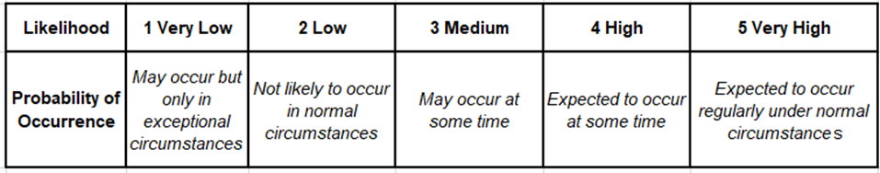
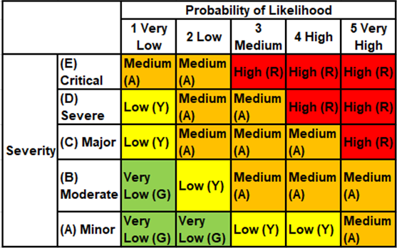
Risk Matrix

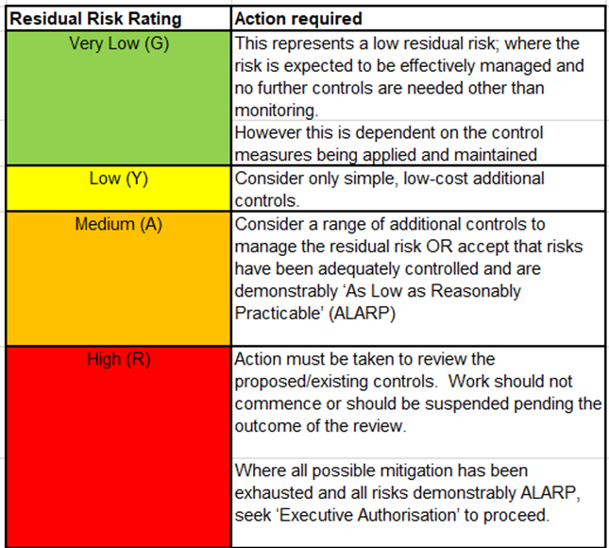

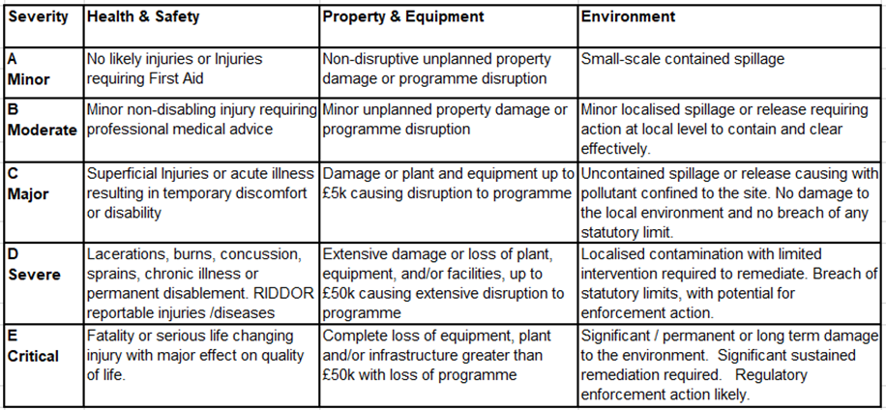

Part 2 – ALARP Justification

Introduction to ALARP
“ALARP” or “as low as reasonably practicable” is a principle of risk management signifying that a risk has been deemed controlled to a standard that the owner of the risk is satisfied with. For a risk to be classified as ALARP, the risk owner has confirmed that the risk is covered within the context and confines of the activity as much as reasonably possible, and that further safety measures would be impractical or have a cost of implementation that goes far beyond the cost of damage incurred [6]. There is no set standard for what is and is not an acceptable risk and must be judged on a case by case basis.
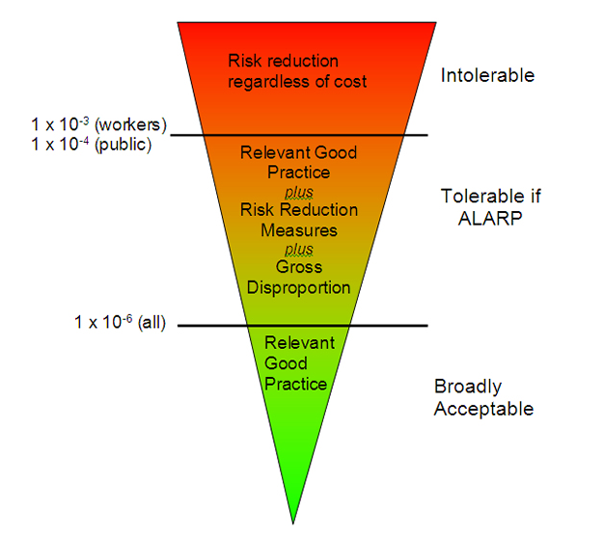
Figure 1: Types of ALARP demonstration [7]
This report will provide an ALARP justification for the risk of accidental initiation in storage of L118 munitions by shock or impact, as defined in the risk assessment above.

Risk – Accidental Initiation
As specified in the risk assessment, accidental initiation could occur through the following methods:
- Shock induced initiation from drop or impact.
- Electrostatic initiation
- Radio frequency emitters
- Spark or fire
- Mixing with incompatible material
- Age-related chemical property changes
- Raised heat or temperature

This ALARP justification will focus on shock-induced detonation, as addressing every method of accidental initiation would be too broad a body of evidence.

In the event of accidental initiation, the effect on the staff present would be severe. Typical storage tasks involve two or three members of staff in the immediate vicinity, with a potential of two more for complex/large moves. A typical L118 munition would likely affect anyone in the magazine, as well as potentially causing sympathetic detonations of other items in the area. Assuming correct explosive licence limits have been followed [3], the event should not affect other magazines or staff working beyond the boundary of the storage area apart from noise. Assuming an average of a four admin staff in a storage management area and six further magazine workers in an office area, half would likely have permanent hearing damage and the other half suffer temporary hearing damage. Beyond this, there would be significant damage to the facility and reputational damage done to the company/institution in charge of the facility, which is included in the cost benefit analysis as a disproportion factor.

Cost Benefit Analysis
A cost benefit analysis (CBA) can provide context for decisions made in regards to ALARP, and help justify to exclusion of additional safety measures that would be deemed beyond reasonably practicable.
The L118 Light gun has been in service since 1974, and is due to be removed from service in 2030. For historical analysis and debate over lifecycle changes, a CBA could be conducted over the full 56 years, but for the purpose of this report only the 7 years remaining of its service life will be considered.
As specified in section 4.2, a worst-case scenario of accidental initiation in storage could involve as many as five fatalities, four permanent injuries, four serious injuries and two slight injuries. Assuming a likelihood of 1 in 1,000,000, a value for reducing this risk can be calculated over the remaining 7-year life cycle. Values for the types of injuries are taken from the Health and Safety Executive [8].
Table 1: CBA of identified risk
Fatalities: | 5 | x 1,336,800 | x 1 x 10⁻⁶ | x 7 years | = £46.79
Permanent injuries: | 5 | x 207,200 | x 1 x 10⁻⁶ | x 7 years | = £7.25
Serious injuries: | 3 | x 20,500 | x 1 x 10⁻⁶ | x 7 years | = 0.43
Slight Injuries: | 12 | x 300 | x 1 x 10⁻⁶ | x 7 years | = 0.0252
Total Cost |  |  |  |  | =£54.50

Adding an additional disproportion factor of 10 due to military nature of items and reputational damage [8], £540 would be an appropriate amount to spend reducing the risk of accidental explosion. The use of a smaller disproportion factor would need to be justified, and in this case would likely be rejected due to the nature of the risk.
There are 126 L118 guns in-service in the British army, and a change to the design of one would be a change to all. Therefore, it is reasonable to multiply the reasonable amount to reduce risk by 126, reaching a final amount of £68,664.58 to spend on reducing the risk of storing the L118 and its munitions. This cost only included the human cost of the risk, and not the potential damage to infrastructure, equipment or other stores.
In relation to military spending, this figure is rather small. It is likely that if an easily applicable safety measure were found for a larger sum it would likely be applied, as storage costs can be calculated for all items in storage, not just these specific munitions. It is also worth noting that this is only a guideline, as the courts do not provide specific factors or methodology on what cost is deemed grossly disproportionate [9]. A CBA cannot provide an ALARP justification, rather must be combined with the applied control measures to detail that the risk is being managed.

Chosen Control Measures – Shock and Impact
The control measures laid out in the risk assessment are based on a number of regulations and recommendations based on explosives work, dangerous goods use, and wider health and safety legislations. As such, all control measures listed are assumed ‘good practice’ [6] and acceptable safety measures for ALARP justification. The safety control measures listed here reduced the risk of accidental initiation down from a high likelihood to a very low, massively reducing the chances of an accident.

Staff competency and control
All staff are to be given training and an appreciation of the dangers of the items. All items should be handled with the appropriate care, and munition safety never sacrificed for cost or speed [10]. Only competent staff should be given access to the storage area, and the number of staff in the storage area should be monitored. Staff involved in an activity in the storage area should be kept to a minimum to conduct the job safely, and should leave the area once the job is complete [3]. Staff should always be supplied with appropriate PPE for the task, including safety footwear as per EN ISO 20345:2011 [4] to reduce the risk of slips or falls.

Shock and Impact reduction
Items should be stored on wooden pallets on the floor, to reduce risk of falls, unless in packaging designed to contain the blast, such as UN hazardous goods classification 1.4S, in which case racking is acceptable. Items to be stored only in NATO approved packaging, and with the inclusion of insulating foam or other shock-reducing packaging to reduce movement of the munition inside its box. Regular custody holder checks should be conducted to ensure items are packaged correctly and are in good condition [1].
The risk of drops can be reduced by moving items distances as short as possible, and by the use of pallet trucks or other lifting equipment, provided the user has adequate training. In situations without lifting gear, two-person lifts are recommended, following HSE manual handling guidelines [5]. The route for the movement should planned out ahead of lifting, and be cleared before lift begins.

Control measures not chosen
As seen in the risk assessment, the residual risk is still classified as medium, with the bulk of the severity assessment coming from the presence of people in and around the explosive area. The removal of people from the explosives area would require a level of automation that at current does not exist (as far as classification within contraband rules and exclusion distances). Even if that technology did exist, the implementation would require a complete retrofit of the magazine, at a cost of millions.
Simpler measures such as the banning of item stacking to reduce the height an item could fall would technically reduce risk, but the extra space that would be required would be excessive, and a box of ammunition falling from 30cm in the air would incur minimal damage to the box or its contents, especially if packaged correctly with insulating material. Procedural checks such as higher level sign-offs for storage of items or sign-offs for the process of storing each item could be used to assess risk management more consistently and in higher detail, but the cost in time for completion of this process for each item would be prohibitive, especially when compared to a single process sign off for storage.

Conclusion
The control measures listed in the risk assessment adequately reduce the risk of accidental initiation by method of shock or impact. These control methods follow guidance from regulations such as the Explosives Regulations 2014 and guidance on safe practice such as the UN international ammunition Technical Guidelines, and as such should be considered ‘good practice’. The cost of implementing further safety measures would be prohibitive, and those options that are affordable would provide little additional protection.

References

[1] | Defence Safety Authority, “STORAGE AND HANDLING OF EXPLOSIVES,” DSA, 2019.
[2] | Defence Safety Authority, “Hazards of Electromagnetic Radiation to Ordnance (HERO),” DSA, 2019.
[3] | UK Government, “Explosives Regulations 2014,” UK Government , 2014.
[4] | ISO, “Personal protective equiptment - Safety footwear,” ISO, 2021.
[5] | Health and Safety Executive, “Manual handling at work,” Crown , 2020.
[6] | Health and Safety Executive, “ALARP "at a glance",” HSE, [Online]. Available: https://www.hse.gov.uk/enforce/expert/alarpglance.htm. [Accessed 20 July 2023].
[7] | Health and Safety Executive, “Guidance on ALARP Decisions in COMAH,” HSE, [Online]. Available: https://www.hse.gov.uk/foi/internalops/hid_circs/permissioning/spc_perm_37/. [Accessed 20 July 2023].
[8] | Health and Safety Executive, “Cost Benefit Analyis (CBA) checklist,” HSE, [Online]. Available: https://www.hse.gov.uk/enforce/expert/alarpcheck.htm. [Accessed 20 July 2023].
[9] | Health and Safety Executive, “HSE principles for Cost Benefit Analysis (CBA) in support of ALARP decisions,” HSE, [Online]. Available: https://www.hse.gov.uk/enforce/expert/alarpcba.htm. [Accessed 20 July 2023].
[10] | United Nations, “IATG 06.30 Storage and handling,” UN, New York, 2015.

