Shelley c lazenby
1905671

Employability skills of the work place
Academic report

Shelley c lazenby
University of wales trinity St David’s
Shelley c lazenby
1905671

Contents page

Introduction…………………………………………………………................
Findings Part 1:……………………………………………………………………
- Why are employability skills important?
- Have employability skills changed in the last decade?
- How has employability changed?
- Are the top 5 employability skills the same as a decade ago?
- What has caused the change?
- Does this mean employability skills aren’t as important as they once were?
- What employability skills does an employer expect to see in current employment?

Findings Part 2:………………………………………………………………..

      - Time management
      - Digital competency
      - Emotional intelligence
      - resilience

References………………………………………………………………..……

Shelley c lazenby
1905671

Introduction

Political and social developments associated with the forces of globalization have far-reaching implications for the provision of social programmes, public services including education and training policies. Both higher education and labour market are changing rapidly. As student intake becomes more diverse in age, back round, previous educational experiences, interests and ambitions, graduate employment is also changing and diversifying as many students continue to work part-time throughout their study programs. Generic skills and employment are inextricably linked and that generic competencies, or the lack of it are key determinants for workforce participation.
Over the last decade there has been an increasing reports papers and political discourses from government, industry, higher education practitioners and civil society groups urging higher education sector and technical and vocalisation’s to focus more on key, core, transferable and employability skills in teaching, training and learning experiences of students.
Shelley c lazenby
1905671

Why are employability skills important?

Employers are always looking to recruit graduates with a broad range of experience and the ability to demonstrate the wide range of skills that they have developed through academic study work experience.
Employers looks for a wide range of employability skills that you should try and develop whilst at uni.
Prospective employees need to acquires a broader range of skills, professional competencies and attitudes to continually adapt and transfer skills and knowledge in different contexts. Industries recruit and retain employees who are capable of combining technical skills with professional competencies in innovative and productive ways for effective patriation in the emerging patterns of work and organization ( Mitchell et al, 2006; Gibb and curtain 2004; brown et al 2008). A study by Australian industry group revealed that over 90% of the firms were looking for people who are flexible and adaptive, willing to learn on the job, team workers, technically competent and committed to excellence ( Allen consulting group, 2006). Studies demonstrate that people with proactive skills, for example, engage in more self – directed learning ( joss Berger et al. 2010).
In most economies, inadequate employable skills in organisations and establishments often leads to automation, increased use of temporary workers, deliberate creations of contingency workforce part time poor or no pension schemes, job security, staff benefits or union compensation.

Shelley c Lazenby
1905671
Transferable skills as they are:
- Numeracy/IT skills
- Communication skills
- Team-working skills
- Research/ critical thinking
- Creativity/ problem-skills
- Commercial awareness
- Organisational skills
www.kent.ac.uk

Shelley c lazenby
1905671
These are often known as transferable skills, as they are generic and can be used equally well in all areas of work. Other examples include:

Prospects. Ac. Uk  Teamwork  Problem- solving  Time management  IT skills  Numeracy  Customer awareness | Jobs.ac.uk  Communication  Teamwork  Initave  Project management  Flexibility  Interpersonal  Organisation
University of kent  Confidence  Creativity and innovation  Critical reflection  Global/cultural awareness  Integrity and accountability  Intellectual curiosity  resilience | Target.jobs.co.uk  Commercial awareness  Communication  Teamwork  Negotiation and persuasion  Problem-solving  Leadership  Organisation  Perseverance and motivation  Ability to work under pressure  confidence

Shelley c lazenby
1905671

Have employability skills changed in the last decade?

Yes, it has changed since the Great Recession had a tremendous impact on the economy not to mention the average worker. The recession began 10 years ago when technological and societal shifts continued to change the way people do business both as customers and as workers actively looking for work and employed has shrunk from 66% 10 years ago to 62.7% today. Wendy Connick (imwconn) ( Dec 23) (2017)
How has employability skills changed?

- Abstract- completive global market in both higher education and labour market that are changing rapidly
- Key, core, transferable and employability skills in teaching training and learning experiences of students.
- Acquisition skills like communication numeracy information technology (IT) and ‘learning to learn’ considered for all undergraduate’s generic skills ‘ Professional skills’ are crucial for graduate level ( Atkins 1999)
- Scientifically changed in the 1980s ( PWC.com)

Shelley c lazenby
1905671

What has caused the change?

Youth unemployment and under employment has reached a critical level and are expected to continue to rise in most G20 economies. Most employers cannot find enough people with skills they need to grow their business to enable the economy to recover. This could lead to ‘ lost generation’ of young adults.
Unfortunately for many young people education isn’t providing skills they need to gain the employment they aspire to. The world economic forum report global risks 2014, notes that “ many current graduates are discovering that despite their academic qualifications – often gained at significant expense- they lack the specific technical and professional skills demanded by the ever- changing jobs market”

Shelley c Lazenby
1905671
What has caused the change?

Business need to combine cost reductions with continual cost reductions with continual investment to ensure sustainable success. Requires a keen understanding of the competitive environment and the drivers of cost, risk and value in business.
The generation coming of age in the 2010s faces high unemployment and precarious job situations, hampering their efforts to build a future and raising the risk of social unrest. In advanced economies the large number of graduates from expensive and outmoded educational systems – graduating with high debts and mismatched skills – points to a need to adopt and integrate professional and academic education. In developing countries, an estimated two – thirds of the youth are not fulfilling their economic potential global risks 2014, world economic formum2

Shelley c Lazenby
1905671

Are Employability skills still as important as once were?

Employability skills are those basic necessary skills, for getting keeping and doing well on a job and they can be divided into these three categories, basic academic skills, higher order thinking skills and personal qualities ( Robinson, 2000)
Employability skills can also be known as a job rewardiness skills. The term also refers to the skills required to acquire and retain a job and recent usage of the term is often used to describe the preparation of foundation skills upon which person must build job-specific skills for example preparing a sales – report ( Saterfiel & Mclarty, 1995)
Employers today are concerned about finding good workers who not only have basic academic skills like reading, writing, science, mathematics, oral communication & listing, but also higher order thinking skills like learning, reasoning thinking creatively, decision making & problem solving. (Published by Canadian Centre of education)

Shelley c Lazenby
1905671

Why use time management?
Its important that you develop effective strategies for managing your time to balance the conflicting demands of time study, leisure, earning money and jobhunting. Time management skills are valuable in jobhunting, but also in many aspects of life: from revising for examinations to working in a vacation job.
Sometimes it may seem that there isn’t enough time to do everything that you need to do. This can then lead to a build up of a lot of stress. While revising for exams, or even during your final year when having to combine the both pressures of intensive study while finding time to look for jobs that are good management of your time can also be particularly important. Once you have sussed out and identified ways to improve the management of our time, you can then begin to adjust your routine and patterns of behaviour to reduce anytime related stress in our lives.

The required skills for effective time management are:
- Breaking your goals
- Using lists
- Setting goals
- Prioritising
- Avoiding procrastination
- Breaking down tasks
- Organising your time
- Revising for examinations

Shelley c lazenby
1905671

Digital competency

The digital competencies are intended as a framework to help individual students:

- Identify the digital skills and critical perspectives they will need to be 21st century leaders.
- Seek curricular and co- curricular opportunities to hone those skills and perspectives
- Develop ways to articulate or demonstrate their competencies to various audiences.

We always assume that individual students will develop competencies in a wide range of ways: for example, one student might develop data management skills while another student might conducting field research for a course project , compiling survey data as part of an internship, or serving as a research assistant in a psychology lab.

The framework below is a collection of the digital skills that are categorized into five main areas to focus on. They are designed as a tool for students to use an reflect on the digital skills and critical perspectives they develop while studying in college, in curricular and co-curricular experiences. Most of the students may use the framework to help find new ideas for working or even thinking critically about digital technologies and seek opportunities to explore them, while other students might recognize skills they have already developed to describe them in many different ways through different audiences including future employers.
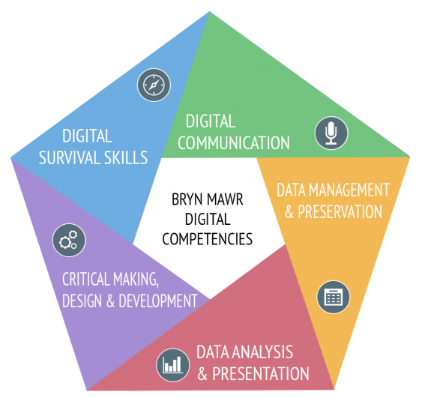
Shelley c lazenby
1905671
- Digital survival skills
- Digital communication
- Data management and preservation
- Data analysis and presentation
- Critical making, design and development

shelley c lazenby
1905671

Emotional intelligence and resilience

This study examined the relationship between emotional intelligence (EI) and the stress process. Participants (N=126) completed an ability-based measure of EI and then engaged with two stressors. We assessed stressor appraisals, emotions, and physiological stress responses over time. We expected that higher EI would facilitate stress responses in the direction of challenge, rather than threat. As expected, EI facets were related to lower threat appraisals, more modest declines in positive affect, less negative affect and challenge physiological responses to stress. However, findings differed for men and women. This study provides predictive validity that EI facilitates stress resilience.

Shelley c lazenby
1905671

References

digicomp@brynmawr.edu

www.kent.ac.uk

( fool.com )

Wendy Connick ( imwconn ) (Dec 23 ) ( 2017 )

www.eajournals.org

PWC.com

( CGMA )

