Exploring the Impact of Qigong Meditation on Intuition and Artistic Practice: An Autoethnographic Approach
Author(s): Xinyu Yang，PHD
yxy1702@outlook.com
University of Wales Trinity St Davids,
United Kingdom

Introduction

This paper explores whether meditation can enhance intuition and its subsequent impact on artistic practice. The fundamental hypothesis is that Qigong meditation can expand practitioners' creative capacity, surpassing the limitations of everyday sensory experiences and consciousness. Artists establish a closer and more heightened relationship between meditation and intuition, releasing more constraints and valuing the creative power derived from intuition to minimize preconceptions in their artistic creations. As a predominantly practice-driven research, the main focus is on expanding an individual's creative freedom. Previous research has been conducted on the behavior of painting and embodied consciousness, as well as the exploration of Qigong practices in achieving a state of "non-mind" in artistic creation. The preliminary conclusion suggested that Qigong benefits painting, yet the lack of substantial supporting evidence resulted in incompleteness. Therefore, I have been contemplating one key aspect: What sparks my initial inspiration in artistic creation? When I, as an artist, enter a highly concentrated state during the creative process, what is my first impulse when picking up the brush? The generation of "flow" during the creative process, where the brush leads most of the time while the mind follows, implies a state where the body precedes consciousness, akin to the sixth sense - intuition. This swift and direct cognitive approach, not dependent on explicit reasoning or experience but rather based on personal intuitive feelings and direct perception, is precisely what I aim to explore - liberating art creation from its rational dimension. Thus, the focus of this paper is on combining meditation to enhance intuition and utilizing it in artistic practice. Despite some previous research indicating that meditation can enhance intuition (Coburn, 2010; Erickson, 2011), studies integrating meditation's utilization of intuition in artistic practice are scarce. Therefore, I will employ two autoethnographic models to explore my artistic practice (before and after incorporating meditation), followed by a comparative analysis. The ultimate discovery suggests that after incorporating meditation into my artistic journey, artistic practice automatically manifests bodily or spiritual consciousness through enhanced intuition, inducing relaxation, an abundance of liberated vitality, and creativity, emancipating artistic creation from its rational dimension. Although bodily freedom largely supplants conscious thought, the unfortunate aspect is the uncertainty regarding its indefinite sustainability, as occasional self-awareness (reflection) cannot be entirely evaded. Nevertheless, my experience indicates that engaging in Qigong meditation before artistic practice fosters harmony between the body and mind and elevates intuition. At least for this artist, this finding seems to liberate art from "rational control." This undeniable, highly personalized experience has driven my artistic practice and the completion of this paper.

- References to concepts

1.1 Intuition

Intuition Intuition plays a crucial role in decision-making and is a term used by various disciplines. When Jobs spoke about intuition, he said, "And most important, have the courage to follow your heart and intuition" (Jobs, 2005). So, what is intuition? The dictionary defines it as "The ability to know something by using your feelings rather than considering the facts; a thought or strong feeling that something is true even when you cannot explain it" (www.oxforddictionaries.com/definition/english/).

Jung (2007) was one of the early researchers to propose the concept of intuition in psychology, considering it one of the four basic psychological functions. He defined it as an unconscious, inwardly directed perception pattern, emphasizing that it is distinct from sensing, which is a conscious perception pattern reliant on sensory organs (e.g., visual or auditory perception). Duggan identified two types of intuition: "strategic intuition," which involves organically combining existing elements to gain new insights while concretely touching upon them, and "expert intuition," which allows for faster problem-solving by recognizing patterns through optimized work (Duggan, 2013).

In the description by Taura and Nagai (2017), intuition is also divided into two categories. They define "experiential intuition" as the ability to make instantaneous decisions based on personal experiential patterns. On the other hand, "associative intuition" involves perceiving relationships between two or more things based on personal senses or feelings. Thus, in experiential intuition, insight arises from fixed eliminations, while in associative intuition, it arises from the resonance of sensory connections between multiple elements. They argue that "associative intuition" encompasses concepts from "intrinsic motivation" (Taura, 2016) and "intrinsic sensation" (Taura & Nagai, 2012).

In the integrated design and creation cycle proposed by Taura and Nagai (2017), the beginning of the design process involves associative intuition of the designer, which links several fundamental pieces of knowledge or techniques to form a hypothesis. Conversely, the hypothesis is derived from the integrated associative intuition, where the underlying parts of knowledge or techniques are connected, leading to a clear end goal. However, it is easy to mix various non-intuitive elements into this process. It is undeniable that this integration of multiple fundamental knowledge or techniques can broaden human sensitivity and lead to qualitative innovations. Nevertheless, it can be said that intuition plays a significant role in the innovative process when utilizing integrated associative intuition, hypotheses, and other factors.

In his research, Erickson (2011) raises an interesting question, "Is the heart the source of emotions and intuition?" In later repetitions of related studies, positive results indicate that both the heart and the brain are continuously perceiving the future. He employs the electrophysiology of intuition to study intuition and finds evidence that the heart and the entire body continually receive, process, and decode intuitive information. The research also reveals that the mind's emotional energy travels at a speed faster than thought, and emotionally related information is communicated through the heart's electromagnetic field via various parts of the body. Therefore, intuition's generation cannot be separated from the role of the mind; in other words, intuition may require the synthesis of the entire mind-body unity.

Hunt (1996) explores the decoding of human thought vibrations and mentions a neutral state, one that must transcend the structures of known space and time, neither being in the past nor the future, but the present. He emphasizes the importance of the present moment. The higher vibrational level he describes goes beyond time and space. Erickson (2011) suggests that any skill can be learned and continuously practiced to enhance confidence, accuracy, and precision. Moreover, as one becomes more skilled in exploring and delving into their field and inner thoughts, they can better decode information from others' domains (Hunt, 1996). In the expression of creativity, intuition often accompanies various skillful expressions and outputs, such as a musician's improvisation in composing or a painter's spontaneous depiction of an objective object. Monet's (1976) oil painting "Impression, Sunrise" exemplifies the fusion of skillful technique and the display of intuitive creativity in capturing a momentary impression.

1.2 Creativity

Creativity is a complex process that has been extensively studied in various fields. Wallas (1926) proposed a classic model of creative thinking in his work "The Art of Thought," dividing the creative process into four stages: preparation, incubation, inspiration, and verification. This process clearly indicates that creativity involves controlled processing and oscillation between the unconscious and conscious mind. However, the incubation and inspiration stages seem to be more related to the cognitive processes of analysis and reflection in comparison to the preparation and verification stages (Barr, 2018).

Using a process-centered approach, where there is interaction between intuitive thinking and analytical thinking, can enhance temporal precision and promote creativity. Barr provides an example stating, "The classical conception of creativity is focused on larger blocks of time, during which a person is either generating or evaluating" (Barr, 2018). Hence, the generation of creativity is intricately tied to an individual's subjective thinking. Even though the apparent goal may be to produce something new or innovative, it does not mean that only a singular associative process is at work. The oscillating cognitive process model involving binary thinking allows for millisecond-level analysis and acknowledges that this interaction is more accurate than relying solely on content (Barr, 2018). It simplifies issues and judgments into two extreme and contrasting options, facilitating quicker and easier decision-making. However, this approach may generate unexpected results, both positive and negative, without considering rationality.

Numerous great thinkers have acknowledged the pivotal role of intuition in their creative work (Raidl & Lubart, 2001). As the saying goes, "We prove by logic, but we invent by intuition," because "unless nourished by intuition, logic remains barren" (Policastro, 1995). Thus, the importance of intuition in creativity has never been forgotten. Intuition often emerges in the part of solving creative problems that involve unutterable or unconscious formation of cohesive elements (Gardner & Nemirovsky, 1991).

Coburn (2010) suggests that combining intuition with rational thinking through learning can lead to the development of the brain's specialized intuition processes. Research has shown that the right hemisphere of the brain exhibits the most activity related to intuition; it is the hemisphere responsible for responding to visual activities. The aim is to manage abstract and divergent thinking to develop intuition, deriving answers based on sensations rather than logic. On the other hand, the left hemisphere prefers fragmented information, and when these micro-events are pieced together, the brain generates multiple systems to execute a holistic approach. If one is trained to disregard intuition, they may frequently miss out on the complete experiences within the entire brain.

1.3 Qi Gong meditation (movement meditation)

According to Erickson, D. L. (2011), the process of generating many of the most creative ideas occurs through daydreaming or meditation before or after sleep. Regular practice of meditation techniques can lead to an expanded awareness of emotions and sensations, achieving psychological and physiological harmony, which is an optimal functional state for an individual. Meditation produces a "mental energy" that allows one to quiet the mind and enter a state similar to daydreaming or the borderline between wakefulness and sleep (Hunt, 1996), thereby enhancing intuition.

Qi Gong is a form of meditation in motion, encompassing mindful movements, breath regulation, and attention control. Meditation techniques specifically involve the sensation and control of bodily movements, resulting in subjective experiences that may differ from those encountered in most daily activities, possessing uniqueness. Qi Gong's meditation practice combines specific movement patterns with psychological skills to achieve the meditative state. This training can trigger positive emotions and flow-like experiences (Pölönen et al., 2019).

Cardoso et al. (2004) identified the characteristics of meditation as follows: (1) spontaneous and self-sustaining; (2) psychological and physical relaxation leading to muscle relaxation; (3) focusing attention by anchoring it on mental imagery, breathing, body states, or other targets; (4) well-defined techniques; and (5) "logical loosening," which reduces the need for evaluative, expectational, and interpretive thinking. Concerning attention and concentration of consciousness, there are two styles of meditation: focused attention and open monitoring. The third style applies solely to focused attention meditation (Pölönen et al., 2019).

Payne and Crane-Godreau (2013) used the term "meditative movement" to describe forms of physical exercise where meditation is directed towards bodily sensations, including proprioception, internal sensations, and kinesthetic sensations. This includes Chinese traditional practices like Qi Gong and Tai Chi. Schmalzl et al. (2014) used the term "movement-based embodied contemplative practices" to describe traditional Eastern practices such as Qi Gong, Tai Chi, and Yoga. In general, the overall purpose of Qi Gong practice is to harmonize the mind-body relationship, balance energy flow, and enhance vitality.

1.4 Flow

Flow (Csikszentmihalyi, 1975) is a complex psychological construct aimed at phenomenologically describing the joy individuals experience during activities they engage in, often without apparent external reasons or incentives. Flow states can be experienced during both challenging tasks ("deep flow") and more ordinary and simple activities ("micro-flow") (Pölönen et al., 2019). Flow is characterized by (1) a loss of reflective self-consciousness or a sense of effortlessness; (2) highly enjoyable experiences; (3) a merging of action and awareness (being "one" with the environment); (4) a continuous flow of output (a tendency to keep completing tasks rather than stopping); (5) a sense of control and confidence; (6) complete immersion and focused attention on the task at hand; and (7) a distortion of the experience of time (a sense that time either passes quickly or slowly). The generation of flow is inherently self-motivated, as individuals continuously seek this state regardless of external rewards. Flow is a multidimensional phenomenon, encompassing behavioral aspects (intrinsic motivation or "autotelic experience"), cognitive aspects (e.g., attention, automatization), subjective experience (emotional quality, enjoyment, self-consciousness, time, and space), and emotional aspects (enjoyment) (Pölönen et al., 2019). The results of the Qi Gong practice research conducted by Pölönen et al. (2019) suggest that most individuals achieve flow states after their first Qi Gong practice. From both practical and theoretical perspectives, understanding how experienced meditation movement practitioners can quickly enter the state of flow is crucial.

The emergence of flow is an elusive state that artists often seek, as it represents an ideal state for creative work. At the same time, intuition holds a strong allure for creativity. It is undeniable that researchers (Hunt, 1996; Erickson, 2011; Coburn, 2010) unanimously believe that meditation can enhance intuition and, consequently, foster new creativity. Exploring the creativity of intuition through meditation is an intriguing endeavor, and the following research will continue to delve into this topic.

I have always yearned for artistic freedom, to explore more creativity related to art. When I mention "artistic freedom," it is not about gaining or sacrificing something, but rather about liberating myself from existing mental constraints and physical limitations, allowing my artistic process to become freer. Hence, I have been searching for a different approach to artistic practice from what I learned in the past, and it has been a delightful surprise to combine it with meditation movement practice. This seems to align more with the philosophical concepts of Taoism and Buddhism, such as "no-self" or "non-attachment," which represents a state beyond the self, leading to the liberation and elevation of the individual.

Therefore, the purpose of this research is to investigate whether practicing Qi Gong meditation can genuinely cultivate artistic freedom, leading to more artistic creativity, and how this artistic freedom differs from conventional artistic practice. Throughout this artistic practice, I continuously ask myself, "How can I gain new creativity and unleash my artistic nature?" and "How can I enhance my daily artistic practice?"

2.Methodology (Practical Work)

To investigate the impact of meditation on intuition in artistic practice, I integrated autoethnography and compared two different approaches to artistic practice in different environments. This is an "action" research on art, as described by May et al., "Action research is the study and enhancement of one's own practice" (May, 1993:114). The project advances in a continuous spiral of iterative cycles involving planning, acting, observing, and reflecting. Each of these activities is systematically and critically executed, with strong interconnections between them (Masters, 1995).

The process of generating ideas begins with active engagement and practice. According to Hsieh (2010), action research is an intriguing exploratory form that allows practitioners to complement their own weaknesses with the strengths of others, gain a clear understanding of their work, conduct investigations and evaluations, and clarify their thoughts to avoid confusion. It is a dynamic learning approach.

I integrated my artistic practice with Taoist Qi Gong meditation practice and conducted a preliminary exploration of intuitive creativity in art. I performed this exploration at different levels of meditation to enhance my artistic practice. My methodology involved using meditation as an artistic practice and conducting these experiments at two different levels, divided into two parts. This paper represents the initial stage of the second part. Each exploration process in this part can be seen as a spiral of ascending and cyclic exploration, involving planning, acting, observing, and reflecting on my artistic practice, comparing it with regular artistic practice in different environments.

(The first part consists of empirical research, where I plan to invite five volunteers from the UK (currently only completed autoethnography) to participate in my Qi Gong art movement practice and engage in art exploratory activities. For more details, please refer to my "Practice-Based Artistic Exploration Research: Qigong and Painting Creation" (initial stage). The first and second parts can be conducted simultaneously.)

The methodology of this paper closely resembles Kurt Lewin's description of research, "each step is carried out in a spiral." It includes a series of planning, action, factual investigation, and action (Hsieh, 2010). This spiral research approach is found in many research and design studies (Hsieh, 2010).A simple spiral diagram for action research is shown below:
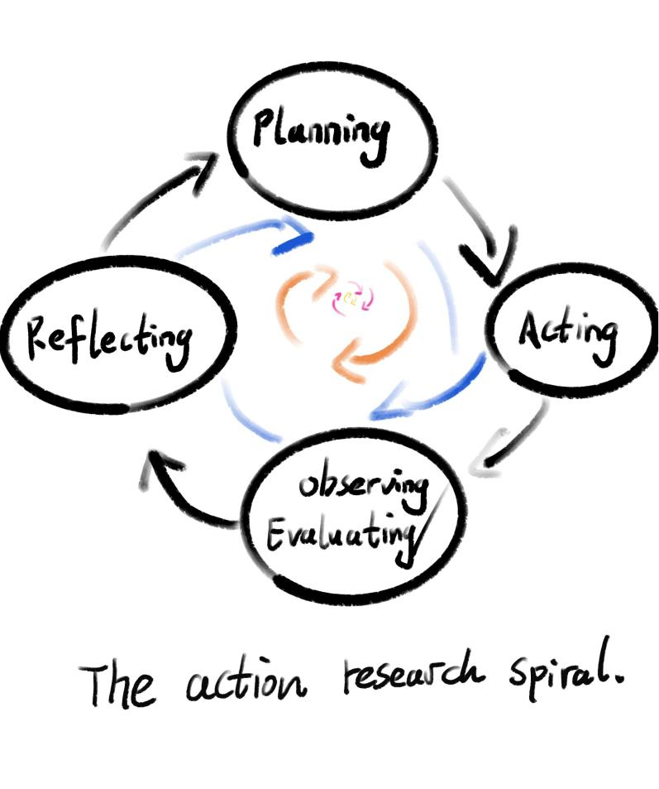
Throughout the spiral cycle of action research, I will continuously ask myself: "Can my artistic practice research help artists break free from physical or mental constraints?" "What needs improvement in this research and how can I improve it to achieve continuous creativity?"These questions will naturally arise during each practice, and actions will support each practice research. Many elements in meditation movement are highly compatible with art, and artists trained in Eastern traditions such as Buddhism, Taoism, or Chinese classical arts are easily able to capture this synergy. For instance, Chinese Dunhuang painters bathe and meditate before painting or writing. Chinese classical arts are also heavily influenced by Confucianism, Taoism, and Buddhism.

Therefore, I believe the primary contribution of this part of the research is to demonstrate how Taoist Qi Gong meditation can be applied to art to yield positive results. The research focuses on exploring how meditation movement enhances intuition and creativity, which is then manifested in painting.

In the current research project, this spiral process is in its initial phase, comparing intuitive painting without meditation and intuitive painting after meditation. In the former, I engage in a few seconds of contemplation before starting to paint, allowing myself to be led solely by intuition. In the latter, I incorporate a dynamic meditation practice before each artistic activity, corresponding to different stages of learning. Utilizing intuition to explore creativity after meditation involves subconscious, instantaneous decisions and extensions, combining imagery and uncontrolled conscious autonomy. I seem to lose a sense of time and space in this process, and it appears as a somewhat frenetic behavior.

The specific steps are as follows:

Art Materials

I will use a portable and powerful iPad for painting (outdoor painting will be involved in this practice). I will work with monochrome tones to focus solely on intuition in the creative process, without distractions from color considerations.Using simple art materials will help me observe my artwork, including lines, body movements, and the utilization of Qi.

- Minute Immersive Qi Gong Practice

Before exploring intuitive painting, I will design a 5-minute dynamic Qi Gong meditation exercise, focusing on perceiving the flow of Qi and exploring intuition. This stage of the research will still use Ba Duan Jin as the chosen form of Qi Gong.

Artistic Production Activity with Qi Gong

After a 10-minute Qi Gong meditation practice, I will randomly select indoor or outdoor scenes for free painting and rely on intuition for seven paintings. Similarly, I will create seven paintings without practicing Qi Gong meditation, solely relying on intuition and focusing primarily on drawing people during outdoor sketches. This will allow me to compare and analyze the differences between works created with and without meditation.

Reflection and Observation

After each practice session, I will save the artworks, review them, and engage in self-reflection and observation. I will record my thoughts and experiences at the time and raise questions for the day, attempting to address them in the next practice session. Finally, I will compile all the data, including images, notes, and reflective texts, and draw conclusions.

3.Artistic Practice Analysis

3.1 Simple intuition exercises

This chapter introduces the entire process of exploring intuitive creativity through movement meditation. After deciding to conduct a two-phase study comprising a total of fourteen art creations using movement meditation, I first selected the locations for my artistic endeavors, focusing primarily on crowded areas like Fountain Square and the beach in Swansea, UK. Throughout each practice session, I used the same research materials to maximize the utilization of intuition in my artwork, regardless of whether it was before or after engaging in movement meditation, ensuring comparability across the entire research process for ease of retrospective analysis and reference. The following section provides a record of my practice.

The entire process was divided into two main stages. The first stage involved avoiding meditation and directly selecting random passersby as subjects for on-the-spot sketching. The second stage encompassed a simple movement meditation session followed by intuitive sketching. These two stages represented the initial ascending spiral in my action research, making this chapter primarily focused on investigating whether meditation enhances intuitive creativity.

At the outset of my intuitive creations (without employing movement meditation), I attempted to create extremely simple compositions while preserving the detailed features of the subjects. This led to a pertinent question of whether I should discard the knowledge I have acquired and attempt a doodle-like approach. I tried to relinquish everything I have learned to create a figurative artwork, but it seemed beyond my reach, potentially resulting in a mere collection of chaotic lines. Thus, I realized that I could not entirely abandon my experiential knowledge; instead, I picked up and accumulated learning experiences from daily life to inform my intuitive artwork. Edmund Husserl, in "Experience and Judgment: Investigations in a Genealogy of Logic (1900-1901)," discusses the unity of objective time perception and life experiences. Based on my current experiences, I concur with his viewpoint. Although Husserl did not further specify how one unifies such perceptions, I believe that this paper's exploration serves to contribute to addressing this question.

Initial attempts left me feeling tense. I utilized my intuition directly in the artistic process without any hesitation, yet the outcomes seemed merely standard student assignments (Figure 1). Regrettably, I did not experience the freedom of expression in my artwork, as my past learned techniques and experiences seemed to restrict me. At least, the results did not align with the uninhibited imagery I had envisioned. Throughout the artistic process, I found myself predominantly engaged in contemplation, frequently disrupting my intuitive flow. For instance, I excessively contemplated the placement of the subject's eyes and nose, aspects crucial for figurative representations. However, this preoccupation outweighed my reliance on intuition throughout the entire process of artistic creation."

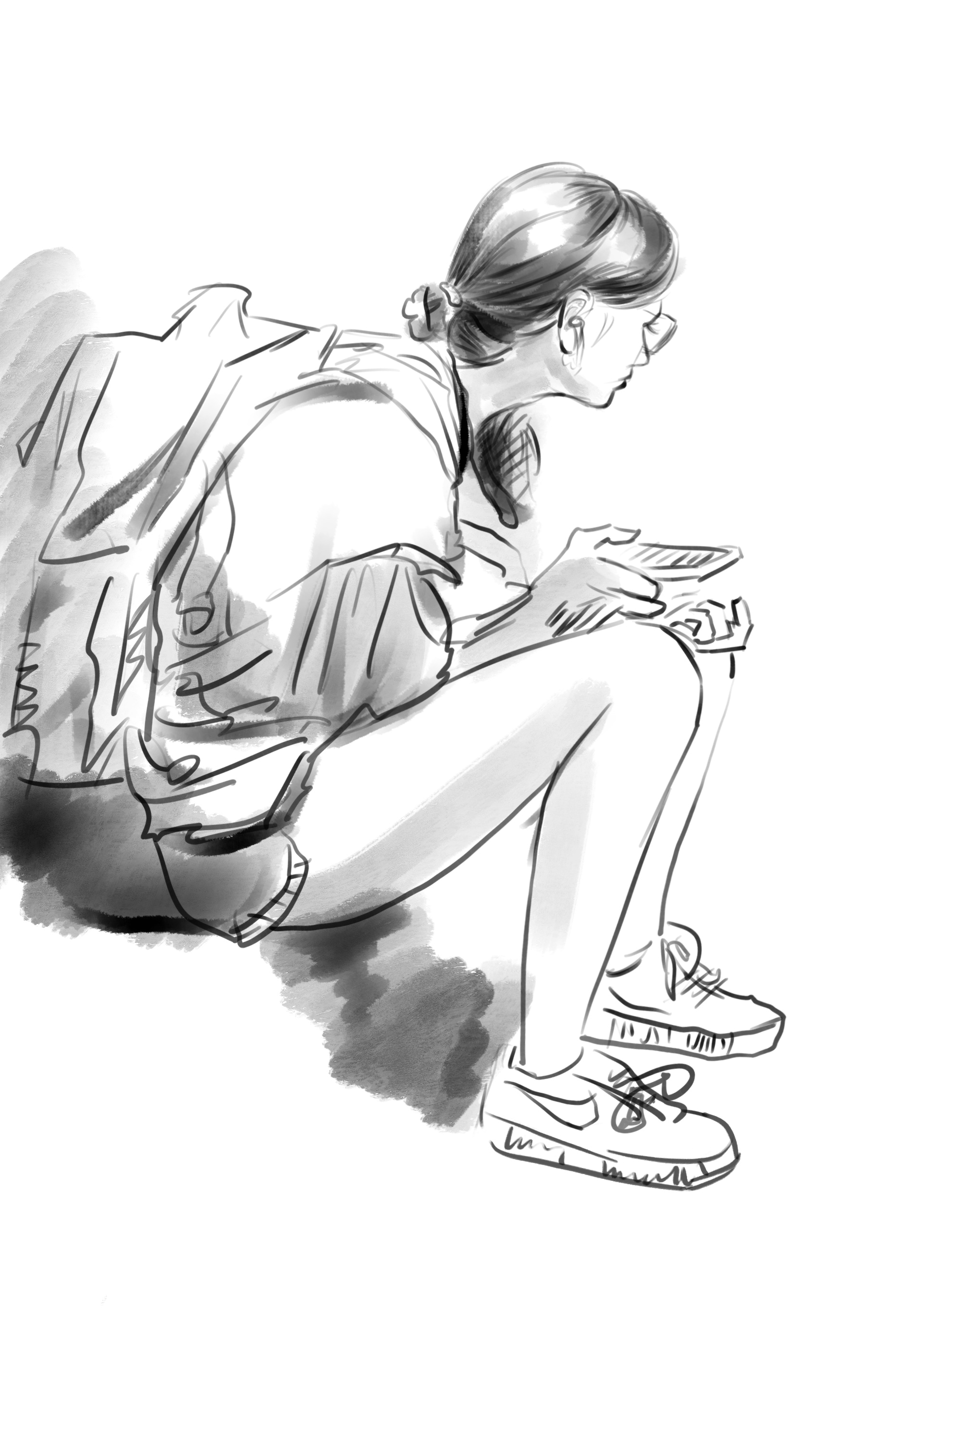
(Figure 1).

As I consciously attempted to reduce the level of detail in my artwork to achieve a sense of urgency and create a feeling of tension, I aimed to complete a piece using minimal lines (Figure 2). Though I still struggled with the same challenges, I seemed to gain better control over the composition. However, at this point, I did not sense how much my intuition was aiding me. It felt more like an accumulation of experiences rather than a substantial assistance from intuition. While I acknowledge the significance of experience, it was evidently not the most critical factor in this artistic practice.

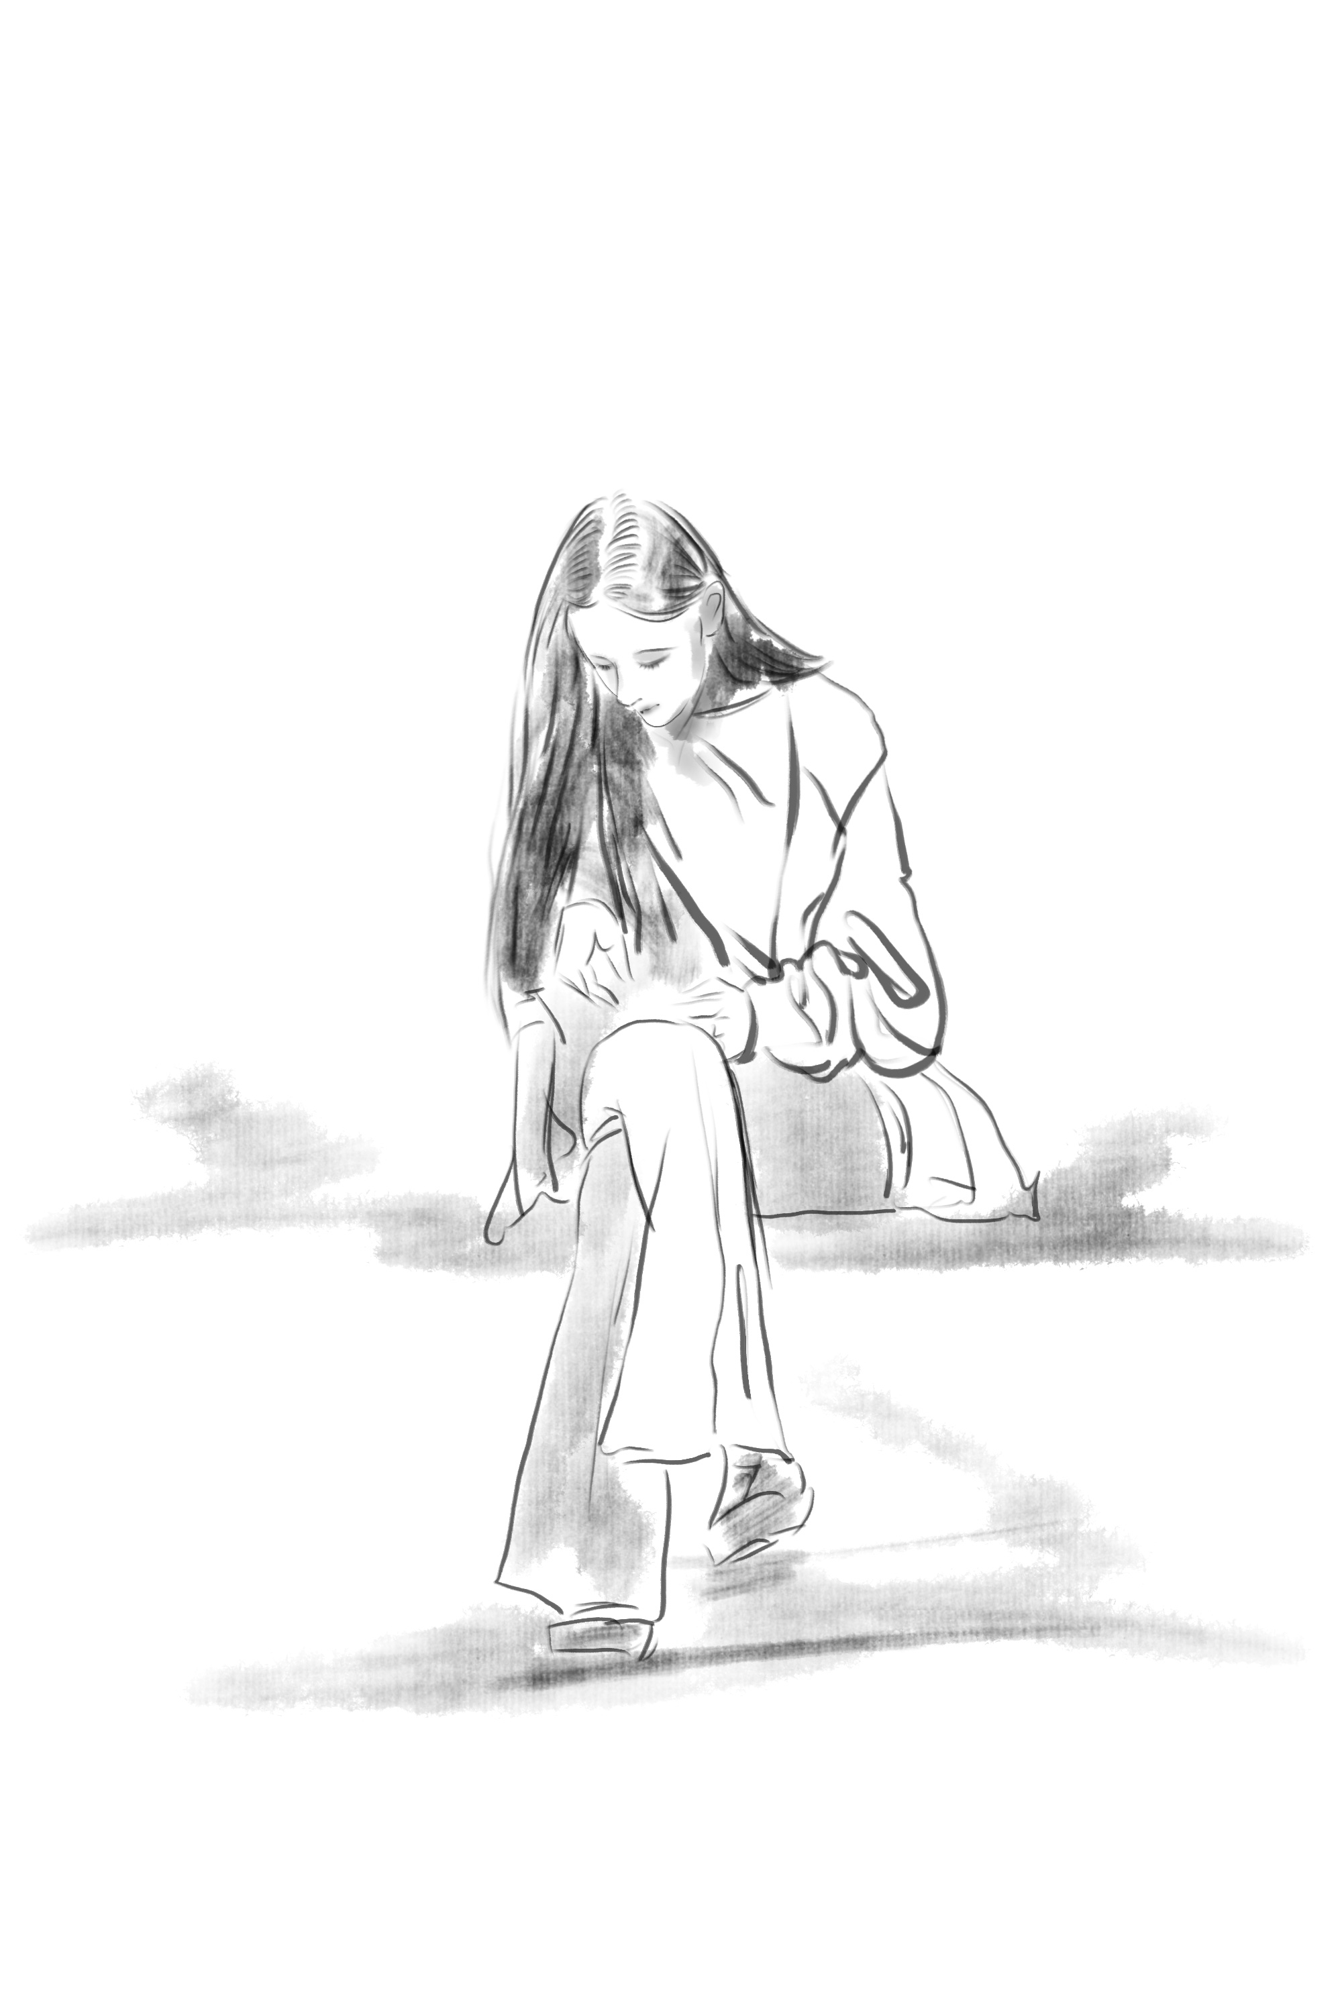
(Figure 2).

Raidl and Lubart (2001) divided intuition into three categories, among which two are "social-emotional intuition" and "applied intuition." The former involves interpersonal relationships and typically comes into play when seeking to understand a person. It includes sensitivity to the needs and feelings of others, direct likes or dislikes, as well as understanding and managing emotional aspects. The latter is referred to as "applied intuition," which is focused on problem-solving or task completion. Many renowned writers, artists, or scientists have claimed to have experienced this type of intuition.

If (Figure 1, 2) were drawn randomly, then this artwork would be deliberately created (Figure 3). Enhancing external stimuli (social-emotional intuition) might intensify my emotions and thus strengthen my intuitive abilities, making the artwork more creative. Therefore, I chose to depict a young couple dining together. I could sense the love in the boy's gaze, but my intuition told me that if I were to draw the boy's eyes, this piece might lose its emotional impact and become ordinary. This time, I still trusted my intuition, and the final result could be pleasantly surprising. So, at this point, it compels me to continue pondering: is the creativity of intuition a random phenomenon?
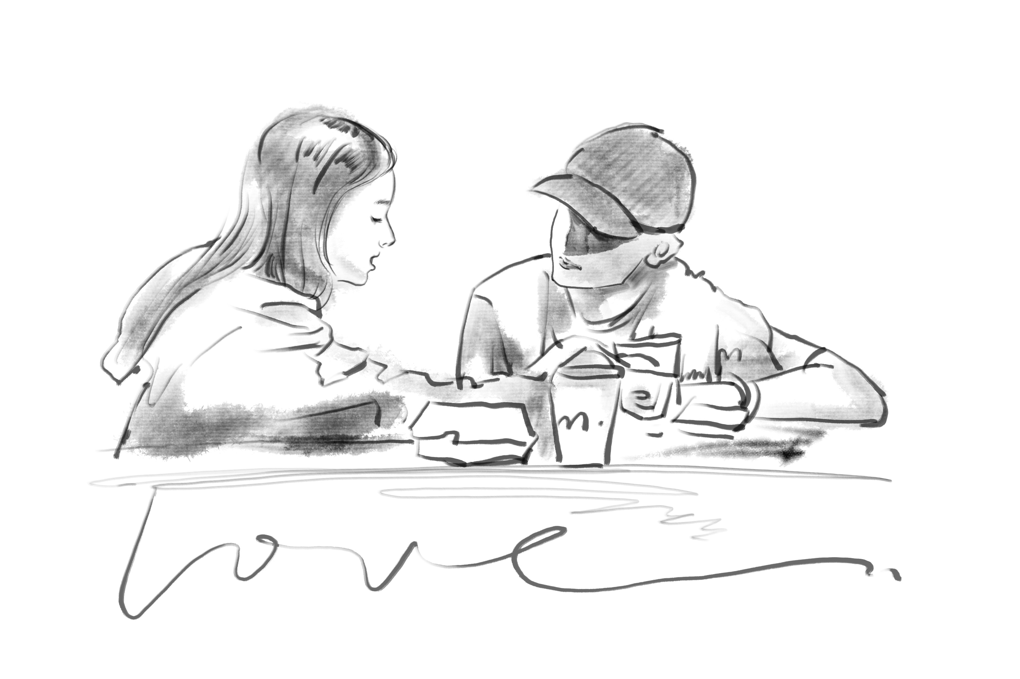
(Figure 3)

So, I had to confront the previous question, which posed a challenge to the spiral ascent of action in the practice. Thus, the author returned to the previous method of randomly sketching a person (Figure 4, 5). Figure 4 is a piece completed amidst wonderful music; I only knew that the music was captivating me. I even wanted to paint an abstract representation of the feeling, but I was bound by rationality and ended up producing a realistic piece; a piece portraying solitude (Figure 5), depicting a girl dining alone. This scene provided a hint, and when I made the first stroke, my intuition told me it would be a portrayal of loneliness. However, it is evident that intuition alone couldn't teach me how to paint the piece; here, the importance of experience can only be highlighted (if one desires to complete a realistic artwork).
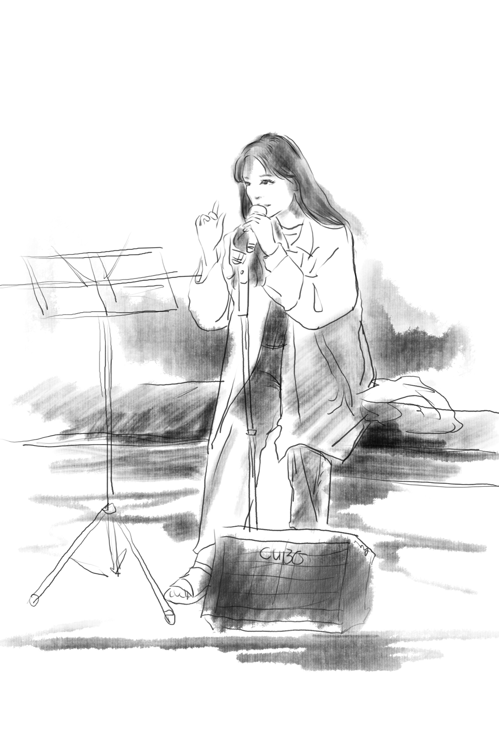
(Figure 4).
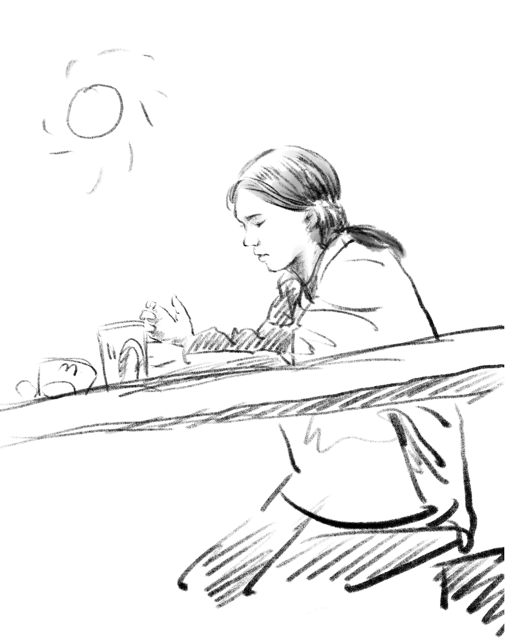
(Figure 5).

Focusing the emphasis of intuition on the narrative or plot within the artwork is an intriguing endeavor. The author deliberately avoids detailing facial features and expressions of the characters, directing attention towards the dynamics and plot instead. "Romantic Moments" (Figure 6) and "Lazy Moments" (Figure 7) are surprising attempts, and the process becomes an enjoyable experience. The brushstrokes flow continuously throughout the entire painting process, with minimal pauses or contemplation, and the emergence of the state of flow feels natural. Excessive overthinking can diminish the intuitive judgment ability. While ordinary intuition possesses creativity, it is not always readily accessible at any given time.
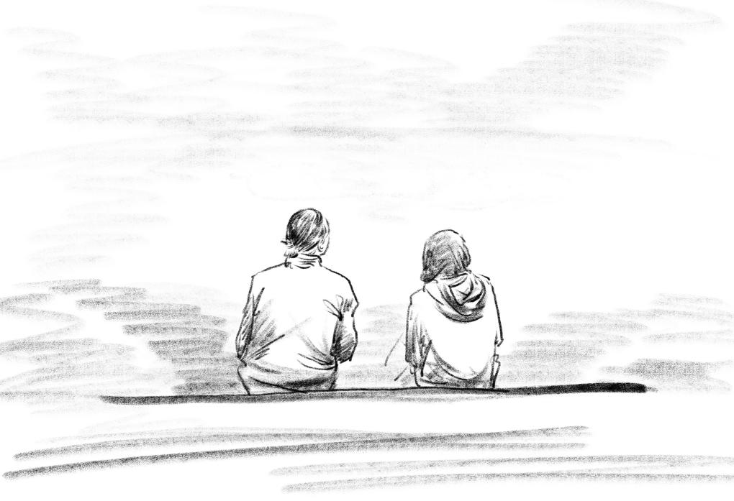
(Figure 6).
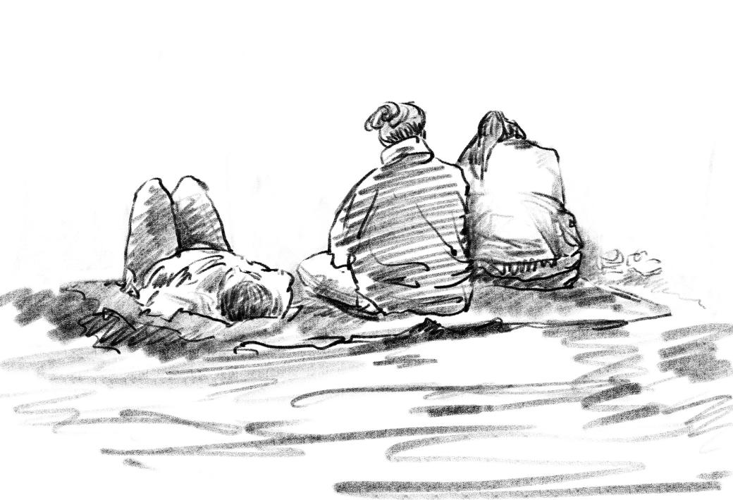
(Figure 7).

3.2 Intuitive Practice for Movement Meditation

Meditative movement practices combine specific patterns of movement, breath, and techniques for focused mental attention to achieve cognitive and emotional changes in humans, offering new insights into the interrelationship between the body and the specific mind (Pölönen, Lappi, Tervaniemi, 2019). Moreover, Pölönen et al.'s research suggests that continuous practice of meditative movements can potentially advance the theoretical understanding of the complex interactions between body movement, breathing, and attention in the process of human experience. Currently, meditation techniques that can rapidly induce a state of flow have been demonstrated by numerous researchers (Pölönen, Lappi, Tervaniemi, 2019). As previously mentioned, improvements in intuitive abilities after meditation have also been highlighted by many researchers (as mentioned above). Therefore, in the upcoming action-based research, I will continue to integrate meditation into the exploration of intuitive creativity in art practice, constantly experimenting with previous inquiries in a spiral learning process.

When I clear my mind, engage in meditative movements, and reach a higher state of consciousness (prior to painting), I enter a state of flow. To maintain focus, I keep my eyes open during this meditative process, avoiding interruptions caused by deliberate scrutiny of the subject. At the end of the meditation, I quickly and briefly create the artwork (Figure 8) (Figure 9). The moment meditation ends, I let go of the details in the painting and tend to describe the immediate feelings. Intuition tells me that both scenes depict "love" - a father with children and two dogs at the seaside, and an elderly person playing with a dog at the beach. A clear mind allows my empathy to reach its peak. However, this approach is not time-efficient since an artist cannot engage in long sessions of meditative or static meditation every time they do observational sketching. No one knows if the objects they want to paint will still be there in the next moment. For instance, in the process of creating Figure 8 and 9, I missed five groups of subjects I wanted to sketch (they had left after I finished meditation). To better conduct my research, I decide to primarily focus on crowds during work or leisure time, ensuring that they are less likely to leave in a short time frame.
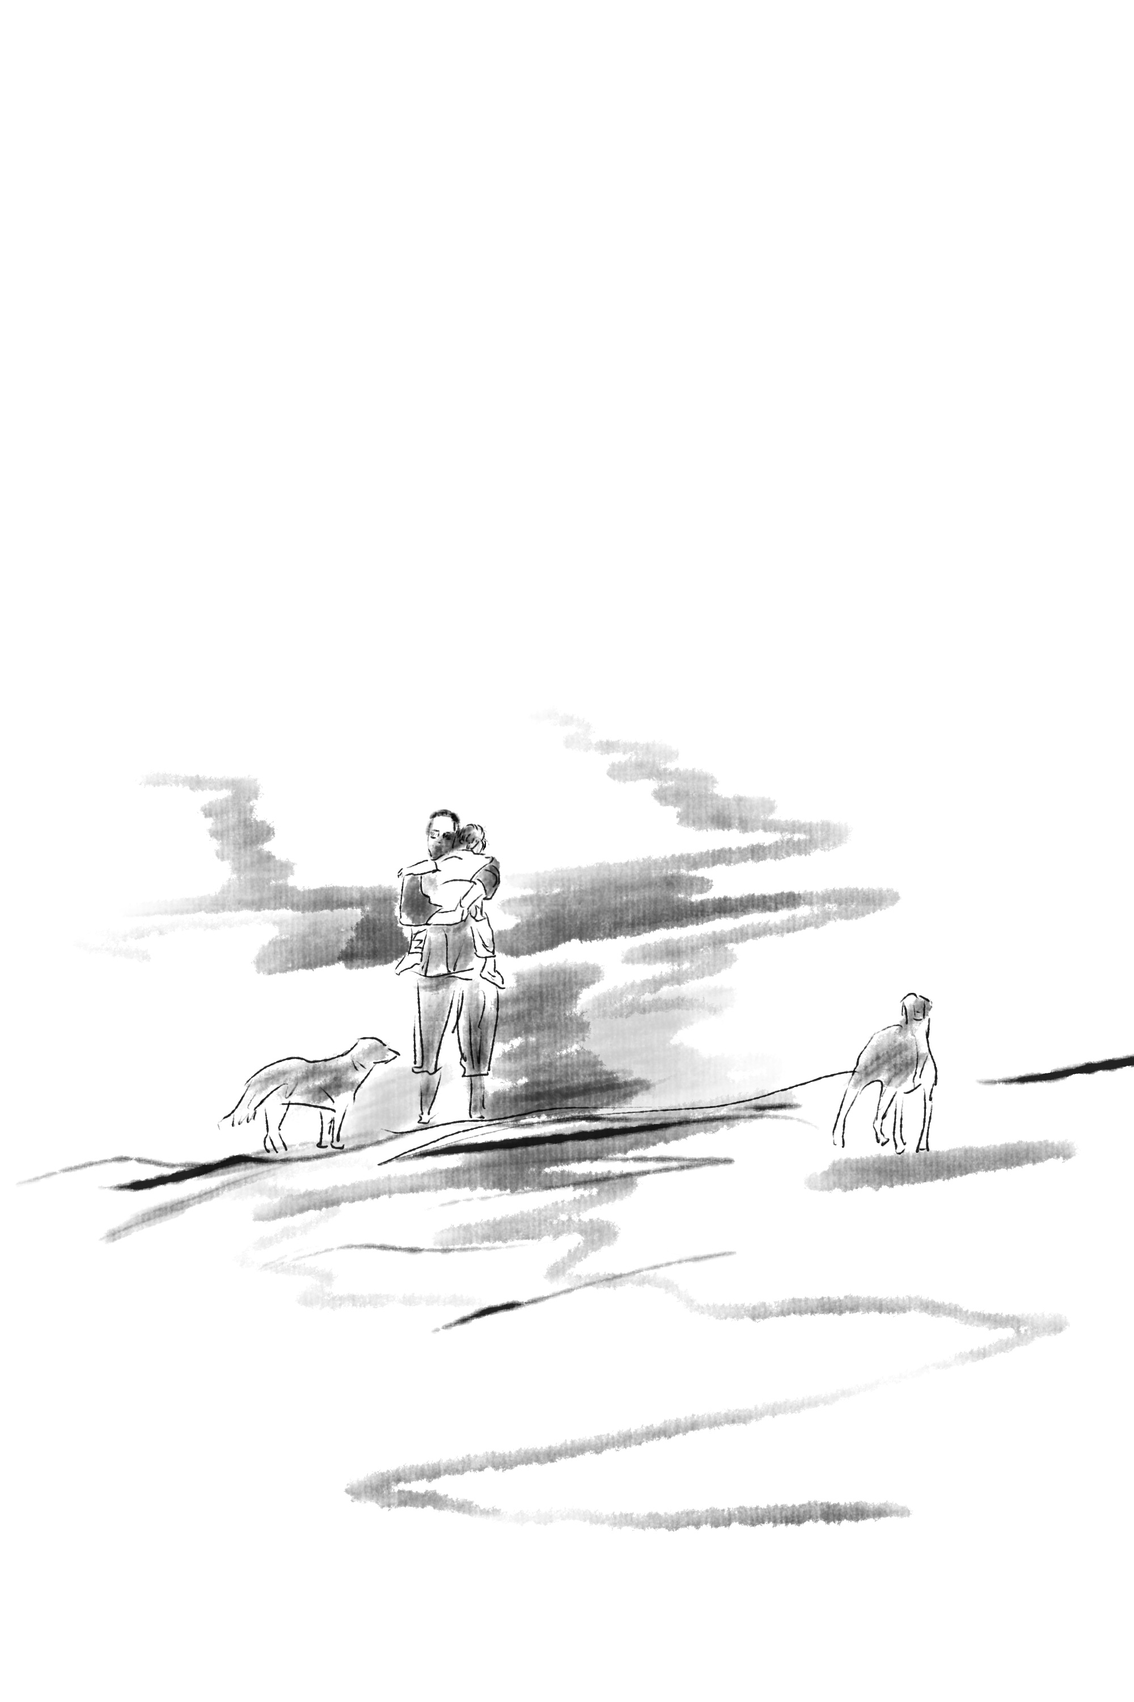
(Figure 8).
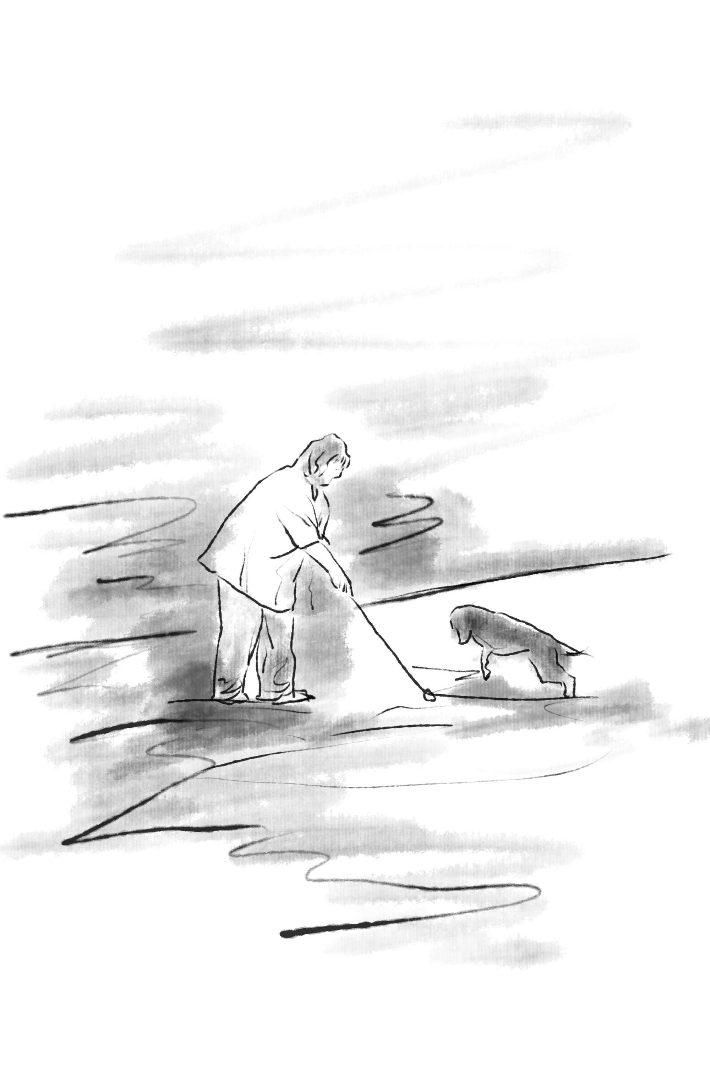
(Figure 9).

According to Rosenblatt and Thickstun (1994), intuition occurs when a pattern of perception unconsciously matches another previously stored pattern of perception in memory. This human collective activity directly appeals to me (Figure 10), as I am someone who enjoys bustling scenes. During my meditative movements, it seems like the images have already appeared on the canvas, and I do not need to think about the positions of the figures; the brush seems to automatically handle the composition. I can feel the subtle differences in emotional states when sketching an individual during meditative movements compared to sketching a group of people. Therefore, this artwork (Figure 11) still depicts a lively scene, where the people in the composition are not sharply defined. My intuition did not instruct me to meticulously capture the facial features of certain individuals or the entire group. I simply felt the urge to paint, and without much thought, ink was placed unexpectedly on the canvas. Yet, I enjoyed this process and found it relaxing, almost like a form of release.
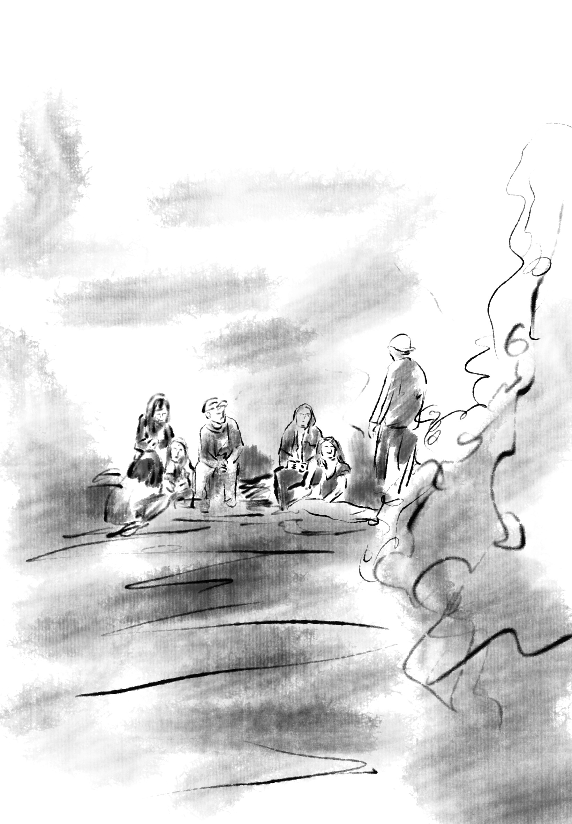
(Figure 10).
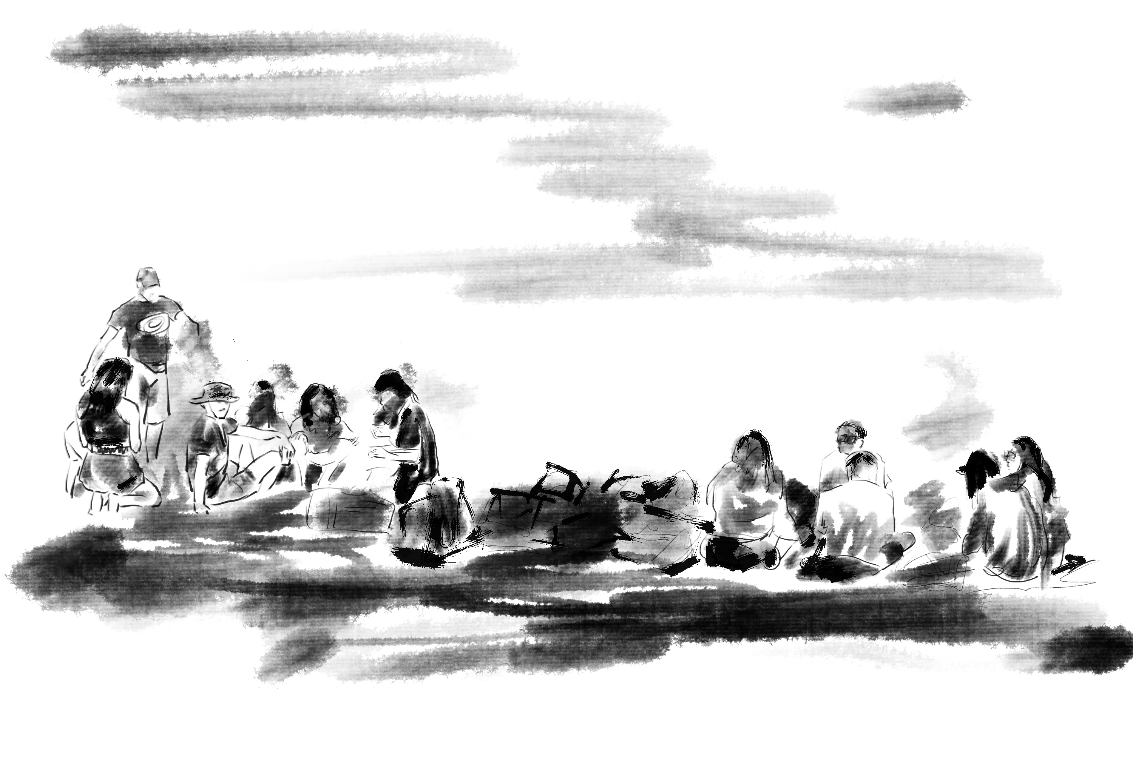
(Figure 11).

This is the only artwork (Figure 12) that I created after interrupting my meditative movements. In that fleeting moment when the person cast their fishing rod, it broke, and I concluded my meditation. However, I seized that moment to create the painting. Interestingly, I felt that interrupting my meditation did not disrupt my state of flow; I thoroughly enjoyed the entire process and even laughed out loud. From my perspective, it was a delightful incident (to express my apology, I offered the painting I made to the person depicted fishing). When the subject itself holds intrinsic appeal, it often maximizes the triggering of flow and the creative capacity of intuition.
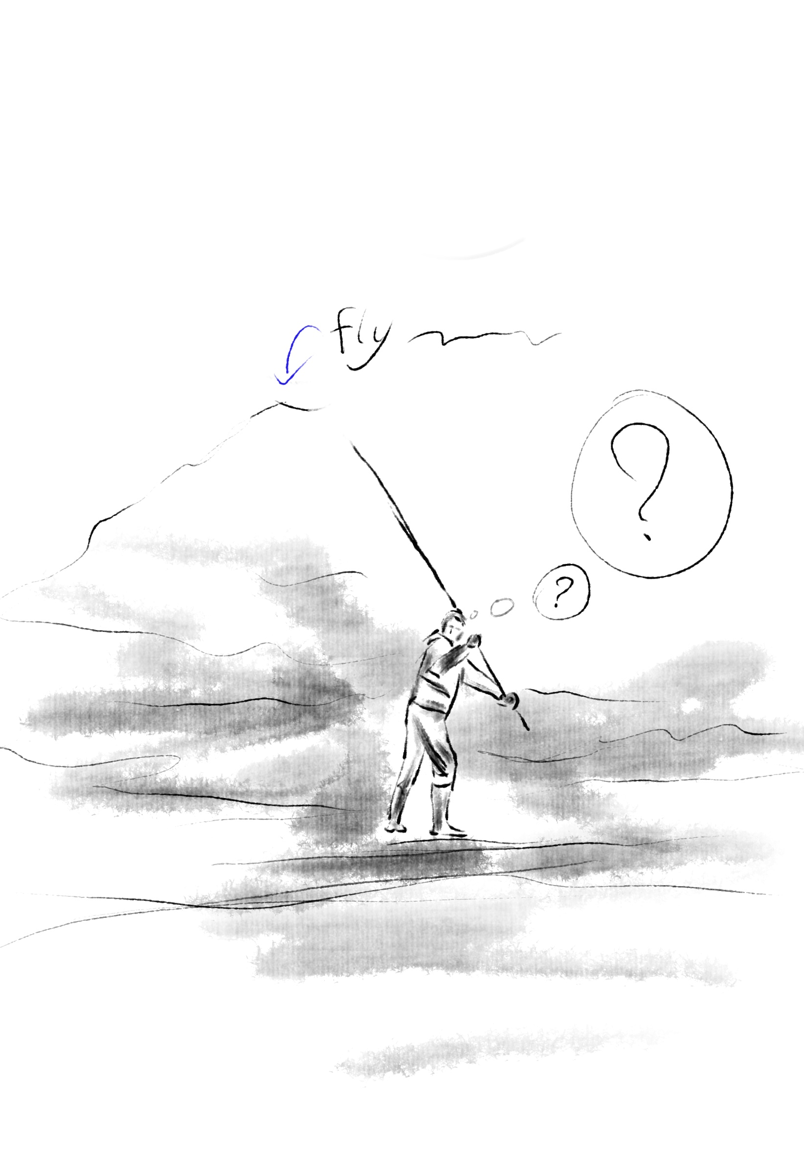
(Figure 12).
In that moment, every stroke I made helped me comprehend the fleeting changes of the body/mind. Through the experimental practice of meditative movements, I experienced both tranquility and eruption in my artistic creation (the serenity of the mind and the burst of the body). My interest lies in the potential of meditative movements, which might be a traditional version of connecting with the ancient creative power of the universe. Although I base my paintings on figures, I seem to be exploring the abstract within the representational. I established a gaze connection with the figures in the painting (Figure 13), and in that moment, I was deeply moved. My intuition seized upon the two pairs of eyes in the midst of eye contact, and with a calm gaze, I swiftly put my pen to paper. Everything continued to happen naturally and effortlessly. The intuitive creativity brought about by meditation allowed me to maintain a state of flow throughout the process of painting. I find myself increasingly relying on simple, unstructured lines, constantly simplifying my compositions (Figure 14). When two figures lean against each other, I wish to complete it using just a single stroke. This also made me realize that the final presentation of the artwork partly depends on my artistic experience (professional skill). However, in the exploration of creativity after meditation, it remains a positive and enriching process.

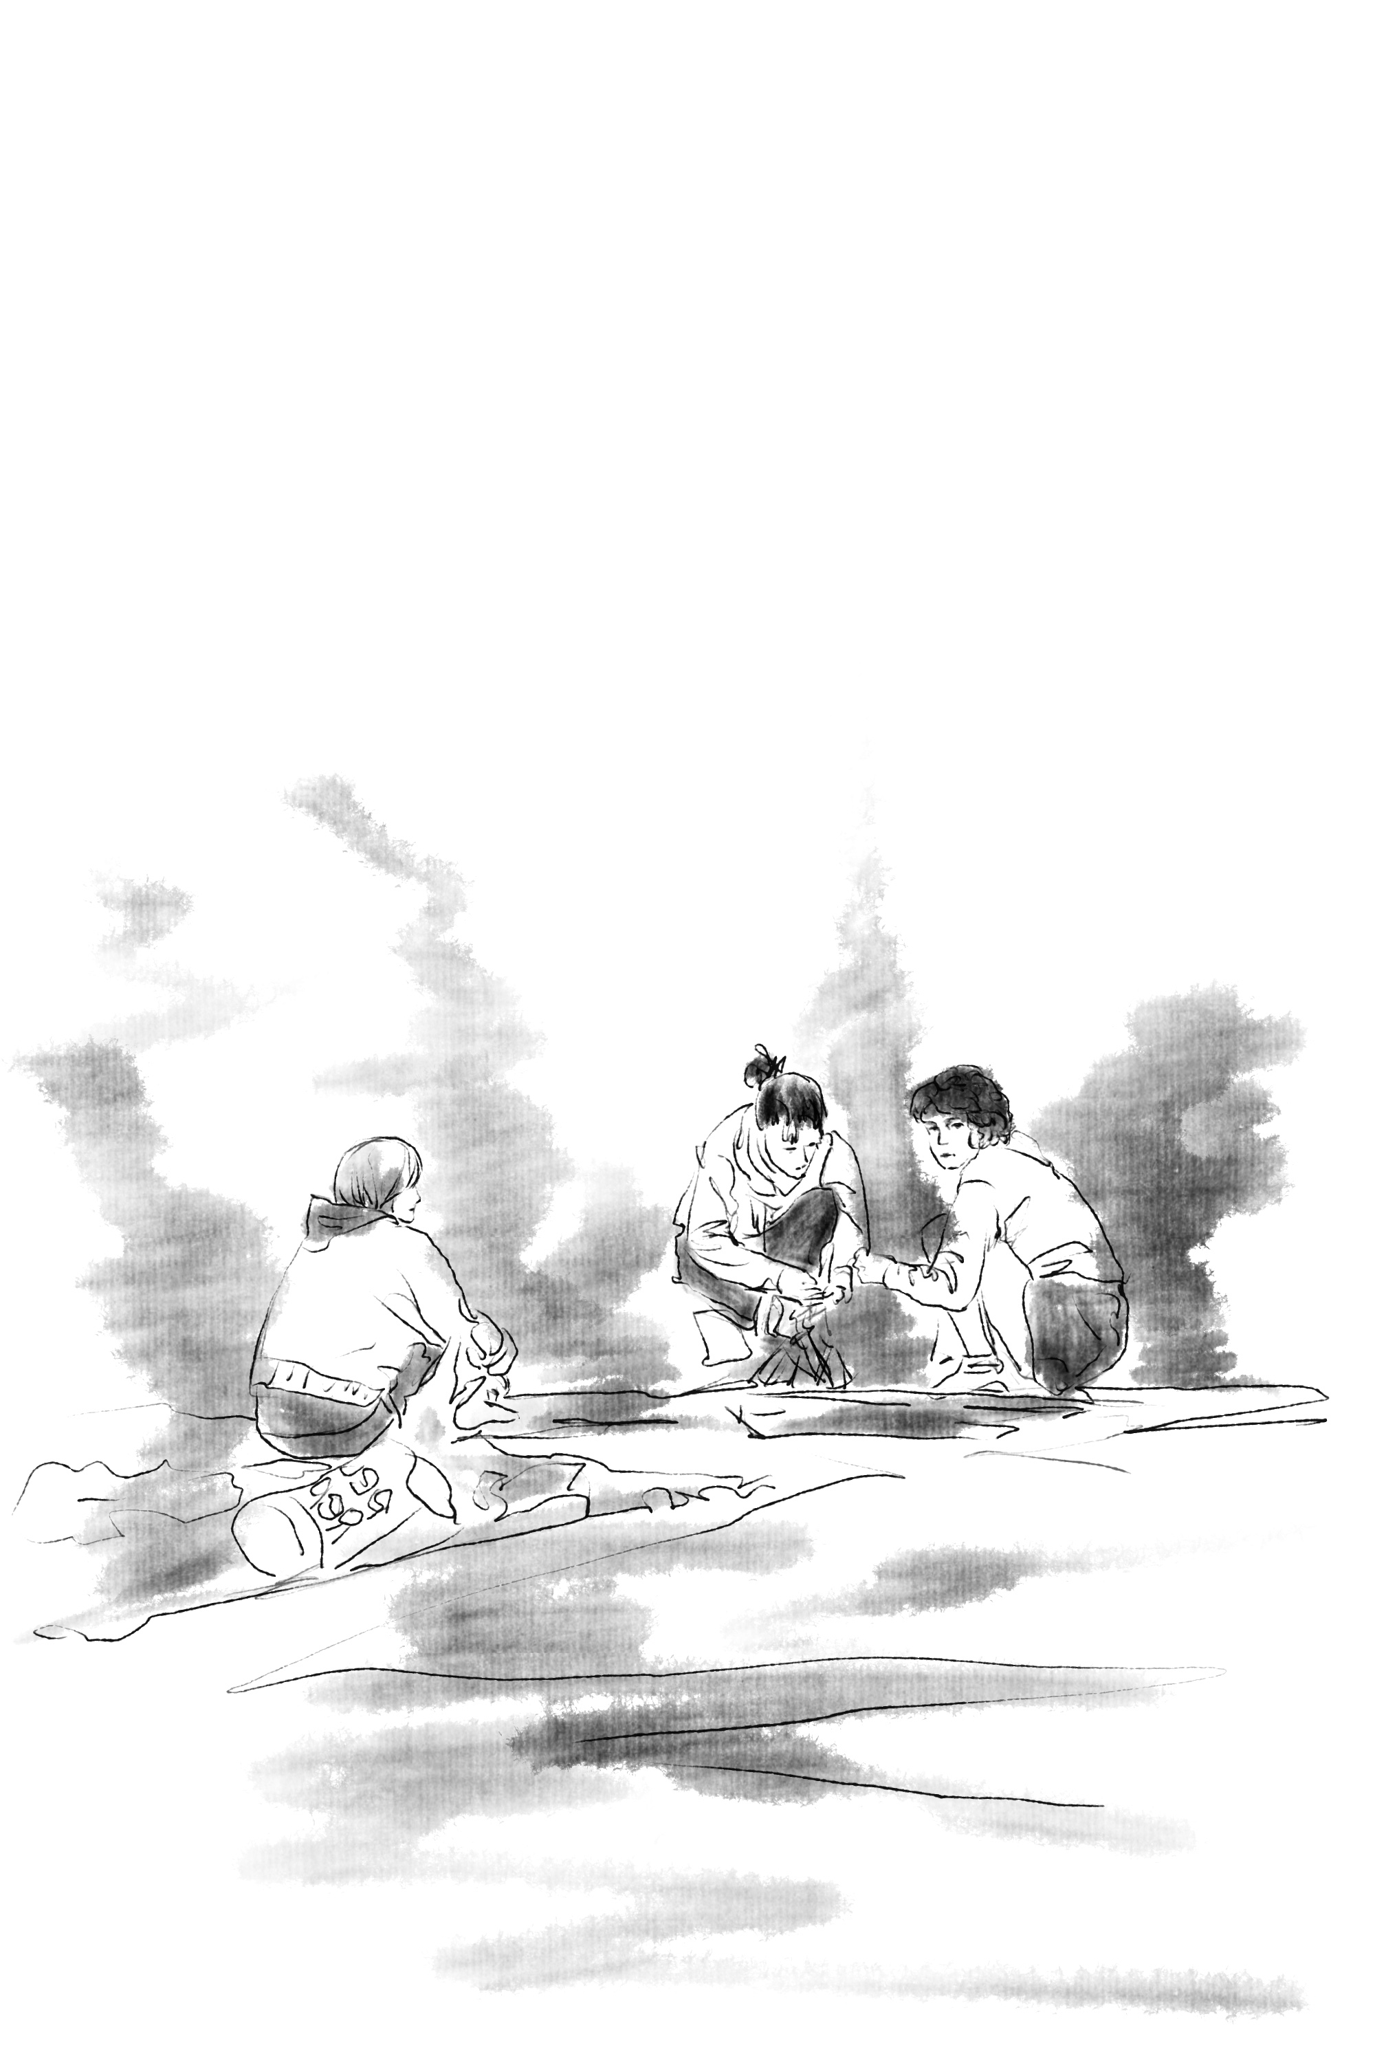
(Figure 13).
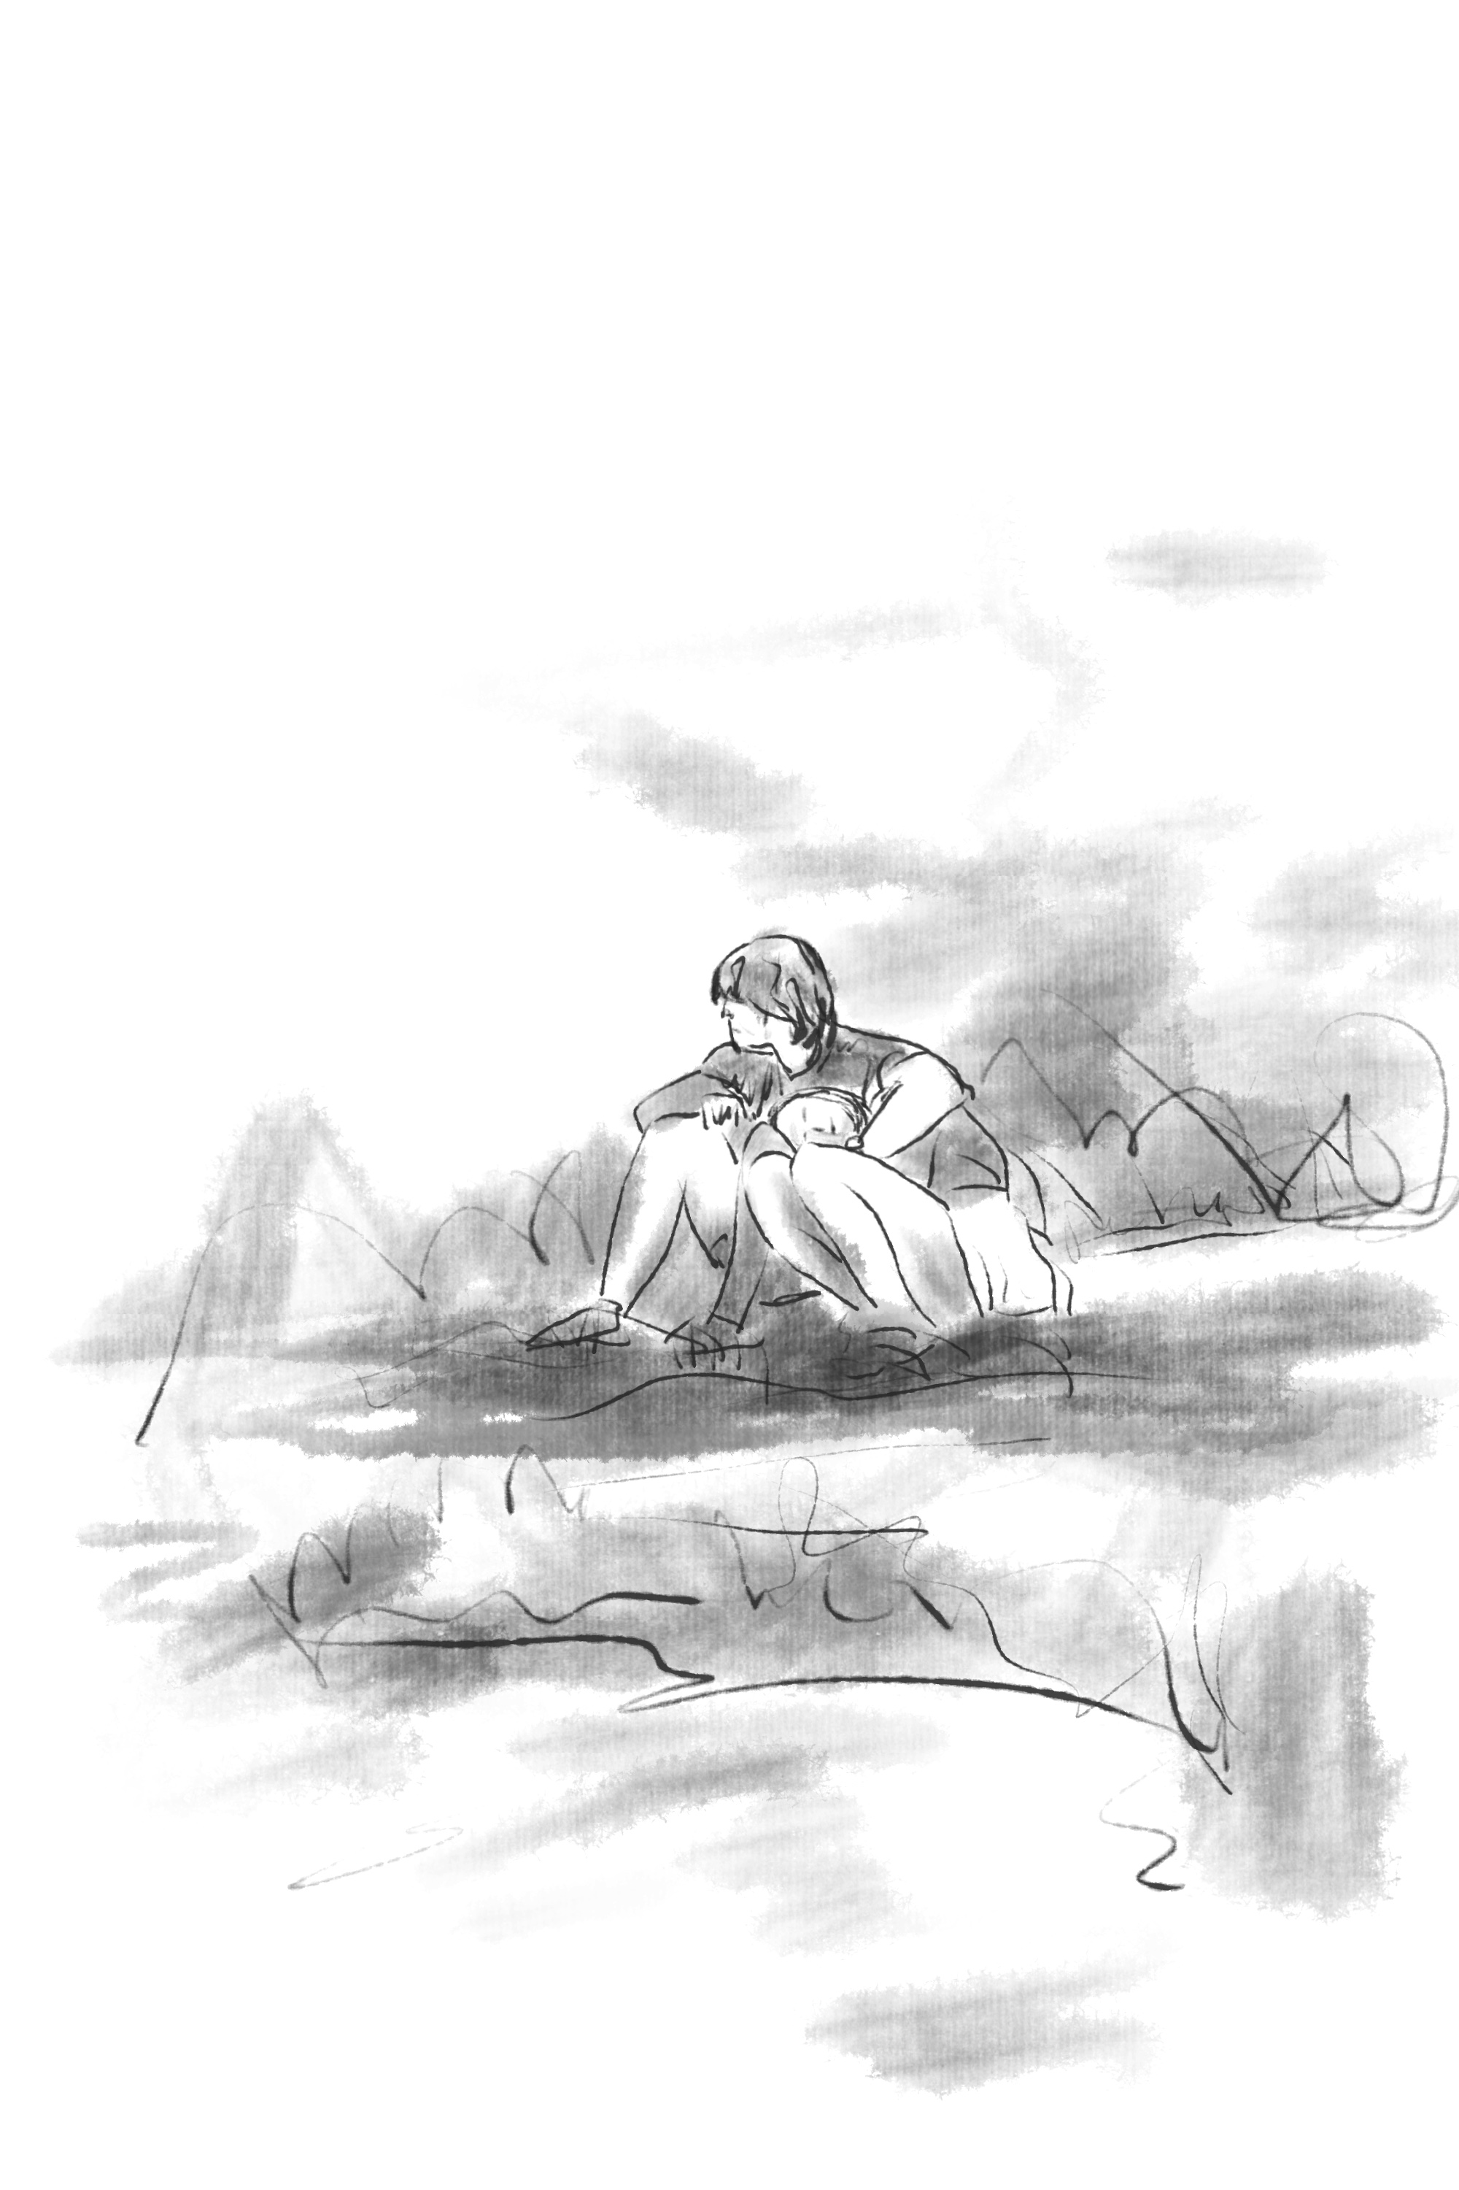
(Figure 14).

What I see before me is a simple humanoid shape and the complex interactions between the environment and the figure, stimulating my intuition. Meditation allows my consciousness to become "void," enabling me to fully believe in the power of intuition, which is a crucial process for creativity. The exploration of intuition through meditative movements has transformed into an exercise of self-awareness. As I paint, I increasingly realize that my body and mind can perceive the processes occurring within my body and in the surrounding environment. Each stroke is never entirely the same, yet it possesses limitless creative potential. I may use different tools (different brushes, papers, inks, or movements), but the differences in the results are not significant.

- Conclusion:

The daily practice of meditative art, specifically sketching human figures, is a method to deepen one's understanding of creativity in all visual forms. I have arrived at my final conclusion and addressed my initial question: "Can my artistic practice research help artists break free from physical or mental constraints?" In this study, I have identified areas for improvement and how to continuously enhance creativity.

The integration of Taoist Qigong meditation with art allows the artistic process to merge with meditation. By continuously believing in and utilizing intuitive abilities to enter a state of "flow," creativity is enhanced. Through meditative movements, when I clear my mind and attain higher consciousness, I can free myself from the constraints of self-awareness and enter a state of "wu-wei," which literally means "doing nothing." As described by Ito, R. (2021), "wu-wei" refers to a state of natural or peacefulness. It emphasizes the harmonious coexistence of individuals with nature and achieving optimal action by following the natural changes and the principles of Tao. The state of flow in artistic practice arises from "wu-wei" and is balanced with real-life skills.

If possible, Qigong meditation is a path that can be used as a tool and continuously transcended. Although recognizing the metaphysical changes in body and mind in practice may not be easy, I believe they will be manifested in meditative art practice. In other words, if transcendence or the ultimate goal is to achieve high levels of physical and mental awareness and development, then meditation becomes a continuous development or growth that signifies creative living in daily life. Progress in practice does not lie.

In conclusion, the integration of meditative movements and art practice has the potential to unlock new levels of creativity, allowing artists to tap into their intuition and achieve a state of "flow" in the artistic process. The continuous development of meditative art practice can lead to enhanced artistic expression and self-awareness, making it a valuable tool for artists seeking to push the boundaries of their creativity.

- Reference

Barr, N. (2018). Intuition, reason, and creativity: An integrative dual-process perspective. The new reflectionism in cognitive psychology, 93-118.）

Cardoso, R., de Souza, E., Camano, L., & Leite, J. R. (2004). Meditation in health: an operational definition. Brain research protocols, 14(1), 58-60.

Coburn, S. (2010). Assigning Value to Intuitive Dimensions in Creativity.

Csikszentmihalyi, M. (1975). Beyond Boredom and Anxiety: Experiencing Flow in Work and Play.San Francisco: Jossey-Bass.

Duggan, W. (2013). Strategic intuition: The creative spark in human achievement. New York, NY: Columbia University Press.

Erickson, D. L. (2011). Intuition, telepathy, and interspecies communication: A multidisciplinary perspective. NeuroQuantology, 9(1).

Gardner, H., & Nemirovsky, R.L. (1991). From private intuitions to public symbol systems: An examination of the creative process in Georg Cantor and Sigmund Freud.Creative Research Journal, (4), 1-21.

Hsieh, S. L. (2010). Buddhist meditation as art practice: art practice as Buddhist meditation.University of Northumbria at Newcastle (United Kingdom).

Hunt, V. V. (1996). Infinite mind: Science of the human vibrations of consciousness. (No Title).

Ito, R. (2021). Tanden art-making as contemplative practice (Doctoral dissertation, Lesley University).

Jobs, S. (2005). His 2005 commencement address at Stanford University.

Jung, C. G. (2007). Psychological types (p. 287). Obscure Press.

Masters, J. (1995). 'The History of Action Research'. In I. Hughes (ed.), Action Research Electronic Reader, The University of Sydney. http://www.behs.cchs.usyd.edu.au/arow/Reader/rmasters.htm

May, Wanda T. (1993). Teachers-as-Researchers or Action Research: What Is It,and What Good Is It for Art Education? Studies in Art Education, Vol. 34, No, 2(Winter 1993): pp. 114-126. http://www.jstor.org/stable/1320448

Monet, C. (1976). Impression Sunrise. Athena International.

Payne, P., and Crane-Godreau, M. A. (2013). Meditative movement for depression and anxiety.Front Psychiatry 4:71. doi: 10.3389/fpsyt.2013.00071

Policastro, E. (1995). Creative intuition: An integrative review. Creativity Research Journal, 8(2),99-113.

Pölönen, P., Lappi, O., & Tervaniemi, M. (2019). Effect of meditative movement on affect and flow in Qigong practitioners. Frontiers in Psychology, 10, 2375.Publishing, 1996.

Raidl, M. H., & Lubart, T. I. (2001). An empirical study of intuition and creativity. Imagination,Cognition and Personality, 20(3), 217-230.

Rosenblatt, A. D., & Thickstun, J. T. (1994). Intuition and consciousness. The Psychoanalytic Quarterly, 63(4), 696-714.

Schmalzl, L., Crane-Godreau, M. A., and Payne, P. (2014). Movement-based embodied contemplative practices: definitions and paradigms. Front. Hum. Neurosci. 8:205. doi:10.3389/fnhum.2014.00205

Taura, T. (2016). Creative design engineering. Waltham, MA: Elsevier.

Taura, T., & Nagai, Y. (2012). Concept generation for design creativity – A systematized theory and methodology. London: Springer.

Taura, T., & Nagai, Y. (2017). Creativity in Innovation Design: the roles of intuition, synthesis, and hypothesis. International Journal of Design Creativity and Innovation, 5(3-4), 131-148.

Wallas G. (1926). The Art Of Thought. New York, NY: Harcourt Brace.

Xinyu ,Y.(2023).The Art Practice 1 [Photograph].
Xinyu ,Y.(2023).The Art Practice 2 [Photograph].
Xinyu ,Y.(2023).The Art Practice 3 [Photograph].
Xinyu ,Y.(2023).The Art Practice4 [Photograph].
Xinyu ,Y.(2023).The Art Practice 5 [Photograph].
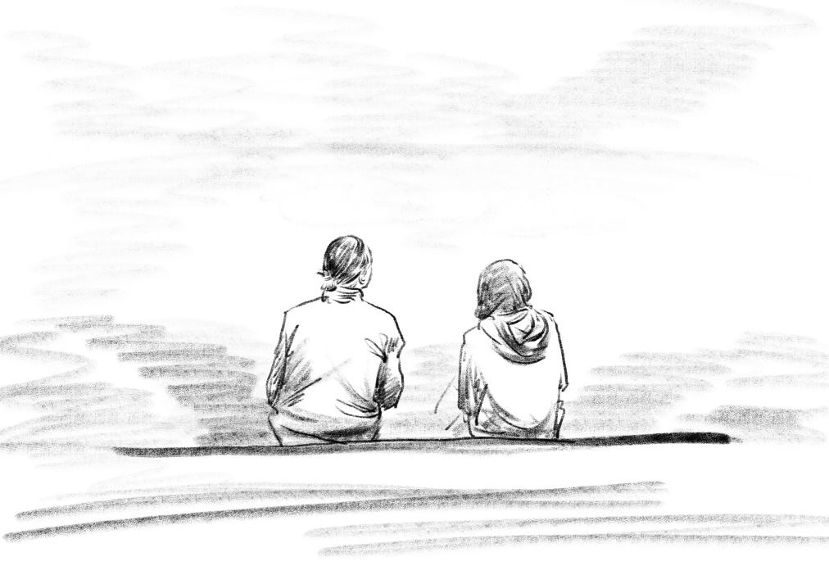
Xinyu ,Y.(2023).The Art Practice 6 [Photograph].
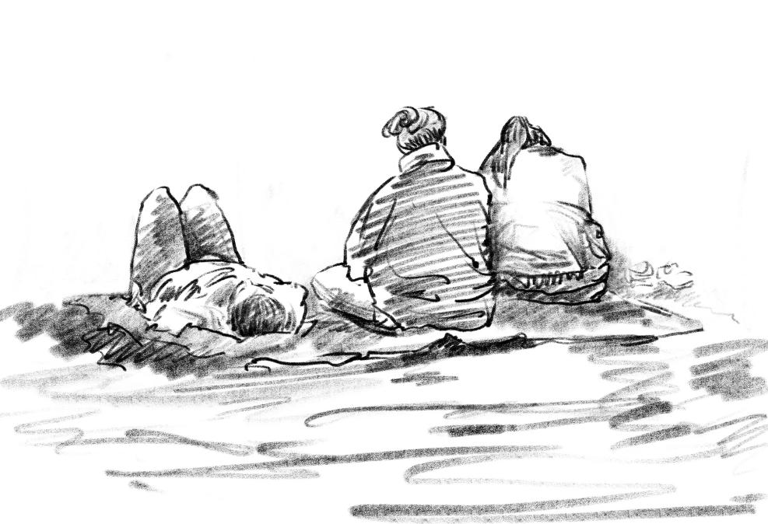
Xinyu ,Y.(2023).The Art Practice 7 [Photograph].
Xinyu ,Y.(2023).The Art Practice 8 [Photograph].
Xinyu ,Y.(2023).The Art Practice 9 [Photograph].
Xinyu ,Y.(2023).The Art Practice 10 [Photograph].
Xinyu ,Y.(2023).The Art Practice 11 [Photograph].
Xinyu ,Y.(2023).The Art Practice 12 [Photograph].
Xinyu ,Y.(2023).The Art Practice 13 [Photograph].
Xinyu ,Y.(2023).The Art Practice 14 [Photograph].

