Lab –2
Andom Fekadu Alemayo
P151438
After downloading the VM and installing the cybercops workstation on the virtual machine as it can be seen on the screen below.

Installing the Mininet
The Mininet was installing after running the python script command and inserting the password cybercops on the prompt see the screen grab below.

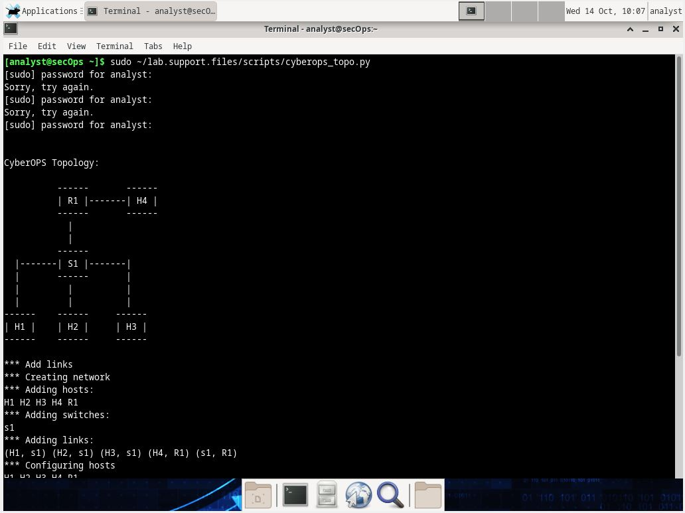

Entering the IP address on the nodes to verify the IP v4 address and recording the MAC address.
- Entering the IP address command on node : H1
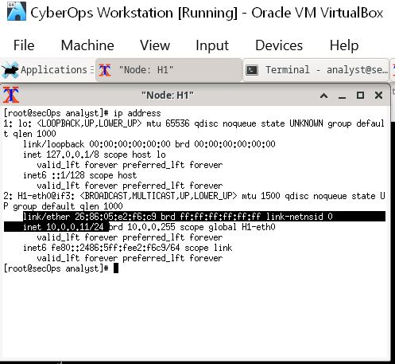

- Entering the IP address command on node: H2
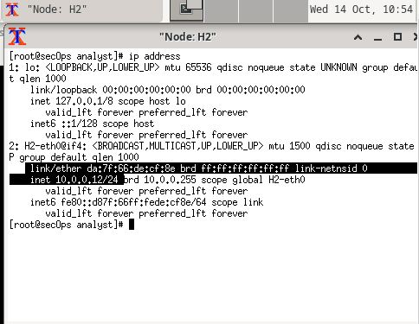

Capture and analysis of ICMP data in Wireshark
After entering the command Wireshark & on H1, the Wireshark Window was started as it can be seen below. Then the H1-eth0 interface was also selected.
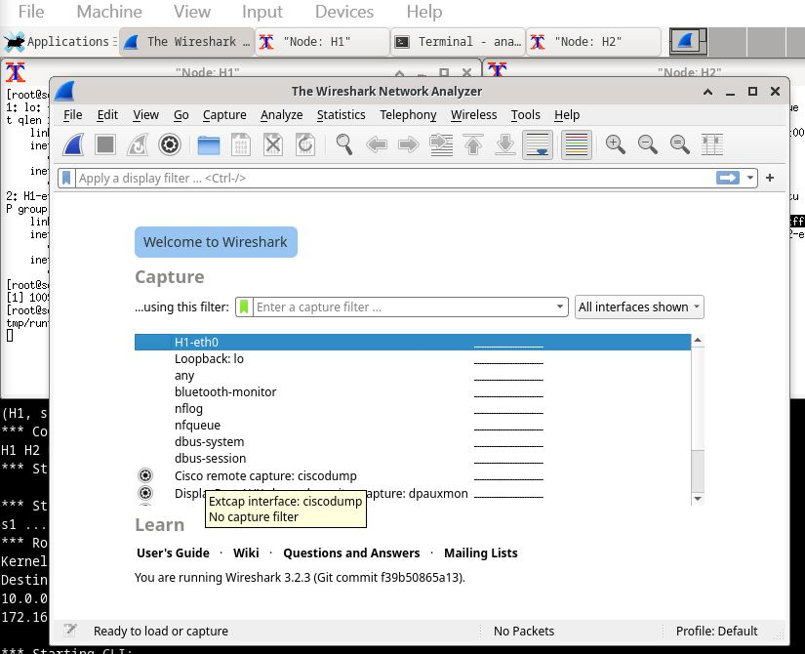

After entering the command ping -c5 10.0.0.12 on node H1 the Wireshark window was populated.
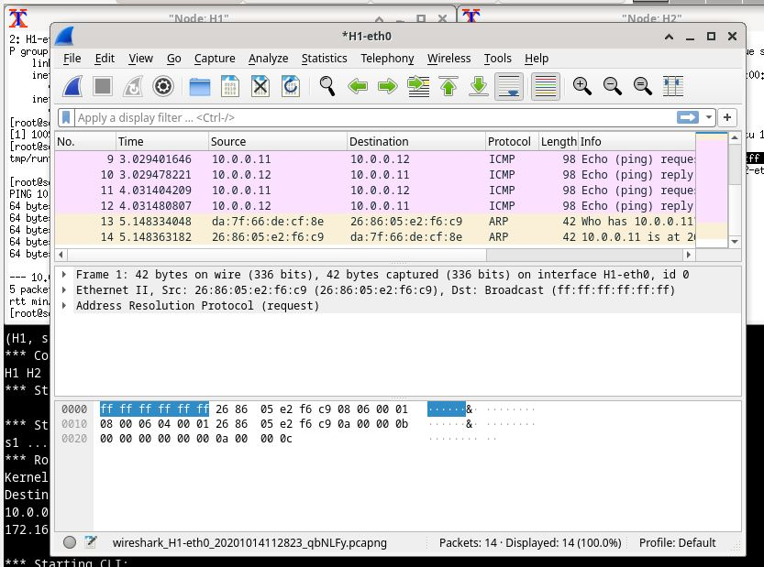
And then the ICMP packets only displayed by filtering them through the filter.

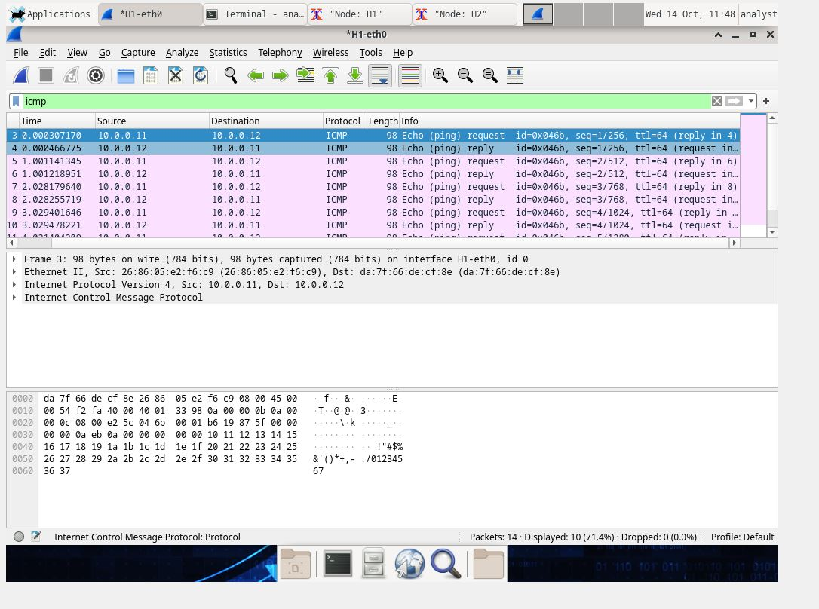
By clicking on the on ether 11, the destination and the source of the frames can be easily identified. See the screenshot below.
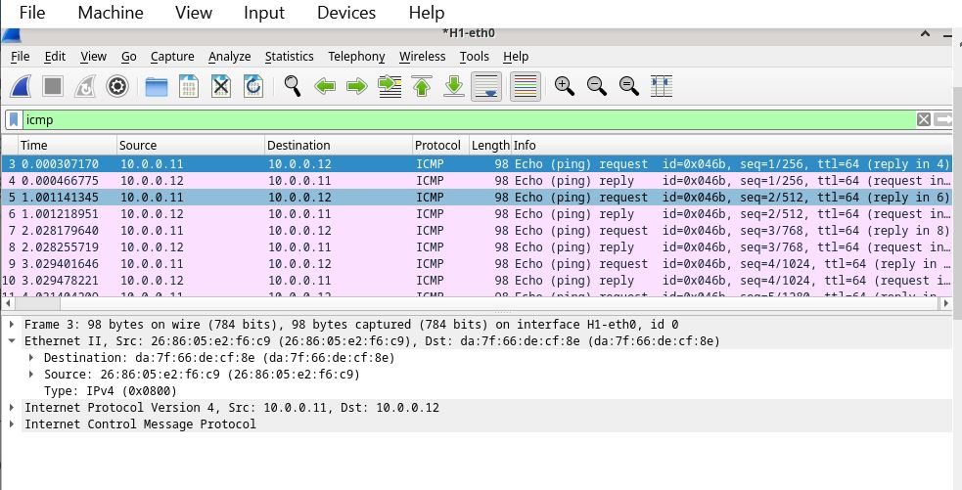
Reflections
- Yes, the source MAC address match H1’s interface.
- Yes, the Destination MAC address in the Wireshark matches H2 MAC adress.
Verifying the ip address of H4
The display below shows the MAC address and the IP address of H4

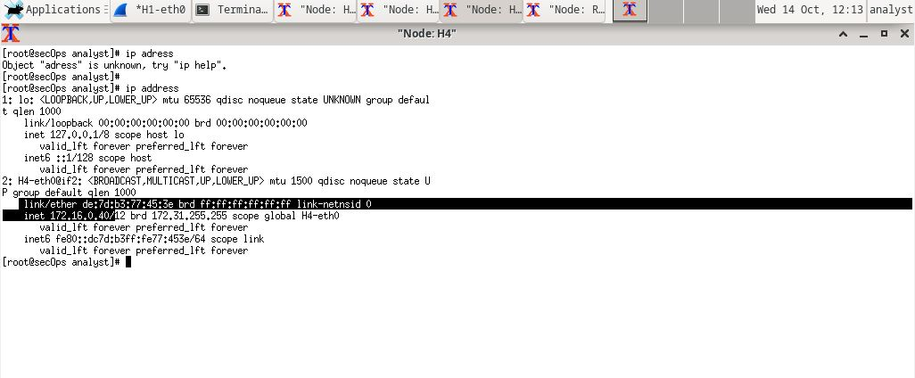
The display below shows the MAC address and the IP address of R1.
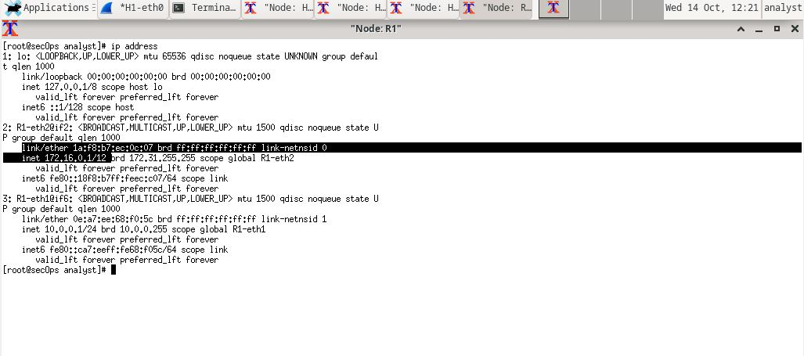
Below are the Mac and IP addresses of H1 and R1.
Host-interface | IP Address | MAC address
H4-eth0 | 172.16.0.4 | De:7d:b3:77:45:3e
R1-eth1 | 172.16.0.1/12 | 1a:f8:b7:ec:0c:07
R1-eh2 | 10.0.0.1 | 0e:a7:ee:68:f0:5c

Traceroute
Pinging to remote server (www.cisco.com).
After executing the command ping -c 4 www.cisco.com the following output was obtained.
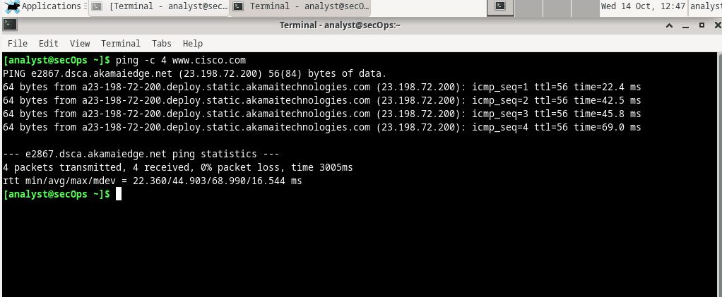
After bridging the adapter the remote server www.cisco.com was tracerouted.

