
UNIVERSITY OF WALES TRINITY SAINT DAVID
Swansea Business School

The Influence of Perceived Line-Manager Leadership Behaviour on Employee Job Satisfaction among UK Retail Employees: A Quantitative Survey Study

A dissertation submitted in partial fulfilment of the requirements for the degree of Master of Business Administration (MBA)

Noman Saddiquee
Student ID: 2510122

Module: BMMB7003 Dissertation
Supervisor: David Greenshields

2025-26

DECLARATION
This work has not previously been accepted in substance for any degree and is not being concurrently submitted in candidature for any degree.

Signed ...................... Noman Saddiquee................................................
Date .........................25/09/2026...............................................

STATEMENT 1
This work is the result of my own investigations, except where otherwise stated.
Other sources are acknowledged by footnotes giving explicit references. A bibliography is appended.

Signed ...................... Noman Saddiquee................................................
Date .........................25/09/2026...............................................

STATEMENT 2
I hereby give consent for my work, if accepted, to be available for photocopying and for inter-library loan, and for the title and summary to be made available to outside organisations.

Signed ...................... Noman Saddiquee................................................
Date .........................25/09/2026...............................................

ACKNOWLEDGEMENT
I would like to thank my dissertation supervisor, David Greenshields, for his guidance, constructive feedback and ongoing academic support during this research. He gave valuable advice for refining the study, clarifying the analysis, and improving the overall quality of the dissertation.
Finally, I would like to thank all the respondents for taking the time to fill out the survey. This study would not have been possible without their answers and the evidence they supplied for the analysis of line-manager leadership behaviour and employee job satisfaction in the retail sector of the UK.
I would also like to thank the University of Wales Trinity Saint David and the academic staff for their help during the programme.
Last but not least, I would like to express my gratitude to my family and friends for their patience, encouragement and support during my studies and the writing of this dissertation. They were very motivating for me when I was at my most difficult moments during research.

ABSTRACT
In the UK retail industry, employee job satisfaction is a major issue because of high staff turnover, the challenging nature of the working environment and the regular contact employees have with frontline supervisors, as the quality of line management is especially relevant. This study investigated the link between employees' perceptions of leaders' leadership behaviour and job satisfaction among non-managerial workers in the UK retail industry. The research was based on Transformational Leadership Theory, Herzberg's Two-Factor Theory and Path-Goal Theory, differentiating between supportive/transformational, transactional/directive and corrective/passive leadership behaviours.
A positivist, deductive and mono-method quantitative approach was followed, which uses a cross-sectional online survey. A total of 180 retail workers who were not managers were drawn for the data, and IBM SPSS Statistics software was used to analyse the data. Descriptive statistics, Cronbach's alpha reliability testing, Pearson correlation, simple and multiple linear regression, independent samples t-test and one-way ANOVA were performed.
The results showed that job satisfaction of the employees was significantly associated with perceived leadership behaviour. The two types of leadership that were positively associated with overall levels of job satisfaction were supportive/transformational leadership and transactional/directive leadership. Job satisfaction was significantly and negatively associated with corrective/passive leadership. The overall job satisfaction was explained by the three leadership dimensions in the leadership-only regression model, which accounted for 26.3% of the variance. Demographic differences were generally small, and intrinsic satisfaction was more related to overall job satisfaction than was extrinsic satisfaction. There were no significant differences in satisfaction between gender, age and role level, but organisation size was found to be statistically significant.
The study concludes that effective line-manager behaviour is an important, but not exclusive, influence on job satisfaction in UK retail. It is important that retail organisations start to develop supportive leadership, provide better clarity and feedback, minimise passive leadership, and integrate leadership development with broader efforts to redesign jobs and support employees. The study also provides sector-specific quantitative evidence to complement existing, rather limited, UK-based retail research.

Keywords: Line-manager leadership; employee job satisfaction; transformational leadership; transactional leadership; passive leadership; UK retail sector; employee experience; quantitative research

Table of Contents
DECLARATION 2
ACKNOWLEDGEMENT 3
ABSTRACT 4
Table of Contents 6
CHAPTER ONE: INTRODUCTION 9
1.1 Background of the Study 9
1.2 Problem Statement 10
1.3 Research Aim 11
1.4 Research Objectives 11
1.5 Primary Research Question 11
1.6 Sub-Questions 11
1.7 Significance of the Study 12
1.8 Structure of the Study 12
1.9 Chapter Summary 13
CHAPTER TWO: LITERATURE REVIEW 14
2.1 Introduction 14
2.2 Conceptualising Leadership: Definitions and Evolving Perspectives 14
2.3 The Line Manager's Role and Its Impact on Employees 15
2.4 Employee Job Satisfaction: Conceptual Foundations and Measurement 16
2.5 Leadership Behaviour and Job Satisfaction: Empirical Evidence 17
2.6 Job Satisfaction in the UK Retail Sector: Specific Contextual Factors 18
2.7 Critical Evaluation of the Literature 19
2.8 Theoretical Frameworks 20
2.8.1 Transformational Leadership Theory (Bass, 1985; Burns, 1978) 20
2.8.2 Herzberg's Two-Factor Theory (Herzberg, Mausner and Snyderman, 1959) 22
2.8.3 Path-Goal Theory (House, 1971; House and Mitchell, 1974) 23
2.9 Conceptual Framework and Hypothesis Development 23
2.10 Chapter Summary 25
CHAPTER THREE: RESEARCH METHODOLOGY 27
3.1 Introduction 27
3.2 Research Rationale and the Research Onion 27
3.3 Research Philosophy 28
3.4 Research Approach to Theory Development 29
3.5 Methodological Choice and Research Strategy 30
3.6 Data Collection Method and Instrument 30
3.7 Population and Sampling 32
3.8 Data Analysis 32
3.9 Reliability and Validity 33
3.10 Limitations of the Research 34
3.11 Research Ethics 34
3.12 Chapter Summary 35
CHAPTER FOUR: DATA ANALYSIS AND FINDINGS 36
4.1 Introduction 36
4.2 Data Screening, Coding and Response Profile 36
4.3 Findings 39
4.3.1 Demographic Profile of Respondents 39
4.3.2 Reliability of the Measurement Scales 44
4.3.3 Descriptive Statistics for the Composite Variables 45
4.3.4 Correlation Analysis 46
4.3.5 Multiple Regression Including Leadership and Satisfaction Facets 48
4.3.6 Simple Regression: Overall Leadership and Overall Job Satisfaction 50
4.3.7 Leadership-Only Multiple Regression: Direct Test of H1-H3 51
4.3.8 Demographic Differences in Overall Job Satisfaction 53
4.4 Summary of Hypothesis Testing 57
4.5 Chapter Summary 57
CHAPTER FIVE: DISCUSSION OF FINDINGS 59
5.1 Introduction 59
5.2 Leadership Behaviour and Employee Job Satisfaction 59
5.3 Intrinsic and Extrinsic Satisfaction 60
5.4 Demographic Differences and H4 61
5.5 Overall Synthesis of the Findings 62
CHAPTER SIX: CONCLUSIONS AND RECOMMENDATIONS 63
6.1 Introduction 63
6.2 Evaluation of the Validity of the Data Analysis 63
6.3 Conclusions in Relation to the Research Aim and Objectives 65
6.4 Implications for Management Practice 66
6.5 Practical Recommendations 67
6.6 Recommendations for Further Research 69
6.7 Final Conclusion 70
REFERENCES 71
Appendices 78
Appendix A: Survey Questionnaire 78
Appendix B: Supporting Files 84

CHAPTER ONE: INTRODUCTION

1.1 Background of the Study
The retail sector is central to the economic life of the United Kingdom, accounting for around £394 billion in total retail sales each year and over 3 million workers in a variety of retail outlets from large chain supermarkets to specialist shops and the emerging online retail sector (British Retail Consortium, 2023). The industry is considered to be of great economic importance, but suffers from long-standing employee turnover. According to a 2024 report from the Chartered Institute of Personnel and Development (CIPD), turnover in the retail sector was around 41.6% per year, well above the UK cross-sector average of around 22% (CIPD, 2024). This chronic fluctuation of staff can have a significant financial and operational impact on organisations, with the replacement cost of one frontline employee coming in at between £1,500 and £3,000 after taking into account recruitment, induction and lost productivity (Taylor, 2023).
Retail employee churn is tightly tied to employee satisfaction in general. Multiple studies have shown that workers whose job satisfaction results are high are much less likely to voluntarily quit their job in the organisation (Locke, 1976; Spector, 1997). Employees' interactions with their co-workers and direct supervisors are a key factor in satisfaction and retention: 51% of those who left their companies in the past six months said that a lack of belonging and appreciation from management was a major reason for their departure (McKinsey & Company, 2022). In the retail setting, where frontline employees are likely to have limited autonomy and deal with high-stress situations with customers frequently, the immediate line manager becomes especially significant.
The focus of scholarly research on line-manager level leadership behaviour has increased in the last two decades. Line managers are those who have a direct responsibility for the team's operational outputs and are held accountable by members of the organisational strategy team, and represent the main interface between organisational strategy and frontline practice (Purcell and Hutchinson, 2007). They are known to influence employee engagement and satisfaction in relation to their behaviours towards communication, support, recognition, task delegation and performance feedback (Harter et al., 2002; Macey and Schneider, 2008). Only 47% of employees in the UK said their line manager was an effective people manager, highlighting the significant scope for improvement in some sectors, including retail, where management quality is particularly critical, according to the CIPD's Good Work Index 2023.
There is a strong theoretical basis for exploring the connection between leadership behaviour and job satisfaction. The theories of transformational leadership (Bass, 1985; Burns, 1978), transactional leadership (Burns, 1978) and Path-Goal (House, 1971) are each complementary in explaining how supervisory behaviour affects employee outcomes. Furthermore, Herzberg's Two-Factor Theory (1959) highlights the difference between intrinsic motivators (recognition, responsibility, personal development, etc.) and extrinsic hygiene factors (pay, working environment, etc.) and all these two types of factors are controlled by the day-to-day decisions of the line manager.
The theoretical depth of this area is relatively high, but empirical studies focusing on the UK retail sector, specifically on perceived leadership behaviours of line managers and the quantitative relationships between perceived behaviours and employee job satisfaction, are relatively scarce. The existing literature focuses on examining leadership in broader organisational contexts (Bass and Riggio, 2006) or on qualitative case studies within a single organisation (Purcell and Hutchinson, 2007), or on examining the intention to turn over the organisation rather than job satisfaction itself (Griffeth et al., 2000). Therefore, this study addresses a gap in the literature and uses a quantitative survey design to investigate the perceived leadership behaviours of line managers and how these behaviours relate statistically to self-reported job satisfaction among retail employees.

1.2 Problem Statement
The retail industry is in a difficult situation in the UK as it tries to keep its business afloat, while simultaneously keeping a large group of employees happy and ensuring they stay on board. The above evidence suggests that the role of the immediate supervisor in shaping employees' perceptions of their job satisfaction is one of the strongest, yet the leadership behaviours enacted by line managers within retail organisations in the UK have not been sufficiently explored using rigorous quantitative studies. Without such proof, retail organisations have no solid empirical foundation for crafting specific management development initiatives that could enhance satisfaction and lower the expense of employee turnover.
This study seeks to tackle the problem by examining the following: There is a substantive but little-studied relationship between the perceived leadership behaviour of line managers and job satisfaction of frontline retail employees in the United Kingdom. If there are no clear quantitative relationships, human resource practitioners and retail managers can't know if they can improve employee satisfaction, and consequently retention, through line-manager training and behavioural development.

1.3 Research Aim
The aim of this research is to examine the relationship between perceived line manager leadership behaviour and employee job satisfaction among non-managerial employees in the UK retail sector.

1.4 Research Objectives
In pursuit of the stated aim, the following objectives guide the inquiry:
- To identify the key line manager leadership behaviours perceived by UK retail employees.
- To measure employee job satisfaction across selected intrinsic and extrinsic work factors.
- To examine the statistical relationship between perceived line manager leadership behaviour and employee job satisfaction.
- To compare reported job satisfaction across selected demographic groups, including age, gender, role level and organisation size.
- To provide practical recommendations for improving line manager practice and employee satisfaction in UK retail organisations.

1.5 Primary Research Question
To what extent is perceived line-manager leadership behaviour associated with employee job satisfaction among non-managerial retail employees in the United Kingdom?

1.6 Sub-Questions
To provide greater analytical depth, the following subsidiary research questions are pursued:
- What are the predominant leadership behaviours that UK retail employees perceive in their line managers?
- What is the current level of job satisfaction reported by frontline retail employees in relation to intrinsic and extrinsic motivating factors?
- Is there a statistically significant association between perceived line-manager leadership behaviour and employee job satisfaction?
- Do patterns of job satisfaction differ descriptively across demographic sub-groups (age, gender, role level, and organisation size) within the sample?

1.7 Significance of the Study
This research has threefold significance, including theoretical, practical and policy-oriented. Theoretically, the study responds to the increasing number of empirical studies that investigate line-manager leadership in sector-specific settings, and as such, calls for more contextually grounded and quantitative evidence of the mechanisms between supervisory behaviour and employee outcomes called for in the literature (Purcell and Hutchinson, 2007; Yukl, 2013). The context of the study is the UK retail industry, an industry that is fast-paced, has a diverse workforce, and presents unique workplace challenges. Thus, the study has implications beyond current research in the field to other settings.
From a practical perspective, the insights from this research study will be relevant to retail HR, Talent Development Managers and retail Senior Leaders who are looking for facts and figures to support employee engagement and turnover reduction strategies. Retail organisations could be saving millions of pounds in costs and operational efficiency each year with modest improvements in satisfaction based on increased line manager behaviours, given the cost of employee attrition in the UK retail sector is estimated to be over £4.5 billion per year (CIPD, 2024).
In a policy context, the research underpins the wider policy agenda set out by the Taylor Review of Modern Working Practices (2017), which highlighted that good work, quality management and fair treatment of employees form the basis for a productive and sustainable UK economy. Retail is one of the largest private sector employers in the country, and an important source of employment.

1.8 Structure of the Study
This dissertation is organised into six chapters. The research context, problem statement and aim, objectives, research questions and significance of the study have been introduced within Chapter One. A critical review of the relevant research in the academic literature is provided in Chapter Two, which examines the theories of leadership, the actions of line managers, and how this impacts on employee job satisfaction, followed by a discussion of the theoretical frameworks underlying the research. The methodology of the research is explained in Chapter Three, which covers the philosophical paradigm, research design, sampling strategy, research data collection instrument, and analysis method. The results of the quantitative analysis are reported in Chapter Four, comprising descriptive statistics, reliability analysis, cross-tabulations, and correlation findings. Chapter Five discusses the key findings in relation to the literature, addresses the research questions and objectives. The conclusions, implications and recommendations for practice and future research are provided in Chapter Six.

1.9 Chapter Summary
This chapter established the conceptually and empirically foundations of the study. It brought the UK retail sector into focus, a sector with a high turnover rate, a high proportion of low paid, where job satisfaction is pivotal and is continually a concern, evidenced by an annual turnover of 41.6% (CIPD, 2024) and its cost to employers. It then identified the gap in the research as the relationship between leadership and satisfaction in the UK retail context is largely theoretical and there is limited quantitative data available. This gap was used to develop the aim and objectives of the study, the research question and sub questions, the significance of the study and the structure of the dissertation.

CHAPTER TWO: LITERATURE REVIEW

2.1 Introduction
This chapter aims to examine in detail the literature on the main themes of this study, which are leadership behaviours, line manager practices and employee job satisfaction in the retail industry. To this end, the chapter starts with a conceptual understanding of leadership and how it has developed as a field of study and research, and then considers the nature of line management, job satisfaction, and the empirical findings on the relationship between these. Three theoretical frameworks are presented to support the study's analytical approach, followed by a summary of the chapter.

2.2 Conceptualising Leadership: Definitions and Evolving Perspectives
Leadership is one of the most researched and controversial concepts in the field of organisational behaviour. Northouse (2021, p.5) views leadership as 'a process whereby an individual influences a group of individuals to achieve a common goal', with influence, process, and shared goals as its key components. This is a fairly universal definition, in line with Yukl's description of leadership as 'the process of influencing others to understand and agree about what needs to be done and how to do it, and the process of facilitating individual and collective efforts to accomplish shared objectives', (2013, p.7). While both definitions emphasize the relational and goal-oriented aspects of leadership, they both centre on individual influence over structural and contextual issues, issues that have increasingly been factored into more contextually sensitive definitions.
Leadership research has undergone a series of paradigmatic changes over time. Popular in the early 20th century, trait theories defined the effectiveness of leadership in terms of the inherited personal qualities of leaders (Stogdill, 1948). The Ohio State and Michigan studies of the 1950s and 1960s led to the development of theories that proposed that effective leadership comprised of a set of observable behaviours that could be learned - task-oriented and people-oriented behaviours (Fleishman, 1953; Likert, 1961). Contingency theories then went on to suggest that no single style of leadership is always most effective; rather, the required leadership style varies with such contextual factors as follower maturity, task structure and environmental uncertainty (Fiedler, 1967; House, 1971).
Burns (1978) introduced the transformational-transactional framework of leadership and Bass (1985) operationalised it and the framework has been used widely in the leadership literature today. Transformational leadership is distinguished from transactional leadership (Bass and Avolio, 1994), which consists of two forms: contingent reward and management-by-exception. Transformational leadership has been shown to be a strong predictor of employee satisfaction, commitment and performance in a large body of meta-analytic evidence (Judge and Piccolo, 2004; Wang et al., 2011). But research into transformational leadership has been limited to senior and middle managers, and operational/frontline managers are not investigated (Purcell and Hutchinson, 2007).

2.3 The Line Manager's Role and Its Impact on Employees
The line manager is a key figure in today's organisations. The line manager is a link between the management and the workers; it is his role to convert the organisational strategy in practice, and at the same time, to cope with the interpersonal and motivational requirements of his staff (Purcell and Hutchinson, 2007). This position is well documented in the HR and people management literature. Drawing on case studies of large UK employers, Hutchinson and Purcell (2003) suggested that line managers' role in implementing HR policies is a key link between HR policies and employee outcomes, such as satisfaction, motivation and commitment.
The quality of the line-management relationship is a recurring theme in research as one of the most important factors influencing employee satisfaction and engagement. Time and again, Gallup's global Employee Engagement surveys have found that immediate supervisors contribute at least 70% of the variance in scores at the team level (Harter et al., 2002; Gallup, 2023). The CIPD (2023) Good Work Index revealed that employees who said their line manager was supportive were 2.5 times more likely to say they were happy with their job compared to those who said their line manager was not supportive. These results highlight that line-manager behaviour is material in determining employee experience.
There is a limited amount of research on line-manager behaviour in the retail sector specifically, although there are several relevant studies. Townsend et al. (2012) investigated line-manager discretion in Australian retail and found that those who were more flexible in their implementation of HR practices (e.g., flexible schedules, more recognition) tended to obtain measurably higher satisfaction scores for the teams they manage, than did those who strictly followed standardised procedures. Likewise, Wilkinson et al. (2020) found that in the UK supermarket sector, staff rated their job satisfaction as much higher and their intention to stay with the company as much lower when their line managers were seen as approachable and transparent, compared to when their line managers were seen as distant and inaccessible.
It should be noted that not every scholarship offers a totally positive view of line manager influence. Hales (2005) suggested that often line managers are literally stuck between the demands of senior management and the needs of front line workers and are neither given enough authority, resources or time to effectively implement a developmental people-management role. This may be particularly true in the retail sector, where cost pressure, high throughput of customers and shift-based rostering make it very difficult to find the time and space for meaningful supervisory interaction. The idea is that although line-manager behaviour is a powerful driver of employee satisfaction, the way it can be expressed depends on the policy and practice of an organization and the circumstances it faces; these are beyond the control of individual managers.

2.4 Employee Job Satisfaction: Conceptual Foundations and Measurement
Job satisfaction is defined by Spector (1997) as 'the extent to which people like (satisfaction) or dislike (dissatisfaction) their jobs'. This affective conceptualisation is generally similar to that proposed by Locke (1976), who defined job satisfaction as 'a pleasurable or positive emotional state resulting from the appraisal of one's job or job experiences'. Both definitions suggest the evaluative and affective nature of the construct and that satisfaction is based on a cognitive appraisal of the work environment in relation to personal expectations and values.
A key dichotomy in the job satisfaction literature is between global satisfaction, or overall affective reaction to the job, and facet-specific satisfaction that breaks down the overall job satisfaction into its constituent parts pay, supervision, job co-workers, working conditions, opportunities for promotion etc. (Smith et al., 1969). Examples of the more commonly used multi-facet instruments in this tradition include the Job Descriptive Index (Smith et al., 1969) and Spector's Job Satisfaction Survey (1985). The present study takes a facet-specific approach to allow for analysis of what dimensions of satisfaction are most sensitive to line manager behaviour - something which is masked by global measures.
Herzberg's Two-Factor Theory (1959) is still relevant in this enquiry. Herzberg et al (1959) identified a difference between hygiene factors (extrinsic factors) which, when lacking or substandard, cause dissatisfaction and motivators (intrinsic factors) which, when present, cause positive satisfaction. Importantly, Herzberg's model makes the supervisor a player in both areas - as a potential dissatisfier if he or she is rude and disruptive to other people, or fails to follow through with management; and as a motivator if he or she recognizes employees and makes development opportunities.
There have been mixed results in empirical findings of Herzberg's theory. Although there is some support for the distinction between hygiene and motivating factors (Hackman and Oldham, 1976), other researchers have questioned the polar nature of satisfaction and dissatisfaction and suggest that it is better viewed as two separate factors (Locke, 1969). More recently, Judge et al., 2010, conducted a meta-analysis of the relationship between intrinsic characteristics of the job and job satisfaction, and the results showed that the link between intrinsic characteristics and satisfaction was significantly greater than the link between extrinsic characteristics and satisfaction. However, for retail workers, where pay and conditions can be fairly low and uniform, the quality of supervision can become an even more important differentiator for employee satisfaction.

2.5 Leadership Behaviour and Job Satisfaction: Empirical Evidence
The empirical literature on the relationship between leadership behaviour and job satisfaction is large, and most of the findings are consistent, indicating that there is positive relationship between leadership behaviour and job satisfaction. Transformational leadership was found to be significantly and positively related to satisfaction with the leader (r = .71), satisfaction with the job (r = .58), and motivation (r = .53) in Judge and Piccolo's (2004) meta-analysis of 87 independent samples. These effect sizes suggest that the relationship of transformational leadership behaviours to employee affective outcomes is strong and likely to be practically significant. By the same vein, a meta-analysis conducted by Wang et al. (2011) spanning 113 studies found that transformational leadership had a positive association with individual and group level performance and satisfaction.
Transactional leadership has also been shown to be positively related to satisfaction, albeit with less consistency across contexts and smaller effect sizes (Lowe et al., 1996). Clarifying expectations and offering tangible rewards for meeting them, known as contingent reward, has been singled out as a particularly powerful transactional approach to engendering job satisfaction in high volume, performance-driven organizations like retail (Bass and Riggio, 2006). However, management-by-exception, especially passive management by exception (when managers only step in when something goes wrong), has been found to be negatively related to both satisfaction and performance (Lowe et al., 1996; Judge and Piccolo, 2004).
The literature available in retail-specific contexts suggests that relational leadership behaviours such as fairness, communication and individualised support are important factors in frontline satisfaction. Rogg et al. (2001) discovered that supportive supervisory behaviour is a key factor in employee satisfaction in service sector organisation, and employee satisfaction has a positive impact on customer satisfaction and organisational performance, including retail. In a more recent Indian retail scenario, Jaiswal and Dhar (2015) showed that transformational leadership had a significant positive impact on employee creativity and satisfaction as moderated by organisational support. Caution should be used when generalising from non-UK contexts to the UK; however, consistency in the direction of the relationship across different contexts is striking.
In contrast, some researchers have warned against exaggerating the direct link between leadership and employee satisfaction, with some contextual factors, such as job design, organisational climate and conditions on the labour market, possibly moderating or mediated the relationship between leadership and satisfaction (Fiedler, 1967; Dienesch and Liden, 1986). For example, leader-member exchange (LMX) theory (Graen and Uhl-Bien, 1995) brings focus on the dyadic nature of the supervisor relationship, and contend that the extent to which employees perceive high quality exchange with their supervisor, (based on trust, support and obligation) is a nearer measure to satisfaction than the general style of the supervisor. This is especially true in the retail industry where the relationship between managers and employees is often short-lived, superficial, and geared toward task completion, which may be insufficient for high-quality exchange relationships to develop.

2.6 Job Satisfaction in the UK Retail Sector: Specific Contextual Factors
The UK retail sector is a unique context in employment that has an impact on the nature of leadership behaviour and its consequences for job satisfaction. There are certain contextual factors that are important. First, there is a high share of part time and zero-hour contract workers: around 58% of retail workers are part-time, according to the Office for National Statistics (ONS, 2023) and a large proportion of these are on variable or non-guaranteed hours contracts. The interaction between these employment arrangements and the satisfaction-leadership relationship can be complex: employees employed on non-standard contracts may have differing expectations of their supervisors and different norms regarding supervisory support.
Secondly, there is a high level of diversity in the UK retail workforce in terms of age, gender and ethnicity. Women make up about 57% of retail employees (ONS, 2023) and many of the retail jobs are temporary entry-level roles held by younger workers, students and those who have re-joined the workforce. Some literature indicates that the effects of leadership behaviour on satisfaction might be moderated by demographic factors including age and tenure, with older employees and employees with longer tenure valuing the relational aspects of leadership (such as recognition and consultation) more than younger employees, who may value more the aspects of leadership that involve clarity of direction and developmental feedback (Twenge et al., 2010). The present study takes these considerations into account by collecting relevant classification variables.
Thirdly, the emergence of large-scale online retail has increased the uncertainty with respect to the job security and role change of front-line employees (Burt and Sparks, 2003; Pantano et al., 2020). Leadership in circumstances of change and uncertainty indicates that communicative, transparent and supportive supervisory behaviour becomes even more crucial, if people are insecure about their future (Herold et al., 2008). The implication for the current study is that the importance of line-manager behaviours as a predictor of satisfaction may be particularly high in the retail context today.

2.7 Critical Evaluation of the Literature
Reviewing the literature above gives a fairly uniform impression of a positive relationship between job satisfaction and leadership behaviour, but there are a number of gaps and limitations. First, as stated above, most of the empirical studies conducted have been in North American, European or Asian settings that are very different from the UK retail context in terms of employment law, representation by trade unions, culture and workforce characteristics. Without being recalibrated in the context, transferring findings has great risk (Hofstede, 2001).
Second, in this line of research, most researchers have used self-report survey measures which raises the possibility of common method bias, since the measurement of both the independent variable (perceived leadership behaviour) and the dependent variable (job satisfaction) are done from the same source, at the same time (Podsakoff et al., 2003). The current study recognizes this constraint and partially addressed it with the utilization of validated scales, pilot testing phase and reporting Cronbach's alpha to evaluate the internal consistency.
Third, there is also much writing on line managers and HR practices that is qualitative in nature, providing useful insights into context but lacking in generalisability (Purcell and Hutchinson, 2007; Hutchinson and Purcell, 2003). The methodology of the present study is quantitative, survey, and is explicitly stated as a methodological complement to this qualitative tradition, with the aim of providing a broader-brush, but more generalisable, evidence of the pattern of association between leadership behaviour and satisfaction in UK retail.
Lastly the concept of retail is generally used in a quite monochromatic way, even though there is a wide range of differences in size, format, product category and management of the retailers in this sector. As in the present study, a survey which includes several retail sectors (including supermarkets, fashion, large format, specialist retail) offers more representativeness than a survey restricted to one organisation or one format, but also poses problems of interpretability due to the added level of heterogeneity.

2.8 Theoretical Frameworks
This study is based on three theoretical frameworks. These are outlined below with a definition, an explanation of their significance for the current study, and a recognition of some of their weaknesses.

2.8.1 Transformational Leadership Theory (Bass, 1985; Burns, 1978)
Burns (1978) and Bass (1985) developed transformational leadership theory which illustrates that effective leaders motivate followers by addressing their higher-order needs, identifying a vision to achieve, encouraging intellectual stimulation, and giving personal attention to followers. These four are idealised influence (charisma), inspirational motivation, intellectual stimulation and individualised consideration, and are contrasted with the four of transactional leadership: contingent reward and management-by-exception (Bass and Avolio, 1994).
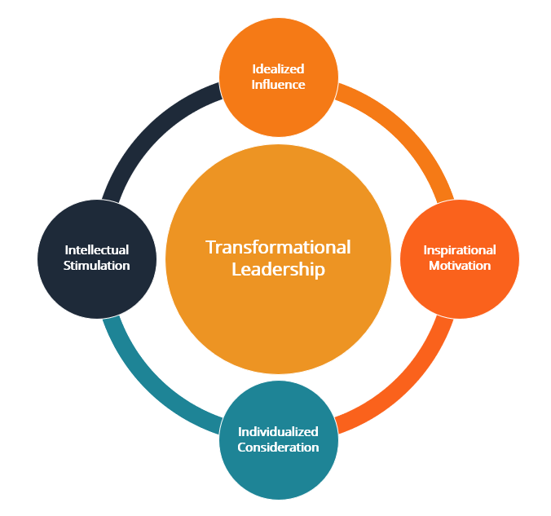
Figure 1: Transformational Leadership Theory adapted from Bass and Avolio (1994)
This framework directly contributes to the development of the leadership behaviour scale in this study which can be used to conceptualise and classify behaviours that store staff observe in their line managers. Transformational behaviours such as recognizing individual contributions, creating a vision of purpose, empowering others to take initiative, and demonstrating care for employees' well-being are predicted to have a positive relationship with job satisfaction. This expectation is supported with robust empirical evidence provided by the meta-analytic evidence cited in Section 2.5 (Judge and Piccolo, 2004; Wang et al., 2011).
Some have doubted whether transformational leadership is truly different from transactional leadership in practice (Yukl, 1999), and whether it actually influences followers' satisfaction through other factors like organisational culture or follower attributes (Avolio et al., 2009). Furthermore, the theory has been challenged for its ‘heroic' conceptualization of the leader, which may not be the case in operational line management where resources and structures significantly reduce the opportunity for inspirational behaviour (Hales, 2005).

2.8.2 Herzberg's Two-Factor Theory (Herzberg, Mausner and Snyderman, 1959)
The Two-Factor Theory of Herzberg (also called the Motivation-Hygiene Theory) suggests that conditions that create job satisfaction are not the same as conditions that create job dissatisfaction. The role provides some intrinsic motivators such as achievement, recognition, the work itself, responsibility, and advancement and these are linked with satisfaction if present. Hygiene factors are external to the job and are factors that have been known to cause dissatisfaction in the absence of the job; however, their presence does not necessarily bring about positive satisfaction (Herzberg et al., 1959).
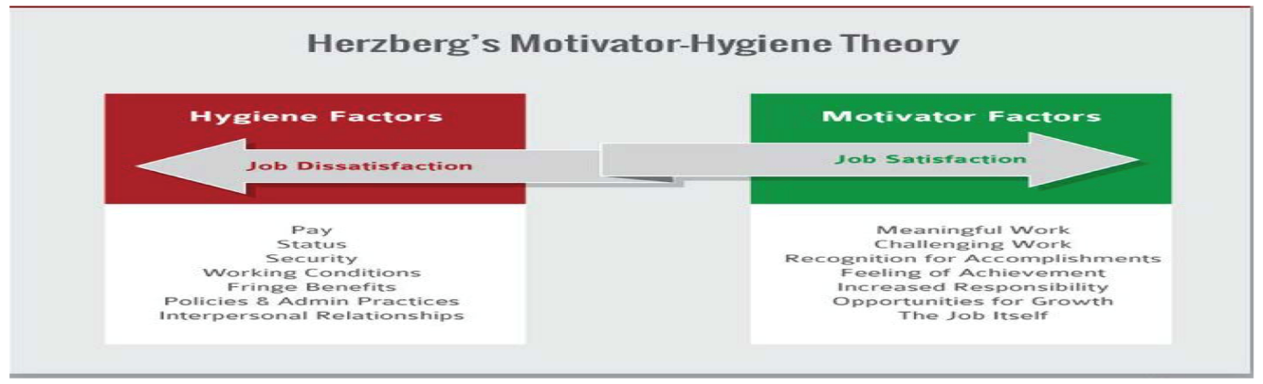
Figure 2: Herzberg's Two-Factor Theory
The conceptual framework serves as the foundation for measuring job satisfaction in a facet-specific manner and also for making the distinction between the intrinsic and extrinsic aspects of the job satisfaction dimension. It also emphasizes the fact that supervision is a hygiene factor, meaning that if it is not done well, employee dissatisfaction will result, but if it is done well (e.g., recognition, developmental feedback and support) it can enter the motivators category. The theoretical and practical implications of whether retail employees in this study primarily connect their line manager's behaviour with hygiene outcomes (avoiding dissatisfaction) or motivator outcomes (producing satisfaction) are important.
The Two-Factor Theory has been criticized on methodological issues, especially the use of critical incident methodology in the original study, which could have led to attribution bias (Wall and Stephenson, 1970). However, the theory has also been cast in doubt because it is suggested that the same factor (e.g., salary) can cause satisfaction or dissatisfaction for an individual depending on his or her situation and expectations (Locke, 1969; Sachau, 2007). However, the conceptual utility of differentiating between satisfaction outcomes and their causes for types of outcomes is still well established in HRM and management in general.

2.8.3 Path-Goal Theory (House, 1971; House and Mitchell, 1974)
The path-goal theory of leadership (House 1971, House and Mitchell 1974) suggests that a leader's main role is to make the path to goal easier for a follower and thus to increase their motivation and satisfaction. The theory distinguishes four leadership styles: directive, supportive, participative, and achievement-oriented and suggests that the effectiveness of each is dependent upon characteristics of followers (e.g., locus of control, task ability) and characteristics of the environment (e.g., task structure, authority). The satisfaction is highest when the leader's actions are complementary and complementary to what is lacking in the work environment.
It has been suggested that the retail context is directly applicable to Path-Goal Theory as it theorises the relationship between certain supervisory behaviours and employee satisfaction in a contingency manner. Supportive and participative behaviours may be more important to satisfaction in structured, repetitive, and highly-monitored retail contexts because of the relative simplicity and boundedness of front-line jobs. The theory, therefore, provides a complex prediction for the specific context being examined, which is positive relationships with leadership behaviours and satisfaction.
Empirical validation of the interaction effects between the leadership style and situational contingency of Path-Goal Theory has yielded mixed results, however, some studies have failed to validate the predicted interaction effects between the leadership style and situational contingency (Schriesheim and Kerr, 1977; Wofford and Liska, 1993). There has also been criticism that the theory has a relatively narrow scope regarding the motivational processes, and that the social, political, and cultural aspects of the leadership context are ignored (Northouse, 2021). However, it is conceptually suitable to the present study, which focuses on line managers in the structured operational environment because it highlights the instrumental and supportive aspects of supervisory behaviour.

2.9 Conceptual Framework and Hypothesis Development
The purpose of this study is to explore the link between the leadership behaviour of line managers and the job satisfaction of non-managerial employees in the UK retail sector. The conceptual framework adopts the theories of Transformational Leadership Theory, Herzberg and Path-Goal Theory, which provide insight into the relationship between supervisory behaviour and employees' attitudes and satisfaction.
The independent variable is perceived line-manager leadership behaviour, which is broken down into three dimensions of supportive / transformational, transactional / directive and corrective / passive leadership. Supportive/transformational behaviour involves practices, including, recognising employee contributions, listening to employees, showing concern for employees' wellbeing and supporting their development. In transactional/directive behaviour, the emphasis is on communicating expectations, establishing work objectives, giving feedback on performance, and ensuring work standards are appropriate. Corrective/passive behaviour, on the other hand, features a delayed response, reduced management time and attention to errors or issues, rather than to positive results.
Intrinsic, extrinsic and overall dimensions of employee job satisfaction are treated by considering it as the dependent variable. Intrinsic satisfaction refers to aspects like achievement, meaningful work, responsibility and opportunities for personal development, and extrinsic satisfaction refers to aspects like pay, working conditions, working hours, workload and organisational support. Job satisfaction is a general assessment of job experiences.
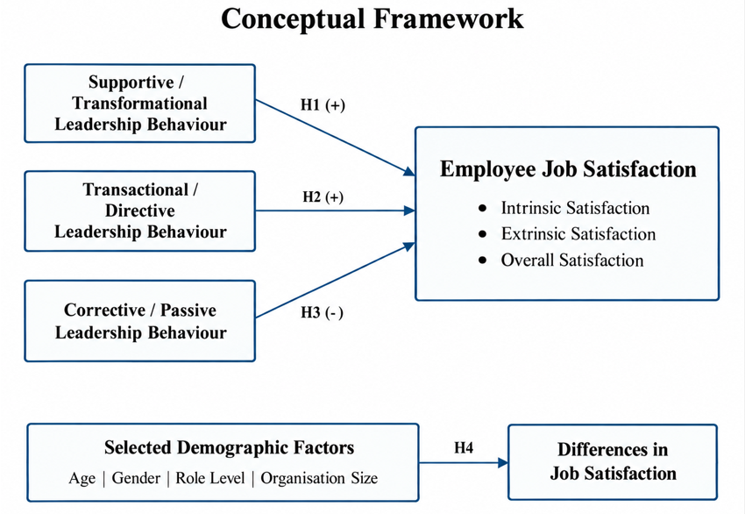
Figure 3: Conceptual Framework (Source: developed by the author from the reviewed literature.)
Based on the literature and theoretical framework, the following hypotheses are proposed:
H1: Perceived supportive/transformational line-manager leadership behaviour is positively associated with employee job satisfaction among non-managerial employees in the UK retail sector.
H2: Perceived transactional/directive line-manager leadership behaviour is positively associated with employee job satisfaction among non-managerial employees in the UK retail sector.
H3: Perceived corrective/passive line-manager leadership behaviour is negatively associated with employee job satisfaction among non-managerial employees in the UK retail sector.
The study also considers demographic variation in satisfaction, consistent with the research objective of comparing age, gender, role level and organisation size.
H4: Employee job satisfaction differs significantly across selected demographic groups, including age, gender, role level and organisation size.

2.10 Chapter Summary
The chapter critically examined literature relevant to the three main themes of the study: Leadership Theory and Practice; line-manager behaviour and employee outcomes; and job satisfaction concept and measurement. The review has shown the need for a deeper understanding of the relationship between transformational and supportive leadership behaviours and improvements in job satisfaction, alongside a lack of evidence that focuses specifically on the retail sector in the UK and the quantitative investigation of line manager behaviours at frontline level. The chapter also outlined some methodological weaknesses in the literature, such as the cross-cultural transferability concerns, the common method bias, and the lack of quantitative studies, especially in the sectors of this study, which will be addressed in the present study.
Three theoretical frameworks (Transformational Leadership Theory (Bass, 1985; Burns, 1978), Herzberg's Two Factor Theory (1959) and Path-Goal Theory (House, 1971)) were presented and evaluated, where the definitions and their importance to the study are discussed along with their limitations. In combination, these frameworks offer a multi-layered, theoretical framework from which to understand the empirical findings of the chapters that follow. The research methodology used to explore the link between perceived leadership behaviour in the line-managers and job satisfaction among employees in the UK retail industry is outlined in the following chapter.

CHAPTER THREE: RESEARCH METHODOLOGY

3.1 Introduction
This chapter elaborates the process of the research conducted and the reasons behind the selection of the methods used in the research. It explains the philosophy of research, theory approach, method and strategy, time frame and the data collection and analysis techniques. The chapter is structured around the elements of the research onion devised by Saunders, Lewis and Thornhill (2023), and which conceptualises research design as a series of connected decisions from outside to the inside, starting from the broad philosophical assumptions and ending with the specific data collection and analysis techniques. The theoretical basis for each decision is elaborated and backed up with references to the literature in the field of research methods and the aim of this study is explored again. The chapter also outlines the sampling protocol, measures used to ensure reliability and validity, the constraints of the design and ethical protections employed.

3.2 Research Rationale and the Research Onion
The methodology was not a discrete series of decisions but was created as a unified chain of decisions. Saunders, Lewis and Thornhill (2023) state that a good research design is one that is consistent between the philosophical perspective of the researcher, the approach to theory, the strategy and the techniques used, each supporting the other. Bell, Bryman and Harley (2022) agree on this saying that the study's credibility relies on its similarity between questions and methods. Hence, the present study adopted one straight path in the research onion, which is positivist philosophy, deductive approach, mono-method quantitative choice, survey strategy, cross sectional time horizon and questionnaire with statistical analysis. This path is indicated in Figure 3.1 and the positions taken at each layer are indicated. The reasons behind each selection are provided in the sections that follow.
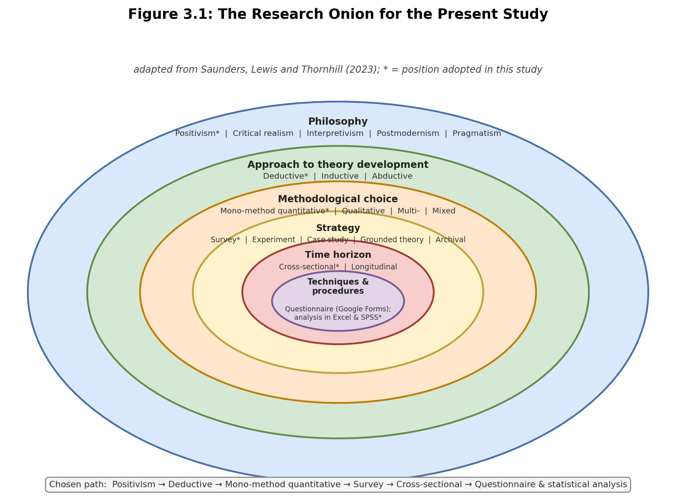
Figure 3.1: The research onion for the present study (adapted from Saunders, Lewis and Thornhill, 2023).

3.3 Research Philosophy
Research philosophy is the researcher's beliefs about the type of reality (ontology) and what constitutes acceptable knowledge (epistemology) (Saunders, Lewis and Thornhill 2023). These beliefs influence the overall design of a study. The major philosophical approaches in business research that are discussed are positivism, critical realism, interpretivism, postmodernism and pragmatism (Saunders, Lewis and Thornhill, 2023; Bell, Bryman and Harley, 2022).
The belief in positivism is that social reality exists and can be objectively observed and measured; knowledge is best generated by the testing of the theory with observable facts. In contrast to positivism, interpretivism holds that social reality is constructed out of a diversity of meanings attributed to their experiences, which are best captured in rich, qualitative data. Pragmatism suggests that the research question should be used to determine methods and favours mixed methods designs (Saunders, Lewis and Thornhill, 2023).
Critical realism is a position which falls between these two extremes, for it does accept that there are real structures, but it does not claim these can be known in a completely objective way, as they are always interpreted in some way (Saunders, Lewis and Thornhill, 2023). Another aspect of philosophy is axiology, which focuses on the role of values in studying, research should be done as far as possible without getting involved in values, the researcher's opinion should not be mixed into the research measurement process (Bell, Bryman and Harley, 2022).
This study is based on positivist philosophy. The purpose is to quantify two constructs - perceived leadership behaviour and job satisfaction - and to examine if there is a statistical relationship between them, rather than delve into personal stories in detail. The research uses numerical data, questions and pre-set variables and the researcher is not part of the participants in the research process and minimises bias (Bell, Bryman and Harley, 2022). Interpretivism was rejected because there is no need to find deep subjective meaning in the study, and a pragmatic mixed-methods design was rejected because the dissertation handbook recommends the use of a single method and because a small study project with limited time and resources will have a limited amount of resources for mixing methods. The choice of positivism, then, as the most clear and unambiguous basis for a study that involves the core issues of measuring and testing hypotheses is quite obvious.

3.4 Research Approach to Theory Development
The second layer of the onion has to do with the use of theory. A deductive method begins by drawing of an existing theory, putting it into the form of hypotheses and then gathering data to validate them. An inductive approach is the reverse of this, constructing the theory from the data. An abductive approach is one that goes back and forth between theory and data (Saunders, Lewis and Thornhill, 2023).
The research method used in this research is deductive. It draws on a foundation of well-established theories of leadership (the full-range leadership model (Bass and Avolio, 1994; Antonakis, Avolio and Sivasubramaniam, 2003) and Herzberg's two-factor theory of satisfaction (Herzberg, Mausner and Snyderman, 1959)) to develop two hypotheses regarding the relationship between supportive and corrective leadership behaviours and job satisfaction. The questionnaire was then developed to collect information which would support or challenge these hypotheses. This approach of theory first followed by data is characteristic of deductive research (Saunders, Lewis and Thornhill, 2023), which is appropriate for the positivist philosophy used above.

3.5 Methodological Choice and Research Strategy
The study adopts a mono-method quantitative choice approach which involves the use of one quantitative data collection method (the questionnaire) and quantitative analysis (Saunders, Lewis and Thornhill, 2023). This ensures the project is manageable, consistent and directly addresses the supervisory feedback to prevent the use of mixed or complex modelling.
The selected research methodology is the survey. Surveys are often associated with positivist and deductive research, and they are very appropriate for the collection of standardised data from many people in an economical manner (Saunders, Lewis and Thornhill, 2023; Bell, Bryman and Harley, 2022). A survey can be used by the researcher to describe patterns in the data and to explore relationships between variables; both of these are objectives of this study. Other strategies were rejected or discarded: experimentation was rejected because those in the study did not have variables controlled in a laboratory setting; a case study or ethnography would have provided very deep, narrow qualitative understanding which would not be useful for the goal of measuring the relationships of many workers.
The study also adopts a cross sectional time horizon as all the data is being collected only once at one timepoint to get a snapshot of perceptions and satisfaction (Saunders, Lewis and Thornhill, 2023). This is suitable for a student dissertation that has a time constraint. A longitudinal design (following the same individuals over time) was not possible within a short time frame of the project.

3.6 Data Collection Method and Instrument
A self-administered online questionnaire was developed in Google Forms to gather primary data. Self-completion online questionnaires are inexpensive, can be sent to widely spread respondents in a short amount of time, eliminate the interviewer bias, and allow respondents to answer anonymously and at their own time, which can increase the likelihood of accurate answers on sensitive issues like opinions about a manager (Bell, Bryman and Harley, 2022; Saunders, Lewis and Thornhill, 2023). The method was appropriate to contact retail employees from a variety of employer and site locations.
The questionnaire comprised six short sections: (1) participant Information and Consent; (2) screening Questions to confirm eligibility; (3) classification Questions on Age band, Gender, Retail subsector, size of the Organisation, Level of role, Employment status, and highest qualification; (4) the statements on perceived Line-Manager leadership behaviour; (5) the statements on Job satisfaction; and lastly (6) an optional comment box. The complete instrument is included in the Appendix.
The researcher created the statements of leadership by applying the full range leadership model which includes supportive or transformational behaviours, transactional or target-focused behaviours, and corrective or passive behaviours (Bass and Avolio, 1994; Antonakis, Avolio and Sivasubramaniam, 2003). The Multifactor Leadership Questionnaire was not reproduced because it is a commercial instrument which needs a licence (Mind Garden, 2026) and a factor structure has been discussed in the literature (Batista-Foguet, Esteve and van Witteloostuijn, 2021). Original, theory-informed statements ensured no copyright infringement, while remaining firmly within theory. The job satisfaction statements were adapted from Herzberg's two-factor theory (Herzberg, Mausner and Snyderman, 1959), and from the short and plainly worded statements with which the Minnesota Satisfaction Questionnaire (Weiss et al., 1967) was used to survey an entire class of students. All attitude statements were measured using a 5-point Likert scale measuring from “strongly disagree” to “strongly agree”, a common approach to measuring opinions in quantitative research (Bell, Bryman and Harley, 2022).
The wording and order of the questions was carefully considered. In line with good practice in questionnaire design, items were kept simple and direct, technical jargon was avoided and each statement was limited to one idea to prevent any double-barrelled question or leading question that might confuse respondents or encourage them to choose a specific answer (Bell, Bryman and Harley, 2022; Saunders, Lewis and Thornhill, 2023). The survey began with some simpler factual questions and progressed to attitude questions later; the leadership and satisfaction questions were done in a logical order to make the flow of the survey feel natural. The idea of keeping the questionnaire short and mobile friendly was also to minimize the number of people who began but did not complete the questionnaire.
The questionnaire was pre-tested with a small group of 3-5 people before the main data collection. The use of piloting is recommended to verify the clarity of questions, non-confusion of the word used, the reasonable time for the survey and also that the response options function as intended (Saunders, Lewis and Thornhill, 2023; Pallant, 2020). Wording and layout of the pilot were adjusted on the base of feedback received, before sharing with a broader audience.

3.7 Population and Sampling
months, employed in the UK retail sector as non-managerial workers who report to a line manager or supervisor. This covers those employed in supermarket retail, fashion retail, large format retail, specialist retail and in online or fulfilment jobs. The study is a survey of employees' perceptions of their managers, and not the managers themselves.
There is no complete sampling frame of all retail workers available to draw a random (probability) sample from. The study thus employs non-probability sampling, a combination of purposive sampling and convenience sampling and also self-selection sampling (Bell, Bryman and Harley, 2022; Saunders, Lewis and Thornhill, 2023). Purposive sampling - those participants who are selected for the study based on their meeting the criteria of the study (e.g. retail workers with a line manager); convenience and self-selection - survey is made available to convenient groups and individuals decide whether or not to participate. Questions at the beginning of the survey filtered out non-eligible respondents.
A total of 150 valid responses were targeted. This figure was considered appropriate for the constraints of time and one researcher for an MBA dissertation, and is adequate for descriptive data analysis, cross-tabulation, correlation and for using a careful approach to regression analysis (Pallant, 2020; Field, 2024). For this reason, more stringent methods (such as structural equation modelling and mediation testing) were not used, as this sample size does not allow for a reliable use of the more stringent methods. Recruitment was done with permission from employers or gatekeepers as appropriate, through retail contacts and HR contacts, appropriate professional and student networks and via online groups if permitted by moderators. It was made clear in the invitation that the participation was voluntary, anonymous and the study was for an MBA dissertation at the University of Wales Trinity Saint David.

3.8 Data Analysis
Responses were downloaded from the Google Forms and put into Microsoft Excel to be cleaned, by discarding incomplete or ineligible responses and by assigning numerical values to the Likert responses. The data obtained after cleaning was then analysed using the software of excel and IBM SPSS statistics.
Several steps were taken in analysis. Demographic data on respondents and responses to the leadership and satisfaction statements were summarised using descriptive statistics which included frequencies and percentages, means and standard deviations (Field, 2024; Pallant, 2020). This type of result is best displayed in simple tables and charts (bar chart, pie chart), to enable patterns to be observed at a glance. Second, the internal consistency of the leadership scale and the satisfaction scale were tested for using Cronbach's alpha where a score of approximately 0.7 or higher was deemed as satisfactory evidence that the items measure the same underlying construct (Field, 2024; Pallant, 2020). Third, the differences in satisfaction between the demographic groups (Field, 2024) were analysed using cross tabulation and chi-square test. The third objective and two of the hypothesis of the study were evaluated through correlation analysis, by the use of Pearson's or Spearman's coefficient depending on the distribution of the data. Simple or multiple regression was used to investigate whether the perceived levels of the leadership behaviour could predict job satisfaction (Field, 2024), with the sample size and statistical assumptions allowing for it. Assumptions were tested for the correlation and regression tests, including level of measurement, how missing data were handled and the general shape of the distribution, and non-parametric alternatives were used when the assumptions for the parametric tests were not met (Field, 2024; Pallant, 2020). These correlation and regression results were then evaluated against the two hypotheses that there is a positive correlation between supportive or transformational behaviour and satisfaction, and a weak or negative correlation between mainly corrective or passive behaviour and satisfaction.

3.9 Reliability and Validity
Reliability is the consistency of a measure's results, whereas validity is the extent to which a measure measures the intended dimension (Saunders, Lewis and Thornhill, 2023: Field, 2024). Several measures were implemented to ensure the safety of both. The instrument was written in an easy to understand and standardised manner, and Cronbach's alpha was reported for the principal scales (Field, 2024; Pallant, 2020), and by pilot testing the instrument. The content of the questionnaire was validated by using the theory of leadership and satisfaction and by the dissertation supervisor's review of the questionnaire prior to use as called for in the handbook.
A common problem in survey research of this nature is common method bias, which results from both the independent (perceived leadership behaviour) and dependent (job satisfaction) variables being measured from the same person at the same time, which may overestimate the relationship (Podsakoff et al., 2003). The risk was minimized by anonymity of the response, careful and neutral wording of the items, and alternating the order of positive and negative statements. An open, non-exaggerated reference to the limitations regarding generalizability in the findings is due to the use of a small non-probability sample.

3.10 Limitations of the Research
The design has a few limitations. First, sample sizes are relatively small (180 respondents) and the sampling was not random, which means the results do not necessarily reflect the views of all employees in the UK retail sector - respondents may have been those with stronger views. Secondly, the cross sectional design only measures one point in time and can only determine association and not the cause of changes in satisfaction. Third, the study relies on self-reports of perceptions, not on perceptions of managers' behaviour, so the study measures the perceptions of employees rather than the actual behaviour of their managers, and is susceptible to the common method bias mentioned above. Fourth, the researcher adapted the leadership statements and not used from a fully validated commercial scale, which does not breach copyright rules but limits the study to direct comparison with studies using the standard instrument. These constraints are common with small student surveys and were addressed as best practice was undertaken, piloting and reporting honestly (Saunders, Lewis and Thornhill, 2023).

3.11 Research Ethics
The study was carried out in accordance with the University of Wales Trinity Saint David Research Ethics and Integrity Code of Practice and the British Psychological Society's Code of Human Research Ethics (British Psychological Society, 2021), and ethical approval was given prior to the collection of any data. The dissertation includes a completed copy of the University ethics form in the appendixes.
The study was a non-risk study with adult only subjects. The first part of the questionnaire served as an information sheet and consent screen, clarifying the purpose of the study, that the participation was voluntary, and that the respondents could either stop at any moment before submitting or not. This meant that no information was gathered to identify each individual response and that once an anonymous response was given, it was not possible to take it back. To ensure anonymity and confidentiality, no names were requested, nor were the names of the employers or stores or exact locations requested. All data was kept securely in the University Office 365 storage where it was only accessed for the purpose of the dissertation and treated in accordance with the General Data Protection Regulation and the Data Protection Act 2018. All of these measures gave assurance that the rights and welfare of participants were respected throughout.

3.12 Chapter Summary
This chapter has provided insights and rationale for the methodology that was used in the study. The research was based on positivist philosophy, deductive method, mono-method quantitative, survey approach and cross-sectional time horizon with the data analysis method used in the form of anonymous online questionnaires and statistical analysis. It outlined the design and piloting of the instrument, the use of non-probability sampling for the final sample of 180 non-managerial retail employees in the UK, and the analysis of the data using descriptive statistics, reliability testing, cross-tabulation, correlation and regression. The chapter also described the measures adopted to ensure reliability and validity of the study, identified the major weakness of the study design, and explained the ethical precautions taken. The results of the analysis are presented in the next chapter.

CHAPTER FOUR: DATA ANALYSIS AND FINDINGS

4.1 Introduction
This chapter presents the empirical analysis of the quantitative survey data collected from non-managerial employees working in the UK retail sector. MS EXCEL was used to screen, code, transform and analyse the dataset. Then the data imported to IBM SPSS for tests, including frequency and descriptive statistics, correlation analysis and regression analysis. The chapter first explains the final response profile, measurement coding and the transformation of variables used to construct the composite measures. It then reports the demographic profile of respondents, the reliability of the multi-item scales, descriptive statistics, Pearson correlations, and regression analyses. Finally, independent-samples t-testing and one-way analysis of variance (ANOVA) are used to assess whether overall job satisfaction differs across the selected demographic groups specified in the study hypotheses. The findings are reported progressively, with a short interpretation followed by a summary table for each stage of the analysis. Diagnostic plots and the demographic charts generated from SPSS are retained where they assist interpretation.

4.2 Data Screening, Coding and Response Profile
The dataset contained 180 completed responses and 41 original variables. Screening confirmed that all 180 respondents provided consent, were aged 18 years or over, had worked in the UK retail sector within the required period, held a non-managerial role, and reported to a line manager or supervisor. No missing values were identified in the analytical dataset; consequently, no case was removed for incomplete data and the final analytical sample remained N = 180. This provided a complete-case dataset for the subsequent descriptive, reliability, correlation, regression and group-comparison procedures.
The screening variables were coded dichotomously as 1 = Yes and 0 = No and were treated as nominal measures. The demographic variables were coded numerically to permit efficient analysis in SPSS. Age group and retail tenure were treated as ordinal variables because their categories have a natural order. Gender, role level, employment status and retail subsector were treated as nominal variables. Organisation size was coded in ordered size bands, although the category "Not Sure" was retained as a separate response category when group comparisons were performed. All leadership and job-satisfaction questionnaire items used a five-point Likert response format ranging from 1 = Strongly disagree to 5 = Strongly agree and were entered as ordinal item-level variables.
Table 4.1: Coding and measurement levels used in SPSS
Variable / construct | Coding | Measure
Consent and eligibility variables | 0 = No; 1 = Yes | Nominal
Age_Group | 1 = 18-24; 2 = 25-34; 3 = 35-44; 4 = 55+ | Ordinal
Gender | 1 = Male; 2 = Female | Nominal
Role_Level | 1 = Frontline/team member; 2 = Experienced/senior; 3 = Specialist/technical; 4 = Other | Nominal
Employment_Status | 1 = Full-time; 2 = Part-time; 3 = Temporary/seasonal; 4 = Zero-hours/casual; 5 = Other | Nominal
Retail_Subsector | 1 = Supermarket/grocery; 2 = Fashion; 3 = Health/beauty/pharmacy; 4 = Electronics/homeware/department/large-format; 5 = Online retail/fulfilment; 6 = Specialist/other | Nominal
Organisation_Size | 1 = Fewer than 50; 2 = 50-249; 3 = 250 or more; 4 = Not Sure | Ordinal / grouped category
Retail_Tenure | 1 = <6 months; 2 = 6 months-<1 year; 3 = 1-<3 years; 4 = 3-<5 years; 5 = 5+ years | Ordinal
STL, TDL, CPL, IJS, EJS and OJS items | 1 = Strongly disagree to 5 = Strongly agree | Ordinal

Several transformed variables were then created using Transform > Compute Variable in SPSS. OJS3 was negatively worded, so it was reverse-coded before reliability testing and composite-score construction using OJS3_R = 6 - OJS3. The resulting reverse-coded frequencies confirmed the transformation: the 22 cases originally scored 1 became 5, the 55 cases scored 2 became 4, the 57 cases scored 3 remained 3, the 36 cases scored 4 became 2, and the 10 cases scored 5 became 1. This ensured that higher scores on all three overall job-satisfaction items represented higher satisfaction. Composite variables were calculated as the mean of the items belonging to each construct.
Table 4.2: Transformed and composite variables used in the analysis
Variable | SPSS computation | Purpose / measure
OJS3_R | 6 - OJS3 | Reverse-coded overall satisfaction item; Ordinal
STL_Comp | MEAN(STL1 to STL6) | Supportive/transformational leadership; Scale
TDL_Comp | MEAN(TDL1 to TDL5) | Transactional/directive leadership; Scale
CPL_Comp | MEAN(CPL1 to CPL4) | Corrective/passive leadership; Scale
IJS_Comp | MEAN(IJS1 to IJS5) | Intrinsic job satisfaction; Scale
EJS_Comp | MEAN(EJS1 to EJS5) | Extrinsic job satisfaction; Scale
OJS_Comp | MEAN(OJS1, OJS2, OJS3_R) | Overall job satisfaction; Scale
CPL_Pos | 6 - CPL_Comp | Positive-direction version used only in overall leadership score; Scale
OverallLeadership | MEAN(STL_Comp, TDL_Comp, CPL_Pos) | Overall perceived leadership; Scale

Table 4.3: Data screening and response profile summary
Indicator | Result
Initial completed cases | 180
Final valid analytical cases | 180
Missing values | 0
Cases excluded for incomplete data | 0
Consent / eligibility status | All 180 cases met the screening criteria
Final sample used in analysis | N = 180

4.3 Findings
The results are presented in the order of the statistical analyses. Each subsection starts with an interpretation of the main output, followed by a brief summary table of the numerical results.

4.3.1 Demographic Profile of Respondents
Demographic profile showed that the sample had a higher proportion of younger retail employees. The largest age category was 25-34 years (46.7%), followed by 18-24 years (27.2%), while 20.0% were aged 35-44 and 6.1% were aged 55 or above. The majority of the sample represented by females (61.1%) followed by males (38.9%). Frontline/team members (56.7%) had more than half of the participants with experienced/senior team members (21.7%) that did not have line-management responsibilities. The largest employment category in the sample was full-time workers, who accounted for 60.6% of the respondents.
The sample also included a variety of retail sub sectors. The biggest category was supermarket/groceries (28.3%), then fashion/clothing/footwear (23.3%) and electronics/homeware/department/large-format retail (16.1%). Most respondents were employed with organisations having 250 or more employees (55.6%). For retail experience, the most popular category was one to under three years (30.0%) with shorter and longer tenures distributed across the rest of the categories. Overall, the profile indicates that the analysis is based on a broad cross-section of retail workplaces, but with a greater representation of younger, female, frontline and full-time employees.
Table 4.4: Demographic profile of respondents (N = 180)
Characteristic | Category | Frequency | Percent
Age group | 18-24 | 49 | 27.2
 | 25-34 | 84 | 46.7
 | 35-44 | 36 | 20.0
 | 55+ | 11 | 6.1
Gender | Male | 70 | 38.9
 | Female | 110 | 61.1
Role level | Frontline/team member | 102 | 56.7
 | Experienced/senior team member | 39 | 21.7
 | Specialist/technical non-managerial | 26 | 14.4
 | Other non-managerial role | 13 | 7.2
Employment status | Full-time | 109 | 60.6
 | Part-time | 38 | 21.1
 | Temporary/seasonal | 5 | 2.8
 | Zero-hours/casual | 20 | 11.1
 | Other | 8 | 4.4
Retail subsector | Supermarket/grocery | 51 | 28.3
 | Fashion/clothing/footwear | 42 | 23.3
 | Health/beauty/pharmacy | 18 | 10.0
 | Electronics/homeware/department/large-format | 29 | 16.1
 | Online retail/fulfilment | 20 | 11.1
 | Specialist/other retail | 20 | 11.1
Organisation size | Fewer than 50 | 23 | 12.8
 | 50-249 | 38 | 21.1
 | 250 or more | 100 | 55.6
 | Not Sure | 19 | 10.6
Retail tenure | <6 months | 25 | 13.9
 | 6 months-<1 year | 33 | 18.3
 | 1-<3 years | 54 | 30.0
 | 3-<5 years | 33 | 18.3
 | 5+ years | 35 | 19.4

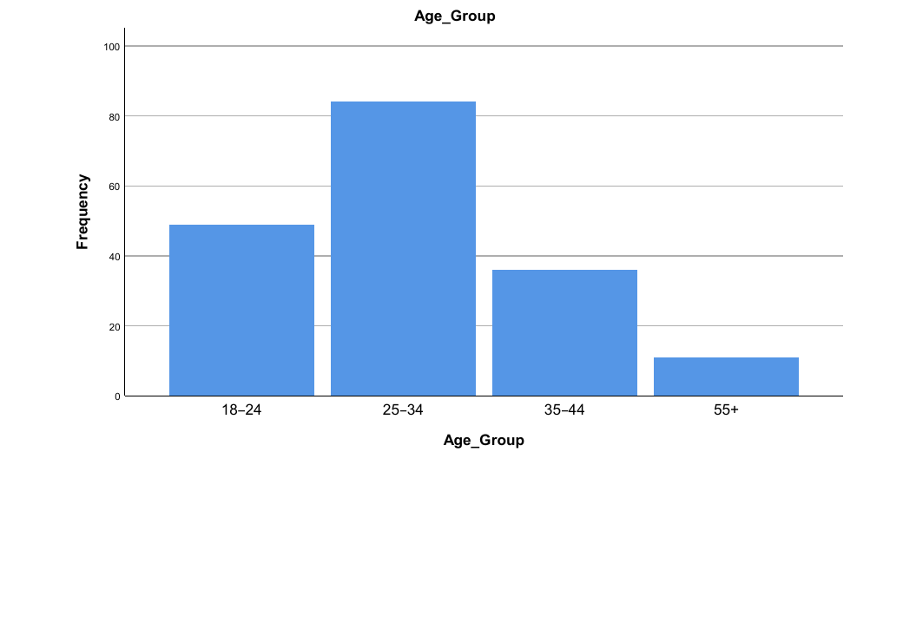
Figure 4.1: Frequency of respondents by age group.
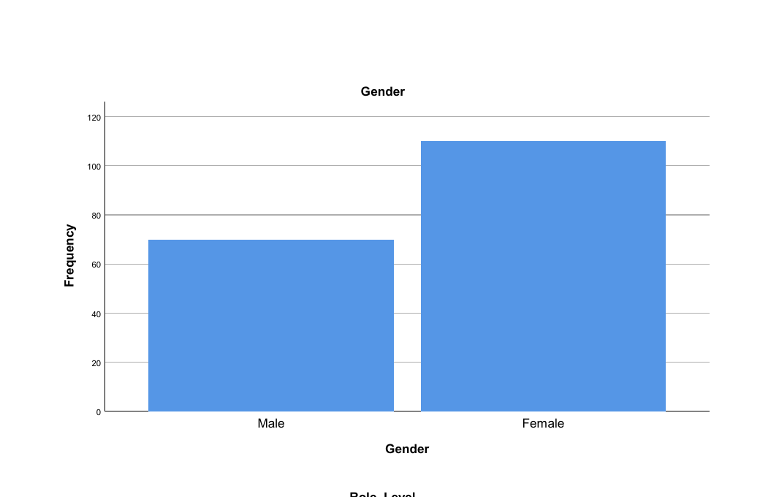
Figure 4.2: Frequency of respondents by gender.
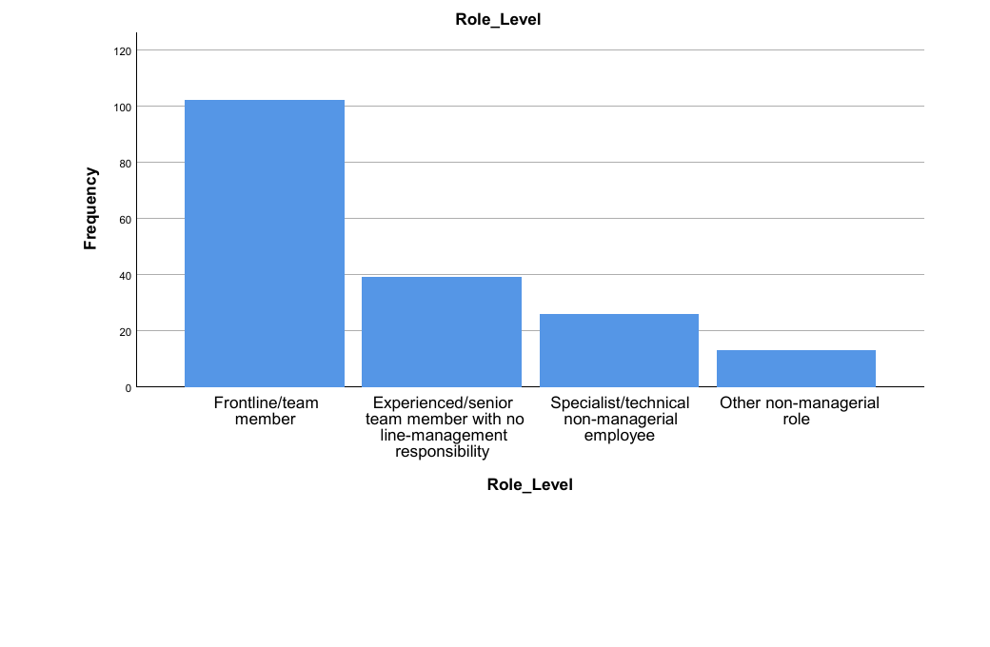
Figure 4.3: Frequency of respondents by role level.
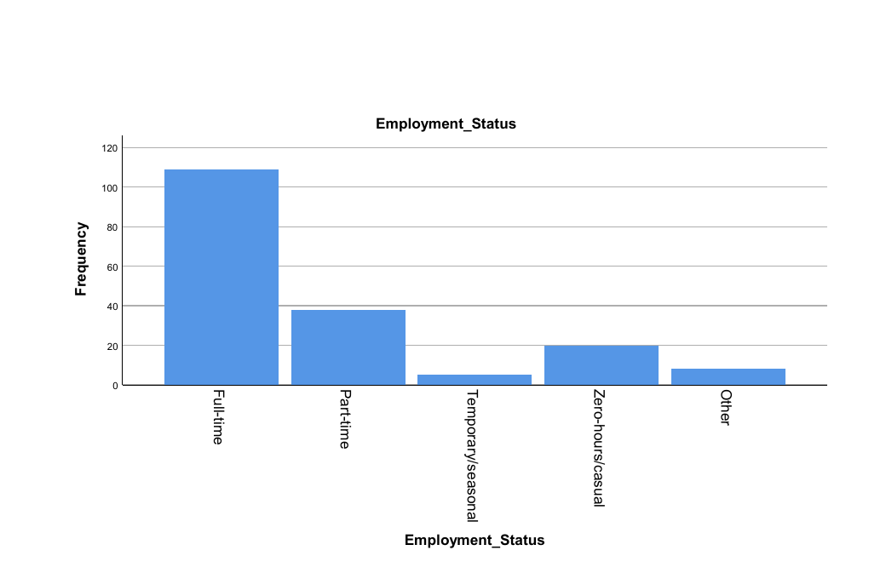
Figure 4.4: Frequency of respondents by employment status.
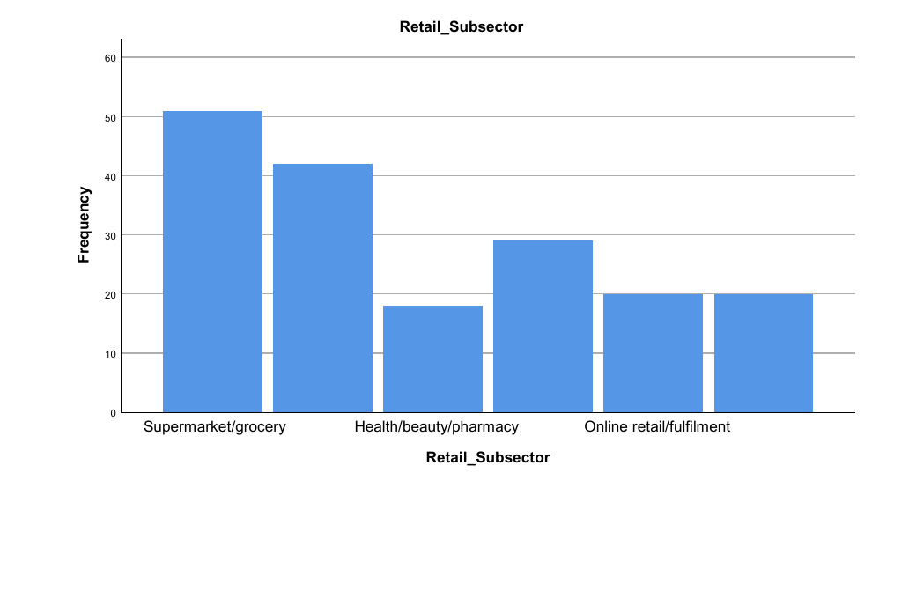
Figure 4.5: Frequency of respondents by retail subsector.
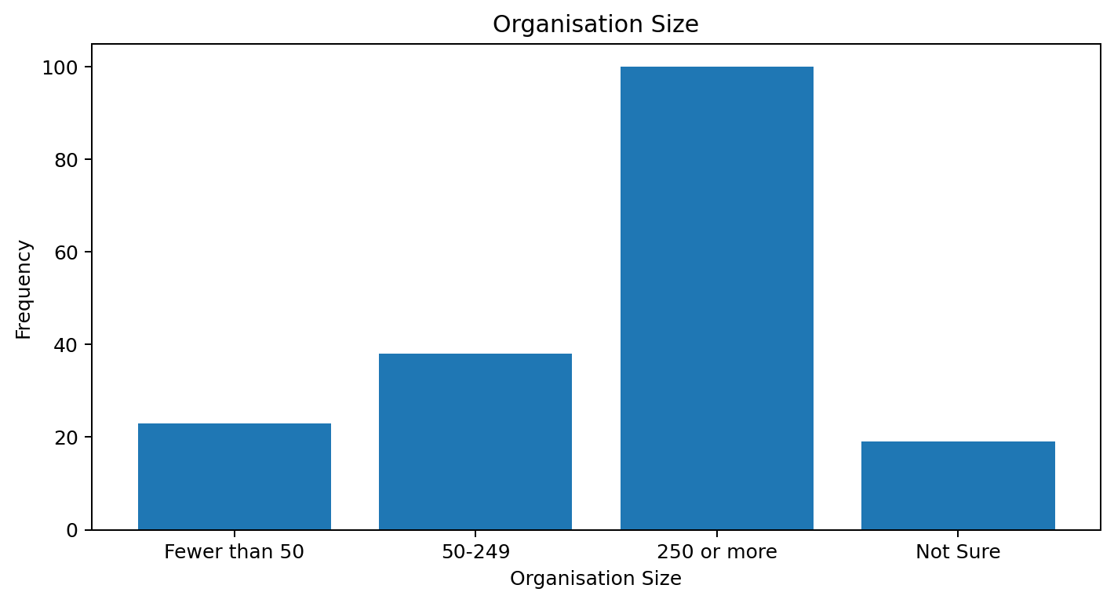
Figure 4.6: Frequency of respondents by organisation size.
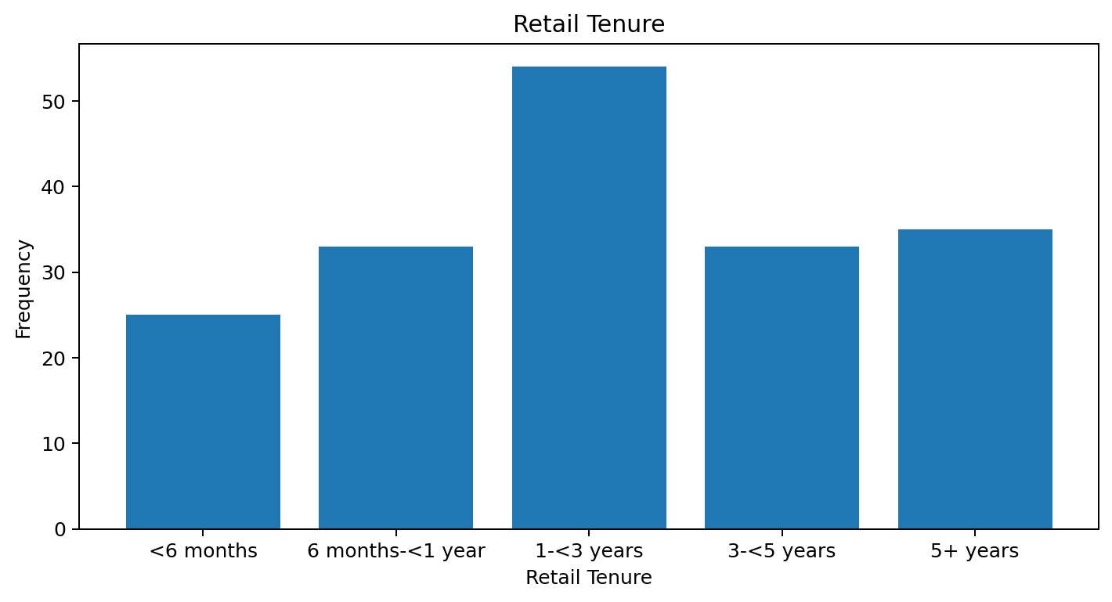
Figure 4.7: Frequency of respondents by retail tenure.

4.3.2 Reliability of the Measurement Scales
The internal consistency was evaluated for each multi-item scale with Cronbach's alpha. The scale reliability coefficient (alpha) was highest for the supportive/transformational leadership scale (alpha = .800), which was found to have good internal consistency. The transactional/directive leadership was also acceptable (alpha = .761). Corrective/passive leadership gave alpha = .698, just below the conventional .70 and considered to be borderline but close to acceptable. The internal consistency of the items for intrinsic satisfaction were strong (alpha = .797), and those for extrinsic satisfaction (alpha = .753) and overall job satisfaction (alpha = .750) were acceptable. The item-total output does not suggest that any items should be deleted from the scales and the constructs were, therefore, left in their original format for composite-score analysis.
Table 4.5: Reliability of the measurement scales
Scale | No. of items | Cronbach's alpha | Interpretation
Supportive/transformational leadership | 6 | .800 | Good
Transactional/directive leadership | 5 | .761 | Acceptable
Corrective/passive leadership | 4 | .698 | Borderline / close to acceptable
Intrinsic job satisfaction | 5 | .797 | Acceptable to good
Extrinsic job satisfaction | 5 | .753 | Acceptable
Overall job satisfaction | 3 | .750 | Acceptable

4.3.3 Descriptive Statistics for the Composite Variables
The means of the composites were in general within one point of the neutral point of the five point response scale. Mean (M) scores for the items of the instrument are as follows: intrinsic job satisfaction (M = 3.297, SD = .812); overall job satisfaction (M = 3.211, SD = .869); supportive/transformational leadership (M = 3.205, SD = .775); and transactional/directive leadership (M = 3.197, SD = .789). The extrinsic satisfaction was only slightly lower (M = 3.053, SD = .815), and the corrective/passive leadership had the lowest mean (M = 2.840, SD = .804). The overall leadership score (after adjusting direction of corrective/passive component) was 3.081 (SD = .468).
Let's examine each item, one by one and see how this picture fills in a bit more. Concern for employee wellbeing was rated second lowest (STL5, M = 3.13), and the encouragement of employee suggestions, the second lowest rated leadership item, was rated (STL3, M = 2.99). The most positive rating was for recognition of good work in relation to the leadership items (STL2, M = 3.36). The highest scores for the satisfaction items were for having the right level of responsibility (IJS4, M = 3.36) and a sense of achievement (IJS1, M = 3.33); the lowest scores for the whole survey were the satisfaction with pay (EJS1, M = 2.94) and a manageable workload (EJS4, M = 2.97). The item level patterns are discussed with regard to the composite scores.
The skewness scores were from -0.259 to 0.184 and the kurtosis scores were from -0.719 to 0.221. The absolute values of these are small and suggest that the composite distributions were fairly symmetrical and not significantly different from normality. This helped with the analysis of Pearson correlation and linear regression procedures used in the later part of the study.
Table 4.6: Descriptive statistics for composite variables (N = 180)
Variable | Mean | SD | Min | Max | Skewness | Kurtosis
STL_Comp | 3.205 | .775 | 1.00 | 4.83 | -.051 | -.264
TDL_Comp | 3.197 | .789 | 1.20 | 5.00 | -.002 | -.288
CPL_Comp | 2.840 | .804 | 1.00 | 4.75 | .184 | -.396
IJS_Comp | 3.297 | .812 | 1.20 | 4.80 | -.259 | -.592
EJS_Comp | 3.053 | .815 | 1.40 | 5.00 | .082 | -.489
OJS_Comp | 3.211 | .869 | 1.33 | 5.00 | -.115 | -.719
OverallLeadership | 3.081 | .468 | 1.68 | 4.26 | -.084 | .221

4.3.4 Correlation Analysis
The Pearson correlation analysis revealed that there were significant association between overall job satisfaction and all the three dimensions of leadership in the predicted direction of the hypotheses. There were moderate positive relationships between overall job satisfaction and the supportive/transformational leadership style (r = .445, p < .001). Overall job satisfaction was also significantly and positively correlated with transactional/directive leadership (r = .301, p < .001) and significantly and negatively correlated with corrective/passive leadership (r = -.287, p < .001). So, those who rated their line managers more favourably for supportive and directive behaviours reported higher levels of satisfaction, while higher levels of corrective/passive behaviours were related to lower levels of satisfaction.
Intrinsic satisfaction was very highly correlated with overall satisfaction (r = .546, p < .001) and extrinsic satisfaction was moderately correlated with overall satisfaction (r = .396, p < .001). The other dimensions of leadership were also correlated with the satisfaction facets: supportive/transformational leadership had positive correlation with both intrinsic satisfaction (r = .450) and with extrinsic satisfaction (r = .375); transactional/directive leadership had positive correlation with both intrinsic satisfaction (r = .388) and with extrinsic satisfaction (r = .210); corrective/passive leadership had negative correlation with both intrinsic satisfaction (r = -.247) and with extrinsic satisfaction (r = -.273). The non-significant association between TDL and CPL was the only one that was not statistically significant at p < .01.
Table 4.7: Pearson correlations among leadership and satisfaction variables (N = 180)
Variable | STL | TDL | CPL | IJS | EJS | OJS
STL | 1 | .357** | -.199** | .450** | .375** | .445**
TDL | .357** | 1 | -.071 | .388** | .210** | .301**
CPL | -.199** | -.071 | 1 | -.247** | -.273** | -.287**
IJS | .450** | .388** | -.247** | 1 | .265** | .546**
EJS | .375** | .210** | -.273** | .265** | 1 | .396**
OJS | .445** | .301** | -.287** | .546** | .396** | 1
Note. ** p < .01 (two-tailed).
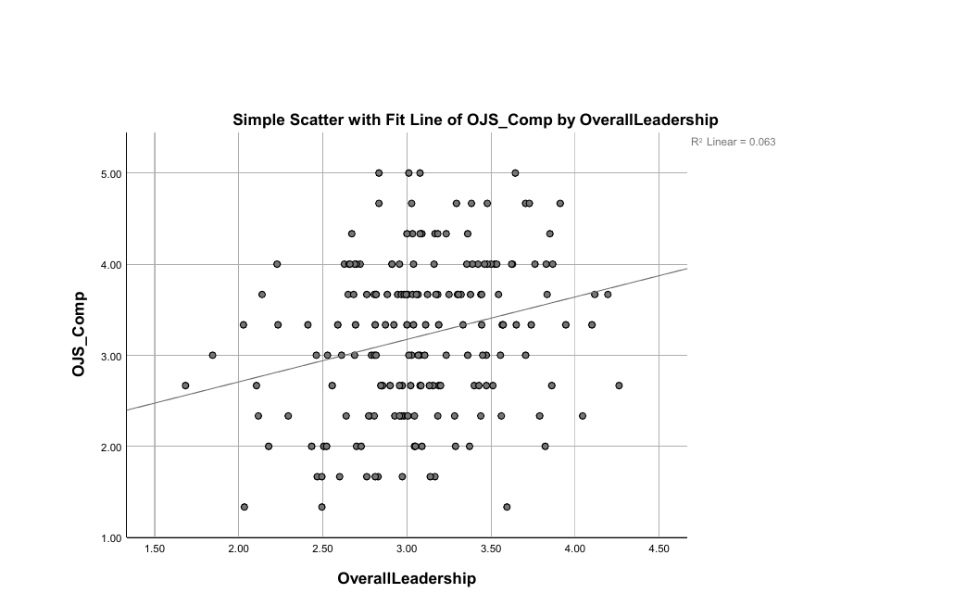
Figure 4.8: Overall perceived leadership and overall job satisfaction. The fitted line indicates a positive relationship (R² = .063).

4.3.5 Multiple Regression Including Leadership and Satisfaction Facets
Overall job satisfaction was first subjected to a standard multiple regression with the three leadership dimensions and intrinsic satisfaction and extrinsic satisfaction as the independent variables. The overall model was statistically significant, F(5, 174) = 23.241, p < .001, with R = .633. The model explained 40.0% of the variance in overall job satisfaction (R² = .400; adjusted R² = .383). This means that the overall job satisfaction was well explained by the set of leader and satisfaction-facet variables.
Intrinsic satisfaction and extrinsic satisfaction had the highest unique contribution at the individual predictor level, Beta = .375 p < .001 and Beta = .196 p = .003 respectively. Even when the other factors were taken into account, supportive/transformational leadership continued to be a significant positive predictor (beta = .165, p = .020). Transactional/directive leadership did not have a significant unique effect in the expanded model (beta = .048, p = .465); corrective/passive leadership had a negative, but non-significant unique effect (beta = -.105, p = .094). There was no significant multicollinearity as the VIF values ranged from 1.127 to 1.434. The conceptual proximity of the two types of satisfaction (intrinsic and extrinsic) to the overall satisfaction outcome led to a separate regression model of the leadership variables, which was subsequently analysed as the direct test of H1-H3.
Table 4.8: Five-predictor multiple regression model summary
R | R² | Adjusted R² | Std. error | F | df | p
.633 | .400 | .383 | .683 | 23.241 | (5, 174) | < .001

Table 4.9: Five-predictor regression coefficients (DV: OJS_Comp)
Predictor | B | SE B | beta | t | p | VIF
STL_Comp | .185 | .079 | .165 | 2.349 | .020 | 1.434
TDL_Comp | .053 | .072 | .048 | .732 | .465 | 1.248
CPL_Comp | -.113 | .067 | -.105 | -1.681 | .094 | 1.127
IJS_Comp | .402 | .075 | .375 | 5.383 | <.001 | 1.409
EJS_Comp | .209 | .070 | .196 | 3.003 | .003 | 1.236

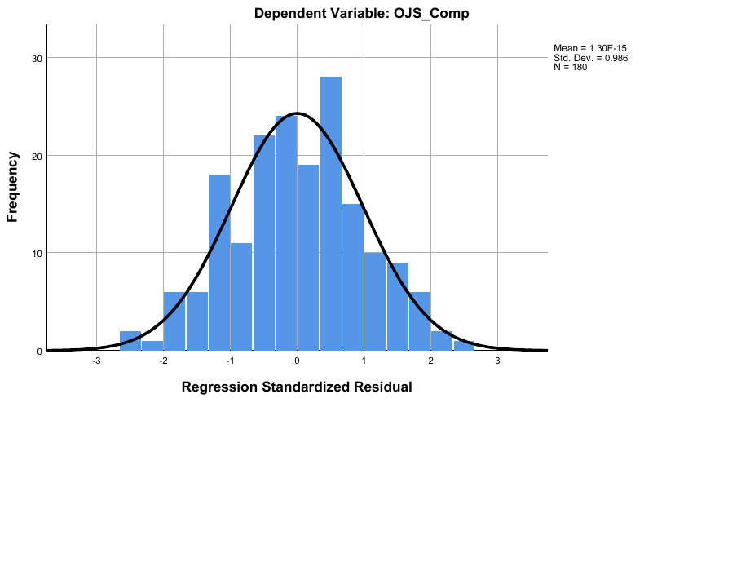
Figure 4.9: Histogram of standardised residuals for the five-predictor regression model.
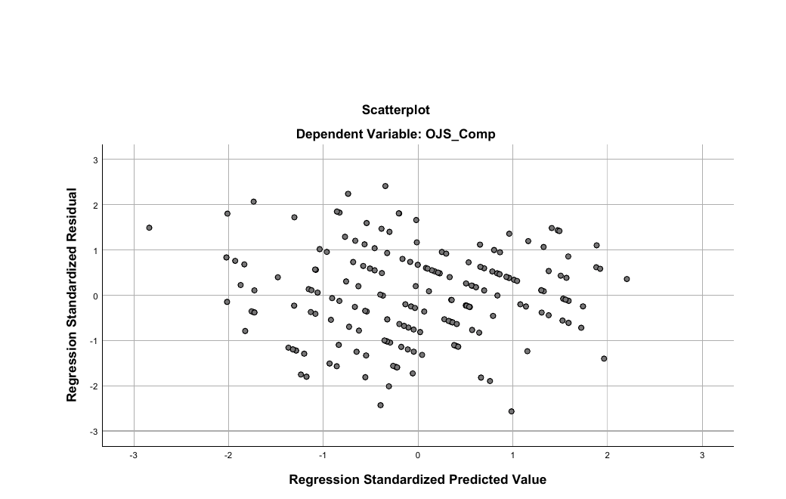
Figure 4.10: Standardised residuals plotted against standardised predicted values for the five-predictor model.
The residual histogram was generally bell-shaped and cantered near zero and the plot of residuals versus predicted residuals was broadly scattered on either side of zero with no discernible severe funnel shape. There were no major violations of the normality or constant-variance assumptions for this model based on the visual inspection.

4.3.6 Simple Regression: Overall Leadership and Overall Job Satisfaction
A simple linear regression was performed to determine if the overall perceived leadership composite correlated with overall job satisfaction. The model was statistically significant, F(1, 178) = 11.956, p = .001. OverallLeadership was positively correlated with OJS_Comp (R = .251) and accounted for 6.3% of the variance in OJS_Comp (R² = .063; adjusted R² = .058). The unstandardised coefficient indicated that the overall leadership score was significantly correlated with the overall job satisfaction score (B = .466, 95% CI [.200, .732]). The standardised effect was positive and significant (Beta = .251, t = 3.458, p = .001).
The effect is small, suggesting that overall line-manager leadership is a factor that influences job satisfaction, but is responsible for only a small percentage of the variance in overall job satisfaction. The distribution of the residuals was roughly normal with approximate middle bell shape and there was no clear indication of a serious normality issue.
Table 4.10: Simple regression of OJS_Comp on OverallLeadership
Predictor | B | SE B | beta | t | p | 95% CI for B
Constant | 1.775 | .420 | - | 4.223 | <.001 | [.945, 2.604]
OverallLeadership | .466 | .135 | .251 | 3.458 | .001 | [.200, .732]

Table 4.11: Simple regression model summary
R | R² | Adjusted R² | F | df | p
.251 | .063 | .058 | 11.956 | (1, 178) | .001

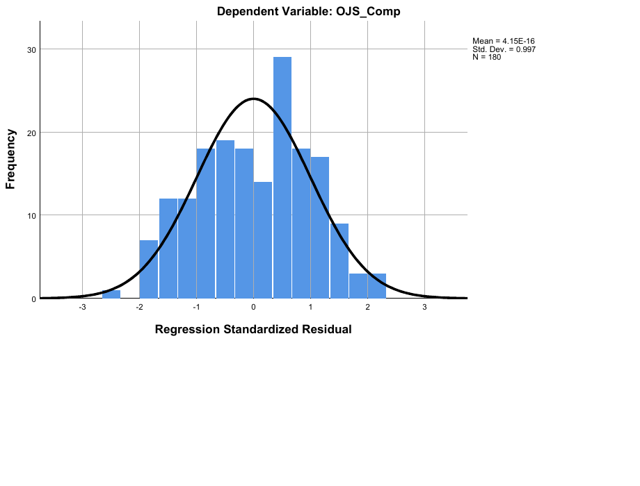
Figure 4.11: Histogram of standardised residuals for the overall-leadership simple regression model.

4.3.7 Leadership-Only Multiple Regression: Direct Test of H1-H3
A second Multiple Regression was run where the three leadership dimensions were the only variables predicting overall job satisfaction. The model is the most direct multivariate test of H1-H3 as predictors are directly congruent with the independent variables of the conceptual framework. The model was statistically significant, F(3, 176) = 20.891, p < .001, with R = .512. The total variance in overall job satisfaction was 26.3% explained by the three dimensions of leadership (R² = .263; adjusted R² = .250).
Each of the three dimensions of leadership was found to be statistically significantly predictive in the directions predicted. The highest positive association was supportive/transformative leadership (beta = .346, p < .001). The transactional/directive leadership had a strong positive influence (beta = .163, p = .020). Corrective/passive leadership was a large negative predictor (beta = -.207, p = .002). The VIF values were in the range of 1.041-1.188, indicating very low multicollinearity. All these results support multivariately the hypotheses H1, H2 and H3 directly.
Table 4.12: Leadership-only regression model summary
R | R² | Adjusted R² | Std. error | F | df | p
.512 | .263 | .250 | .753 | 20.891 | (3, 176) | < .001

Table 4.13: Leadership-only regression coefficients (DV: OJS_Comp)
Predictor | B | SE B | beta | t | p | 95% CI | VIF
STL_Comp | .388 | .079 | .346 | 4.906 | <.001 | [.232, .545] | 1.188
TDL_Comp | .179 | .076 | .163 | 2.350 | .020 | [.029, .330] | 1.146
CPL_Comp | -.224 | .071 | -.207 | -3.130 | .002 | [-.364, -.083] | 1.041

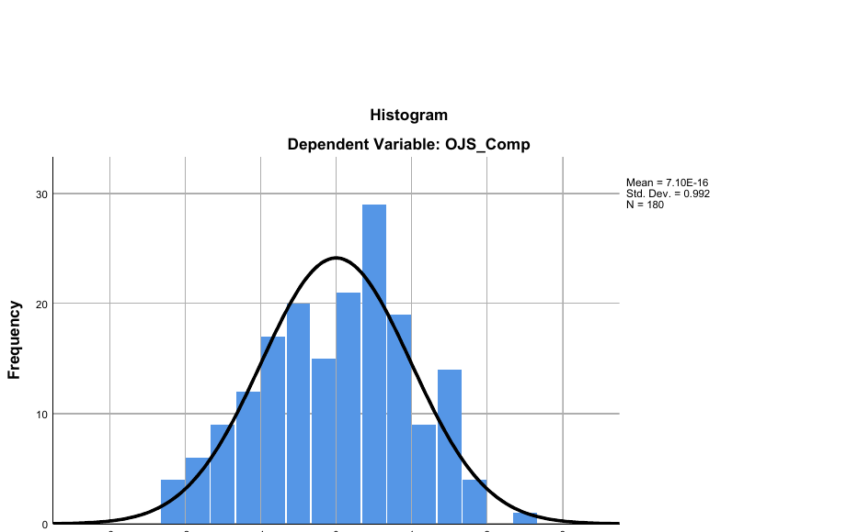
Figure 4.12: Histogram of standardised residuals for the leadership-only regression model.
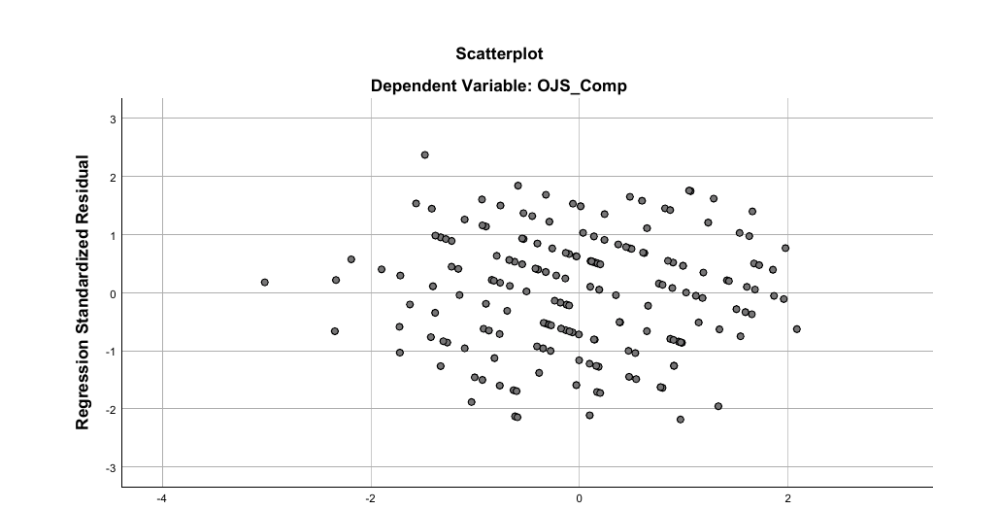
Figure 4.13: Standardised residuals plotted against standardised predicted values for the leadership-only regression model.

4.3.8 Demographic Differences in Overall Job Satisfaction
The fourth hypothesis was that there would be differences among selected demographic groups in terms of overall job satisfaction. The independent-samples t-test was used to assess gender, and one-way ANOVA was used for age group, role level and organisation size. Although group tests were run for each group, homogeneity of variance was first tested.

4.3.8.1 Gender and Overall Job Satisfaction
The mean overall job satisfaction for males (M = 3.276, SD = .948) was slightly higher than for females (M = 3.170, SD = .817). The result of the Levene's test was non-significant (p = .115) and the equal-variances-assumed result was used. The difference did not differ significantly, t(178) = .800, p = .425, 95% CI for the difference between means from -.156 to .369. Gender, however, was not found to have a significant difference in overall job satisfaction in this sample.
Table 4.14: Independent-samples t-test for gender differences in OJS_Comp
Group | N | Mean | SD | t | df | p
Male | 70 | 3.276 | .948 | .800 | 178 | .425
Female | 110 | 3.170 | .817

4.3.8.2 Age Group and Overall Job Satisfaction
There was no significant difference between the overall job satisfaction means for the four age groups, with the range from 3.155 for age 25-34 to 3.394 for age 55 or older. The equal variance assumption was supported by results of Levene's test (p = .459). The ANOVA was not statistically significant, F(3, 176) = .332, p = .802. The post hoc comparisons were also not significant. The data therefore show no significant differences between job satisfaction in the various age groups.
Table 4.15: One-way ANOVA for age-group differences in OJS_Comp
Age group | N | Mean | SD
18-24 | 49 | 3.225 | .768
25-34 | 84 | 3.155 | .897
35-44 | 36 | 3.269 | .946
55+ | 11 | 3.394 | .905

Table 4.16: ANOVA summary - Age group
Levene p | F | df | p | Decision
.459 | .332 | (3, 176) | .802 | Not significant

4.3.8.3 Role Level and Overall Job Satisfaction
The overall score of job satisfaction was highest for those in the "Other non-managerial role" group (M = 3.615) and lowest for frontline/team members (M = 3.134). The homogeneity assumption was met (p = .269 for Levene test) and the overall ANOVA was not significant, F(3, 176) = 1.443, p = .232. The post hoc tests also failed to show any significant pairwise differences. As a result, differences in means across groups were not sufficient to draw a conclusion about the differences in job satisfaction among the levels of job in the population sampled.
Table 4.17: One-way ANOVA for role-level differences in OJS_Comp
Role level | N | Mean | SD
Frontline/team member | 102 | 3.134 | .782
Experienced/senior team member | 39 | 3.316 | .936
Specialist/technical non-managerial | 26 | 3.154 | .999
Other non-managerial role | 13 | 3.615 | .999

Table 4.18: ANOVA summary - Role level
Levene p | F | df | p | Decision
.269 | 1.443 | (3, 176) | .232 | Not significant

4.3.8.4 Organisation Size and Overall Job Satisfaction
The omnibus group comparison was statistically significant only for the size of the organisation. Those in organisations of 50-249 workers reported the lowest mean of overall job satisfaction (M = 2.833, SD = .827) and those of 250 or more workers reported the highest mean of overall job satisfaction (M = 3.323, SD = .831). The mean score (M = 3.404) for those who answered “Not Sure” was the highest, whereas the mean score (M = 3.188) for employees of organisations with fewer than 50 employees was the lowest. The Levene's test was not significant (p = .973), which means that variance was homogeneous. The one-way ANOVA was statistically significant, F(3, 176) = 3.393, p = .019.
A Tukey post hoc comparison of the scores revealed that scores for job satisfaction for employees in organisations of 250 or more employees were significantly higher than those in organisations of 50-249 employees. The mean difference was .490 points (p = .015). A similar Games-Howell test gave a result that was essentially the same (p = .014). No other pair other than the one mentioned attained .05 significance level. Therefore, organisation size contributed partial support to H4, whereas gender, age and role level did not.
Table 4.19: One-way ANOVA for organisation-size differences in OJS_Comp
Organisation size | N | Mean | SD
Fewer than 50 | 23 | 3.188 | .864
50-249 | 38 | 2.833 | .827
250 or more | 100 | 3.323 | .831
Not Sure | 19 | 3.404 | .997

Table 4.20: ANOVA summary - Organisation size
Levene p | F | df | p | Decision
.973 | 3.393 | (3, 176) | .019 | Significant

Table 4.21: Significant post hoc comparison
Comparison | Mean difference | Tukey p | Games-Howell p
250+ vs 50-249 | .490 | .015 | .014

4.4 Summary of Hypothesis Testing
Both the correlations and leadership-only regressions results support the three directional leadership hypotheses. Supportive/transformational leadership was significantly related positively with job satisfaction, whereas corrective/passive leadership was significantly related negatively with job satisfaction. H4 was only partially supported as overall job satisfaction was found to be statistically significantly different for the different sizes of the organisation, but not for gender, age groups or role level.
Table 4.22: Summary of hypothesis-testing results
Hypothesis | Key statistical evidence | Decision
H1: Supportive/transformational leadership is positively associated with job satisfaction | r = .445, p < .001; leadership-only beta = .346, p < .001 | Supported
H2: Transactional/directive leadership is positively associated with job satisfaction | r = .301, p < .001; leadership-only beta = .163, p = .020 | Supported
H3: Corrective/passive leadership is negatively associated with job satisfaction | r = -.287, p < .001; leadership-only beta = -.207, p = .002 | Supported
H4: Job satisfaction differs across selected demographic groups | Gender p = .425; age p = .802; role p = .232; organisation size p = .019 | Partially supported

4.5 Chapter Summary
This chapter analysed valid, complete responses from 180 non-managerial UK retail workers. Perceptions of leadership and satisfaction were moderate, and roughly symmetric, with most scales being satisfactory (above .70) for reliability. The overall satisfaction was significantly correlated with all three dimensions of leadership. In the leadership only regression, supportive/transformational and transactional/directive behaviours had positive significant loadings and corrective/passive behaviour had a negative significant loading (26.3% variance explained), and in a larger regression, the intrinsic satisfaction variable had the highest loading (40.0%). There was no significant difference between satisfaction by gender, age, role level but higher in organisations with 250+ employees than 50-249. H1-H3 were supported and H4 was partially supported as discussed below.

CHAPTER FIVE: DISCUSSION OF FINDINGS

5.1 Introduction
This chapter critically discusses the findings presented in the Chapter Four in light of the research aim, objectives, research questions, hypotheses, conceptual framework and theoretical foundations of the study. The primary purpose was to explore the relationship between line manager leadership behaviour and job satisfaction of non-managerial employees in the UK retail sector. The study distinguished between supportive/transformational leadership, transactional/directive/corrective/passive leadership and job satisfaction measured by intrinsic, extrinsic and overall dimensions of job satisfaction. This talk not only asks if leadership is important, but also asks what types of leadership are correlated with employee satisfaction, as well as if there is a difference in satisfaction by demographic characteristics.

5.2 Leadership Behaviour and Employee Job Satisfaction
The main research question which was posed was: What is the extent of the relationship between perceived leadership behaviour of line-managers and job satisfaction of employees? The results are quite clear and indicate that such an association does exist. Supportive/transformational leadership, r = .445, p < .001, and transactional/directive leadership, r = .301, p < .001, had the highest positive bivariate correlations with overall job satisfaction followed by corrective/passive leadership, r = −.287, p < .001, which had the highest negative correlation with overall job satisfaction. The three dimensions explained 26.3% of the variance in job satisfaction for the leadership-only regression, F(3,176) = 20.891, p < .001. The supportive/transformational leadership was the largest positive predictor (β = .346, p < .001), while the transactional/directive leadership was a smaller but still significant positive predictor (β = .163, p = .020), and the corrective/passive leadership a significant negative predictor (β = −.207, p = .002).
These results provide support for the conceptual framework. The first hypothesis, which stated that supportive/transformational leadership would be positively linked to job satisfaction was highly supported. This corresponds to the ideas of Transformational Leadership Theory that employees' attitudes toward work are influenced by recognition, individual consideration, encouragement and a sense of purpose; and is consistent with Judge and Piccolo (2004) and Wang et al. (2011), who found positive correlations between transformational leadership and employees' outcomes. It is seen at item level; the highest level of supportive behaviour was recognising the good work (STL2, M = 3.36); the lowest level of supportive behaviour was encouraging employees to suggest better ways of working (STL3, M = 2.99) and showing concern for wellbeing (STL5, M = 3.13). This implies that those in retail management roles are more likely to recognise performance than to seek employee voice or to pay attention to wellbeing. This is likely to be the case in a retail environment where there are strong operational constraints, workload and staffing pressures and systems which are highly standardised, meaning that managers have less opportunity to show transformational behaviours consistently.
H2 was also shown to be supported. Transactional/directive leadership had a positive correlation with satisfaction, but not as strong as the connection with supportive/transformational leadership. This aligns with the Path-Goal Theory that suggests that employee motivation and satisfaction can be improved by keeping objectives clearly defined and by providing guidance and eliminating ambiguity in how to achieve the goals. In retail, performance criteria are well known and customer-service expectations are high, and the clarity is important. Employees' responses were reasonably positive at item level for setting clear goals (TDL2, M = 3.24), and least positive for direction of good performance (TDL4, M = 3.12), indicating that direction is more consistent than recognition of good performance. The weaker coefficient suggests that while clarity and direction are important to the employee, recognition and support influences their overall job experience more.
Corrective/passive leadership was also positively correlated with satisfaction, as was supported by H3. This mirrors previous findings that passive management (where managers only act when issues get to a critical stage, if at all) is linked to lower employee satisfaction and performance. These were the highest endorsed passive behaviours, along with the limited availability when employees need support (CPL3, M = 2.81), and the focus on mistakes as opposed to good work (CPL4, M = 2.88). The negative coefficient is indicative of the fact that the lack of active and engaged leadership does not "equal" a lack of satisfaction; it can actually lower satisfaction.

5.3 Intrinsic and Extrinsic Satisfaction
The second objective was to compare between the satisfaction of the jobs regarding intrinsic and extrinsic factors. The total satisfaction scores (M = 3.211) and intrinsic satisfaction scores (M = 3.297) were significantly higher than the score for extrinsic satisfaction (M = 3.053). This means that the respondents were not completely satisfied, but were only moderately satisfied, and that they rated intrinsic aspects of the work a little more favourably than extrinsic ones.
This is in line with Herzberg's Two Factor Theory in which there are intrinsic motivators: achievement, recognition, responsibility and development and extrinsic motivators called hygiene factors: pay, working conditions and organisational policies. Most important, intrinsic satisfaction correlated better with overall satisfaction (r = .546) than did extrinsic satisfaction (r = .396), consistent with the literature reviewed in Chapter Two, which found that intrinsic job characteristics generally have a stronger relationship with satisfaction than do extrinsic ones.
The 5-predictor regression provides additional insight. The addition of intrinsic and extrinsic satisfaction, plus leadership dimensions, resulted in an explained variance of 40.0% in overall satisfaction. Again, intrinsic satisfaction was the strongest predictor (β = .375, p < .001); extrinsic satisfaction (β = .196, p = .003) and supportive/transformational leadership (β = .165, p = .020) still provided significant unique contributions. In terms of items, the lowest extrinsic ratings were for pay (EJS1, M = 2.94) and a manageable workload (EJS4, M = 2.97) showing that pay and workload were the specific sources of extrinsic dissatisfaction, the highest intrinsic ratings were for an appropriate level of responsibility (IJS4, M = 3.36) and a sense of achievement (IJS1, M = 3.33) indicating that appropriate level of responsibility and a sense of achievement were specific sources of intrinsic satisfaction. This does not imply that leadership is not important, but rather intrinsic and extrinsic satisfaction conceptually overlap and exert some of the effect of leadership through the experience of recognition, meaningful work, support and working conditions by employees in a cross-sectional design.

5.4 Demographic Differences and H4
The fourth objective focused on the comparison of job satisfaction based on age, gender, job level and job size of the organization. The sample was predominantly frontline/team members (56.7%), full-time employees (60.6%) and female employees (61.1%) and majority worked in organisations of 250 or more employees (55.6%).
The demographic results were mixed. Satisfaction did not differ significantly by gender, t(178) = .800, p = .425, by age, F(3,176) = .332, p = .802, or by role level, F(3,176) = 1.443, p = .232. Overall, however, organisation size did make a difference (F(3,176) = 3.393, p = .019): employees in the largest organisations (250 or more) were significantly more satisfied (M = 3.323) than employees in mid-sized organisations (50-249) (M = 2.833, Tukey p = .015). H4 was thus halfway supported. The difference is for organisation size, and not for any individual employee, which means that it does not merely reflect line-manager behaviour, but also the broader employment situation (reflected in the overall satisfaction items).
This outcome aligns with a main point from the literature, namely that leadership is not an isolated phenomenon. The way employees respond to their jobs depends on the organisational climate, job design and employment conditions as well, not only the leadership style, so that not the leadership style alone is the determinant for employees' satisfaction. This is a possible explanation where larger retail organisations would have more formalised HR systems, development and support systems and also this was not measured directly.

5.5 Overall Synthesis of the Findings
Taken together, the results answer the main research question: line-manager behaviour is related to job satisfaction but is not its sole determinant. The three leadership dimensions accounted for 26.3% of the variance in satisfaction and 40.0% when intrinsic and extrinsic work factors were included, while the single overall-leadership composite accounted for only 6.3% - supporting the idea that distinguishing specific behaviours is more informative than viewing leadership as one construct. As predicted in the conceptual and theoretical framework, supportive behaviour (e.g. recognition of good work: STL2, M = 3.36) is the most beneficial; clear, directive behaviour is beneficial; and passive or mistakes-focused behaviour is associated with poorer outcomes (CPL4, M = 2.88). Meanwhile the poorest scores are on pay (EJS1, M = 2.94), workload (EJS4, M = 2.97) and the limited extent to which employees' voice is encouraged (STL3, M = 2.99), indicating that job satisfaction is also linked to aspects of intrinsic experience and the surrounding conditions and organisational environment that are not directly under the control of any employee's manager. The study therefore achieves its core objective, by offering the quantitative evidence that will support the view that enhancing line manager behaviour will lead to greater employee satisfaction in the UK retail sector where it is part of a more comprehensive strategy that encompasses reward, workload and support.

CHAPTER SIX: CONCLUSIONS AND RECOMMENDATIONS

6.1 Introduction
The study is closed in this chapter by summarizing the research aim, objectives, research questions, theoretical framework and empirical findings. The study was designed to investigate the association between perceived line-managers leadership and employee job satisfaction in UK retail sector (excluding managers). In particular, it examined supportive/transformational, transactional/directive and corrective/passive leadership behaviours, as well as intrinsic, extrinsic and overall job satisfaction. It also looked at the differences in satisfaction by age, gender, role level and organisation size. A quantitative, deductive and cross-sectional survey design with statistical analysis of 180 valid responses were used to achieve these objectives.
The overall conclusion is that there is a meaningful association between line-manager behaviour and employee job satisfaction, but that it is not the only influence. Supportive and Transformational behaviours were found to be the greatest positive predictors of satisfaction, followed by the transactional and directive behaviours, and corrective and passive behaviours showed negative association with satisfaction. Intrinsic and extrinsic qualities of jobs also played a significant role in the general appraisal of jobs by workers during the period. The findings thus corroborate the main thesis of the dissertation and provide evidence that leadership should be considered as being embedded in a broader Employee-Experience system.

6.2 Evaluation of the Validity of the Data Analysis
The data analysis was generally suitable to the research question and adhered to some of the recommended principles of quantitative data analysis. Finally, 180 complete cases were selected, well above the original sample size specified in the methodology. The analytical data set contained no missing data items, the negatively worded item on the OJS3 was appropriately reverse coded, and multi-item composite scores were consistently created prior to conducting any inferential testing. Reliability was also checked prior to the main statistics. Cronbach's alpha values were .800 for supportive/transformational leadership, .761 for transactional/directive leadership, .797 for intrinsic satisfaction, .753 for extrinsic satisfaction and .750 for overall satisfaction. Corrective/passive leadership was marginally lower at .698, but near enough to the conventional .70 standard to warrant some caution in the use of the scale, rather than automatic deletion of items.
Pearson correlation and linear regression were reasonable to use, as the composite variables were approximately normally distributed, and the residual plots and diagnostics of multicollinearity were examined. For the leadership-only regression, the VIF values ranged from 1.041 to 1.188, which suggests that there was no multicollinearity among the three leadership predictors, and they were all statistically valid to be included in the regression simultaneously. Importantly, the leadership-only regression was close to the conceptual framework, and hence served as a better test of the hypothesis as compared to bivariate correlations.
However, there are some flaws in the analysis and the findings should be tempered. The first was that the sample was drawn using non-probability sampling techniques namely purposive sampling, convenience sampling and self-selection sampling. This does not imply that the 180 responses are a nationally representative sample; rather, this is a sample that increases the statistical precision over the original planned sample. The demographic profile was also not quite balanced: 46.7% were in the 25-34 age band, 61.1% were female, 56.7% were frontline/team members and 55.6% worked in an organisation with 250 or more employees. The results should therefore be interpreted with caution as generalisations to the UK retail workforce.
Second, the cross-sectional design can only be used to establish association, not causation. Satisfied employees may be the result when there are supportive managers, and perhaps the reverse is also true - satisfied employees rate their managers favourably. Another possible source of inflated association is common method bias due to the fact that satisfaction and leadership were assessed by the same employees at the same time. This restriction was already acknowledged in the methodology.
Third, the items related to leadership were not directly taken from a completely validated commercial instrument, but were theory-informed and researcher adapted. Construct validity would have been stronger if exploratory or confirmatory factor analysis were utilized to determine if the items actually empirically formed the intended STL, TDL and CPL dimensions, however, this was not tested for internal consistency.
Fourth, the five-predictor regression should be interpreted with caution as intrinsic and extrinsic satisfaction are close to overall satisfaction. Their inclusion naturally caused the R2 to rise to 40.0% but this should not be interpreted as a model of independent antecedents. The regression of leadership only was thus the more appropriate model for testing H1-H3.
Another statistical note of warning for H4 is that the data are limited. Four Demographic comparisons were made. There was a significant relationship between organisation size (p = .019) while gender, age and role level were not significant. This actually resulted in the entire chapter being part of the description of H4 being partially supported, but a strict correction for testing four demographic effects would set the significance threshold level lower. Hence, the results of the finding of the organisation size should be seen as indicative and should be repeated before firm practical conclusions are made.
The suggested enhancements for future studies would then be to increase the stratification of the sample, have a validated leadership instrument used, run factor analysis of the measurement model, have multi-source data from employees and managers, measure longitudinally, and run sensitivity checks using alternative statistical methods and outlier/influence diagnostics.

6.3 Conclusions in Relation to the Research Aim and Objectives
The research aim has been achieved: The main research question asked how far perceived line-manager leadership behaviour is related to employee job satisfaction. In the leadership-only model, the three leadership dimensions predicted significantly overall job satisfaction, F(3,176) = 20.891, p < .001, accounting for 26.3% of the variance (adjusted R² = 25.0%). Supportive/transformational leadership was the most significant positive predictor (β = .346, p < .001), while transactional/directive leadership was also positive (β = .163, p = .020) and corrective/passive leadership was negative (β = −.207, p = .002).
The first aim was to define the UK retail workers' perception of the key leadership behaviours. The scores of the mean were moderate: supportive/transformational leadership 3.205, transactional/directive leadership 3.197 and corrective/passive leadership 2.840. The proximity of the first two scores indicates that there is a combination of relational/supportive and task/directive supervision as opposed to one or the other.
The second goal was to determine the employee satisfaction with their jobs. However, moderate scores were obtained for intrinsic satisfaction (M = 3.297), overall satisfaction (M = 3.211) and extrinsic satisfaction (M = 3.053). Overall satisfaction was more closely related with intrinsic satisfaction (r = .546) than with extrinsic satisfaction (r = .396), and broadly speaking, in agreement with Herzberg's separation of motivators from hygiene factors and the Chapter Two literature which suggests that intrinsic characteristics of the job can have a strong influence on satisfaction.
The third goal was to evaluate the statistical associations between leadership and satisfaction, with all three hypotheses being supported. Overall satisfaction was positively correlated with supportive/transformational leadership (r = .445, p < .001), and supported by H1 and was the strongest leadership predictor in the multivariate model. After controlling for the other styles, transactional/directive leadership was also positively correlated with satisfaction (r = .301, p < .001) which lent support to H2. Corrective/passive leadership was negatively correlated with satisfaction (r = −.287, p < .001), and the regression coefficient for the corrective/passive leadership was also negative, supporting H3. These findings were consistent with what was predicted from the TLT, the PAT and previous empirical research: recognition, concern, development and individualised support correlated positively with the outcomes of the employees: clear, directive behaviour also correlated positively with satisfaction, as in previous research, structured guidance works in an operational retail context, while passive, corrective behaviour correlated negatively, similar to previous studies on passive management by exception.
Demographic differences were explored in the fourth objective. There was no significant gender, age or role level difference in satisfaction; only organisation size was significant with the employees working in an organisation of 250 or more employees reporting higher levels of satisfaction than those working in an organisation of 50-249 employees. Therefore the support for H4 was only partial and needs to be interpreted with caution. Importantly, the extent of variance is relatively low when compared with the stronger links between leadership behaviours and satisfaction. This indicates that the immediate supervisory relationship is more important than being grouped in general demography and further highlights the importance of concentrating management interventions on behaviours that can be modified.

6.4 Implications for Management Practice
The results indicate that leadership development needs to be behaviour based, not "one-size-fits-all". Since supportive/transformational leadership was the best predictor of satisfaction, it is important that manager development focuses on encouraging employees to suggest better ways of working (STL3, M = 2.99) and showing concern for wellbeing (STL5, M = 3.13), and on maintaining the existing strength of recognising good work (STL2, M = 3.36). Transactional/directive behaviour should not be seen as negative, in the retail context, having clear expectations, giving prompt feedback and keeping to a standard are still useful, though it is the least positive of the four behaviours in which the employees are less positive about how well good performance is recognised (TDL4, M = 3.12).
There is a price to corrective/passive leadership. Managers who are only engaged when there are major issues, are not available when necessary, or concentrate on failures instead of successes are likely to reduce satisfaction. So one key take-away is that it is as much about what a manager doesn't do as what they do as an effective leader.
Lastly, the size of the effect determines the expectations of a realistic effect. The three dimensions of leadership accounted for 26.3% of the variance in satisfaction, 40.0% when the intrinsic and extrinsic factors of work were included and only 6.3% when using the single overall-leadership dimension. Leadership development is not enough to address dissatisfaction - it needs to go hand in hand with action on meaningful work, recognition, development, pay, workload, working conditions and organisational support.

6.5 Practical Recommendations
The recommendations below describe what retail organisations could realistically do based on the results of the analysis and are linked to specific results. The first three are based on the leadership-only model which accounted for 26.3% of the variance in satisfaction; the fourth reflects that leadership is important but partial (40.0% when work factors are added); and the fifth is diagnostic, based on the difference between organisations with 50-249 and 250+ employees (M = 2.833, p = .015).
Table 6.1: Practical Recommendations
Recommendation | Practical implementation | Responsibility | Suggested measure of success
1. Introduce behaviour-focused line-manager development | Provide short mandatory workshops and coaching that focus on the weakest supportive behaviours in the survey - encouraging employee suggestions (STL3, M = 2.99) and concern for wellbeing (STL5, M = 3.13) whilst maintaining the existing strength in recognising good work (STL2, M = 3.36). Provide reinforcement throughout the quarter via manager review, not just one time training. | HR / Learning & Development / Area Managers | Improvements in employee ratings of the supportive items (STL3, STL5) and their overall job satisfaction after 6-12 months
2. Establish regular employee-manager check-ins | Regular check-ins between employee and manager - brief monthly meetings, following a template with flexibility. This addresses the lowest performing transactional element, clarity on how good performance is recognised (TDL4, M = 3.12), and minimizes need for problem-driven contact. | Store/Department Managers | Completed monthly check-ins; improved TDL4 ratings; less unresolved employee issues
3. Reduce passive and purely corrective management | Establish clear guidelines on when managers can be counted on and when they can intervene and train managers to when they intervene, they acknowledge good work as well. This covers the most-endorsed corrective behaviour - focusing on mistakes instead of good performance (CPL4, M = 2.88), and limited availability when staff are in need of support (CPL3, M = 2.81). | Operations and HR | Lower corrected/passive item scores (particularly CPL4 and CPL3); fewer repeated grievances; Improved perceptions of manager accessibility
4. Combine leadership improvement with job-design actions | Pay (EJS1, M = 2.94), manageable workload (EJS4, M = 2.97) had the lowest ratings for satisfaction, so take action on those, as well as on recognition, development and working conditions. Perform a short pulse every quarter with the same dimensions of the previous study. | HR / Operations / Store Leadership | Enhanced EJS1 and EJS4 ratings as well as enhanced intrinsic, extrinsic and overall satisfaction in successive quarters.
5. Investigate medium-sized organisations or business units more closely | conduct a local focus group or pulse survey to determine if development opportunities, manager capacity, HR support or working conditions are the source of the lower satisfaction. Avoid thinking that size is causal. | Senior Management / HR Business Partners | Identification and resolution of local issues; Pre-Post analysis of satisfaction

The first three recommendations are directly related to the leadership-only model; they should be given priority. The fourth acknowledges that satisfaction includes an important but incomplete element of leadership. The fifth is purposely diagnostic since the organizational size rating could be driven by other non-measured organizational attributes, not size.

6.6 Recommendations for Further Research
Before further research, the representativeness of the sample needs to be improved by increasing the sample size, and by implementing quotas or stratification by age, gender, employment status, organisation size and retail subsector. Secondly, longitudinal studies might be done to make causal inferences about the relationship between change in line manager behaviour and change in satisfaction. Thirdly, future research should employ validated leadership assessment tools, and conduct factor analysis to validate the dimensions of leadership suggested. To reduce common method bias, the multi-source designs should also involve employee perceptions and manager self-assessment as well as HR indicators and/or turnover data.
Other than focus on direct relations, further research on mechanisms could be pursued. The current results suggest that intrinsic satisfaction and extrinsic satisfaction explain the portion of the relationship between leadership and overall satisfaction with the job. This might be tested in mediation analysis using a larger sample. Other moderators could be taken into account such as organisation size, employment status, tenure and retail subsector. Lastly, the size of the organisation is a result which should be repeated independently before it can be considered a consistent characteristic of the UK retail sector.

6.7 Final Conclusion
The study offers quantitative evidence of the importance of the immediate line manager in an employee's job satisfaction in the UK retail sector. Correlates of positive satisfaction were supportive and transformational behaviours, with positive contributions from clear transactional and directive behaviour, while corrective/ passive management was related to poorer outcomes. The conceptual framework and the core predictions of the Transformational Leadership Theory and Path-Goal Theory are supported by these findings, and the greater importance of intrinsic satisfaction also provides some support for the motivational logic of Herzberg's Two-Factor Theory.
The evidence does, however, indicate that the issue of leadership is part of a larger system. The results should not therefore be taken to indicate that the problem of employee satisfaction can be solved by training managers. For retail organisations, there is a need to intertwine the elements of effective line management, meaningful work, recognition, employee development, reasonable working conditions, and appropriate organisational support. In a cross-sectional, non-probability, self-report study of the kind carried out here, this study therefore fills this identified gap in the literature by delivering sector-specific evidence from the UK retail sector which then serves as a practical basis for targeted improvements in line management practice.

REFERENCES
Avolio, B.J., Walumbwa, F.O. and Weber, T.J. (2009) 'Leadership: Current theories, research, and future directions', Annual Review of Psychology, 60(1), pp. 421-449. https://doi.org/10.1146/annurev.psych.60.110707.163621
Bass, B.M. (1985) Leadership and Performance beyond Expectations. New York: Free Press.
Bass, B.M. and Avolio, B.J. (1994) Improving Organizational Effectiveness through Transformational Leadership. Thousand Oaks, CA: Sage.
Bass, B.M. and Riggio, R.E. (2006) Transformational Leadership. 2nd edn. Mahwah, NJ: Lawrence Erlbaum Associates.
British Retail Consortium (2023) Retail 2030: Shaping the Future of UK Retail. London: BRC.
Burns, J.M. (1978) Leadership. New York: Harper & Row.
Burt, S. and Sparks, L. (2003) 'Power and competition in the UK retail grocery market', British Journal of Management, 14(3), pp. 237-254. https://doi.org/10.1111/1467-8551.00377
CIPD (2023) Good Work Index 2023: UK Working Lives Survey. London: Chartered Institute of Personnel and Development.
CIPD (2024) Resourcing and Talent Planning Survey 2024. London: Chartered Institute of Personnel and Development.
Dienesch, R.M. and Liden, R.C. (1986) 'Leader-member exchange model of leadership: A critique and further development', Academy of Management Review, 11(3), pp. 618-634. https://doi.org/10.5465/amr.1986.4306242
Fiedler, F.E. (1967) A Theory of Leadership Effectiveness. New York: McGraw-Hill.
Fleishman, E.A. (1953) 'The description of supervisory behavior', Journal of Applied Psychology, 37(1), pp. 1-6. https://doi.org/10.1037/h0056314
Gallup (2023) State of the Global Workplace: 2023 Report. Washington, DC: Gallup Inc.
Graen, G.B. and Uhl-Bien, M. (1995) 'Relationship-based approach to leadership: Development of leader-member exchange (LMX) theory of leadership over 25 years', Leadership Quarterly, 6(2), pp. 219-247. https://doi.org/10.1016/1048-9843(95)90036-5
Griffeth, R.W., Hom, P.W. and Gaertner, S. (2000) 'A meta-analysis of antecedents and correlates of employee turnover: Update, moderator tests, and research implications for the next millennium', Journal of Management, 26(3), pp. 463-488. https://doi.org/10.1177/014920630002600305
Hackman, J.R. and Oldham, G.R. (1976) 'Motivation through the design of work: Test of a theory', Organizational Behavior and Human Performance, 16(2), pp. 250-279. https://doi.org/10.1016/0030-5073(76)90016-7
Hales, C. (2005) 'Rooted in supervision, branching into management: Continuity and change in the role of first-line manager', Journal of Management Studies, 42(3), pp. 471-506. https://doi.org/10.1111/j.1467-6486.2005.00506.x
Harter, J.K., Schmidt, F.L. and Hayes, T.L. (2002) 'Business-unit-level relationship between employee satisfaction, employee engagement, and business outcomes: A meta-analysis', Journal of Applied Psychology, 87(2), pp. 268-279. https://doi.org/10.1037/0021-9010.87.2.268
Herold, D.M., Fedor, D.B., Caldwell, S. and Liu, Y. (2008) 'The effects of transformational and change leadership on employees' commitment to a change: A multilevel study', Journal of Applied Psychology, 93(2), pp. 346-357. https://doi.org/10.1037/0021-9010.93.2.346
Herzberg, F., Mausner, B. and Snyderman, B.B. (1959) The Motivation to Work. New York: John Wiley & Sons.
Hofstede, G. (2001) Culture's Consequences: Comparing Values, Behaviors, Institutions and Organizations across Nations. 2nd edn. Thousand Oaks, CA: Sage.
House, R.J. (1971) 'A path goal theory of leader effectiveness', Administrative Science Quarterly, 16(3), pp. 321-339. https://doi.org/10.2307/2391905
House, R.J. and Mitchell, T.R. (1974) 'Path-goal theory of leadership', Journal of Contemporary Business, 3(4), pp. 81-97.
Hutchinson, S. and Purcell, J. (2003) Bringing Policies to Life: The Vital Role of Front Line Managers in People Management. London: CIPD.
Jaiswal, N.K. and Dhar, R.L. (2015) 'Transformational leadership, innovation climate, creative self-efficacy and employee creativity: A multilevel study', International Journal of Hospitality Management, 51, pp. 30-41. https://doi.org/10.1016/j.ijhm.2015.07.002
Judge, T.A. and Piccolo, R.F. (2004) 'Transformational and transactional leadership: A meta-analytic test of their relative validity', Journal of Applied Psychology, 89(5), pp. 755-768. https://doi.org/10.1037/0021-9010.89.5.755
Judge, T.A., Piccolo, R.F., Podsakoff, N.P., Shaw, J.C. and Rich, B.L. (2010) 'The relationship between pay and job satisfaction: A meta-analysis of the literature', Journal of Vocational Behavior, 77(2), pp. 157-167. https://doi.org/10.1016/j.jvb.2010.04.002
Kelliher, C. and Parry, E. (2015) 'Change in work and employment in the hospitality industry: A review of the empirical research', in Lucas, R. and Deery, M. (eds.) The Routledge Handbook of Hospitality Management. London: Routledge, pp. 174-184.
Likert, R. (1961) New Patterns of Management. New York: McGraw-Hill.
Locke, E.A. (1969) 'What is job satisfaction?', Organizational Behavior and Human Performance, 4(4), pp. 309-336. https://doi.org/10.1016/0030-5073(69)90013-0
Locke, E.A. (1976) 'The nature and causes of job satisfaction', in Dunnette, M.D. (ed.) Handbook of Industrial and Organizational Psychology. Chicago: Rand McNally, pp. 1297-1349.
Lowe, K.B., Kroeck, K.G. and Sivasubramaniam, N. (1996) 'Effectiveness correlates of transformational and transactional leadership: A meta-analytic review of the MLQ literature', Leadership Quarterly, 7(3), pp. 385-425. https://doi.org/10.1016/S1048-9843(96)90027-2
Macey, W.H. and Schneider, B. (2008) 'The meaning of employee engagement', Industrial and Organizational Psychology, 1(1), pp. 3-30. https://doi.org/10.1111/j.1754-9434.2007.0002.x
McKinsey & Company (2022) The Great Attrition is Making Hiring Harder. Are you Searching the Right Talent Pools? New York: McKinsey Global Institute.
Northouse, P.G. (2021) Leadership: Theory and Practice. 9th edn. Thousand Oaks, CA: Sage.
Office for National Statistics (2023) UK Labour Market Overview: 2023. Newport: ONS.
Pantano, E., Pizzi, G., Scarpi, D. and Dennis, C. (2020) 'Competing during a pandemic? Retailers' ups and downs during the COVID-19 outbreak', Journal of Business Research, 116, pp. 209-213. https://doi.org/10.1016/j.jbusres.2020.05.036
Podsakoff, P.M., MacKenzie, S.B., Lee, J.Y. and Podsakoff, N.P. (2003) 'Common method biases in behavioral research: A critical review of the literature and recommended remedies', Journal of Applied Psychology, 88(5), pp. 879-903. https://doi.org/10.1037/0021-9010.88.5.879
Purcell, J. and Hutchinson, S. (2007) 'Front-line managers as agents in the HRM-performance causal chain: Theory, analysis and evidence', Human Resource Management Journal, 17(1), pp. 3-20. https://doi.org/10.1111/j.1748-8583.2007.00022.x
Rogg, K.L., Schmidt, D.B., Shull, C. and Schmitt, N. (2001) 'Human resource practices, organizational climate, and customer satisfaction', Journal of Management, 27(4), pp. 431-449. https://doi.org/10.1016/S0149-2063(01)00102-7
Sachau, D.A. (2007) 'Resurrecting the motivation-hygiene theory: Herzberg and the positive psychology movement', Human Resource Development Review, 6(4), pp. 377-393. https://doi.org/10.1177/1534484307307546
Saunders, M., Lewis, P. and Thornhill, A. (2019) Research Methods for Business Students. 8th edn. Harlow: Pearson.
Schriesheim, C.A. and Kerr, S. (1977) 'Theories and measures of leadership: A critical appraisal of current and future directions', in Hunt, J.G. and Larson, L.L. (eds.) Leadership: The Cutting Edge. Carbondale: Southern Illinois University Press, pp. 9-45.
Smith, P.C., Kendall, L.M. and Hulin, C.L. (1969) The Measurement of Satisfaction in Work and Retirement. Chicago: Rand McNally.
Spector, P.E. (1985) 'Measurement of human service staff satisfaction: Development of the Job Satisfaction Survey', American Journal of Community Psychology, 13(6), pp. 693-713. https://doi.org/10.1007/BF00929796
Spector, P.E. (1997) Job Satisfaction: Application, Assessment, Causes, and Consequences. Thousand Oaks, CA: Sage.
Stogdill, R.M. (1948) 'Personal factors associated with leadership: A survey of the literature', Journal of Psychology, 25(1), pp. 35-71. https://doi.org/10.1080/00223980.1948.9917362
Taylor, M. (2017) Good Work: The Taylor Review of Modern Working Practices. London: Department for Business, Energy and Industrial Strategy.
Taylor, S. (2023) Resourcing and Talent Management. 8th edn. London: Kogan Page.
Townsend, K., Wilkinson, A. and Burgess, J. (2012) 'listened to but not heard: Senior managers and the elusive voice of nurses', International Journal of Human Resource Management, 23(2), pp. 348-360. https://doi.org/10.1080/09585192.2011.606111
Twenge, J.M., Campbell, S.M., Hoffman, B.J. and Lance, C.E. (2010) 'Generational differences in work values: Leisure and extrinsic values increasing, social and intrinsic values decreasing', Journal of Management, 36(5), pp. 1117-1142. https://doi.org/10.1177/0149206309352246
Wall, T.D. and Stephenson, G.M. (1970) 'Herzberg's two-factor theory of job attitudes: A critical evaluation and some fresh evidence', Industrial Relations Journal, 1(3), pp. 41-65. https://doi.org/10.1111/j.1468-2338.1970.tb00847.x
Wang, G., Oh, I.S., Courtright, S.H. and Colbert, A.E. (2011) 'Transformational leadership and performance across criteria and levels: A meta-analytic review of 25 years of research', Group and Organization Management, 36(2), pp. 223-270. https://doi.org/10.1177/1059601111401017
Wilkinson, A., Townsend, K. and Burgess, J. (2020) 'The line manager's role in human resource management', in Townsend, K. and Wilkinson, A. (eds.) Research Handbook on Line Managers. Cheltenham: Edward Elgar Publishing, pp. 1-20.
Wofford, J.C. and Liska, L.Z. (1993) 'Path-goal theories of leadership: A meta-analysis', Journal of Management, 19(4), pp. 857-876. https://doi.org/10.1177/014920639301900404
Yukl, G. (1999) 'An evaluative essay on current conceptions of effective leadership', European Journal of Work and Organizational Psychology, 8(1), pp. 33-48. https://doi.org/10.1080/135943299398429
Yukl, G. (2013) Leadership in Organizations. 8th edn. Harlow: Pearson.
Antonakis, J., Avolio, B.J. and Sivasubramaniam, N. (2003) ‘Context and leadership: An examination of the nine-factor full-range leadership theory using the Multifactor Leadership Questionnaire’, The Leadership Quarterly, 14(3), pp. 261-295. https://doi.org/10.1016/S1048-9843(03)00030-4
Bass, B.M. and Avolio, B.J. (1994) Improving Organizational Effectiveness through Transformational Leadership. Thousand Oaks, CA: Sage.
Batista-Foguet, J.M., Esteve, M. and van Witteloostuijn, A. (2021) ‘Measuring leadership: An assessment of the Multifactor Leadership Questionnaire’, PLOS ONE, 16(7), e0254329. https://doi.org/10.1371/journal.pone.0254329
Bell, E., Bryman, A. and Harley, B. (2022) Business Research Methods. 6th edn. Oxford: Oxford University Press.
British Psychological Society (2021) Code of Human Research Ethics. Leicester: British Psychological Society.
Field, A. (2024) Discovering Statistics Using IBM SPSS Statistics. 6th edn. London: Sage.
Herzberg, F., Mausner, B. and Snyderman, B.B. (1959) The Motivation to Work. New York: John Wiley & Sons.
Mind Garden (2026) Multifactor Leadership Questionnaire (MLQ). Available at: https://www.mindgarden.com/16-multifactor-leadership-questionnaire (Accessed: 9 July 2026).
Pallant, J. (2020) SPSS Survival Manual: A Step by Step Guide to Data Analysis Using IBM SPSS. 7th edn. London: Open University Press/McGraw-Hill.
Podsakoff, P.M., MacKenzie, S.B., Lee, J.Y. and Podsakoff, N.P. (2003) ‘Common method biases in behavioral research: A critical review of the literature and recommended remedies’, Journal of Applied Psychology, 88(5), pp. 879-903. https://doi.org/10.1037/0021-9010.88.5.879
Saunders, M.N.K., Lewis, P. and Thornhill, A. (2023) Research Methods for Business Students. 9th edn. Harlow: Pearson.
Weiss, D.J., Dawis, R.V., England, G.W. and Lofquist, L.H. (1967) Manual for the Minnesota Satisfaction Questionnaire. Minneapolis: University of Minnesota, Industrial Relations Center.

Appendices

Appendix A: Survey Questionnaire
Section 1: Participant Information and Consent
Thank you for taking part in this survey. This questionnaire is part of an MBA dissertation at the University of Wales Trinity Saint David. The purpose of the study is to examine the relationship between perceived line-manager leadership behaviour and employee job satisfaction among non-managerial employees in the UK retail sector.
The survey should take around 5 to 7 minutes to complete. Your participation is voluntary. You may stop the survey at any time before submitting it. Once submitted, your response cannot be withdrawn because no identifying information will be collected. Please do not include your name, employer name, store name, exact workplace location or any other identifying details in your responses.
C1. I confirm that I have read the information above and agree to take part in this anonymous survey.
☐ Yes, I agree to take part
☐ No, I do not agree to take part
If you select “No”, please do not continue.
Section 2: Screening Questions
A1. Are you aged 18 or over?
☐ Yes
☐ No
A2. Do you currently work, or have you worked within the last 12 months, in the UK retail sector?
☐ Yes
☐ No
A3. Are you a non-managerial employee?
☐ Yes
☐ No
A4. Do you report, or did you report, to a line manager or supervisor in your retail role?
☐ Yes
☐ No
Only participants who answer “Yes” to all screening questions should continue with the survey.
Section 3: Classification Questions
B1. What is your age group?
☐ 18 to 24
☐ 25 to 34
☐ 35 to 44
☐ 45 to 54
☐ 55 or above
☐ Prefer not to say
B2. What is your gender?
☐ Female
☐ Male
☐ Another gender identity
☐ Prefer not to say
B3. What best describes your current or most recent retail role?
☐ Sales assistant or customer assistant
☐ Cashier or checkout assistant
☐ Stock, replenishment or warehouse support
☐ Customer service assistant
☐ Online retail or fulfilment assistant
☐ Other non-managerial retail role
B4. What is your employment status in your current or most recent retail role?
☐ Full time
☐ Part time
☐ Temporary or seasonal
B5. Which best describes the retail subsector you work in?
☐ Supermarket / grocery
☐ Fashion / clothing
☐ Large-format / department store
☐ Specialist retail
☐ Online retail / fulfilment
☐ Other
B6. Approximately how many people does your organisation employ?
☐ Fewer than 50
☐ 50 to 249
☐ 250 or more
☐ Not sure
B7. What is your highest completed qualification?
☐ GCSE / school level
☐ A-level or equivalent
☐ Undergraduate degree
☐ Postgraduate degree
☐ Other
Section 4: Perceived Line-Manager Leadership Behaviour
For each statement, please indicate how much you agree, using the scale: 1 = Strongly disagree, 2 = Disagree, 3 = Neither agree nor disagree, 4 = Agree, 5 = Strongly agree. In these questions, “my line manager” means the supervisor you report to most directly.
L1. My line manager communicates a clear sense of purpose about our work.
1 ☐ 2 ☐ 3 ☐ 4 ☐ 5 ☐
L2. My line manager recognises and appreciates my contribution.
1 ☐ 2 ☐ 3 ☐ 4 ☐ 5 ☐
L3. My line manager encourages me to suggest better ways of doing things.
1 ☐ 2 ☐ 3 ☐ 4 ☐ 5 ☐
L4. My line manager shows genuine concern for my wellbeing at work.
1 ☐ 2 ☐ 3 ☐ 4 ☐ 5 ☐
L5. My line manager makes clear what I need to do to meet targets.
1 ☐ 2 ☐ 3 ☐ 4 ☐ 5 ☐
L6. My line manager praises or rewards me when I meet expectations.
1 ☐ 2 ☐ 3 ☐ 4 ☐ 5 ☐
L7. My line manager sets specific goals for my daily tasks.
1 ☐ 2 ☐ 3 ☐ 4 ☐ 5 ☐
L8. My line manager checks that rules and procedures are followed.
1 ☐ 2 ☐ 3 ☐ 4 ☐ 5 ☐
L9. My line manager only speaks to me when something goes wrong.
1 ☐ 2 ☐ 3 ☐ 4 ☐ 5 ☐
L10. My line manager avoids dealing with problems until they become serious.
1 ☐ 2 ☐ 3 ☐ 4 ☐ 5 ☐
L11. My line manager is often unavailable when I need support.
1 ☐ 2 ☐ 3 ☐ 4 ☐ 5 ☐
L12. My line manager focuses mainly on mistakes rather than on good work.
1 ☐ 2 ☐ 3 ☐ 4 ☐ 5 ☐
Section 5: Employee Job Satisfaction
For each statement, please indicate how much you agree, using the same scale: 1 = Strongly disagree, 2 = Disagree, 3 = Neither agree nor disagree, 4 = Agree, 5 = Strongly agree.
S1. I feel a sense of achievement from the work I do.
1 ☐ 2 ☐ 3 ☐ 4 ☐ 5 ☐
S2. My job gives me the chance to use my skills and abilities.
1 ☐ 2 ☐ 3 ☐ 4 ☐ 5 ☐
S3. I feel that my work is meaningful.
1 ☐ 2 ☐ 3 ☐ 4 ☐ 5 ☐
S4. I have opportunities to learn and develop in my role.
1 ☐ 2 ☐ 3 ☐ 4 ☐ 5 ☐
S5. I feel recognised for doing my job well.
1 ☐ 2 ☐ 3 ☐ 4 ☐ 5 ☐
S6. I am satisfied with my pay for the work I do.
1 ☐ 2 ☐ 3 ☐ 4 ☐ 5 ☐
S7. I am satisfied with my working conditions.
1 ☐ 2 ☐ 3 ☐ 4 ☐ 5 ☐
S8. I am satisfied with the way I am supervised.
1 ☐ 2 ☐ 3 ☐ 4 ☐ 5 ☐
S9. I am satisfied with my working hours and scheduling.
1 ☐ 2 ☐ 3 ☐ 4 ☐ 5 ☐
S10. I am satisfied with the support provided by my organisation.
1 ☐ 2 ☐ 3 ☐ 4 ☐ 5 ☐
S11. Overall, I am satisfied with my job.
1 ☐ 2 ☐ 3 ☐ 4 ☐ 5 ☐

Appendix B: Supporting Files

Data File

SPSS Output PDF Version

Survey Questionnaire Printed File (Google Form)

