
Databases and Application Development

Assignment Title: AdventureWorks Cycles’ Database Design & Implementation
Student ID: 2311568
Nate Fox

Contents
Introduction 3
Database Creation 4
Entity Relationship Diagram 4
ERD Design Justification 5
Database Implementation 7
SQL Code Screenshots 7
SQL Query Tables 13
SQL Queries for Testing 16
Query 1 16
Query 2 17
Query 3 18
Query 4 19
Query 5 20
Transaction Management 21
Commit 21
Rollback 23
Database Performance Indexes 25
Report Conclusion 26
References 27

Introduction

AdventureWorks Cycles, known for its range of bicycles and accessories, aims to expand its business by launching an online platform for browsing, customizing, and purchasing products. A robust database is essential to manage customer and manufacturer information, track orders and payments, and store product details efficiently.
This report outlines the design and development of the database, beginning with an Entity Relationship Diagram (ERD) illustrating table connections. It also includes the SQL code used for table creation, sample data insertion, and testing. Additionally, the report covers database optimization and testing to ensure it meets the company's requirements.

Database Creation

Entity Relationship Diagram

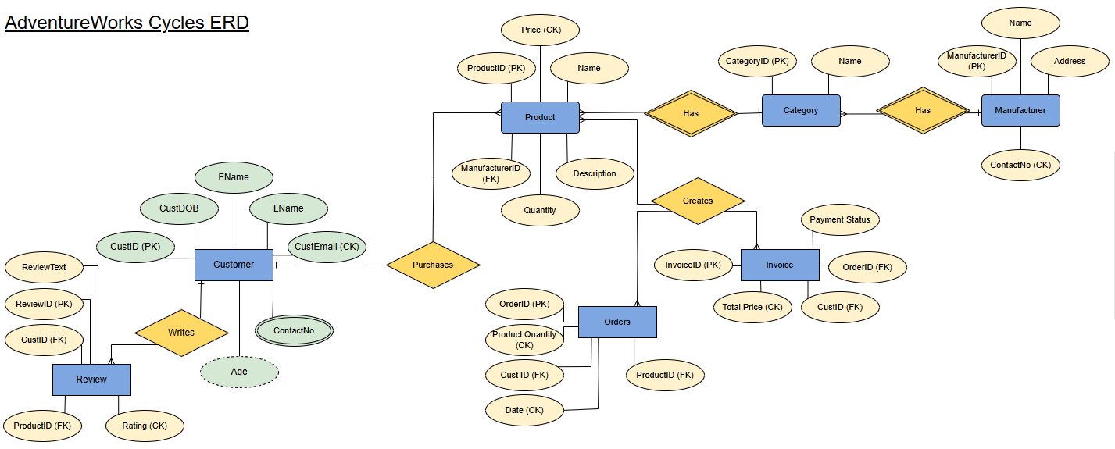

Figure 1 - AdventureWorks Cycles ERD

ERD Design Justification

The Entity Relationship Diagram (ERD) for AdventureWorks Cycles show how the different parts of the database are connected to support key processes like managing customers, roles, products and reviews [1][2][3].
Customer Table:
The customer table stores key details about each customer, such as their name, date of birth, and contact information. The primary key (CustID) ensures each customer is unique. The table’s relationships indicate that a customer can place multiple orders and write product reviews.
Product Table:
This table contains information about each product, including its name, description, price, and stock quantity. It links to the manufacturer and category tables via foreign keys (ManufacturerID and CategoryID), indicating that each product belongs to a specific category and is produced by a manufacturer.
Manufacturer and Category Tables:
The manufacturer table tracks details about companies that produce products, such as their name, address, and contact number. The category table organizes products into groups, such as "Road Bikes" or "Accessories," to facilitate product filtering.
Orders Table:
The orders table records customer purchases, specifying the product, quantity, and date of the order. It connects to the customer and product tables to ensure each order is linked to valid entries. Check constraints, such as ensuring quantities are above zero, help maintain data integrity.
Invoice Table:
The invoice table logs payment details for each order, including the total price and payment status. It links to the order and customer tables, making it clear which customer the payment relates to.
Review Table:
The review table enables customers to leave feedback on purchased products, with fields for a rating (between 1 and 5) and review text. Relationships ensure that reviews can only be created for valid customers and products.
Normalization:
The database is normalized to 3rd normal form (3NF), meaning each piece of information is stored in the appropriate table without redundancy. For example, customer details are not repeated in the orders table. This minimizes data duplication and ensures each table focuses on a single topic, making the database more efficient and easier to maintain [4].
Referential Integrity:
Foreign keys ensure valid relationships, such as linking orders to valid products and customers. Rules like ON DELETE CASCADE ensure that related records (e.g. orders) are handled correctly when a primary record (e.g. a customer’s account) is deleted.
Each table in the Entity Relationship Diagram (ERD) serves a distinct purpose and connects logically to others, enabling the database to handle tasks like tracking orders, storing product information, and managing customer feedback while remaining well-organized, accurate, and easy to query.
Database Implementation
SQL Code Screenshots
This section will provide screenshot snippets, along with a description to each.
Figure 2 – The Create Database AdventureWorks; command initializes the database where all the tables and data will be stored. This is the first step in setting up the database.
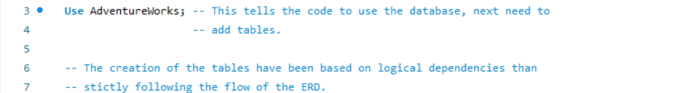
Figure 3 – The Use AdventureWorks; command sets the context to the AdventureWorks Database, ensuring that the following SQL commands apply to this specific database.
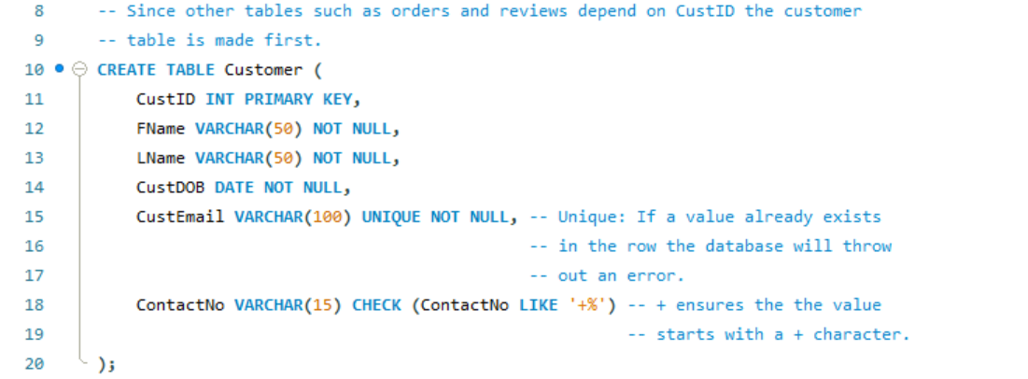
Figure 4 – The customer table stores customer details such as name, date of birth, email, and contact number. The primary key (CustID) ensures each customer has a unique identifier, while a unique constraint on CustEmail prevents duplicate addresses. A check constraint ensures that ContactNo starts with a "+" symbol to follow the required format. CustID also serves as a foreign key in related tables to maintain referential integrity.

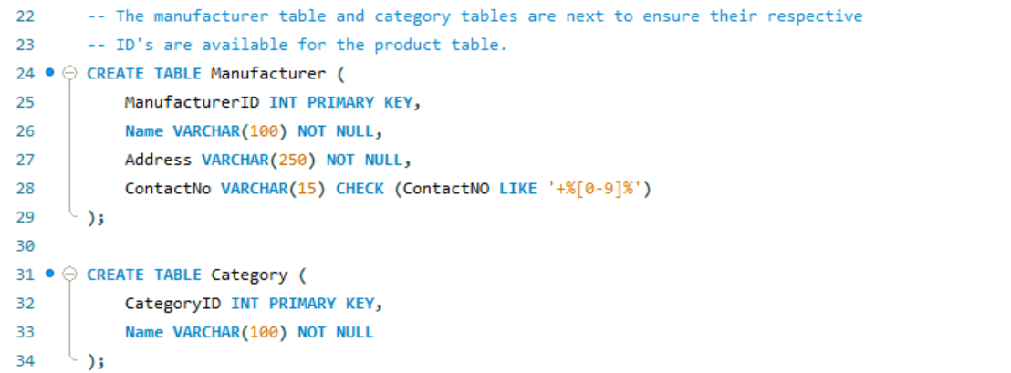
Figure 5 – The manufacturer table stores manufacturer details, including name, address, and contact number, with a primary key (ManufacturerID) to uniquely identify each manufacturer. A check constraint ensures the contact number starts with a "+". The category table classifies products into categories like "Mountain Bikes" or "Accessories," with CategoryID as the primary key to ensure category uniqueness.
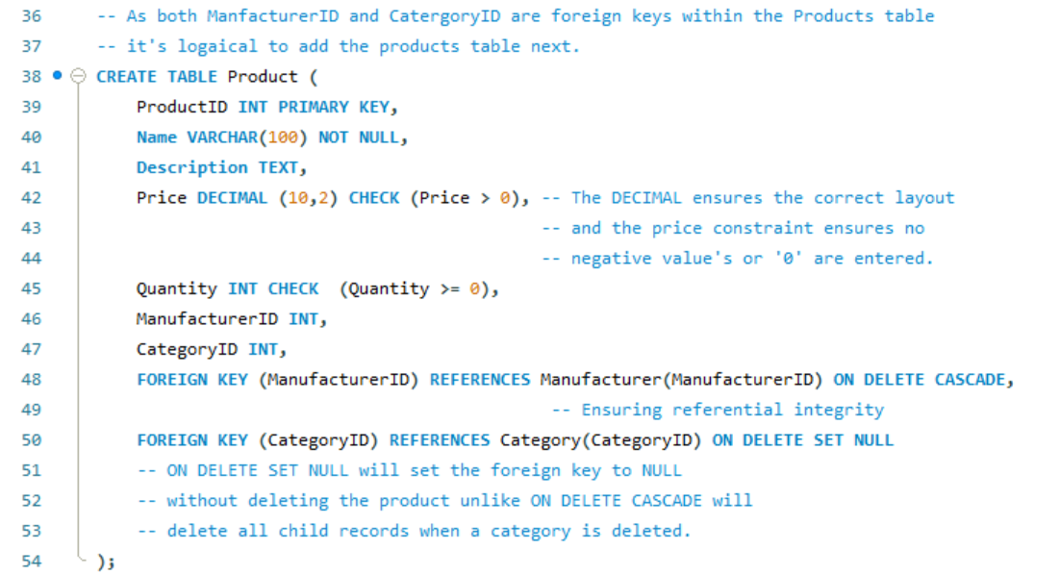
Figure 6 – The product table stores product details such as name, description, price, and stock quantity. The primary key (ProductID) ensures each product is unique. Check constraints enforce a price greater than 0 and a non-negative stock quantity. Foreign keys link ManufacturerID and CategoryID to the manufacturer and category tables, ensuring products are associated with valid entries. The ON DELETE CASCADE and ON DELETE SET NULL options handle deletions to maintain data consistency.
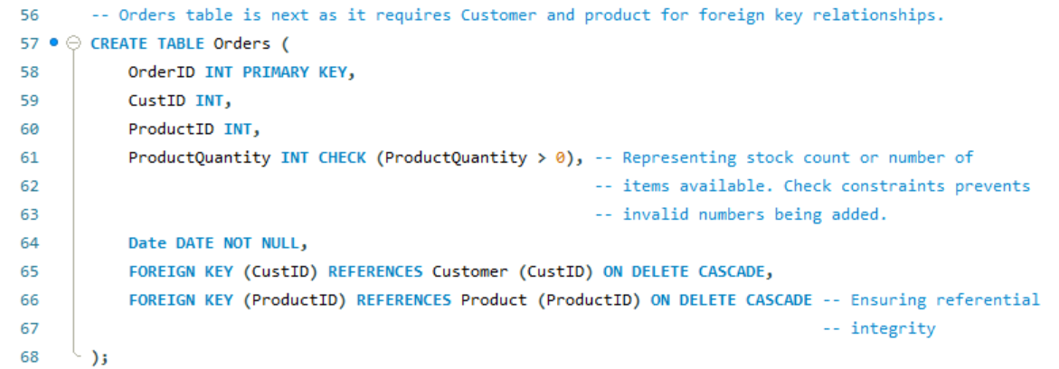
Figure 7 – The orders table tracks customer purchases. It includes fields for OrderID (the primary key), CustID (foreign key to customer), and ProductID (foreign key to product). A check constraint on ProductQuantity ensures that only positive values are accepted. The ON DELETE CASCADE rule ensures that when a customer or product is deleted, related orders are automatically removed to maintain integrity.
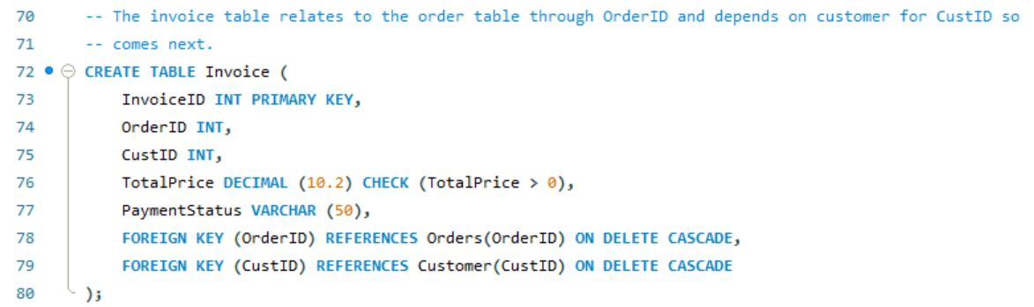
Figure 8 – The Invoice table stores payment-related details, such as the total price and payment status. The InvoiceID is the primary key, ensuring each invoice is unique. Foreign keys (OrderID and CustID) maintain references to the orders and customer tables. The ON DELETECASCADE option ensures invoices are removed if the associated order or customer is deleted. The check constraint on TotalPrice ensures the total is a positive value.
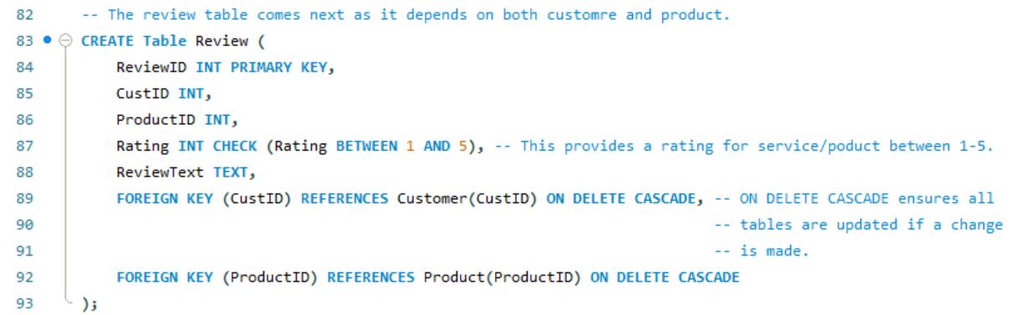
Figure 9 – The review table records customer feedback for products, including a rating and review text. The primary key is ReviewID. A check constraint ensures that the rating is between 1 and 5. Foreign keys (CustID and ProductID) ensure reviews correspond to valid customers and products. The ON DELETE CASCADE option ensures reviews are removed if a related customer or product is deleted.
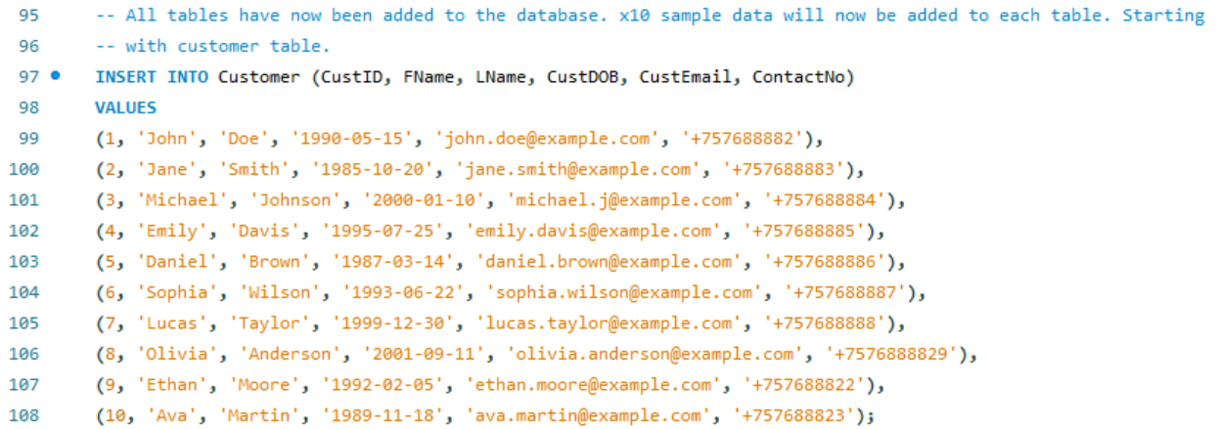
Figure 10 -The insertion of 10 sample customers into the customer table for testing purposes. Sample data includes names, emails and formatted contact numbers.
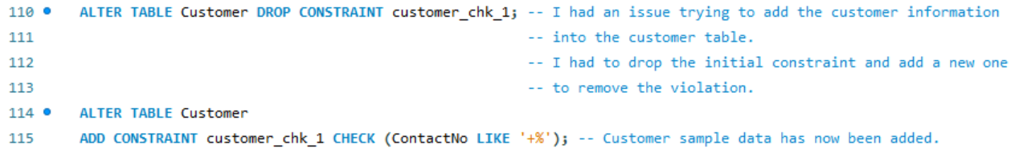
Figure 11 -An issue with the initial check constraint for ContactNo in and customer table is resolved by dropping the existing constraint and adding a corrected one. This ensures that the data follows the correct format.
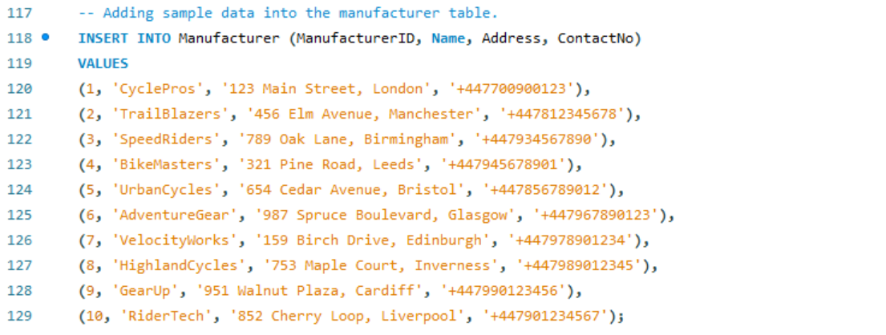
Figure 12 – Ten sample manufacturers are inserted into the manufacturer table, including names, addresses and contact numbers for each company.

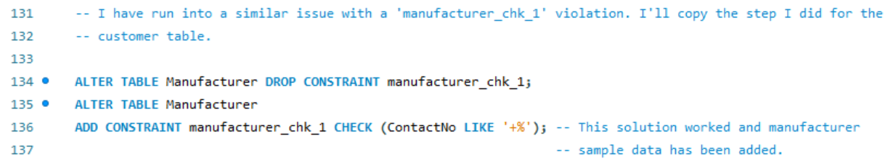
Figure 13 – A similar contact number constraint issue in the manufacturer table is resolved by dropping and readding the check constraint.
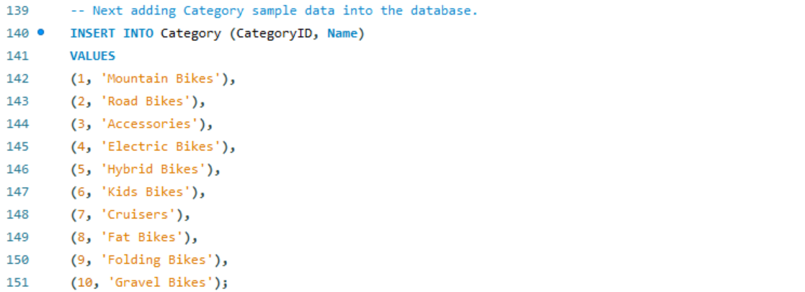
Figure 14 – Ten sample categories are added to the category table, covering different types of products such as “Road Bikes” and “Accessories”.
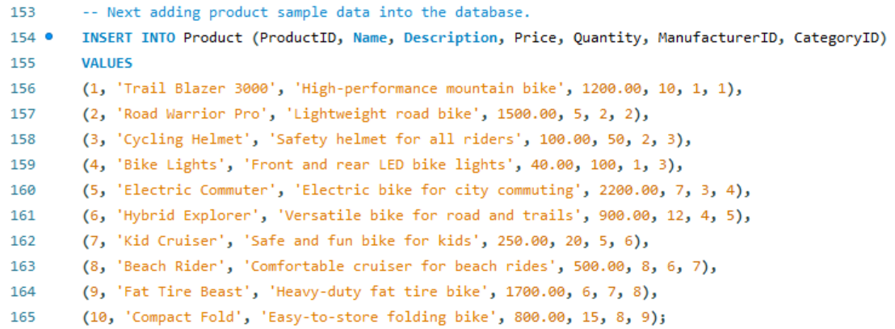
Figure 15 – Ten sample products are inserted into the product table. Each product is linked to a manufacturer and a category using their respective foreign keys.
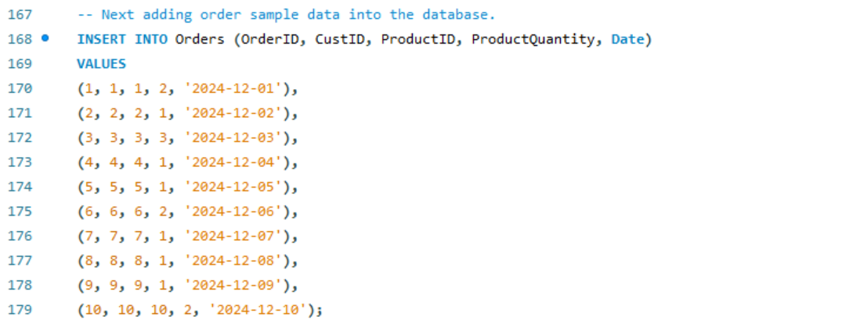
Figure 16 – Ten sample orders are added to the orders table.
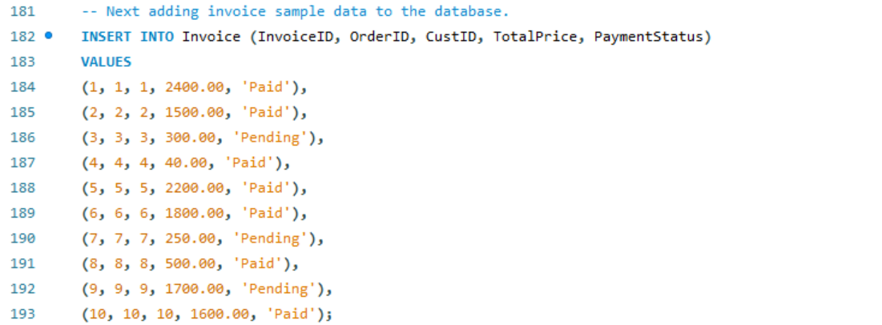
Figure 17 - Ten sample invoices are inserted into the orders table, showing payment details for each order, including total prices, and payment statutes (“Paid” or “Pending”).
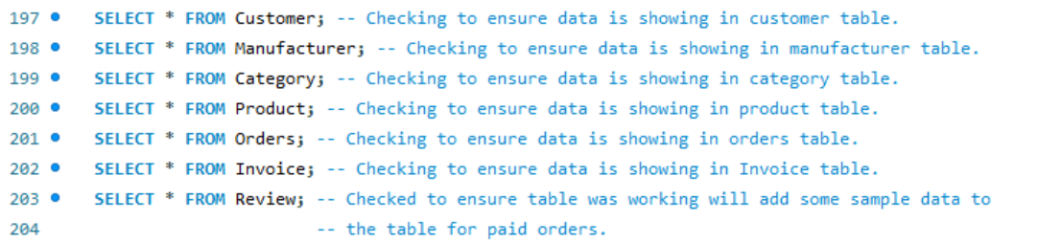
Figure 18 – SELECT * FROM queries were tested to display the contents of the tables, confirming that the sample data has been correctly inserted into the customer, manufacturer, product, orders, review and invoice tables.
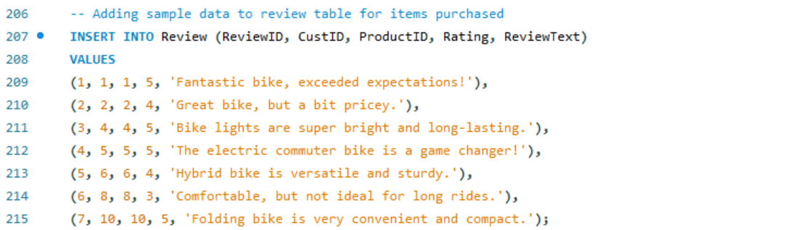
Figure 19 – Seven sample reviews are added to the review table, each containing a customer’s rating and review text for purchased products.
Figure 20 – This SELECT * FROM Review; query retrieves all the data from the review table to verify that the sample reviews have been successfully inserted.

SQL Query Tables

Customer Table
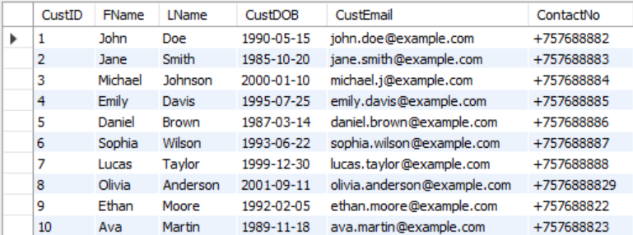
Figure 21 – Displaying the data stored in the customer table, showing unique CustID for each customer alongside their first name, last name, date of birth, email and formatted contact number. The sample data demonstrates the correct application of constraints, such as unique email addresses and contact numbers starting with a “+”.
Manufacturer Table
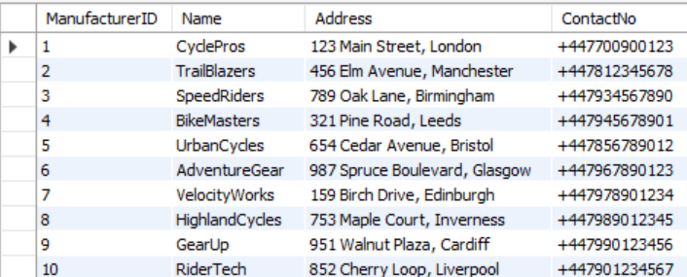
Figure 22 - Listing details for each manufacturer, including the ManufacturerID, name, address, and contact number. The data confirms that the check constraint for the contact numbers has been applied correctly.

Category Table
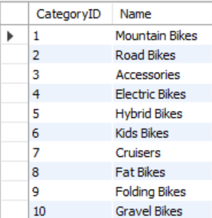
Figure 23 – Showing the different categories available, such as “Mountain Bike” and “Accessories”. Each category is identified by a unique CategoryID, verifying that the category table correctly holds distinct values.

Product Table
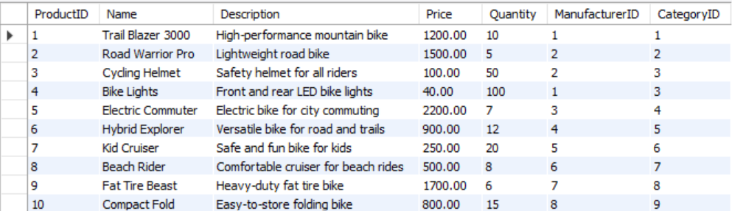
Figure 24 – Displaying information for each product, including its name, description, price, and stock quantity. The ManufacturerID and CategoryID columns confirms that products are correctly linked to their respective manufacturers and categories. The data also reflects the enforcement of check constraints for positive prices and non-negative quantities.

Orders Table
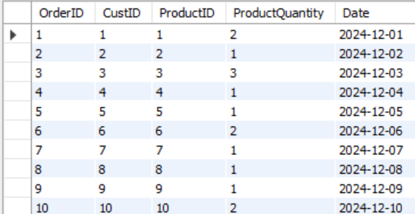
Figure 25 – Recording customer purchases, showing the OrdrID, CustID, ProductID, ProductQuantity, and the date of the order. The CustID and ProductID foreign keys demonstrate the connection between customers, products, and orders, ensuring referential integrity.

Invoice Table
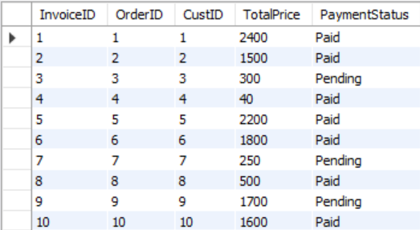
Figure 26 – Presenting data from the invoice table, including InvoiceID, OrderID, CustID, TotalPrice, and PaymentStatus. The records show both “Paid” and “Pending” statuses, confirming that the sample data accurately represents different payment scenarios.

Review Table
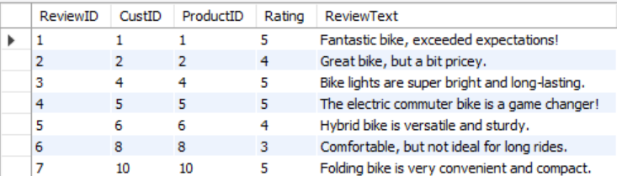
Figure 27 – Showing customer feedback for purchased products, including the ReviewID, CustID, ProductID, Rating, and ReviewText. The ratings fall within the enforced range of 1 to 5, as required by the check constraint, and each review is correctly associated with valid customers and products through the foreign keys.

SQL Queries for Testing

Query 1

Fetching Customers Who Left Reviews:
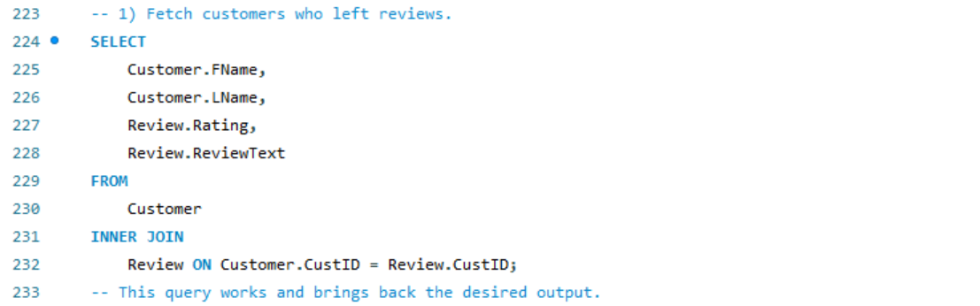
Figure 28 – Showing the SQL query used to fetch the first and last names of customers who left reviews, along with their rating and review text. The inner join between the customer and review tables ensures that only customers who have left reviews are displayed.
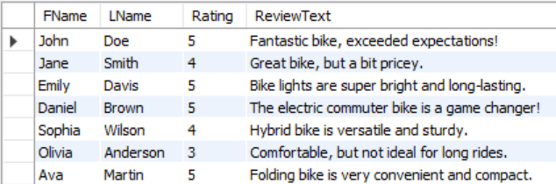
Figure 29 – Displaying the output table generated by the SQL query in Figure 28. The table shows customer names, ratings, and review feedback, confirming that the query correctly retrieved the relevant data from the customer and review tables.

Query 2

Calculating Total Sales Per Product:
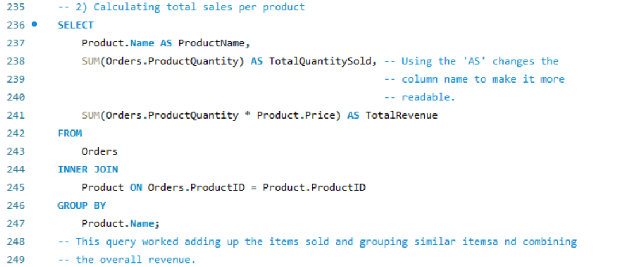
Figure 30 – Presenting the SQL query for calculating total sales per product. The query sums the ProductQuantity and calculates the total revenue by multiplying the quantity sold by the product price. The inner join links the orders and product tables by ProductID, and the GROUP BY clause groups the results by product name.
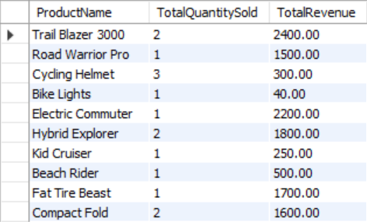
Figure 31 – Showing the output table generated by the query in Figure 30. It lists each product’s name, the total quantity sold, and the total revenue generated. The results confirm that the query correctly summarized the sales data.

Query 3

Fetching Customers with Pending Payments:
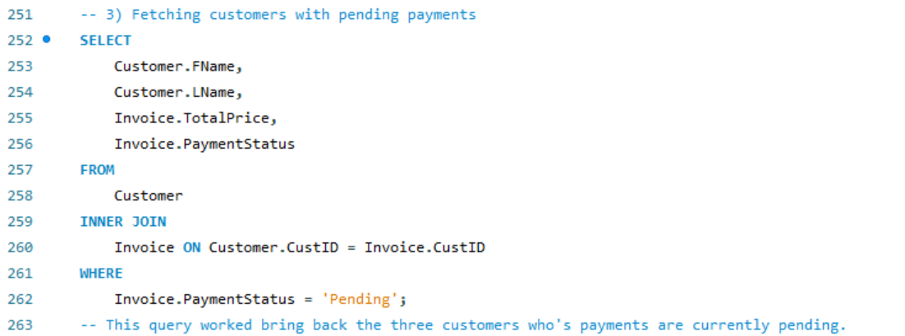
Figure 32 – Showing the SQL query used to fetch customers with pending payments. The query joins the customer and invoice tables by CustID and filters for invoices on PaymentStatus of “Pending”.
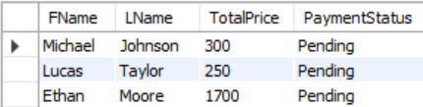
Figure 33 – Representing the output table for the query in Figure 32. It lists the names of customers with pending payments, the total amount owed, and the payment status. The results confirm that the query successfully retrieved customers with incomplete payments.

Query 4

Finding Products with a Reviewed Rating of 4 or Higher:
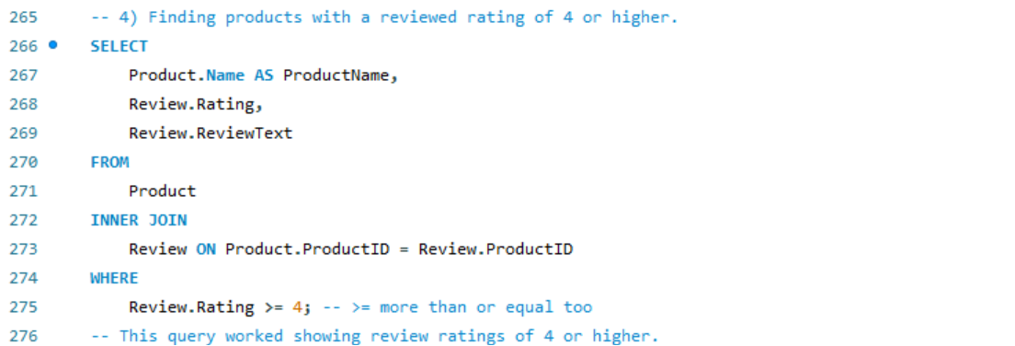
Figure 34 – Displaying the SQL query for finding products with a review rating of 4 or higher. The query joins the product and review tables by ProductID and filters for reviews where the rating is 4 or higher.
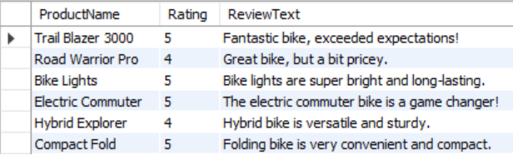
Figure 35 – Showing the output table for the query in Figure 34. It lists the product names, ratings, and review comments for products that receive high ratings. The output confirms that the query correctly filtered and retrieved the expected data.

Query 5

Fetching All Products and Their Manufacturer Details:
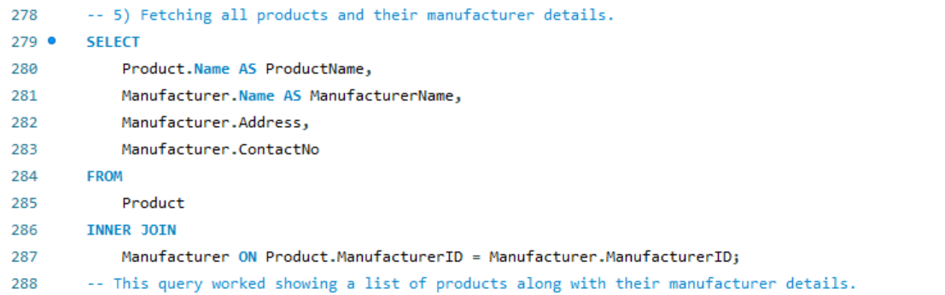
Figure 36 – Showing the SQL query used to fetch all products along with their manufacturer details. The query joins the product and manufacturer tables by ManufacturerID to display manufacturer name, address, and contact number alongside each product.
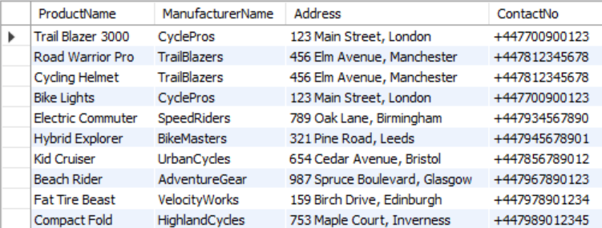
Figure 37 – Presenting the output table for the query in Figure 36. If shows each product’s name the associated manufacturer’s name, address, and contact number. The output verifies that the query correctly linked and retrieved data from both tables.

Transaction Management

Commit

Figure 38 – Showing the START TRANSACTION command, which initiates a new transaction. All subsequent operations will either be committed together or rolled back, ensuring data consistency during the transaction process.
Figure 39 – Showing the INSERT INTO Orders command, which adds a new order record to the orders table. The values inserted correspond to the columns in the orders table along with a quantity of 1, with the purchase date set to 2024-12-11.
When running the SELECT * FROM Orders table the following output is generated, showing that the order has been added.
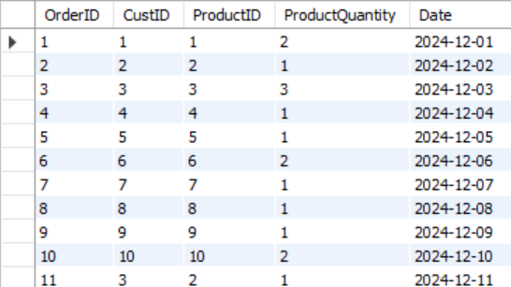
Figure 40 – Displaying the output of the SELECT * FROM Orders query, confirming that the new order has been successfully added to the Orders table. The new row for OrderID 11 is shown at the bottom of the result set.
Figure 41 – Showing the SQL query, which retrieves the current stock quantity for the product with ProductID 2. This step checks whether there is enough stock available to fulfil the order.
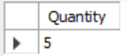
Figure 42 – Showing the result of the SELECT query, indicating that the current stock quantity for ProductID 2 is 5. Since this value is greater than 0, the transaction can proceed without issues.
Figure 43 – Showing the UPDATE Product command, which reduces the stock quantity for ProductID 2 by 1. The commit command saves the changes made during the transaction, confirming that the new order is finalized, and the stock has been updated.
When the command is then run to see if the ProductID 2 has been reduced by one in the products table it can be seen as reduced from 5 items down to four items remaining.
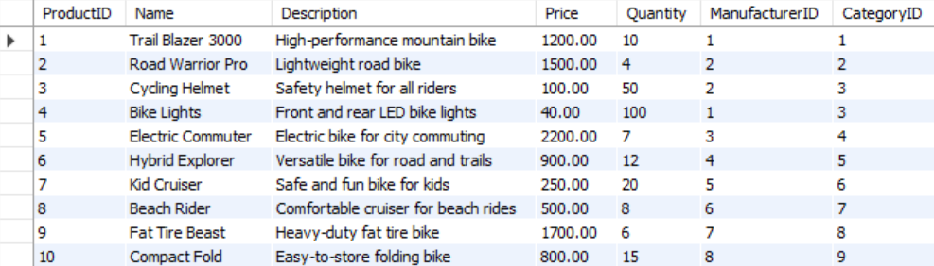
Figure 44 - Displaying the updated product table after the commit command has been executed. The quantity for ProductID 2 (Road Warrior Pro) has been reduced from 5 to 4, confirming that the transaction successfully updated the stock quantity as expected after the new order was placed.

Rollback

Figure 45 – Showing the start of the rollback transaction process with the START TRANSACTION command. This begins the transaction.
Figure 46 – Displaying the INSERT INTO Orders statement, which attempts to insert as order requesting 10 units of ProductID 2. This is used to demonstrate what happens when the requested quantity exceeds available stock.

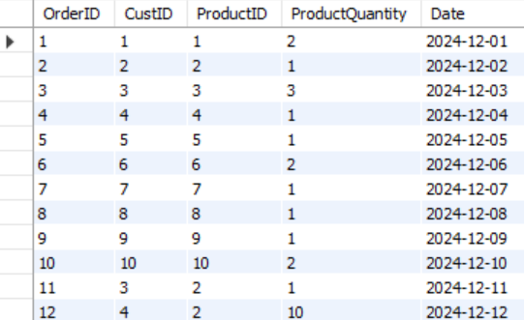
Figure 47 – Showing the output of the SELCT * FROM Orders query, confirming that the attempted order with OrderID 12 was temporarily added during the transaction process before checking stock availability.
Figure 48 – Showing the SQL code to view the Quantity of the requested item. This ensures the system verifies whether an order can be fulfilled.
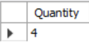
Figure 49 – Displaying the result of the stock check, indicating that there are only four units available for ProductID 2. Since the order requested 10 units, this triggers the rollback process.
As the customer wished to purchase 10 items from ProductID 2 and there are only four items available. The command rollback will now be used.
Figure 50 – Showing the rollback command being executed due to insufficient stock. This will now cancel the entire transaction, ensuring no changes are saved to the database for this failed order.

To ensure to rollback has taken place the command to view the output of the orders table is used SELECT * FROM Orders.
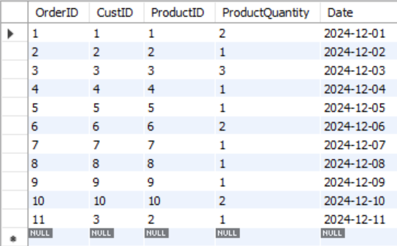
Figure 51 – Showing the result of the SELECT * FROM Orders query after the rollback. The attempted order with OrderID 12 has been removed, confirming that the rollback successfully undid the transaction, preserving the integrity of the orders table.

Database Performance Indexes

To enhance the performance of the database, indexes have been added to key columns that are frequently used in queries [5][6].
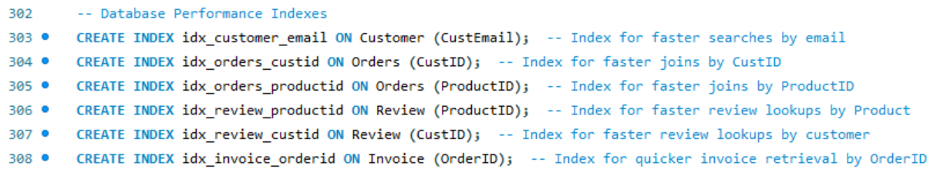
Figure 52 – Six indexes have been added to the database to make queries on commonly search criteria faster.
Indexes act as shortcuts that help the database quickly locate records without scanning the entire table, improving query efficiency especially for SELECT statements with WHERE, JOIN, ORDER BY, or GROUP BY clauses [7].
For example, searches for orders by CustID or reviews by ProductID run faster due to indexes on these columns. By indexing commonly queried fields like CustEmail in the customer table and ProductID in the orders and review tables, the database handles lookups and joins more efficiently, even as the dataset grows.

Report Conclusion
In conclusion, this report outlines the design, creation, and testing of a relational database for managing orders, customers, products, and reviews. A structured approach ensured that tables, relationships, and constraints-maintained data integrity while supporting key operations such as data insertion, updates, and queries.
Transaction management handled successful data changes (commit) and prevented invalid operations (rollback), ensuring consistency. Performance tuning, including indexing, improved query efficiency for large datasets.
Overall, the database design meets real-world requirements by supporting reliable data operations, efficient retrieval, error prevention, and performance optimization.

References

[1] Wikipedia Contributors, “Entity–relationship model,” Wikipedia, May 13, 2019. /https://en.wikipedia.org/wiki/Entity%E2%80%93relationship_model (accessed 15/12/2024)
[2] T. J. Teorey, Database modeling and design : logical design, 5th ed. Amsterdam ; Morgan Kaufmann Publishers, 2011. (accessed 15/12/2024).

[3] T. M. Connolly and C. E. Begg, Database Systems : a practical approach to design, implementation, and management, Sixth, Global edition. Boston: Pearson, 2015. (accessed 15/12/2024)

[4] J. L. Harrington and J. L. Harrington, Relational database design and implementation : clearly explained, 3rd ed. Amsterdam ; Morgan Kaufmann/Elsevier, 2009. (Accessed 12/12/2024) (Chapter 6 third normal form)

[5] Wikipedia Contributors, “Database index,” Wikipedia, Nov. 15, 2019. https://en.wikipedia.org/wiki/Database_index (accessed 12/12/2024)

[6] GeeksforGeeks, “Indexing in Databases | Set 1 - GeeksforGeeks,” GeeksforGeeks, Jul. 15, 2016. https://www.geeksforgeeks.org/indexing-in-databases-set-1/ (accessed 12/12/2024)
[7] J. D. Ullman and J. Widom, A first course in database systems, Third edition. Harlow, England: Pearson Education Limited, 2014. (accessed 12/12/2024) (chapter 8 Vies & Indexes)

