BA (Hons) International Hotel Management
Module Handbook Autumn Term 2025

Hotel Placement – Managing Guest Service Operations
BMIH6002
Badrul Jamal 2126642
Level 6

Module Lead

Jessica Newport BA (Hons), MBA
Contents
Introduction 3
Main body 3
Conclusion 6
References 6

Introduction

Leonardo’s is a four-star hotel located in Bradford centre. The Food and Beverage section of the hotel operates three joints and occasions. The Hotel has a sit down restaurant which has got the capability of serving a day long and has the capacity of seating 120 people. It provides new menu and modern British food subject to the season. This will be the Bar and Lounge with a capacity of 80 seats. It sells cocktails, local craft beers, and has the afternoon tea programme. Meetings and Events, corporate conferences and social gatherings are held here. The team will be arranged into two major sections: Back of House, which will consist of the Executive Chef and the outlet Sous Chefs; and the Front of House led by the food and beverage Manager alongside the outlet Managers and Supervisors.
This reflection is on sustainability in hospitality business and food and beverage businesses. I applied concepts such as the Triple Bottom Line, HACCP, Menu Engineering, SERVQUAL and PDCA to understand how theory does not work in real world. I discuss my increasing knowledge, potential points of strengthening the experience of guests, environment, and profit. I also discuss my personal activities and my experience.

Main body
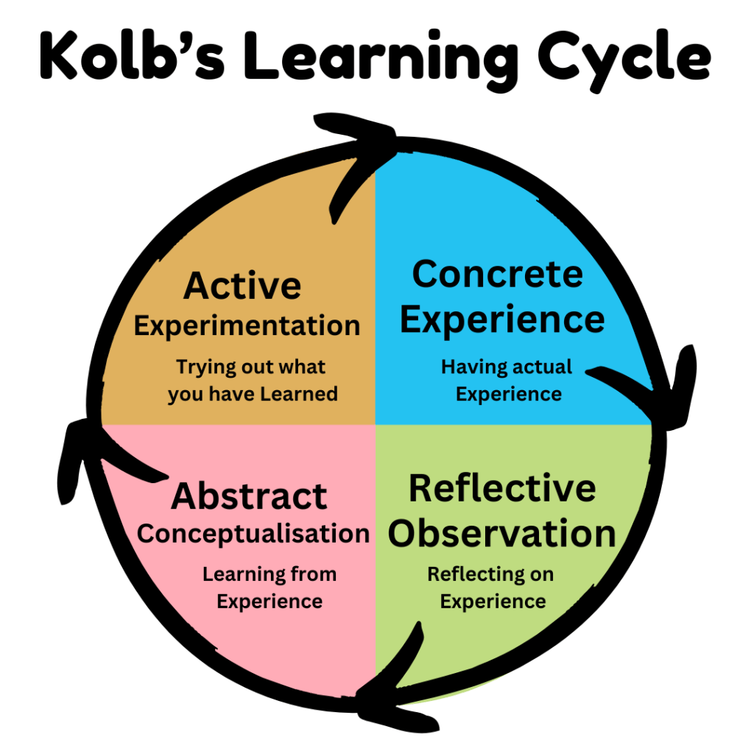
Figure: Kolb’s learning cycle (source: earlyyearstv.com)
Concrete Experience
My work experience at Leonardos hotel Bradford during the ten weeks consisted of spending the majority of my time at the food and beverages, assisting at Bar during the busy nights, and some work on banquet assignments (Anon, 2010). There were two cases that remained with me. First, the main meals diminished on Saturday night, at night time when the restaurant was full at around 7-8.30 pm. The grill and the garnish pass were busy and our best selling products required an extra work in the last minute. Second, during one of our corporate lunches, three customers informed us that they had allergies towards the end of the service. We were educated on allergens and I had a folder in the host stand, however, the urgency was there, and it was not easy to go through it. I observed servers attempting to recall the information. I was also aware of the sustainability practices of the hotel: separate containers in the back kitchen, oil recycling, the menu contains the names of suppliers (MSC fish, Red Tractor meats) and information about minimizing waste is also presented on the posters. We completed temperature logs at each shift, but several of the items were rounded. I interviewed James O’Connor, the Assistant FandB Manager, and he just told me one thing that I did not forget: When we manage waste, we actually control the menu.
Reflective Observation
I also considered the pressure points otherwise. They were not related to people working harder but to the suitability of our processes to the peak demand. Our mains were selling really and made our guests happy, and also blocked the pass at an extremely bad time (Johnston et al., 2012). The allergen system was introduced and was difficult to utilize when there was more than one guest; the guests did not even see clear signs on the menu, therefore asking questions would occur late and the checks would take more time. Sustainability was a consideration with us though the waste notes were vague and thus we could not easily tell what items were being disposed of and at what time. Temperature measurements were rounded off and I wondered as well whether we were recording an estimate and not the actual temperature. I came to learn that the sustainability, allergens, speed, and cost areas are interrelated. A slow pass causes delays when the guests are queueing, pressure to staff and errors that could result into accidents. Over planning too far in advance may result in wastage. All these problems form a complex.
Abstract Conceptualisation
By associating this with theory, I was able to make sense of this:
- Menu Engineering demonstrates why we are concerned with what dishes yield us a lot of money; however, it does not take into consideration the time spent by those dishes. By putting next to the margin of the dish how much prep it requires we can maintain speeds and profit levels at the same time.
- HACCP provides a framework of safety, and in a hurry people have an opportunity to complete the paper forms too fast. An automatic means of recording the temperatures are probably more precise and require less labor in the long run.
- It is not only having the appropriate information that is required in managing allergens; it is also the way the staff and guests feel about the process. The design options, such as menu icons, a standard confirmation and repeat-back sentence are small elements that can make the process safer and faster.
- When taking care of the Triple Bottom Line, it is the idea of sustainability that has reminded me that waste is not just a cost. It is also damaging to staff morale (disposing of work does not always feel good) and environment. Realistic changes that can be helped are shown in better data.
- Testing improvements through PDCA is a good idea; since you do not need to make an enormous promise, you can plan a minor change, implement it, and decide whether it works or not, and further change or not.
Active Experimentation
Some minor, risk-minimizing changes that had confirmatory input in the team would be tried:
- I timed some few orders during busy Saturdays and undertook to observe where delays occurred. The two suspected dishes were already the longest taking dishes. Instead of cooking many vegetables in the end, I pre-portioned a service of a sauce in small cups in advance and recommended that one cook the asparagus by blanching and searing it first. No big thing, two little frictions to remove. The following service of the same type got slightly calmer and the mains completed in less time (Johnston et al., 2012). None of the data about the stopwatch, however, the grill chef and a server reported that it was much smoother.
- I created basic icons of allergens to the restaurant menu and gave a brief script to the servers: ask, note and repeat the allergen back at the pass before passing on the script. We tried it for a few shifts. It did not make anything slow and there was better communication with guests.
- My log system was a simple one (photo + quick note), in which I kept a list of things, which were discarded at the restaurant, and especially salads and fruit garnish. I was making early preparations in case of peace of mind, yet the lunches of weekdays were not so active as to consume all. The following week or so, the number of those items going to the bin reduced. It was a more casual preparation method in comparison to preparing everything simultaneously, so to speak.
- One day I requested to test a Bluetooth probe on the carvery hot -hold during one shift. The readings were immediately on a tablet, and hence there was neither writing nor cube numbers. The chef de partie claimed that it was even easier as it eliminated an activity. I believe that this would assist training as well since new employees can observe correct histories, rather than making predictions.

Conclusion
As I found out during my Leonardos hotel placement, the operations of sustainability and food and beverage are interconnected. A glance at the department based on TBL, HACCP, Menu Engineering, SERVQUAL, and PDCA showed that the department has strong terms: reliable sourcing (MSC/Red Tractor/local), proper waste separation, and the rigid sequence of service. It could be most improved in the quality of data, the form of the allergen and faster in a high-change period. I also included a waste heat map, subdivision of prep times into stages, simplified pass-side steps and included a menu-mix briefing card. These brief modifications delivered evident outcomes: a reduction in the quantity of waste of perishable products, acceleration of main courses in seasons of high demand, and simpler discussions of allergens. I have understood that the system comprises a combination of guest satisfaction, cost control, and environmental impact. These improvements should then be formalized, i.e. at least one of the HACCP records should be digitized, the allergen procedures and menu signs must be formalized, and the emphasis on the difficulty of the prep should be included in the monthly menu planning.

References
- ‘Anon (2010) A Good Practice Guide for Placement and Other Work-based Learning Opportunities in Higher Education – Good Practice for Placements Guides – Volume 2. 52 (4). doi:10.1108/et.2010.00452dab.013.
- Hagg, E. (2013) Internship Guide: Work Placements Step by Step. 5th Ed. The Hague: Eleven International Publishing.
- Johnston, R., Clark, G. and Shulver, M. (2012) Service Operations Management: Improving Service Delivery. 5th Ed. London: Pearson.
- Rutherford, D, G and O’Fallon, M J (eds.) (2007) Hotel management and operations. 4th ed. Hoboken, N.J, John Wiley.
- Walker, J.C. (2021) Introduction to Hospitality. 8th Ed. Harlow: Pearson Education Limited.
- Andersen, V., Lelieveld, H.L.M. and Motarjemi, Y. (eds) (2023) Food safety management : a practical guide for the food industry. Second edition .

