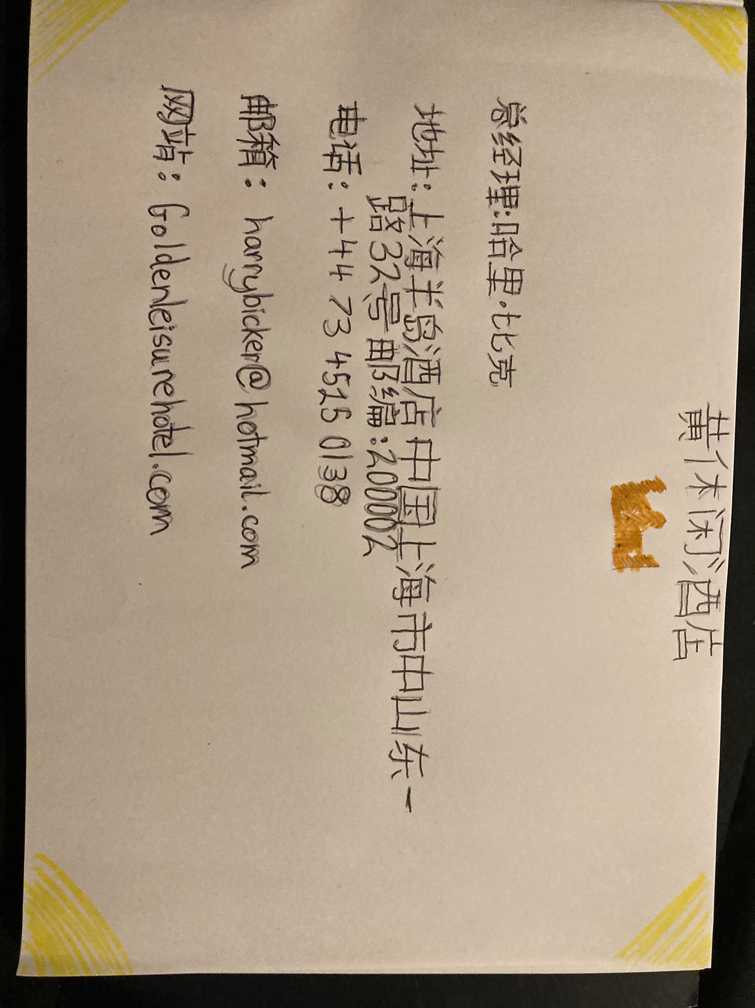
Student Name and Number: Harry Bicker
Assignment: Hotel Business Card M5X01923_LON
Lecturer: Jinping Li
Here is my hotel business card in Chinese characters.

