MODULE: Foreign Languages and Cultural Awareness
MODULE Code: BMIH5003
Lecturer: Giulia Chifari
Assignment type: Report

Student name: Dimitar Evtimov Karamanov
Student number: 2235640

Executive summary
This study looked at the differences in culture between Portugal and England and how they might affect leadership in a global hotel chain that was hiring Portuguese staff for headquarter in Portugal. The GLOBE culture study showed that Portugal has a bigger power gap and a focus on unity compared to England, which puts more stress on equality and independence. There were also big differences between the two countries in how aggressive people were, how gender roles were viewed, and how important work-life balance was seen. Both Spain and Portugal put a lot of value on personable and team-oriented leadership styles, but Spain and Portugal both put more value on caring and inspiring people in leadership jobs. The hotel business faces several intercultural difficulties, such as dealing with different power relations, communication styles, and the need for freedom from Portuguese workers who have family obligations. If not handled carefully, these could cause problems between people from different countries who work together. The research shows that these problems can be solved with cross-cultural training, policies that encourage knowledge of different points of view, and flexible leadership that considers specific cultural differences. This way, the company with multiple locations can get the most out of its variety.

Table of Contents
Introduction 4
Cultural Differences between England and Portugal 4
GLOBE Project’s Culture and Leadership Study: England vs Portugal 7
Challenges of Intercultural Leadership in the Hospitality Industry 7
Conclusion 8
References 9

Introduction
Making it easier for teams from diverse cultures to work together has become more important as the Multicultural hotel company grows its foreign activities. The planned move of Portuguese hotel staff from the Lisbon office to the London team could bring new possibilities but also latest problems if cultural differences are not understood and dealt with properly. The purpose of this study is to look at some of the most important cultural differences between Portugal and England that might affect how people work together and how leaders lead in the hotel industry. This study looks at cultural aspects such as power gap, independence, and gender roles by analysing data from the well-known GLOBE cultural research project and comparing the two countries. There is also a critical discussion of intercultural leadership issues in the hotel business. It is hoped that the research and discussions here will help the multicultural hotel company successfully combine its multicultural staff and get the most out of variety.

Cultural Differences between England and Portugal
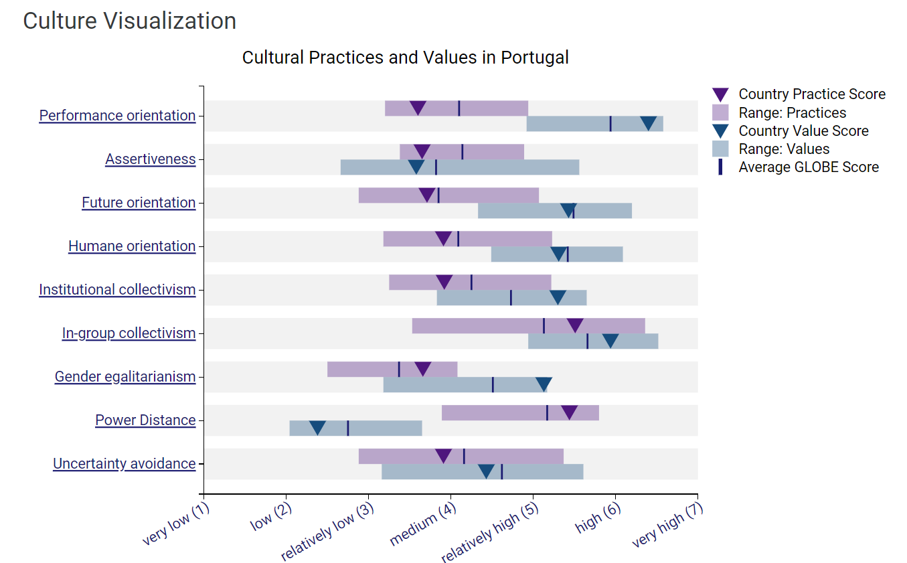
Figure 1: Cultural Practices and Values in Portugal
Source: GLOBE Project (2020)
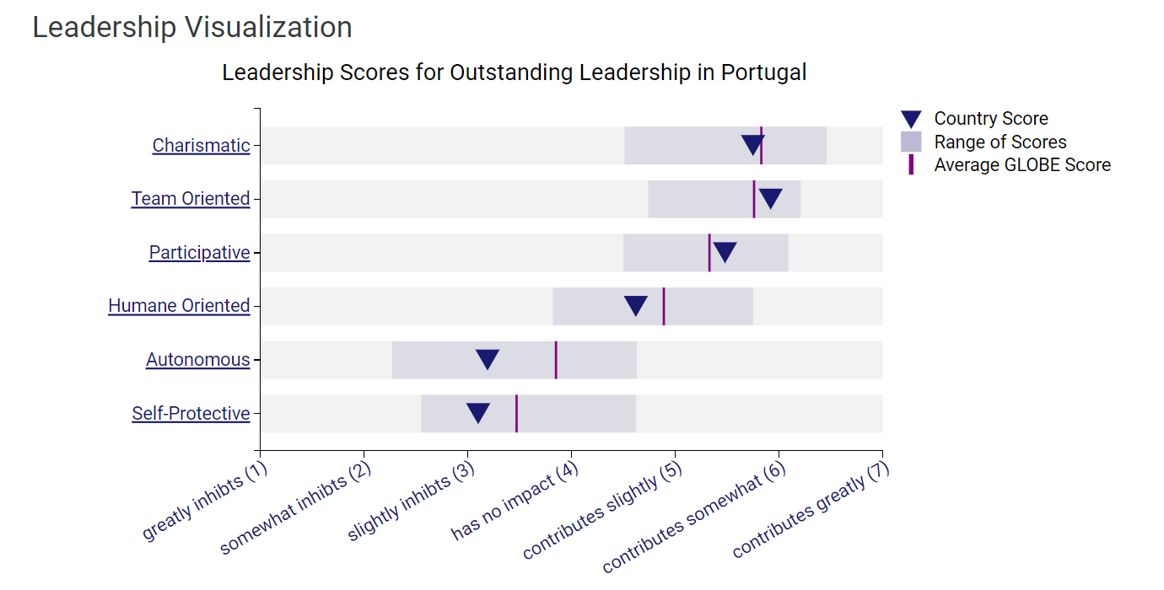
Figure 2: Leadership Scores for Outstanding Leadership in Portugal
Source: GLOBE Project (2020)
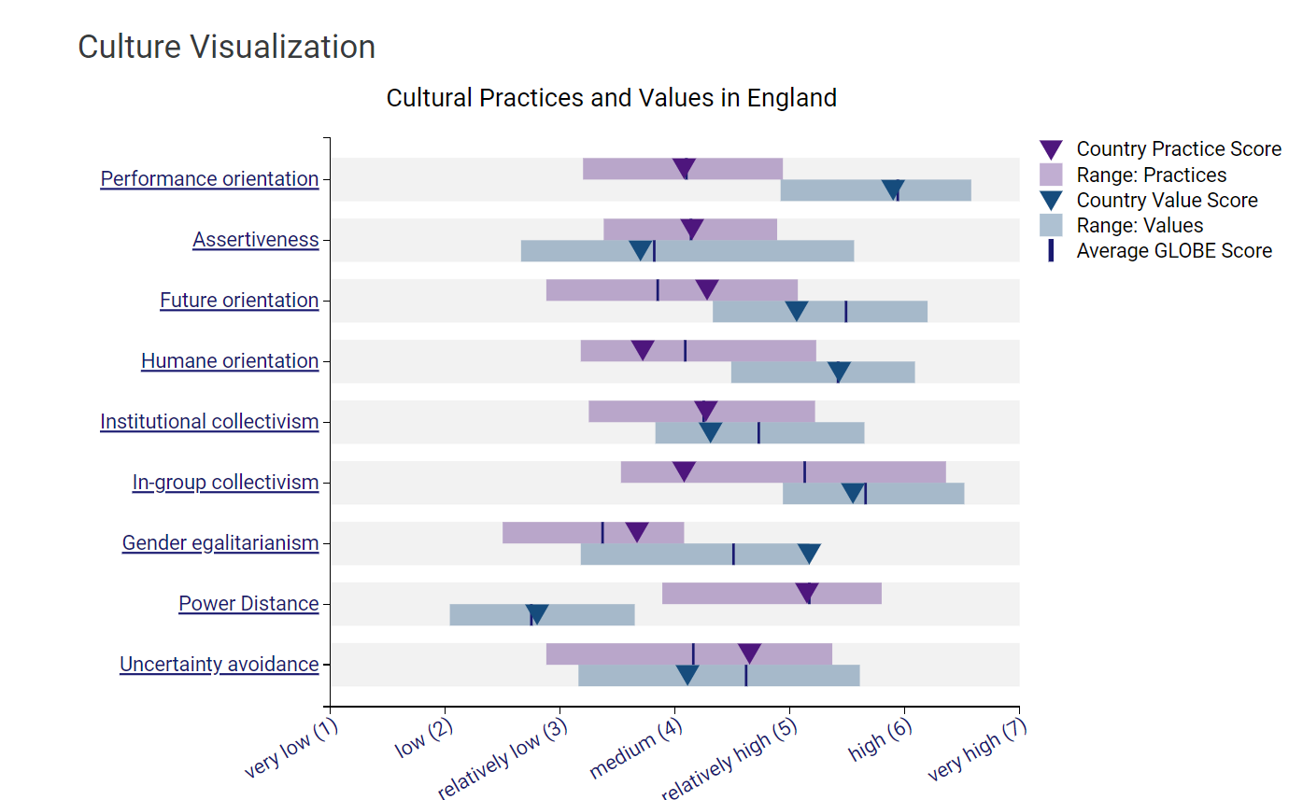
Figure 3: Cultural Practices and Values in England
Source: GLOBE Project (2020)

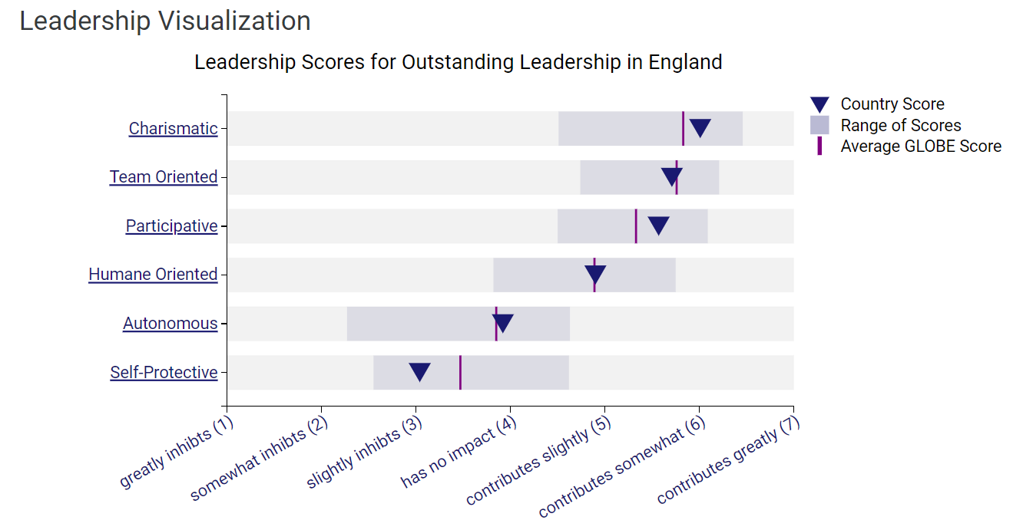
Figure 4: Leadership Scores for Outstanding Leadership in England
Source: GLOBE Project (2020)
Because of their different historical and social effects, Portuguese and English cultures are vastly different from one another. According to the GLOBE study, one difference is that they are different in how they feel about power gap. In Portugal, there is more power distance than in England. This means that leadership and centralised authority are more common, and people are used to unequal power sharing in their personal and professional lives. This is clear from the fact that leaders are treated more formally and with respect in Portugal than in the UK, where equality is emphasised (GLOBE Project, 2020).
In a hotel setting, Portuguese employees may be used to clear instructions from managers, while English employees may want more freedom and input into choices. Getting people to agree with changes might take a different way of leading with each under the guidance GLOBE Project,2020. Portugal also has a higher level of in-group unity, which means that close ties and trust within families, friends, and work groups are valued more. England, on the other hand, got a lower score, which means that people there value their own needs more than group responsibilities. In real life, Portuguese workers may expect more open schedules to balance work and family duties than their British peers, who are more focused on getting things done. Leaders need to produce a mix of strategies to deal with these distinct cultural goals when it comes to duties outside of work (GLOBE Project, 2020). Also, people in Portugal tend to be more direct, bold, and emotional when they communicate and make decisions, while people in England tend to be quieter and more reserved. During meetings, British viewers who are used to informal language may find Portuguese input to be rude, while their own comments may go ignored. So, it is important to make it easy for people of both countries to participate and make sure that everyone is fairly represented. Also, the two cultures have hugely different ideas about how people should behave. Portugal still has high marks for traditional masculinity, which shows that men follow certain roles in society. England, on the other hand, has moved towards greater gender equality by improving women's rights and participation.

GLOBE Project’s Culture and Leadership Study: England vs Portugal
The GLOBE study gives more culturally complex information about what qualities leaders in England and Portugal look for based on social rules and beliefs. Both countries get high marks for personable and team-oriented leadership, recognising that creative leaders can inspire people and that working together is an important part of hotel management. Portugal, on the other hand, puts more weight on dynamic leadership. This is probably because the country values guidance and support from above more (Afs-Usa, 2019). Team leadership is also highly regarded because of Portugal's better in-group unity, which values group goals over individual success. This desire for interesting and motivating people in leadership roles has effects on implementing change. For example, English employees may respond better to logic, while Portuguese employees may look for an emotional connection to suggested changes (Silva, and Henriques, 2021).
Human leadership that cares about people's health, happiness, and quality of life is also viewed highly across countries, but more so in Portugal than in England. This fits with Portugal's higher levels of cooperation, which value teamwork and support among coworkers. The American Occupational Therapy Association (2020) states that the British work ethic values results and equality more than having a good relationship with others. Leaders need to adapt how they deal with people. Caring for Portuguese employees with kindness works well, but it could hurt the confidence of British employees who expect leaders to be forceful. The worst types of leadership are those that look out for their own interests. This is true in both countries, though it is not as bad in Portugal, where attractive leaders allow some personal desire. These results show that there are subtle differences between nationalities in what makes for good management.

Challenges of Intercultural Leadership in the Hospitality Industry
Leading an international team in the complicated and ever-changing hotel industry can be hard for people from diverse cultures who need to communicate and work together. Differences in power gap between Portuguese and British culture could cause problems if they are not recognised. Staff in Portugal who are used to formal structures may become unhappy if managers who are seen as leaders fail to provide clear instructions. On the other hand, British coworkers who want to be left alone may feel micromanaged when their Portuguese coworkers use these styles. Open-door policies and joint decision-making are needed to create mentally safe places where everyone's voice is heard (Hampden-Turner, et al. 2020). There are also differences in how people like communicate to each other. For example, British people who are used to quiet conversations might take British people who are more outspoken for disinterest. Leaders need to make sure that talks are open to everyone, giving everyone a chance to participate and preventing problems that could arise from cultural misunderstandings.
When it comes to work-life balance, individualism vs. unity can also mean having different goals, which can lead to fights if they are not fixed. Flexitime policies for Portuguese workers that consider their family responsibilities without lowering service standards need to be planned strategically and jobs need to be rotated. Laws are important, but promoting social unity is also important so that people from different areas can understand how the personal responsibilities of people in different countries may affect access. It is also important to stay away from unconscious gender bias in the service industry, where gender roles are always changing. Classes against discrimination and funds for different education courses can help everyone feel more welcome and help workers from different countries understand each other's cultures better. To build trust between groups, it is also helpful to speak often and deal with problems quickly.

Conclusion
In the hotel business, one must understand and be able to deal with the cultural differences between people from different countries in order to lead foreign teams well. This study from a well-known culture research project shows some significant differences in how people in Portuguese and British countries live and think. By understanding these differences, employees can work together to make the workplace a better place to be. To get the most out of variety while minimising the problems that can arise from mistakes between cultures, it will be important to have regular conversations and be open to changing the style. With care and awareness of differences, integrating Portuguese staff in London can be a beneficial experience for everyone.

References
Afs-Usa. (2019). Portugal: Exploring Portuguese Culture | Learn with AFS-USA. AFS-USA. https://www.afsusa.org/countries/portugal/ [Accessed on 20th May 2024]
American Occupational Therapy Association, 2020. Educator’s guide for addressing cultural awareness, humility, and dexterity in occupational therapy curricula. The American Journal of Occupational Therapy, 74(Supplement_3), pp.7413420003p1-7413420003p19.
GLOBE Project, 2020. Results - GLOBE Project 2020, Globeproject.com. Available at: https://globeproject.com/results.html#cluster [Accessed on 22 May 2024].
‌Hampden-Turner, C., Trompenaars, F. and Hampden-Turner, C., 2020. Riding the waves of culture: Understanding diversity in global business. Hachette UK.
Silva, H.E. and Henriques, F.M., 2021. The impact of tourism on the conservation and IAQ of cultural heritage: The case of the Monastery of Jerónimos (Portugal). Building and Environment, 190, p.107536.
Lee, C.K., Ahmad, M.S., Petrick, J.F., Park, Y.N., Park, E. and Kang, C.W., 2020. The roles of cultural worldview and authenticity in tourists’ decision-making process in a heritage tourism destination using a model of goal-directed behavior. Journal of Destination Marketing & Management, 18, p.100500.
Loh, J.M., Thorsteinsson, E.B. and Loi, N.M., 2021. Workplace incivility and work outcomes: Cross‐cultural comparison between Australian and Singaporean employees. Asia Pacific Journal of Human Resources, 59(2), pp.305-329.
Perreault, M. and Power, N., 2023. Work-life balance as a personal responsibility: The impact on strategies for coping with interrole conflict. Journal of Occupational Science, 30(2), pp.160-174.
Christian, E.O., 2023. Exploring employee perspectives into technology-mediated communication in multinational organizations.
Globeproject.com, 2024. Country Analysis. Available at : https://globeproject.com/results/countries/AUS%3Fmenu=list.html#list [Accessed on 6 May 2024].

‌

