Appendices
- Plan for lesson one and two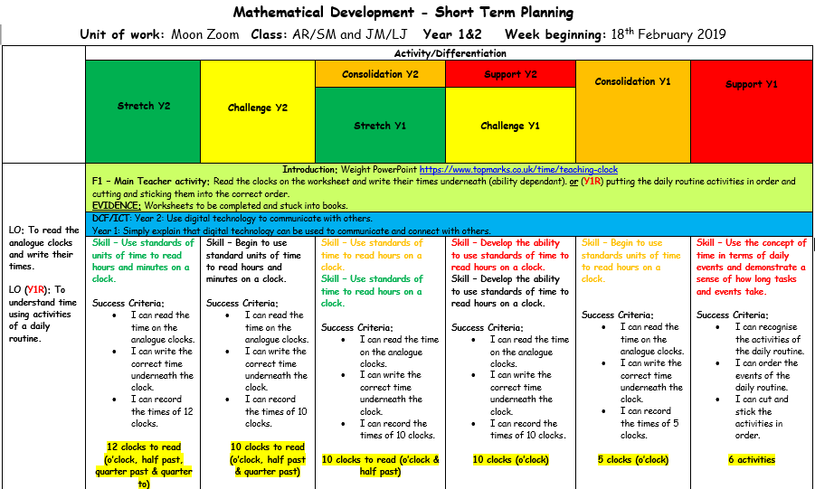

Name of Trainee: | Angelea Brabon |  |  | Session ref: |  | Maths |  | Date: |  | 21/02/19 |  |  | Class: | Y1/2 |  | Cynllun Ffocws y Cyfnod Sylfaen  2d
Targed(au) Hyfforddi Personol |  |  |  |  |  |  |  | Number of learners: |  |  |  |  | Age: |  |  | Cynllun Ffocws y Cyfnod Sylfaen  2d
Learning objectives/intentions: |  | WALT:  - Use standard units of time to read ‘o’clock’ using both analogue and 12-hour digital clocks.  - Read ‘half past’ ‘quarter past’ and ‘quarter to’ on an analogue clock. |  |  |  |  | Success Criteria |  | By the end of the week the children will be able to read the time to o’clock and half past on an analogue clock and have some understanding of the digital clock. |  |  |  |  | Meeting learners’ needs:
Introduction/plenary tasks |  |  |  |  | Main activities |  |  |  |  |  | Resources/  Key Vocabulary |  |  |  | Assessment for Learning (strategies and opportunities)
Introduction  Re-cap on what we have already learnt about time, I will ask the children time questions, e.g. show me 3 o’clock and they will use their mini clocks to show me their answers. |  |  |  |  | Trainee focused task (purpose, outline of trainee’s role and children’s learning):  Group 1: Create a clock as a group making sure the children know where all the numbers should be, then I will give ask the children time questions which they can show me on the clock we have made. I will choose one child at a time and the rest will also show me the time on their mini clocks. (stick to o’clock and half-past)  Play time dominoes- matching up analogue and digital times.  Group 2/ 3 I will test the childrens understanding of time by asking them a series of word questions that involve them having to think forward and back wards, e.g. ‘Sams bed time is 7 but on a Friday he can stay up for one hour longer, what time does he go to bed?’ This will test the childrens understanding of time and their problem solving skills also. |  |  |  |  |  | Mini clocks- 1 for each child.  Time dominos. |  |  |  | ASL will take place throughout the lesson, for example, every time the children show me their clocks when I ask them a time question, when they answer the challenge card questions and also i will observe when they play dominos and use it as an ASL oppurtunity.
 |  |  |  |  | We will then play time dominos which include both anaologue and digital times, i will ask the children to complete this in small groups or pairs.
Curriculum coverage (range and skills)
- Numeracy (LNF)
Use standard units of time to read ‘o’clock’ using both analogue and 12-hour digital clocks Read ‘half past’ ‘quarter past’ and ‘quarter to’ on an analogue clock.
- Oracy- include some detail and some relevant vocabulary to extend their ideas or accounts
- Knowledge and understanding of the World
Time and people- measure time, using simple measuring devices, clocks, watches and calendars

- Observation schedule

- Reflective model
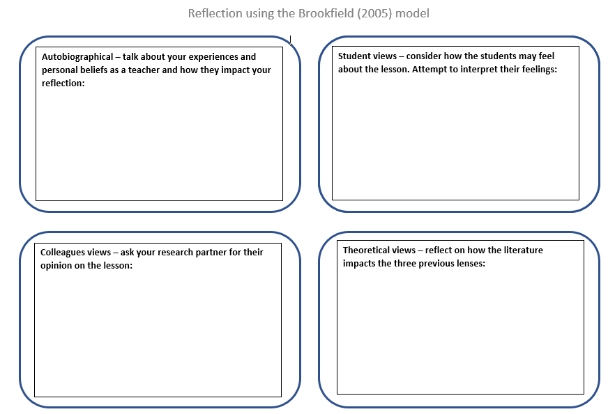
- Focus group questions
- What part of the lesson did you like? Why?
- What part of the lesson didn’t you like? Why?
- What did I do during the lesson that you liked?
- How do you feel when a teacher asks you a question?
- How do you feel when you don’t know the answer to a question?
- How do you feel when you do know the answer to a question?
- Do you ever feel as if you need more time to answer a question?

