Hand rendered half drop repeat tile (you use the same format for a brick repeat tile, cutting horizontally, then vertically)
Use graph paper to mark out your tile and to help line up and ensure that your artwork is square (at 90˚angles)
This pattern has been worked as a scatter; other pattern types would work too (see the introductory to pattern types PowerPoint)

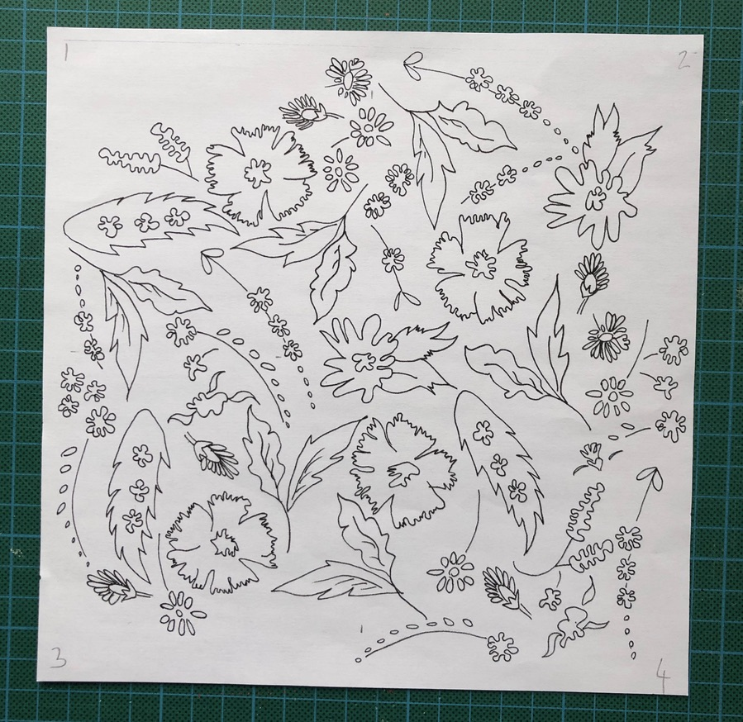

Step 1:
Mark the size of your tile on graph paper
Transfer this tile to tracing paper
Draw out your design on the tracing paper, leaving space around the edges (consider the rhythm and flow of the overall design, and careful placement, spacing and rotations of motif, this tile has been worked as a scatter pattern).
Scan your artwork before the next stage so you have a record and printable copy! Good practice and recommended or trace it out again so that you have an uncut copy.

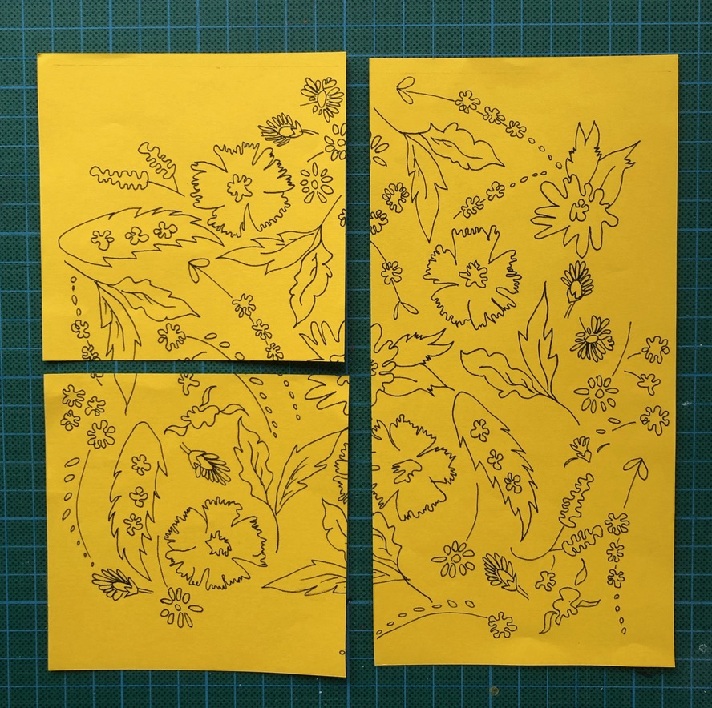
Step 2:
Cut the design in half vertically and then in half again on only one of the now separated sides/ pieces.

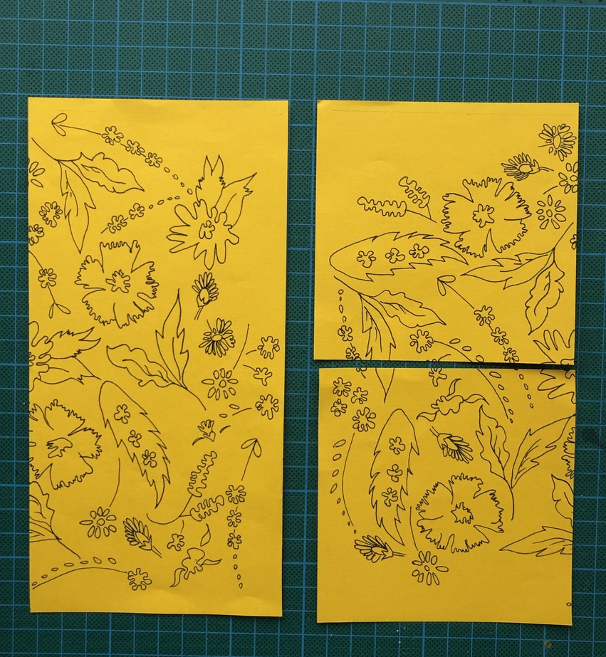
Step 3:
Move the longer piece from the right side to the left side of the 2 smaller cut squares.

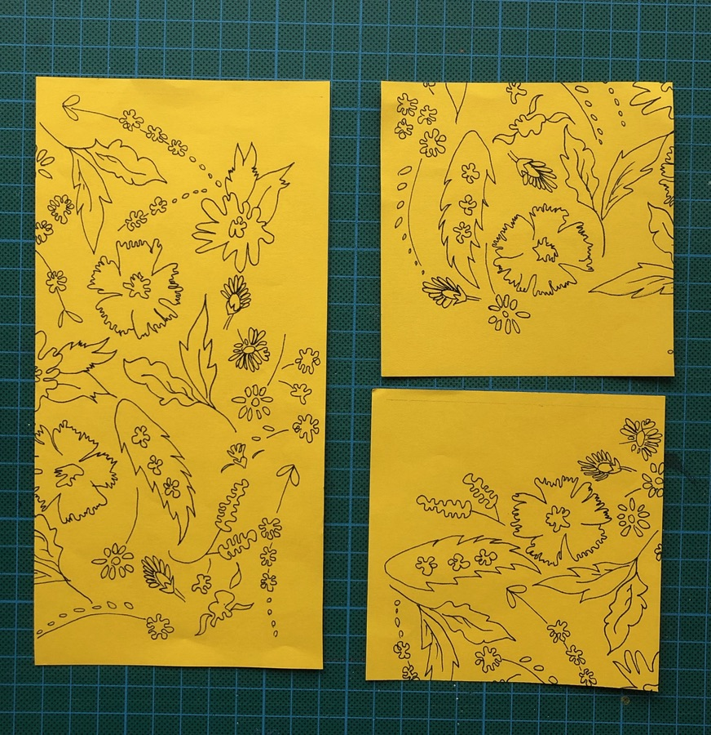
Step 4:
Move the bottom square to the position of the top square and slide the top square into the space now created from moving the bottom square.
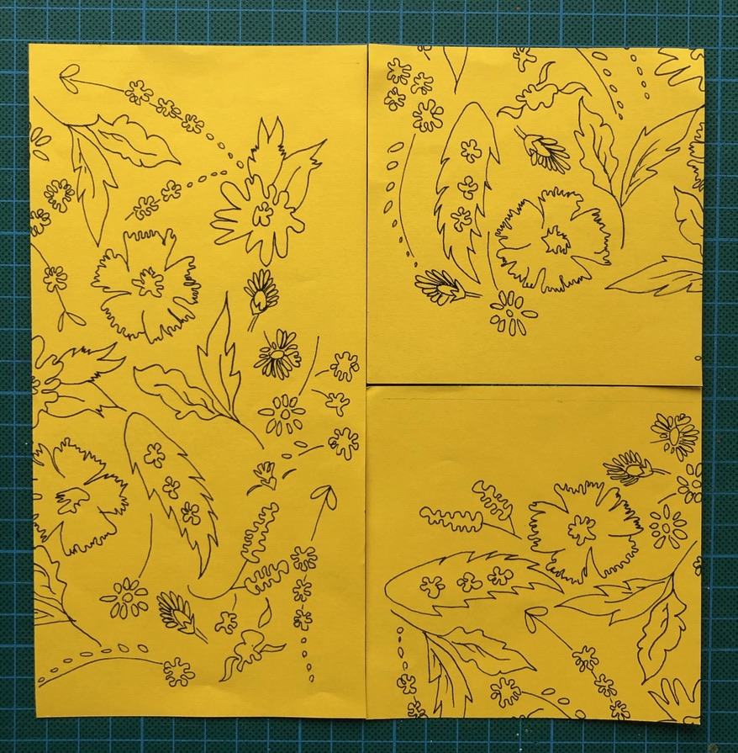
Step 5:
Slide the pieces together if, you have marked your tile out correctly on tracing paper the lining up will be easy (use your pencil lines and graph paper to ensure it goes back together square at 90˚ angles). Tape the pieces together on the back of the tracing. You may want to scan your artwork at this point, this is always good practice!
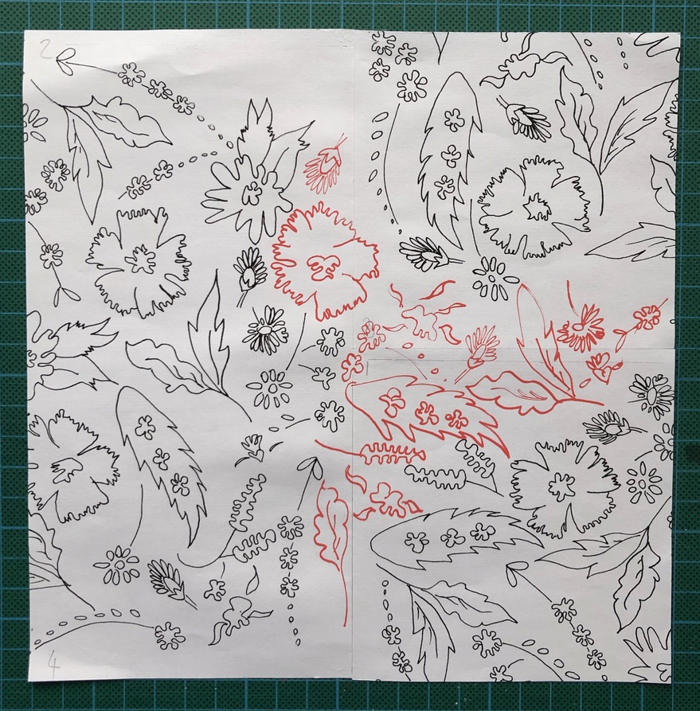
Step 6:
Fill in the blank space with more motif and elements to make the design flow (but do not add anything to the edges, this is where your repeat will join to make a repeat).

Step 7: Trace the design out multiple times so that the design repeats and fits side by side and top and bottom. You can then fill in your design in any way you choose. You could also use the technologies available within the department for example stitch, cut, print, form etc to output and innovate.



