
Programme: BA Business Management
Module Title : Management Accounting
Lecture Name :winifred soribe
Student Name : Andreea Constantin
Student Number : 1913092

(Assignment 1 – Essay)

Table of Contents
Introduction 1
Main Discussion 2
Conclusion 5
References 6

Introduction
It is highly essential to generate necessary information to make the appropriate business decision and here management accounting contributes a lot as it is the process of creating necessary information about the various business activities (Weetman, 2018). Cost accounting is a type of management accounting and it contributes a lot to make the business operation cost-effective as it deals with analysing, reporting and leading the business organisation with improving the internal cost control as well as efficiency (Seal et al., 2017). Every business organisation in the world is facing several challenges due to the COVID-19 pandemic and it affected the hotel and tourism industry in a greater way as people are unwilling to go outside so that they can’t prevent themselves from this Virus (Adhikari, 2020).
I have been hired as a manager of Harriot Hotels so that I can control their business costs to overcome the various challenges due to the COVID-19 pandemic. Harriot Hotels is the key player in the global hotel industry and this business organisation was established by John D. Brockville in 1914 and they are basically operating their business operation in the Americas, Europe, Asia and Africa.

Main Discussion
It is highly urgent to make the business organisation cost-effective by controlling the business costs efficiently for all the business organisations and except not for Harriot Hotels. By ensuring this essential characteristic, they can easily face many business problems as well as overcome various challenges efficiently (Seal et al., 2017). Before going to control the business costs, it is essential to know about the behaviour of costs and other characteristics of costs as the reduction of certain costs without considering the various aspects of this cost can hamper the business productivity. Costs can be various types like fixed cost, variable cost, mixed cost, etc. whereas fixed cost never changes whether the business outputs change or not. The variable cost has been changed with the production level though the mixed cost has been changed to a certain limit (Weetman, 2018).
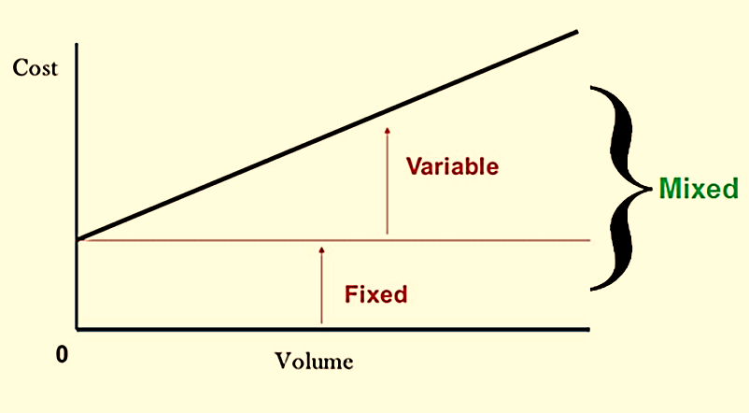
Figure 1: Cost Behavior (Seal et al., 2017)
Harriot Hotels needs to cut down the unnecessary costs to overcome the arisen challenges due to the COVID-19 pandemic so that they can reduce the projected losses. Before cutting down the business costs, they need to consider whether it will affect their business operation as well as productivity or not (Adhikari, 2020). After critically analysing the business costs of the UK division, some recommendations have been provided below so that they can reduce their business costs without compromising their business performance.
Employee Wages: The projected revenue is £ 60,000 of the UK division and here the projected employee wages is 15,000 and that is 25% of the projected revenue. This amount of cost in this area is not favourable and it should be adjusted to overcome the challenges of the COVID-19 pandemic (Soni, 2020). Employee wages can be both variables and fixed and the lower of employees can be varied based on the business situation and they also can work hour basis but the salaries of the top-level manager are fixed cost (Weetman, 2018). They have to reduce their employee wages amount and for that, they can offer senior manager an appropriate redundancy package like the Furlough Scheme. Again, they have to properly layoff their lower employees efficiently.
Advertising cost: This cost is all about the creation of brand value and increases business sales by facilitating the marketing process like campaign, advertisement through television, brochures, online marketing and other activities. Their projected advertising cost is £7000 and that 12% of their revenue and that is a little bit higher considering the present business situation due to the COVID-19 pandemic (Meyer, Prescott and Sheng, 2020). To reduce their projected losses, they must have to reduce this cost as people are unwilling to go outside without any basic needs. Advertising cost depends on many aspects like market condition, season, demand, supply, and also it can be in any pandemic situation (Seal et al., 2017). To reduce this cost, they have to stop their extreme marketing activities and other expensive ways efficiently.
Interest on loans: A business organisation can borrow money with interest from different financial institutions as well as banks to expand their business activities. Their projected revenue is £60,000 whereas their projected interest is £10,000 and that is 17% of their projected revenue and which is unfavourable during this economic recession (Bondarenko and Dugienko, 2020). This is one types of fixed cost but the business organisation can reduce it by refunding the borrowing amount or reduce the projected interest cost by avoiding loan. During this pandemic, they have to stop their extreme business expanding activities to avoid borrowing so that they can reduce their projected interest on loan though they have to pay interest on already taken loan amount (Adhikari, 2020).
Housekeeping and cleaning supplies: This is the basic level task and cost of a business organisation and here the projected cost regarding this cost of Harriot Hotels covers 8.3%. Every business organisation has been given more focus on this cost during this pandemic and it is highly essential for the hotel industry. For Harriot Hotels, this cost shouldn’t be reduced and even they have to increase this cost to ensure a healthier environment for their business organisation and it is also highly essential to grab more customer comparably (Bondarenko and Dugienko, 2020). This cost has been considered as variable cost as this cost varies on the number of customers of them. They have to efficiently handle this cost to reduce wastage to ensure efficient usages of the supplies.
Customer discount: This is related to provide some offers to the customers regarding their room fare and other services. A business organisation provides an offer or discount to the customer to enhance their business revenue by grabbing more customers (COVID-19: Hotel Industry Impact, 2021). Harriot Hotels projected that this will cover 13.3% of its projected revenue. As the COVID-19 pandemic reduced the number of customers therefore they must offer a discount so that they can increase their customers as well as business interest. If they offer a discount to the customers then their business cost will be increased with the number of customers therefore it has been considered as a variable cost (Weetman, 2018). To overcome the various challenges and reduce the projected losses, they shouldn’t reduce this cost in the present situation.
Stationeries used in front desks and restaurants: This cost has been covered 5% of their total projected revenue and though this is favourable, to overcome the challenges of the COVID-19 pandemic, they have to slightly reduce this cost. There have a huge chance of losing the business image if they reduce this cost in a greater way (Impact of COVID-19 on the hospitality industry and its effect on audit | Deloitte Middle East | ME PoV issue 33, 2021). This cost has been considered as a variable cost and they conduct this cost to enhance the customer service as it is related to decorate the front image and provide core service to the customers (Seal et al., 2017). As they are facing problems therefore they can slightly reduce this cost by ensuring efficient use of the stationaries without losing the brand value.
The above recommendations regarding the various cost segments of the Harriot Hotels will help to reduce their projected losses and also helps to overcome the arisen challenges due to the COVID-19 pandemic.

Conclusion
In conclusion, it can be expressed that the efficient management of the various business costs helps to overcome the various challenges as well as to enhance the business interest with ensuring sustainable competitive advantages (Weetman, 2018). Harriot Hotels are facing some challenges due to the COVID-19 pandemic as they are in the hotel industry and this pandemic affected this industry in a greater way. The essentialness of overcoming these challenges is very much high and making business operation cost-effective is one of the most effective way (Bondarenko and Dugienko, 2020). They have projected some costs during 2021 and as a manager of them, I have suggested in this study some direction to make their business operation more cost-effective. They have to reduce their employee wages, advertising cost, interest on loan and stationeries used in front desks and restaurants costs and they have to slightly increase their housekeeping and cleaning supplies cost and no need to change their customer discount cost to enhance their business interest by overcoming the arisen challenges due to COVID-19.

References
Adhikari, U., 2020. COVID-19: THE ECONOMIC OUTLOOK, IMPACT, AUTHORITIES AND LONG TERM STRATEGIES OF NEPAL. International Journal of Business and Management, VIII(1).
Bondarenko, A. and Dugienko, N., 2020. THE IMPACT OF THE COVID-19 PANDEMIC ON INTERNATIONAL TOURISM. Eastern Europe: economy, business and management, 3(26), pp.123-128.
Deloitte. 2021. Impact of COVID-19 on the hospitality industry and its effect on audit | Deloitte Middle East | ME PoV issue 33. [online] Available at: <https://www2.deloitte.com/xe/en/pages/about-deloitte/articles/the-grind/impact-covid-19-hospitality-industry-effect-audit.html> [Accessed 25 March 2021].
Meyer, B., Prescott, B. and Sheng, X., 2020. The Impact of the COVID-19 Pandemic on Business Expectations. SSRN Electronic Journal, 12(6), pp.167-172.
Seal, W., Rohde, C., Garrison, R. and Noreen, E., 2017. Management accounting.
Soni, N., 2020. Impact of COVID-19 on Business Organisation, Industries and Economy. SSRN Electronic Journal, 5(6), pp.57-62.
STR. 2021. COVID-19: Hotel Industry Impact. [online] Available at: <https://str.com/data-insights-blog/coronavirus-hotel-industry-data-news> [Accessed 25 March 2021].
Weetman, P., 2018. Financial and management accounting.
Who.int. 2021. Coronavirus disease (COVID-19): Working in hotels and other accommodation establishments. [online] Available at: <https://www.who.int/news-room/q-a-detail/coronavirus-disease-covid-19-working-in-hotels> [Accessed 25 March 2021].

