NAME : Rohit Pansuriya

STUDENT NUMER : 2211326

LECTURER : Mushfiqur Rahman

PROGRAMME : Masters of Business Administration

MODULE CODE : LCMB7000

MODULE NAME : Human Resource Management

ASSIGNMENT TITLE : Assessment 1 Human Resource Management

WORD COUNT : 2500

Executive summary
This study sheds some light on the labour market of the UK and analyses the different strategies used by the HR of an organization to cope up with loss due to COVID-19. This study even highlighted the internal as well as external analysis of a UK-based company. By incorporating current technology that is already widely available on the market, HR can enhance its operations. The application of artificial intelligence technology can make HR-related jobs far more productive and efficient. HR would have a great chance to attract qualified workers and support the company's growth. HR may adopt new, changing laws to increase productivity and employee performance.
Table of Contents

Introduction 3
Organizational Overview 3
a) The current state of the labor market in the UK 3
PESTLE of the UK labor market 3
Discussion 6
Political 6
Economic 6
Social 7
Technological 7
Legal 8
Environmental 9
b) Emerging changes in human resourcing strategies in the post covid, post-Brexit external environment 9
Critical review on to evaluate managerial and business environment where resourcing is affected and informed by internal and external factors of the company 10
SWOT analysis of UK-based organization's human resourcing strategies 10
Discussion on how internal and external factors influence policies, procedures, and processes adopted by the organization 11
Conclusion and recommendation 12
References 13

Introduction
This report will shed some light on the labour market of the UK along with the strategies which are been used by the human resource management of an organization. The area in which employers and workers operate is called a labour market. Throughout the labour market, work assumes to secure the most fulfilling jobs as well as employers stay competitive to recruit the most qualified candidates. For a company’s growth HRM department is responsible for handling employee recruitment, strategic planning, and termination. HRM places a strong emphasis on how employees contribute to the operation of the company and constantly monitors the implementation of quality standards. This report will discuss in detail about the labour market and HRM strategies used in UK post-COVID-19.

Organizational Overview
Tesco Plc is a worldwide supermarket chain of essential commodities. Tesco intends to maintain 16,000 of the additional employees they hired during the pandemic in order to cope with rapid growth mostly in the e-grocery market (Jacopo, B. and Gabriele, 2022). Along with a number of many other positions in regional distribution centres, this same role and responsibilities also provide 3,000 drivers as well as 10,000 workers who choose and crate local supermarket orders of the customers for package delivery.

The current state of the labour market in the UK

PESTLE of the UK labour market
Political | - Even though the impact on human resources has received little attention three years after the Brexit vote, it continues to be a politically divisive news area of focus.  - Since the implementation of Brexit actions, employee procurement like an HR practice has indeed been affected.  - The UK's choice to leave the European Union has an effect on human resources practices.
Economic | - Throughout the UK, the labour force participation rate for said three months of June to August 2022 seems to have been 75.5%, which would have been 0.3 points less than the rate of employment for said three months of March to May 2022, which would have been significantly greater than other times (Eierle et al., 2022).  - On a monthly basis, fewer people were employed, although more people were working for themselves.  - Compared to prior to the pandemic, the employment rate has dropped by 1.0 percent on average.
Social | - The social factors remain unchanged. Employees continue to anticipate an increased demand for primary care for longer life expectancy.  - Following COVID-19, HR regulations regarding selecting workers had already been modified.  - Employee desires for urban versus residential branch offices had already altered. The choices might be postponed unless nonverbal barriers have a greater influence on everyday activities.
Technological | - Robots and artificial intelligence will be able to automate 30% of UK employment by 2030.  - It moreover discovered that several employment opportunities are probably expected to be created, which will have a gross benefit for the economy.
Legal | - The performance of the workers can sometimes be impacted by a broad range of variables in such a post-pandemic working place, including the advantages and benefits the employees expect, the organization's culture, and much more (Wainwright et al., 2022).  - The total of the environmental factors which have an impact on office profitability, however, never changes.
Environmental | - One‘s mental and emotional state of mind, mental focus, actions, activities, and skills are all influenced by the working environment.  - It has a significant impact on both the performance and involvement of the people employed.  - The organization actually benefits greatly from keeping a high degree of employee performance, which in turn increases employee effectiveness.

Discussion

Political
Brexit has a significant impact on hiring and selecting employees, directing and controlling, and how staff members end up living their professional years. It looks at worker commitment, employment market, skills and knowledge, large-scale immigration outside of the European Union, and more flexible working schedules. The unexpected "Brexit" decision that was made by the UK to leave the European Union (Zhaozhen, 2022). Ever since, the UK has formally separated from the EU by initiating Article 50, the formal application of leaving the European Union. While related agreements are already in progress, the time frame between them and how the choice will affect employers moving forward once Brexit has become a reality is ambiguous, which puts employers at risk of key financial, legitimate, and governmental market turmoil.

Economic
The inflation rate is 1.94% at present time., this became roughly 1.7% in 2019. Since the year 2017, it already has risen by about 3.1%. It represents an increase even if it is a temporary increase and lacks any significance (McKernan and McDermott, 2022). The UK country's economic rate of unemployment throughout February 2021 was around 3.8%. The rate from previous years, it already has decreased by roughly 0.2%. Since everyone is making their fair proportion of economic contributions, the nation's per capita income has increased. the labour force participation rate for said three months of June to August 2022 seems to have been 75.5%, which would have been 0.3 points less than the rate of employment for said three months of March to May 2022, which would have been significantly greater than other times.
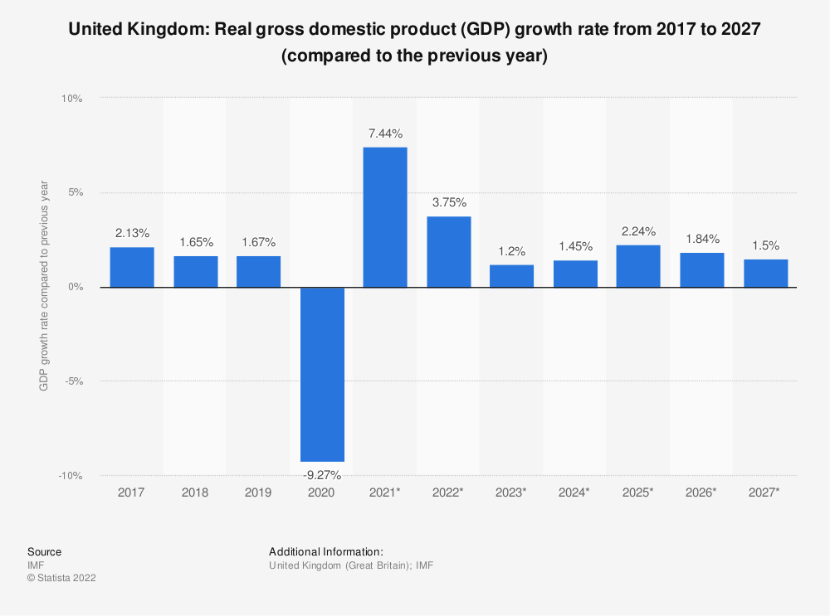
Figure 1: Economic Growth of the UK post covid
(Source: statista, 2022)

Social
Evidently, throughout the COVID-19 global recession, there has been a significant correlation between one worker's prior limited income and their greater chance of being given the boot or laid off. This has already been clear from the employee market analysis that 2019 saw an annual gross hourly minimum wage of £8.60 throughout the catering services and food hotel industry as well as £19.20 throughout the computer and technology sector (Khan and Khan, 2022). More generally, the total average median income mostly in the different industries most negatively impacted is approximately £10.60 for every hour, while it is approximately £14.60, or however, almost 40% greater, mostly in the different industries most closely impacted.

Technological
The labour market, its extreme inequality of all its gains, or whether the employees of the coming years will possess the necessary abilities to collaborate with advanced technologies Various projections of automation's effects mostly on the employment market exist. According to a PwC evaluation from 2021, robots and artificial intelligence will be able to automate 30% of UK employment by 2030. It moreover discovered that several employment opportunities are probably expected to be created, which will have a gross benefit for the economy (Flegr and Schmidt, 2022). Several professionals had already made clear the need to look into which work within career paths can indeed be replaced by robots because, often, even just a portion of the contribution will probably be done by robots instead of the whole one. Several positions require human skills that are challenging to replace with technological advancements.
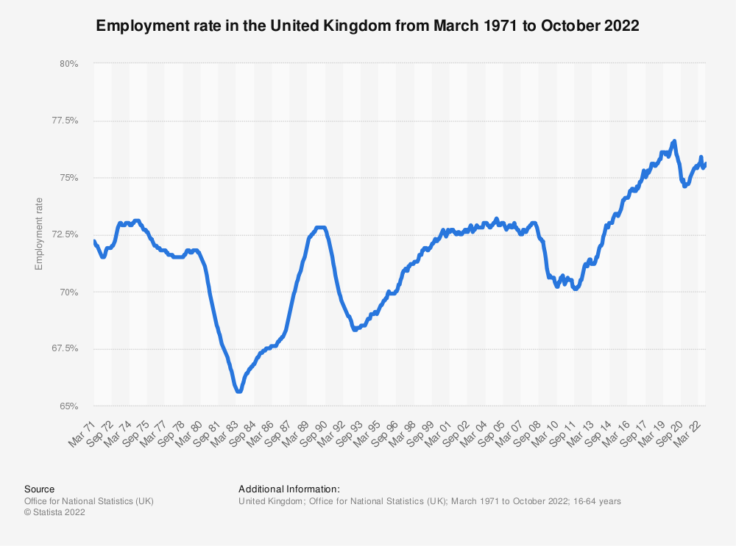
Figure 2: Labour Market in UK Post Covid-19
(Source: statista, 2022)

Legal
The legislation makes a distinction among employees, staff members, as well as independent contractors. Employees are provided with the most rights. Unless the company possesses responsibility for the work, there have been mutual obligations, and nothing occurs that is unpredictable including an employment agreement, then a person is an employee. Employees are just not obligated to family-related notice or unemployment insurance and therefore are they secured against illegal dismissal (Malik, 2022). There is usually very little security for self-employed people. Employees are entitled to a number of legal minimums, such as the right to a limit of 12 weeks written statement and one week's notice for every year of employment. Many employees are subject to a 48-hour highest maximum work period including a £9.50 for every hour basic wage. Every year, the basic income is raised in April. The highest workweek can indeed be "opted-out" of employees. Employees have the right to 5.6 weeks of annual vacation time as well as to lower limit hourly and weekly periods of rest.

Environmental
The working environment could even refer to everything that is present in which staff work that has an impact over how workers complete their tasks. It contains including both internal and external factors that can affect an individual's professional performance and, as a result, how well they operate at the job. Employee performance as well as the physical work culture are strongly correlated (Afridi et al., 2022). The workplace's conceptual environment has a significant influence on worker's productivity, happiness, interpersonal relationships, and general well-being. The physical environment at the office is a significant factor that affects employee's team spirit, work motivation, and effectiveness.

Emerging changes in human resourcing strategies in the post covid, post-Brexit external environment
Employers and hiring managers were indeed worried regarding trying to fill many such roles of UK applicants, but current works to satisfy low or moderate-skills roles have met with too little achievement, because UK applicants were also highly qualified or reluctant, or maybe because employees have been unable to perform the responsibilities of the position due to limitations or other obligations. A transitional immigration phase run from the day after the UK leaves the EU to December 31, 2020. The ability to continue as well as working in the UK even during the transition phase is granted to EU nationals and their family. The UK government aims to overhaul the immigration process starting in January 2021, which might affect how long EU residents can work there (Pearce, Quan, and Dziewanowska, 2022). Employers may assist to ensure and safeguard their personnel by giving existing and prospective workers precise instructions on the EU relocation plan including their living and employment rights. Flexibility in scheduling is a very alluring employee advantage that cuts across ethnicities, improves staff morale and commitment, and will not cost companies a buck. Considering the employee's present work schedules and looking for opportunities for working remotely job sharing, or flexible scheduling. Flexible schedules for work make it easier to meet the requirements and preferences of parents, students, and employees who have daily journeys.

Critical review on to evaluate managerial and business environment where resourcing is affected and informed by internal and external factors of the company
Tesco appeals to all sorts of clients by using a cost-effective and evolutionary divergence approach. The employees of Tesco succeed with customers who have good salaries while yet managing to appeal to clients who are cost conscious. the supply of a sizeable amount of capital and the implementation of the pricing scheme used by the Tesco. The company adopted the items purchased by budget-conscious clients, enabling the merchant to retain their appeal to this population. The emphasis on sustainability and business responsibilities may also be seen as positive (Shahzad et al., 2021). For example, the Tesco accepted responsibility for implementing a thorough report, as well as "dropped significantly the scope of its logistics" as a possible reaction to the food products problem. The behaviour of an employee towards the organization is defined and limited by its organizational framework. A company's growth is influenced by the size from its number of employees, the number of outlets it has, as well as the number of clients that come to visit every day. Overall Tesco's mindsets come in two forms: biological and mechanical. Tesco cannot take a choice for modification right away when it is natural.
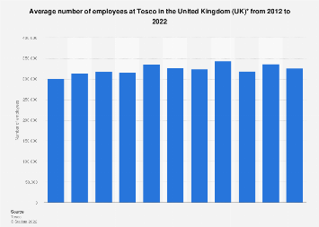
Figure 3: Tesco Employment of 2022 in the UK
(Source: statista, 2022)

SWOT analysis of UK-based organization's human resourcing strategies
Strength - Considering HR works with the employee, every strategy, practice, or tactic which increases the employee's effectiveness and productivity would be regarded as a strength of HR. Other variables which would contribute inside a Tesco’s growth might also be regarded as strengths of HR. The number of staff members quitting a Tesco more than a particular time period is measured by the employee turnover rate. A high turnover rate among employees signifies that a Tesco struggles to keep workers on board for an extended period of time.
Weakness - HR's main goal is to distribute assets effectively to achieve the greatest possible outcomes. HR would not be capable of functioning efficiently unless there is a budgetary restriction. Insufficient funds will limit HR's procedures for hiring, evaluating employees, and other working population activities (Soegoto, 2021). Tesco’s ability to perform would suffer as a result of the employee's low morale and unhappiness. Being unpopular usually leads the company into problems. Whenever the Tesco’s reputation suffers and there is bad press concerning it in the marketplace, human resources have to work extremely hard to recruit qualified candidates.
Opportunities - By implementing new technology, which is now easily obtainable on the market, HR may enhance its operations. HR activities may be carried out much more effectively and efficiently with the use of artificial intelligence. HR would be given the great chance to attract competent workers and support the expansion of the Tesco (Sabokro, Masud, and Kayedian, 2021). HR can implement new, emerging regulations to improve productivity and employee performance.
Threats - Once rival companies begin hiring for roles with comparable responsibilities, HR may view the situation as a threat. Information privacy has become more prevalent. Therefore, everyone is entitled to privacy laws. HR faces a tremendous issue because its main responsibilities revolve around handling the private information of its staff.

Discussion on how internal and external factors influence policies, procedures, and processes adopted by the organization
Tesco uses an economical and evolutionary divergence strategy to appeal to a wide range of customers. Tesco's personnel are successful with wealthy clientele while yet managing to appeal to budget-conscious customers. the provision of a sizable quantity of money and the implementation of the company's pricing strategy. The company adopted the items purchased by budget-conscious clients, enabling the merchant to retain their appeal to this population. The emphasis on sustainability and business responsibilities may also be seen as positive. The idea of moral standards is acting in a way that is respectable and morally right (Lu et al., 2021). They operate their company in a responsible and lawful way in order to preserve our important image and grow on their progress. TESCO's dedication to upholding good ethical principles is outlined throughout this standard of corporate integrity and ethical values. It outlines the core values of ethical company behaviour and lays out the obligations including all owners, executives, staff members, consultants, and so on.

Conclusion and recommendation
From the above study, it can be concluded that the labour market of the UK had declined after the outbreak of COVID-19. A UK-based company has been used here named as Tesco, to understand the strategies and internal as well as external factors that are taking place after the COVID-19. This study also consists about an in-depth analysis of the labour market as well as the company Tesco.

HR can improve its operations by integrating modern technology that is already freely accessible on the market. Artificial Intelligence or AI technology can be used to do HR-related tasks considerably more effectively and efficiently. HR would have a fantastic opportunity to entice skilled personnel and aid Tesco's expansion. To boost productivity and worker performance, HR might introduce new, evolving legislation.

References
Afridi, H.H., Shoaib, M., Al-Joufi, F.A., Shah, S.W.A., Hussain, H., Ullah, A., Zahoor, M. and Mughal, E.U., 2022. Synthesis and Investigation of the Analgesic Potential of Enantiomerically Pure Schiff Bases: A Mechanistic Approach. Molecules, 27(16), p.5206.
Eierle, B., Hartlieb, S., Hay, D.C., Niemi, L. and Ojala, H., 2022. External factors and the pricing of audit services: A systematic review of the archival literature using a PESTLE analysis. Auditing: A Journal of Practice & Theory, 41(3), pp.95-119.
Flegr, S. and Schmidt, S.L., 2022. Strategic management in eSports–a systematic review of the literature. Sport Management Review, pp.1-25.
Jacopo, B. and Gabriele, S., 2022. The impact of socially relevant content and aroused emotions in social media consumer engagement behaviour. In Boosting knowledge & trust for a sustainable business (pp. 653-657). FONDAZIONE CUEIM.
Khan, A.T. and Khan, S., GIG Economy: Renaissance of Blue Collar Jobs in India. Emerging Issues in Management & Economics in the Post Pandemic Era, p.50.
Lu, M.H., Sha’ari, M.A.A.H., Annamalai, D., Norazmi, M.S.A.B., Hizani, N.A.B. and Tan, K.K., 2021. FACTORS INFLUENCE CUSTOMERS PURCHASE INTENTION TOWARDS HYPERMARKETS AT KOTA BHARU, KELANTAN. Jurnal Manajemen dan Kewirausahaan, 23(2), pp.159-166.
Malik, A., 2022. HRM and ER: a strategic perspective. In Strategic Human Resource Management and Employment Relations (pp. 13-23). Springer, Cham.
McKernan, D. and McDermott, O., 2022. The Evolution of Ireland’s Medical Device Cluster and Its Future Direction. Sustainability, 14(16), p.10166.
Pearce, A., Quan, R. and Dziewanowska, K., 2022. Lundgren Tours: Out of the Frying Pan and into the Fire. A young entrepreneur survives and thrives after the ‘double-whammy’of Brexit and Coronavirus. The International Journal of Entrepreneurship and Innovation, 23(2), pp.86-98.
Sabokro, M., Masud, M.M. and Kayedian, A., 2021. The effect of green human resources management on corporate social responsibility, green psychological climate and employees’ green behaviour. Journal of Cleaner Production, 313, p.127963.
Shahzad, M., Qu, Y., Zafar, A.U. and Appolloni, A., 2021. Does the interaction between the knowledge management process and sustainable development practices boost corporate green innovation?. Business Strategy and the Environment, 30(8), pp.4206-4222.
Soegoto, F.A., 2021. Product development using SWOT analysis. International Journal of Entrepreneurship & Technopreneur (INJETECH), 1, pp.1-10.
statista.com, 2022. Economic Growth of UK post covid. Available at: https://www.statista.com/statistics/275311/employment-in-the-united-kingdom/ (Accessed on: 23/12/2022)
statista.com, 2022. Labour Market in UK Post Covid-19. Available at: https://www.statista.com/statistics/490882/tesco-group-united-kingdom-uk-number-of-employees/ (Accessed on: 23/12/2022)
statista.com, 2022. Tesco Employment of 2012-2022 in UK. Available at: https://www.statista.com/statistics/275311/employment-in-the-united-kingdom/ (Accessed on: 23/12/2022)
Wainwright, E., Jordan, A., Fisher, E., Wilson, C., Mullen, D. and Madhavakkannan, H., 2022. Beliefs about worry and pain amongst adolescents with and without chronic pain. Journal of Pediatric Psychology, 47(4), pp.432-445.
Zhaozhen, A.N., 2022. UK: Green Trade Transition and Policy. Cross-Cultural Communication, 18(3), pp.1-9.

