

Entrepreneurship (LCBB5001)

Name : Bianca Petronela Paunescu

Student ID : 2024896

Name of Lecturer: Riaz Bhatti

Title
Assessment 1

Table of Contents

- Introduction…………………………………………………………........2
- New wave of entrepreneurs.………………..…………………….….…...2
- Skills an entrepreneur should master………………………...……...……3
- SWOT Analysis....……………………………………………………......6
- Skills Audit…………………………………………………………....….7
- PEST Analysis…………………………………………….………..….....10
- Conclusion………………………………….…………………………….13
- Reference list…………………………………………………………......15

Introduction
The enthusiasm for entrepreneurship is now becoming stronger than ever. We link it with the profound changes technology delivers, including the new services, goods, business models, and organisational structures that transform how we live and provide brand-new possibilities. Many of us regard it as a venue for independence and creative expression, a way to address issues pertaining to the long-term viability of our planet and communities, and a mean of achieving success both professionally and financially. The difference between regular people and entrepreneurs is people have ideas, whilst entrepreneurs go for opportunities. Although appearing to be the same thing, pictures of the future, ideas and prospects feel different. All opportunities come from or may be categorised as ideas, however not all ideas can be said to be opportunities. When we get an idea, the first thing we do is consider whether there is an opportunity (Dimov, 2020).
New wave of entrepreneurs
Crisis can occasionally serve as a catalyst or an accelerant, hastening changes that are already underway. The COVID-19 outbreak has put our existence itself in jeopardy. Following the pandemic, businesses that desired to grow quickly were able to do so by developing expertise in or repurposing their operations in sectors that are important to the country's economic and social recovery. They succeeded by taking advantage of the new consumer mindsets, attitudes, perceptions, and behaviours (Singh, 2020).
The strongest motivators for founders in their entrepreneurial journeys were elements such as having more free time to start something and recognising a market need. 96% of newly established business owners indicated they had always wanted to launch their own company. Covid-19 gave roughly 40% of them the boost they required to start their small business. The pandemic presented a business opportunity for roughly 37% of people. This new wave of business owners that has emerged since the pandemic is known as "necessity entrepreneurship”, as part of the motivation comes from the lack of opportunities in a paying position (Peake, 2020).
Skills an entrepreneur should master
Entrepreneurial skills may be categorised as technical skills, leadership and management skills, as well as creative thinking. Because they may be used to a broad variety of work sectors and industries, training the entrepreneurial abilities might include developing a variety of distinct skill sets. Entrepreneurs can have a variety of business titles, which allows them to diversify their skill sets in order to support the expansion of their brands and enterprises. Some of the skill sets we can improve in order to develop our entrepreneurship journey can be:
• Business management skills
• Teamwork and leadership skills
• Customer service skills
• Financial skills
• Analytical and problem-solving skills
• Technical skills
• Time management and organizational skills
• Branding, marketing and networking skills
Business management skills
To manage and develop a firm or brand, successful entrepreneurs often rely on their business talents. Increasing the capacity to multitask, delegating work to staff members, and making decisions about the future and profitability of the organisation are all instances of improving business management talents.
Teamwork and leadership skills
Being a successful business owner means working with a team and as a supervisor or manager, one needs strong leadership abilities to inspire and motivate the employees.
Customer service skills
Effective customer service abilities may help anybody connect with their client base and make sure that the company is offering the products or services the market needs, from communicating with new consumers to creating commercial connections.
Financial skills
Running a business also includes managing the capital of the firm. One may develop their financial management abilities by working with a financial planner, reading financial books, and using financial software to assist organise and keep track of the financial processes in the company.
Analytical and problem solving
Successful businesspeople often have excellent analytical and problem-solving skills. This is because creating plans and strategies to support the accomplishment of corporate objectives frequently entails making tough choices, overcoming obstacles, and using creative thinking.
Technical skills
It could be a good idea to further develop one's technological abilities given that software tools are available for so many departments nowadays and can assist on planning, marketing, and other business-related activities, including financial analyses. Business owners may measure sales and income, coordinate projects, and assess the effectiveness of business development using various types of software or other digital tools.
Time management and organisational skills
For company entrepreneurs, organisation and time management are essential skills. Techniques that can help in the development of these skill sets include deadline setting, setting realistic objectives for oneself and the team, and breaking tasks down into manageable to-do lists.
Branding, marketing, networking skills
In order to improve and grow their firms, entrepreneurs may spend quite a lot of their time on marketing and networking with other businesses. Being able to implement successful branding and marketing strategies is a critical part of being an entrepreneur (Herrity, 2020).

SWOT Analysis
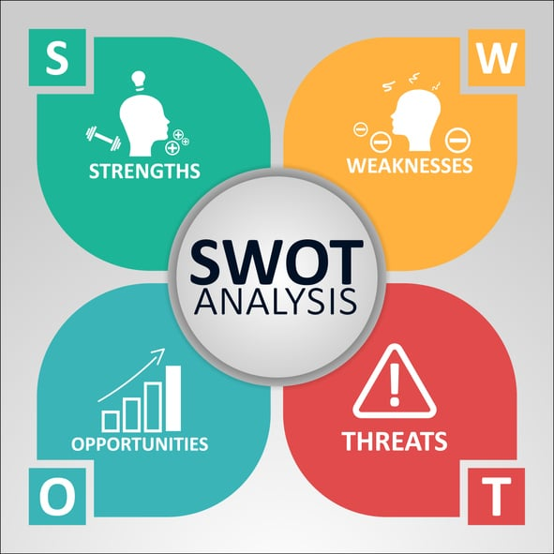
Strengths  - I am a very efficient and proactive person.  - I am willing to go above and beyond to fulfil the proposed goals.  - I am a quick learner when it comes to process and technology. | Weaknesses  - I overthink certain activities until I end up not doing them anymore.  - I do not have enough experience in marketing and social media engagement.  - I care too much about other people’s opinion and that can influence my decision-making process.
Opportunities  - Studying Business and Management.  - Huge demand in the beauty industry where I want to open my start-up, making room for multiple businesses to be successful.  - Living in the social media era, gives me a slight advantage compared to other entrepreneurs not used to the online climate. | Threads  - As a small new business, there is little awareness of its existence.  - Not having enough budget for advertisement.  - Cheaper prices from competitors.

Skills Audit
SKILLS I HAVE | EXAMPLES
- Multi-tasking skills | - I’m able to juggle my full-time job, university and starting a small business. At the same time, I can prioritize important tasks and delegate others.
- Leadership attitude | - Being in positions as supervisor and manager helped me develop a leadership attitude. The best way to lead is through example, and I’m always dedicated to the job I must do.
- Interpersonal skills | - I have a good level of adaptability to any situation, and I find it easy to interact with people around me. Likewise, individuals find me a trustworthy person and easy to open to, which helps me absorb information and opinions regarding the market.
- Customer service skills | - Based on previous jobs experience, as Front of House receptionist, supervisor and manager, I developed effective and efficient customer service skills, which can help me connect with my customers and identify the market needs, in order to improve my products or services.

SKILLS I’D LIKE TO IMPROVE | HOW? EXAMPLES
- Financial skills | - As finance is a core element when considering opening a business, knowing how to better utilise it can bring greater profit to the organisation. I’d consider attending a financial course specializing on start-ups/new entrepreneurs.
- Technical skills | - Especially after COVID-19 pandemic, the Internet has been the go-to for everyone in terms of shopping and services. The easiness of having everything only one click away, has encouraged entrepreneurs to re-orientate toward online. Having more knowledge in terms of data analysis, sales tracking and other tools available would increase my business’s ROI. Attending workshops or courses would be a good first steps to achieve the above.
- Networking | - Networking is one of the biggest assets an entrepreneur has. Using personal or professional network can provide great feedback on the products or services one provides. Alternatively, a good network can include other entrepreneurs, who can provide an insight on their journey and even put you in touch with professionals in the field. I need to start reaching out and conduct a survey by asking individuals in my network what they are looking for in a particular product, what they haven’t seen on the market and how I can improve my products.

PEST Analysis
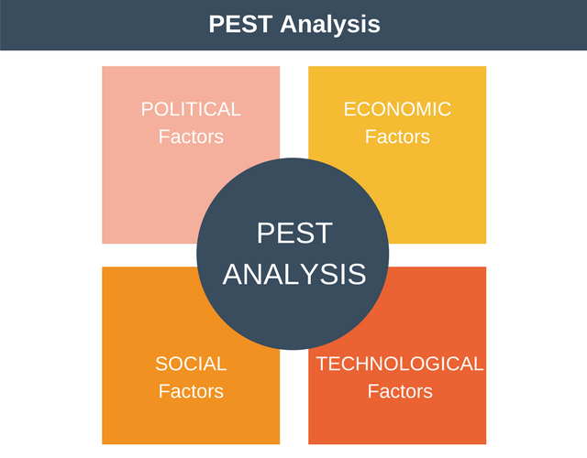
Political:
Positive:
- As one of the richest and most powerful nations in the world, United Kingdom has a big influence on international events. It is one of the founding members of the North Atlantic Treaty Organization, one of the permanent members of the UN Security Council, and it is also a member of the G8.
- The Westminster system, a democratic, parliamentary form of government, is used in the UK. The bicameral legislature, the judiciary, and the executive branch, headed by the prime minister, are all given an appropriate amount of power under this system (David, 2022).
Negative:
- The political stability of the nation is one of its greatest assets, but Brexit - the UK's choice to quit the EU - has sparked ambiguity and political unrest. While some observers assert that Brexit has already wreaked havoc, others assert that it has also provided the nation with tremendous opportunity. The reality is that Brexit has had and will continue to have an enormous negative impact on UK’s economy.
Economic:
Positive:
- The UK is in a good economic situation when compared to other nations. According to nominal GDP, it has the 6th largest economy in the world.
- Every year, the National Living Wage increases, which is very beneficial in helping individuals who are on a low-income (Bush, 2016).
- Diversity is the engine that propels the UK economy forward. Its market is so diversified that it gives every firm an equal opportunity to grow. as long as there is a market for it and as long as it enhances the consumers' lives.
- Foreign direct investment has for a long time taken interest in the UK. Global corporations and organisations have made investments in a variety of diverse UK sectors. Many industries have attracted a lot of attention from outside, including sports, real estate, technology, grocery stores, and others. It draws millions of tourists each year. Similarly, a big number of international students go to the country each year and contribute significantly to its economy.
Negative:
- The Government is providing financial aid and free public services which is a great expenditure for the state.
- The Coronavirus pandemic's economic shock has had a huge negative impact on the UK's budget. The government's budget deficit hit an all-time lowest point for a year during 2020/2021, while spending increased, and tax revenues dropped. Over £315 billion is spent on the government's assistance programme for citizens, companies, and government organisations (Harari et al., 2021).
Social
Positive:
- Whilst the free public services are a strain on the Government budget, they are a blast for the general public. In terms of giving patients high-quality care, the UK's health care system has made significant progress in recent years.
- The UK is one of the top ten countries in the world for having the most educated population. Additionally, it ranks third overall among the greatest nations. The British educational system's degrees are recognized all around the world.
Negative:
- Nevertheless, those who grow up in lower-class or impoverished environments have some challenges. It is difficult for persons from disadvantaged backgrounds to keep up with the rate of social progress in the UK due to the country's significant inequality. Although UK’s educational system is a well-respected one, University education is a heavy cost for students all across UK, with prices constantly increasing.
Technological
Positive:
- The IT industry has a substantial impact on the UK economy. The industry is receiving a lot of funding and expertise. It is significant to highlight that development and investments are taking place all around the country.
- United Kingdom is among the nations with the most advanced technology in the world. Both technical and financial businesses are prospering in London. In order to always be one step ahead and provide consumers with the right choice, companies are permanently being inventive and coming up with high technology options for everyone (Shaw, 2020).
- Having effective intellectual property laws helps individuals, entrepreneurs and companies to stop having their products/brands name, inventions or designs stolen or copied. Patents, designs, trade names, and copyright are all examples of intellectual property protection (GOV, 2017).
Negative:
- The UK is lagging behind the US, South Korea, India, Japan, and a number of other countries in terms of technical development.
- Technology is changing faster than UK regulations laws can keep up with.
Conclusion
Prior to starting their own businesses, many entrepreneurs get experience working for well-known companies, but it's not apparent whether there is any actual connection between cumulative experience and the rate of entrepreneurship. The views on this matter are various, as researchers have proven that this relationship depends very much on the industry (Rider et al., 2019). However the case, an idea that everyone can agree upon is that entrepreneurial activity results in the creation and exploitation of new business models, which in turn encourages competition either when a new firm joins a market with other established businesses or when it develops a new method, a substitute, to satisfy the demands of its clients (Matusik, 2016).

Reference list
- Bush, T. (2016). An Example PEST Analysis of The UK. [online] PESTLE Analysis. Available at: https://pestleanalysis.com/pest-analysis-of-the-uk/ [Accessed 15 Nov. 2022].
- Dimov, D. (2020). The reflective entrepreneur. Abingdon, Oxon ; New York, Ny: Routledge.
- Gov.uk (2017). Intellectual property and your work. [online] GOV.UK. Available at: https://www.gov.uk/intellectual-property-an-overview [Accessed 16 Nov. 2022].
- Harari, D., Keep, M. and Brien, P. (2021). Coronavirus: Effect on the economy and public finances. commonslibrary.parliament.uk. [online] Available at: https://commonslibrary.parliament.uk/research-briefings/cbp-8866/ [Accessed 17 Nov. 2022].
- Herrity, J. (2020). A Guide to Entrepreneurial Skills: Definition and Examples. [online] Indeed Career Guide. Available at: https://www.indeed.com/career-advice/career-development/entrepreneurial-skills [Accessed 16 Nov. 2022].
- Joe David (2022). PESTEL analysis of the UK. [online] Howandwhat.net. Available at: https://howandwhat.net/pestel-analysis-uk/ [Accessed 15 Nov. 2022].
- Matusik, S.F. (2016). Entrepreneurship, Competition, and Economic Development. The Antitrust Bulletin, 61(4). doi:10.1177/0003603x16676142.
- Peake, C. (2020). New Wave Of Entrepreneurs Overcomes Crisis Economy. [online] Forbes. Available at: https://www.forbes.com/sites/forbesfinancecouncil/2020/09/08/new-wave-of-entrepreneurs-overcomes-crisis-economy/?sh=5386085abb49 [Accessed 15 Nov. 2022].
- Rider, C.I., Thompson, P., Kacperczyk, A. and Tåg, J. (2019). Experience and Entrepreneurship: A Career Transition Perspective. ILR Review, 72(5), pp.1149–1181. doi:10.1177/0019793919852919.
- Shaw, A.A. (2020). PESTLE Analysis of UK | The United Kingdom Pestel Analysis. [online] Marketing Tutor. Available at: https://www.marketingtutor.net/pestle-analysis-of-uk/ [Accessed 17 Nov. 2022].
- Singh, S. (2020). Witnessing The Rise Of A New Wave Of Entrepreneurs. [online] www.linkedin.com. Available at: https://www.linkedin.com/pulse/witnessing-rise-new-wave-entrepreneurs-somdutta-singh [Accessed 15 Nov. 2022].

