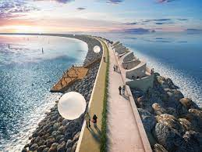

Research Methods
  - REPORT SUBTITLE
Trace King |MSc Sustainable Construction | 2021
Contents
Table of Figures 1
Abstract 2
Introduction 2
Aims and Objectives. 4
Literature Review 5
Sea Levels 5
The Need for Increased Residential and Tourism 7
Will it be Expensive to Build? 8
Methods 8
Swansea Tidal Lagoon. 10
Waterfront Development Case Study: 11
Results and Evaluation. 13
Timeline 13
References 14

Table of Figures
Figure 1 Sea Level Measurements (NASA, 2021) 6
Figure 2 Flood Alert for Spring Tide 2021 (NRW, 2021) 7
Figure 3 Proposed Lagoon at Swansea (TLP, 2018) 10
Figure 4 Milford Haven Docks to Milford Haven Marina (Riley, 2021) 12

Abstract

Tidal lagoons are a good energy source for the UK to meet its ambitious renewable energy goals. They are also theoretically a highly beneficial method of protecting coastal towns, villages and cities.
A large barrier to tidal development to date has been regulatory issues and focus on expenditure vs return. The views of developers and other important parties such as government bodies, regulators, conservationists, and practitioners must be aligned in order for the lagoon development industry to progress. This study will use online questionnaires and semi-structured interviews to focus on potential occupants, developers' and stakeholders' views on the tidal lagoon environment and the desireability of the beachfront developments that would be made possible to create by the construction of tidal lagoons as a flood defense, funded by the construction of residential accommodations, providing owners with sustainable, free power as a return for their initial increased investment.
We seek to discover that while both environmental influences and developers are working towards the common goal of sustainable long-wave power generation, there are differences in their views on the key environmental impacts, benefits, and solutions. This research will provide an understanding of current developer and influencer thinking, helping to transform that into industry-forward policy recommendations, and bypassing governmental funding issue by gauging interest of private financial backing to develop one lagoon which could be a catalyst for further developments in the UK and potentially worldwide.

Introduction

Global Warming is an issue at the forefront of many conversations, a situation created by the actions of humans, Carbon dioxide amounts in the Earth's atmosphere are now approaching 412 parts per million (ppm) and increasing. This is a 47 percent increase since the Industrial Age began, when the concentration was near 280 ppm, and an 11 percent increase since 2000, (Buis, 2019) which is now at breaking point and requires drastic action to reverse the effects. However, the process of reversing global warming is going to be a long-drawn-out process, with no complete guarantee that we will succeed.
Coastal areas are already under threat from human activities, pollution, invasive species, and hurricanes, so climate change poses a serious threat. Coastal habitats may be eroded and inundated. Coastal and aquatic environments are likely to be disrupted as waters get warmer and more acidic. Further inland, it may result in devastating erosion, wetland flooding, salt pollution of aquifers and agricultural soil, and the loss of habitat for fish, birds, and plants.
Island countries like the UK are at high risk of the worst of the effects of rising sea levels, with the West suffering severe weather storms, and the East coast is susceptible to storm currents from the North Sea. Both very different weather patterns, but equally as destructive and capable of submerging the coastlines, or washing lands away, as has been evident on Isle of Sheppey in the last decade, as large masses of land have collapsed into the sea with further 6.6km of erosion predicted in the next decade. (EKEP, 2011)
Much research has been done to highlight the devastating effects of global warming and what can be done to slow it or reverse it, but data states it will take 1000 years for the effects of current CO2 emissions to dissipate from the atmosphere (NOAA, 2009)
According to a recent report, summers lasting nearly six months in the Northern Hemisphere may become the new standard by 2100 if climate change is not tackled. According to the study's authors, the move will have far-reaching consequences for agriculture, human health, and the environment. (AGU, 2021)
With warmer summers would come warmer more violent winters, the Welsh coast is particularly vulnerable to violent storms, which have become increasingly regular and strong over the past two decades and will continue to do so as global warming worsens.
Using Man-made Coastal Construction will slow down the effects of global warming, maybe long enough to reverse it. Through strengthening coastal defences, we will expand the available land mass without risk of floods and life-threatening storm surges.

Aims and Objectives.

The aim of this report is to
- Highlight the devastation caused by coastal flooding as a result of global warming related storms and sea level rise.
- Deduce possible methods of implementing an expanded initiative to tackle global warming. Making sea front towns and cities safe from rising sea levels, rather than relying on the possibility we can reverse climate change.

To achieve our aims, we would pay close attention to the following research objectives.

- Gauge interest in beachfront developments either as permanent or holiday accommodation by locals and tourists and observe if the potential owners would be more likely to purchase if they were assured the protection of sea defences.
- Develop a potential plan to raise funds from private residential sales that will cover the cost of constructing flood defences that could both save coastal towns and provide sustainable renewable energy sources, with the added possibility of providing a limited amount of social housing which would begin to alleviate the homeless crisis in the UK.

There are two mutually exclusive groups of issues facing humanity as they work to implement defenses against natural disasters; those with regards to the issue of flood protection who are concerned with protecting their existing homes, middle-class citizens, and those who have money to spend to construct them, in addition, more upscale ones, marketable buildings that seek long-term gains in terms of both expansion and the possibility of shortening the time that construction results in rising sea levels.
The author believes that these are valid and realistic aims and objectives to meet within the time frame of the proposal, whilst adding to the vast knowledge gained by the reports gathered prior to the applications for other tidal lagoons within the UK. We recognize the challenges faced by the issue of funding and lack of existing construction of this kind, upon completion of this report the author believes that they may have shown enough evidence to make the technology viable and the future of flood defences everywhere.

Literature Review

To construct the main components of the authors research, an in depth literature review has been conducted, with aim to research further to establish existing knowledge and use of the proposed plan. It is vital to highlight existing research and prejudice toward completed data collection. The author will be discussing the extensive efforts being undertaken daily by countries to reduce their CO2 emissions and will use literature to show examples of how this has worked in the past, or where peers have highlighted possible uses for the future.
In an ever changing industry the information that currently exists could be out of date by the time this is published and the author understands tis limitation, and is willing to revise the written works periodically to maintain validity
The 2015 Paris Agreement establishes targets for reducing CO2 emissions in order to avoid dangerous temperature increases by 2050. This aims to keep global temperatures below the predicted 2°C increase above pre-industrial levels, preferably below 1.5°. As a legally binding international treaty, it allows participating nations to define their own plans and objectives for achieving their targets. If these NDCs are adhered to, there is a very good chance that we can meet certain goals and perhaps exceed them. Additionally, it enables all countries to see the activities and outcomes of other members for the first time via the ETF's Enhanced Transparency Framework.

Sea Levels

Since 1880, the start of the Industrial Revolution, sea levels have increased 8 inches globally, with the last 30 years accounting for almost 4 inches of the increase. According to the latest scenarios, on a low-emissions course global sea level is very likely to increase at least 12 inches (0.3 meters) above 2000 levels by 2100. Sea level rise could exceed 8.2 feet (2.5 meters) above 2000 levels by 2100 if potential greenhouse gas emissions continue at their current rate (Lindsey, 2021) As a result, we are now in the stage of damage limitation. This necessitates the construction of coastal flood defenses to protect coastal communities from the worst-case scenario. To remove the need to retreat away from established coastal communities is the most viable option but also the most expensive option. Figure 1 shows the rate of sea level change over a relatively short period of time and history dictates this will continue to rise on the same gradient. Therefore, in order to minimize the damages of increasingly violent storms, land degradation, erosion, and river pollution, we must prepare the area’s most at risk.

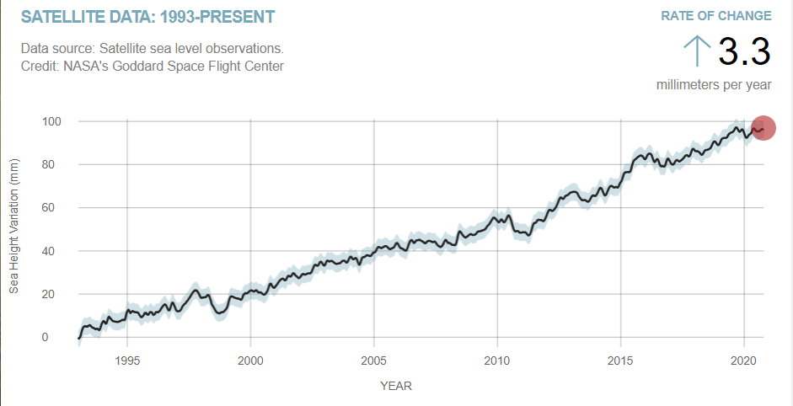
Figure 1 Sea Level Measurements (NASA, 2021)

The south of Wales is most susceptible to flood issues, with many low lying seafront as shown in figure 2 even without storms, seasonal high tides can trigger flood alerts, with risk to life and properties without the inclusion of high winds and storm surges. Our example location of Newgale beach has been repeatedly victim to these conditions and will continue to suffer as sea levels rise year on year.
The current flood defence at Newgale is a shale bank, which as storms grow in severity each year becomes a financial burden due to the shale shifting location onto the road, and nearby properties continue to flood. Sea fronts in Pembrokeshire have a variety of flood defences from solid sea walls, at Pembroke Dock, Milford Haven, to groynes at Amroth and temporary barriers at Little Haven.
Reports this year that glacier ice is melting faster than anticipated despite everything countries are doing to reduce CO2 levels just highlights even further that we cannot rely on reversal, we will lose coastal towns. (Amos, 2021)

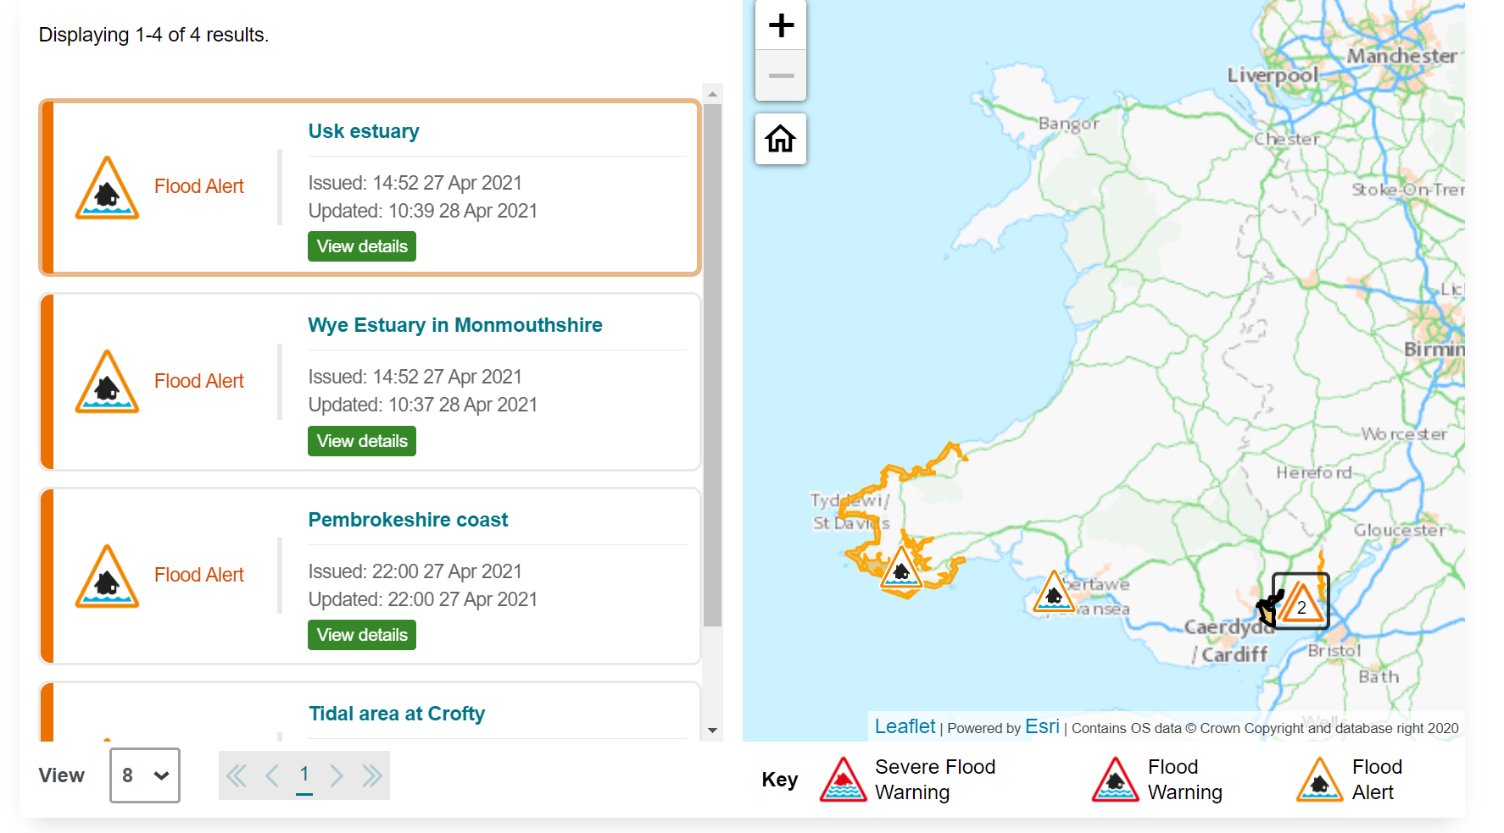
Figure 2 Flood Alert for Spring Tide 2021 (NRW, 2021)
There are many methods of constructing flood defences both natural and engineered, and all have their advantages and disadvantages, as yet there are not any tidal lagoons, while several have been planned for the UK shores and some agreed through planning none have been constructed. They are an expensive method of defense while offering more than just flood protection, they offer renewable energy, safe recreational space, protected environment for sealife, however they take a long time to construct and could possibly have detrimental side effects.

The Need for Increased Residential and Tourism

The UK has lost a large portion of its industry in the last 3 decades, many of these areas have now reinvented themselves and become tourist destinations, beaches are highly attractive to tourists and to locals with enough financial stability to afford a residence near one. Identifying the financial difference between cost and sale price would dictate how to best promote a project of this magnitude. Comparing the cost of a town house to an existing beachfront apartment would provide an estimation of the availability of funds to build both accommodation, retail, hospitality and catering, behind the safety of a tidal lagoon, while also providing a safe water attraction increasing tourism even further, especially in a time such as Covid-19 when people are unable or unwilling to travel abroad for vacations.
The UK is also in the midst of a seemingly unending housing crisis, creating both high end residential and basic social housing on a tourist location provides homes, and also workforce for the area, as many local authorities now make this a pre-requisite for all planning applications this could have positive implications for areas with high levels of homelessness and unemployment, whilst also reducing carbon emissions emitted from commuting to places of work.

Will it be Expensive to Build?

Yes, but all infrastructure is. The benefit of this project would be the return it would provide and the financial stability it could bring to deprived areas, reduction in flood clean ups, reduced insurance costs for home owners and businesses, and stimulated economy created by increased grid power, and reduction in benefits payments. As a privately funded venture prototype this construction would provide a working example of coastal protection which could encourage government to adopt further projects of this type.

Methods

To best develop an understanding of the plausibility of how to fund projects of this size would require gauging interest in coastal accommodation, increased tourism venues, hospitality and entertainment premises and retail options. With Pembrokeshire being heavily reliant on tourism for much of its income it would be beneficial for extra facilities to become available.
The residential element of the project would likely be second homes for people who like to holiday in the area or investment properties to increase their portfolio. With coastal property being premium real estate in the UK the style and quality of the projects would need to match the cost, whilst also allowing for the completion on a number of social housing units in the development as per local authority guidelines.
Tidal lagoons have the potential to be used to protect coastal communities, manage flooding, and mitigate its effects. The lagoon walls create a more protected environment, minimising the risk of overtopping and allowing for the manipulation of water levels during times of surge.
By using a number of data collection sources the information collected would provide a wide scope of feelings towards a project of this size. By not limiting the participants to local inhabitants we gather opinions of the people who may provide the most footfall and financial expenditure.

To ascertain whether there is sufficient interest in a project of this nature, the following methods would be used:
- Interview prominent local real estate agents to ascertain the number of clients seeking beach front residential properties and whether there is a waiting list for this kind of properties. Other coastal towns in the area have high demand for both permanent and seasonal residential accommodations. To provide an accurate price difference between beach/seafront properties and those in towns or other rural locations.

- Interview national parks and local governments to learn about the restrictions on building in National Parks and Coastal Parks, as well as to determine whether flood defences would be exempt from the restrictions as a necessary construction to preserve the coastline and protect wildlife habitats both at sea and further in land.

- Online Questionnaire for tourists who use the Pembrokeshire area to establish the requirement for such developments as a factor in returning to the area on a regular basis.

- Case Study as a two-pronged project incorporating a tidal lagoon and residential properties, with substantial tourist venues the author acknowledges the need to highlight the benefits of both developments and as a result has chosen to use examples close to their home location that have been marked successes. In the situation of the tidal lagoon, they will use the proposed site at Swansea that may or may not go ahead in the near future. With this in mind, we will summarise the uses and potential primary flood protection of tidal lagoons, as well as the financial benefits of seafront development as a further reserve flood defence and community enhancement practise.

Tidal Lagoon Case Study: Wales currently has no tidal lagoons despite several applications to develop them most recently Swansea as a test for a much larger development at Cardiff. Swansea would have been a world first, and much controversy has surrounded the initial agreement to build it which was then revoked. Due to the cancellation of construction this case study will be based on the estimations made by the government commissioned report that was prepared for the planned development at Swansea and subsequently Cardiff, and the planned documents highlighting the uses and benefits. Other parts of the UK are considering developing tidal lagoons, these locations will also be briefly discussed to determine the phase of planning they are at, and whether they will go ahead.

Swansea Tidal Lagoon.

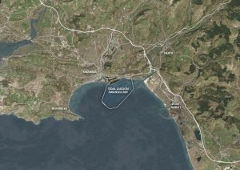
Figure 3 Proposed Lagoon at Swansea (TLP, 2018)

A fully developed plan that reached as far as being given planning permission to go ahead, now sits idle after government rescinded the permission. Greg Clark presented to parliament that “this, a world first, and the others would not represent value for money compared to a mix of offshore wind and nuclear” (GCR, 2018) The £1.3bn development would have cost four times that of an offshore wind farm, and more than twice the cost of Hinkley Point Nuclear Plant. However while true neither of these developments have the capacity to protect our shorelines from tidal surges, storms, and rising sea levels, the author aims to highlight this fact and propose that smaller more manageable and affordable sites at multiple locations all over the UK would not only protect the coast, but provide vital income to poverty stricken areas and generate jobs from consultation, construction, and in use phases in areas of the country that desperately need reinvigoration, but also generate enough clean energy to reduce the need for controversial Nuclear Power, at a time where would should be focusing on using less energy and providing low carbon developments.
By combining the two case studies a wider scope for how the proposals for tidal lagoons paired with developed seafronts could transform Welsh (UK/Worldwide) coastal areas into safe usable, desirable land mass zones.

Waterfront Development Case Study: As a peninsular Wales has large swathes of land situated near sea level that will be inundated by predicted rising sea levels, making its economic development dependent on future developments aimed at protecting those areas, or migrating those seafront towns further inland at great cost and disturbance of inland wildlife, increased traffic, noise, pollution. As a tourist destination West Wales would provide a solid example of protected coastline, developed into usable land.
As Wales’ industry has diminished the tourism trade has increased in its place, Milford Haven is one such example of this. Once a bustling fishing port the industry left to relocate in other European countries, as a result the area was left derelict and dangerous. The owners of the land MHPA developed a plan to repurpose the area and changes began in the early 90’s with this brought new life to a disused docks. Much criticism was encountered by locals who protested that the developments would remove trade from the town centre because of no direct link between the locations. Despite this the dockyard was renamed Milford Marina and grew into a focal point for the town, that now draws tourists and people from other local towns for the many events they organize each year, while the town centre is also experiencing growth after a period of decline.
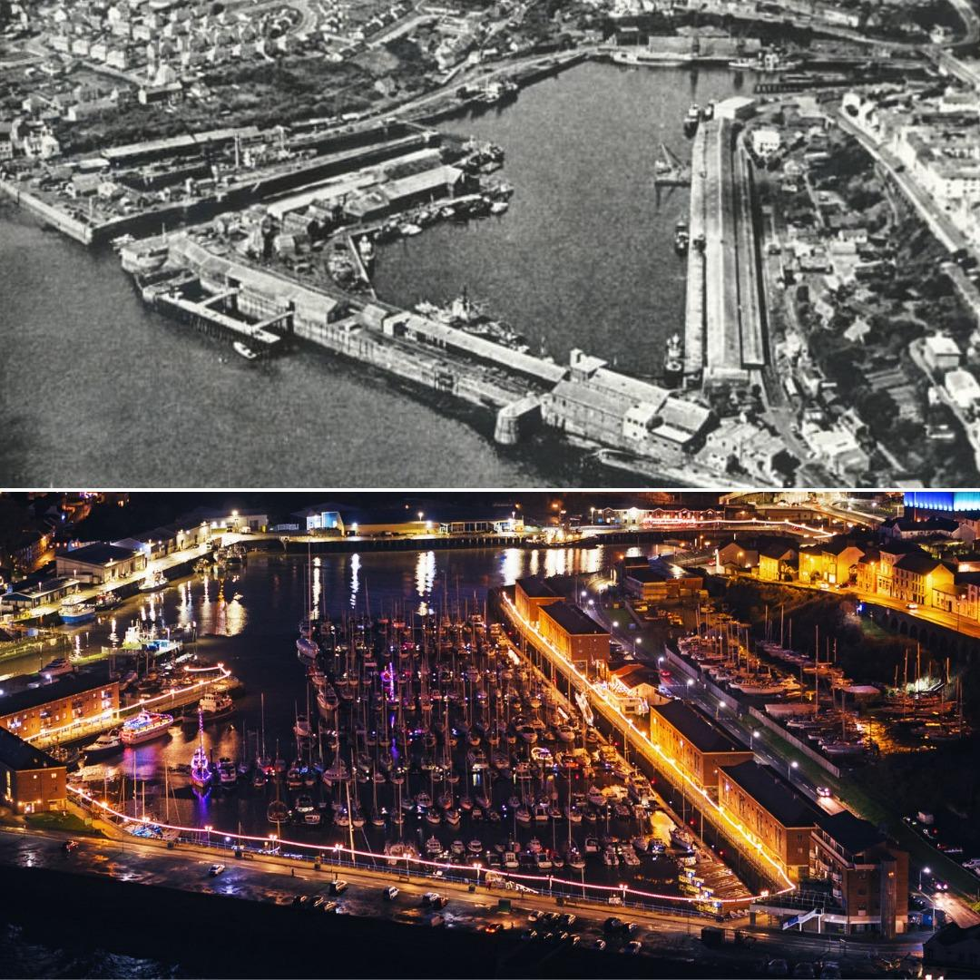
Figure 4 Milford Haven Docks to Milford Haven Marina (Riley, 2021)
New clean apartments and retail units have replaced broken disused fish warehouses, and the Marina's changing face is being further enhanced by the construction of a new luxury hotel. This has injected much-needed life into the town, preventing it from succumbing to closure, as many Welsh towns have. With some industry still operating in the dockyard, full transformation is currently impossible; however, as fewer and fewer fishing trawlers dock in the yard, more space is being considered for expansion. The Marina is built within high port walls that protect against the worst storms while also creating usable, profitable land space both on the waterfront and further up river.
To emphasise the goals of the Milford Haven Port Authority, much of the materials removed from the construction site were recycled rather than disposed of, increasing the sustainability of the projects in accordance with their mission statement and adherence to the Future Wellbeing in Wales.
This case study will highlight the issues faced by towns such as Milford Haven that rely heavily on one type of industry, as well as how its use of land protected by sea defences allowed for high-end development..

Results and Evaluation.

While this might sound like a basic requirement, a single measure cannot cover all of data collection methods and as a broad topics, so we will also be conducting a variety of qualitative and quantitative assessments
It will be of the utmost importance to discover if this kind of development is financially backed by the energy companies, travel firms, and local developers looking to develop their portfolios, while also identifying the people's priorities and concerns, as they do so with any proposed large-scale development that would affect the neighbourhood.
As the technology for the tidal lagoons is untested only estimates of the power generated, and the reduction in storm damage can be discussed, this could paint an incomplete picture.
As an architectural technician, the author is interested in developing projects that are sustainable and cause minimal disruption to local residents and wildlife, while providing maximum return, and he believes that leading with a clean and modern approach, such as Passivhaus, may elicit fewer objections.
The author believes that this proposal is critical for the future of countries throughout the world, as well as their local community. If such a project proves feasible in practice, global efforts could be made to stave off the forces of global warming while we work to reduce emissions sufficiently to reverse temperature increases.

Timeline

This research will be completed by September 2021 and submitted to peers for scrutiny as completion of MSc Sustainable Construction Dissertation.
Interviews and questionnaires will be completed by June 30th in order to allow sufficient time to collate the data into relevant categories for in depth analysis to determine the validity of the hypothesis. Any follow up questions will be completed by August 30th to ensure any possible missed options are covered.
Due to current Covid restrictions the author is allowing extra time for responses and increased levels of tourists in the area, which may skew the data.

References
AGU, 2021. Northern Hemisphere summers may last nearly half the year by 2100, s.l.: American Geophysical Union.
Amos, 2021. Climate change: World's glaciers melting at a faster pace. [Online]
Available at: https://www.bbc.co.uk/news/science-environment-56921164
[Accessed 29 April 2021].
Buis, A., 2019. The Atmosphere: Getting a Handle on Carbon Dioxide. [Online]
Available at: https://climate.nasa.gov/news/2915/the-atmosphere-getting-a-handle-on-carbon-dioxide/
[Accessed 16 March 2021].
EKEP, 2011. North Sheppey Erosion Study, Swale: Swale Borough Council.
GCR, 2018. Why the UK government scrapped Swansea tidal lagoon. [Online]
Available at: https://www.globalconstructionreview.com/news/why-uk-government-scrapped-swansea-tidal-lagoon/?_ga=2.256940168.2093465327.1619693804-1536610143.1619693804
[Accessed 29 April 2021].
Lindsey, 2021. Climate Change: Global Sea Level. [Online]
Available at: https://www.climate.gov/news-features/understanding-climate/climate-change-global-sea-level#:~:text=Based%20on%20their%20new%20scenarios,above%202000%20levels%20by%202100.
[Accessed 18 April 2021].
NASA, 2021. NASA Sea Level Change. [Online]
Available at: https://climate.nasa.gov/vital-signs/sea-level/
[Accessed 18 April 2021].
NOAA, 2009. Climate Change Largely Irreversible For Next 1,000 Years, NOAA Reports, s.l.: Earth System Research Labratory.
NRW, 2021. Flood Warnings and Alerts. [Online]
Available at: https://flood-warning.naturalresources.wales/
[Accessed 28 April 2021].
Riley, 2021. Milford Haven Marina celebrates 30th anniversary. [Online]
Available at: https://www.westerntelegraph.co.uk/news/19186586.milford-haven-marina-celebrates-30th-anniversary/
[Accessed 28 April 2021].
TLP, 2018. An iconic, world-first infrastructure project in South West Wales. [Online]
Available at: http://www.tidallagoonpower.com/projects/swansea-bay/
[Accessed 29 April 2021].

