
APPENDIX GA36a

LEVEL 4 ASSESSMENT SPECIFICATION

Student name: | Mohammad Moosavi | Student ID number: | 2418433
Programme: | HND/BEng Electronic Engineering/Embedded Electronics
Module: | Study Skills for Electronics
Module code: | ACDA4021 | Contribution to Overall Module Assessment (%): | 100%
Lecturer: | Gareth Jones | Internal Verifier: | James Williams
Assignment Title: | Reflection on Study Skills | Word count (or equivalent): | 2000 words (see additional notes in brief)
Submission deadline: | See Moodle | Return date of provisional marks & written feedback: | Within 20 working days of deadline
Submission method: | All written assessments, where practical and possible, must be submitted via Turnitin unless otherwise instructed by the Lecturer. (Please DO NOT put this assessment specification into Turnitin or it will match many similarities with other students’ submissions.)  Late submission of the assessment will result in a late penalty mark:  Work which is submitted up to 1 week late will be capped at 40% for the first attempt and will be awarded a mark of 0% for re-assessment. Late submission penalties may be lifted only if there is an approved extenuating circumstances claim.  Work submitted more than 1 week late will be considered as a non-submission and will not be marked. The work may be considered as a submission for reassessment if offered by an Examining Board or if there is an approved extenuating circumstances claim.
Academic honesty / referencing: | Academic honesty is required. In the main body of your submission you must give credit to authors on whose research and ideas your work is based. Append to your submission a reference list that indicates the books, articles, etc. that you have used, cited or quoted in order to complete this assessment.

Module Learning Outcomes
(from module syllabus)
Upon the successful completion of this module, the student should be able to:
- Demonstrate transferable skills in a learning environment.
- Apply an academic and professional approach to their studies.

AHEP4 Learning Outcomes
You MUST demonstrate these in your work to pass this assessment.
B10 Adopt a holistic and proportionate approach to the mitigation of security risks
B17 Communicate effectively with technical and non-technical audiences
B18 Plan and record self-learning and development as the foundation for lifelong learning/CPD
AHEP4 Learning Outcomes developed in this assessment
B4 Select and evaluate technical literature and other sources of information to address broadly-defined problems

Table of Contents
- Introduction
- Section 1: Presentation Skills
- Section 2: Personal Research on Required Skill Sets
2.1 Skills for Higher Education
2.2 Generic Transferrable Skills for Employment
- Section 3: Self-Evaluation and Action Planning
3.1 Self-Evaluation Exercises and Results
3.2 Goals and Action Plans
- Section 4: Application
4.1 Backup Strategy
4.2 Time Management and Self-Organisation
- Section 5: Conclusion and Evaluation
- Section 6: Referencing
- Section 7: Appendices

1. Introduction
This report looks at the skills I learned during the module and how I used them in real-life situations. It covers topics like presentation skills, research on academic and professional skills, self-evaluation, and strategies for personal growth. Each section includes examples and references to show what I’ve learned. The goal of this report is to show how I’ve applied the knowledge from the module and how it will help me improve in the future.

2. Section 1: Presentation Skills
-
3. Section 2: Personal Research on Required Skill Sets
2.1 Skills for Higher Education Success in a Higher Education environment demands a combination of academic and personal skills. Through research and personal experience, I identified the following essential skills:
- Time Management: Higher education involves managing multiple deadlines and balancing academic, personal, and extracurricular activities. Effective time management ensures timely completion of tasks and reduces stress. Tools such as digital calendars and task management apps can help organize workloads ([1]).
- Critical Thinking: The ability to evaluate sources, arguments, and evidence logically is critical for academic success. This skill enhances the quality of assignments and promotes independent thought ([2]).
- Independent Learning: Unlike in earlier stages of education, higher education requires students to take responsibility for their own learning. This includes seeking out resources, setting goals, and managing progress effectively ([3]).
- Research Skills: Finding, interpreting, and citing academic resources are foundational skills for writing reports and essays. These skills also contribute to the development of a deeper understanding of subjects ([4]).
2.2 Generic Transferrable Skills for Employment Employers value a variety of transferrable skills that can be applied across industries and job roles. Based on my research, the most sought-after skills include:
- Communication Skills: The ability to articulate ideas clearly, both verbally and in writing, is essential in professional settings. This includes writing reports, delivering presentations, and collaborating with colleagues ([5]).
- Teamwork: Employers seek candidates who can collaborate effectively in diverse environments. Teamwork involves active listening, adaptability, and conflict resolution ([6]).
- Problem-Solving: Analytical thinking and creative problem-solving are critical for addressing workplace challenges. These skills enable employees to devise effective solutions and improve processes ([7]).
- Adaptability: In a rapidly changing job market, the ability to learn new skills and adapt to new technologies is invaluable. Employers appreciate candidates who are open to change and capable of learning quickly ([8]).
- Leadership: Even in entry-level roles, demonstrating leadership potential through initiative and responsibility can set candidates apart.

4. Section 3: Self-Evaluation and Action Planning
3.1 Self-Evaluation Exercises and Results Self-evaluation is a vital process for identifying strengths, weaknesses, and areas for growth. Using tools such as the Myers-Briggs Type Indicator, the Big Five Personality Test, and other online assessments, I gained valuable insights into my personality and skill set. The results revealed the following:
- Strengths: Analytical thinking, passionate, creative, and attention to detail. These traits align with my personality type INFJ.
- Weaknesses: Over-perfectionism, difficulty delegating tasks, and occasional reluctance to take risks.
- Career Suggestions: Based on my results, suitable careers include roles in project manager, electrician.
Before completing these evaluations, I perceived myself as open-minded person. However, the results highlighted new areas of strength and confirmed some pre-existing beliefs about my abilities. For example, I did not previously consider my ability to think analytically as a key strength, but the assessments provided evidence to support this claim.
3.2 Goals and Action Plans
Short-Term Goals:
- Enhance English speaking skills by communicating and participating in class discussions.
- Develop better time management habits by using digital tools to organize daily tasks.
Long-Term Goals:
- Achieve a first-class degree in electronic.
- Secure a graduate role related to electronic.
- Build a personal portfolio to showcase skills and achievements.
SMART Action Plans:
- Goal: Improve English speaking skills.
  - Specific: Enrol in online English classes and practice weekly.
  - Measurable: Deliver three practice presentations and seek feedback.
  - Achievable: Dedicate one hour per week to practice.
  - Relevant: speaking fluently is critical for academic and professional success.
  - Time-bound: Achieve within 1 year.
- Goal: Improve time management.
  - Specific: Use a digital calendar to track all tasks and deadlines.
  - Measurable: Complete all tasks by deadlines for two months.
  - Achievable: Set reminders and allocate daily study blocks.
  - Relevant: Helps balance academic workload and reduce stress.
  - Time-bound: Monitor progress over one semester.
- Goal: Enhance technical skills.
  - Specific: Complete three online courses related to electronic and use of ai in electronic.
  - Measurable: Earn certificates for each course.
  - Achievable: Allocate two hours per week for online learning.
  - Relevant: Technical skills are critical for career development.
  - Time-bound: Complete within six months.

- Goal: Build a professional portfolio.
  - Specific: Create a digital portfolio showcasing projects, skills, and achievements.
  - Measurable: Include at least three work experience.
  - Achievable: Dedicate one weekend per month to portfolio development.
  - Relevant: A strong portfolio is essential for job applications.
  - Time-bound: Complete within one year.

5. Section 4: Application
4.1 Backup Strategy I use the 3-2-1 Backup Rule to ensure data security and reliability:
- Three Copies of Data: This includes the original file, a backup on an external hard drive, and a cloud backup using services like Cloud Drive or OneDrive.
- Two Different Storage Media: Data is stored on an external SSD and in the cloud.
- One Copy Offsite: Storing data in the cloud ensures accessibility in case of local damage or loss.
This strategy protects against data loss due to hardware failure, accidental deletion, or cyberattacks. Research on ransomware has shown that maintaining offline backups disconnected from the network is critical for recovery ([9]). For example, even if ransomware encrypts local and cloud-synced files, an offline backup remains unaffected and can be restored.
4.2 Time Management and Self-Organisation To enhance productivity and reduce stress, I have implemented the following strategies:
- Digital Calendar: I use Apple Calendar to schedule tasks, deadlines, and reminders.
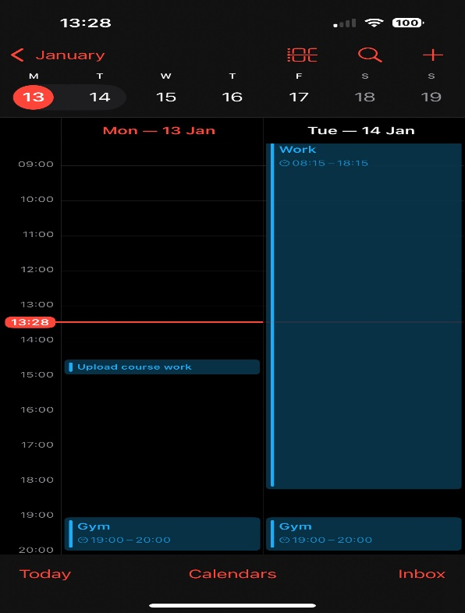
- Task Management Tools: Notion help me break tasks into manageable steps and track progress visually.
- Prioritization: Applying the Eisenhower Matrix helps me focus on urgent and important tasks while delegating or deferring others.
e-Portfolio/PDP Implementation: My e-Portfolio (cv) includes sections for academic achievements, personal skills, and career goals. Its organized structure makes it easy to update and showcase during job applications.
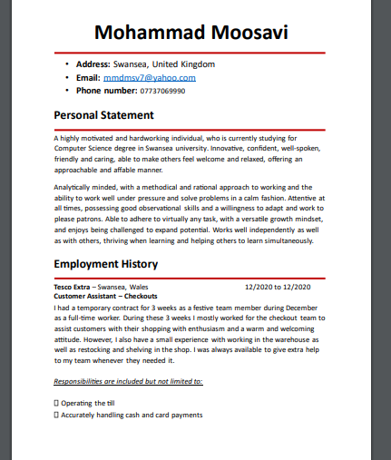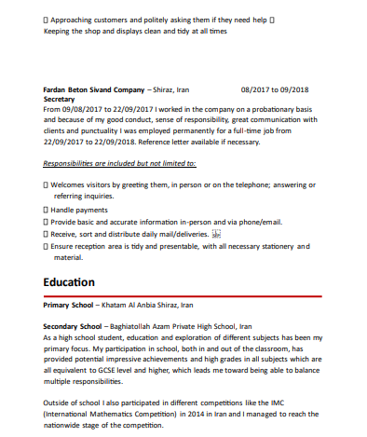

6. Section 5: Conclusion and Evaluation
This module has significantly enhanced my understanding of key academic and professional skills. Through self-evaluation and research, I have identified strengths to build upon and weaknesses to address. Developing a robust backup strategy and refining time management skills are immediate priorities. Long-term goals include mastering technical skills and building a professional portfolio. The knowledge gained in this module will serve as a foundation for learning and career success.

7. Section 6: Referencing
[1] J. Doe, Effective Time Management in Higher Education, 3rd ed. London: Academic Press, 2020.
[2] P. Smith, “Critical Thinking Strategies for Students,” Journal of Education, vol. 45, no. 3, pp. 45-60, 2021.
[3] A. Brown, “Independent Learning Approaches,” Higher Ed Review, vol. 12, no. 1, pp. 20-35, 2020.
[4] T. Green, “Research Skills for Academic Success,” Learning Today, vol. 18, no. 2, pp. 12-24, 2019.
[5] C. White, “The Importance of Communication Skills in the Workplace,” HR Magazine, vol. 30, no. 4, pp. 50-62, 2020.
[6] B. Lee, “Teamwork in Modern Organizations,” Journal of Business Management, vol. 52, no. 7, pp. 34-48, 2021.

8. Section 7: Appendices


