ENGINEERING DESIGN M4X01160
research report and design specification
GROUP D
School of Engineering


Contents
Introduction 3
Design Specification 4
Team Coordination, Mounting System & Systems Integration 5
Integrating Frame 5
Lateral Aiming and Range Adjustment System 6
Aiming Techniques 6
Aiming Predictions 6
Rigidity 7
Energy Release (Trigger) and Safety System 9
Projectile Launch and Line Management 10
Power generation and storage system 12

Introduction

In this report we, as a group will be presenting our initial research on the production of the line launcher for this challenge. A line launcher is a device that fires a line from one ship to another. It is used for several situations, such as, for rescue operations. In this competition, we are to produce a device that fires a squash ball attached to a line at a target at different distances. The closer to the centre of the target shows how accurate and reliable the device is.

The aim for our group in this competition is to design and manufacture a device that is cheap, easy to use, accurate and reliable. Accuracy and reliability are as we see, the two main aspects of designing this device. We have come to this conclusion due to the device must be able to fire the line at a target multiple times, each time at a different location. This will also require the device to be easy to use because we must then reset the device and fire again with different variables within a time limit.

Design Specification

Performance Requirement | Design Requirement | Design Specification | Group Member
The device must launch the line a certain distance. | The device must be able to fire the line attached to the squash ball with enough power to hit the target. | The device must involve a sufficient power generation system to launch the line towards the target. | Adam Rowe (1802339)
The line should hit the designated target area. | The device should be designed in order to change the trajectory of the launch so that the line will reach the target. | The device must have a suitable barrel design with a height adjustment system to aim the projectile. | Nathan Watson  (1900683)
Must be cost effective | Needs to be low cost within budget. | Less than £30 | Andrew White (1803827)
Needs to be set dimensions | Must fit within dimensions specified. 600 x 600 x 600mm is the specified envelope for the device to fit. | The device will be designed to fit within this envelope. | Andrew White (1803827)
Must be safe | The device must be safe for use. | The device needs to have safety mechanism on the trigger. | Josh Watson (1900149)
All components must be independent from any similar products. | Components should be newly designed. | All components will be designed and evaluated. | Andrew White (1803827)
Required to be in a fixed position | The device must be attached to the firing bench by launch location pin using the washer and wing nut provided. | The device must have a mounting system or base that can be place upon the location pin and fixed in place with the washer and wing nut. | Andrew White (1803827)
The line must have a quick and simple method of use. | The line should be attached/detached without the use of tools. | Quick release mechanism. | Josh Watson (1900149)
The launch must be executed remotely from at least 2m away. | Electrical switch used to trigger the launch of device. | Electrical mechanical mechanism to ensure the launch can be executed from specified distance. | Josh Watson (1900149)
Needs to be relatively lightweight | The device should be easy to manoeuvre and move around. | Lightweight materials and mechanisms. | Nathan Watson  (1900683)
Time restraints | The reload and set up processes must be quick and not take too long. | The device should be comprised of simple mechanisms | Josh Watson (1900149)
Must withstand more than one use | The launcher should be able to be used more than once. | Simple design processes and engineering mechanisms will be used to gain optimum durability. | Adam Rowe (1802339)

Team Coordination, Mounting System & Systems Integration

As team coordinator, my responsibilities include a general project oversight. This requires me to make sure everything within the group is acting smoothly. I am to ensure that each group member’s work and research fall within the competition’s guidelines. So, I must ensure that each part or system designed is compatible with the specifications, for example, the total envelope of the design fits within the published dimensions. Also, I will keep record of the expenses. I will calculate the total cost of manufacturing the design and confirm that it falls under the threshold of the spend limit of £30. As team coordinator, I will also keep record of when the team meets, and the duration of that meeting. We have created a communications platform so that if a member is absent, we are able to update them on what occurred in the meetings. This will also help us keep communication to a good standard so that we are all confident that each separate team member is designing their nominated system of the project so that they will all be compatible together in the final product.
Overseeing systems integration, I can integrate each members’ designs of their respective systems in a CAD design using Solidworks software. This then can be used to create a technical drawing of the product. For instance, this can then be used to show that the product lies with the specifications, such as, the total envelope of the design.

Integrating Frame
The integrating frame or the chassis of all the systems to be connected is an important part of the design. It must be sturdy enough so it can hold all parts together in a solid structure so that when firing it can hold firmly to give an accurate and reliable projectile each launch. But at the same time, it must give enough leeway so that the barrel can be adjusted to give a different angle of aiming to hit the target at a different location. The best design I have found for this to be achieved is to emulate a cannon resembling design. As shown in figure 0 below, a triangular base frame would give a good chassis design to house each system of the launcher. It is a fairly simple design, that can be made from cheap materials such as plastic or wood, that will give us good access to all areas of the launcher, and that will give us a sturdy platform to then launch the line at the target with good reliable results.
To comply with the regulations, similar to the design in Figure 0, the chassis should sit on a base so that the whole structure can be attached to the table in the competition with the location pin, washer and wing nut.

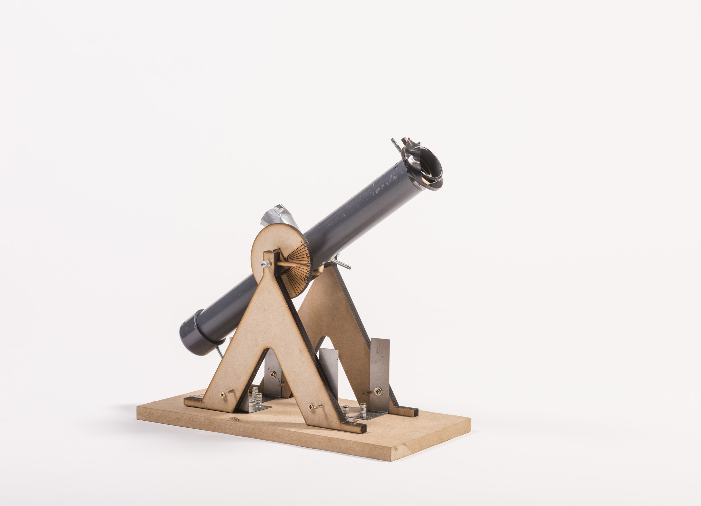

Figure 0 – Chassis design (University of Southampton, 2016)

- University of Southampton (2016) Design Show 2016 [image] Available at: https://uosdesign.org/designshow2016/year-1/line-launcher/ (Accessed: 8 December 2019)

Lateral Aiming and Range Adjustment System

Aiming Techniques
Because the base must be mounted this means that the entire device cannot move from left to right. There is still the possibility of rotation due to the connection being 100mm from the rear boundary, but this will probably not be necessary if the device can shoot straight. With a single bolt to connect to, putting this in the centre will allow for the device to be rotated on it between shots by unscrewing the wing nut and repositioning.

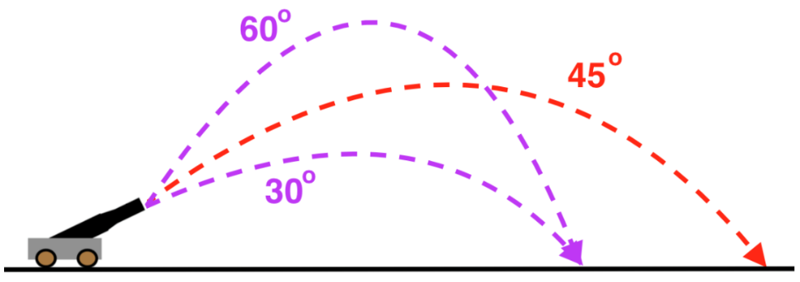
The vertical aiming is more important as this will determine how far the projectile can be fired with the given power that we have. An effective way to adjust this is with the use of a pivoting barrel, in the style of a cannon/mortar. With a design such as this, the power of the launch as well as the angle of trajectory will have to be calculated before the demonstration through testing. Once these values are determined, the device should perform precisely by firing from certain angles to reach the desired distances. Increments of angle adjustment will be subject to the results of testing, ideally having many small increments rather than a few large ones.
Figure 1 – Angles of launch and their trajectory path

To angle the barrel there are multiple ways to do this by pivoting the barrel.
- The barrel can be pivoted at the base. This design means that to change the angle of the barrel, the end can either be lifted or lowered. This will make the angle easy to show as it will be pivoting from a flat base but will require support at the barrel end. To secure the barrel in this way an adjustable height strut can be manufactured to provide different elevations.
- A mid-barrel pivot will provide the possibility of a more compact design that is easier to angle but will be more difficult to lock into place to prevent the angle changing during firing. This will therefore require reinforcement of the barrel at another location to hold it in place.
Figure 2 - Example of mid-barrel pivot
- Pivoting the barrel at the launch end is also a possibility. This will require a solid mount at the front of the device such as a tripod, with the bottom end of the barrel to be lifted to create desired angle.

Aiming Predictions
To provide the most accuracy, an angle scale will have to implemented to line the barrel up with. This will depend on the pivot point of the barrel. These will be decided on during testing as they will be affected by the power. To make it easy to use, only angles which will provide results within the range of the challenge will be marked on the device.

Rigidity
The rigidity of the device is vital for accuracy and it is import ant that the structure will not allow for the barrel to move once it is secured.
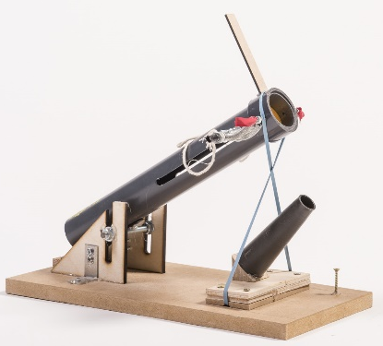
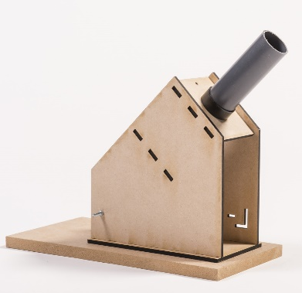
Figure 3 - adjustable, not rigid
Figure 4- rigid, no adjustment
These two examples of a similar challenge showcase the extremes of rigidity. The first device (Figure 3) has an element of adjustability, but no support to be able to keep it accurate. Figure 4 is extremely rigid and will likely shoot precisely, but cannot be aimed differently, this will have to be adjusted by changing the power used.
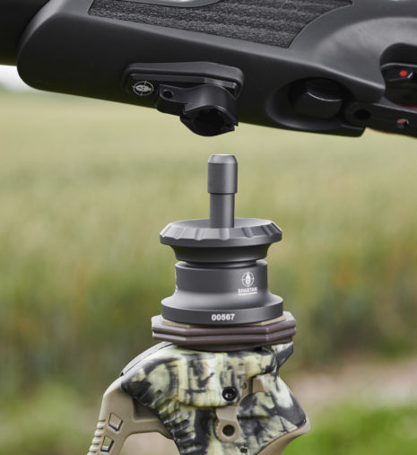
If the device can be designed with a strong structure that allows for free movement then optimal accuracy can be achieved.
A use of a bipod could add a range of movement as well as stiffness. Figure 5 shows an example of a bipod that allows for rotational and vertical adjustability, as well as the option to lock.
Figure 5- adjustable, lockable bipod
Figure 1 – Angles of launch and their trajectory path 6
Figure 2 - Example of mid-barrel pivot 6
Figure 3 - adjustable, not rigid 7
Figure 4- rigid, no adjustment 7
Figure 5- adjustable, lockable bipod 7
Bibliography
Design Show 2016 [Online] / auth. University of Southampton. - 2016. - 07 December 2019. - https://uosdesign.org/designshow2016/year-1/line-launcher/.
First impressions: Umarex and Spartan Precision [Online] / auth. Airgun Shooter. - 2019. - 7 December 2019. - https://www.airgunmagazine.co.uk/features/reviews/first-impressions-umarex-and-spartan-precision/.
FIRST YEAR DESIGN CHALLENGE [Online] / auth. Institution of Mechanical Engineers. - 2019. - 06 December 2019. - https://moodle.uwtsd.ac.uk/pluginfile.php/321420/mod_resource/content/0/2020%20Branded%20IMechE%201st%20Year%20Spec%20Design%20Challenge%20-%20Project%20Specification%202020%20-%20V1.1.pdf.
Projectiles launched at angle review [Online] / auth. Khan Academy. - 2018. - 7 December 2019. - https://www.khanacademy.org/science/ap-physics-1/ap-two-dimensional-motion/projectiles-launched-at-an-angle-ap/a/projectiles-launched-at-angles.

Energy Release (Trigger) and Safety System
- Mechanism Options
In terms of mechanism options that could be used for the launcher device, there is a couple of different options that could be considered. A more conventional single action trigger could be used, these single action triggers are the simplest trigger mechanism of them all, when the trigger is pulled, this releases the hammer, which then hits the firing pin and then in turn makes contact with the object being fired. These single action trigger mechanisms need to be cocked each time they are fired. They are reliable since they utilise a spring, and simple. This trigger mechanism is a relatively cheap one to set up and use.

A PCP (Pre-Charged Pneumatic) trigger mechanism could also be considered for this application. They work by using a gas canister that is filled with pressurised gas, that when the trigger is pulled, a small valve opens and allows a small volume of the pressurised gas to leave and go down the barrel and then push the object down and out of the barrel. The amount of gas within the canister will determine the power the shot will have. These mechanisms are good although the gas level drops after each shot is taken and to recharge the gas canister, specialist equipment is needed. This type of trigger mechanism isn’t as simple as a single action trigger although it still has its own benefits, like the fact that the power of the shot can be pre-determined depending on the volume of gas that is pre charged into the canister.

- Life In service/reliability
Since the Single action trigger is more mechanical than the PCP mechanism, it could be expected to last a longer period in service if it is regularly maintained and serviced. Regular cleaning and lubrication of the moving parts within the mechanism will ensure that they perform to the correct standard all the time. After extensive use over a period of time with no maintenance, then there is the possibility that the single action mechanism may become tired and not work to its full potential, this could be because the spring inside the mechanism becomes worn or stretched which reduces the potential energy that it has, therefore reducing the life in service and reliability of the single action mechanism.

The PCP mechanism may begin with a slightly shorter expected life in service/reliability as the use of gas could incur some problems with the way that the mechanism works. The mechanism could begin to lose pressure through leakages, which could be caused if the small valve in the mechanism sticks and doesn’t seal properly then this would allow more gas than is necessary to move down the barrel, therefore the mechanism loses power. These types of mechanism are much more expensive than the single action mechanism also.

- Materials
Commonly, stainless steel is used within these trigger mechanisms as it has a resistance to corrosion and is good as it reduces the maintenance needs of the mechanism. Springs are commonly made from spring steel as it has its tendency to return to its original size unless over stretched.

- Safety Mechanism (To Avoid Miss Fire)

There are different ways that a safety mechanism can be incorporated into the launcher device, a lever or button that must be manually switched or pressed can be a simple and effective way to prevent the launcher from firing.

A hammer block could also be used, these are simple mechanisms that go across the front of the hammer within the firing chamber to prevent the hammer from contacting the firing pin. These can only be overcome by physically pulling the trigger.

Projectile Launch and Line Management

- Barrel/Channel Geometry
For the most effective launch possible, a long cylinder for the object to be launched from would be the best option. As far as geometry is concerned. The diameter of the barrel only needs to be slightly larger than that of the object being launched, this will reduce the opportunity for the object bouncing around the barrel and will also keep it on its path of trajectory.

In terms of length of the barrel, a longer barrel would create a more accurate launch, although would potentially create more of a loss in force if it has further to travel down the barrel. A shorter barrel would be less accurate although would potentially maintain more of its initial launch force.

- Material Selection
On existing launching devices, materials used are commonly carbon steel or stainless steel, which are the best options for when launching rounds of ammunition although for this application, a Perspex material of a piece of UPVC pipe would be a suitable choice as they are lightweight, strong enough to withstand the force being exerted through it and also relatively cheap to obtain compared to carbon steel or stainless steel.

Using a plastic material for the launching device would be beneficial when referring to the design specification that outlined that the launcher should be lightweight and durable. The use of plastic also means that it is durable and is easily manipulated if other components needed to be mounted.

- Life in Service Requirements
The launching device and line management system must be reliable and durable. The materials and processes used to manufacture the device have to be able to withstand a series of intense tests and uses whilst still being able to perform to the expected level each time.

The device must be effective whilst also meeting the points mentioned within the design specification. The device must be able to last a set period without failure.

- Entanglement Avoidance
In order to prevent a potential entanglement, a way to prevent this, would be not to put too much line into the launch device. Only using the minimum amount of line is a good way to reduce clutter on the retrieval process of the line. This minimises the chance of the line becoming tangled.

Another way to prevent entanglement would be to create a small channel to hold the line in the correct way and to guide it in the direction it needs to go to prevent it from creating loops and then tying itself into knots. This could be made of plastic and would be a cheap and effective way to prevent this issue.

- Drag/Loss Reduction
A good way to reduce drag on the line of the launcher would be to use a line that was made of a material that had little friction and that wouldn’t create drag when being retrieved. Although this method would not completely eliminate the issue, would be to use a retrieval mechanism that used bearings, this would be the most effective method and would mean that as long as the bearings were lubricated and maintained regularly then the amount of friction would be reduced therefore reducing drag.

Completely eliminating the drag acting on the retrieval device is very hard, although these methods discussed would go a long way in largely reducing it so that the device was as effective as possible.

References used:
, Safety Mechanisms19/7/, 2011-last update. Available: http://firearmshistory.blogspot.com/2011/07/safety-mechanisms.html [6/12/, 2019].
, What are PCP air rifles?. Available: http://www.straightshooters.com/what-are-pcp-air-rifles.html [4/12/, 2019].
JAKE, 2/8/, 2017-last update, An Introduction to Trigger Actions and Mechanisms &nbsp;. Available: https://gunbelts.com/blog/an-introduction-to-trigger-actions-and-mechanisms/ [4/12/, 2019].

Power generation and storage system

This section is going to be about the power generation and the storage system used in the line launcher. The main topics discussed in this section will be the type/configuration, weight/size, cost/availability, mounting/compatibility, service life and reliability.
The two main types that could be used in the line launcher are gas and spring powered designs. The more simple design to use would be that of a spring system compressed in the barrel of the line launcher. The type of spring that would be best suited in this task would be a compression spring as they are ‘designed to operate with a compressive load’ (Wu, 2019). One type of compression spring is a progressive rate spring. Here is an example of one of these:
Picture 1 available at: https://www.fictiv.com/hwg/design/types-of-springs-and-their-applications-an-overview Accessed: 06/12/2019
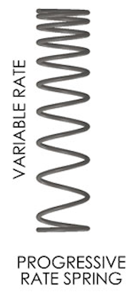
As seen the string becomes harder to compress the more it is compressed. This would hopefully be good because on release the start of the movement should be slower to the end. Leading to a more efficient release with more of the power coming at the end of the movement, in the hope that this causes it to be more reliable and withstand more runs, as laid out in the design specification. These can be picked up for around £6 which is not a big chunk out of the £30 budget for what is a fundamental part of the design. Here is a website selling these springs:
https://www.makeitbuildit.co.uk/traxxas-springs-front-progressive-20-rate-blue-2-trx6864-39782?gclid=CjwKCAiAlajvBRB_EiwA4vAqiLEfxMrkjnMQtUJSShq3VVeF317f2wxwnnnk5jiGnO88xYef-mFueBoCofkQAvD_BwE

If we were to use a gas canister to power our line launching device then there is no doubt it would easily have enough power to complete the task. However, although it would potentially be a more efficient and reliable option there would be a few issues that would arise, especially in relation to the design specification. The main issue would be the actual cost to purchase the canister. Looking online there is a professional line launcher that is powered by gas. This line launcher in particular can be used in extreme weather conditions, with a maximum firing range of up to 80 metres. These are clearly good features but for the task which we are competing in they would not really be necessary, and if anything would give us too much power, making it harder to aim our launcher and ultimately hit our target. The gas canisters they use also cost £34 which is way over budget.(I.C Brindle and co, 2019) https://www.icbrindle.com/Line_Launcher.html?gclid=CjwKCAiAlajvBRB_EiwA4vAqiI1GYMQ_DQAhMSK030fuKdgnvVx-P7lZ4QkcHHTp7XWH-Z7T1vLcRBoCTG0QAvD_BwE
However, there could be a way to do it for much cheaper using a small canister. By using a BB gun cartridge which is only 20cm long, we would obtain 900psi of compressed air which would be put to effect on the squash ball. These can be picked up for £5 or less which is within out budget and can be directly threaded onto the device using an M16 x 1.5 thread. However, as they are only small and have a volume 118ml, it would be risky to assume they will have enough gas in them to withstand multiple runs, as they cannot be refilled and will only last a certain amount of time which will only be found out through testing which would dent out budget further. (C0₂Cartidges.co.uk, 2019) https://www.co2cartridges.co.uk/88g-threaded-paintball-co2-bb-cartridge-co2
Overall the best design for repeated use, cost, size and simplicity in mounting would be a spring system as it would give us a stable amount of power, hopefully over a high number of runs.

