Study Skills
Summary of ‘How does music make you feel?’
In this article Zoe Nendick is finding whether there is a correlation between music and emotion. Emotions linked with songs may not always be just to do with how it sounds but it may be the memories that they associate with a certain song and the emotions that they felt in the past situation. Our brain has been studied to find that it responds to music in the part of the brain that locates rewards meaning we are enjoying it. These parts of the brain that found activity during the music are called ventral striatum, amygdala and medial prefrontal cortex (Blood & Zatorre, 2001). There is a framework called BRECVEMA that is in its early stages of studying the way music produces emotions with the relation of the listener, music, and the situation they are in (Juslin, P.N. & Västfjäll, D,. 2008). This framework was made as they found they was not enough research on western listeners musical interests to find the responses with those individuals with music.
Further research is still being made to see the differences in responses with both personality and individual differences; as an example, they believe that people listening to music with an increased level of neuroticism are more likely to feel nostalgia. In addition, factors that could affect the person listening to the music are external factors, these being what kind of environment they are in, whether the person has chosen the music or not. Then internal factors that could impact someone is what mental state, how much attention they are paying, and their motivations to listen.
One correlation that has been discussed is for alleviating stress is most successful when listening to major music rather than listening to minor music (Suda et al., 2008). However, some people just don’t experience any response with emotion when listening to music, which is known as having music anhedonia. But there are also some people that than have an uncommon amount of fulfilment out of listening to music (Nendick, Z,.2022, September 12).

Essay plan
(b) Describe and discuss the psychological, social and physical benefits of engaging in a sporting activity.
Introduce the topic:
- I will be discussing how engaging in a sporting activity can impact on someone psychological, socially and physically.
- I will give examples of Olympians that have had these impacts.
- I will discuss how I will talk about a variety of ages of people engaging in activities.

- Talk about the psychological benefits of engaging in sporting activity
- Discuss benefits of playing sports has on helping with cognitive function. For example, how playing sport can help with the release and production of neurochemicals and neurophysiological changes to the brain. Give examples of mental health issues that can be prevented due to playing sport, with the help of improving cognitive function.
- Give examples contradicting the benefits of people who have struggled or had to stop playing sport professionally due to their mental health issues. Discuss the side of sport that is unhealthy and can put a lot of psychological stress on the body. (Martín-Rodríguez, A., et.al, 2024)
- Talk about the social benefits of engaging in sporting activity
- Analyse how important playing sport is for benefitting socially and this can in reference to a sport city (Pye, P,.et.al, 2015).
- Explain how social interaction such an important thing is and with sport it is a lot easier to find this. Sport has many positives as with being more social will then have a big impact positively on mental well-being (Okechukwu, C. E., 2021).
- Talk about the physical benefits of engaging in sporting activity.
- Discuss the health benefits on elderly people engaging in a sporting activity. Give examples of the benefits on their body and how they had a better quality of life. Can discuss a bit how it also helped elderly people mentally not just physically when engaging in sport (Suryadi, D.,2024).
- Talk about the advantages of sport on anyone playing a sport. Discuss what can be prevented due to being active. A brief discussion on the guidelines of the amount of physical exercise for each age category (NHS,. August 14th, 2024).
Conclusion
To conclude I will make a judgement to weather I believe these three aspects actually have an impact on someone when playing a sport. Also to choose out of the three which one I think benefits someone the most.
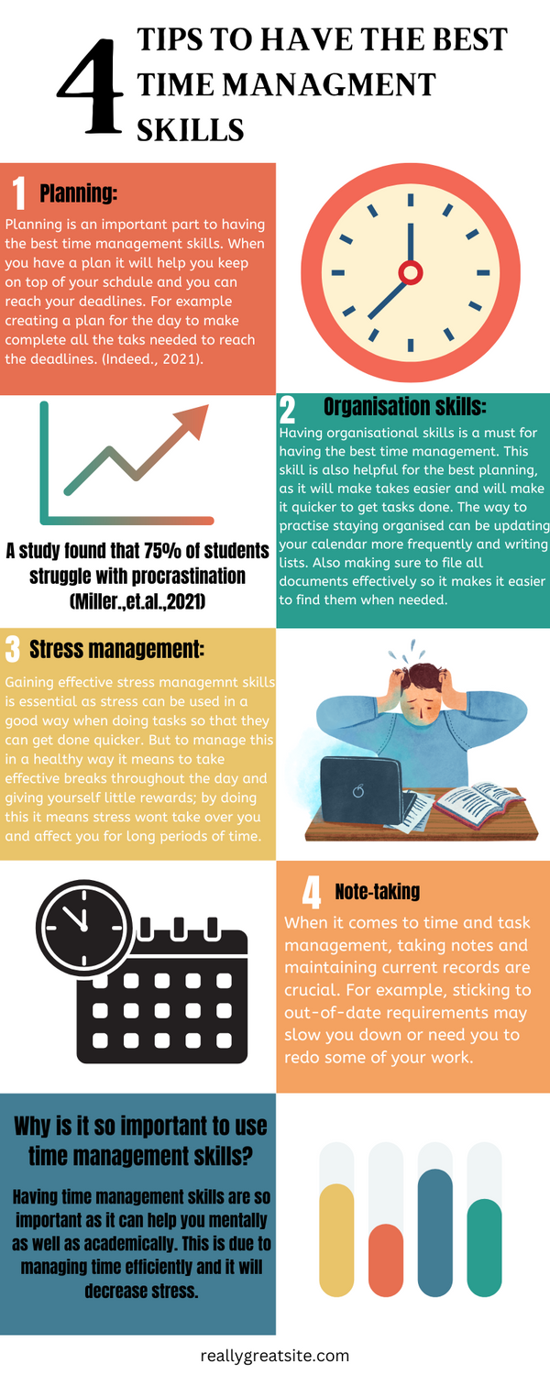
Reference list
Indeed. (2021). Time-Management Skills: Definition, Examples and Tips for Improvement. Indeed Career Guide. https://uk.indeed.com/career-advice/career-development/time-management-skills
Miller, A.,et.al (2024). Examining social support and procrastination among college students. Frontiers in Psychology, 15. https://doi.org/10.3389/fpsyg.2024.1425524
Blood, A. J., & Zatorre, R. J. (2001). Intensely pleasurable responses to music correlate with activity in brain regions implicated in reward and emotion. Proceedings of the national academy of sciences, 98(20), 11818-11823.
‌Juslin, P.N. & Västfjäll, D. (2008). Emotional responses to music: The need to consider underlying mechanisms. Behavioral and brain sciences, 31(5), 559-575.
‌Martín-Rodríguez, A., Gostian-Ropotin, L. A., Beltrán-Velasco, A. I., Belando-Pedreño, N., Simón, J. A., López-Mora, C., Navarro-Jiménez, E., Tornero-Aguilera, J. F., & Clemente-Suárez, V. J. (2024). Sporting Mind: The Interplay of Physical Activity and Psychological Health. Sports, 12(1), 37. https://doi.org/10.3390/sports12010037
Suryadi, D., Susanto, N., Faridah, E., Wahidi, R., Samodra, Y. T. J., Nasrulloh, A., Suganda, M. A., Wati, I. D. P., Sinulingga, A., Arovah, N. I., & Dewantara, J. (2024). Exercise for health in old age: Comprehensive review examining the benefits and efficacy of interventions. Retos: Nuevas Perspectivas de Educación Física, Deporte y Recreación, 55, 88–98.
‌ NHS. (2024, August 15). Benefits of Exercise. NHS; NHS. https://www.nhs.uk/live-well/exercise/exercise-health-benefits/
Pye, P. N., Toohey, K., & Cuskelly, G. (2015). The social benefits in sport city planning: a conceptual framework. Sport in Society, 18(10), 1199–1221.
‌ Okechukwu, C. E. (2021). Role of Sports in Social Health Promotion. International Journal of Preventive Medicine, 12, 44. https://doi.org/10.4103/ijpvm.IJPVM_332_19
Nendick, Z. (2022, September 12). How does music make you feel? - The British Psychological Society. Www.bps.org.uk. https://www.bps.org.uk/psychologist/how-does-music-make-you-feel

‌
‌

