

Effective Team Working and Communication
Module code: BMSW4002

Student: Shenay Ulanova
Student number: (2121082)
Lecturer: Soban Sadiq

Content
1.Introduction – 1p
2. Three model of communications-2,3,4 p
3. Communication skills 4,5p
4. Advantages and Disadvantage in technology in communication 5,6p.
5.Conclusion – 6p.
7.References- 7p.

1.Introduction
Information is transferred from one place, person, or group to another through communication, where the efficient conversation involves excellent or good result. There are many factors that can affect the transmission of a message from the sender to the recipient to gets effective communication or otherwise with miscommunications can lead to misunderstanding unless contradiction or misuse.
2.Three model of communication
Shannon and Waver Model of Communication
(Kobiruzzaman, 2016) American scientist Cl. Shannon and W. Weaver established the Shannon and Weaver Communication model in 1949, which becomes in main model of communication. They increased to develop those communication model to exchange telecommunication and nowadays is applicable in every field to transmission of information. In 1950 Norbert Wiener improved the communication model when he added Feedback classification. We clarified Shannon transmission model of communication with Pedro and Maria telephone communication case, where sender Maria initiates the process to Pedro “To buy chicken after finishing the work”. The transmitter is Maria, because she calls Pedro, channel is phone call and receiver Pedro misunderstood Maria, because has a noisy source, he works at a rowdy place and did not hear very well his wife by phone. Finally, until Pedro comes home, they are confident that they understood each other clearly, but when Pedro gets home it becomes clear to him that he should have bought a chicken. In this case the failed communication is the noise at workplace. Maria and Pedro to has efficiently swap of information they need change their type of communication, when Pedro is at work, like example she could send message to him and Pedro send quick answer, even he has template like “Ok, dear” this will make Maria sure that he has seen her message.
I would like to explain my one professional case 7 years ago with Schramm’s model. Where the sender Ana made reservation at Daisy café by phone-(transmitting channel) to celebrate her 22 years birthday on 20 June, (but I heard July, in Bulgarian language they sound similar). I was in a hurry, because other people were waiting for me nervously and I was worried, then I forgot to double check the client for the date before the calls ends. The failure is low staff, which involve employee restlessness. To prevent this situation the customer needs to keep calm when talks with current client, if she has colleague, who is free to ask him to pay attention to other clients.
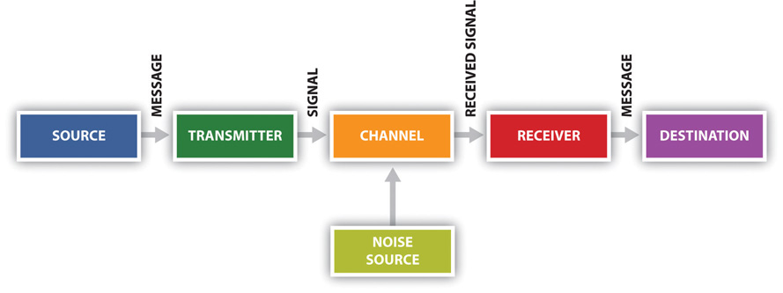
1 Shanon model

photolink

Schramm’s Model of Communication
Wilber Schramm ingrained from Shannon and Weaver Model of communication he was inspired to reinvent Schramm’s communication model in1949, where he admitted having effective conversation the people needed exchange of observation, because the relation between two person is not operating when other side does not express his opinion. Any conversation after transmitting the information don’t have expression from receiver the relationship is inefficient, that involve fail in their mission. Schramm’s also noticed that personal skills, emotional facts, and cultural environment play significant part in the human behaviour.
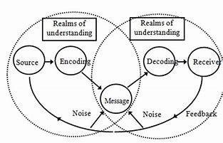
2 Schramm's model

I will explain my first job interview before 10years, which is unforgettable for me, the senders were restaurant’s manager and ask me question: What are my expectations from this work? My understanding to show my ability to work that was I present myself that I’m friendly person creates good relationship in the team, to work more productively. The sender understanding is different than receiver opinion for effective work, the manager gives feedback that receiver answer doesn’t show enough maturity. The sender feedback shows the diverse of understandings and knowledge between experienced manager and beginner waitress which involve unsuccessful interview, but effective communication, where the receiver understood for sender expectations.
Also, Schramm’s communication model shows the mistake between Pedro and Maria, because if receiver Pedro had thought about sender Maria call seems strange, why she would call and say she’s waiting him in the kitchen. The call back after work would have prevent Pedro’s mistake.

Berlo’s Model of Communication
(Bhasin, 2021) David Berlo established communication model in 1960, where he features importance that emotional specifications of participant determine the conversation. The sender if did not have good talking and expression skills thus affected the communication process, also if receiver did not have good listening, writing, or reading could be confused. Another fact that affects effective contacts is the behaviour of the participants, if source shows positive frame of mind will build agreeable start of conversation, but if he creates to the receiver gloomy mindset that will be involve undesirable consequences. Both sender and receiver will have a different reaction to the message depending on their knowledge of the topic, but if either has little or no knowledge about the topic, the message may not be effectively conveyed and may contain errors. Also, in delivering a speech, the speaker must consider the cultural background of the community or listeners. The transmitting information is going in text, video, and other media can be used to send information from one point to another. According Berlo it is possible the message-related or affected by: Structure: messages that lack structure are not only difficult to understand but can also be misinterpreted. Treatment elements means the most accurate way to convey a message is to know how to present it to presents our opinions. Code fact is including audio, text, sound, using incorrect code in communication can interruption the message. The channel can be diverse in depends on the case: smelling, touching, hearing, tasting. Finally, the messages are decoded and assimilated by the receiver, as such there is effective communication the sender and receiver should have similar understanding and thinking.
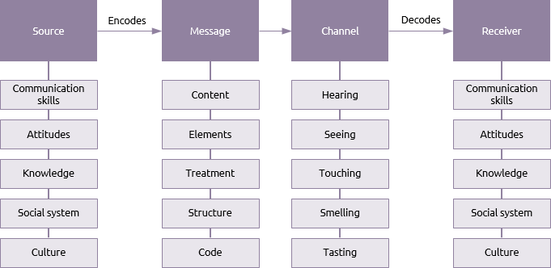
This Photo by Unknown Author is licensed under CC BY-SA
3 Berlo model
According Berlo’s methodology we discussed the case with Professor case: highly educated professor lives in the village where he doesn’t know his neighbours. On the night when a fire broke out in professor’s home, he wants help from villains, but he is screaming and expressed in a style incomprehensible to them, and therefore no anyone paid attention to help him. The source is professor with different culture and social ability, the message is content element, which is incomprehensible, the channel is hearing, the receiver is villains with different culture and basic language skills. The advice in this case that the Professor could talk more clearly and understandable with other people.
According Berlo I appreciate my experience with photographer from my work at patisserie (2014) where I was source and I choose this photographer for shooting menu photos and social media advertising. I believe he is the best, because I was inspired from his work seen on the website. My opinion when we discussed the project with him that I want fabulous stand-out photo not only portrait with the item, that he will understand what I mean. The channel is hearing system where the receiver decodes this message incomplete, because his answer was: “Of course”, but he was Greek speaker and was just learn the Bulgarian language, so he didn’t understand what I mean stand-out and fabulous, he thought I want high quality. To prevent situations, I had should explain my mind more widely and shows some ideas, but my excitement prevented me from thinking straight. The receiver needs to improve his conversation and language skills to try understood more deeply client’s opinion. My and the photographer thinking about favourable pictures turn out dissimilar, due to language barriers.

3. Communication skills
From professional life to social gatherings, developing communication skills will be beneficial in all areas of life. We use our correspondence ability in every aspect in our life, where with the importance of good communication and understanding takes us efficiently present ourselves and give a big chance to rich the purposes. Keeping them in mind guides us excellent body language, express ourselves clearly, demonstrate diverse verbal skills, listen well, convey our thoughts appropriately, and write clearly and briefly. A career's growth can be optimized by improving communication skills.
Communicating verbally involves exchanging information, emotions, and ideas through speech and writing. It is important what words we use when talking with a friend to describe our minds. In an interview or job application, using non-official language could indicate a lack of ability to show our skills.
As opposed to verbal communication, non-verbal communication involves exchanging messages without speaking. Face expression, gestures, tone of voice, eye contact show our body language and finalize our presence in the communication.
Listening skills also demonstrate our communication ability with our attitude when other side talking with interested attending in conversation is important part of efficient conversation.
It is very important to pay attention and don’t show distracting across talking, be attentive and try to understand the speaker’s idea, then give our feedback. Also seeing issues through the speaker's eyes is crucial.
I appreciate my communicative skills at my last work in call centre in Bulgaria where I worked like seller and at the beginning, I didn’t like this work, but I must work and began to work there even I thought the job doing unnecessary things. Therefore, my speaking sounded negatively and without success, when I change my opinion and I started to sound more positive with properly set of words listening to people thoroughly and showing understanding, put my selves in their shoes and thus improve my ability and help me be more productive.

4.Advantage and disadvantage of technology in communication.
Nowadays the technological communication is useful in every aspect in our lives, for work, education, and personal purposes. The technologies involve the transmission of information flexible and easier between people, however it has downsides. We use technological communication in the workplace via Email, Voice mail, Online conversation by platforms etc.
The advantage of technology in the workplace:
- Quickness of information exchange, the information can be sent more efficiently within and outside the organization using communication tools. Additionally, via database system the organization can organise easier sharing information between different departments.
- Facilitate the communication and speeds decision, the instant of exchange of information facilitates the work of the team as the information arrives quickly, without intermediaries and wasting time. Via mail system or shared information platform low-level employee can touch the manager, franchise organisation or associated organization like hospital and pharmacy the necessity information can flows freely. Furthermore, it saves time and speeds up decision-making.
- Everything is arranged and saves space. The companies can retain lots of information for years and the worker with one click to discover the necessary facts and with data base system to shares such as like banking system, NHS, teaching system, Government etc.
- Organisation an inquiry. The company can ask it customers for their opinion through established forums, social media, or review platforms to improve the organization and customer demand.
- Encourage people: sometimes for some people face-face conversation can be a worrisome, sending message or voicemail could be encourage them to express their concerns.
Disadvantage of technology in communication:
- Poor socialization: the digital devices communication is far from real, there is a no eye contact between workers, thus drives people apart and minimizes and understanding of sincerity and establish cohesion. Additionally, for someone to overcome their shyness.
- Hardship of technology skills: if company is established new system, they should have to ensures training and it can create stress for people who have a hard time accepting new skills.
- Costing a lot of money: the establishing digital environment it could be expensive specially for new organization, mostly additional service needs to be purchased to maintain the system safety and renewed.
- Unsafety: with all the information centralized under one database, it is accessible to people with malicious intentions within the organization. A hacker or a virus can also attack information, resulting in all data being lost instantly. Keeping this information secure costs, the organization extra money.

5.Conclusion
Effective communication everywhere is important trait to rich efficiently result, understanding transmission information or finalize work. The model of communication describes that the communication is effective only when has feedback between conversation team, otherwise is possible to discover misunderstanding, which will be involve failure. As a big role plays the experience, catch different understandings, cultural backgrounds, talking same language, have ability to be good listeners and shows empathy, where the participants wield good nonverbal ability of communication would be prerequisite for efficiently transmission of information.

7.References

Bhasin, H. (2021) Schramm Communication Model. Available at: https://www.marketing91.com/schramms-model-of-communication/ (Accessed 26.07.2022)

Bhasin, H. (2021) Berlos Model of Communication Explained. Available at: https://www.marketing91.com/berlos-model-of-communication/ (Accessed 29.07.2022)

Kobiruzzaman, M. (2016) Shannon and Weaver Model of Communication Explanation & Examples. Available at: https://newsmoor.com/shannon-and-weaver-model-of-communication-explanation-examples/#:~:text=Shannon%20and%20Weaver%20Model%20of%20Communication%201%20Information,Receiver.%20...%205%20Destination.%20...%206%20Noise.%20 (Accessed 23.07.2022)

Masterclass staff (2022) Verbal vs. Nonverbal Communication Explained. Available at: https://www.masterclass.com/articles/verbal-vs-nonverbal-communication#verbal-vs-nonverbal-communication-whats-the-difference (Accessed on 16.08.22)

Ramey, K. (2022) Advantages and disadvantages of communication technology in an organization. Available at: https://useoftechnology.com/advantages-disadvantages-communication-technology-organization/#respond (Accessed 24 August 2022)
Schilling, D. (2012) 10 Steps to Effective Listening. Available at: https://www.forbes.com/sites/womensmedia/2012/11/09/10-steps-to-effective-listening/?sh=23a14b243891 (Accessed on 03.08.22)

