Name : Mehnaz Akhtar
Student ID number: 1813781
Module : Professional Career Development
Module code :BMSW 4005
Lecturers name ; Abdi Rahman

Content page
Introduction………………………………………………………………………………………..…..3
Part A
Introduction……………………………………………………………………………………………3
Skills and knowledge needed for working effectively……………………………………………..3
Time management in a Workplace ………………………………………………………………...4
Self- awareness Tests………………………………………………………………………….…….4
Swot anaylsis…………………………………………………………………………………….……4
Belbin Test 123……………………………………………………………………………………….6
Johari window…………………………………………………………………………………………7
Personal Development Plan (PDP) ………………………………………………………………..8
Conclusion…………………………………………………………………………………………….9
Part B
Introduction…………………………………………………………………………………………...9
Importance of a job advert………………………………………………………………………….10
Recruitment and selection process………………………………………………………………..10
Importance of a CV and Cover letter………………………………………………………..…….11
My preparatory steps before interviews on performance……………………………………….11
Personal development plan………………………………………………………………………..13
Conclusion…………………………………………………………………………………………...15
Reference…………………………………………………………………………………………….16
Apendix 1……………………………………………………………………………………………19
Apendix 2……………………………………………………………………………………………20
Apendix 3……………………………………………………………………………………………21
Apendix 4……………………………………………………………………………………………23

Introduction
In this report i will be assesing my personal experience of the self awareness test. These self awareness tests will give me an insight of my strengths and weaknesses. SWOT, Belbin test123 and Johari are self awareness tests that will support me in having a better undertanding and make future decisions of how I can developmyself further. This reort will then explain the recruitment process I went through and what I have planned to achieve for future career goals.
Part A
Introduction
In this discursive report I will look into the importance of skills and knowledge needed to work effectively. It will include the difference between skills and knowledge and how both are needed to be successful in your job. I will also look at time management and the importance of it in a work place as well as the advantage and disadvantages of it. This report will also include how time management can effect ones work if it is not used effectively. In this report I will also use SWOT, Belbin test 123 and Johari tools to assess myself self. This will help me understand and gain an insight of myself through these tests. By doing this I can develop personal development plan (PDP) for my future career goals.
Skills and knowledge needed for working effectively
It is important to understand the skills and knowledge needed for working effectively. Firstly, it is important to understand the difference between skiils and knowledge. Skills are developed through pratical activities and experiences during life, if that is at home, school social activities or in a workplace. Skills help us to perform effectively in our lives if that is as a student or in employment (Cottrell, 2015). There is a whole range of skills that we learn without even realising that we are. Communication, decision making, time managemnet, leadership,self motivation and ability to work under pressure are just a few skills that are needed in a work place. We might be good at some of these skills and some these skills may need to be further developed through recognising and setting tasks and goals to become a better skilled individual. Knowledge on the other hand is a theorectical understanding in a area or subject (Career Onestop work ReEmployment,2020) It is firstly important to have the knowledge in the area you are working in as this gives you the confidence to gain better results and succeed. Knowledge is education and this is needed to build and gain confidence in youself. By gaining knowledge about your workplace is the first step on the ladder. Knowing the history and future goals shows you have educated yourself and have the requiered knowledge to drive the business further. Without the right knowledge and skills you can not work effectively and succeed. Both are as important as each other without the knowledge the skills are pointless and vice versa. For exampla, to know or have the instructions to bake a cake without having skills in baking is pointless. Both are needed the knowledge and the skills to bake a perfect cake is important.
Time management in a Workplace
One important skill that is needed to working effectively is time management. This skill is developed over the years by planning your time according to what is most important that nedds to be done. During the years of studing at school college and university you are always planning ahead example a school diary. Where you wrote all your homework and when it needed to be handed in by and how long it will take to get it done. In a workplace time management is very crucial meeting deadlines is what makes or breaks your success. Benefits of time management shows your productivity. It shows better quality of work as your focused on the task well, this represents one as a hardworking and organised individual. Making better decisions helps to reduces stress and anxiety and become a more happier person. This just not help you in your work life but also in you personal life (Andrews, 2014).Poor time management in a workplace shows lack of professionalism by missing deadlines which causes stress and anxiety. It also can result in your collegues losing trust in you and the main problem is it can cause a loss in the company (Kashyap,2016). According to Andrews (2016) says ‘ The better you manage your time the more productive you are’.
Self- awareness Tests
For me to further develop myself I need to recognise my skills and knowledge I have by recognising my strengths and weaknesses. I can do this by using self-awarness tools such as a a SWOT, Johari and belbin test 123. Results from these tools will make me aware of where I need to make changes and develop my self further. Self awarness is way to self-tracking your personal self in different ways by monotoring and recording personal data (Li and Hopfgartner, 2016). By this I can understand myself better and set goals to make changes that can help me in future career aspiration and make me stand out far more better where I am right now. According to Hartman (2001), one person should understand and learn factors of themselves that can affect their performances in a positive or negative way. Understanding and learning about youself gives you the knowledge to plan forward in a better way.
Swot anaylsis
First I will conduct a SWOT anaylsis. This will first let me look at different areas of myself, my strengths, weakness, opportunities and threats. SWOT is well used tool that can be used in every area of your life . It is a framework developed by Albert Humphrey in the 1960’s. According to Sarsby (2016), SWOT is a framework that is used to bullet point information that are internal/external. Each box holds factors that can be controlled (internally) or can not be controlled (externally).
STRENGTHS  - I have excellent communication skills  - I do my work to the best of my abilities. I don’t cut corners  - I enjoy working with other people which makes it easier for me to work  - I am already working as a baker so have gained many skills which gives me confidence to apply for a higher position.  - I have been selected as a leader in university as a rep and as a group project leader.I have successsfully completed my roles with great achievement  - I am confident person | WEAKNESS  - I overwork myself and get stressed very easily  - I need to develop on my IT skills, which sometimes makes me rely on others  - I leave work to the last minute. I need to plan more better and develop better time management skills  - Ive always struggled with public speaking especially in a new environment or new people, which results in me not delivering my presentation or speech as best as I planned
OPPORTUNITIES  - I have the opportunity to further educate myself on a level 5 course which will help me overcome and work on some of my weaknesses  - My university have very good IT technician who can help me increase my IT skills  - Future online business opportunities are available  - The demand of skilled bakers has increased | THREATS  - Not fitting in because of my culture or religion  - Worry of falling in behind in work or study
Looking at my Swot anaylsis I can see ways that I can change my weaknesses into my strengths. As I am weak in my IT skills I can see opportunity to develop in this area by the support of my university. Also as there is opportunities to work online and progress in the furture as a baker I need to develop this skill further to make it a strength for me. I also need to find ways to manage my time better because as a baker time mangemnet is crucial to meet dealines on time. I need to start working on this skill and find ways so I don’t fall behind as this can really become a major issue for me. I need to set tasks for myself on a regular basis even if that’s at home and make sure I meet them. According to Nofsinger (2019), to be succesful time manager you need to set tasks according to their importance. By writing the tasks in this way you know what needs to be done and what can be left for later. Nofsinger (2019), also says that it is importenat to delegate tasks on other people who can help so you don’t feel so overwelmed with so many tasks. I believe that is my main problem I don’t delegate tasks on others because I think they wont get done to my expetation which results me falling behind or over working and getting stressed out.
Belbin Test 123
This method was developed by Meredith Belbin to measure peoples behavior in teams and best roles that suit them. It is a widely used test. The test is in two parts. First part has 30 questions each question giving you two words and you choose which word best suits you. After answering all the questions it gives you a report showing the results of what roles are best suited to you according to your results. Belbin purpose was so that teams have better communication and understanding between them as the teams were built according to their behavior (Bullen and Wood, 2016)
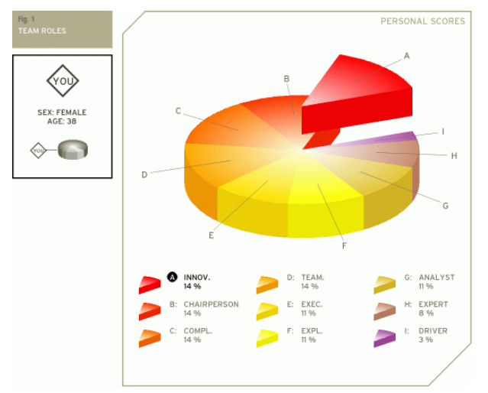

My results show that I am Innovator, a person with strong imagination and desires to be original (Broom, 2016). I believe this right about me but I do plan many things but fall back because of lack skills in other areas. The results also show I am a Chairperson, Completer and a Team player. This sounds very like me and have experienced it in many times being selected as team leaders and also when I was a team player the team leader changed position with me. I definitely feel that I take 100% responsibility of the team achievement. Which puts a lot of pressure on me. I disagree with me being 3% driver. I motivate my team members very much and set tasks to push them to their ability so they can recognise their ability.

Johari window
Johari window is a feedback of self-awareness on one self. The purpose of this tool is for you and others to recognise characteristics about you. This gives you a picture of what is visible to you and others (Open Area), just to you (Hidden) and just to others (Blind Area). The Open area and the Blind area are the most important. Once you know what your Blind area is it gives you an opportunity to work on those areas further. Opinions of others make us realise what we think about ourselves and gives us a chance to understand who we are. We should increase our Open area and reduce our Blind area for better self-awareness (Luft and Ingham, 1961).

OPEN AREA  - Mature  - Helpful  - Independent  - Friendly  - Trustworthy  - Calm  - Logical  - Sensible  - Team player | BLIND AREA  - Headstrong  - Team leader  - Good decision maker  - Smarter than you think  - Wise  - Hardworking
HIDDEN  - Nervous  - Emotional | UNKNOWN

Looking at my Johari results I was surprised to see that my peers said I was ‘Headstrong’, ‘Good decision maker’ and have ‘Leadership skills’. This shows that I sometimes underestimate myself and my capability. According to Karges (2010), we underestimate ourselves because of the lack of confidence we have in ourselves. We are scared of taking risks and the consequences it can hold. Taking risks is the only way we to explore ourselves and our capabilities. Karges says ‘not taking risks causes you to become stagnant’. I need to push myself in these roles and become more confident in it. These skills will make be a lot of a stronger person. These are kind of skills employees look for in their employers.

Personal Development Plan (PDP)
The self-awareness test has shown me places that I can work on to make myself a more confident person. By developing a PDP I can plan ahead to improve on my weaknesses.
Development Need | Action | Target Date
Time Management- I am always struggling with making time to complete tasks at home/uni/work.im regularly falling behind and then rushing to get things done. Because I want things done to the best of my ability I stress a lot which results in other tasks being ignored | - I need to keep a diary and set daily tasks that need to be completed according to their importance. This will help me be less stressed.  - Be organised  - Make sure all tasks are done at the end of the day  - Set reasonable tasks that I can complete | Ongoing through 2020
IT skills- I need to develop new skills required for me to be successful. Learn to use IT as a tool to make myself stand. | - Practise skills that I have learnt  - Research in my own time further  - Networking  - Take IT course | Ongoing through 2020-2021
Public Speaking- I want to further develop this skill and make it a strong point for myself. | - Enrol on a course  - Attend regular Rep meetings  - Class presentations | ongoing 2020-2021

Conclusion
By recognising my strengths and weaknesses I have a more clear understanding of myself. I know what areas I need to work on and what I can use as my strengths to deliver myself in a better way. Swot, Belbin123 test and Johari have opened my eyes on myself and made me develop a PDP to help me enhance myself and increase my knowledge and skills which will help me in the future.
Part B
Introduction
This part of the report will be looking at the important of a job advert as well as the importance of a CV and cover letter. Further to this it will talk about the process of recruitment an employee goes through. My personal experience of a mock interview will also be discussed and what I have learned from the process and what future plans I have through a PDP table.
Importance of a job advert
A job advert is a printed or electronic informing potential candidates of an available position in a company. The company put this advert to the public so they can reach out to as many candidates as possible who would be interested in the role. A job advert is the first thing that attracts a candidate searching for a job. It is written in manner that it is clear and precise. The advert contains a ‘job description’, ‘job role’ and ‘skills required’ and any other offers that a company has to offer. Each part is written in detail as companies have to spend a lot of time going through CV’s and resumes. Which can be very time consuming. The purpose of a job advert is that they are very clear of their requirement and attract the right person for the job. The information in the advert gives the potential employee of what is expected of them in the job. What skills and experience the company is looking for. Also what opportunities are available if they get the job.
Recruitment and selection process
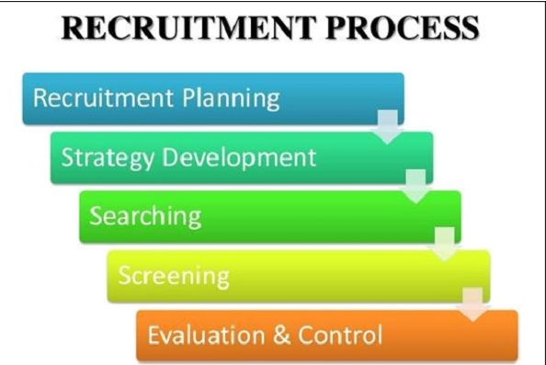

(TutorialsPoint, 2020)
Recruitment is a process to get the best candidate in the best possible way. Different companies use different methods, but the process are very similar. The HR of the company plan the recruitment process.
Steps of recruitment
- Recruitment planning- identifying the job that is available and the skills, abilities and responsibilities needed for the role.
- Strategy development- this is where the board is step up and analysing the HR strategy.
- Searching – this when the search begins. HR have two options either to recruit internally or externally
- Shortlisting-during the shortlisting the HR review all resumes and cover letters
- Evaluation and Control- this is the final step. The HR review the process from start to end. Taking in consideration the cost and time it took to recruit and fill the vacancy
It is important for an employer that this process runs smoothly and effectively. This is because it is a costly and time consuming process. From advertising, to going through CV’s and resumes, interviewing candidates and then running reference checks on candidates. It all takes time and if a wrong candidate who is not fit for the job can cost further time and money to put in right place by further training the candidate would need. This action could have been avoided in the first place if the right candidate was selected in the first place. According to Maud, Schrek and Tinkler ( 2017), when employers are looking to hire someone they look at the skills that they can offer and what they can bring for their company. This is called a ‘skill gap’.
Importance of a CV and Cover letter
A cover letter is the front page to your application. It is a personal letter to the company replying to their job vacancy. It has all the necessary skills and abilities that the employees are looking for in their candidate. Your cover letter should win the reader over by meeting all their requirements regarding the job you are applying for. If you have any supporting history then that will also look good on your cover letter. Your CV has all your skills and abilities that you have developed and worked on. It also has your qualifications and previous employments. This is a supporting document which shows your lifetime achievements. The CV shows your skills and knowledge you have overall (Morgan, 2017).
The first impression of the candidate the employer gets is the cover letter and the CV. This is very important to the employer as they are interested in candidates that are self-managing and versatile (Fry,2018). This can be presented through ones CV.
My preparatory steps before interviews on performance
For my mock interview the first step was to find a job that I wanted to apply for. As this was the first time I was looking for a job I didn’t know where to look. But I knew I was going to look for a baker’s position because I am currently a baker working from home so I have the skills and experience in this field. My first place was to search online. Within half an hour I found an advert at a bakery that was close to home. This would have worked well for me as a mother of four it would be convenient to work around my children’s times and avoid traffic and long travelling. After reading the job description (see appendix 1) I knew I had the skills for this job.
So my first thing was to write a CV (see appendix 3). I haven’t written a proper CV in years. The last CV I wrote was in secondary school which was over 15 years ago. So I went online and searched how to write a CV and what should be included in it and what the layout should look like. I looked at many images to get an idea. I wrote a draft CV on paper of how I wanted my CV to look like. I thought I had concurred the hard step and all I have to do is type it up. But reality was that I wasn’t as simple. The way I wanted to lay my CV out wasn’t as simple and didn’t have the skills to create one like that. After further searching I used a template on Word and planned my CV according to it making changes to my original draft plan. It took me a few hours to complete my CV. After this I had to write a cover letter (see appendix 2). After seeing some online cover letters I wrote mine. Which I didn’t find difficult. I made sure I included the skills the bakery was looking for and backing it with my experience in the field. I felt relieved.
Then came the preparation for the interview. This was the most difficult and nerve wrecking part for me. I spent hours searching for what kind of questions are asked at interviews. I searched on many sites like prospects.ac.uk, themuse.com and indeed.com and many other sites. They gave me examples of questions and answers that are asked in interviews. Some of the questions that were:
- What is your strength?
- What is your weakness?
- Tell me a little about yourself
- Why should we hire you for?
These are some the example questions I started preparing for. I approximately spent 3-4 hours researching interview questions the night before the interview. I practised saying my answers with my children. I wanted to keep my answers short and to the point because I know I can get carried away and start talking all over the place. I made notes of questions and answers on paper so I can go over them in the morning. I was very nervous and in doubt that I haven’t all questions. Hoping the interviewers do not ask a question that I have not covered. That was stressing me.
On the morning of the interview I woke up early and sorted my clothes out and made sure I was ready and left home early so I can be at campus early. As I had not printed my CV and cover letter off I needed to make sure I had enough time to print them and set them in my folder. I also planned to take in with me my portfolio of my work of cakes. I had made a folder which I had to print off. When printing them at university they came black and white and not clear. I found out that the campus did not provide coloured prints. This was a let-down as I did not know and it was too late to go elsewhere to print my portfolio. My mistake for printing my work last minute.
After my interview I was very disappointed in myself. I felt I didn’t answer the question well and was talking all over the place. At one moment during I was giving the interviewers an answer my mind went blank to what the question was. I just did my best and answered what I thought best.
I was shocked and surprised of the results of my mock interview. I couldn’t believe what I saw. I was so worried about the results that I planned of not sharing my results with anyone as it will be an embarrassment. Result was ‘YOURE HIRED’. I got 96% (see appendix 4), the highest in the class. I was relieved and over excited. My first interview and I was hired.
The interview and planning was a very good experience for me. I learnt many new things during the process. My experience showed me that I under estimate myself and I should not always look at the negative things but sometimes be proud of the positive things that I was pleased with.
Personal development plan
To continue with my future career plans I plan to strengthen myself and develop further to continue being successful. My PDP shows my plans for the near future after reviewing my mock interview results.
SPECIFIC | MEASUREABLE | ACHIEVABLE | RELEVANT | TIME
Research company needs to have more knowledge about the company | I will research about the company in online and also make a visit before the interview and get an idea of how the company looks and maybe talk to a staff member if possible. | I think this will be the best way and is achievable | This will help me before the interview and during the interview to stay relax because I know I have researched well on the company and have the knowledge. | Before all interviews
Research on interview questions and answers. This will prepare me well before any interview I have | I will search online for possible questions and answers. Practise them with friends and family. | This is achievable | This will give me the confidence and reduce stress before interviews. I will have covered all questions possible and related them to myself and the job role | Start planning as soon as I want to apply for an interview
Time Management-I need to plan things on time so I’m not worried on the day of the interview. | I need make all preparation way beforehand. If that is researching on the company, printing portfolios or any other documents that I need on the day. Also my clothes for the day should ne ironed and set the day before. I need to reduce any unnecessary stress that can occur on the day of the interview | Its achievable if I plan ahead | This help me reduce stress. Be well organised. Make time for breakfast/tea/lunch. | This will be ongoing
IT Skills- I need to develop this skill further so I have confident to write in any format I please. As most jobs need employers to be IT skilled. | Take IT courses- Word, Excel, Microsoft PowerPoint are some courses that I need to do. | Its achievable. South & City run many courses | This will give me confidence to carry on with my level 5 in business and support me in future career | 2020

Understanding the importance of a job advert, cover letter and CV shows me how I can build and sell myself in the role I want. Using the right techniques and following the adverts requirement can see me as a potential candidate that the employers are looking for. My experience in my mock interview taught me many things about myself and how I can build on them further. The PDP is my first step in building myself and getting on to the first stepping stone.
Conclusion
I have learnt through the self-awareness test and the mock interview process that it is important to re-evaluate yourself. To think about the importance of the skills and knowledge you have and what changes can be made to develop yourself for your future goals. This can be done by having an objective mind. Listening to yourself and what other people think about you. Looking at the challenges that are out there that can stop you from achieving your goals. The lessons learnt from these tests and interview process I have developed a PDP and set myself targets that I will work on in the near future. I need to update my PDP every six months to a year. This will help me progress further and become a successful and confident person.

Reference
A.Andrews.,2016. Why is time management important at work? The Activia Training Blog. Activia Training. Available at: https://www.activia.co.uk/blog/why-is-time-management-important-at-work (accessed on 27th January 2020)
Broome, M.E., 2016. The innovator. Nursing outlook, 64(1), pp.1-2. Available at: https://www.nursingoutlook.org/article/S0029-6554(15)00333-4/fulltext (Accessed on 27th January 2020)
Bullen, F. and Wood, D., 2006. The construction of undergraduate student engineering design teams using the MBTI and Belbin Test. In Proceedings of the 17th Annual Conference of the Australasian Association for Engineering Education: Creativity, Challenge, Change; Partnerships in Engineering Education (p. 111). Australasian Association for Engineering Education. Available at : https://eprints.usq.edu.au/8132/2/Bullen_Wood_AAEE_2006_PV.pdf (accessed on 27th January 2020)
Career Onestop work ReEmployment., 2020.Knowledge, Skills and abilities. State of Minnesota. Available at: https://www.careeronestop.org/WorkerReEmployment/JobSearch/ReflectAnalyzeAndExplore/knowledge-skills-and-abilities.aspx.(Accessed on 23rd January 2020)
Cottrell, S., 2015. Skills for success: Personal development and employability. Macmillan International Higher Education. Available at: https://books.google.co.uk/books?hl=en&lr=&id=1J67BgAAQBAJ&oi=fnd&pg=PP1&dq=skills+for+success+by+S+Cottrell&ots=4sDQYZ8kWi&sig=VC6_xZnMD7QbhM-xGpZXTwHxttc&redir_esc=y#v=onepage&q=skills%20for%20success%20by%20S%20Cottrell&f=false(Accessed on 23rd January 2020)
Fry, R., 2018. 101 great answers to the toughest interview questions. Open Road Media. Available at: https://s3.amazonaws.com/academia.edu.documents/35819723/101_great_answers_to_the_toughest_interview_questions.pdf?response-content-disposition=inline%3B%20filename%3D01_Great_Answers_to_the_Toughest_Intervi.pdf&X-Amz-Algorithm=AWS4-HMAC-SHA256&X-Amz-Credential=AKIAIWOWYYGZ2Y53UL3A%2F20200130%2Fus-east-1%2Fs3%2Faws4_request&X-Amz-Date=20200130T182126Z&X-Amz-Expires=3600&X-Amz-SignedHeaders=host&X-Amz-Signature=32394026a63b12d2a4d20bb9a1bb647ccde1fdc7d6d65e827a33a095a21bf122 (Accessed on 28th January 2020)
Hartman, H.J., 2001. Developing students’ metacognitive knowledge and skills. In Metacognition in learning and instruction (pp. 22). Springer, Dordrecht. Available at: https://link.springer.com/chapter/10.1007/978-94-017-2243-8_3 (Accessed on 23rd January 2020)
Karges, C., 2010. Ignite Your Intuition: Improve Your Memory, Make Better Decisions, Be More Creative and Achieve Your Full Potential. Simon and Schuster. Available at:https://books.google.co.uk/books?hl=en&lr=&id=ki6bDwAAQBAJ&oi=fnd&pg=PT5&dq=ignite+you+intuition.+improve+your+memory&ots=gR-6NnAJrz&sig=4DOpgisC3tunmVeDTISMKul1Xcs&redir_esc=y#v=onepage&q=ignite%20you%20intuition.%20improve%20your%20memory&f=false (accessed on 27th January 2020)
Kashyap,S., 2019. Importance of Time Management in the Workplace. ProofHub. Available at:https://www.proofhub.com/articles/importance-of-time-management-in-the-workplace (Accessed on 27th January 2020)
Li, N. and Hopfgartner, F., 2016. To log or not to log? SWOT analysis of self-tracking. In Lifelogging (pp. 305-325). Springer VS, Wiesbaden. Available on: http://doras.dcu.ie/21304/1/eRed2_Li-Hopfgartner.pdf. (Accessed on 23rd January 2020)
Luft, J. and Ingham, H., 1961. The johari window. Human relations training news, 5(1), pp.6-7. Available at:http://www.richerexperiences.com/wp-content/uploads/2014/02/Johari-Window.pdf (Accessed on 28th January 2020)
Maund,A.,Schriek,M and Tinkler,P.K..,2017. Certificate in Higher Education; Skills for the Workplace Student Yearbook. Sage, London.
Morgan, P.2017. The Business Students Guide to Study and Employability. London: Sage
Nofsinger, M.M., 2019. Time management skills: A checklist. College & research libraries news, 57(10), pp.648-651. Available at: https://crln.acrl.org/index.php/crlnews/article/view/23370/30579 (Accessed on 23rd January 2020
Sarsby, A., 2016. SWOT analysis. Lulu. com. Available at: https://books.google.co.uk/books?hl=en&lr=&id=Yrp3DQAAQBAJ&oi=fnd&pg=PA1&dq=+swot+on+yourself&ots=OCraZyz20C&sig=WtGgeBO8mN5YvGrrmpJNvqGBst4&redir_esc=y#v=onepage&q=swot%20on%20yourself&f=false (Accessed on 23rd January 2020)
Tutorials Process., 2020. Recruitment process. Tutorials Process. Available at: https://www.tutorialspoint.com/recruitment_and_selection/recruitment_process.htm (Accessed on 28th January 2020)

Appendix 1
Job Advert
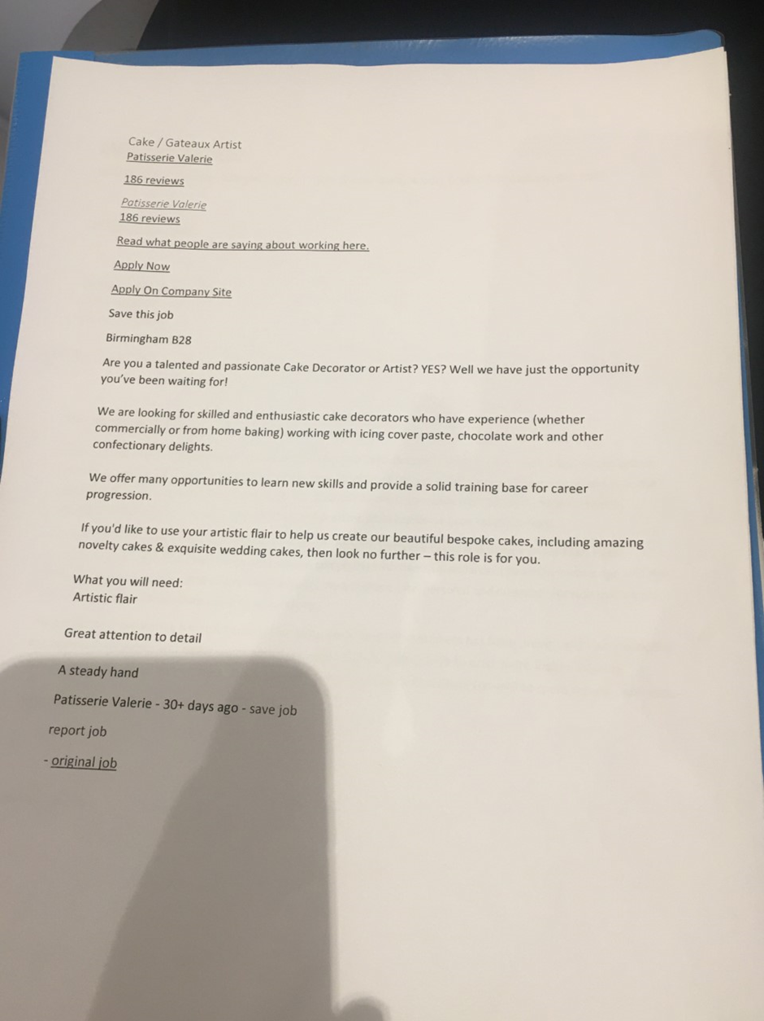

Appendix 2
Cover Letter

Mehnaz Akhtar
07743169207 | (Mehnaz.isa@gmsil.com) | [421 Shirley Road, Acocks Green, Birmingham, B27 7NX]
11th December 2019
Mr Abdi & Mr Olu
Store Managers
Patisserie Valerie
146-156 Sarehole road
Birmingham B28
Dear Mr Abdi & Mr Olu
Upon reading of you search for an experience and creative Cake Decorator to join your team. I felt compelled to submit my resume for your consideration. I have over 10 years of baking experience creating unique and bespoke cakes and desserts. I am skilled in using different methods to decorate cakes from fondant, buttercream to chocolate. I am prepared to make a significant and positive contribution to your establishment.
My experience includes using creativity and my steady hand to decorate cakes and using various food items, accessories and tools. Ensuring I meet deadlines to complying with health standards. I have the knowledge and the artistic to meet customer satisfaction. Furthermore, my excellent interpersonal and customer service talents are sure to make me an immediate asset to your bakery.
My expertise in decorating beautiful and unique cakes for a range of customers has been proven and I am confident my additional strengths will easily translate in your environment. The chance to offer more insight into my qualifications would be appreciated. Thank you for your consideration and I look forward to speaking with you soon.
Your sincerely,
Mehnaz Akhtar

Appendix 3
CV
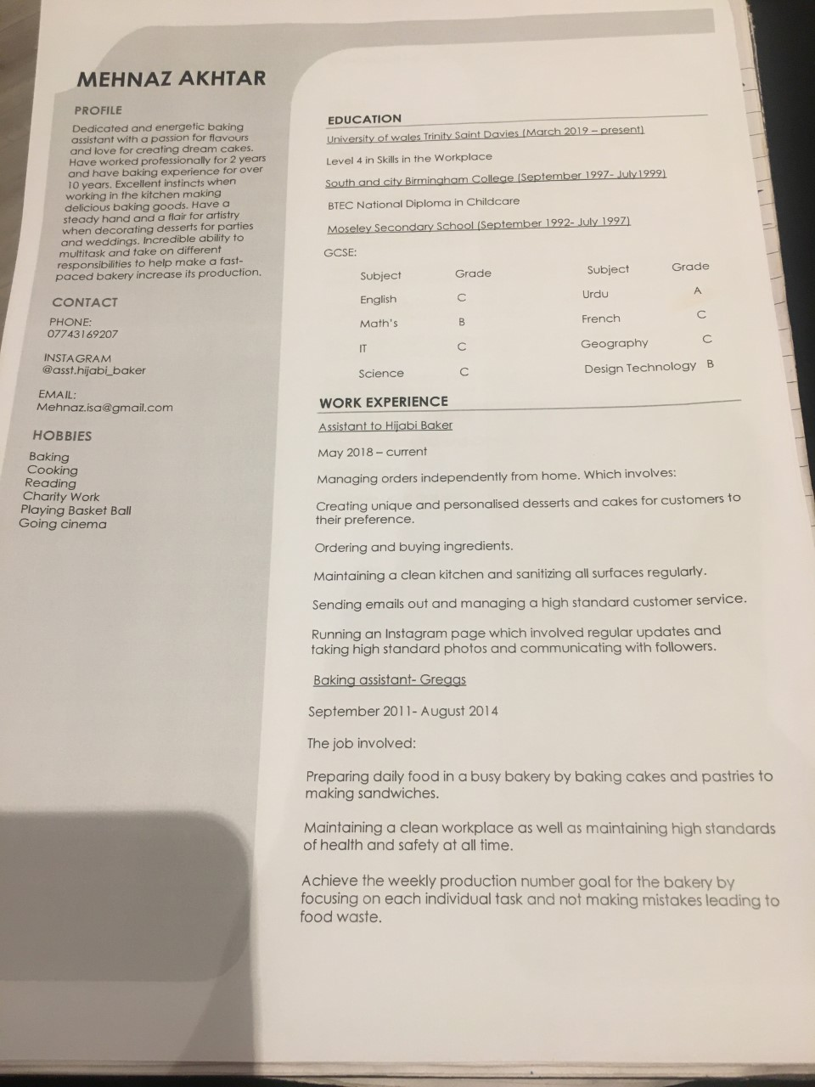

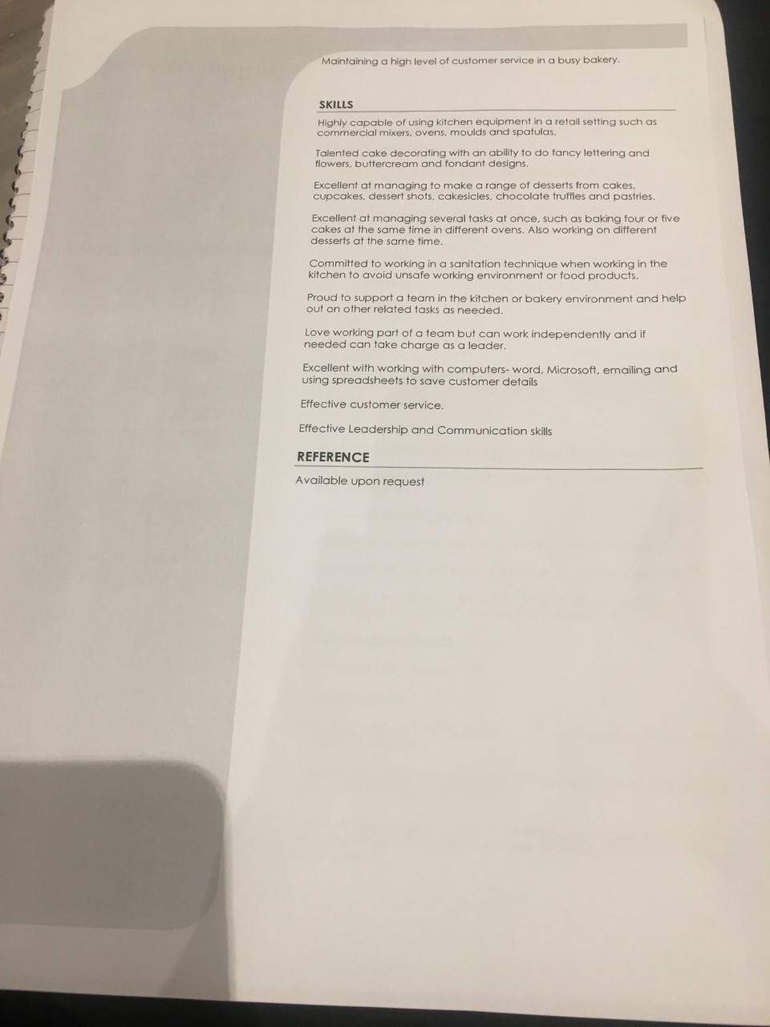
Appendix 4
Mock interview feedback.


