NURSEL ALAEKSANDROVA
1905701
TERM 3 GROUP 4
UNIVERSTITY OF WALES TRINITY SAINT DAVID
LECTUTURER AMARE DESTA
18/12/2020
PROBLEM SOLVING AND DECISION MAKING
BMSW4004

TABLE OF CONTENTS
Introduction…………………………………………………………………………………pg3
Problem……………………………………………………………………………….….pg3-5
Problem Solving…………………………………………………………………………pg6
Decision making………………………………………………………………………pg7-9
Hairdressing salon (my problem)………………………………………….pg10-13
References………………………………………………………..……………………pg14
Appendices…………………………………………………………………………pg15-23

INTRODUCTION
The purpose of this report is to identify and define a problem in the workplace and apply appropriate problem solving techniques and tools. Furthermore to purpose a relevant solution using a hairdressing salon as an example. This report will showcase points such as analysing information to help inform the decision-making process. Elevating range of alternative solutions to a problem is the main goal of this report. Moreover I will generate and use decision making techniques to evaluate a range of solutions to identify the most suitable option. Lastly this report will portray the appropriate monitoring and review techniques to ensure successful implementation of the solution.

Problem
What is a problem?
A problem (MORGAN, 2017)is an unpleasant or unsatisfactory state that needs to be changed to a pleasant and satisfactory as soon as possible. Also it can mean deviation from the standard that can make the objective hard to achieve. A problem can also mean the missing element of problem solving techniques

What is problem solving?
With the words of (Stottler, 2019) Problem solving is the meaning of identifying anything in the organization that is either going downhill or basically not going to plan. Diagnosing cause of the problem and finding different approaches and technique to make it better and make sure everything is going to plan. Moreover making decisions as to which path to take and which actions need to be considered. Then finally implementing the change and observing the impact of the actions on the environment.
The effectiveness of each step taken to solve a problem is determined by the skills and methods used while solving the problem and the level of complexity the problem is.
Problem solving is crucial for organizations as it enables us as human beings to exert over our environment.
There are two main Problem solving approaches:
Number one approach of solving a problem is to make sure you and your surroundings are aware that problems can become unmanageable if they are in large quantities. For example if one problem leads to another and it becomes too much to manage. Another approach to practise is not allowing problems to liger this means solving each problem as it occurs and not waiting for it to solve itself out. Always practise fairness in solving problems meaning criticise the decisions and answers of everyone that is involved in the decision making process and not just certain individuals.
Approach number two to solving a problem is trial and error method. Without trying the solution out there is no way to know if it’s effective or not and how effective it is.

Problem solving models:
There are types of Problem Solving techniques:
Fishbone diagram (Ishikawa diagram)
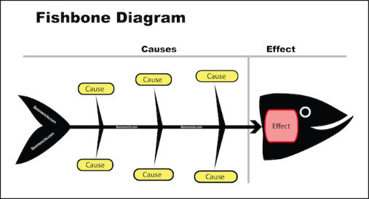 (Barone, 2015)
Mind mapping (Brainstorming)
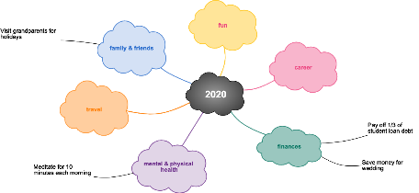 (Gratius, 2020)
Force-field analysis
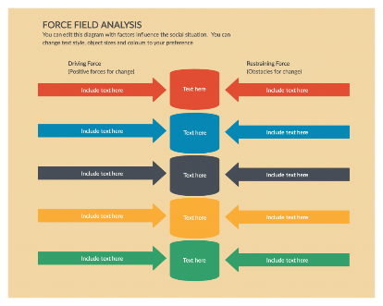 (Authraliya, 2020)
SWOT analysis
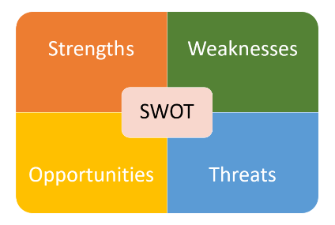 (AMIT, 2020)
Pestle diagram
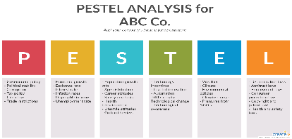 (Luis, 2017)
Decision Making?
Decision making is the process of identifying a problem. This can be any problem anywhere. The next is finding couples of solutions to solve the problem. Finally weighing the advantages and disadvantages of the problem solving methods making sure the one you choose will have the least negative impact or side effect as possible. Another point to consider would be making sure the solution is long lasting.
As (mugridge, 2020)mentions in his article when making a decision there are 5 key points that need to be considered. First one of these is the uncertainty of the method. Many facts and disadvantages of this solution may not be known. Second point of consideration can be complexity the solution may not be as simple and many interrelated factors may need to be considered before making the decision. High-risk consequences may also need to be considered as the chosen solution may have bad consequences on the problem or company as a whole. Considering alternatives is crucial when making a decision because there is always a better solution to a problem. Lastly interpersonal issues can be considered when coming to a conclusion and making a decision of a possible solution. This is because there should be a prediction of how different people will react.

TYPES OF DECISION

Routine decision: These decisions are made in the events that the problems are defined and common. This means that rules of solving a specific problem is already established. This decision making type is the easiest as advantages and disadvantages of the problem have already been analysed as it is a commonly occurring problem and the decision made of the solution usually works.
Adaptive decision: This decision making type is mused when the problem is not recognised and it hasn’t occurred before. This type of decision making is harder as the solution has to be considered in depth.
Innovative decision are usually made when the problems and solutions are unclear and more creative solutions are necessary

Porter’s Five Force Model
Porters five force analysis is a type of decision making model that is an attempt to analyse the level of competition in an industry and how the organisation can (WILLIAMS, 2002) develop to overcome that. Five force model describes that attractiveness is overall company profitability. An unattractive company or industry is one approaching competition therefore overall profit goes down.
As it suggests from the name given there are five component of the Porters Five force model. First stage is the threat of new entrants this can be newly opening businesses with the same business plan. Second component is Threat of substitutes this is copying the brand and giving it another name. Bargaining of buyers is the third component of this model. This is a great struggle on the manufacturing companies as there are many producing same products but only one buyer. Since a company needs raw suppliers to be able to grow their business and make profit, they will be looking for the cheapest raw materials. This enquires for good relationships between buyers and suppliers. However when the suppliers have the power in their hands they can sell the raw materials at higher prices. This component is called bargaining power of suppliers. Lastly Rivalry inside the industry is the final component of this model. The intensity of competitive rivalry determines the intensity of competitiveness.
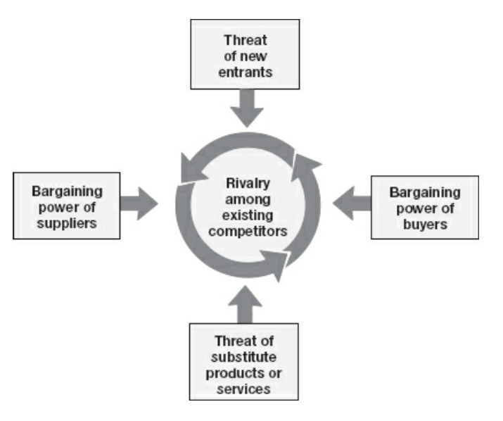 (Cheng, 2018)

Hairdressing Salon (America)
My main goal in life is to be able to open up my own hairdressing salon in America. I had this dream since I was a little kid. I have made my plan and started off with going to college to undertake a hairdressing course after the completion of my secondary school. I have undertaken hair and beauty courses for three years. Those course equipped me with the skills and knowledge of hair and hair styles. During my time in college I have also practised my hairdressing skills by going to work experience salons. I even had a job in a hairdressing salon as an assistant.
Following on from that I now have all the skills to be a hairdresser however I did not have any skills of running a business. Therefore I had planned to go to university and start off with a foundation course to learn skills for the workplace and then progress to business and finance courses. As it was coming to the end of the year I felt very confident in myself and I truly believed that I had gained skills and knowledge for the workplace.
I have also completed my bachelor’s degree in business which gave me all the necessary qualifications to be able to open up and run my business successfully. The fact that I gained so many qualifications skills and knowledge will allow me to continue making profit and hopefully open a chain of salons all across the world.
At present I have opened up my salon in America Los Angeles and I was doing all okay, making profit gaining new customers. However I noticed a downfall in my profits. Today I was walking from home to the salon on the residential street along the supermarket and other shops when I noticed there is a new hairdressing salon opened up few weeks ago.
This is a huge problem and risk to my business as all of my customers are going to the newly opened hairdressing salon. There are couple of ways which I can solve this problem and deal with my competitors.
Firstly I will create a swot analysis and consider my strengths. My main strength is that I have already built clientele. This means I have regular clients who wouldn’t go to anyone else as they are very happy with how I do their hair. My second strength is that my salon is well established meaning everyone in the area already knows I exist and they are more likely to come and get their hair done in my salon. My last strength would be my reasonable pricing. I do not charge anyone that visits my salon more than the minimum pricing. This makes my customers very happy as they are getting good service for good value of money.
On the other side I would need to consider my weaknesses. My biggest weakness would be that I am working alone and cannot have as many clients as my competition as they are a bigger salon and with couple of staff. Running my business alone means I only work with appointments to avoid taking on more work than I am capable of. This is a disadvantage for my business because any last minute clients would go to my competitors. Another weakness of my organisation is the accent barrier. Although I am learning how to communicate with my clients better my competitors are born and raised in USA so they have a better dialect. This can make clients prefer my competitors as they will/can cater their needs better.
On a positive note I will also consider my opportunities in this competitive state. As I have competitors this gives my organisation the opportunity for forming unexpected partnerships. This gives my business a chance to grow and develop by allowing us to create alliances, work together exchange tools and emerging hairstyles get ideas from each other and educate each other. Having competitors also gives me the opportunity to plan long term. This means I would not get lost in day-to-day exercise to maintain my business. I will start challenging myself to accomplish more and better myself and my hairdressing salon
However when resolving this problem I will consider the threats competitors will have on me. One of these threats can be new and better talented hairdressers. This will be a disaster for my organisation as all of my clients will want to try out my competitors if a word of mouth spreads. Moreover another threat would be Intellectual property my competitors can develop a superior intellectual property for example trading secrets and patents to outperform my organisation.

Another problem solving model I can use can be the FISHBONE DIAGRAM. I can put down my problem as my competitors and analyse further what has caused this. Continuing on from that I can get to the root problem of why someone has suddenly decided to open up a hairdressing salon next to my salon.

I will make my decision as to how I should deal with my competitors using the Porters Five force decision making component. This decision will be an adaptive decision as my organisation has never had to deal with such a problem. Using the Five force component I know that threat of new competitors entering has already occurred. Therefore I will need to make sure that my competitors do not copy or generate a substitute of the products I use in my salon. Therefore I will keep in close contact with my suppliers as if they are also supplying to my competitors they will mark up the prices of the products and tools used in the organisation. This will increase my chances of making profit. Lastly I will need to understand the rivalry of competition in order to determine the intensity of competitive activities.
In order to solve the problem of my competitors I will create advertisements. I will advertise my business more and let more people know about the products and services I use. There is also a chance of switching my products to more affordable one to make sure I can put my prices down. This will be a great competition because I will be able to extend my niche market and be afforded by everyone. However I will still make sure to keep my services above average to make clients happy. Customer services is crucial for competition. I will pay extra care and attention to my clients to make sure I understand their needs and can cater to them

I will review my action in couple of months and measure my capability of making profit. If I my profit has been increasing in the process of competition than my business is doing great.

References
AMIT. (2020). SWOT Analysis – What is it and How to do it. talyffy.
Authraliya, A. (2020). The Ultimate Guide to Understanding the Force Field Analysis. crately.
Barone, j. (2015). Cause and effect analysis. Barone rock.
Cheng, A. (2018). Porters five force model. Wikipedia.
Gratius, B. (2020). Strategy and planning. Retrieved from cacoo.
Luis, S. (2017). pestle analysis. ponterest.
MORGAN, P. (2017). PROBLEM SOLVING AND CREATIVITY. In P. MORGAN, BUSINESS STUDENTS GUIDE TO STUDY AND EMPLOYABILITY (pp. 296-303). LONDON: SAGE.
mugridge, T. (2020). How to make decisions. Mindtool.
Stottler, W. (2019). What is problem solving and why is it important. kepner tregoe.
WILLIAMS, S. (2002). problem solving and decision making. In A. M. Tinkler, Certificate in higher skills for the workplace student year book (pp. 179-183). london: sage.

Appendices:



