The synagogue at Dura Europos
In terms of archaeological value for the study of religion in the Roman Empire at a specific locale, a melting pot of various religions both local and ‘foreign’, Dura-Europos is certainly agreed to be one of the most important finds.
Uncovered by excavations in 1928-1937, it is notable for the presence of certain religious buildings. These included a variety of pagan, or rather Graeco-Roman temples, along with a Christian ‘house church’ that is ‘the only excavated example of a clearly identified Christian meeting place from the whole of the empire earlier than the 4th century AD.’ In addition, and most surprisingly, there was discovered a synagogue decorated all around with images of various biblical scenes. As Kelley puts it (1994: 57), this find ‘scandalised’ many with the images. It is the best preserved of all synagogues and, as it stands, unique in its portrayal of biblical scenes.
The nature of Dura-Europos’s history and its location seem to have made it the ideal sport for acting as this melting pot, a place for religions to cross-fertilise. Founded in 300BC by Seleucus Nikator, located on the Euphrates river, it was a well-defended spot in terms of natural geographical location. As Professor Leriche explained in his 2016 lecture on the many years of archaeological research there, it was defended naturally by the valley, cliff and the river. As such, it would prove to be a logical place for garrisons for an army, as it was used by the Roman army in the 3rd century AD.
Particularly in the case of the Roman army, made up of Roman citizens not necessarily from Rome, it would have meant that soldiers likely brought their own religions with them, as well as the expected Graeco-Roman cults. Indeed, a calendar prescribing the festivals to be celebrated by the army was found at Dura, known as the Feriale Duranum. The rituals to be carried out by the army were the same as those at Rome but the calendar ‘presumably was not intended to regulate the private religious worship of individual soldiers.’ As Beard et al. emphasise, this calendar did not ‘prevent worship of other gods’ (1998b: 327).
Dura acted as a ‘lonely midpoint’ between Antioch and Babylon, and also Palmyra and Damascus, on the way to Galilee and Tiberias. There was constant traffic through Dura by the couriers coming through, uninterrupted by wars, and presumably (according to Kelley), this meant that Jewish visitors to the synagogue may have been of ‘an official, authoritative sort.’ Steinberg also notes the city as situated on a caravan route, further supporting the suggestion that there would have been a steady flow of visitors, again likely with their own personal beliefs and religions, similar to the soldiers mentioned above. Soldiers, merchants, other travellers are agents of spreading religious ideas and Dura would have seen them all, despite its distance from any particular religious centre. Jane Webster’s model of ‘creolizing the Roman provinces’ is a useful lens to view Dura through, particularly in considering the materials discovered and the religious buildings all found quite close by to each other. She emphasises the way that ‘creole material culture represents the blending of various ways of life, with a degree of mastery on both sides’, an important note to bear in mind when we consider who in Dura actually created the decorations and other material remains.
Moving on from this general sketch of Dura, we will focus on the paintings of the Jewish synagogue and the implications of the iconography and style of the paintings. We will explore how the iconography and content were used to respond to Roman as well as Christian influence in Dura. We will furthermore touch upon the issue of the iconoclasm committed upon some of the figures of the paintings and consider whether it was indicative of a negative attitude towards Jews themselves, or motivated by some other feeling.
Before we proceed, we must note that as fantastic the findings were at Dura, particularly for our understanding around Jewish art and their use in ‘writing a progressive linear narrative of Jewish influence’, it is important to not overstate the synagogue’s relevance for the rest of the Empire or infer too much from it. Kelley (1994:58) says that ‘we may wonder how many other similarly decorated synagogues travellers may have known; no one supposes that Dura was unique in this regard.’ However, the synagogue remains the only find of its kind to this day, though certain other evidence might suggest it is possible other similarly decorated synagogues existed (and we shall touch on this too).
As mentioned above, the synagogue was a surprising find due to the images decorating the inside. Synagogues were generally thought of as lacking imagery as Steinberg notes, citing Tacitus and Josephus. This is due to the Second Commandment, that states: “Thou shalt not make unto thyself any graven image, nor the likeness of anything that is in the heavens above, nor in the bearth beneath, nor in the waters under the earth; thou shalt now bow down to them nor worship them.” Furthermore, the images ‘represent the earliest known continuous biblical narrative cycle in the world. The oldest known Christian cycles of comparable complexity date to the fifth century.’ The images actually decorate a ‘second phase’ of the synagogue built at this location. Underneath was an initial phase, developed from a private house, expanded and developed upon in 244/245 AD. This first version did not have images of people or animals, and the second version was ‘larger and more ambitious’.
The images have been viewed as the first of a Jewish art cycle but at this stage, as Elsner posits, it may be too early to consider them as their own distinctive category. The model he proposes is to view art at this time, in the 2nd and 3rd centuries AD, on the ‘Graeco-Roman level’ first and view Christian or Jewish art on the level of Mithraic or Isiac art. That is, to categorise on the level of the culture first, then on the level of religion.
There is strong evidence to support this particular model, since it has been shown that the images in the synagogue do draw upon Roman iconography. As Beard et al. note, in the second phase of the shrine the iconography ‘follows a standard pattern found in the west’. Indeed, much of the iconography and the art has much in common with the other finds in Dura and this is not something we should find surprising – ‘none of the religious arts are independent from each other’. It is highly likely in fact that the workshops in Dura created art for all the religious buildings of the city, regardless of the artists’ own personal affiliations.
As mentioned above, the images found in the synagogue are from a second phase of the temple that was expanded in around 244AD. The content of the images and the iconography reflect conscious choices on what to include and how to represent them.
Moon notes that ‘many of the narrative devices and decorative motives are unmistakably Roman’. Importantly, he also points out that in the absence of a literate population, images would have been the main means of communication and so choices made in the narrative of images reveal much about what is being communicated. Moon and Elsner see the images as a way of implicitly criticising other religions, and Steinberg sees a programme of enticing women adherents to either remain faithful to Judaism or from the competing pagan and Christian religions.
The images recall Roman iconography in the appearance of the figures, and in the arrangement of the scenes, and they were overlaid traditional biblical scenes. Moses, for example, is presented as a Classical hero, possibly recalling the ‘authority of the Roman adlocutio’. His body is ‘classically proportioned… according to Classical schemes’. Elsewhere, Moses appears in the crossing of the Red Sea (Figure 3). Here he has been ‘compared to contemporary images of Hercules found at Dura and Palmyra’ – he carries a ‘club-like staff’. In this same image, naked Egyptians are drowning in the Red Sea – their nudity is viewed by Moon (1992:597) as emphasising their non-Jewishness, while Weisman takes a more practical stance that they may be supposed to have been stripped of their armour after battle (2012:14). I believe that Moon does argue convincingly overall for the use of nudity to elevate Jewish figures above non-Jewish ones and the naked Egyptians are part of this programme.
In the case of the Pharaoh’s daughter (Figure 8), she is shown naked, head uncovered, in contrast to the rest of the women in the image. Moon links the depiction of the daughter to similar images of Aphrodite that were found at Dura. This adds an overt tone of ‘non-Jewishness’, as the princess is made to look similar to a pagan goddess. As Moon puts it, the artist has ‘gone out of their way to depict the princess’s sexuality’ (1992:596). He emphasises the fact that Jewish law is ‘repeatedly and most emphatically explicit about covering the body’ (1992:595). The Jewish women receiving Moses have covered heads and are in various shades of clothes, but not white – a colour exclusive to men. The princess, mapped to pagan iconography, is juxtaposed against the Jewish women, and this emphasises her state of non-Jewishness. Moon points out that ‘antithesis was an important technical device in ancient rhetoric – as it is in the paintings’, and the artists certainly use it to great effect.
Roman and ‘pagan’ imagery appear elsewhere in the images. Perhaps the most explicitly critical images are those depicting the ‘Dagon cycle’. Where Elsner states that the temple depicted in Figure 6 may or may not be the Temple of Solomon (2001:281), Moon argues that the depiction of naked figures on the central doors means that the temple is not Jewish (1992:600). As such, the pagan door suggests pagan activities inside. Moon emphasises again the use of juxtaposition by the artists in the way this contrasts the ‘Ark of the Covenant toppling the idol of Dagon before that god’s very own temple’ (1992: 600, Figure 10). This depicts the lesson of the ‘might of the God of Israel over all other deities.’ Elsner agrees with this estimation, following Moon in identifying the appearance of the fallen statues of Dagon with the ‘imperial images from the idolatrous imperial cult’.
Still more images bring forth the juxtaposition of Jewish versus pagan practice. Elsner highlights the fresco of the Prophets of Baal (Figure 4) as juxtaposing the anti-sacrifice stance of Judaism against the failed sacrifice depicted in the fresco (and indeed the fact that Judaism was defined by this specific rejection of sacrifice). He suggests that it would likely have been evocative of the nearby Temple of Bel, though implicit enough that any criticism may have still been plausibly denied. Moon points out that the serpent depicted in this image may have been borrowed from ‘Roman domestic painting’, lending further credence to the idea that the artists were using Roman iconography and schemes to promote Judaism over other religions.
The designers of the second phase of the synagogue certainly seem to have been reacting to not only pagan influence, or perhaps more specifically resisting the Roman imperial dominion, but also to the perceived expansion and possible threat of Christianity. Despite the pluralistic tendencies of religion in Dura, each religion or cult can be read as resisting each other in their images.
Steinberg notes that the second phase of the synagogue was built ‘about twelve years after the Christian house was opened’ (and as we see in Figure 1, they were certainly not far from each other). The dramatic change from a synagogue that displayed no images of animals or people, to the richly decorated biblical scenes in the second phase, certainly suggests some radical shift in thinking. The images in the Christian house did show scenes of people, and Elsner points out that they juxtaposed images of Old Testament against images of New Testament, perhaps implying the ‘completion’ of the former by the latter.
Steinberg suggests that there may have been some radical event in the community, such as the conversion of a Jewish woman to Christianity, or local pagan women in general being converted. As such, Steinberg suggests a need for Jewish leaders to make clear the important role of women in Judaism and for this reason we see more women depicted in the synagogue images than we might otherwise expect given the fairly restrictive Jewish laws on women.
Particularly in Dura, where several religious temples existed along the same street, it may have been considered particularly important to portray one’s religion as enticingly as possible. With so many coming and going, whether they were soldiers, traders, visitors of other kinds (transient Jews, for example, as Weisman suggests), it must have been particularly important to ensure that the images were accessible to all. This being the case, the use of Roman iconography to make such messages easier to understand is understandable.
We have explored the use and influence of Roman iconography in the Jewish art in the synagogue, and how it can be interpreted as resisting both Roman and Christian influences. At the other end, we can consider the reaction to these images and what viewers might have thought of them. Though the concept of orthopraxy in the Roman Empire means that there was generally tolerance between and among religions, we can observe that some of the eyes of the figures depicted in the synagogue were gouged out, suggesting that there was somewhere some level of intolerance.
Kelley explores this issue, investigating the suggestion by Goodenough that it was committed by a disapproving rabbi, and the assertion by Kraeling that it was a Roman. The contention that the act was committed by a Jew is based on the assumption that a visiting rabbi, taking offence at the apparent breaking of the Second Commandment, showed their disapproval by gouging at the eyes. As Kelley notes, this sort of action was not totally unheard of.
However, Kelley rightly points out that vandalism of this kind left the rest of the image intact, a strange choice if the image itself was the offence, and more easily accessible images were left untouched. He further expands on Kraeling’s assertion that a Roman carried out the iconoclasm by noting that the location of the vandalism is concentrated in certain areas, indicating it may well have taken place when the synagogue was being filled in preparation for an oncoming siege, by a Roman who was working in a particular area.
Most interestingly, Kelley suggests that the act was done by a ‘Roman officer… who suspected the Jews as Sassanian sympathizers and “went after2 the images of Ezekiel in Iranian clothing’ (1994:66). As part of his argument for this, he notes inscriptions that are found on the images around the temple, which do not appear to have been considered vandalism, since there appears to be no attempt to remove them. We might bear in mind Rüpke’s observation that ‘users of graffiti endeavoured to leave a lasting memorial of their requests to be remembered or blessed’ and that this was the case in all the religious buildings or temples at Dura, including the synagogue. Kelley brings forward suggestions that the inscriptions were made by Iranian Jews - if that’s the case, then they made no show of disapproval. I believe this lends further credence to the idea of the iconoclasm being done by a Roman. Kelley’s suggestion that the attack was aimed at figures in Iranian dress, or seemingly aligned with the enemy Sassanian empire, suggests that it was not the Jewishness of the temple or the images that drew the Roman’s ire, but perceived sympathising with the enemy. As such, we can understand Dura as continuing the tradition of tolerance of and among various religions in the community, and this underlines the fact that we should not be surprised at the interdependence of iconography between these religions.
Finally, as we have touched upon above, the existence of the Roman garrison at Dura likely had an influence on the use of iconography in the synagogue images and likely the accuracy of the images. Indeed, though only one scene actually depicts a full-on battle, there are several indirect references to violence. As Weisman notes, the depiction of armour and weapons in the images is accurate to those used at Dura and the artists had ‘an understanding of the correct way to use a sword’. The heavy influence of military themes in the images should not surprise us – Dura was ‘exposed to the military on a daily basis’, even without the Roman garrison, by virtue of its frontier position.
Weisman says that ‘Jews were known to have made up an important part of Person, Hellenistic and Egyptian arms’ and though the evidence is not as prevalent, it is ‘certain that some Jews did serve’ in the Roman army. As mentioned above, though the military did have a calendar that prescribed the festival days for the army that corresponded to those at the city, it does not mean that all the soldiers were expected to abide by it. The militaristic tendencies of the synagogue may well have been influenced by the existence of Jews in the Roman garrison and a desire to provide ‘hope and spiritual guidance’ for those particular soldiers.
In general, Dura is a fascinating case study due to its location and fantastic finds. However, though Steinberg and Kelley suggest that there may have been other instances of synagogues decorated in a similar manner to that of the Dura synagogue, I believe it would be disingenuous to overstate this. No other similar synagogues have been found and as Steinberg points out, it was even commented upon in antiquity that Jewish religious buildings were unadorned. Furthermore, though Dura was well-connected in terms of well-travelled routes, and by the Roman garrison, it is still a single city in a single province of the Roman Empire. Comments on the influence of Roman religion should not be extrapolated too far abroad.

Bibliography
Beard et al., 1998a. Religions of Rome / Vol. 1. A history., Cambridge: Cambridge University Press.
Beard et al., 1998b. Religions of Rome / Vol. 2. A sourcebook., Cambridge: Cambridge University Press.
Elsner, J., 2003. ‘Archaeologies and Agendas: Reflections on Late Ancient Jewish Art and Early Christian Art.’ The Journal of Roman Studies, 93, pp.114–128.
Elsner, J., 2001. ‘Cultural Resistance and the Visual Image: The Case of Dura Europos.’ Classical Philology, 96(3), pp.269–304.
Kelley, C.P., 1994. ‘Who Did the Iconoclasm in the Dura Synagogue?’ Bulletin of the American Schools of Oriental Research, 295(295), pp.57–72.
Liebeschuetz, J.H.W.G., 1979. Continuity and change in Roman religion, Oxford: Clarendon Press.
Moon, W.G., 1992. ‘Nudity and Narrative: Observations on the Frescoes from the Dura Synagogue.’ Journal of the American Academy of Religion, 60(4), pp.587–658.
Rüpke, J. 2018. Pantheon: a New History of Roman Religion. Translated by D. M. B Robinson. Princeton: Princeton University Press.
Schenk, K.L., 2010. Temple, Community, and Sacred Narrative in the Dura-Europos Synagogue. AJS Review, 34(2), pp.195–229.
Steinberg, F., 2006. ‘Women and the Dura-Europos Synagogue Paintings.’ Religion and the Arts, 10(4), pp.461–496.
Webster, J., 2001. ‘Creolizing the Roman Provinces.’ American Journal of Archaeology, 105(2), pp.209–225.
Weisman, S.H., 2012. ‘Militarism in the Wall Paintings of the Dura-Europos Synagogue: A New Perspective on Jewish Life on the Roman Frontier.’ Shofar: An Interdisciplinary Journal of Jewish Studies, 30(3), pp.1–34.

Lecture
Leriche, P. (2016) Dura Europos: a lecture by Professor Pierre Leriche [video]. Available at: https://www.youtube.com/watch?v=YLnQ2UH9jwk

Figures
Pics to include
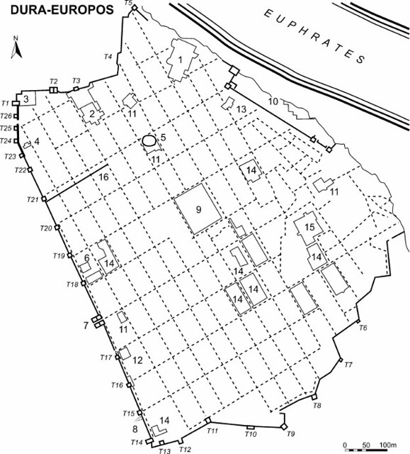
Fig. 1.
Plan of Dura-Europos. 1: Palace of the Dux Ripae; 2: military HQ building; 3: Temple of the Palmyrene Gods; 4: Mithraeum; 5: amphitheatre; 6: synagogue; 7: Palmyrene Gate; 8: Persian siege ramp; 9: agora; 10: citadel; 11: baths; 12: Christian building; 13: military temple; 14: temple; 15: old citadel; 16: military boundary wall. Mike Bishop, 2009, available at: https://www.flickr.com/photos/thearmaturapress/3437198687/

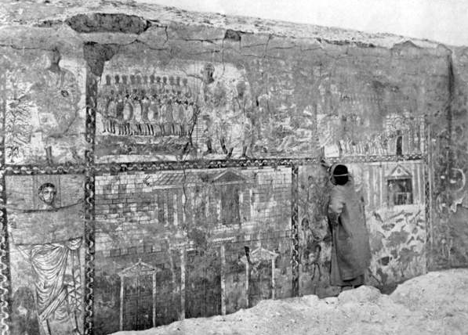
Fig. 2.
Syria: The west wall of the synagogue at Dura Europos shortly after its discovery in 1932. Now displayed in the National Museum of Damascus. Image number PFH1172229. Bridgeman Images. Available at: https://www-bridgemaneducation-com.ezproxy.uwtsd.ac.uk/en/asset/1172229/summary?context=%7B%22route%22%3A%22assets_search%22%2C%22routeParameters%22%3A%7B%22_format%22%3A%22html%22%2C%22_locale%22%3A%22en%22%2C%22filter_text%22%3A%22dura+europos%22%2C%22page%22%3A%221%22%7D%7D

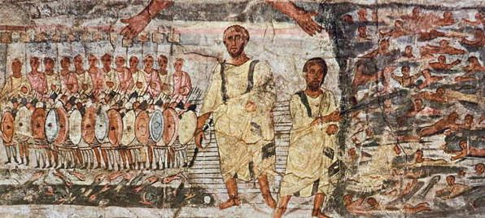
Fig. 3.
Exodus and the crossing of the Red Sea (tempera on plaster). Now displayed in the National Museum of Damascus. Image number BLP397881. Bridgeman Images. Available at: https://www-bridgemaneducation-com.ezproxy.uwtsd.ac.uk/en/asset/397881/summary?context=%7B%22route%22%3A%22assets_search%22%2C%22routeParameters%22%3A%7B%22_format%22%3A%22html%22%2C%22_locale%22%3A%22en%22%2C%22filter_text%22%3A%22dura+europos%22%2C%22page%22%3A%221%22%7D%7D
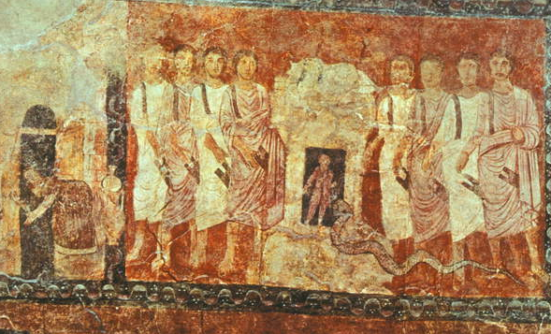
Fig. 4.
The Prophets of Baal on Mount Carmel (tempera on plaster). Now displayed in the National Museum of Damascus. Image number BLP397878. Bridgeman Images. Available at: https://www-bridgemaneducation-com.ezproxy.uwtsd.ac.uk/en/asset/397878/summary?context=%7B%22route%22%3A%22assets_search%22%2C%22routeParameters%22%3A%7B%22_format%22%3A%22html%22%2C%22_locale%22%3A%22en%22%2C%22filter_text%22%3A%22dura+europos%22%2C%22page%22%3A%221%22%7D%7D
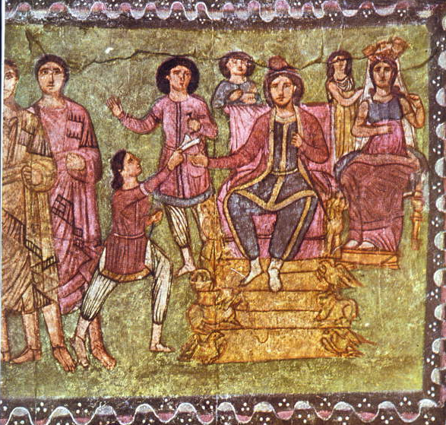
Fig.5.
Mordechai and Esther (tempera on plaster). Now displayed in the National Museum of Damascus. Image number BLP397876. Bridgeman Images. Available at: https://www-bridgemaneducation-com.ezproxy.uwtsd.ac.uk/en/asset/397876/summary?context=%7B%22route%22%3A%22assets_search%22%2C%22routeParameters%22%3A%7B%22_format%22%3A%22html%22%2C%22_locale%22%3A%22en%22%2C%22filter_text%22%3A%22dura+europos%22%2C%22page%22%3A%221%22%7D%7D
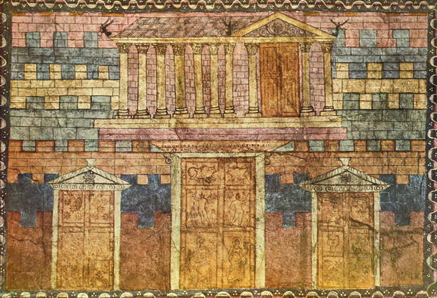
Fig.6.
The Temple of Solomon (tempera on plaster). Now displayed in the National Museum of Damascus. Image number BLP397879. Bridgeman Images. Available at: https://www-bridgemaneducation-com.ezproxy.uwtsd.ac.uk/en/asset/397879/summary?context=%7B%22route%22%3A%22assets_search%22%2C%22routeParameters%22%3A%7B%22_format%22%3A%22html%22%2C%22_locale%22%3A%22en%22%2C%22filter_text%22%3A%22dura+europos%22%2C%22page%22%3A%221%22%7D%7D
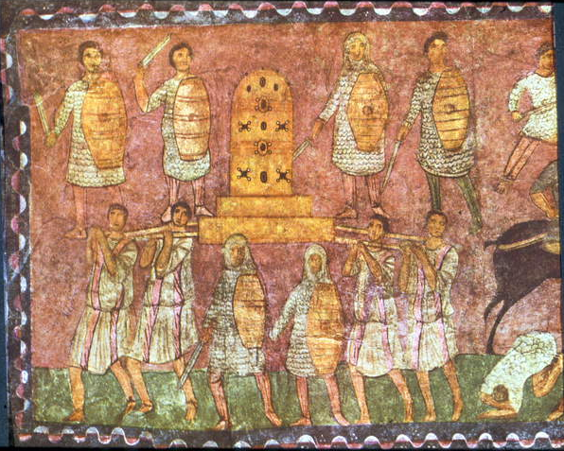
Fig.7.
The Battle of Eben-Ezer (tempera on plaster). Now displayed at the National Museum of Damascus. Image number BLP397884. Available at: https://www-bridgemaneducation-com.ezproxy.uwtsd.ac.uk/en/asset/397884/summary?context=%7B%22route%22%3A%22assets_search%22%2C%22routeParameters%22%3A%7B%22_format%22%3A%22html%22%2C%22_locale%22%3A%22en%22%2C%22filter_text%22%3A%22dura+europos%22%2C%22page%22%3A%221%22%7D%7D
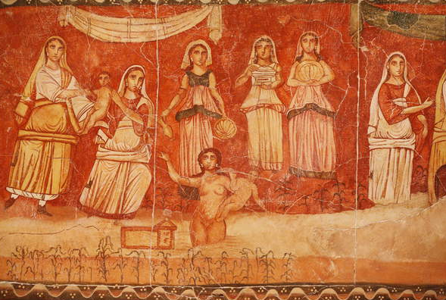
Fig. 8.
Pharaon et l'enfance de Moise, fresque provenant du Synagogue de Doura (Dura) Europos, 244-245. Now displayed at the National Museum of Damascus. Image number GNG5299576. Photo taken at the Jewish Museum at New York during an exhibition. Bridgeman Images. Available at: https://www-bridgemaneducation-com.ezproxy.uwtsd.ac.uk/en/asset/5299576/summary?context=%7B%22route%22%3A%22assets_search%22%2C%22routeParameters%22%3A%7B%22_format%22%3A%22html%22%2C%22_locale%22%3A%22en%22%2C%22filter_text%22%3A%22dura+europos%22%2C%22page%22%3A%222%22%7D%7D
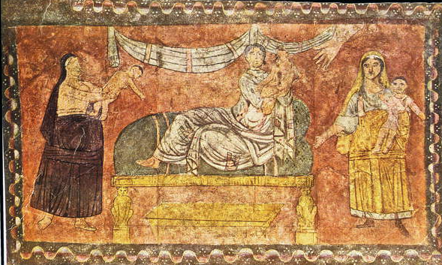
Fig. 9.
Elijah revives the widow's child (tempera on plaster). Now displayed at the National Museum of Damascus. Image number BLP397877. Bridgeman Images. Available at: https://www-bridgemaneducation-com.ezproxy.uwtsd.ac.uk/en/asset/397877/summary?context=%7B%22route%22%3A%22assets_search%22%2C%22routeParameters%22%3A%7B%22_format%22%3A%22html%22%2C%22_locale%22%3A%22en%22%2C%22filter_text%22%3A%22dura+europos%22%2C%22page%22%3A%221%22%7D%7D

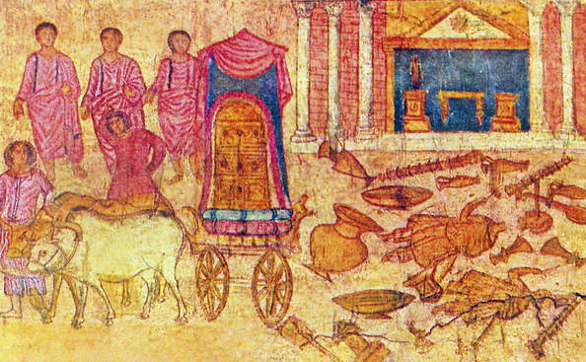
Fig. 10.
Syria: The images of the gods of the Philistines are overthrown. Fresco from Dura Europos synagogue, c.250 CE. Now displayed in the National Museum of Damascus. Image number PFH1172225. Bridgeman Images. Available at: https://www-bridgemaneducation-com.ezproxy.uwtsd.ac.uk/en/asset/1172225/summary?context=%7B%22route%22%3A%22assets_search%22%2C%22routeParameters%22%3A%7B%22_format%22%3A%22html%22%2C%22_locale%22%3A%22en%22%2C%22filter_text%22%3A%22dura+europos%22%2C%22page%22%3A%221%22%7D%7D
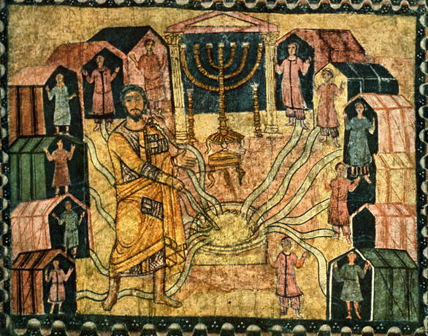
Fig. 11.
The Encampment at Be'er and the Miraculous Well (tempera on plaster). Now displayed in the National Museum of Damascus. Image number BLP397880. Bridgeman Images. Available at: https://www-bridgemaneducation-com.ezproxy.uwtsd.ac.uk/en/asset/397880/summary?context=%7B%22route%22%3A%22assets_search%22%2C%22routeParameters%22%3A%7B%22_format%22%3A%22html%22%2C%22_locale%22%3A%22en%22%2C%22filter_text%22%3A%22dura+europos%22%2C%22page%22%3A%221%22%7D%7D
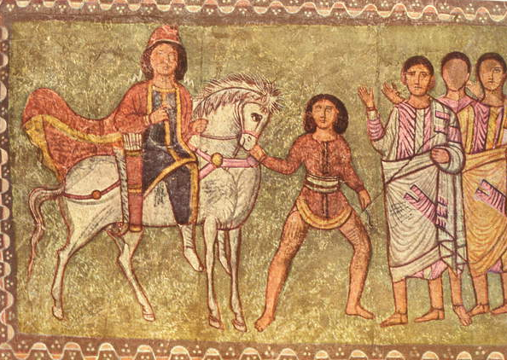Fig. 12.
Mordechai and Haman (tempera on plaster). Now displayed in the National Museum of Damascus. Image number BLP397887. Bridgeman Images. Available at: https://www-bridgemaneducation-com.ezproxy.uwtsd.ac.uk/en/asset/397887/summary?context=%7B%22route%22%3A%22assets_search%22%2C%22routeParameters%22%3A%7B%22_format%22%3A%22html%22%2C%22_locale%22%3A%22en%22%2C%22filter_text%22%3A%22dura+europos%22%2C%22page%22%3A%221%22%7D%7D

Steinberg, 2006, p. 461
Beard et al, 1998a, p.267
Beard et al, 1998b, 4.14b; Kelley, 1994, p.57; Elsner, 2003, p.123
Elsner, 2001, p.271 on Dura being ‘impacted’ by the fact of being part of a permanent frontier.
Weisman, 2012, p.1
Leriche, 2016
Weisman, 2012, p.1
Beard et al, 1998b, p.327
Beard et al, 1998b, p.327
Kelley, 1994, p.57
Steinberg, 2006, p.469; Webster, 2001, p.219
Weisman, 2012, p.4, on Dura being seemingly far from any major cultural centre; Kelley, 1994, p.59 on the Roman garrison being made up of men of mixed origin.
Fig. 1. – We see that the synagogue, Christian building, Mithraeum and other temples all were built along the same street
Webster, 2001, p.218
Moon, 1992, p.587 on Dura as the ‘Pompeii of Syria’.
Elsner, 2003, p.121
The exact images and what they depict have been summarised many times by various scholars, including Beard et al, 1998b, and for this reason I will not be repeating such summaries here but referring specifically to relevant images.
Steinberg, 2006, p.467; see also Weisman, 2012, p.4
Exodus 20:4
Weisman, 2012, p.4
Beard et al., 1998b, 4.14b;
Steinberg, 2006, p.471
Elsner, 2003, p.115
Elsner, 2003, p.125
Beard et al, 1998a, p.302
Elsner, 2003, p.126
Elsner, 2003, p.118; Weisman, 2012, p.24 n84 on possible significance of a flower design on a ceiling tile in the synagogue and a rosette in the Temple of Bel; Elsner, 2003, p.119 on the ceiling as a ‘standard local job’.
Steinberg, 2006, p.473
Moon, 1992, p.587 and p.589 on how Dura was Roman only for about 100 years but ‘much in the synagogue paintings was characteristically Roman’.
Moon, 1992, p.588 and p.591 on ‘Roman artistic schemes being immediately apprehensible’, to locals and visitors alike
Moon, 1992, p.592
Moon, 1992, p.592
Weisman, 2012, p.13
Moon, 1992, p.596
Moon, 1992, p.597
Mon, 1992, p.601
Moon, 1992, p.600
Elsner, 2001, p.283, and also on the images of the cult probably being visible due to the Roman garrison.
Elsner, 2001, p.299
Elsner, 2001, p.299
Moon, 1992, p.609
Elsner, 1992, p.300
Steinberg, 2006, p.486
Elsner, 2001, p.281
Steinberg, 2006, p.487
Steinberg, 2006, p.475
Weisman, 2012, p.4
Elsner, 2003, p.125 on the ‘hey-day’ of religious pluralism.
Kelley, 1994, p.59 on Goodenough’s use of an example of a Rabbi Samuel insisting eyes on a figure on a seal be put out.
Kelley, 1994, p.59
Kelley, 1994, p.60
Kelley, 1994, p.60
Rüpke, 2018, p.258
Kelley, 1994, p.60
Kelley, 19944, p.65
Elsner, 2003, p.125
Weisman, 2012, p.6
Weisman, 2012, p.8
Weisman, 2012, p.31
Weisman, 2012, p.24
Weisman, 2012, p.31
Steinberg, 2006, p.469

