Title: “How are games influenced by real world events”

Student Name: Kieran Pope
Student Number: 1700308
Programme of Study: BA Illustration
Module: Independent Inquiry (ADAD6001)
Word Count: 6109
Tutor’s name: Iwan Vaughan
Submitted in partial fulfilment of the requirements for the degree of BA (Hons) University of Wales Trinity Saint David, Swansea December 11th 2019

Table of Contents

Introduction
Chapter One: Terrorism
Chapter Two: Feminism
Conclusion
Bibliography
Table of Images

Introduction

This dissertation will be looking and answering my dissertation proposal question which was
“How can I apply a unique narrative structure and storytelling but avoiding the mainstream way of creating a world or story” however this has changed to “How are games influenced by real world events” and how this can either start a small debate or a full blown news article in which games that are in pre-production are either change massively or the developers have just taken a small portion of the game out, in this dissertation I will be looking at many different sources that spans this topic one in particular is the Battlefield 5 and the feminism argument, In the end I will have a clear conclusion on how and why these outside influences can change the final outcome of a game and other aspects in life as it might change people's views and help them gain a new perspective on this topic.

Chapter One: Terrorism
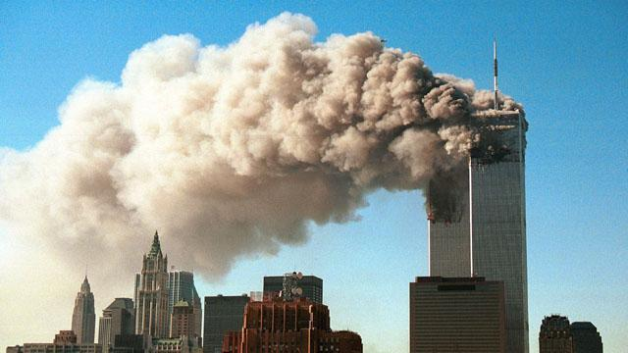
One of the major issues that has affected games in pre-production or after the release of the games is Terrorism more specifically “9/11” BBC, Smoke pours from the twin towers of the World Trade Centre, 11 September 2001”. as after this event game company’s and developers have been hesitant to displays this in games as players or the public may find it offensive as to this day 9/11 is the worst act of terrorism on US soil and 2,977 lives were lost on that day, For example “Call of Duty Modern Warfare”(2009)” during one of the mission in the single player campaign called No Russian were the play takes control of an undercover CIA agent who the proceeds to take part in a mass shooting in Moscow airport to gain the trust of a Russian terrorist group. The level was highly criticized for allowing players to take part in a terrorist attack, furthermore international copies of the game were subject to censorship due to the graphic level’s content. Furthermore, allegations of homophobic contented arose when Infinity Ward released a YouTube video titled “Fight Against Grenade Spam”, the reason these allegations came to light was because in the video there was use of profanity, and that the title forms the acronym F.A.G.S, a term to represent gay people. In response to this Infinity Ward removed the video from YouTube and apologized. However, despite these controversies Call of Duty Modern Warfare 2 grossed $310 million on its initial day of release.
At the start of this discussion on the topic of terrorism is a game called “Grand Theft Auto III (2001)” and how its developer at the gaming company Rockstar has stated the reasons why the September 11 attacks changed GTA3, which launched just weeks after the terrorist attacks at World Trade Centre and the Pentagon. Alterations were made to distance the game's fictionalized Liberty City environment and theme from New York City, and a mission that mentioned terrorists was also cut down to the bare bones.
"As far as I recall, we changed the color of the cop cars so they weren't identical to NYPD, we altered the flight path of a plane so that it didn't look like it was flying into or behind a skyscraper as a plan drove into the World Trade Centre, and we removed one mission as it made a reference to terrorists," How 9/11 Changed Grand Theft Auto III (2011)”. Rockstar executive Dan Houser told Edge. A few lines of dialogue for the pedestrians were cut and lines that came over the radio were also cut, while the US game box cover was redesigned. The alterations were less dramatic than the rumors suggested, Houser explained. "That's a little bit of a misconception that changes were significant," he added. "Some people believe we removed an entire strand of missions because they found some reference in the code to a character called Darkel, but he had been cut months before release and the missions were never completed." How 9/11 Changed Grand Theft Auto III (2011)”.

Because of the 9/11 the game was delayed, the Rockstar New York office was close to Ground Zero and so any work for the game was stopped and was impossible to continue as the area was under lock down by the NYPD and state government.

"The mood in the office... It was very upsetting, very unnerving and overwhelming. It was the same for us as it was for anybody. But we also felt we'd come this close to making this great game and that despite these problems, just as despite the problems of Take Two, it was our duty to finish it." How 9/11 Changed Grand Theft Auto III (2011)”. The reason for all these changes in the game was due to the nation's grief and sadness for the people that were taken from them as well as the first responders to arrive at Ground Zero and risked their lives evacuating The World Trade Centre.

To carry on the issue of acts of terrorism in games is the fact that is give players a certain perspective that the Islam faith is evil as in most first-person shooter games/war games the player fights against a terrorist group or organization and most of the time the antagonist is of the Islam faith because of the fact the player might gain this perspective and share it with friends and family especially with acts of terrorism have happened in their country, For example the US and because of this fact the American people not all have a distrust in any person who follows the Islam faith as to them it’s an evil faith or a faith that breeds terrorists, furthermore it doesn’t help that the current American President Donald Trump promotes Islamophobia and actively says to the American public the he will look into the “Muslim Problem” which he has said “Absolutely. I mean, I don’t notice Swedish people knocking down the World Trade Center. There is a Muslim problem in the world, and you know it and I know it.” 86 Times Donald Trump Displayed or Promoted Islamophobia (2018)”. Even before he became the President of the United States of America Donald Trump was a massive supporter of extreme actions against Muslims even suggesting that America isn’t at war with any nation but with the Muslims people he said “Does this, in fact, suggest that we are officially at war with Muslims?” to which Trump responds, “Well somebody knocked down the World Trade Center… somebody’s blowing us up. Somebody’s blowing up buildings, and somebody’s doing lots of bad stuff” 86 Times Donald Trump Displayed or Promoted Islamophobia (2018)”.
Donald Trump as supported the monitoring of all Muslims in the US to avoid any further acts of terrorism and the loss of life. As President of the “Free world” he advocates the “Muslim Registry” he said this at a rally “So the database — I said yeah, that’s alright fine… but database is okay, and watch list is okay, and surveillance is okay. If you don’t mind, I want to be — I want to survey”86 Times Donald Trump Displayed or Promoted Islamophobia (2018)”. Where all Muslims are required to sign a document and wear a badge with the symbol of Islam, this is exactly what Adolf Hitler did to the Jews in Germany during World War II. This treatment to Muslims on American soil is clearly linked to the idea of giving players and the public a false reality or perspective the Muslims and Islam are seen as the evil faith in the world and that the American government is openly trying the push all acts of terrorism or mass shootings that have happened a onto the “Muslim Problem” because everyone needs someone to blame for the tragic events that have plagued the US and the US government has chosen to blame Islam and Muslims and in doing so planting the false reality or perspective that all Muslims are to blame for the evil in the world.

To make matters worse, this type of treatment and environment that Muslims have to live under especially for young Muslims can easily be radicalized than ever before even more so because of Donald Trump and his views about Islam and Muslims. The distrust and the false reality and perspective of Muslims and how they have been treated can lead to home grown terrorism all because years of mistreatment by Donald Trump and the public. Social media has labeled them as evil, furthermore some game developers have displayed Muslims as the antagonist for many games especially the Call of Duty franchise which again plants the idea that all Muslims are evil and are terrorists. It also helps that many of the players on Call of Duty are teenagers and kids so it’s much easier to manipulate and brainwash them and plant the idea that all of Islam and Muslims are evil and are to blame for the acts of terrorism because they might not understand the Islam faith or the message the game developers is trying to get across in the game or they could misinterpreted news pieces or politicians all these factors can mess up their moral compass which allows a person the ability to judge what is right and wrong and act accordingly.

On the other hand, there’s nothing logical about putting the blame on millions of people who are spread across the entire world and are unrelated to each other except by religious views, ideas and traditions for the actions of a few, as Rupert Murdoch as said “Maybe most [Muslims are] peaceful, but until they recognize and destroy their growing jihadist cancer they must be held responsible” All Muslims are often blamed for single acts of terror. Psychology explains how to stop it. (2017). You wouldn’t blame all white people for the actions of “Dylan Roof” Charleston church shooter Dylann Roof pleads guilty to state murder charges (2017) a Christian, who walked into a church in Charleston, South Carolina, and killed nine African-American worshippers. Yet the world doesn't blame all Christians for the actions of one man. Yet collective blame happens, with ugly consequences. Many Muslims have spoken out against Muslim terrorist groups and organization even saying that the actions of such groups aren’t Muslims and that the men and woman aren’t true followers are the Islam faith.

Going back to in game terrorism in “Dragon Age II” (2011)” during the finale Act called the Last Straw of the game Anders one of the protagonist Hawke’s companions and a Mage blows up the Kirkwall Chantry a religious building and murdered the Grand Cleric Elthina the religious leader in Kirkwall as well as the sisters and even common citizens, to make a stand against the injustice to Mages and to make a stand against Templars who hunt free Mages, and the Mage Circles is a place where Mages that want to be free and not hide for their entire life are watched and protected by the Templars but are looked down upon by the Templar Order. Because of this event, it has caused a great divide between players as some players see Anders as the villain or anti-hero as his actions were manipulative of Hawke, a person who is either a dear friend or lover, and were altogether selfish not all Mages wished to lose their Circle, and Anders made that decision for them with no right to do so. He instigated not only the events that destroyed Kirkwall, yet also a War that cost thousands of lives. Was the war required? Possibly, yet there's also a chance events could have played out more peacefully, and thanks to Anders, we will never know.

However, some players believe that Anders actions were justified because in Dragon Age Lore the Mages had been prisoners and treated poorly for hundreds of years, and Anders knew that the current conflict between Mages and Templars would end up being resolved and nothing would change. Anders blew up the Chantry to make sure that things would change, for better or worse. To players the fact that Anders murdered hundreds of innocents is a small sacrifice for preventing thousands of Mages being hunted down or being held in captivity for the rest of their life. Furthermore, players believe that Anders killed no innocents that day as most of the people that were inside the Chantry were all members of the Chantry, and thus direct supporters of the Templar regime. Even Grand Cleric Elthina supported the Templars actions against the Mages and did nothing to ease the Mages plight when she had the power to stop the Templars and make them treat the Mages with respect. All these factors combined make the players that sided with the Mages believe that Anders isn’t evil or a terrorist Anders was just tired of the stalemate between the Templars and Mages. As Anders said, “I removed the chance of compromise because there can be no compromise.” Darrah, M “et al.” May 06, 2015, Dragon age: the world of thedas volume 1, Dark horse, Canada. he simply believed that there was no point in arguing and debating about the issue if no one would do anything about it. The plight of the Mages is so extreme that it drove a good man to do an awful thing out of desperation, this links perfectly with how Muslims are treated and how the world blames one act of terrorism on all of Muslims collective blame will not solve anything eventually more Muslims will feel pushed to the edge and out of desperation think that violence is the only way to get people's attention on the unfair treatment of Muslims.

The first example in this diccusion was about 9/11 and how after this infamous tragedy the world would start gain a false perception and realty of the Islam faith as evil and it only spreads violence and use violence to recruit and gain more worshippers but in reality it’s a kind and gentle faith like Christianity but because of the actions of a few men that used the faith for their own personal gain and to cause pain and suffering the world has never seen before and because of this the world now sees Islam as an evil faith and those who follow it are accused of being a terrorist or being singled out. Even in the present day the action of those who have distorted and corrupted the Islam don’t represent the Islam faith or community but there are certain people In the world that just want to cause pain and loss and make money by making sure there is a war going on so they can profit off it for example the NRA that advocates guns rights and is closely linked with companies that make guns for profit. But at the end war is just a cover for some people to push their ways of thinking onto the public. There are also arms dealers who also benefit if there is a war going on as both sides will buy from them and in turn causing more pain and suffering on both sides and in the day and age nobody cares who fired the first shot or how many lives will be shattered. How many hearts broken as everyone in the world needs to blame someone and because the actions of a few men that collectiby blame is placed upon the Islam faith and Muslims as terror attackes are only going and will keep happing unless country sit down and talk with them ans ask what they want cause not all terrotist are terrorist some just want to bring peace to their nation and stop the war that has been raging on for decades but Westeran govermeants and leaders lable them as terroist which cuts of any line of communcation.
“Dragon Age II” (2011)” links so well with 9/11 and the event in Dragon Age 2 where Anders blows up the chantry which is the issue of war that links well with how an action of a man or men can cause a war. In the world of Thedas is the Mage - Templar War it is also referred to as the Mage Rebellion, it broke out after the events of “Dragon Age II” (2011)” As mentioned before the world of Thedas is divided by two major groups The Templar Order which is charged with controlling Mages and magic use and keeping the Mages save from themselves and other its counterpart The Circle of Magi an association of mages, connected to the Chantry, that teaches and enforces the responsible use of magic. The main reason the Mage- Templar war broke out was because how the Mages were treated by the templars and the constant threats against them and how they were are there mercy, to get rid of the templars power each First Enchanter of each mage circle decided to separate the Circle of Magi from the Chantry meaning the Mages would be able to have true freedom and be able rule over themselves. The Templar ordered didn’t take well to this as one of the principles of the chantry is that “Magic exists to serve man, and never to rule over him. Foul and corrupt are they, who have taken His Gift and turned it against His Children They shall be named Maleficar, accursed ones. They shall find no rest in this world or beyond.” Darrah, M “et al.” May 06, 2015, Dragon age: the world of thedas volume 2, Dark horse, Canada.
This means that if you were born a mage you would be taken away from your family by the Templar order even if that child was a noble or a prince because according to the Chanty mages aren’t allowed to rule a nation or have a noble birthright. So, if you’re a mage you are instantly hated by the public as they see magic as a double edge sword it can help but it is more likely to do more harm. This was one of the reasons why the Templars separated itself from the chantry once the Mage- Templar war broke out because they hated the fact that the Chantry was limiting their power and given more rights to Mages to govern themselves but still under the watchful eye of the Templars Order.
The events in “Dragon Age II” (2011)” as mentioned above links perfectly well to 9/11 were in both cases a tragedy happened by a group of men or just one man, and caused a war like with 9/11 and Anders from Dragon Age 2 it caused a war on terror all around the world and governments started to move all efforts to stop this war on terror by any means necessary for example bombing a entire nation as a counter attack for 9/11 and leaving the war on drugs behind as the american public saw the war on terror a bigger threat than the one on drugs. In Dragon age 2 because of Anders’s actions at war broke out all around the world of Thedas between the two major factions the Mages and the Templar Orders as the people of the world saw all Mages as evil or terrorist as they would attack civilians, just like how in the actual world most people see all Muslims and Islam as evil and as terroist. Furthermore in the Dragon Age world the Templar Order also attacked civilians out of free as they thought that some members of the public were helping the Mages hide and escape from them, even though there was some outcry against them many of the people supported their actions against the Mages. So in this case the Templars in the actual world is both the government and the people that agree to this false reality and perspective that the Islam faith and all Muslims are evil and don’tt think twice on the topic.

Chapter Two: Feminism

Another issue for this dissertation is how female characters are displayed and represented to the players and the public. A good example of this is the game “Battlefield 5 (2018)”. which game under fire by “Feminists” EA DICE Exec Fires Back About Women in ‘Battlefield V’ (2018)”. as the game developers decide to not include female characters in the game single player campaign nor any playable female models in the multiplayer it was entirely male characters. Because of this design choice by the developers created an outcry by feminists who were calling the developers and the game sexist and that they have an old-world way of thinking that only men can fight in wars which is an outdated idea. However, in response to this the developers apologized to everyone they might have offended and that they were in design talks on how to proceed on this issue. The conclusion of this argument leads the developers to create and design female player models for the single player campaign and multiplayer and to make other small changes to the game because of the decision to add females’ characters to the game. However, in doing this many of the long-time fans of DICE the game developer company and of the Battlefield franchise found that adding female character models into the game was disrespectful to the men who fought and died in World War II and it was wrong for people to damned that female character models be implanted in the game even though DICE is infamously known for creating and developing historically accurate games. So, to fans this felt like a betrayal to the franchise they love and, in the end, fans refused to purchase the game and many were labelled sexist.

To carry on the topic of feminism is that during the year’s women didn’t have the right to vote and were given a specific role to fulfil such has to give birth, stay home, clean and support the man of the house. However, now women have thousands of job opportunities to take for example doctors, police and a go into politics and more, but even to this day some men still have that old-world idea that woman are week and inferior to men so a group of feminist is a good thing as their goal is to achieve fair treatment and equal rights for both genders as everyone person is part of mankind, but not to the point where they are pushing their perspective that woman are superior to men and if a woman was in power most of the world issue would have been solved that is taking two steps back into the past and having the same attitudes as the old-world thinking men.

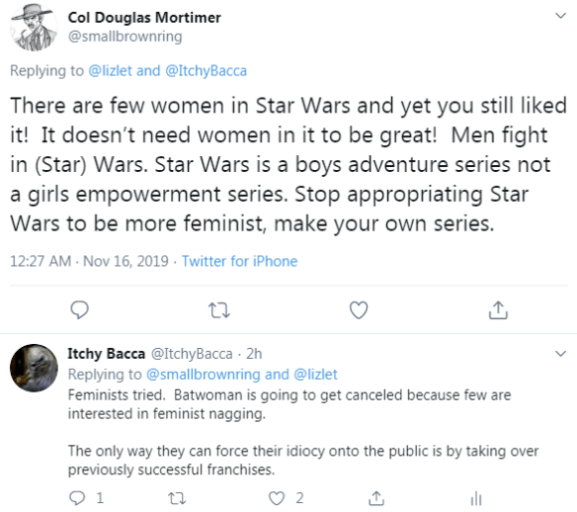
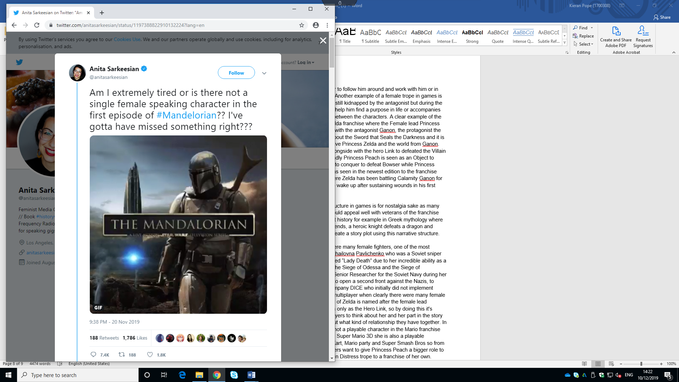
The new Disney+ TV show “The Mandalorian (2019)” set in the infamous Star Wars universe has come under fire from prominent feminists on Twitter saying that the show and the Star Wars universe is sexists, misogynists. They believe that there is a lack of prominent and powerful female characters in the Star Wars universe especially in the Mandalorian which is a new TV show that follows a Mandalorian bounty and his purpose in the universe. One of the main issues that Anita Sarkeesian a prominent feminist on Twitter brought up is the fact that there has been only one female character speaking role and that the Mandalorian is already on episode four and from this Anita Sarkeesian has already made a final judgment on the show without letting the first season to conclude and allow the story to advance forward.

In response to this many fans have harassed Anita Sarkeesian online for her opinions on the Mandalorian and Star Wars as a whole, the counter argument that one fan used was this. “That’s because the title of the franchise is Star Wars. Not Star Girl Power, or Star Female Empowerment, or Star Gender Equality, or Star Feminist Idiocy. It’s about wars being fought in the stars. And who is it that fights wars? Predominantly men. And until women start signing up for selective service, that inequity will likely remain.” Feminists Are Very Upset Over Disney’s ‘The Mandalorian’ (2019)Feminists Are Very Upset Over Disney’s ‘The Mandalorian’ (2019)”. This one fan is basically just saying that the original audience for Star Wars movies and comic books was for men who were fascinated with sci fi and action movies even the Star Wars: The Clone Wars cartoon was primarily focused on men as during war men were predominantly the fighters while women were given the role as nurses, working in weapons factories and communication officers.

Another counter argument from a fan is this “It never ceases to amaze me how many middle-aged women suddenly became fans of Star Wars since “childhood,” despite the fact that for decades Star Wars was considered mostly girl kryptonite. Where in the hell were you back then? Because I didn’t see the bulk of you show up until cosplay became trendy, and geek culture, unfortunately, went mainstream.” Feminists Are Very Upset Over Disney’s ‘The Mandalorian’ (2019)”. This fan is talking about when the original Star Wars trilogy was first released in 1977-1983 during this entire time there were no outcry’s from any feminists as it grabbed the attention of both men and woman and was beloved by all so why where there no feminist then and why only now are they raising their voice about the new Star Wars trilogy and the Mandalorian even though the new main lead character in the new trilogy is a woman who has taken up the mantle that was left by Luke Skywalker to save the universe from the Dark Side and restore the Jedi Order. So why are feminist outraged by this when they should be over the moon about it as this is a huge leap for woman actors everywhere as Star Wars is a well-known franchise that is about war and loss furthermore it is a franchise loved by all around the world.

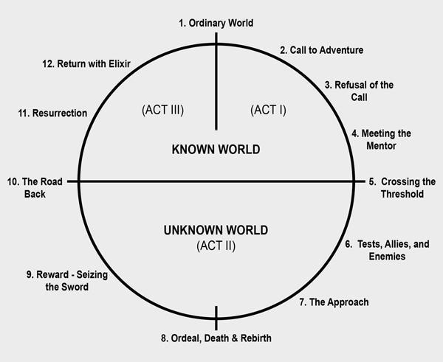
Delving deeper into the issue of feminism in games is the tropes that female character fall into especially with Nintendo’s “Mario Franchise (1988)” where the female character Princess Peach is the “Damsel in Distress” Feminist Frequency(2013). troupe who is always kidnapped by the antagonist Bowser and is later saved by the protagonist Mario and during the time between the kidnapping of Princess Peach and the rescue, the female lead doesn’t get a lot of screen time as Mario and Bowser. Expect when the narrative structure needs the female lead to show up to give the male lead a sense of purpose and a reason for going on the quest/adventure as most RPGs and games like Mario follow the “12 Stages of The Hero's Journey” The Hero's Journey - Mythic Structure of Joseph Campbell's Monomyth By Dan Bronzite (2019)”. and the structure for telling a story. Narrative structure which is the setup (act one) is where all the main characters and their basic situations are introduced and contains the primary level of characterization (exploring the character's backgrounds and personalities). A problem is also introduced, which is what drives the story forward. The second act, the conflict, is the bulk of the story, and begins when the inciting incident (or catalyst) sets things into motion. This is the part of the story where the characters go through major changes in their lives as a result of what is happening; this can be referred to as the character arc, or character development. The third act, or resolution, is when the problem in the story boils over, forcing the characters to confront it, allowing all the elements of the story to come together and inevitably leading to the ending.

There are many tropes in games many about female characters to make the male character look better in the eyes of the player or to give him more depth or to show that the male lead is able to get a hot and attractive female character to follow him around and work with him or in rare cases it’s a love interest for the male lead. Another example of a female trope in games is “The Helpful Damsel” Feminist Frequency(2013). in which the female lead is still kidnapped by the antagonist but during the story helps the protagonist finish his mission or help him find a purpose in life or accompanies the hero as a spirit which forms a love interest between the characters. A clear example of the Helpful Damsel is Nintendo’s “The Legend of Zelda the Breath of the Wild (2017)” franchise where the Female lead Princess Zelda is kidnapped or stuck in an eternal battle with the antagonist Ganon, the protagonist the legendary hero Link is told about the legends about the Sword that Seals the Darkness and it is later revealed that Link is that hero and must save Princess Zelda and the world from Ganon. However, unlike Princess Peach Zelda fights alongside with the hero Link to defeated the Villain Ganon even though she gets kidnapped, Secondly Princess Peach is seen as an Object to Mario as to him Peach is an obstacle he needs to conquer to defeat Bowser while Princess Zelda plays a more prominent role in the story as seen in the newest edition to the franchise The Legend of Zelda the Breath of the Wild where Zelda has been battling Calamity Ganon for over a century while waiting for the Hero Link to wake up after sustaining wounds in his first encounter against Calamity Ganon.

The reason many game developers use this structure in games is for nostalgia sake as many retro games are based on this structure so it would appeal well with veterans of the franchise also this narrative structure is present in ancient history for example in Greek mythology where Perseus saves Andromeda and in Medieval legends, a heroic knight defeats a dragon and saves the Princes, so it is an effective way to create a story plot using this narrative structure.

On the other hand, during World War II there were many female fighters, one of the most famous one in the Eastern front was “Lyudmila Mikhailovna Pavlichenko” Lady Death: Lyudmila Pavlichenko, the Greatest Female Sniper of All Time (2018)”. who was a Soviet sniper with 309 confirmed kills. Lyudmila was nicknamed “Lady Death” due to her incredible ability as a sniper. She was also part of the defense during the Siege of Odessa and the Siege of Sevastopol. After the War she reassigned to a Senior Researcher for the Soviet Navy during her life she visited Allied Nations to convince them to open a second front against the Nazis, to counter the game developers and the game company DICE who initially did not implement female characters or female models for use in multiplayer when clearly there were many female fighters during World War II. Nintendo’s Legend of Zelda is named after the female lead Princess Zelda but the player cannot play Zelda only as the Hero Link, so by doing this it's putting Zelda in the spotlight and getting the players to think about her and her part in the story while playing as the Hero Link trying to figure out what kind of relationship they have together. In the case of Princess Peach even though she’s not a playable character in the Mario franchise except in two rare cases, Super Mario Bros and Super Mario 3D she is also a playable character in the spin off games such as Mario Kart, Mario party and Super Smash Bros so from this fans of the character and even the developers want to give Princess Peach a bigger role to play and slowly move her away from a Damsel in Distress trope to a franchise of her own. Furthermore, Princess Zelda is also a playable character in the same spin off games for the first time ever. So, from these factors its clear to see that female roles in games that follow this old style of narrative structure are improving by giving them a more prominent role in the games main plot or by giving a female character its own franchise furthermore there are many examples of female characters with their own franchise like “Tomb Raider (2018)” and Metroid.

However, a recurring theme in any game that has a female protagonist or even a helpful damsel is the sexual objectification and sexualization, done to appeal to a presumed male audience as well as the degree to which female characters are independent from their male counterparts within the same game. Research on this issue of the sexualization of women in television, games and in all social media platforms, has asked whether it has reduced male compassion towards women and that it also reduces women’s perceptions of their desire and suitability of various vocations.

Conclusion

In conclusion, by doing research and looking at real life events that links perfectly with the two topics that have been mentioned though out this entire discussion which is Terrorism and Feminism, and have caused game company’s and developers to change or remove parts of their game because such events have left a wound on the nation and the people that were directly involved and that wound can never heal, and all these events or issues have happened in the actual world that have affected the process of pre-production and the entire development of games. During this discussion there have been many examples of events and issues that have changed aspects of games or have caused the initial idea for a game to change. Furthermore, both topics can be linked to other issues which have been mentioned in each chapter for example how a single act of terrorism can lead to a full blown war cause the actions of a few also political views from prominent world leaders like Donald Trump and prominent feminist on twitter raising their voice against female roles in games, TV shows and movies. All these examples have helped to compile all the necessary information to give a factual answer to the question that was set which was “How are games influenced by real world events”.

To answer the question that was set you must first understand both sides of each issue and events which have been explored throughout this discussion. Firstly, Chapter One the topic of terrorism, in this chapter it was exploring and finding a clear link to any events or issues that relates to any act of terrorism and how that event or issue has affected the development of any game. But this also falls under any kind of social platform or any news outlet even TV shows and movies because as discussed in this chapter there is a clear and undeniable link between the atrocities that happened on 9/11 and the multiple games that have been affected because of it especially GTA3 that had to remove a mission from the game, redesign the cover image as well as the NYPD cars to look nothing like them and cut lines of dialogue from the game, this also goes for Call of Duty Modern Warfare 2 in which during a mission you take the role of a terrorist and shoot civilians in an airport and because of the many terrorist attacks around the world is it giving young people and players who play these type of games a false perspective and realty of the Islam faith and Muslims. Furthermore, it doesn’t help that the current US President advocates islamophobia and laws that restrict Muslims and that he has already passed a Muslim ban, he also refers to this as the “Muslim Problem” and this led to the radicalization of young Muslims as they have been pushed to the brink. There are many more factors to consider to answer the question that was set.

The Second Chapter of this discussion is Feminism and the many different troupes that have surround female roles for decades especially in the movie/TV/game industry during this discussion it was focused on the “Damsel in Distress” trope and the “Helpful Damsel” as they are most used troupes used in retro games and present day games too as they resonate well with veterans of the games. Also, In this chapter it has explored the game Battlefield 5 as there were no female lead characters or models for multiplayer as so it caused a backlash against the game developers and the game company DICE from feminists and from that it links well to the traditional roles of men and women during World War 2. Furthermore, this chapter explores the point of view of a prominent feminist in twitter named Anita Sarkessian who voiced her opinion on the entire Star Wars universe and its new addition to the universe the Mandolorain a new TV show where she expresses that there were no female characters only men and that the producers follow an outdated way of thinking. This chapter explores many more factors to give enough information to give a clear answer that was set.

To answer the question “How are games influenced by real world events” is yes but games are not only the only thing affected by real world events, Movie/TV industry are affected too and all kinds of social platforms and news outlets too as the game developers, news editors and directors have their own view of the world and the examples of issues and events that have been discussed about throughout both chapters. Futhermore, devllopers, news edioters and directors sometimes but in hidden meanings in some dieloge or scenes like in Call of Duty Mordan Warfare 2 where you take the role of a terroirst but by doing this it is planting a false realty an dpercpetion of ythe islam faith. With Feminism is harder as some people want more female lead characters in games and movies like in the new Star Wars trilogy and the Lora Croft game franchise but there are some who want games and movies to be historically accurate or follow the lore/history of the games fransche not to upset the long time veterans of the game and the last group are those who just don’t care as they will play or watch something that is enjoyable to them and insterstssing so in the end it's all about iIndividual opinion on matter. However it's clear shown that games are influenced by real world events no matter what as people will look at these issues and events and come up with their own view and perspectives about it.

Bibliography

BioWare. (2011). Dragon Age II. [DISC]. PlayStation3. California: Electronic Arts Inc.
Darrah, M “et al.” May 06, 2015, Dragon age: the world of thedas volume 2, Dark horse, Canada.
Darrah, M “et al.” May 06, 2015, Dragon age: the world of thedas volume 1, Dark horse, Canada.
BBC, Smoke pours from the twin towers of the World Trade Centre, 11 September 2001
InfinityWard. (2009). Call of Duty Modern Warfare . [DISC]. PlayStation3. California: Activision.
RockStar. (2001). Grand Theft Auto III. [DISC]. PlayStaion2. Edinburgh: DMA.
How 9/11 Changed Grand Theft Auto III (2011): https://www.eurogamer.net/articles/2011-11-18-rockstar-how-9-11-changed-grand-theft-auto-3
86 Times Donald Trump Displayed or Promoted Islamophobia (2018): https://medium.com/nilc/86-times-donald-trump-displayed-or-promoted-islamophobia-49e67584ac10
All Muslims are often blamed for single acts of terror. Psychology explains how to stop it. (2017):https://www.vox.com/science-and-health/2017/11/30/16645024/collective-blame-psychology-muslim
Charleston church shooter Dylann Roof pleads guilty to state murder charges (2017): https://www.theguardian.com/us-news/2017/apr/10/charleston-church-shooter-dylann-roof-pleads-guilty-murder-charges
DICE. (2018). Battlefield 5. [DISC]. PlayStation4.California: Electronic Arts Inc.
Eidos Interactive. (2018). Tomb Raider. [DISC]. PlayStation4. Derby: Core Design
Nintendo. (2017). The Legend of Zelda the Breath of the Wild. [CARD]. Switch. Kyato: Nintendo EPD.
Nintendo. (1988). Mario Franchise. [CARD]. All Nintendo consoles. Kyato: Nintendo EAD.
Feminists Are Very Upset Over Disney’s ‘The Mandalorian’ (2019): https://bleedingfool.com/blogs/feminists-are-very-upset-over-disneys-the-mandalorian/
Disney+ (2019) The Mandalorian. Disney+
EA DICE Exec Fires Back About Women in ‘Battlefield V’ (2018): https://variety.com/2018/gaming/news/battlefield-v-women-1202822531/
Aarseth, Espen (1997): A Narrative Theory of Games. Copenhagen, Denmark: ACM New York.
The Hero's Journey - Mythic Structure of Joseph Campbell's Monomyth By Dan Bronzite (2019): http://www.movieoutline.com/articles/the-hero-journey-mythic-structure-of-joseph-campbell-monomyth.html
Feminist Frequency(2013) Damsel in Distress: Part 1 - Tropes vs Women in Video Games.https://www.youtube.com/watch?v=X6p5AZp7r_Q
Lady Death: Lyudmila Pavlichenko, the Greatest Female Sniper of All Time (2018): https://www.mentalfloss.com/article/565151/retrobituaries-lyudmila-pavlichenko

Table of Images
Feminists Are Very Upset Over Disney’s ‘The Mandalorian’ (2019): https://bleedingfool.com/blogs/feminists-are-very-upset-over-disneys-the-mandalorian/

Aarseth, Espen (1997): A Narrative Theory of Games.

Screenshot. (2019). Twitter: https://twitter.com/anitasarkeesian/status/1197388822910132224?lang=en
BBC, Smoke pours from the twin towers of the World Trade Centre, 11 September 2001

