Workshop: Celebrating the dead in Pompeii
Pompeii: The life, death and rediscovery of a Roman town (HPAH5078/HPAH6078)

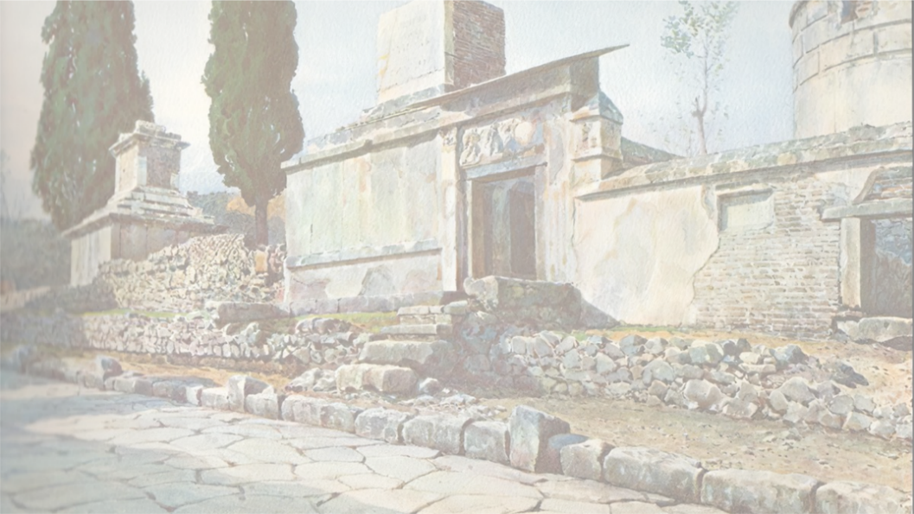

Across the Roman world, honouring the dead and ensuring their proper burial was of central concern to individuals, families and the community writ large. Among the elements of a funeral were the 1) preparation of the body of the deceased, often by female family members (but the wealthy could afford to hire libertinarii, undertakers) ensuring, among other things, its washing, anointing and the last pronouncing of the deceased’s name (conclamatio); 2) the pompa funebris or procession of the deceased, in which members of the familia, the “ancestors” (actors wearing funerary masks, imagines), and often wider members of the community (at least observing) might participate (though those of lower status, like slaves and very poor free-persons, might not receive much in the way of pompa); 3) the cremation or inhumation of the body (interred at a specially dedicated funerary monument if more well-to-do, or potentially in a family mausoleum, typically along roadsides outside the main gates); 4) and then the purification of the family and those who had participated. This was not the end of one’s relationship with the dead, with annual festivals to the dead taking place, notably the Parentalia (13-21 February), of which gifts would be given at tombs on the Feralia day. For instance, in the area of Pompeii we can see some tombs with pipes leading to buried cinerary urns.
Historians and archaeologists often try to study traces of such commemoration, funerary monuments and cemeteries to try and provide an insight into issues such as social composition within a community, expressions of status and ideology (what was emphasised about the dead), careers and relationships (prosopography) and belief and rituals. For this short workshop, we will consider some of the epigraphic, iconographic and archaeological evidence for funerary practices at Pompeii. Have a look at some of the images and short texts in the sections below and consider the connection questions.

Relationships gone awry: the tomb of P. Vesonius Phileros
The tomb of Vesonius Phileros was located outside the Nucerian Gate of Pompeii. Three figures are represented on this tomb: ‘in the centre is the deceased’s patron, Vesonia, daughter of Publius, flanked by two men, the deceased Publius Vesonius Phileros and his ‘friend’ Marcus Orfellius Faustus’ (A. Cooley and M. Cooley 2014: 153). It appears that Vesonius had commissioned this tomb during this lifetime, and 18 herms have been found within the tomb enclosure, including those representing Vesonia, Phileros and Orfellius. However, it seems the herm of Orfellius had been ‘sliced off where the shaft enters the ground; (ibid). As the funerary epitaph makes clear (see below) the relationship between the two men had turned sour.
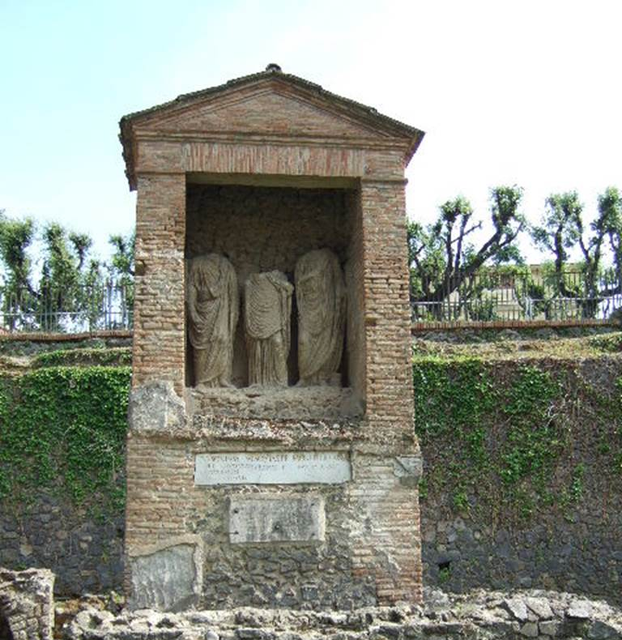
Image from: https://pompeiiinpictures.com/pompeiiinpictures/Tombs/tombs%20nocos%20p8.htm

Dedicatory inscription on tomb’s façade
Publius Vesonius Phileros, freedman of a woman, Augustalis, built this monument for himself and his kin in his lifetime, for Vesonia daughter of Publius, his patron, and for Marcus Orfellius Faustus, freedman of Marcus, his friend. (AE (1986) 166a + AE (2008) 323) – Transl. from A. Cooley and M. Cooley 2014: 154.

Later addition to the tomb
Stranger, delay a brief while if it is not troublesome, and learn what to avoid. This man whom I had hoped was my friend, I am forsaking: a case was maliciously brought against me; I was charged and legal proceedings were instituted; I give thanks to the gods and to my innocence, I was freed from all distress. May neither the household gods nor the gods below receive the one who misrepresented our affairs. (AE (1964) 160) – Transl. from A. Cooley and M. Cooley 2014: 154.

Short inscriptions accompanying some of the herms inside the enclosure (ibid):
Vesonia daughter of Publius
To Publius Vesonius Proculus, lived 13 years
Eliodorus, lived for 17 years.

What can this tomb and the accompany inscriptions tell such about social status, patronage and (familial) relationships?

Tomb of Gaius Vestorius Priscus
This tomb is located by the Vesuvian Gate, inside a rectangular enclosure with an altar. It features some impressive wall paintings, and the accompanying inscription:
To Gaius Vestorius Priscus, aedile. He lived 22 years. His burial place was granted along with 2,000 sesterces for his funeral by decree of the town councillors. Mulvia Prisca, his mother, set this up at [her own] expense. (AE (1913) 70) – Transl. from A. Cooley and M. Cooley 2014: 184.

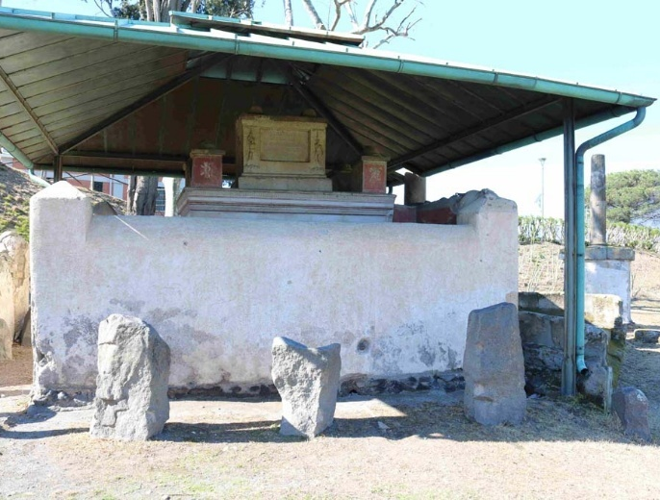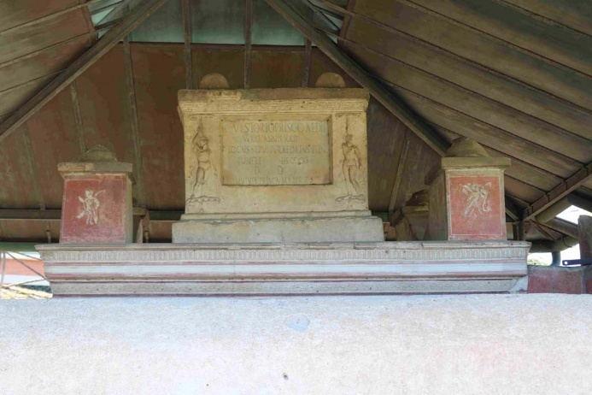
Images from PompeiiinPictures

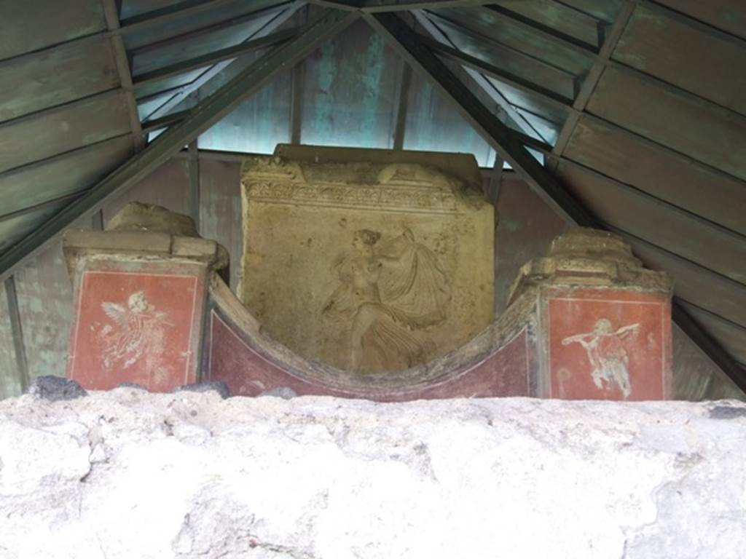
North side of inner tomb with carved marble figure and paintings of cupids.

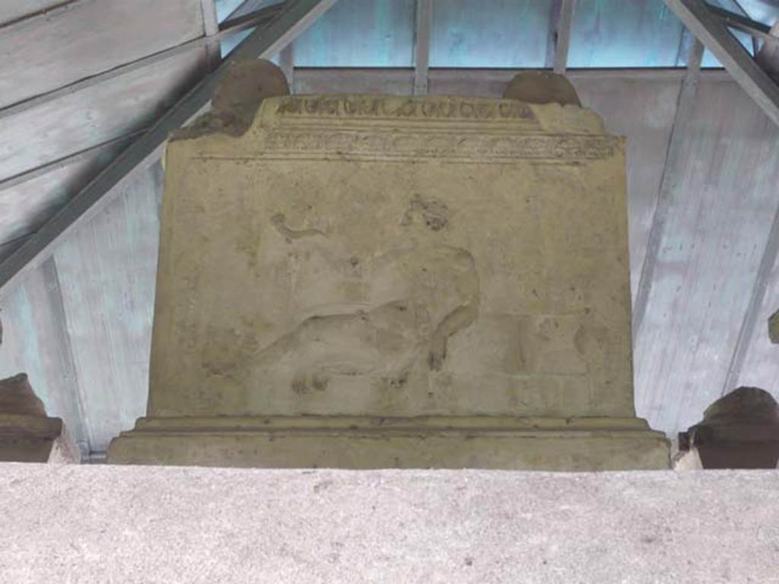
Relief of a man with a cornucopia on west side centre of inner tomb

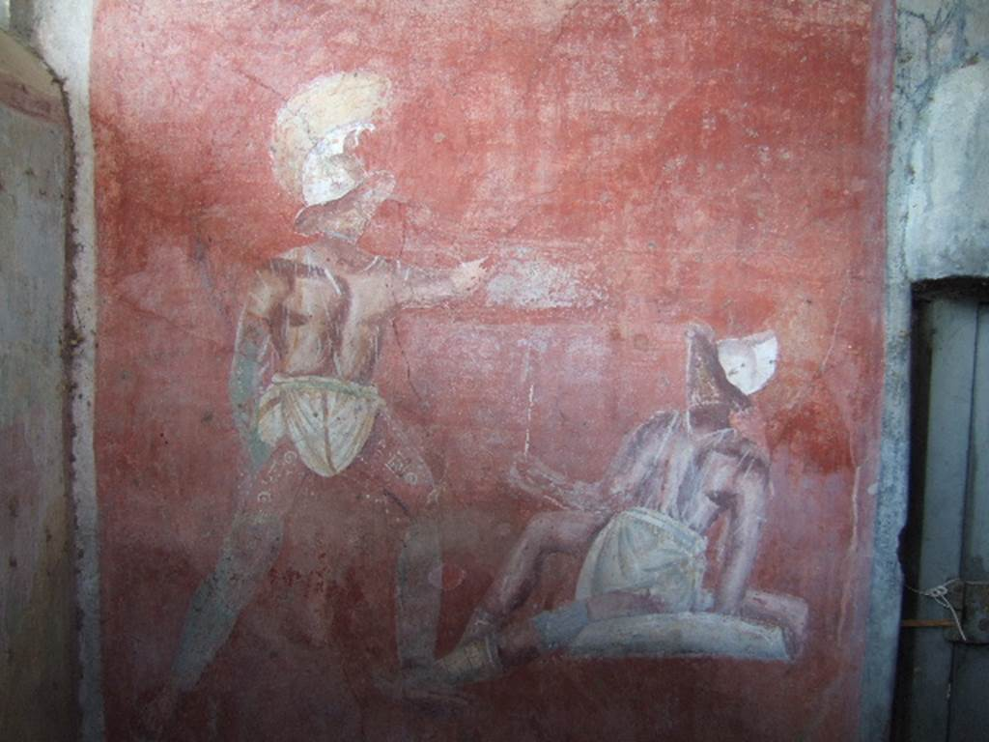
Inner side of west wall of tomb with entrance door on right

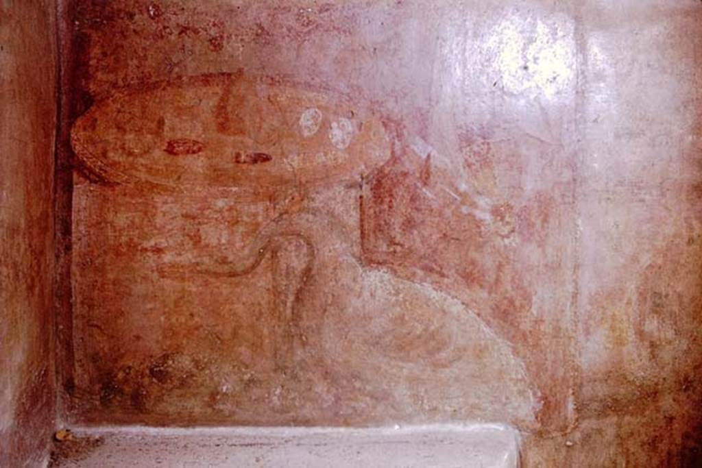
Painting of circular table or altar at south-east corner. On the top are dates, eggs and nuts, in front is a swan and fruit.

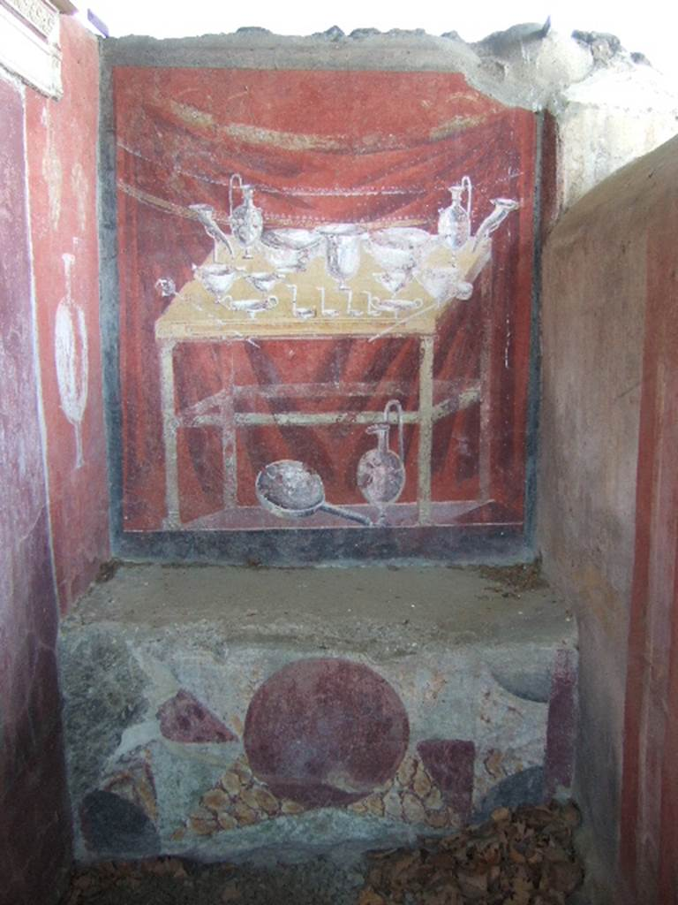
Inner side of north wall of tomb

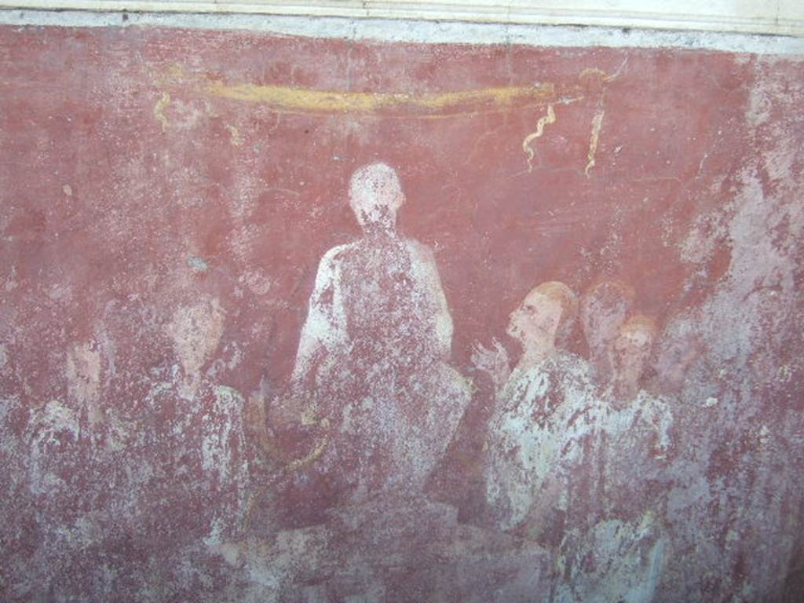
Inner tomb east wall with painting of seated aedile

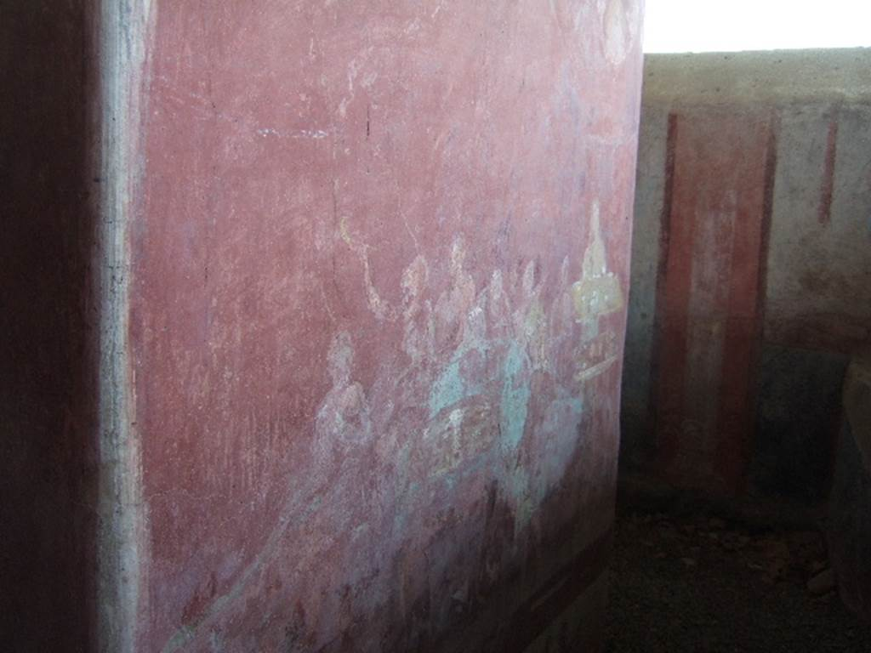
Inner tomb south wall with painting of a (funerary) banquet
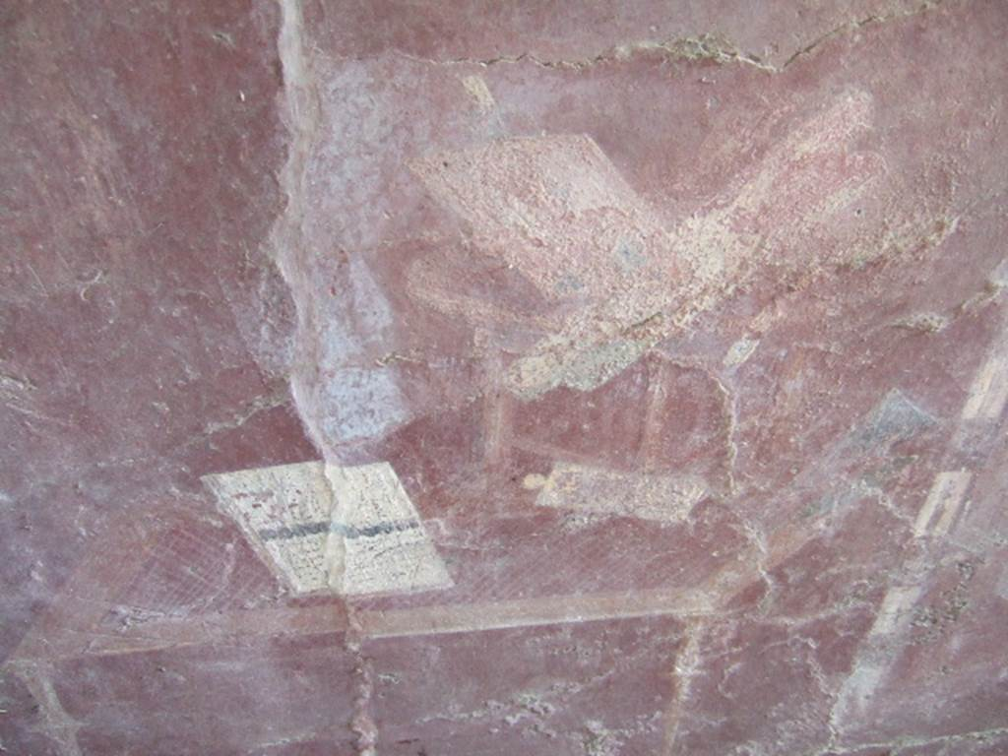
West wall of inner tomb with painting of writing implements and money on a table.

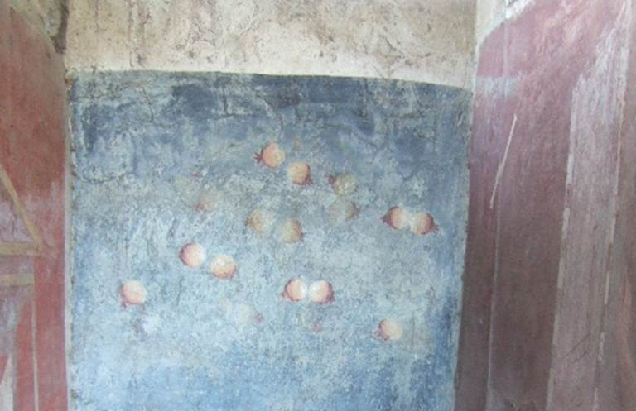
West end of inner side of north wall with painting of pomegranate tree laden with ripe fruits

What can the funerary epitaph and the imagery tell us both about the life of Gaius Vestorius Priscus and his death?
Can we guess at why he received such honours?
Funerary pompa
Whenever any illustrious man dies, he is carried at his funeral into the Forum to the so-called rostra, sometimes conspicuous in an upright posture and more rarely reclined. Here with all the people standing round, a grown-up son, if he has one left who happens to be present, or if not some other relative mounts the rostra and discourses on the virtues and successful achievements of the dead. As a consequence the multitude and not only those who had a part in these achievements, but those also who had none, when the acts are recalled to their minds and brought before their eyes, are moved to such sympathy that the loss seems to be not confined to the mourners, but a public one affecting the whole people. – Polybius 6.53 [Transl. Loeb Classical Library).
But on the contrary, in the days of our ancestors, it was these that were to be seen in their halls, and not statues made by foreign artists, or works in bronze or marble: portraits modelled in wax were arranged, each in its separate niche, to be always in readiness to accompany the funeral processions of the family; occasions on which every member of the family that had ever existed was always present. The pedigree, too, of the individual was traced in lines upon each of these coloured portraits. Their muniment-rooms, too, were filled with archives and memoirs, stating what each had done when holding the magistracy. – Pliny HN 35.4-6 [Transl. J. Bostock and H. T. Riley 1857]
Let the neighbours praise the handsome funeral… – Horace Sat. 2.5.106.

Funerary epitaph of Arellia Tertulla
This epitaph is only attestation of a fully funded public funeral (i.e., completely paid for by public funds) that we have from Pompeii, although there are other examples of partially funded funerals (i.e., the decurions award some funds, see above and below).
To Arellia Tertulla, daughter of Numerius, (wife) of Veius Fronto. To her the decurions gave the place for burial and a funeral with public money by decree after her death. (NSA 1910, 405) – Transl. V. Campbell 2021: 151.

Funerary epitaph of Titus Terrentius Felix
To Titus Terrentius Felix maior; son of Titus, of the Menenian tribe; aedile. He was given this place and two thousand sesterces by the people. Fabia Sabina, daughter of Probus, wife. (CIL X 1019) – Transl. V. Campbell 2021: 152.

Funerary epitaph of Septumia
To Septumia, daughter of Lucius, by decree of the decurions she was given publicly a place for burial and two thousand sesterces for her funeral. Antistia Prima, daughter of Publius, her daughter, made this. (AE 1911: 72 = AE 1913: 70) – Transl. V. Campbell 2021: 152.

Funerary epitaph of Aulus Umbricius Scaurus
To Aulus Umbricius Scaurus, son of Aulus, of the Menenian tribe, duovir with judicial powers. The decurions decreed him the space for this monument and two thousand sesterces for the funeral and an equestrian statue to be erected in the Forum. Scaurus senior, for his son. (CIL X 1024 = ILS 6366) – Transl. V. Campbell 2021: 153.

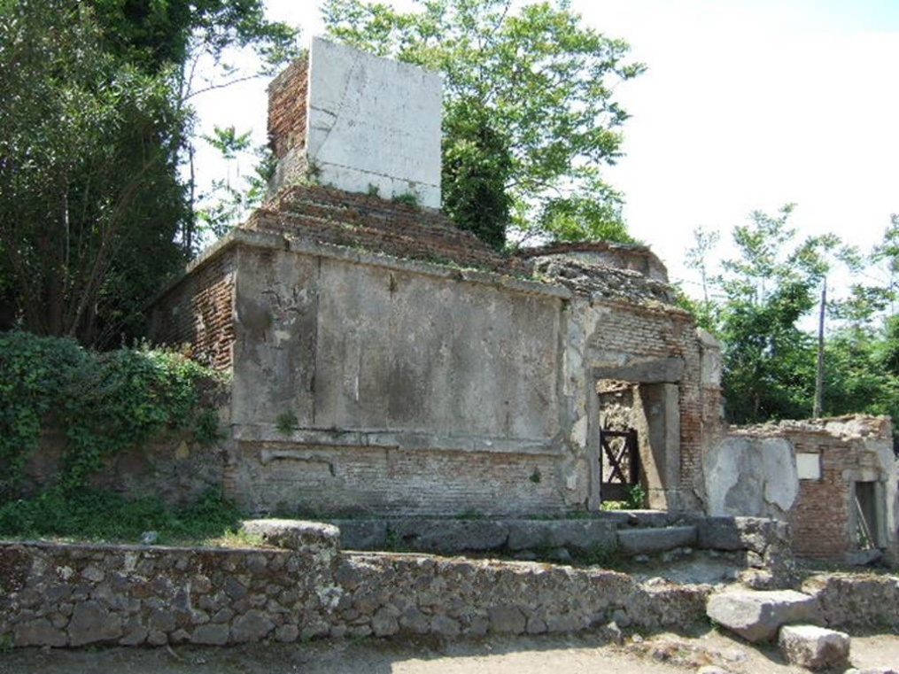
Looking west towards the front of the tomb

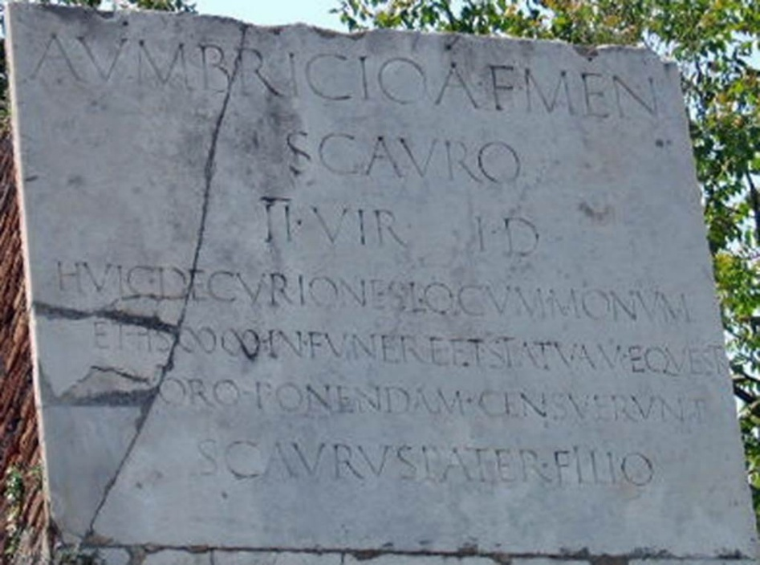

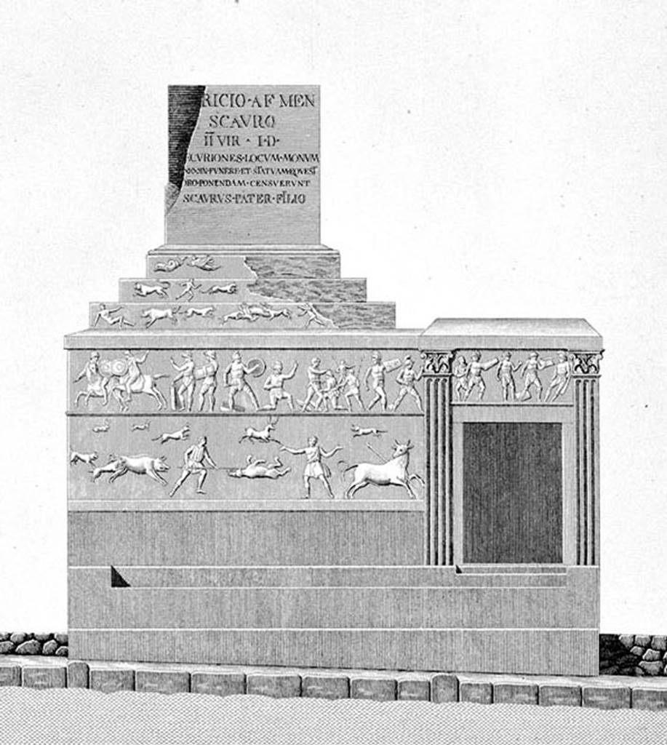
Drawing by Mazois of the tomb, inscription and the gladiator reliefs.

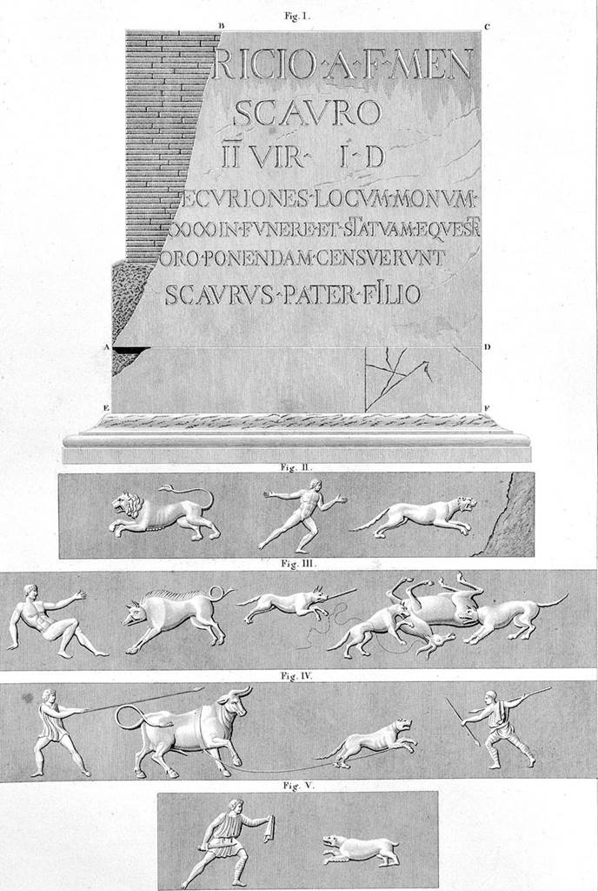
Drawing by Mazois of the inscription and scenes of combat with wild beasts

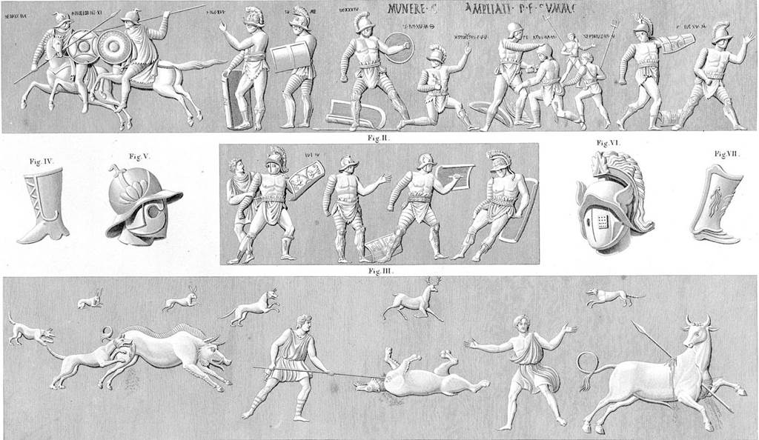
Drawing by Mazois of the Gladiator reliefs

House of Aulus Umbricius Scaurus (VII.16.15)
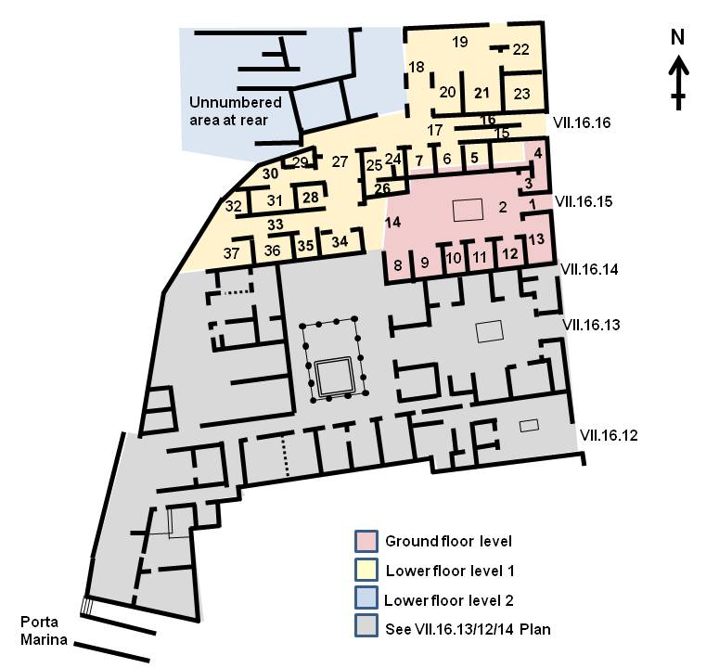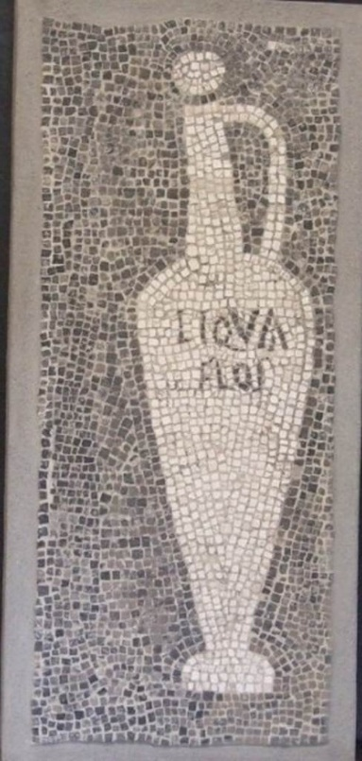

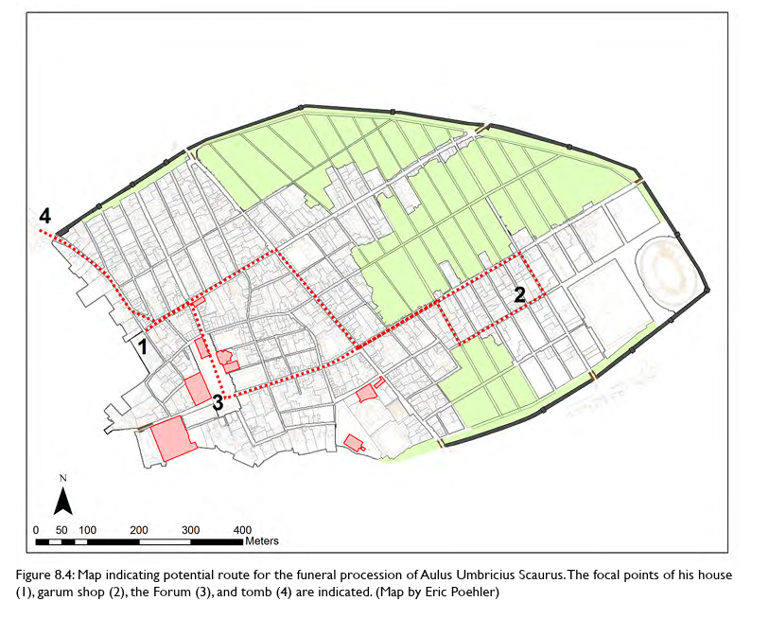
Reconstruction of the possible funerary pompa of Aulus Umbricius Scaurus, son of Aulus from V. L. Campbell (2021). ‘POMPA IN POMPEII: EXPERIENCING A FUNERAL PROCESSION IN THE ANCIENT CITY.’ Open Arts Journal 10: 145-159.

Why do you think town council (ordo decurionum) would have granted these funds to commemorate these individuals, and what do you think it would be spent on? How do you think such funerals impinged upon the lives of “ordinary” Pompeiians?

