Digital Skills & Research Methods
Mominur Rahman
Student ID: 1705768
Lecturer: Renuga Jayakumar
Module Code: BMSK4003

Table of Contents
Introduction 3
LO 01 Evaluate the appropriate use of contemporary technologies to improve workplace efficiency and employability 4
LO 02 Identify and effectively evaluate a range of data sources 6
Cloud Storage: 11
Dropbox: 11
One drive: 12
Comparison Chart: 12
Emails: 13
Advantage of Email: 13
Disadvantages of Email: 14
Conclusion 17
References 17

Introduction

In the cutting edge working condition, advanced abilities are greatly regarded; later on, modernized aptitudes will be crucial. The electronic age is wandering into all parts of our lives, and it isn't just the people who work in IT that ought to be an alert of this change. The House of Lords has communicated that best in class aptitudes should be taught as a third focus subject, and viewed with an indistinguishable hugeness from numeracy and capability. They proceeded to ensure that access to the internet, in the UK, should be considered as basic as access to water or power. Added to this there is the claim that mechanized capacities are entering all districts of work 2; the arrangement, diversion, correspondence and retail are by and large changing into fields where cutting-edge aptitudes are a flat out need.

LO 01 Evaluate the appropriate use of contemporary technologies to improve workplace efficiency and employability
What about Automation?
Automation is the fear that, as a result of the mechanized aptitudes opening, supervisors will utilize automated development in order to fill this entire (Hsu, Wang and Hamilton, 2011).
This fear isn't ridiculous, and there are various cases all through history where advancement has supplanted vocations that were once done by people. Regardless, computerization should not to be seen as a comment baffled of. Or then again perhaps, our worry over automation should be the reasoning behind getting a handle on automated aptitudes in the way we can (Hsu, Wang and Hamilton, 2011).Thus, there are three things that we should do (Hsu, Wang and Hamilton, 2011).
Immediately, we should empower governments towards authorization that backings the training of cutting edge instruction.
Besides, we should help associations that are trying to fill the electronic educating opening that the lawmaking body has gotten out.
Finally, as individuals, we need to guarantee that our propelled scope of capacities is as wide as plausible for future needs.
What exactly are Digital Skills?
Cornell University describes computerized instruction as 'the ability to find, evaluate, utilize, offer, and make content using Data advancements and the Internet. By this definition, advanced abilities are any aptitudes recognized as being deliberately capable (Spiezia, 2017).
Jobs Require Digital Skills?
The pursuit of employment site Indeed has recorded HTML5, MongoDB, iOS, Android and Mobile App as the quickest developing watchwords found in online posts for occupations (Spiezia, 2017).
Coding is work related to these catchphrases, and it is plainly an industry that is impacting, in any case, it isn't the primary business that requires propelled aptitudes. Displaying, customer advantage, retail, regulating, forming and offering are overall business related with these watchwords and those occupations could well require propelled aptitudes (Spiezia, 2017).
Basically, it is protected to acknowledge that all occupations will require some level automated capacities. Despite whether they don't, it is canny for jobseekers to promise themselves against the rising necessity for mechanized capacities in the workplace (Spiezia, 2017).
How will Digital Skills Change the Workplace?
It isn't exceptional for columnists to examine, plan, make, alter and send an article to a distributer all using their mobile phone or tablet (Eynon and Geniets, 2015).
In a couple of distinguishes, propelled aptitudes make the workplace a more freed and more clear place to investigate. A lot of work should now be conceivable from home, or moving, yet this moreover brings its own specific game plan of challenges (Eynon and Geniets, 2015). A client expects more from an association understanding that development has made everything so remarkably speedier.

LO 02 Identify and effectively evaluate a range of data sources
Digital literacy and employability
These days the business needs to procure that representative who has numerous abilities on digitalisation and the current employability relies upon the how much education has a worker to carry out the activity (Eynon and Geniets, 2015).
Why is digital literacy important to employers and employees?
Enter revelations in our audit exhibited that: (Eynon and Geniets, 2015).
81% of supervisors regard propelled capacities to be a basic essential while using people
97% felt email aptitudes are basic to the overwhelming piece of parts in their relationship, close by:
Word getting ready (92%)
Spreadsheets (89%)
Electronic person to person communication (71%)
68% evaluated extended efficiency as extraordinary compared to other two focal points of cutting edge capability for labourers.
Evaluating Data Resources
Criteria used to evaluate print and Internet Data resources contrasts among print and Internet resources, characteristics of shrewd versus acclaimed periodicals, and the savvy creation cycle (De Marco, Robles and Antino, 2014).
Surveying Data sources is an imperative bit of the investigation methodology. Not all Data is strong or certifiable, nor will all Data be fitting for your paper or wander. Print and Internet sources vacillate by and large in their energy, precision, objectivity, money, and degree. Customers must have the ability to essentially survey the fittingness of an extensive variety of Data sources before relying upon the Data cycle (De Marco, Robles and Antino, 2014).
The Internet, especially the World Wide Internet, has beaten most libraries in the measure of Data it makes open. In any case, the Internet has not outflanked libraries in the general idea of Data it makes open. Generally, a central fragment of library gatherings has been print (paper) materials. Today, regardless, various online resources are being added to supplement collections, supplant printed (paper) things, or improve get to. Yet online sources are open by methods for the Internet, many started in a paper casing and take a comparative creation criteria. Likewise, the nature of print and online Data sources are similar and will be seen as the same in this talk. A look at two or three properties of print and Internet sources will recognise huge quality capabilities among print and Internet Data sources.
World Wide Internet vs. Print Sources
Internet
On the internet, anyone can, with no supervision or overview by any methods, set up an internet page page. On the Internet, there is no productive seeing of a considerable amount of what appears, except for, clearly, for articles conveyed in the online kinds of by and large reliable quick journals and books. Slants, hid inspiration, damaged perspectives, business progressions, botches, and so forth are not checked (Holmes, 2007).
There is no standard design for destinations and files. Site pages show less signs concerning their causes and authenticity than print sources. Fundamental data, for instance, dates, author(s), and references are not for the most part easy to discover. While an examine can without a doubt observe this data in a book or periodical article, the internet customer ought to frequently look for through a couple of pages, if the data is given by any extend of the creative ability (Holmes, 2007).
Internet sources are furthermore not unfaltering. Internet reports can be changed successfully. Additionally, once changed, the first is gone everlastingly unless a specific effort is made to spare it. Honestly, many Internet chronicles are intentionally planned to change as principal, and with modified changes as with manual changes, the primary vanishes (Holmes, 2007).
Internet resources use hypertext associations and need not be made in any straight form. One can without a doubt be driven off track and occupied from the present subject. In any case, clearly, one can similarly be coordinated to additional data of huge worth (Holmes, 2007). The changing thought of the internet and internet documents make main problems with the reliability of data and with joins between different units of data. Dead or broken and interfaces on the Internet are ordinary and others essentially vanish or are not invigorated. See Online Subscription Databases versus Sites to make sense of how to quickly isolate between participation (library-picked) and Internet sources (Holmes, 2007).
For print sources, quality control is searched for through essential evaluation in the midst of the generation system. In any case, on the internet, anyone with access to the Internet can circulate. Site pages are definitely not hard to make with beside zero getting ready. Likewise, there is no superseding affiliation or overseeing body ensuring the authenticity of site page Content (Holmes, 2007). There is a not too bad course of action of splendid data on the internet, yet there is also much that is of defective quality. Make an effort not to expect that data on the internet is more present or correct. Each site page ought to be broke down in a general sense.
It is the customer's commitment to survey data sources, in print and on the internet that they find in the midst of the examination method before using it in a paper or presentation.
Print Sources
Quality measures of composed words are controlled through a game plan of administering rules constrained by peer review, editors, wholesalers, and chairmen, each one of who regulates and control access to printed data. This ensures conveyed materials have encountered some sort of essential study and evaluation, maintaining a strategic distance from easy-going, incapably formed, hard to-use and by and large risky materials from gaining under the power of customer’s cycle (De Marco, Robles and Antino, 2014).
In academic and other research libraries, most books and periodicals are a consequence of the smart correspondence structure. This structure ensures that makers indicate data in an exact and true blue path fitting to the subject.
Printed data in books and periodicals take subsequent to setting up straight arrangements for the honest to goodness and capable affiliation.
Materials in the printed outline are enduring. Once in print, data remains settled until the end of time. New forms and amendments consistently are conveyed, yet these are autonomous and unmistakable physical components that can be set one beside the other with the principal's cycle (De Marco, Robles and Antino, 2014).
Five Criteria for Evaluating Resources:
For this short preface to surveying sources in LS101, we will use an once-over of five essential criteria. You should need to recall AAOCC (Authority, Accuracy, Objectivity, Currency, and Coverage), if for no other clarification than you might be asked for to list these criteria and portray them rapidly. Comparative crucial request should be asked of all data sources: books, journal articles, site pages, internet diaries, accounts, sound narratives and eBooks (Tapscott, 2009).
Authority
Who is the creator or producer (who is accountable for the academic substance) and what are his or her accreditations? Is there any indication of the maker's preparation, distinctive creations, capable affiliations or experience? (Tapscott, 2009).
Objectivity
Creators as often as possible have their own specific designs, for example, to offer things, affect institution or catch changes over. There probably is no aggregate objectivity whereupon everyone could agree. While using any data resource, you ought to pick whether the data is sufficiently objective for your inspiration or whether it is uneven. Clearly, an exceptionally uneven presentation can be consolidated into scholastic research as long as that inclination is delineated and weighed against elective viewpoints or understandings (Tapscott, 2009).
Accuracy/Quality
For investigate on any point overseeing things and events as a general rule, exactness is, plainly, of most bewildering centrality. Data and data must be established on recognitions, estimations, examinations, interpretations and conclusions. In articulations of the human experience and humanities, where inventive capacity is the basic creative power, precision is up 'til now imperative in recording names, dates and places from which imaginative works, considerations, and suppositions began (Tapscott, 2009).

Coverage
Pick whether the data source acceptably covers the subject. Chronicles may cover simply bit of the subject, and you may require more sources to have a more thorough cognisance. Consider how scope from one source complexities and degree by various sources (Tapscott, 2009).
Currency
Consider paying little heed to whether the luckiness of the data will impact its handiness. In all cases, there should be some indication of the date of the material. If examination comes to fruition are given, consider the date of the dispersion and additionally when the investigation was truly driven (Tapscott, 2009).

LO 03 Show competence in workplace data handling
Data Handling
Data Handling is the path toward ensuring that examination data is secured, chronicled or masterminded off in a protected and secure route in the midst of and after the choice of an investigation wander. This joins the headway of game plans and philosophy to regulate data dealt with electronically and furthermore through non-electronic means (Tapscott, 2009).
Important things to think about data taking care of in an association
Data dealing with in a business or association is a test for a few affiliations and business. Data setback can cost the business its future, and thusly, a guaranteed security is great basic. Utilizing a data ace, any expert can fathom the perfect ways to deal with management data for prosperity, security, collection, and examination to help the business in settling on better advancement decisions. Email database, for instance, is one of the methodologies in data dealing with that is conflicting use and requires a brain in managing. This generation is focused on including the perfect ways to deal with management data in an affiliation (Tapscott, 2009).
Data handling in an organisation
Data collection
In case data isn't assembled, by then, it beats the core of managing it regardless. All associations and affiliations expect data to settle on their decisions, and they must choose between limited options than to use the best data techniques available. Some of them consolidate the use of a study, the organisational commitment of data by staffs with the end goal of aggregation and sourcing for data from the internet. A couple of affiliations utilise data authorities to do this, especially if they require colossal data gathering procedures like outlines (Tapscott, 2009).

Cloud Storage:

Cloud storage has made a huge amount of data available to you, from anywhere in the world. You can save everything from your own computer and save it on cloud and access from any other computer with the right login ID.
It has made researchers share their finding to all the Colleague around the world. It’s opened so many doors like collaboration of their work and finding solutions more effectively. scientists from round the world can now share their finding with other colleague because they can store huge amount of date on the cloud and compare their work fast. In my opinion the cloud storage has made a huge difference in our everyday life

Dropbox:

Dropbox was introduced in 2007 and is cloud storage that is used widely and trusted by millions of people around the world.
It is good way to share large files online and storing your files, photos, and document securely.

One drive:
OneDrive is a product of Microsoft this is a cloud based storage you get 1TB of cloud storage with a yearly subscription. OneDrive is a wide spread used application and because it comes from Microsoft people trust it more. You get the feeling it is safer than other cloud-based storage.

Comparison Chart:

Cloud Storage  Comparison | 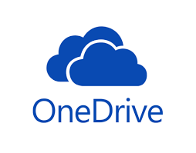  OneDrive | Dropbox
Storage Space | 5GB Free  50GB about £2.00 month  1TB about 69.99 year  And one computer also included is office 365  1TB each and office 365 for 5 PCs, Tablets, or 5 smartphones.  For £99.99 year | 5 GB Free
Advantage | OneDrive is now a part of Windows 10.  You don’t have to be online to use one drive it can be used offline.  Transfer speed are very fast | You only pay for what you use  By inviting friends and family you can increase your storage space  Smartphones, Social Media, Android, iOS, and Blackberry widely use it
Disadvantage | You only get 5GB free  There is no encryption for home users. | Developers have the right to delete information from free services  It has been hacked few times

Emails:
The email also is known as electronic mail, it has made writing a letter to anywhere in the word and sending it to one or multiple people in a matter of seconds. It has made communication fast and very reliable. In a working environment, an email is an essential tool that is widely used. On an email, you can attach document or photos maximum of 10 to 30 mega bites. You should always keep emails short and to the point and include the most important information on the subject.

Advantage of Email:

There are so many advantages for an Email
The ease of use
Fast and reliable
Good marketing tool for companies
Having proof that you have sent a message
A good way to spread your message, communicate with buyers and sellers.
Ask questions about a product and get a fast response.
Very convenient to contact out off hours because it can be sent any time of the day.
Save the environment by going paperless
Banks, Utility Bills, Legal Documents are all sent by emails nowadays.

Disadvantages of Email:

You can get viruses from an Email attachment
Once you register your Email address you get lots of spam emails
Your Email can be hacked
Sometimes you might not get the email because it went to spam.

Data software and hardware
The two are a part of the structure plans which allow data managing to be possible. The PCs and servers that people use in the affiliation are the gear part. Telephones, printers, and various another physical bit of the data plans in like manner outline some segment of the gear. Programming courses of action which can perform diverse endeavours on data like social event and examination are presented in PCs and other gear. Guaranteeing that both are of high gauge will guarantee correct and safe data dealing with (Tapscott, 2009).
Data safety and security
Data requires being shielded from the mishap which is a vital hazard to various affiliations. People can upset it intentionally, or machine frustration can realize the same. Further, its security can be imperilled if the association does not consider the usage of antiviruses, against malware, and firewalls. Staff can in like manner be prohibited from getting too specific unstable data through a watchword, get to rights and physical locking of the server rooms (Tapscott, 2009).
Social Media Account

3.1 Facebook
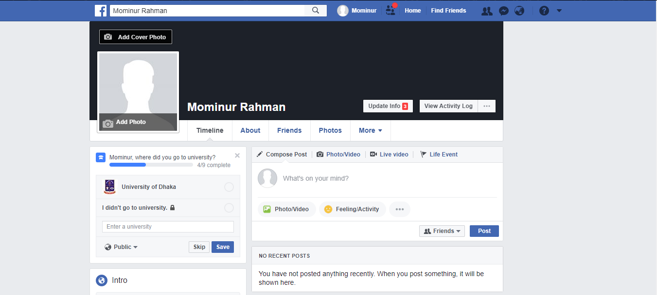
ID Link: https://www.facebook.com/mominur.rahman.5437923

3.2 LinkedIn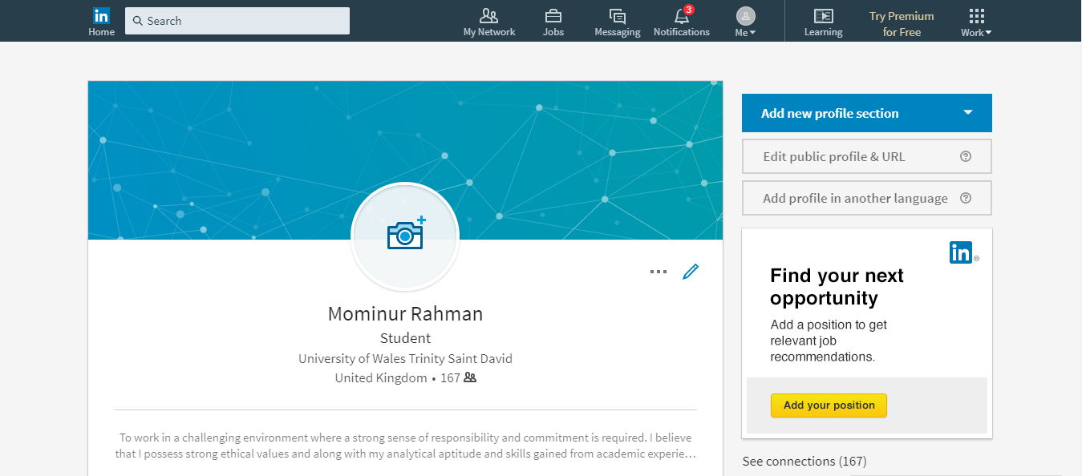
ID Link: https://www.linkedin.com/in/mominur-rahman-12674b156/

3.3 Twitter
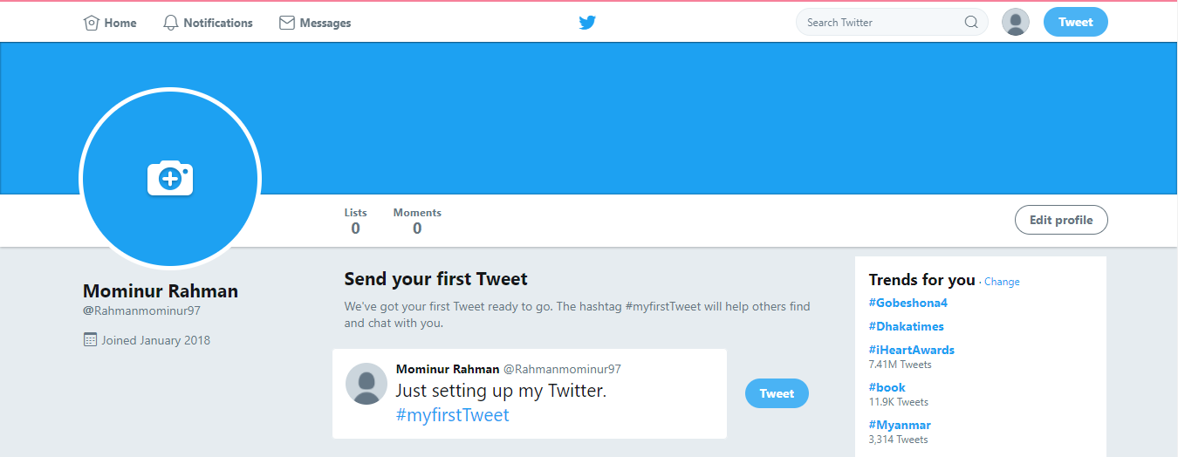
ID Link: https://twitter.com/mominurrahman564

Conclusion
With everything taken into account, this brief graph underlines the estimation of the undertakings made by work administrations, trade unions and organizations' relationship to facilitate capacities change issues and frameworks into the layout of methodologies on trade, development and nature. Coordination with the administrations and workplaces responsible for approach design and use in these locales is in this manner required if national preparing and aptitudes headway systems are to have the ability to: (1) plan workers, supervisors and young women and men with the capacities required by rising organizations and business; and (2) make national capacities to manage the advance among declining and creating fragments and occupations. Without such measures, the result will be inclination openings, high individual and social adjustment costs, and missed opportunities to help productivity, animate business advancement and develop change.

References
- De Marco, S., Robles, J. and Antino, M. (2014). Digital skills as a conditioning factor for digital political participation. Communications, 39(1).
- Eynon, R. and Geniets, A. (2015). The digital skills paradox: how do digitally excluded youth develop skills to use the internet?. Learning, Media and Technology, 41(3), pp.463-479.
- Holmes, N. (2007). Digital Technology and the Skills Shortage. Computer, 40(3), pp.100-99.
- Hsu, J., Wang, Z. and Hamilton, K. (2011). Developing and Managing Digital/Technology Literacy and Effective Learning Skills in Adult Learners. International Journal of Digital Literacy and Digital Competence, 2(1), pp.52-70.
- Radovanovic, D. (2012). Digital Divide and Social Media: Connectivity Doesn’t End the Digital Divide, Skills Do. SSRN Electronic Journal.
- Spiezia, V. (2017). Jobs and skills in the digital economy. OECD Observer.
- Tapscott, D. (2009). Grown up digital. New York: McGraw-Hill.
- Woods, E. and Murphy, E. (2013). Get the Digital Edge: a digital literacy and employability skills day for students. Journal of Information Literacy, 7(2).

