Project management plan

Name: Sara Al Hashidi
Student ID: 1919947
Name of university: University Of Wales Trinity Saint David
Name of lecturer: Daminabo Pokubo
Module code: BMSW5104
Module name: Managing projects in the workplace
Assignment title: Project management plan

Table of content
Introduction………….……………………………………………………………..….1
Definition of project management plan……………………………………2
Define what is scope………………………………………………………………..3
Project life cycle……………………………………………………………………….4
Stakeholder analysis………………………………………………………………..5
Work breakdown structure……………………………………………………...6
Quad chart……………………………………………………………………………….7
Risk management…………………………………………………………………….8
Tuckman’s five stages………………………………………………………………9
Conclusion………………………………………………………………………………10
Reference list………………………………………………………………………….11

Introduction
Project management plan is really important step that identifies the organisational process and how it functions from the start till the end. Launching a new project is to focus on the goals and objectives of an organisation. However, this report will demonstrate a new product that is launched and the key factors that is involved to produce the best idea implemented in the project. Sweetcorn mini market of multi flavour spices is the idea of this new product that will be known and developed to enhance the company’s reputation. Sweetcorn flavoured taste is an additional concept of the normal sweetcorn that will promote the sales and provide innovation to it. There will be around 50 different spices and flavours that will differ the taste from one another, and the key of the various sweetcorn taste is to include the spices of different countries which will enhance the organisation culture. The success of any business process is the key strategies and innovations that is put to promote and maintain the idea by planning the project to be able to manage it effectively. To support the idea of launching this product, the report will identify the steps, process, plan, scope and how this project will be done, the cost, time, budget and stakeholders involved. Moreover, to assess the function of such project, the report will cover a project life cycle, a quad chart to discuss the scope and project plan, a work breakdown structure (WBS), stakeholder analysis and risk management that may occur and how to reduce the possibility of its occurrence and impact.



Definition of project management plan

A project manager creates a Project Management Plan (PMP) with input from key stakeholders and the project team. The project management plan is a legally binding document that lays out how the project will be monitored and implemented (2021). This document, on the other hand, is utilised to identify the technique that the project team will use in providing the project's scope of project management (2021). The project management plan (PMP) is a set of baselines and supplementary plans that include management plans for scope, schedule, cost, and quality, as well as baselines for schedule, quality, cost, and scope, human resources, communication, risk, and procurement, as well as requirement management plans, change management plans, configuration management plans, and process improvement plans (2021).
The project management plan gives the process structure by putting all of the important aspects of the plan in order (2021). The goal of a project management plan is to figure out what the project's goal is, how it will be achieved, who will be engaged, and how the project will be communicated and measured. It also dictates how the objectives will be met, as well as the ability to identify stakeholders and the roles they will play in the process (2021). Any project's project management strategy, or planning, is necessary and critical. It does, however, assist in identifying the company's goals, avoiding missed deadlines, prioritising critical work, reducing risk, and delivering the intended results. It can also give a clear focus and objectives for the project, as well as adequate planning that allows communication, effective resource allocation, risk assessments, and project milestones to aid in project monitoring (2021).
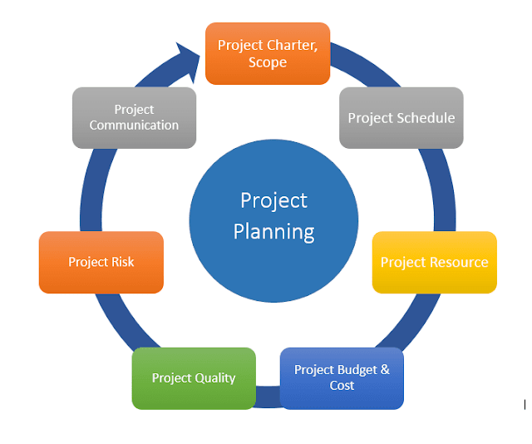
Define what is scope
The scope of a project refers to the set of requirements and objectives that must be met in order for it to be completed effectively. Scope management is a crucial aspect of every organisation because it determines the cost and duration of a project (Project Scope,2021). The scope of a project or a product specifies the resources and processes required to complete it. Scope management aids the organisation in recognising distinct variables of a project, allowing it to save money and time on the project. Project scope and product scope, on the other hand, are two distinct types of scope management (Project Scope,2021).
Project scope refers to all of the work that goes into delivering a product or service. It explains how the mission can be completed. It include identifying and recording the project's goals, members, tasks, milestones, and deadlines (Scope,2021). The scope statement, the breakdown of the work organisation, and the statement of work are all part of the documentation. It also identifies the project's limitations by stating what is not included in the plan's scope. It could include details on the project's budget and available resources. The scope of the project also contains project timeline information and task assignment (Scope,2021).
Product scope is mainly concerned with the end result. The function and qualities of the service or product are defined by the product scope (Project Scope,2021). The qualities, on the other hand, include functional specifications as well as physical aspects such as materials and size. Functional considerations define what the product is designed to do, as well as its intended function and purpose. The product scope is concerned with the actual offering or the outcome (Scope,2021). Product scope considers how to assess if the object is on track and being closely monitored for completion, as well as whether it achieves the desired result.
Scope creep, on the other hand, occurs when uncontrollable changes cause the project's deadlines to be extended. Extended deadlines have the potential to alter the project scope's original needs (Project Scope,2021). In order to properly manage the project, it is necessary to examine the likelihood of scope creep as well as ways to mitigate it. Scope creep can be avoided through recognising appropriate initial planning, the vision, and the core aim, as well as developing and implementing approaches (Scope,2021).
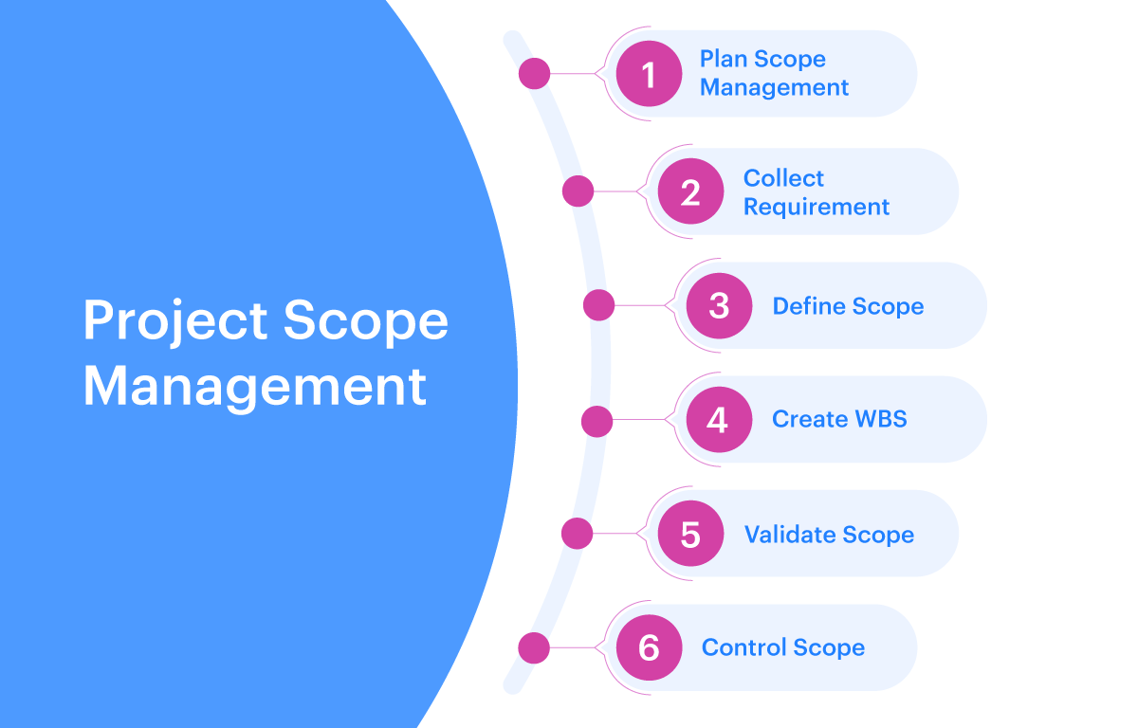
Project life cycle
Project management life cycle is a four step process that includes the initiating management stage, planning, executing and closure management. However, this project cycle provides a schedule planning to manage any types of project in a business. Leaders in project management conducts research to identify the best process that functions effectively to run a project. Project life cycle is important for organisations to define and plan projects effectively (Techniques and Cycle,2021).
- Identify the project scope
- Budget levels
- Indicate time frame
- Organise project roles

Initiating
- Schedule
- Overall budgets
- Resources
- Quality definition
- Risk assessment
- Planning communication
- Procedure planning
- Train staff
- Feedback
- Provide service
- Final handover to
customers
Project life cycle
Closure
Planning

Executing

- Manage changes
- Quality control
- Deliver outcome and outputs
- Stakeholders, team management

Source: (Techniques and Cycle,2021).

Stakeholder analysis
Stakeholder analysis is important in any organisational project that involves all of the internal individuals and teams within the project. The process of a stakeholder analysis is to identify the people included in the project before it begins, this is categorised according to the levels of participation, interests and influences (2021). However, launching a sweetcorn product with 50 different flavours require the company to conduct a stakeholder analysis to help maintain key stakeholders involves, promote interests and enhance the influence to attain project goal successfully ( Stakeholder Analysis,2021).

Stakeholders | Interests | Importance | Influence
Manager | Developing high quality of product and service. | Maintain good condition workplace environment for the staff, workers to work effectively. | Control over the project progress and financial aspects. Promote individuals to perform and develop product scope. Reduce risk of losing people involved.
Staff | Enhance customers satisfaction and engagement in purchasing new products advertised, meet their needs.  Manufacture good quality of sweetcorn continuously. | Produce 50 different flavours sweetcorn spices from different traditions. Develop work process, quality, service and production. | Lack of appropriate customer interactions, meet product quality expectation, negative customer feedback.
Customers | Expect high product quality, delicious sweetcorn taste, predicted product cost, high performance of service, issue resolutions. | High hygiene rate, online website availability, quick responsive staff. | Order delays, poor quality of product, different taste than usual, lack of customer assistance, wrong orders received.

Source; (Stakeholder Analysis,2021).

Work breakdown structure (WBS)
A work breakdown structure is a deliverable oriented hierarchical analysed of the work to be executed by the project team to be able to accomplish the project objectives and create the required deliverables. However, work breakdown structure helps to effectively conduct project planning, monitoring, reporting, controlling and executing (Work Breakdown Structure,2021). All the factors contained within the (WBS) is to be estimated, identified, budgeted and scheduled. It established the project scope and resources as well as the time needed to complete the project. the sweetcorn flavoured product team launch support its process by conducting a work breakdown structure to develop more structured project target (Work Breakdown Structure,2021).

Work packages | Cost (£) | Time consume | Responsibility | Resources
Order product | 800,000 | 2 months | Project manager, staff, investors | Manufacturers, drivers, workers
Approval of product | 500 | 3 weeks | Staff, project manager, investors, manufacturers | Materials, scan check, policy conduct legislation,
Generate product sweetcorn tasting | 9000 | 6 months | Employees, project manager and manufacturers. | 50 various spices from different countries, water, package
Product sale | 750,0000 | 5 months | Project manager, stakeholders | Market, online website, advertisement

Source; (Work Breakdown Structure,2021).

Quad chart
Quad chart is a form of technical documentation used to describe innovation through out a strategic planning tool. Sweetcorn flavoured product identifies scope of the project by implementing this descriptive method to demonstrate the project whole idea (2021).
Stakeholders
Aim/objective
- To produce new product in the market
- To develop company reputation
- To increase profit and sales
- To conduct additional product that people may be interested in
- Provide innovation and competitive advantage
- To enhance number of consumers for this specific product
- Develop organisational culture that involves different taste of different countries spices
- To enlarge a particular product creation and company investment
- To gain customer satisfaction

- Project manager
- Staff, workers
- Manufacturers
- Customers

Quad chart for launching a new sweetcorn flavoured product

Measure of success
Desired results
- Successful company reputation
- Trained staff
- Customer satisfied
- Developed workplace culture
- Desirable product
- High amount of purchase
- Positive customer feedback
- Additional profit sale
- Online orders
- Develop sweetcorn flavoured product further
- Increase profits
- Customers satisfaction
- Customer expectations and requirements met
- Promote company’s performance
- Produce a successful new product made by the company to achieve organisation goals
- Enhance workplace culture

Source: (2021)
Risk management
Project risk management is the process of identifying, analysing and responding to any risk that could arise over the project life cycle process, it helps the project to remain being on track and considering any sudden issue or risk that could damage the project plan and it also meet business goals by providing the possibilities of any risk that arise within the project (2021). However, risk management is important or the project planning to be able to identify risks that may occur in the project and how to control it if it occurs in fact (Ray.S,2021). Risk could potentially impact the level of performance in the project, timelines, or even the budget that is set for the project. Risk management is different from project to another, small project risk management may involve simple prioritised list of high, medium to low priority risks. Compared to large scale projects, risk management strategies might include extensive detailed planning for each risk to ensure mitigation strategies are conducted if risk arise anytime. However, for the sweetcorn flavoured product launch, the risk assessment is essential to determine the key risks that may arise in the future (Ray.S,2021).
Source; Ray.S,2021)
Risk | Impact | Likelihood | Overcome
Budget | The budget of the project might go over the plan which can impact on the business process as it may cause delays to complete the project within a certain duration. | The possibility of the budget risk that may arise is moderate because the project manager may not consider some external costs. | It is not hard to overcome this risk because, the project manager should prepare an additional amount for any barriers in case anything happens.
Stakeholders | Lack of employees could impact on the business work, sufficient staff is required for the project to deal with different tasks.  Lack of customer also have a huge impact on the profit and success of the business | The possibility is very high because, having enough number of the workers and consumers have a significant role in maintaining the process of the project. | Associating with this risk management can be by providing the new employees and staff with training.  Engaging the customers by meeting their needs and expectations.
Customer review | Customers review and feedback could have an impact on the business. Launching a new product such as sweetcorn flavoured project can either add an advantage or disadvantage to the company.  The company’s reputation is important for new customers recommendations. | This can likely occur depending on the performance of the project. | Employees can reduce this by providing each customer needs, improve service and product quality, and provide surveys frequently.  This helps to enhance business productivity and helps to identify negative feedback to be improved.
Tuckman’s five stages

In many projects and occupations employees are required to work together in teams. It always takes some time for employees to get familiar with each other and the different ways in which each individual work. Therefore, there is a theory that facilitates the steps where teams go through team development five stages before any business can reach its potentials (Tuckman’s Theory,2021). Tuckman’s theory was proposed consisting the five common stages that each team take to establish within a project or organisational plan. However, Sweetcorn project team decide to adopt the theory of Tuckman’s five developmental stages to enhance teamwork and promote the function of the business team. These five development stages plays a significant role in building a productive, effective team members (Tuckman’s Theory,2021).
Tuckman’s five development stages are forming, storming, norming, performing and adjourning. Sweetcorn project team require to go through these development stages to indicate the different process that involves in reaching the common goals of the team members (Tuckman’s Theory,2021).
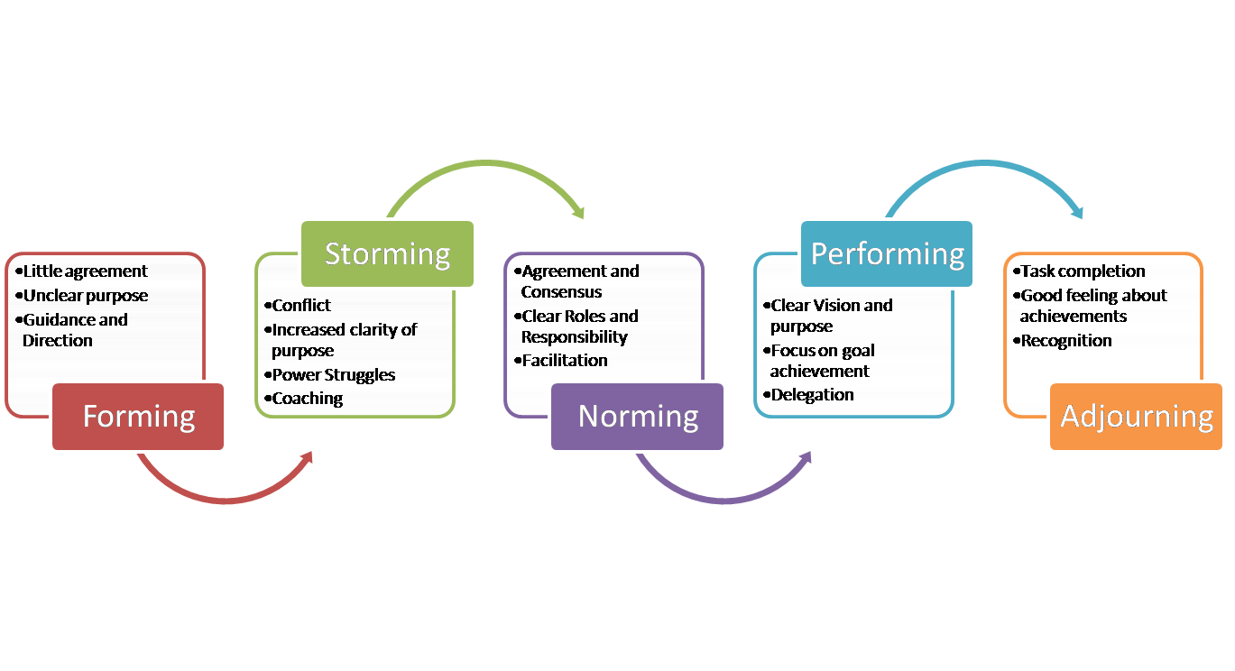
Source; (Tuckman’s Theory,2021)

Conclusion
In conclusion, project management plan is the key aspect to build a successful project, develop its performance and promote its potentials as well as maintaining a continues high quality of product and services. Planning is an essential step of project attainment and it improves the project innovation and future success. Launching a new project needs identification of the significant barriers and methods that determines ways in which each factor can be reached (Productivity,2021). However, planning each steps of the project and the overall process of the project facilitates the actions while implementing to achieve the goals. Its important for the project manager to consider the different steps that needs to be done, how it can be done, who will be involved, who is targeted, aims and goals to achieve, profit, budget, methods , duration, and allocated resources etc. Project scope management plan outlines the process involved in executing a certain project and it delivers and serves as a guideline to keep the project within a specific limit. The main purpose of scope management plan is to create project structure by documenting the resources needed to attain the project objectives. Being able to produce a scope management plan reduce the chance of scope creep which occurs if any unexpected change arise (Productivity,2021).

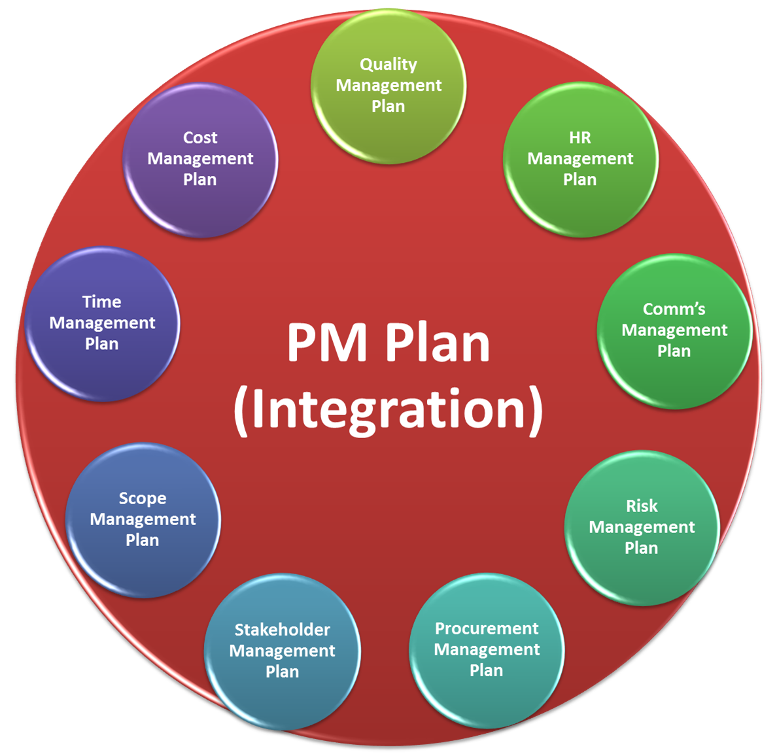

Reference list

- Apm.org.uk. 2021. What is risk management? | APM. [online] Available at: <https://www.apm.org.uk/resources/what-is-project-management/what-is-risk-management/> [Accessed 18 November 2021].

- Business Opportunities. 2021. The Importance of Planning in Project Management – Productivity. [online] Available at: <https://www.business-opportunities.biz/2019/12/28/importance-planning-project-management/> [Accessed 17 November 2021].

- Eln.co.uk. 2021. Tuckman's Theory of Group Development | ELN Blog. [online] Available at: <https://www.eln.co.uk/blog/tuckmans-theory-of-group-development> [Accessed 18 November 2021].

- FreshBooks. 2021. Tuckman's Theory: Five Stages of Team Development. [online] Available at: <https://www.freshbooks.com/hub/other/tuckmans-theory> [Accessed 17 November 2021].

- Investopedia. 2021. Scope. [online] Available at: <https://www.investopedia.com/terms/s/scope.asp> [Accessed 17 November 2021].

- Mavenlink.com. 2021. What is the Project Life Cycle | Mavenlink. [online] Available at: <https://www.mavenlink.com/resources/what-is-the-professional-services-project-life-cycle> [Accessed 17 November 2021].

- Mindtools.com. 2021. Stakeholder Analysis: Winning Support for Your Projects. [online] Available at: <https://www.mindtools.com/pages/article/newPPM_07.htm> [Accessed 18 November 2021].

- Opinaldo, N. and Opinaldo, N., 2021. What is Stakeholder Analysis: Definition and Example. [online] Gitmind.com. Available at: <https://gitmind.com/stakeholder-analysis.html> [Accessed 18 November 2021].

- Ray, S. and Ray, S., 2021. The Risk Management Process in Project Management. [online] ProjectManager.com. Available at: <https://www.projectmanager.com/blog/risk-management-process-steps> [Accessed 17 November 2021].

- Techniques, P. and Cycle, P., 2021. The Project Management Life Cycle. [online] Project Management Skills. Available at: <https://www.project-management-skills.com/project-management-life-cycle.html> [Accessed 17 November 2021].

- The Online Learning Platform. 2021. Project Scope - 6 Steps to Define the Scope of a Project - Potential.com. [online] Available at: <https://www.potential.com/articles/project-scope/> [Accessed 17 November 2021].

- Thinkoutsidetheslide.com. 2021. [online] Available at: <https://www.thinkoutsidetheslide.com/issue-348-october-13-2015/> [Accessed 17 November 2021].

- toolshero. 2021. Stakeholder Analysis. [online] Available at: <https://www.toolshero.com/change-management/stakeholder-analysis/> [Accessed 17 November 2021].

- Upwork.com. 2021. The 5 Stages of Team Development (Including Examples) | Upwork. [online] Available at: <https://www.upwork.com/resources/stages-of-team-development> [Accessed 18 November 2021].

- Visual-paradigm.com. 2021. What is Work Breakdown Structure?. [online] Available at: <https://www.visual-paradigm.com/guide/project-management/what-is-work-breakdown-structure/> [Accessed 17 November 2021].

- workbreakdownstructure.com. 2021. Work Breakdown Structure. [online] Available at: <https://www.workbreakdownstructure.com/> [Accessed 17 November 2021].

- 2021. [online] Available at: <https://www.simplilearn.com/what-is-a-project-management-plan-article> [Accessed 17 November 2021].

- 2021. [online] Available at: <https://study.com/academy/lesson/project-management-plan-definition-purpose-examples.html> [Accessed 17 November 2021].

- 2021. [online] Available at: <https://www.pmi.org/learning/library/stakeholder-analysis-pivotal-practice-projects-8905> [Accessed 17 November 2021].

