
School of Hospitality & Tourism Management
BA International Hotel Management

Module Financial Management for the Hotel Industry
Student Name: Sabbir Ansar Hussain
Student ID: 2233891
Lecturer: Tristan Hawkins
Module Code: BMIH5007

Declaration
I certify that no artificial intelligence technologies of any kind were utilised during the whole research, writing, or editing process. The assignment is the result of my independent work and original thought process. I confirm I have copies of my resources I used, which I may be asked to provide in evidence.

Table of Contents
Introduction 3
Comparison between Shangri-La Hotels and Premier Inn Hotels 3
Total Revenue 3
Market Position 6
Growth Potential 7
Financial Commitment to CSR (Corporate Social Responsibility) 8
Conclision 10
Recommendations 10
References 12

Introduction
The hospitality industry has undergone tremendous change in the last couple of years. This has been evidence for the same as per the changing preferences and economic implications of COVID-19. This report provides a comparative analysis of two of the major players in this sector, namely Shangri-La Hotels and Premier Inn. Shangri-La is a luxury hotel chain focusing on high-quality services and personalised service, blurring exclusive Asian hospitality in the operations of more than 104 hotels and resorts in 78 destinations with around 44,000+ employees globally (Shangri-La Group, 2024a). Premier Inn is a budget hotel group with a strong presence in the UK's budget hotel chain, offering 85,443 accommodations with more than 800 locations across the United Kingdom and Ireland (Statista, 2024a). Total revenue, market position, growth potential, and CSR commitments are considered in the analysis brief. By examining these factors, the research will be able to come up with findings pertaining to the strategies of financial management embraced by both hotel chains and their reaction to the new hospitality scenario (Walker, 2021).

Comparison between Shangri-La Hotels and Premier Inn Hotels

Total Revenue
Shangri-La
The most recent financial reports from Shangri-La show that the company's total revenue (TTM) is ₹122.93 billion. The company made ₹122.93 billion in 2022, which was more than the ₹104.34 billion it made in 2021(CompaniesMarketcap.com, 2024). The return of international travel fueled it; the credit for that goes to further relaxation of COVID-19 restrictions. The luxury segment rooms contributed to the highest share of revenue, which increased by 20% annually from USD 130 to USD 155, even though the Group's operating cash flow and operating profit after tax from operating properties was positive for the first time since the Covid-19 pandemic in the Asia and Pacific regions (Shangri-La Asia Limited, 2022).
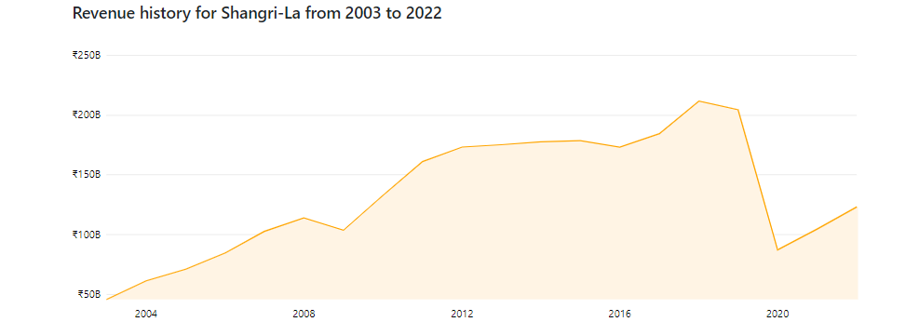
Figure 1: Revenue history for Shangri-La from 2003 to 2022
Source: (CompaniesMarketcap.com, 2024)
Shangri-La sources revenue from room bookings, dining, spa services, and hosting events, all high-end services. During the past couple of years, demand for luxury travel rebounded as countries such as China, Hong Kong, and Singapore saw an increase in demand from the affluent populations (Learnings from the concept of Supply, Demand Pricing, and pg. 11). According to data from the Grand View Research (2024), luxury travel is expected to increase at CAGR of 7.9% from 2024 to 2030 due to the increase in the spending of the elite customers for travelling.
By 2022, Shangri-La's RevPAR (Revenue per Available Room) had grown by 25% as it went from $ 51 to $ 64, even though there were ongoing challenges in mainland China and Hong Kong. Considering the areas outside these, RevPAR rose 130% to USD 100. The Group also used cost-management strategies to improve profits (Shangri-La Group, 2022).
Premier Inn:
Premier Inn reported yearly revenues in Europe of approximately 2.96 billion British pounds during the fiscal year 2023–2024. Compared to prior years, this represented an increase of more than 300 million British pounds (Statista, 2024b). Growth within the business was mainly accounted for by a bounce back in domestic leisure and increased business travel, with the chain averaging 79.1% occupancy. Premier Inn's model is about consistent, affordable accommodation-a formula that works resiliently during times of economic fluctuation. The budget hotel chain exploited the dominant market position by charging competitive prices without risking the quality of service. It recorded an average room rate of £79.76/night, thus being attractive to families and business travellers (Statista, 2024c). Revenues for Premier Inn are largely from room sales, while its ancillary services have gained popularity, including restaurant services, which increased food and beverage sales by 12%.
The chain has strategically invested in its properties, refurbished hotels, and expanded itself in key urban areas. This commitment to quality and customer satisfaction has helped it sustain occupancy rates even in trying economic times. Premier Inn, through effective marketing strategies (Rest Easy Campaign) and loyalty programs, developed strong customer relationships; their revenue went stable and aided them in boosting customer volume from 4.2 mn in the year 2018 to 5.9 mn in 2022, depicted in Figure 2.
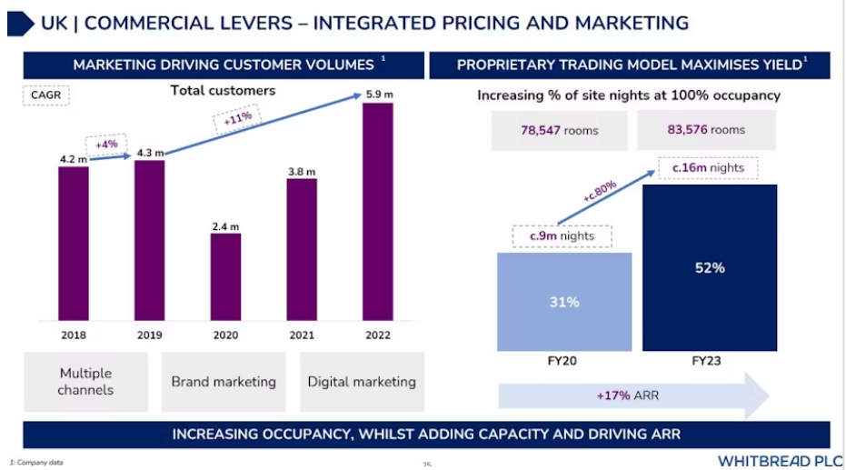
Figure 2: Marketing Driving Customer Volumes
Source: (Stephenson, 2023)

Comparison:
Shangri-La and Premier Inn, plan to generate revenues in comparison and contrast. While Shangri-La acquires high-value customers through luxury Asian hospitality pricing and personal service (Shangri-La Asia Limited, 2022b). Premier Inn follows a volume-based strategy for budget-conscious travellers. Due to Shangri-La's focus on upscale experience and exclusivity, it strategically lies in the luxury market. Conversely, Premier Inn's idea of affordability makes it a market leader in the budget market; they suggest their customers book early to avoid higher prices of the accommodations (Premier Inn, 2024). Both companies have benefited from market trends in different ways-targeting specific segments of customers: the post-pandemic recovery in travel and growth in consumer spending for Shangri-La's luxury travel business and for Premier Inn through its well-established position within the domestic market.

Market Position
Shangri-La Hotels:
Shangri-La Hotels’ room accommodation displays enticing designs, astounding dining facilities, and first-class amenities. The hotel group, with a Comparably Score of 81/100, outperforms its rivals in terms of overall culture and employee satisfaction NEP of 49, meaning it scored rather high in customer loyalty and satisfaction (Comparably, 2024). Shangri-La's strategic positioning proclaims its luxury offer; it also focuses on delivering unforgettable experiences (Comparably, 2024). It is famous for its Horizon Club service, offering elite members special privileges in return for loyalty from customers. Key markets for Shangri-La are in the Asia-Pacific regions, where demand for luxury accommodations still lingers around.
Premier Inn:
Premier Inn boasts more than 800 hotels and over 80,000 rooms, targeting budget-conscious travellers looking for affordability without costing too much. In fact, for 2022, the company delivered an NPS of 58, manifesting a strong, good level of customer satisfaction and loyalty (Rogers, 2019). The market position at Premier Inn is reliability and accessibility. Premier Inn is actually very famous for its massive presence in the UK. This makes it a suitable place for both leisure and business travellers. Premier Inn continues to offer better facilities to ensure that customers get the same quality of service (Page and Connell, 2020). Among these are comfortable rooms, on-site eating and drinking venues, and state-of-the-art modern facilities.
Comparison:
The positioning of Shangri-La appeals well to the profitable traveller who strives for high-life experiences; conversely, Premier Inn emphasises affordability and access, attracting customers aiming for value. Both have developed powerful imagery in their markets, thus becoming loyal to the customers. Shangri-La's philosophy focuses on "hospitality from the heart" or feeling emotional bonds with guests through warm, personalised service (Martin Roll, 2017). Premier Inn's consistent quality has provided a robust base in the budget segment.

Growth Potential
Shangri-La Hotels:
Expansion and growth for Shangri-La are through geographic expansion into emerging markets in luxury. Shangri-La's growth potential is the strongest: it focuses on several key markets in China with new properties such as Shangri-La Nanshan and JEN Kunming, targeting high-demand areas by affluent consumers, focusing more on luxury and sustainability (Shangri-La, 2024). Market analyses from recently available studies suggest that the global luxury hotel market will grow at a CAGR of 6.5% through 2027.
Shangri-La may face economic downturns that may very easily affect the high-end market of luxury travel. The high cost of maintaining operational standards of luxury and the nature of high-end markets is extremely competitive in comparison (Drury, 2024). Geopolitical tensions, as well as health crises such as COVID-19, can impact the ability to travel and, thereby, affect occupancy rates (Tsui and Chi, 2022).
Premier Inn:
Premier Inn is focused not only on expansion in the UK but also on opportunities in Europe. Its ambition is to step up its presence in about 3,000 rooms by the year 2025, targeting the city centre and other space-constrained areas with much-needed budget accommodations (Caswell, 2024). The plan for this chain is to have its presence in European countries, particularly in Germany, from where it will gain a share of the budget market. The UK budget hotel market is pegged to grow at 4.1% CAGR till 2025, primarily influenced by growth in the demand for affordable accommodations and changing lifestyles (Smallbusinessworldjournal.com, 2024). Premier Inn's challenges are at its doorstep in the form of competition in the market and saturation in the budget segment. The chain needs to continually evolve to keep up with changing customer preferences and maintain its service quality in the market to survive.
Comparison:
When compared, the growth strategies of both of them reveal that Shangri-La is majorly focused on geographical expansion into luxury markets (Shangri-La Circle, 2024). Premier Inn focuses more on expansion in the budgetary space. Each of them has its own set of issues, and in the case of Shangri-La, there would have been fluctuating economics as well as operating costs; and in the case of Premier Inn, competition as well as market saturation could lead to most of the problems. The growth of Shangri-La in relation to capturing growth in emerging markets is at par with the overall development of luxury travel (Woo and Mun, 2020). The Premier Inn strategy, on the other hand, is geared to take advantage of the budget travel industry.

Financial Commitment to CSR (Corporate Social Responsibility)
Shangri-La Hotels:
Shangri-La Hotels have corporate social responsibility as part and parcel of their business strategy. The company aims to reduce carbon emissions and energy intensity. For this, they have implemented green building standards design and constructed renovated projects using rooftop solar installations (Shangri-La Group, 2024b). It installed energy-efficient technologies in every property to reduce consumption. With house visits, pre-packaged meals, and necessary supplies, Shangri-La hotels provided 26,000 volunteer hours of COVID-19 pandemic aid in 2022, helping nearly 200,000 members of underprivileged communities worldwide (Shangri-La Asia Limited Sustainability Report, 2022b).
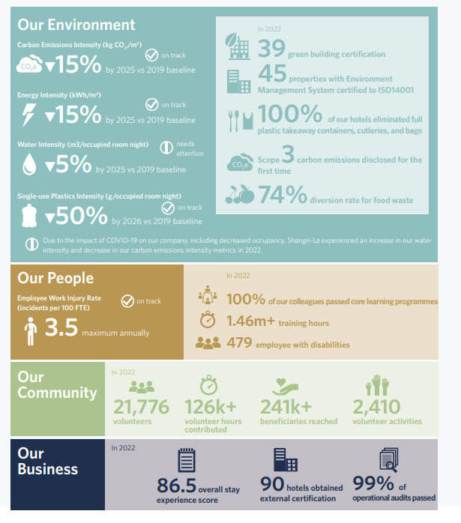
Figure 3: Sustainability at a glance
Source: (Shangri-La Asia Limited Sustainability Report, 2022b)
Premier Inn:
Premier Inn also emphasizes CSR with a focus on sustainability and social impact in its operations. The company has ambitious targets to reduce carbon emissions by as much as 50% by 2025 and 88% by 2050 and has invested a great deal into renewable energy sources, like solar panels and energy-saving technologies (Premier Inn, 2018).
Implementing many measures to reduce food waste from its restaurant sections and promoting recycling activities in all its hotels. It liaises with local charities and companies to build on and bring employment to the community. It offers diversity in its workforce and equal opportunities to all employees from underrepresented groups like gays, lesbians, and others (Premier Inn, 2024).
Comparison:
Based on their CSR commitment, Shangri-La and Premier Inn are taking steps towards sustainability as well as community engagement through the CSR initiative. While Shangri-La may focus on luxury sustainability initiatives to attract such a high-end traveller, Premier Inn could focus on responsible practices in a budget segment (Martin Roll, 2017). Each has adopted direct, clear-cut sustainability goals and is also demanding accountability of the local communities in their region; both have fortified their corporate reputation. Shangri-La's luxury positioning demands a premium over sustainability efforts. Premier Inn places a specific emphasis on its budget-friendly approach to cost-effectiveness and accessibility (Whitebread. Co, 2023).

Conclusion:
This comparative analysis of Shangri-La Hotels and Premier Inn brings out distinctive strategies through which each of the brands progresses with markets in different ways. Shangri-La has focused on luxury and bespoke experiences, thus advantageously positioning itself in the high-end segment, whereas Premier Inn has stayed ahead in the budget market by being focused on affordability and accessibility. Both the brands showed resilience in the difficulties posed due to COVID-19 and have dealt with revenue growth because of shifts in consumers' preferences as well as a bounce in demand for travel. Both companies are well positioned to take advantage of emerging market opportunities: Shangri-La goes for emerging luxury markets while Premier Inn continues its expansion into the UK and Europe. Their commitment to corporate social responsibility also reflects a deepening appreciation within the hospitality industry for sustainability as an important factor in customer loyalty and brand reputation.

Recommendations:
Shangri-La Hotels:
Shangri-La should look towards digital platform upgrading, which may include an easy mobile app and AI-driven services, which will provide a more personalised customer experience (Chaturvedi and Verma, 2023). Digital engagement is the future of luxury, and advanced technology will avail tailored offers, make booking easier, and spike direct sales. The expansion to new markets that are becoming luxury destinations like Vietnam or Cambodia since affluent travellers are resorting to these countries to discover high-end hospitality experiences (George, 2023).
Premier Inn:
Premier Inn should further expand more of its international markets, focusing more on Europe in which budget travel continues to rise. Diversification cuts risks associated with a one-regional market focus. Further, the more digital transformation opportunities in improving mobile booking and integrating AI for personal budget travel reviews will allow it to play in changing patterns of travel (Millere and Rivza, 2022). With shifting travel demand for budget-conscious trips, Premier Inn can gain a larger market share by being agile and digitally competent in understanding and fulfilling these changes in consumer preference over time (Seal, 2019).

References
Caswell Mark, (2024). Whitbread to convert underperforming restaurants into Premier Inn rooms [Online] Available at: https://www.businesstraveller.com/business-travel/2024/05/01/whitbread-to-convert-underperforming-restaurants-into-premier-inn-rooms/ [Accessed 12 October 2024].
Chaturvedi, R. and Verma, S., (2023). Opportunities and challenges of AI-driven customer service. Artificial Intelligence in customer service: The next frontier for personalised engagement, pp.33-71. Available at: https://link.springer.com/chapter/10.1007/978-3-031-33898-4_3 [Accessed 12 October 2024].
CompaniesMarketcap.com, (2024). Revenue for Shangri-La (0069.HK) [Online] Available at: https://companiesmarketcap.com/inr/shangri-la/revenue/ [Accessed 12 October 2024].
Comparably, (2024). Shangri-La Hotels and Resorts Ranks 1st in Overall Culture Score [Online] Available at: https://www.comparably.com/companies/shangri-la-hotels-and-resorts/competitors [Accessed 12 October 2024].
Drury C (2021) (11th Ed) Management and Cost Accounting, London, Prentice Hall Available at: https://nibmehub.com/opac-service/pdf/read/Management%20and%20Cost%20Accounting.pdf [Accessed: 12 October 2024].
George Diamantopoulos, (2023). Phu Quoc: Vietnam’s emerging luxury tourism escape [Online] Available at: https://www.traveldailynews.asia/hotels-lodging/phu-quoc-vietnams-emerging-luxury-tourism-escape/ [Accessed 12 October 2024].
Kindzule-Millere, I. and Zeverte-Rivza, S., (2022). DIGITAL TRANSFORMATION IN TOURISM: OPPORTUNITIES AND CHALLENGES. In Economic Science for Rural Development Conference Proceedings (No. 56). Available at: https://llufb.llu.lv/conference/economic_science_rural/2022/Latvia_ESRD_56_2022-476-486.pdf [Accessed 12 October 2024].
Martin Roll, (2017). The Shangri-La brand communication strategy [Online] Available at: https://martinroll.com/resources/articles/asia/shangri-la-hotels-resorts-bringing-asian-hospitality-to-the-world/ [Accessed 12 October 2024].
Page, S.J. and Connell, J., (2020). Tourism accommodation and hospitality services. In Tourism (pp. 216-241). Routledge. Available at: https://www.taylorfrancis.com/chapters/edit/10.4324/9781003005520-12/tourism-accommodation-hospitality-services-stephen-page-joanne-connell [Accessed 12 October 2024].
Premier Inn, (2018). Our Earth Day commitment to cut our carbon emissions intensity by 50% [Online] Available at: https://www.premierinn.com/gb/en/news/2018/world-earth-day.html#:~:text=To%20mark%20Earth%20Day%2C%20we,based%20carbon%20target%20(SBT). [Accessed 12 October 2024].
Premier Inn, (2024). FAQs | Room rates [Online] Available at: https://www.premierinn.com/gb/en/faq/room-rates.html#:~:text=The%20higher%20the%20demand%20for,book%20early%20to%20avoid%20disappointment. [Accessed 12 October 2024].
Premier Inn, (2024). We value difference at Premier Inn [Online] Available at: https://www.premierinn.com/gb/en/terms/diversity-and-inclusion.html#:~:text=We're%20committed%20to%20supporting,term%2C%20and%20people%20with%20disabilities. [Accessed 12 October 2024].
Rogers Charlotte, (2019). Just 10% of brands in the UK excel at customer experience [Online] Available at: https://www.marketingweek.com/brands-excel-customer-experience-nps/ [Accessed 12 October 2024].
Seal W (2019) (6th Ed) Management Accounting, London, McGraw Hill Available at: https://www.mheducation.co.uk/management-accounting-6e-9780077185534-emea-group [Accessed 12 October 2024].
Shangri- La, (2024). Shangri-La Group Expands Its Presence in China with Shangri-La Nanshan, Shenzhen and JEN Kunming by Shangri-La [Online] Available at: https://www.shangri-la.com/group/media/media_post?post=Shangri-La%20Group%20Expands%20Its%20Presence%20in%20China [Accessed 12 October 2024].
Shangri-La Asia Limited Sustainability Report (2022). Sustainability at A Glance [Online] Available at: https://sitecore-cd.shangri-la.com/-/media/Project/Shangri-La-Group/Investor/Files/Corporate-Governance-and-CSR/Sustainability-Reports/2022_SLA_Sustainability-Report_EN.pdf [Accessed 12 October 2024].
Shangri-La Asia Limited, (2022a). Introduction and 2022 Key Financial Highlights [Online] Available at: https://sitecore-cd.shangri-la.com/-/media/Project/Shangri-La-Group/Investor/Files/Public-Disclosures/Latest-Top-Publications/e0069_230418_AR.pdf [Accessed 12 October 2024].
Shangri-La Asia Limited, (2022b). Beyond Covid: Recovery and Growth Initiatives [Online] Available at: https://sitecore-cd.shangri-la.com/-/media/Project/Shangri-La-Group/Investor/Files/Public-Disclosures/Latest-Top-Publications/e0069_230418_AR.pdf [Accessed 12 October 2024].
Shangri-La Circle, (2024). Shangri-La Circle [Online] Available at: https://www.shangri-la.com/ [Accessed 12 October 2024].
Shangri-La Group, (2022). Shangri-La Group Releases 2022 Full Year Results [Online] Available at: https://www.shangri-la.com/group/media/media_post?post=Mar24_2022AnnualResults#:~:text=The%20Group%20increased%20its%20owned,COVID%2D19%20outbreaks%20throughout%202022. [Accessed 12 October 2024].
Shangri-La Group, (2024a). Our Presence [Online] Available at: https://www.shangri-la.com/group/ [Accessed 12 October 2024].
Shangri-La Group, (2024b). Driving Energy Efficiency and Reducing Carbon Emissions [Online] Available at: https://www.shangri-la.com/group/sustainability/stay/ [Accessed 12 October 2024].
Smallbusinessworldjournal.com, (2024). Budget Hotels Market: Rising Valuation to Reach $430.9 billion by 2032, Fueled by Strong CAGR of 4.1% [Online] Available at: https://www.smallbusinessworldjournal.com/article/723085754-budget-hotels-market-rising-valuation-to-reach-430-9-billion-by-2032-fueled-by-strong-cagr-of-4-1 [Accessed 12 October 2024].
Statista, (2024a). Number of Premier Inn (Whitbread) hotel rooms in the United Kingdom and Ireland from 2011/12 to 2023/24 [Online] Available at: https://www.statista.com/statistics/629446/whitbread-premier-inn-hotel-rooms-united-kingdom-uk/ [Accessed 12 October 2024].
Statista, (2024b). Annual revenue of Whitbread in Europe from 2011/12 to 2023/24 [Online] Available at: https://www.statista.com/statistics/511372/total-revenue-whitbread-united-kingdom-uk/ [Accessed 12 October 2024].
Statista, (2024c). Premier Inn: average room rate in the UK and Ireland 2009-2024 [Online] Available at: https://www.statista.com/statistics/740692/premier-inn-arr-average-room-rate/ [Accessed 12 October 2024].
Stephenson, (2023). Premier Inn owner hails brand marketing a ‘powerful tool’ [Online] Available at: https://www.thinkwithgoogle.com/intl/en-emea/marketing-strategies/search/premier-inn-captures-40-more-bookings-with-google-hotel-ads/ [Accessed 12 October 2024].
Tsui, S. and Chi, L.K., (2022). Surviving through community building in catastrophic times. Monthly Review, 74(3). Available at: https://our-global-u.org/oguorg/en/download/Conferences/ssfs9/SIT-TSUI-and-LAU-KIN-CHI-Surviving-Through-Community-Building-in-Catastrophic-Times-2022-.pdf [Accessed 12 October 2024].
Walker J (2021) Introduction to Hospitality, Harlow, Pearson Available at: https://www.pearson.com/en-us/subject-catalog/p/introduction-to-hospitality/P200000001995/9780137496020 [Accessed on: 11 October 2024].
Whitebread.Co, (2023). The Economic Impact of Premier Inn Hotels [Online] Available at: https://cdn.whitbread.co.uk/media/2023/08/The-Economic-Impact-of-Premier-Inn-hotels_2022-study_final.pdf [Accessed 12 October 2024].
Woo, L. and Mun, S.G., (2020). Types of agglomeration effects and location choices of international hotels in an emerging market. Tourism Management, 77, p.104034.Available at: https://www.sciencedirect.com/science/article/pii/S0261517719302328 [Accessed 12 October 2024].

