Accor Hotel Group audit report

Student name: Marina Ancuta
Student number: 2122372
Module: BMIH5004- Management & Organisational Behaviour
Lecturer name: Jaliya De Silva

Contents
I. Introduction 3
A. Background 3
II. Organisation Structure, Culture, and Goals 3
A. Organizational Structure 3
1. Overview 3
B. Organizational Culture 4
1. Cultural Analysis 4
2. Implications of Culture on Operations 7
C. Organizational Goals 7
1. Stated Goals 7
III. Recent Change Initiatives and Management 8
A. Overview of Recent Change Initiatives 8
1. Identify Changes 8
2. Impact Analysis 8
B. Change Management 8
1. Application of Dobson's Guide to Changing Culture 8
2. Employee Feedback 9
IV. Strategic Direction and Current Business Performance 10
A. Strategic Direction 10
1. Current Strategy 10
2. Strengths and Weaknesses 11
B. Business Performance 12
1. Financial Performance 12
2. Key Performance Indicators (KPIs) 12
V. Conclusion 13
A. Summary of Findings 13
B. Recommendations 13
VI. Reference list 14

I. Introduction

A. Background
Accor Hotel Group, a prominent player in the global hospitality industry, has witnessed substantial growth and change. Accor operates in over 5,100 locations in 110 countries, encompassing a wide range of brands and services, including luxury, premium, midscale, and economy hotels, as well as upscale private residences and vacation properties.
Accor's portfolio includes well-known brands such as Sofitel, Novotel, Ibis, Mercure, and Fairmont, catering to various market segments and traveler preferences. The company has also expanded its offerings beyond traditional hotel services, incorporating lifestyle and experience-oriented elements into its business model. (Ogbonna, Harris, 2022).
Accor has been at the forefront of industry trends, emphasizing innovation, sustainability, and digital transformation. This report conducts a thorough audit of the organization at both the corporate and individual unit levels, applying key theories such as Schein's layered conceptualization of culture and Dobson's guide to changing culture (Higgins, 2017). The focus is on three critical areas: organization structure, culture, and goals; recent change initiatives and their impact; and the organization's strategic direction and current business performance.
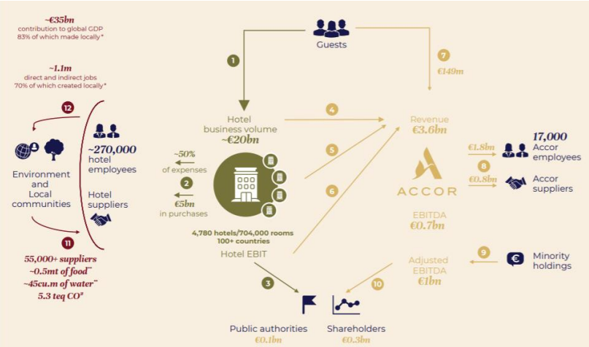
Figure 1 The Accor business model

II. Organisation Structure, Culture, and Goals

A. Organizational Structure

1. Overview
Accor Hotel Group exhibits a complex organizational structure that reflects its expansive global operations. The hierarchy is divided into corporate and unit levels, with distinct reporting lines. Accor has a multi-brand and decentralized organizational structure, reflecting its diverse portfolio of hotel brands and services (Seidu, et al, 2022). The structure is designed to accommodate the varied needs and characteristics of different market segments. Here's a simplified breakdown of Accor's organizational structure:
Corporate Level:
Board of Directors: The Board of Directors provides strategic direction and oversight at the highest level. It includes executives with diverse expertise, often led by a Chairman and Chief Executive Officer (CEO). (Rutherford, O\’Fallon, 2007).
Executive Committee: The Executive Committee, led by the CEO, consists of top-level executives responsible for key strategic decisions and operational management.
Business Units or Divisions:
Hotel Operating Divisions: Accor's various brands are often organized into operating divisions based on market segments. For example:
Luxury Brands Division (e.g., Sofitel, Raffles, Fairmont)
Premium Brands Division (e.g., Pullman, MGallery, Swissôtel)
Midscale & Economy Brands Division (e.g., Novotel, Mercure, Ibis)
Geographic Divisions: Accor may organize its structure based on geographic regions, allowing for localized strategies and operations. For instance, divisions for Europe, Asia-Pacific, Americas, etc.
Individual Hotels and Properties:
Hotel Level Management: Each individual hotel operates with its own management team responsible for day-to-day operations. This may include roles such as General Manager, Sales Manager, Operations Manager, etc.
Staff at the Property Level: Within each hotel, there are various departments, including front office, housekeeping, food and beverage, and more, each with its own management and staff.

B. Organizational Culture

1. Cultural Analysis
Accor's culture is characterized by a blend of professionalism and hospitality. The hierarchical structure is reflected in the day-to-day operations, where clear reporting lines are maintained. The emphasis on customer service creates a positive and service-oriented atmosphere.
Analysing Accor Hotel Group's cultural conduct through Schein's model indicates a culture that values consistency in service delivery, emphasizes a customer-centric approach, and is committed to corporate responsibility (Jinkyung Jenny Kim, 2023). However, underlying assumptions related to hierarchy and the balance between stability and innovation might influence the organization's adaptability. Recognizing and addressing these assumptions can contribute to a more agile and responsive organizational culture. Regular assessment and alignment with evolving industry trends are essential for sustaining a positive and adaptive organizational culture. (Gheorghe, et al, 2019)
1.1 Artifacts:
Artifacts are the visible, tangible aspects of culture. They include behaviours, symbols, and structures.
Uniformity in Service Standards:
  - Artifacts: Standardized service processes, consistent across Accor brands, indicate a shared understanding of how service should be delivered.
  - Analysis: The uniformity in service standards reflects the visible and tangible aspect of Accor's culture, emphasizing consistency and quality in guest experiences.
- Branding and Visual Identity:
  - Artifacts: Accor's logo and visual branding convey a professional and global image, representing a shared symbol across the organization.
  - Analysis: The visual identity serves as an artifact that communicates a consistent image, contributing to a unified organizational culture.
1.2. Espoused Beliefs and Values:
Espoused beliefs and values are the organization's stated ideals, goals, and philosophies.
- Customer-Centric Philosophy:
  - Beliefs and Values: Accor emphasizes a customer-centric approach, as evident in its mission statements and communications.
  - Analysis: This espoused belief indicates a value for customer satisfaction and loyalty, shaping the organization's approach to service delivery.
- Corporate Responsibility and Sustainability:
  - Beliefs and Values: The company communicates a commitment to corporate responsibility and sustainability.
  - Analysis: This reflects a value for ethical practices and environmental consciousness, contributing to the organization's overall identity.
1.3. Underlying Assumptions:
Underlying assumptions are the unconscious, taken-for-granted beliefs and perceptions that shape behaviour and decisions.

- Implicit Hierarchy:
  - Underlying Assumptions: There might be an implicit acceptance of hierarchy, impacting decision-making processes. (Edelman, Singer, 2015).
  - Analysis: While not explicitly stated, the organization may operate with an underlying assumption about the importance of hierarchy, which can influence how information flows within the organization. (Edelman, Singer, 2015).
- Balancing Stability and Innovation:
  - Underlying Assumptions: The organization may have assumptions about the balance between stability and innovation (Edelman, Singer, 2015).
  - Analysis: There could be underlying beliefs about the need for stability in the hospitality industry, potentially impacting the organization's receptivity to innovative practices. (Edelman, Singer, 2015).

2. Implications of Culture on Operations
While the culture enhances customer experiences, it may hinder quick decision-making and innovation. The emphasis on conformity might suppress diverse perspectives, impacting adaptability in a rapidly changing industry.

C. Organizational Goals

1. Stated Goals
Accor's official goals emphasize customer satisfaction, sustainability, and employee engagement. These goals are prominently communicated, aligning with the company's commitment to corporate responsibility.
Customer Satisfaction: Providing exceptional guest experiences and ensuring high levels of customer satisfaction across all brands and properties.
Sustainability: Demonstrating a commitment to environmental sustainability and corporate social responsibility. This includes initiatives to reduce the environmental impact of operations, promote sustainable practices, and support local communities. (Bagdadi, 2022)
Employee Engagement: Fostering a positive and inclusive workplace culture that promotes employee well-being, professional development, and engagement.
Innovation: Embracing innovation and technology to enhance the guest experience, improve operational efficiency, and stay competitive in the dynamic hospitality industry.
Expansion and Diversification: Continuously expanding the global presence of Accor through the addition of new properties, partnerships, and acquisitions. Diversifying the brand portfolio to cater to different market segments and consumer preferences. (Natalia, 2023)
Digital Transformation: Investing in digital technologies to enhance customer interactions, streamline operations, and stay at the forefront of digital trends in the hospitality sector. Accor Hotels enhances the guest journey through mobile applications, offering features such as online check-in, swift check-out on digital platforms, in-app hotel services (including room service, restaurant menu, and taxi reservations), and seamless one-click payment via a personal E-wallet. Notably, Accor Hotels integrates online city guides, collaborates with 500 restaurants available for online booking, and offers complimentary access to 6,000 magazines and newspapers through the Accor application (Torres, 2018).
Corporate Responsibility: Upholding ethical business practices and contributing to social and environmental well-being through responsible business operations.
Financial Performance: Achieving sustainable and profitable growth to deliver value to shareholders.

III. Recent Change Initiatives and Management

A. Overview of Recent Change Initiatives

1. Identify Changes
Recent changes include leadership transitions, technological upgrades, and sustainability initiatives. These changes aim to position Accor as an industry leader in innovation and environmental responsibility.

2. Impact Analysis
The changes have positively impacted customer experiences and sustainability practices. However, there are challenges in terms of employee adaptation and potential disruptions in service during technological transitions.

B. Change Management

1. Application of Dobson's Guide to Changing Culture
The implementation of change aligns well with Dobson's guide. Communication strategies are effective, and employees are provided with the necessary training and support. However, there's room for improvement in addressing employee concerns during transitions.
Accor Academy:
Overview: Accor has its training arm known as the Accor Academy, responsible for designing and implementing various training programs.
Scope: The Accor Academy covers a wide range of training topics, including hospitality skills, leadership development, customer service, and specialized training for different roles within the organization.
Hospitality Training:
Frontline Staff: Accor invests in training programs for frontline staff to ensure high-quality service delivery. This includes training on communication skills, guest interactions, and cultural awareness.
Leadership Development:
Management Training: Accor provides training programs for managers and leaders to develop leadership skills, strategic thinking, and effective management practices.
Succession Planning: Leadership development may also involve programs aimed at identifying and nurturing talent for future leadership roles within the organization.
Digital and Technological Training:
Adapting to Technology: Given the industry's increasing reliance on technology, Accor likely offers training programs to help employees adapt to new technologies, software, and digital tools.

2. Employee Feedback
Surveys indicate mixed responses from employees. While many appreciate the focus on innovation and sustainability, some express concerns about the speed of technological changes and the need for more comprehensive training.
Employee Satisfaction Surveys:
Accor conducts regular surveys to gauge overall employee satisfaction. These surveys often cover aspects such as workplace culture, job satisfaction, work-life balance, and relationships with colleagues and managers. (Wiastuti et al., 2023)
Performance Reviews:
Individual performance reviews provide employees with an opportunity to provide feedback on their own experiences and to discuss their career development and goals with their supervisors. (Accor, 2022)
360-Degree Feedback:
Collecting feedback from peers, subordinates, and supervisors provides a more comprehensive view of an employee's performance and interpersonal skills. (Wiastuti et al., 2023)
Exit Interviews:
When employees leave the company, exit interviews can be valuable for understanding their reasons for departure and gathering insights into the overall employee experience. (Accor, 2022)
Internal Communication Channels:
Utilizing internal communication tools, such as intranets or suggestion boxes, to allow employees to share feedback or suggest improvements. (Demi̇rçi̇ftçi̇ and Kizilirmak, 2016)
Focus Groups and Town Hall Meetings:
Organizing focus groups or town hall meetings where employees can express their opinions, ask questions, and engage in open discussions with leadership.

Anonymous Feedback Mechanisms:
Providing anonymous channels for employees to share concerns or feedback, allowing for candid responses without fear of reprisal.
Employee Recognition Programs:
Recognizing and rewarding employees for their contributions and achievements can contribute to a positive feedback culture.
Diversity and Inclusion Feedback:
Soliciting feedback on diversity and inclusion initiatives to ensure that the workplace is welcoming and supportive of employees from diverse backgrounds.

IV. Strategic Direction and Current Business Performance

A. Strategic Direction

1. Current Strategy
Accor's current strategy emphasizes digital transformation, sustainability, and diversification. The focus on technology aligns with industry trends, but the success of diversification strategies needs continuous evaluation. (Casidy, Wymer and O’Cass, 2018).
2. Strengths and Weaknesses
A SWOT analysis reveals that Accor's global presence and brand recognition are significant strengths. However, the reliance on traditional service models may be a weakness in the face of emerging trends in the sharing economy.
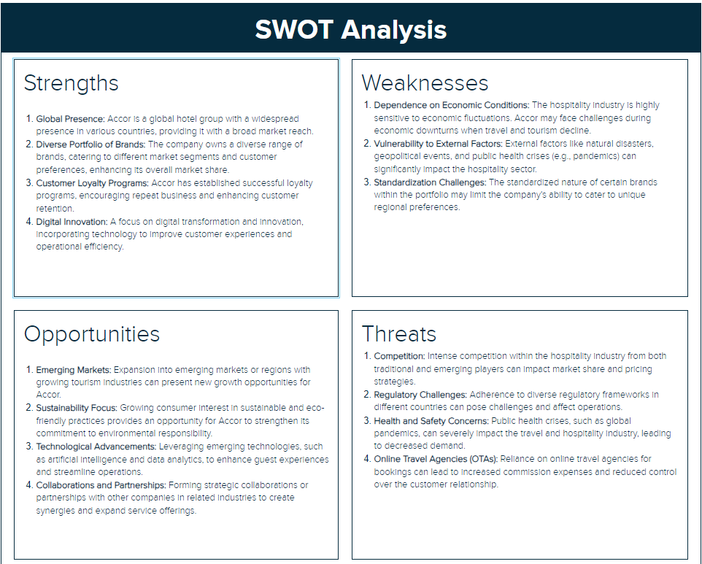
(Accor SWOT & PESTLE Analysis | SWOT & PESTLE, 2020)

B. Business Performance

1. Financial Performance
Financial reports indicate steady growth, with increased revenue and profit margins. However, there are fluctuations in performance across different regions, indicating the need for a more region-specific approach.
In 2020, Accor Hotel Group underwent a series of significant events that shaped its financial and strategic landscape. The year commenced with the initiation of a €300 million share buyback agreement on January 20, signaling the company's financial strategy. Notably, on March 11, Accor finalized the sale of its majority stake in Orbis and disposed of the Mövenpick leased hotels portfolio, contributing €1.06 billion and €430 million, respectively, to its financial position (Accor, 2021). The company secured a €560 million revolving credit facility in May and, in August, unveiled a €200 million cost-saving plan to align with its asset-light business model (Accor, 2021). A notable strategic move occurred in November, with the acquisition of sbe's asset-light activities, reflecting Accor's focus on the lifestyle hospitality sector (Accor, 2021).

2. Key Performance Indicators (KPIs)
Accor performs well in customer satisfaction and sustainability KPIs. The main KPI’s evaluated which are reviewed monthly on-board meetings include:
Occupancy Rate
Average Daily Rate (ADR)
Revenue per Available Room (RevPAR) (Demi̇rtaşÜ, 2019).
Customer Satisfaction Scores
Employee Satisfaction and Engagement
Net Promoter Score (NPS)
Revenue and Profitability
Return on Investment (ROI) (Demi̇rtaşÜ, 2019).
Direct Booking vs. Online Travel Agency (OTA) Bookings
Environmental Sustainability Metrics
Brand Loyalty and Membership Program Metrics
Market Share (Society', Barnabas and Kulkarni, 2023)
However, there's room for improvement in employee engagement metrics, possibly linked to the challenges faced during recent technological changes.

V. Conclusion

A. Summary of Findings
The audit provides a comprehensive understanding of Accor Hotel Group's organizational structure, culture, recent change initiatives, strategic direction, and current business performance. While the organization exhibits strengths in global presence and financial performance, there are opportunities to enhance agility, innovation, and employee engagement.

B. Recommendations
Foster a more adaptive and innovative culture by encouraging diverse perspectives and empowering employees to contribute ideas.
Enhance change management strategies by addressing employee concerns more proactively and providing comprehensive training during technological transitions.
Continuously evaluate and adjust the strategic direction to align with emerging trends and regional variations in the market.

VI. Reference list

- Accor (2021). Full-Year 2020 Results Accor demonstrates resilience and adaptability Tangible signs of improvement in Asia, Middle East & Africa and South America in Q4. [online] Accor – Newsroom. Available at: https://press.accor.com/accor-results/?lang=en.
- Accor SWOT & PESTLE Analysis | SWOT & PESTLE. (2020). SWOT & PESTLE.com. [online] 3 Oct. Available at: https://www.swotandpestle.com/accor/.
- Accor. (2022). 10 reasons to join Accor hotels. Retrieved April 1, 2022 from AccorHotels-Group: http://www.accorhotels-group.com/en/franchise-and-management/10-reasons-to-join-accorhotels/powerful-distribution-and-revenue-management.html
- Accor. (2022, May 1). Our Brand Portfolio. Retrieved May 5 2016 from Accorhotels-group: http://www.accorhotelsgroup.com/fileadmin/user_upload/Contenus_Accor/Franchise_Management/Documents_utiles/factsheet_reasons_April_15/leading_and_attractive_brands.pdf
- Bagdadi, A. (2022). Corporate social responsibility practices within the scope of sustainable tourism : A research at Accor Hotels. Prosperitas, (In press), pp.1–10. doi:https://doi.org/10.31570/prosp_2022_0022.
- Casidy, R., Wymer, W. and O’Cass, A. (2018). Enhancing hotel brand performance through fostering brand relationship orientation in the minds of consumers. Tourism Management, 66, pp.72–84. doi:https://doi.org/10.1016/j.tourman.2017.11.008.
- Damnjanović, V., Lončarić, D., Dlačić, J., Digital Marketing Strategy, Of Accor and Hotels (2020). TEACHING CASE STUDY DIGITAL MARKETING STRATEGY OF ACCOR HOTELS: SHAPING THE FUTURE OF HOSPITALITY. Tourism and Hospitality Management, [online] 26(1), pp.233–244. Available at: https://hrcak.srce.hr/file/346425.
- Demi̇rçi̇ftçi̇T. and Kizilirmak, İ. (2016). Strategic Branding in Hospitality: Case of Accor Hotels. Journal of Tourismology, [online] 2(1), pp.50–64. Available at: https://dergipark.org.tr/en/pub/iuturizmoloji/issue/24615/260504?publisher=istanbul.
- Demi̇rtaşÜ. (2019). SPECIFIC KEY PERFORMANCE INDICATORS AND COMPETITIVE SET DATA FOR HOTELS: A CASE STUDY IN IZMIR. Journal of Business in The Digital Age, [online] 2(1), pp.36–48. Available at: https://dergipark.org.tr/en/pub/jobda/issue/46621/581161.
- Edelman, D.C. and Singer, M. (2015), “Competing on customer journeys”, Harvard Business Review, R1511EPDF-ENG, vol. `11
- Gheorghe Camelia, Marinescu Ioana-Valentina-Alexandra, and Neacşu Larisa-Andreea. "Organizational culture: A case study of the impact of ethical organizational culture on the efficiency of Accor Hotels." Romanian Economic and Business Review 14.2 (2019): 86-96.
- Higgins Stacey Mieyal (2017) ‘Accor reorganizes leadership, structure’, Hotel and Motel Management, 222(19), vol 1
- Jinkyung Jenny Kim (2023). Brand personality of global chain hotels, self-congruity, and self-discrepancy on customer responses. International Journal of Hospitality Management, 114, pp.103565–103565. doi:https://doi.org/10.1016/j.ijhm.2023.103565.
- Natalia, C. (2023). ‘Green’ hotels: opportunities and barriers. [online] ediţia a 2-a. Available at: https://ibn.idsi.md/vizualizare_articol/189117 [Accessed 14 Nov. 2023].
- Ogbonna, E. and Harris, L.C. (2022). Managing organisational culture: insights from the hospitality industry. Human Resource Management Journal, 12(1), pp.33–53. doi:https://doi.org/10.1111/j.1748-8583.2002.tb00056.x.
- Rutherford, D.G. and O\’Fallon, M.J. (2007) Hotel management and operations. 4th ed. Hoboken, N.J: John Wiley.
- Seidu, S., Opoku Mensah, A., Issau, K. and Amoah-Mensah, A. (2022), "Does organisational culture determine performance differentials in the hospitality industry? Evidence from the hotel industry", Journal of Hospitality and Tourism Insights, Vol. 5 No. 3, pp. 535-552. https://doi.org/10.1108/JHTI-11-2020-0208
- Society', B., Barnabas, V. and Kulkarni, M. (2023). Disruptive Business Environment. [online] Available at: https://www.imscdr.ac.in/public/iqac/IMS%20Conference%20Proceedings%20January%202023_579911696830062.pdf#page=381 [Accessed 14 Nov. 2023].
- Torres, A. M. (2018), "Using A Smartphone Application as A Digital Key for Hotel Guest Room and Its Other App Features", International Journal of Advanced Science and Technology, Vol. 113, pp. 103-112, http://dx.doi.org/10.14257/ijast.2018.113.11
- Wiastuti, R.D., Adi, S.C., Sarim, S. and Rashid, B. (2023). THE IMPACT OF WORK-LIFE QUALITY ON HOTEL EMPLOYEE PERFORMANCE. Jurnal Manajemen Perhotelan, [online] 9(2), pp.55–62. doi:https://doi.org/10.9744/jmp.9.2.55-62.

