Module Code | BMSK4004
Module Title | Problem Solving and Decision Making
Lecturer’s Name | Gregory Cowan
Level | 4
STUDENT’S ID.NO. AND FULL NAME | 1713706

Contents
Introduction 3
Problem identification 3
Scope of the problem 3
Impact of the problem 4
Problem criteria definition 4
Informational analysis for identified problem 4
Macro environmental analysis 5
Micro environmental analysis 6
Analysis over the nature of problem 7
Tools/models/theories for different solutions to problems 8
1) Force Field Analysis 8
2) Lewin’s change management model 9
Alternative Solutions considerations 9
Implementation of solution 11
Considerations for implementation of solution 12
Communicating the implemented solution 12
Monitoring of implemented solution 13
Conclusion 14
References 14

Introduction
Organizational functions are conducted so that the operations can bring about the aspired goals and objectives within the business of the company. Although there are immense numbers of planning and implementations in place for achieving the perfect synchronization of work to smoothly operate, problems emerge and then the organizations is left with dealing with the problem to help the scenario to best play out. Problem solving is thus a basic required technique to deal with disadvantageous emergence at the earliest disposal (Butterfield, 2010). Also, decision making is to be considered to solve problems as specific set of task are usually undertook meaning that decisions are to be made after careful deliberation. This report will discuss quixotic measures for a complex workplace-problem in order to solve it through decision making weighing alternative measures in my workplace at Capricci restaurant in London along with a monitoring and review process for the decisions effectiveness.

Problem identification
Capricci is a specializing artisan Italian restaurant and deli that brings forth the taste of authentic Italian dishes and wines form native producers of Italy. The restaurant and deli is known for its years of experience service customers with classic wine and dine as well as helping them with deli products to enjoy at home. The restaurants one special feature is that they keep changing the menu once in a week making it thrilling and exciting with seasonal produces and original Italian taste with great food and even greater recipes from the equally expert chefs (User, 2019). The restaurant gives comforting opportunity to its customers to enjoy their shelve products which are also heavy in original produces at their own convenience whether at the restaurant or brought from the deli to home.
Recently, the restaurant although is doing pretty well as much as previous years have seen that the profit margin is not expectantly increasing and there seems to be several problems making it complex to deal with the least efforts possible. Hence, the identified problem in this problem solving and decision making discussion will be-
“Decline in expected profit margin in the Capricci restaurant in the UK.”

Scope of the problem
Restaurant business is one of the most lucrative business in the Great Britain and especially in London, UK for past several years. The investments put in dining restaurants and innovative delis are hence expected to be increasing. Yet, a significant in profit margin has been experienced in past couple of years. The reason has been identified to be multifaceted and as almost 1,200 restaurants in UK reported incurring a 24% insolvency in last decade, the problems seems to be Omni-present in the industry and requires special attention. Several sources discussed this fall in restaurant business with BREXIT led financial instability and declining average purchasing power (ASP) of the respective growing customers. BREXIT also seems to have impacted the chef hiring process making it harder for restaurants to hire perfect candidates making it evident that foods have been losing due appeal to customers and their increasing awareness to keep a healthy lifestyle do not seems to help at all at this point.

Impact of the problem
The decreasing expected profit margin is threatening the business prospect of this restaurant as the restaurant will seemingly have to deal with severe loss in future if the declining profit growth cannot be mended to be steady and prosperous for the growing business.

Problem criteria definition
The restaurant and deli business of Capricci has been envious in since its first introduction. The restaurant specializes in authentic Italian menu while also serving classic and flavorful wine collection. The restaurant as provides these amazing collection of foods made of fresh seasonal produces, attract a lot of customers to the business since the business’s dawn (User, 2019). However, the present economic recession has been badly affecting the restaurant as the expected profit margin growth is in decline. For a business this prospective, the problem is surely serious as negligence can lead to complete bankruptcy in future. Except for the economic recession that has been affected by BREXIT caused decrease in ASP and higher cost in hiring expert employees for restaurants, there are significant changes in social behavior for fancy dine outs rather than consuming healthily at home.

Informational analysis for identified problem
With all these criteria playing in the background, the followings seems to be the current objective for problem solving and decision making process to keep steady and possibly increase the profit margin for the business.
The problem for solution is expected to face several constraints or barriers. The barriers are usually those aspects or considerations that can seriously impede progress for certain projects (Burns, 2008). In this case however, barriers seem to be the exact same problems that are expected to be solved through decision-making process. The identified barriers in this case is the economic shift and shift in consumer behavior in consumption of goods and services.
While analyzing information for this complex problem, it is necessary to effectively investigate all underlying problems. There are various means to measure causes and degrees of affliction of the problems. In here, I will be discussing the occurring problem in my workplace inside Capricci though a macro environmental analysis as well as a micro environmental analysis.

Macro environmental analysis
Macro environment refers to those environmental considerations that have sever effect over business performance yet cannot be controlled though business’s strategizing. So, the only way for surviving a catastrophic macro environmental influence is to adjust the business strategy to align with ongoing positive stream (Adair, 2013). The business prospect of Capriccio restaurant in the UK is also subject to these environmental factors and so will be discussed next for connecting these factors to declining profit margin of the restaurant.
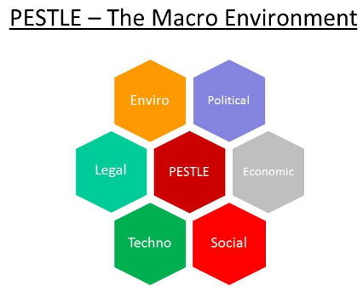
Figure: PESTLE Analysis (Barry, 2015)
Political influence
Post BREXIT, there has been various changes and this political instability is causing the UK people to change own behavior to stay strong for any possible insufficiency. Furthermore, taxation rate, legislative authority, etc. changed and effected economy and practice in England. It has become increasingly difficult to hire employees form migrated workforce and affecting the business of Capricci as well.
Economic influence
Economic influences of macro factors are associated to interest rate, inflation, price hike and so on in macro environment (Morgan, 2016). These factors are essentially affected by various other associations and cannot be easily intervened. The present economy of UK has been seeing decline in customer preference to lessening on fancy dining in restaurants as Capricci as they are trying to adjust their economic downturn by investing in basic livelihood more often.
Social influence
The newly emerged awareness of lifestyle changes to cope with stressful life by cutting back on comparatively unnecessary costs and staying healthy is creating negative effects for the businesses selling ready-made food products. However, for Capricci, it can be seen as positive since the fresh produce sold has its own appeal to these customers as well as deli sold products help them with fast paced life.
Technological influence
The technological innovations being used in businesses emphasize that customers are loving the change and tend to associate them with more technologically advanced businesses and become consumers of such businesses (Cottrell, 2011). Capricci need to up their online presence as well as increasing technological implementations to attract new customers.
Legal influence
Laws regarding business conventions in UK as well as minimum wage, labor cost, etc. have been subject to great change and as result is effecting medium to small business like Capricci greatly.
Environmental influence
The new age of business requires that any organization big or small try to stay environmentally friendly and lessen carbon emission. Thus, the customers of this restaurant are also making demands over proper waste disposal, reducing carbon emission from business as well as being more ware of health and safety laws to be maintained in such restaurants.

Micro environmental analysis
Micro environmental analysis is the analysis of factors and their influences that are internal to the business. This type of environmental analysis brings forth the understanding of the affecting factors to the business that may be changeable once they are determined by the business organizations. SWOT analysis is a standard micro environmental analysis method where, business organization can assess own strength, weakness as well as potential opportunities to threats for business and as a result have an in-depth knowledge over own operations and ways to adjust them for better outcome (Jones, 2007).
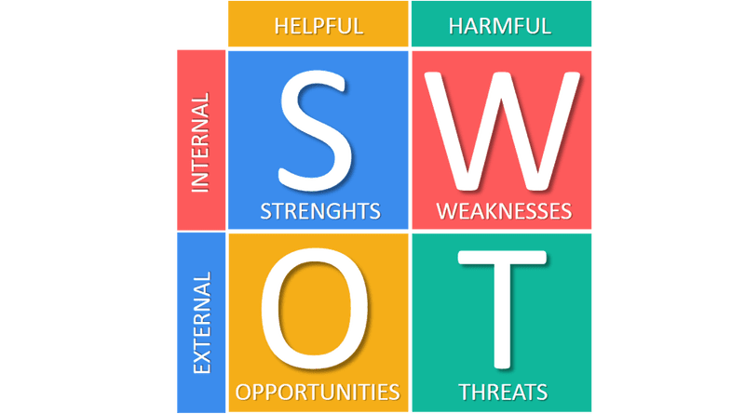
Figure: SWOT Analysis (business-to-you, 2017)
Here is a discussion over Capricci’s micro environment that is expected to inform the problem solving and decision making for the business in achieving better profit margin:
Strength
- The restaurant and deli by Capricci has specialized Italian menu and wine to serve to customers which is lucrative for customers.
- The menu is changeable over each week making it exciting to come back next time.
- The foods are made of seasonal produces form authentic sources making the service healthy and flavorful at the same time.
- The associated deli has plethora of offerings to take to home and helps recurring visit for customers as well.
Weakness
- The restaurant is highly dependent on fresh produces making it vulnerable to any changes of weather or supply chain disarray.
- The primary advertisement of the restaurant seems to have become less stimulant in attracting new customers successively.
Opportunities
- The restaurant has a well-known presence by now and can leverage this fame to attract customers at present.
- The restaurants business has bigger opportunities waiting upon use of social event s and marketing though social media as new customers can be attracted by both.
Threats
- Capricci is situated at London where there are multiple quality Italian cuisine restaurants making hard to compete in this market.
- The economic shift causing the decline in sales and thus profit margin for the restaurant that has stared from BREXIT is not going to easily subside and so patient actions are required to sustain in this tumultuous situation.

Analysis over the nature of problem
The problems that I have identified in my workplace of Capricci and am going to take action over are the problem of declining profit margin for the business. The analysis over the problem has let me know that the nature of the problems is mainly financial, while also it refers to business environmental changes occurred by recent shift in customer valuation of such businesses and behavior with buying power. Their behavior is shifting towards healthy lifestyle and primarily they are starting to avoid restaurant bought food which is in a convenient time as the economic shift is forcing those who are confused as well. So, with all these discussions, the nature of the problem is almost purely financial and somewhat political environment based. The restaurant however has a high chance of countering the situation if their dedication toward serving customers with fresh produce is highlighted in marketing planning and advertisements.

Tools/models/theories for different solutions to problems
Scholars and practitioners around the world have been working toward synthesizing the perfect model or tools for solving problems and as result a lot of theories and management model started emerging. These models, tools or theories are capable of ascertaining on specific causes of problems so that accurate decisions can be made by leadership and management by discerning between plethora of data and relevant information. Data in this case are raw information in large volume, while information is that relevant knowledge that prods the accurate decisions for solving on problems. Here, I will be discussing three important theories and models of problem solving to pinpoint on alternative solutions.

Force Field Analysis
Force field analysis is a problem solving tool that specializes in analyzing on underlying forces of certain changes in business functions and outcomes of organizations. The idea is to weigh among all available options to offset the forces that affects negatively or utilize the implications of positive forces (Christ, 2008). Since, all available alternative solutions can be related and weighted for best possible outcome, it helps plan robust decisions for solving organizational problems.
Force field analysis in organization is done through a small group of employees who discuss over relevant problems or concerns and formulate plans to solve these. For that, they converge on a few anonymously identified forces in effect causing the problem and prioritize main concerns by setting numbering to determine the most affecting force of the problem. Afterwards, these forces are dealt separately through rigorous planning and decisions made through these employees by weighing around available options. For example, this problem with Capricci can be best described through force field analysis as the primary concern or problem of declining expected profit margin is truly associated to varying forces especially financial decisions over business environment and among them economic shift and customer perspective shift are prioritized he most.
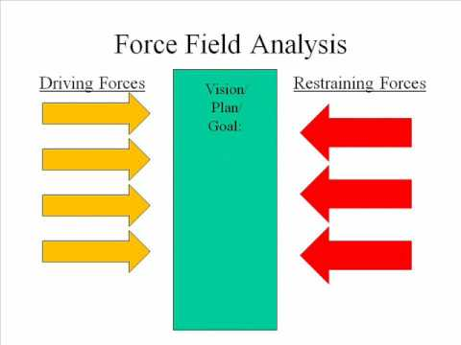
Figure: Force Field Analysis (DePaul, 2010)

Lewin’s change management model
Kurt Lewin, a well-known psychologist and theorist provided the Lewin’s force-field theory of change describing that in organizations. The level of performance improvement with time is equivalent to less resistance to change as well as increased forces effecting the change. He described that there are certain force if present prod change on business functions and operations and when employees of the organization are least resistant to change, the new planning for improving organizational efficiency and thus profitability becomes successful. The change management model takes this idea even further as the process of change is said to go through three distinct phases (Jones, 2007). Unfreezing meaning the first identification and willingness for change, change referring to all actions undertook for accelerating the change and freezing meaning sustaining the change.
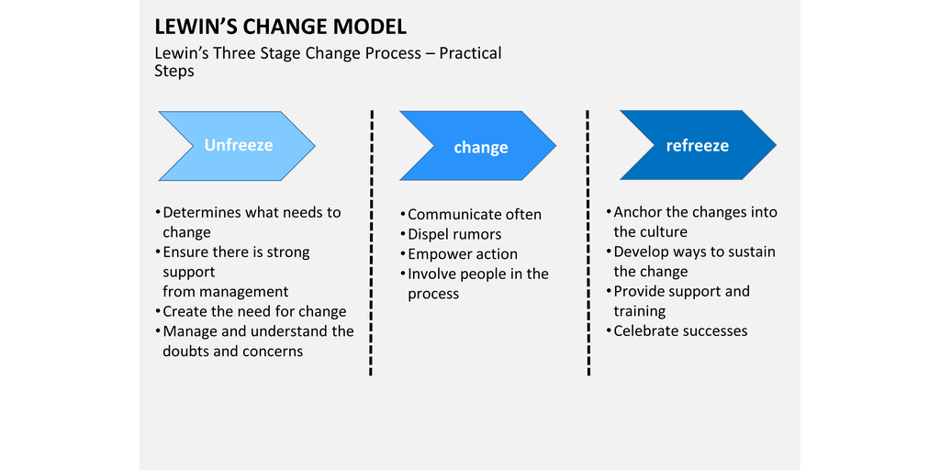
Figure: Lewin’s change management model (Mulholland, 2017)
This problems can do that as well since the analysis of problem to believe that there are several forces affecting the situation and working to unfreeze, change and freeze for each force might be beneficial as it will help with less complexity of process and less resistance to change as opposed to force-field analysis.
However, the premise of declining profit margin is serious issue and thus needs earliest robust solution that is provided by force field analysis.

Alternative Solutions considerations
After analyzing the problem for its full effect and the exact forces behind its emergence, it is then required to take actions. For that, decisions have to be made based on various available solutions. However, many of these solutions are exclusive meaning following one might discard another, so, considerations have to be made for choosing among alternative solutions (Hung, 2013). The followings are found to be the alternative solutions presently available for the business of Capricci restaurant and I will try to discuss the advantages and consequences both good and bad for each solution in the following discussion:
Solution A: Lowering the price in menu
Lowering the price of foods and beverages in the menu of the restaurant will communicate the value of customer to the business and eventually help increase customer presence for the business.
On the other hand, lowering price of products and services is not easy since there have to be rigorous strategic planning and reformation of some aspects of the business and renegotiation with suppliers will have to be facilitated.
Solution B: Increasing social media advertisements
Increasing social media advertisement will help the restaurant become known for their awareness over the need of the present time and preferences of customers. Also, the increased exposure before customer will make it possible to attract more of the new customers on daily basis. Furthermore, it will be a cost effective yet efficient medium of marketing.
Social media marketing content need to be thoughtful and have to appeal to target customers properly or else the whole idea will go to waste with improper contents failing to attract customers.
Solution C: Introducing special events and discount offers for loyal customers
After being catered by special events and discount offers, satisfied customer will feel valued and make frequent visits. The events also have the potential to involve new customer through attractive media coverage (Morgan, 2016).
However, cost or less profit could be incurred by the restaurant for the time being. Also, there needs to be proper strategic planning and functional support as in time of offers and events business can become hectic.
Solution D: Training employees to communicate the businesses eagerness in serving the customer through the implemented changes
Trained employees can communicate changes and lucrative information to customers of the restaurant effectively to increase sales. Also, given that the sales pitch is excellent, customers will feel more obligated to support word-of-mouth advertising. Additionally, customers in such case will feel more connected to the business.
Wrong way of approaching customer or ineffective sales pitch can be harmful for the business as customers can feel annoyed at all those marketing tactics all the time.
The most appropriate solution among all of these has to be the lowering of price as well as social media presence increment. The lowering of price of foods and other servings will let the customer fell more inclined to buy from the restaurant more than ever. Also, since, they will be feeling valued and understood, their repertoire with the restaurant’s business will be strengthened. Also, social media has become the first place of visit for any modern Londoner and so visiting the restaurant can be more appealing to them upon coming over advertisement in such media.

Implementation of solution
While solving problems and making decisions, it is important to converge on a specific method of implementations of the developed plan. Otherwise, the work could go astray as any new factors emerge to influence the outcome. Implementing plan can be supported through various tools and techniques such as WBS, Gantt charts and flow charts, etc. (Tonelli, 2011). The implementation plan of this problem solving and decision making for increasing profit margin for Capricci restaurant in London will be-
- Analyzing market to support lowering the price of products
To lower the prices, it is essential to understand the possible effects of the step. The economic shift due to BREXIT did not only affect the customer buying power but also the price of produces and ingredients. So, effective market analysis is required for planning the price lowering.
- Setting up a new price chart for foods to both please the customer and gain profit
An optimized price needs to be fixed to lessen the customer burden while still being profitable for the business. So, the new food menu with price needs to maintain both.
- Hiring employees for accelerating social media marketing
The social media marketing operations are not likely to be similar to previous marketing techniques and also increased manpower is needed. So, hiring experienced candidate in this specific subject area can be found helpful for business prospect.
- Setting up KPIs to represent the growth in profit margin and its scheduled monitoring
After planning thoroughly of presently requires activities and plans, it is essential to set up performance indicators to be monitored to successfully determine growth in profit margin. Also, schedule for monitoring of these KPIs helps further strengthen the process that earliest interventions can be possible in time of emergency.
- Planning for risk management
The plan also can support a risk management strategy that will effectively utilize any risk for positive effect on the business and mitigate potentially harmful ones.
- Documentation of the whole problem solving and decision making implementation plan
The process of problem solving implementation plan is finally completed when documentation of the whole process is done. The documentation can be in the form of formal report and may be presented for annuls publication to be distributed among employees.

Considerations for implementation of solution
While approaching to implement the decided solution, it is necessary to consider few key points (Pizlo, 2012). These considerations for implementing the suggested solutions are-
- What does the customer think of the price off the menu?
- How much would be convenient for them to purchase food from Capriccio?
- What needs to be price for bets support a profitable business?
- How many employees are to be hired for social media marketing and how will they be operated?
- What will be the best possible interval for monitoring solutions effectiveness?
- What kind of documentation method will be used?

Communicating the implemented solution
The decision made over the problem solving phase needs implementation sand the implemented solution needs communication with associated entities such as employees, customers and other stakeholders such as the suppliers (Proctor, 2009). Since, the associated parties have different connections to the business as well as motivation for keeping up their loyalty to the restaurant’s business, appropriate communication method should be followed.
Customers of the Capricci restaurant should be made aware of the implemented changes in the forms of promotional events, discount fair, etc. These changes or implemented decisions can be marketed through regular advertisement s and through word-to-mouth method. But, social media marketing can be extremely helpful in tis front.
Employees as vital part of this business need to know the changes that the price structure is going to change for the menu and by knowing that they can effectively perform to make bets outcome possible. Also, their own knowledge and sales tactics can be utilized in informing visiting customers of the exciting changes. Other stakeholders can be informed of the changes business structure of the restaurant though newsletters, email notifications, face-to-face meetings, etc.

Monitoring of implemented solution
Monitoring and review is an important part of planning and implementing solutions to problems as oftentimes the effects of the planned solutions is not theoretically realizable. Monitoring hence is such a process that helps evaluate important parts of the business prospect to make informative decisions to control the outcome for positive consequences (Gano, 2011). The parts to be evaluates in this case are KPIs or key performance indicators set alongside the development of plan. This problem solving session and decision making to solve the problems of declining profit margin will be monitored by seeking customer feedback over their motivation and enthusiasm to recurring visit to the restaurant as well as sales and profit figures from weekly sales. The detailed monitoring plan for the implemented solution is given below-
- The first step is to determine KPIs for the measurement of profit margin increase of the restaurant. Since, the problems is mainly financial and the profit margin is usually measurable through assessment of primary documents of finance, the followings are the KPIs to be monitored weekly:
- Weekly sales target
- Gross revenue
- Weekly profit margin
- Average table turnover
- Stakeholder feedback, etc.
- Primarily, the implementation plan accommodates for a monitoring session each week to see if the plan has been effectively working towards attracting increased sales thus increased profit margin for the business. While financial parts such as revenue, profit, table turnovers are easier to measure from weekly sales report, we will also implement feedback taking process from customers as well as employees to see if the overall mentality of customers has been positively affected to buy service in the restaurant.
- After collecting the said information over predetermined KPIs, it will be time for us to compare the figures to previously available figures to make connections and observe if the implemented solution worked.
- If the measures KPIs follow the predicted outcome that is if the profit margin seems to be increasing, the plan is to be sustained, while any signs of failure of the plan needs to be properly investigated for causes and their prolonged effects to decide on whether to terminate or adjust the implemented plan (Deno, 2005).
The primary plan is to monitor the KPIs for each week throughout the next three months straight and if the plan seems to be going well, this can be integrated into present system completely and continued to be evaluated as before.

Conclusion
This report has been a descriptive analysis of complex workplace problem solving though structured decision making. To do that, I have firstly identified and analyzed the problem for its nature, association and impacts for the restaurant business of Capricci. The analysis has been supported with a few standard theirs and tools as well as analysis technique such as SWOT and PESTLE. Then, alternative solutions were discussed for their advantages and other consequences, form which I could identify possible fruitful solutions and planned the implementation procedure as well as technique to communicate the associated change to stakeholders. A plan for monitoring of the planned solution was also provided. My recommendation is to keep a vigilant eye for any changing behavior of the consumer behavior and profit margin to make best efforts to increase profit margin.

References
Adair, J. (2013) Decision making and problem solving strategies. 2nd edn. London: Kogan Page.
Burns, M.K., Wiley, H.I., &Viglietta, E. (2008). Best practices in implementing effective problem solving teams In A. Thomas & J. Grimes (Eds.), Best practices in school psychology V (pp. 1633-1644). Bethesda, MD: National Association of School Psychologists.
Butterfield, J. (2010). Problem solving and decision making. Boston, Mass.: Course Technology/Cengage Learning.
Christ, T.J. (2008). Best practices in problem Analysis. In A. Thomas & J. Grimes (Eds.), Best practices in school psychology V (pp. 159-176). Bethesda, MD: National Association of School Psychologists.
Cottrell, S. (2011) Critical thinking skills: Developing effective analysis and argument (Palgrave study skills). 2nd edn. Basingstoke: Palgrave Macmillan.
Deno, S.L. (2005). Problem-Solving Assessment. In Brown-Chidsey, R. (Ed). Assessment for intervention: A problem-solving approach. (10-40). New York, NY, US: Guilford Press.
Gano, D. (2011) Seven steps to effective problem solving and strategies for personal success. 1st edn. EBook: Reality Charting.
Hung, W. (2013). Team-based complex problem solving: a collective cognition perspective. Educational Technology Research and Development. 61 (3): 365–384.
Jones, G. and George, J. (2007). Contemporary management. 5th ed. Boston: McGraw-Hill/Irwin.
Maund, A. Schriek, M. and Tinkler, P. (2017). Certificate in Higher Education: Skills for the Workplace Student Yearbook. Sage Publications
Morgan, P. (2016). The Business Student’s Guide to Study and Employability. Sage Publications
Pizlo, Z. (2012). Human problem solving in 2010. The Journal of Problem Solving, 4(1). doi: 10.7771/1932-6246.1120.
Proctor, T. (2009) Creative problem solving for managers: Developing skills for decision making and innovation. 3rd edn. New York: Routledge.
Tonelli, M. (2011). Unstructured Processes of Strategic Decision-Making. Saarbrücken, Germany: Lambert Academic Publishing.
User, S. (2019). ABOUT US. [online] Capricciforlondon.co.uk. Available at:https://www.capricciforlondon.co.uk/about_us.php.

