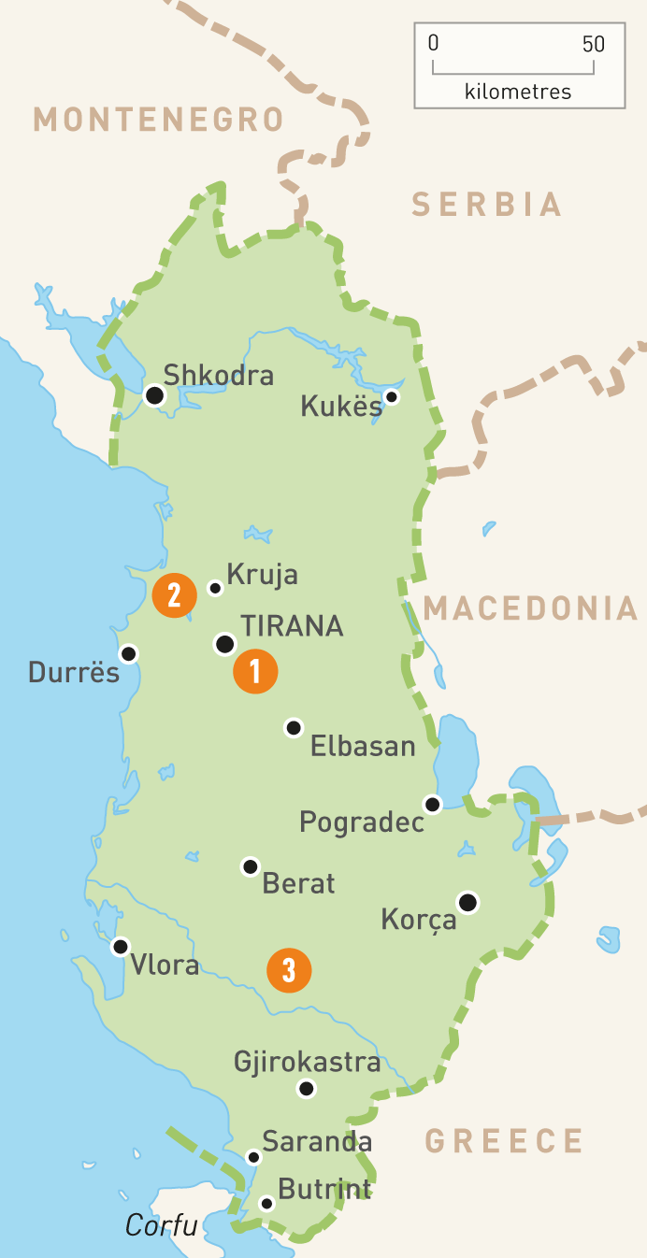 Travel review of Albania
Adrienn Popelis (1903168)

Albania is a place to be loved, geographical it is in the heart of the Mediterranean (saltwater Adriatic and Jon), but unfortunately has not yet established its identity in the Balkans regional tourism. In this small Mediterranean country, the virgin nature and cultural mysteries combine to create a unique sense of place. From the snow-capped mountains in winter to the fields covered by spring flowers, so the landscape of Albania is always changing with the seasons offering visitors the opportunity to enjoy a warm beach vacation in the summer or a mountain trip in the cool cold air in the fall.
Albania is increasingly being recommended as a tourist destination by various tour operators and international travel guides. The tourism sector has generated economic development, employment and self-employment opportunities for the country, so indirectly tourism constitutes 30% of employment.
Albania attracts the attention and curiosity of many foreign tourists and visitors who book tourists trips to various cities of Albania during the summer season and wintertime. A century ago Albania attracted the attention of the famous writer Edit Durham , who visited north and the south and fell in love with beautiful places of this country, she also write some books for Albanians such as-HIGH ALBANIA 1909. In Albania visitors are welcomed as guests as part of the cultural traditions. Every traveler feels at home in this wonderful little place. There are very clean beaches from Saranda to Durres, spectacular mountains Albanian Alp, the highest peak to be climbed by climbers Korab mountain, river valleys Buna river, Drini river, canyons of Osum offering adrenaline and many other natural surprises for visitors. Tourists can see and experience the ancient past of Albania, historic castles, The Castle of Berat, of Kruja who had the history of surviving fighting, and as well the traditional culture.
The peak of tourists is in the summer season as they show interest in coastal tourism. Because of the Lon coastline, Albania offers several beaches, from north to south as in Velipoja of Shkodra, Shengjin of Lezha, in Durres, Vlora, Himara, Saranda, these beaches are frequented besides Albanians and from foreign nationals, who choose Albanian as a tourist destination during the summer months. These beaches offer two possibilities that are rare to find elsewhere having rocky beach with small tones reflecting blue water and the magical underwater world and having sandy beach. Taking one of the most famous beach SARANDA. The city is known for its blue deep waters of the MEDITERRANEAN. Near Sarandë are the remains of the ancient city of Butrint, a UNESCO World Heritage site. In recent years, Saranda has seen a steady increase in tourists, many of them coming by cruise ship. Visitors are attracted by the natural environment of Saranda and its archaeological sites. Stretching along the Albanian Ionian Sea Coast, Saranda typically has over 300 sunny days a year. Saranda's stony beaches are quite decent and there are plenty of sights in and around town, including the mesmerizing ancient archaeological site of Butrint and the hypnotic Blue Eye Spring. Between Saranda and Butrint, the lovely beaches and islands of Ksamil are perfect for a dip after a day of exploring. It's a prosperous region with varied attractions, mountains, rivers and lakes, springs and virgin beaches olive groves and vineyards, pastures and woods, fish and shellfish farming, desirable hunting places. Now going to the other exctreme from the south beaches to the north beaches. SHENGJIN is a coastal town and a former municipality in Lezha northwestern Albania. Shëngjin offers a wide arrange of environmentally friendly activities. To the south of the city, the protected area of Kune-Tale Nature Park which offers a beautiful and undisturbed place to enjoy the natural surroundings of wetlands and seafront. Similarly, just north of city center, "Rana e Hedhun” is located, which also offers a wonderful experience of rural and undeveloped sand dunes along the coastline. “Being an ecological city, Shengjin in Albania offers some of the best fishing grounds that ensure that there is a balance between the rate of fishing and the frequent of fishing so that to ensure that there is no too much loss fish from the sea. They respect the fact that the fish need to bree in order to maintain their population. If you think that Albania has only gergous beaches to offer visitors, you wrong. One of the mos beautiful things to do in The Land of the Eagles is ti spend time relaxing, surrounded only by nature, in the country’s amazing mountains.So come to visit one of the wildest areas of Europe. The Albanian Alps or Accursed Mountains feature an array of sun-kissed peaks that watch over the wooded patches as they come into their own. A pocket of uninterrupted peace, the micro mountain village of Theth holds the Tower and sublime mountain views. Theth is undoubtedly the most charming mountain hamlet to be seen in Albania and maybe one of the best of the Balkans. The highlight here is a lovely Catholic church situated in the heart of the village. If you want to live a unique and romantic experience, come to Theth and you will not be disappointed.
Hidden in the north of Albania near the Montenegrin border, Vermosh is the northernmost village in the country. This mountain hamlet lies in one of the most spectacular valleys of the Accursed Mountain, a mountain range in Northern Albania that extends to Montenegro and Kosovo, famous for its glaciers and stunning landscapes.
Valbona isn’t a hamlet, more a mountain hub formed by guesthouses, restaurants and camping grounds. Valbona is worth a visit because is a gorgeous place surrounded by mountain peaks and sits within one of the most important national parks of Albania.
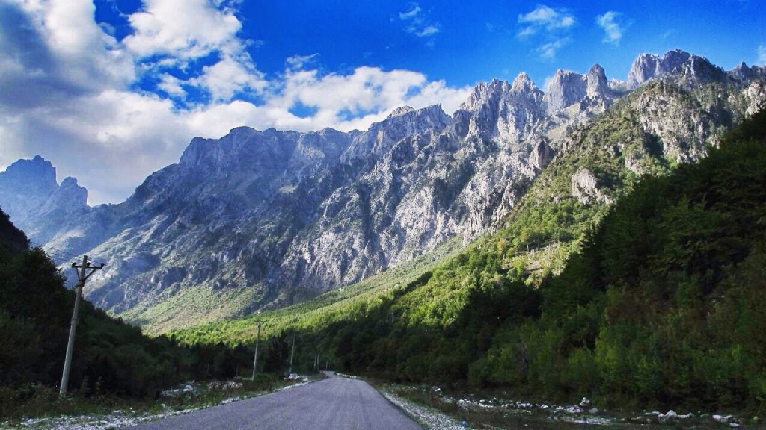 Journey to Valbona
It is also well known for its lakes, The Lake of Shkodër, Lake of Ohrid, Large and Small Lake of Prespa. Rivers originate mostly in the mountainous east of Albania and discharge into the Adriatic Sea in the west. As such, these rivers are rather short and could be exemplary of the river stretches. Valbona river gives us Alpine landscapes with turquoise water, white pebbles, rapids, and snow-clad mountaintops. There are also Shala Valleys in the Northern Alps, Tomorica Valley, Këlcyra on the Vjosa River, and the Bënça and Osumi Canyons. The canyons, in particular, offer a beautiful backdrop for a variety of paddling and rafting sports. Waterfalls are also a part of this vast network, such as those located at Grunas, Thethi, Shoshan, and Kurveleshi. More than 200 springs feed the tributaries and provide clean water for household use. Some of them are thermal waters that have been used since antiquity for medicinal purposes. But rivers have shaped much of the coast, with its alluvial plains and sea mouths. Albania have the Blue Heart of Europe. The Vjosa River in Albania is one of Europe’s last living wild rivers. it is untamed and free flowing and characterized by beautiful canyons, braided river sections, islands, oxbows and meandering stretches. It represents one of the last intact large river systems in Europe, hosting all different types of ecosystems: from the narrow gorges in the upper part to the wide braided river sections in the middle part to the near natural delta at the Adriatic Sea. The Vjosa River has a special and crucial place in the daily lives of the people that live along its banks. Its terraces provide the villages with fertile land for agricultural activities such as crop production and livestock farming. Recreational tourism on the Vjosa and its tributaries is ever-increasing, particularly in recent years in which enthusiasts have started to enjoy activities such as rafting, canoeing, kayaking, swimming, etc. Many small-scale businesses and new emerging eco-tourism companies have based their existence on the free-flowing waters of the Vjosa. Moreover, the Vjosa and its crystal-clear water have had an impact on the hearts of Albanians and their cultural values.
From north to south, Albania offers travelers enchanting discover lakes to include in their travel itineraries. We start with Shkodra.
In the north of Albania, nestled against Montenegro, Lake Shkodër. It offers many outdoor activities, such as kayaking, swimming and birdwatching, perfect for spring and summer days. To admire breathtaking views over the lake, there is nothing better than heading to the wonderful ancient Rozafa Fortress of Shkodër.
Lake Butrint is located near the archaeological park of Butrint. Butrint is not far from Saranda, so it can be easily considered as a day trip from the coastal town. The most enchanting thing about Lake Butrint besides being close to the terrific archaeological park, is that it overlooks the Ionian Sea and offers gorgeous views over it.
Not far from the cultural town of Shkodër, in the north of the country, lies Lake Koman. Lake offers to visitors some of the most beautiful panoramas and views of Albania. The best thing to do here is to take a boat ride across the reservoir.

THE SECRETS OF ALBANIA THE SAZAN ISALAND.

Sazan island has a bit of an odd history. for the longest time it was closed off to the public as a military base. Sazan Island is beautifully situated at the point where the Adriatic and Ionian seas gently meet. As the largest island in Albania, with an area of 5.8 square kilometers, Sazan looks like a detached portion of the Karaburun Peninsula and is also the gateway to the Gulf of Vlora. Sazan has quickly become one of the most attractive tourist destinations in the entire country. Old legends tell of fierce battles to gain this highly desired territory, with the secret coves of the island being used by pirates to hide the robbed spoils. Perhaps what most inspires these tales are Sazan’s numerous underground tunnels that extend throughout the entire area. Because of both its mysterious history and its abundant beauty, Sazan remains a place that must be experienced firsthand.

Ksamil is Albania’s hidden paradise.

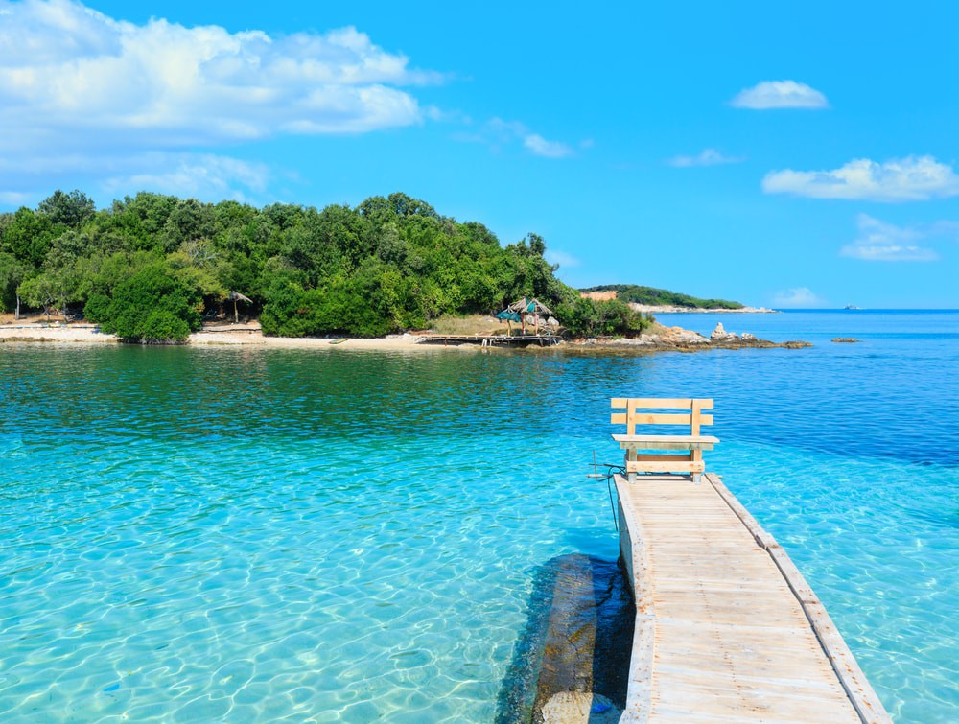

But what to expect?

Once in Ksamil, you can enjoy Paradise beaches offering white sand and crystal-clear water with a Mediterranean climate year-round. Ksamil is a small village in southern Albania. Locals have long gone here in the summer for sunbathing and swimming, but it is only now in recent years that foreign tourists have found their way here. Several charter companies offer trips to Ksamil, but it’s just as easy to get here on your own. Especially on the four islands located a bit out in the water. These four islands are uninhabited, and you get to them via boat. The village has also retained the charm to some extent, and there are plenty of cozy little restaurants serving Albanian cuisine.

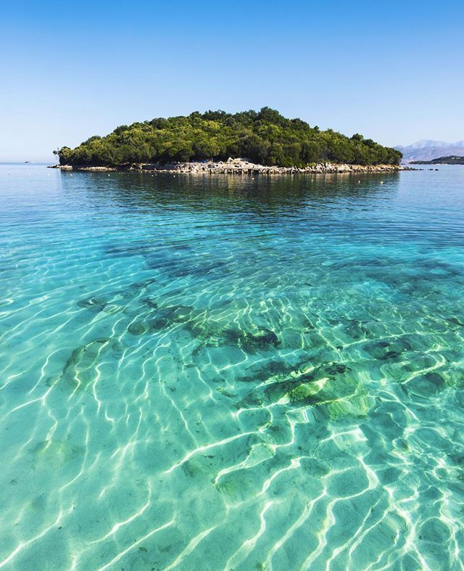 Ksamil ALbania
We don’t forget the capital of the country Tirana. Tirana, the capital, is a cosmopolitan and curious place.
With many cultural objects, modern architecture and high-quality hotels, there are many things you can do in Tirana. The city is also very nice, and you will find there energetic and willing people to assist travelers. There are many museums, zoos and parks in Tirana where you can enjoy endlessly. Or to not forget historic cities such as Apolonia.
Named so in honor of Lord Apollo, Apollonia was one of the most important cities of prehistoric times. The ruins here are very impressive and show how glorious and original this city once was. Some of the attractions are theaters, temples, libraries and other buildings. This place is impressive and offers a great view of the entire area.
Historic city Berati, it’s called by tourist city ​​of 1001 windows.
Situated in central Albania on the Osumi River, Berat was built as a glorious castle on a hill. You can find the original ancient castle on this hill called the Castle. The large castle contains a full district with many mosques and churches, which is well worth a visit. An important feature of Berat is that the houses in this area have large windows. The small villages around are another feature that you can only visit on a day trip.
Albania is making every effort to use monuments as opportunities for sustainable economic development by promoting these destinations, promoting additional tourism products of local communities around the areas by financing various projects that contribute to poverty reduction and the development and well-being as increasing employment in these regions and satisfying the needs of tourists.
What more can we tell just everybody is Welcome to Albania in any time of the year in every season offering to you the beautiful of the country.

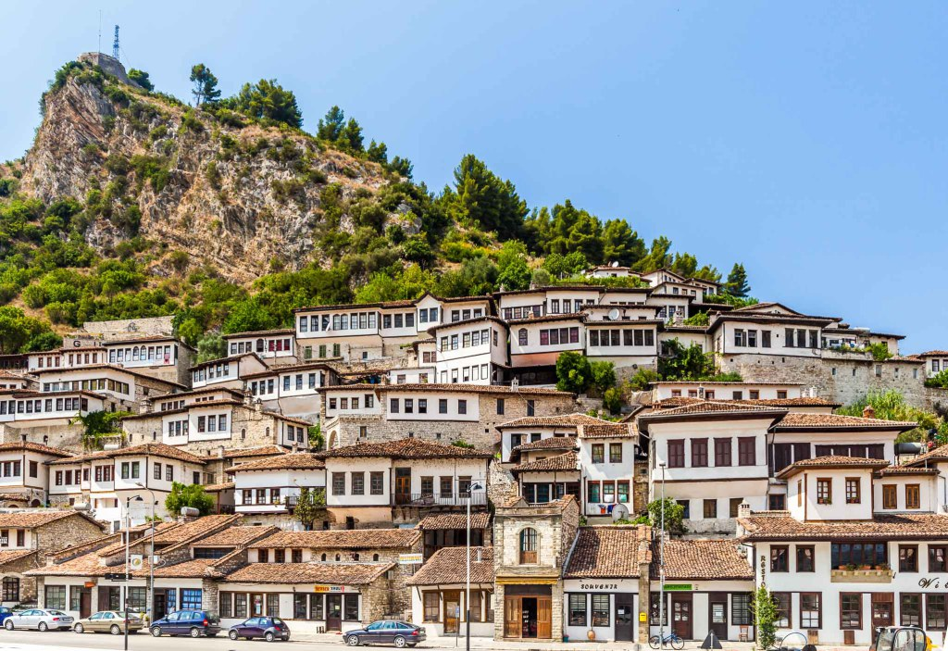Berat town

