Daniel Enubele – 2232136

In today's job market, possessing essential skills is crucial for academic success and employment opportunities Anne.G (2018) [1]. One essential skill that is often overlooked but vital in data analytics is communication skills. Communication skills involve the ability to express ideas, thoughts, and concepts effectively and clearly (Johnson, S and Scott, J, 2019, p 11).[2].
In data analytics, communication skills are essential as data analysts need to present their findings and insights to various stakeholders such as executives, team members, and clients. They must be able to convey complex data insights in a simple and understandable manner to non-technical stakeholders.
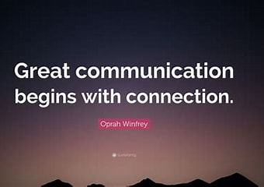
Oprah Winfrey Quote: “Great communication begins with connection.” (quotefancy.com)

Data analytics is also often involves working in teams, where team members work together to analyse data, identify patterns and trends, and generate insights that can drive business decisions. Therefore, developing teamwork skills is essential for success in data analytics.
Effective teamwork in data analytics involves clear communication, collaboration, and trust. Team members must be able to communicate effectively and understand each other's roles and responsibilities. They must be able to collaborate and work together towards a common goal, sharing information and insights to generate the best possible outcome. Wang, K (2021). [3]
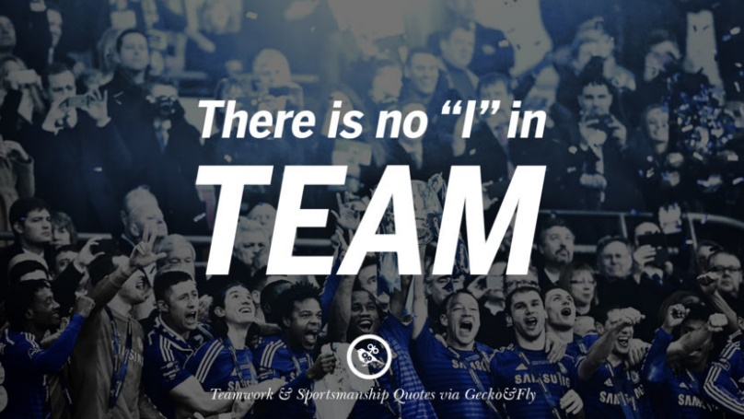
50 Inspirational Quotes About Teamwork And Sportsmanship (geckoandfly.com)

Developing time management skills is essential for success in data analytics. Time management skills can help data analysts to prioritize their work effectively, manage their workload, and meet project deadlines. Effective time management can also reduce stress levels and increase productivity, allowing data analysts to achieve their goals efficiently Erich C. Dierdorff (2020). [4].
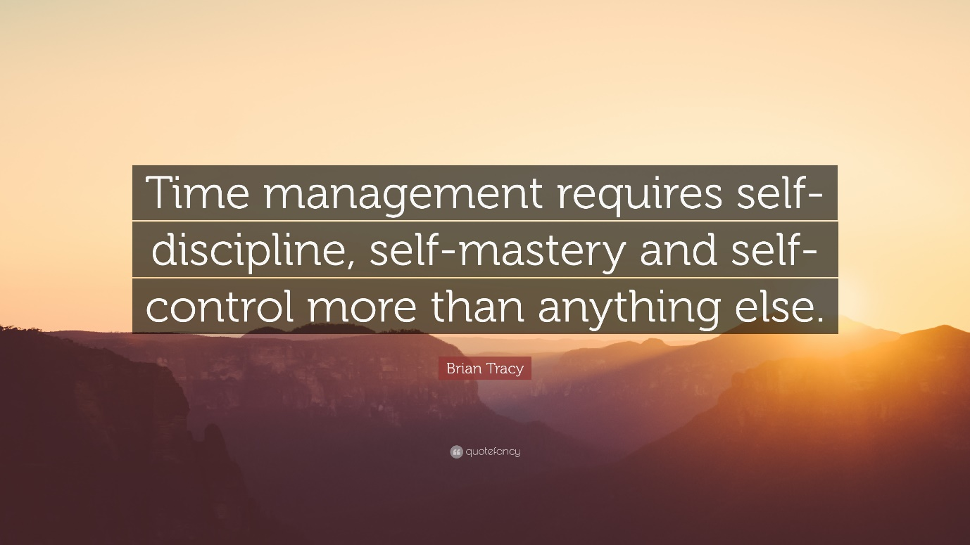
Brian Tracy Quote: “Time management requires self-discipline, self-mastery and self-control more than anything else.” (quotefancy.com)

REFERENCES:
[1] Anne.G. (2018) ‘Why People Skills Are So Important -- And How You Can Polish Yours To A Shine’. https://www.forbes.com/sites/anneglusker/2018/06/08/why-people-skills-are-so-important-and-how-you-can-polish-yours-to-a-shine/?sh=3c086df12458
[2] Johnson, S and Scott, J. (2019). Study and communication skills for the biosciences. 3rd edn. United Kingdom. Oxford University Press.
[3] Wang, K (2021). ‘The Importance of Teamwork in Analytics Organization’. https://kxwang.medium.com/the-importance-of-teamwork-in-analytics-organization-ac77c768a60a#:~:text=Image%20source%3A%201%201.%20Teamwork%20aligns%20data%20analytics,enables%20innovation%20...%203%203.%20Teamwork%20improves%20agility
[4] Erich C. Dierdorff (2020). ‘Time Management Is About More Than Life Hacks’. https://hbr.org/2020/01/time-management-is-about-more-than-life-hacks

