
12/12/2025
Claudiu MacEseanu (2426938)
Wash Doctor
Digital Skills for Personal Development and Business Growth (BMSW4008_CARD)
Module lead: Muhammad Cassamo
Task 1 Market Research and Website Development Project
1. Introduction
This report analyses how market research helped the development of the Wash Doctor business concept, website, and marketing materials. The primary research consisted of a questionnaire completed by 53 respondents, designed to understand customer preferences regarding mobile car valeting (Saunders, Lewis and Thornhill, 2019). The analysis focus on four key questions that most strongly shaped the business strategy: likelihood of using a mobile valet, preferred service type, preferred service location, and the importance of eco-friendly cleaning products. Secondary research was also used to understand industry trends and support decision-making (Stone, 2023). The findings were then applied to the creation of a two-page website and promotional materials, ensuring alignment between customer expectations and brand identity.

2. Questionnaire Design and Sampling
The questionnaire included 13 carefully structured questions using a mix of liker scales, multiple-choice, and closed-ended items. The questions were developed to measure customers cleaning habits, expectations of service quality, environmental preferences, and price sensitivity. The survey was shared with friends and local community members to obtain a diverse sample of people. Responses were collected through Microsoft Forms to allow automatic graph generation and accurate data obtain. This structured approach enabled the researcher to identify clear patterns that directly influenced the business and website development. The use of digital distribution allowed quick collection of over 50 responses, supporting a meaningful analysis (DeFranzo, 2011).

3. Key Findings from the Questionnaire
Likelihood of Using a Mobile Car Wash
One of the strongest findings came from the question asking participants to rate how likely they were to use a mobile car wash service. The majority rated their likelihood between 8 and 10, showing high demand for convenience-based cleaning services. This aligns with industry insights that modern consumers increasingly favour mobile, flexible solutions (Autotidy, 2025). This finding validated the core business model and highlighted the importance of promoting convenience across all branding.
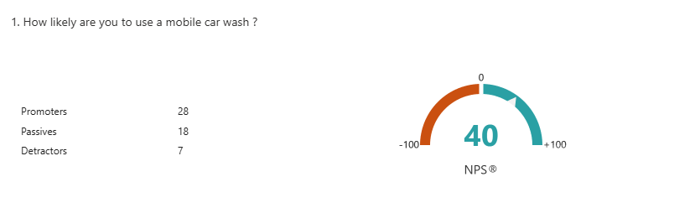
Preferred Type of Service
The survey revealed that full valet services were the most preferred option. Many respondents indicated that if they were paying for a mobile service, they expected a thorough, premium-quality job rather than a basic wash (Simoniz, 2025). This insight shaped the service structure on the website, ensuring that full valeting and deep cleaning services were prominently featured on the homepage and included detailed descriptions.
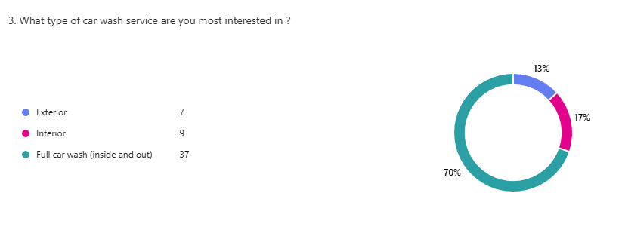
Preferred Service Location
A key behavioural insight emerged from the question asking where customers preferred to receive the service. The majority selected “At home”, suggesting that residential convenience is a key selling point. This is supported by industry commentary noting that a major advantage of mobile car washing is the ability to have vehicles cleaned at home or work without travelling or waiting, making it significantly more convenient for customers (Ponomarova, 2025). This shaped the entire marketing strategy, reinforcing the message “We come to you” which was placed on the flyer, business card, and website homepage.
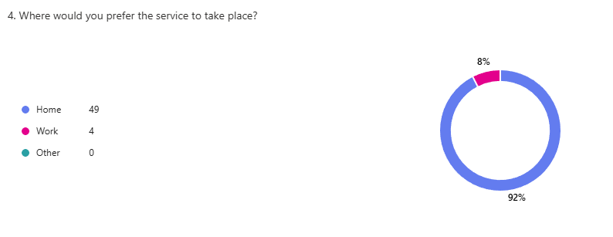
Importance of Eco-Friendly Products
Respondents rated eco-friendly cleaning products at 8.15/10 in importance. This finding supported the decision to use low-water, biodegradable cleaning materials and highlight this USP across branding. Environmental concerns have become a key consumer motivator in the UK car wash market, making sustainability a strategic advantage (Valet95, 2025).
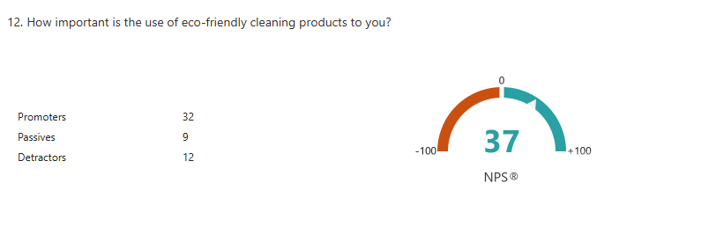

4. Influence on Website Development

The website (https://www.washdoc.org.uk/) was designed based on insights gained from the questionnaire.
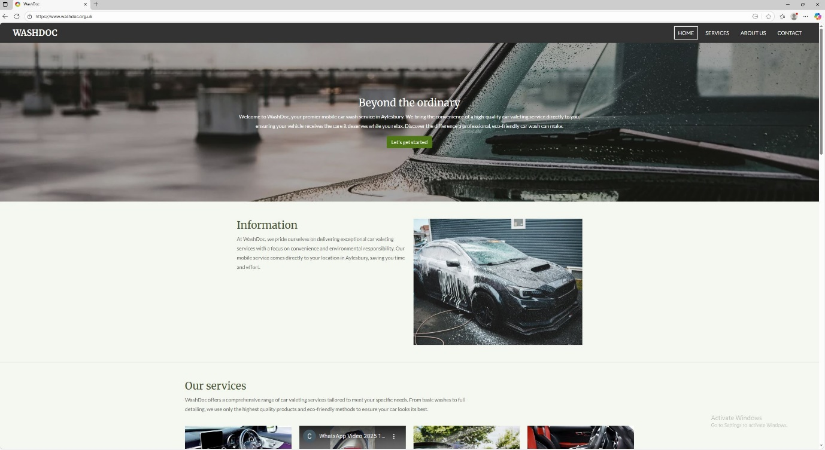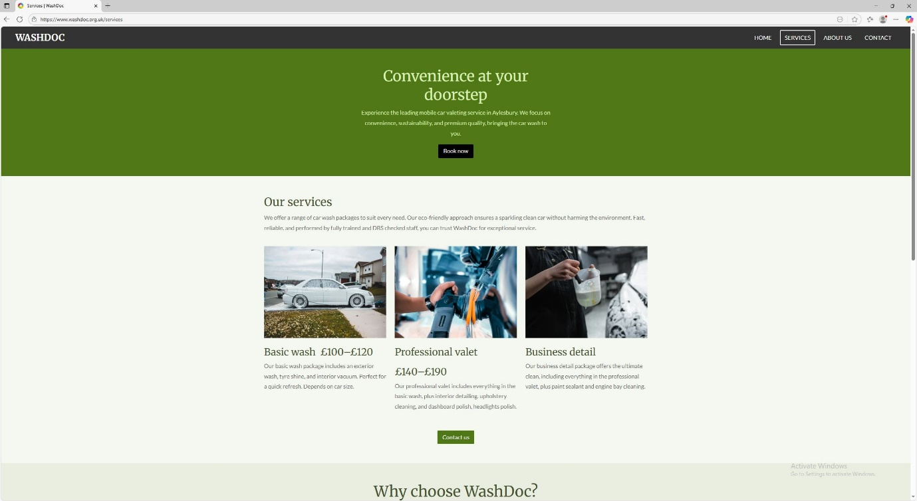
Several key design decisions were directly informed by customer preferences:
Convenience
Because respondents prioritised ease and timesaving, the website features simple navigation, bold headings, and a clear call to action (“Book your mobile wash”). Buttons were placed prominently at the top of each page to reduce user effort.
Highlighting Full Valet Services
As the most popular service category, the full valet option was placed on the homepage with images and short feature lists. The second page includes detailed descriptions and transparent pricing to match consumer expectations for clarity.
Eco-Friendly Branding
The survey insight that customers care about sustainability led to the use of green and blue tones, supported by phrases such as “Eco-friendly products” and “Low-water cleaning methods”. These messages appear on page one and within the service descriptions.
SEO Strategy
The SEO keywords were chosen based on both questionnaire findings and search trends, including:
- “Mobile car wash”
- “Eco-friendly car valeting”
- “Full valet service near me”
These reflect what respondents indicated they value most: convenience, sustainability, and quality. Basic SEO practices were applied, including alternative text and keywording headings (Nicholson, 2024).

5. Influence on Marketing Materials
Canva-created marketing assets include a flyer, business card, and logo. These materials were designed based on market research insights and tested visually to match customer expectations, reflecting guidance that effective marketing visuals must be aligned with audience needs, preferences, and behaviours (Norris, n.d.).
Flyer Design
The flyer emphasises “Expert Mobile Car Wash” and “Fast, clean, and reliable,” reflecting the finding that people care most about convenience and service quality. The clean, modern design uses blue tones to align with the eco-friendly theme.

Business Card
The business card features bold branding and clear contact information, ensuring ease of access for customers wanting quick communication. This aligns with the consumer preference for effortless booking.

Facebook Post & Customer Reviews
The Facebook ad includes before-and-after images, which were chosen because visual proof strongly influences trust, especially when offering premium services. The positive customer comments (“Great service and fantastic results”) were included as social proof, mirroring findings that quality is the top decision factor.
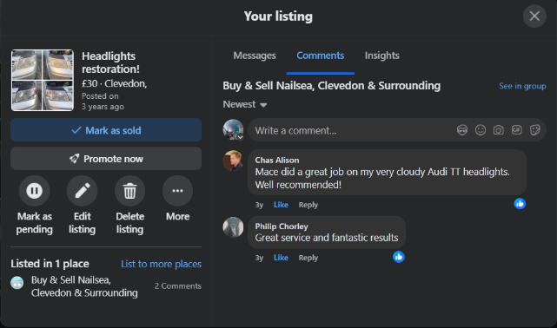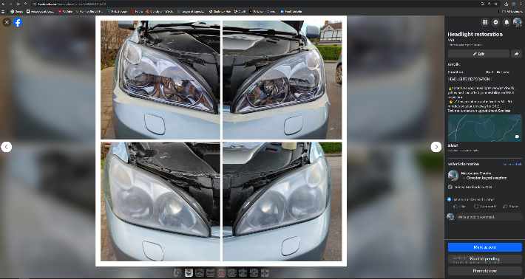
Logo
The “Wash Doctor – Drive Fresh” logo reflects a professional and trustworthy brand image. The car sparkle design communicates cleanliness and premium service, matching customer demand for high-quality results.


6. Audience Segmentation
The research identified three main customer groups:
- Busy Professionals – value convenience and time-saving services.
- Families and Homeowners – prefer home-based services.
- Eco-Conscious Drivers – value sustainable cleaning solutions.
These segments informed targeted branding and service positioning, ensuring that the message “We come to you” and the eco-friendly focus reaches the right audiences (Wavetec, 2024).

7. Conclusion
The market research provided strong evidence of demand for a mobile, eco-friendly valeting service. Key findings shaped the business idea, website, branding, and marketing materials to ensure alignment with consumer expectations. The website reflects user preferences for convenience, full valet services, and sustainability, while the marketing materials reinforce trust and accessibility. The research-supported strategy positions Wash Doctor effectively within a growing and competitive market.

Task 2 Importance of Excel in the digital era
In the digital era, data has become a central resource for effective business management and strategic decision-making. Among the many digital tools widely available, Microsoft Excel remains one of the most essential applications for organising, analysing, and managing business information. It’s flexibility, accessibility, and analytical capabilities make it particularly valuable for small businesses and student-led entrepreneurial ventures. For this reason, Excel has played a crucial role in the development and management of Wash Doctor, the mobile car-valeting business concept (Khan, 2023).
Excel’s importance begins with its ability to structure, store, and analyse large volumes of data quickly and efficiently. Modern businesses generate continuous streams of information—from sales and expenses to customer interactions and stock levels. Excel allows this data to be arranged into clear worksheets, tables, and formulas, enabling the identification of trends, patterns, and performance indicators. For the student’s business, Excel provides the foundation for financial planning, operational forecasting, and day-to-day managerial decisions (Tuttle, 2023).
One of the most significant Excel applications for Wash Doctor is the creation of a detailed 12-month cash-flow forecast, which the business developed as part of the start-up analysis. The business begins with £5,000 in personal savings, and Excel allows this starting amount to be carried across all relevant calculations using automated formulas. This ensures accuracy and consistency throughout the financial model. The owner projected anticipated sales of £2,000 in the early months, rising to £3,000 and later £4,000 as brand awareness grows. Excel’s ability to update these figures instantly makes it easy to adjust forecasts if demand increases or market conditions change (Charlesworth, 2024).
Excel also enables the systematic tracking of cash-out expenses, which are essential for measuring business sustainability. The Wash Doctor cash-flow sheet includes key monthly costs such as fuel (£100–£160), cleaning products (£30), insurance (100), and marketing budgets (£50). Initial equipment costs, such as the steam generator, vacuum, extension leads, and microfibre kits, appear as a larger upfront expense (£800). Using Excel formulas such as SUM and SUMIF, these expenses are automatically combined, allowing the student to monitor total monthly spending, which ranges from £3,470 to £3,540 depending on the period.
Excel also calculates net cash flow, which represents the difference between total cash in and total cash out. For Wash Doctor, the early months show modest negative balances, such as –£510 in Month 1 and –£540 in Month 2, which is typical for start-up businesses investing in equipment and early marketing. As monthly sales increase, the running balance improves, with the end-of-year total reaching approximately £7,730. Excel’s ability to calculate these figures automatically helps the owner identify when the business becomes financially stable and when it can begin to support growth initiatives such as hiring staff or renting a small unit.
Beyond financial planning, Excel supports automation, reducing administrative workload and human error. For example, formulas can automatically calculate totals, averages, and remaining balances, while conditional formatting highlights unusual spending or low stock levels. These features allow the owner to react quickly to unexpected changes, such as increased fuel costs or higher demand for cleaning supplies (Thomson, 2022).
Excel also supports customer management for the business. A customer database can be created to store information on service history, locations, and cleaning preferences. Using filters and pivot tables, the owner can identify loyal customers, analyse repeat booking patterns, and segment consumers into groups based on behaviour—such as busy professionals, families, and eco-conscious drivers. These insights support targeted marketing and service development, ensuring that promotional messages align with customer expectations (Navarro, 2025).
Inventory management is another area where Excel benefits Wash Doctor. Cleaning chemicals, microfibre cloths, and detailing tools need to be monitored to ensure smooth service delivery. An Excel stock sheet makes it possible to track product use each month, predict when supplies will run low, and reorder materials efficiently. Visual alerts such as conditional formatting help prevent shortages that might disrupt operations (Raymond, 2024).
Excel’s modelling tools also support scenario planning, enabling the owner to test how different decisions would affect the business financially. For example, the owner can model the impact of increasing full valet prices, expanding service areas, or gaining additional customers. Excel allows multiple scenarios to be compared easily, helping determine the most sustainable growth path for the business.
In summary, Excel is an essential tool in the digital era, enabling businesses to manage financial data, automate administrative processes, and make informed strategic decisions. For the Wash Doctor mobile valeting business, Excel supports accurate cash-flow forecasting, expense tracking, customer insights, inventory management, and scenario evaluation. By integrating Excel into its operational planning and financial processes, the owner ensures that Wash Doctor is organised, financially informed, and well-positioned for future growth in an increasingly data-driven business environment (Khandavilli, 2024).

Task 1 References

- Saunders, M., Lewis, P. and Thornhill, A. (2019) Research Methods for Business Students. 8th edn. Harlow: Pearson.
- Stone, N. (2023) ‘Advantages of questionnaires in online research’, SmartSurvey Blog, 26 January. Available at: https://www.smartsurvey.co.uk/blog/advantages-of-questionnaires-in-online-research (Accessed: 1 November 2025).
- DeFranzo, S.E. (2011) ‘Advantages and disadvantages of online surveys. Snap Surveys Blog. Available at:https://www.snapsurveys.com/blog/survey-advantages-disadvantages/ (Accessed: 2 November 2025).
- Autotidy (2025) ‘15 UK Car Wash Statistics Every Mobile Valeter Should Know’, Autotidy.co.uk, 13 September. Available at: https://autotidy.co.uk/mobile-valet-car-wash-statistics/ (Accessed: 2 November 2025).
- Simoniz (2025) ‘What is the difference between car valeting and car detailing?’, Simoniz UK Blog, 15 January. Available at: https://www.simoniz.uk/blog/what-is-the-difference-between-car-valeting-and-car-detailing/ (Accessed: 5 November 2025).
- Ponomarova, Y. (2025) ‘Understanding the benefits of mobile car wash services vs traditional car washes in the UK’, ThatCarWashGuy, 5 August. Available at:
https://www.thatcarwashguy.co.uk/post/understanding-the-benefits-of-mobile-car-wash-services-vs-traditional-car-washes-in-the-uk (Accessed: 6 November 2025).
- Valet95 (2025) ‘Trending Eco-Friendly Car Care Solutions in the UK — What You Need to Know’, Valet95 Blog, 26 September. Available at: https://www.valet95.com/blog/trending-eco-friendly-car-care-solutions-in-the-uk--what-you-need-to-know (Accessed: 9 November 2025).
- Nicholson, R. (2024) ‘What is SEO? A beginner’s guide to search engine optimisation’, HubSpot Blog, 28 March. Available at: https://blog.hubspot.com/marketing/seo (Accessed: 9 November 2025).
- Norris, E. (n.d.) ‘What is visual communication?’, Canva Design School. Available at: https://www.canva.com/learn/visual-communication/ (Accessed: 10 November 2025).
- Wavetec (2024) ‘The Benefits & Definition of Customer Segmentation Analysis’, Wavetec Blog, 11 November. Available at: https://www.wavetec.com/blog/customer-segmentation-benefits-definition/ (Accessed: 12 November 2025).

Task 2 References

- Khan, J. (2023) ‘The Importance of Microsoft Excel in Data Analytics’, LinkedIn Pulse, 28 March. Available at: https://www.linkedin.com/pulse/importance-microsoft-excel-data-analytics-jehanzeb-khan/ (Accessed: 15 November 2025).
- Tuttle, L. (2023) ‘Features of Excel to Use in Data Analysis’, Western Governors University, 15 August. Available at: https://www.wgu.edu/blog/features-excel-use-data-analysis2308.html (Accessed: 15 November 2025).
- Charlesworth, L. (2024) ‘Is Microsoft Excel still relevant?’, Kaplan UK Blog, 7 November. Available at: https://kaplan.co.uk/blog/features/is-microsoft-excel-still-relevant (Accessed: 20 November 2025).
- Thomson, N. (2022) ‘The importance of financial analysis using Excel’, INTLBM, 11 August. Available at: https://intlbm.com/2022/08/11/importance-of-financial-analysis-using-excel/ (Accessed: 20 November 2025).
- Navarro, B.J. (2025) ‘10 most useful Excel functions for financial analysis’, Workday Blog, 7 November. Available at: https://blog.workday.com/en-us/10-most-useful-excel-functions-financial-analysis.html (Accessed: 22 November 2025).
- Raymond, D. (2024) ‘10 Advantages of Managing your Projects with Excel’, AceProject Blog, 21 January. Available at: https://www.aceproject.com/blog/10-pros-advantages-of-managing-your-projects-with-excel-9387815/?afmc=pmnet (Accessed: 23 November 2025).
- Khandavilli, P. (2024) ‘Microsoft Excel For Data Analysts: 7 Unique Features’, Hevo Data, 15 December. Available at: https://hevodata.com/learn/excel-for-data-analysts/ (Accessed: 24 November 2025).

I confirm that I have not presented any AI generated text as my own work. I confirm I have copies of my drafts, notes, and other resources I used before, and after the use of AI tools which I may be asked to provide in evidence.
All student related guidance (included guides and videos) is available at:
Course: AI Learning Community | Home AI Guidance | UWTSD Intranet AI Guidance » Hub

