

University of Wales Trinity Saint David
School of Engineering
Six Sigma Principles for Process Improvement
Written by Joshua Hadden
Student Number: 2206081
Engineering Management
Date Written: 10/05/2024
L4 – Quality & Business Improvements ACMA4004

Table of Contents
Introduction 4
Literature Review / Background / Research 5
Methodology* 6
Results* 7
Analysis* 8
Discussion 9
Conclusions 10
Evaluation* 11
References 12
Appendices* 13

Table of Acronyms
Acronym | Definition
DMAIC | Define, Measure, Analyse, Improve, Control
DOE | Design of Experiment
SPC | Statistical Process Control
PESC | Precision Electronic Solutions Cymru
CEM | Contract Electronic Manufacturer
MFR | Metal Film Resistor
OEM | Original Equipment Manufacturer
SMART | Specific, Measurable, Achievable, Relevant & Time-Bound
MSA | Measurement System Analysis
Gauge R&R | Gauge Repeatability and Reproducibility
SCADA | Supervisory Control and Data Acquisition
FMEA | Failure Mode and Effect Analysis
SWP / SOP | Standard Work Procedures / Standard Operating Procedures

Introduction
The quality of manufacturing is the practice of ensuring customers receives the component they have ordered; this is achieved by using creative and efficient tools that often follow a structure that enable an environment in which problem solving can thrive. A terminology often associated with problem solving and quality management is ‘Six Sigma’; six sigma is a methodology for reducing variation in manufacturing, by using a metric that measures the parts failed in a process and applies standard deviation to drive the failure output to fall within 6 sigma’s of the mean (this usually transpires to 3.4 defects per million opportunities).
(American Society for Quality, 2024)
A tool commonly associated with six sigma is the DMAIC approach to problem solving and the cycle of six sigma projects. DMAIC relates to a logical, scientific approach to solving problems, and stands for:
Define – Define the problem statement and determine the scope of the issue.
Measure – Collect data to understand as much as possible about the problem, such as frequency, variation, time, machine number, operator, time, day etc.
Analyse – Use statistical tools to analyse the data and understand the correlation between the variables and the defect quantity. Understand the natural variation of the process, and the different failure faults that can occur as well as what triggers these faults.
Improve – Use the information collected from the previous steps to implement Poke-Yoke’s (error proofing) that either eliminate the faults from occurring or improve detection when the faults do occur. Use additional continuous improvement tools such as Kaizen (continuous improvement) and ‘Design of Experiment’ (DOE) etc.
Control – Update manufacturing documentation, internal audit requirements, standard work procedures, and implement ‘Statistical Process Control’ (SPC) to ensure the new process is adhered to and now a part of the standard day to day operation, ensure the possibility of this work being undone is eliminated.
(Tanner, 2024)
Using the above methodologies, a DMAIC project will be designed to support ‘Precision Electronic Solutions Cymru’ (PESC), a ‘Contract Electronic Manufacturer’ (CEM) that provides high quantities of ‘Metal Film Resistors’ (MFR’s) for an ‘Original Equipment Manufacturer’ (OEM). The report will set out to answer the following questions:
- Why is an effective problem statement important?
- What potential tools could be used to measure the MFR manufacturing process, and what variables should be tracked to provide sufficient insight into the potential problems?
- Using the data provided in the previous DMAIC step, what analysis tools are available to measure the data in a way that clearly defines the causes for the high failure rates experienced in the manufacturing process?
- Using the analysis of the data, what improvements can be made to reduce the number of defects?
- What strategies can be implemented to control the positive changes made to this manufacturing process, and ensure the permanent elimination of these issues?
Additional to the above discussion, the following actions will be completed:
- A problem statement will be generated with an explanation surrounding the logic of the statement.
- A plan for collecting data will be provided.
- A plan for analysing the data will be provided.
- Three strategies will be outlined for reducing the number of defects.
- Strategies for controlling this process will be defined for continuous monitoring of the variation reduced in the relevant manufacturing processes.

The DMAIC Approach
Six sigma is a methodology designed to reduce the variation of a process. Every process regardless of how controlled an element of variation in which unwanted results has can occur, and by following simple and consistent methodologies, finding, and reducing this variation becomes simple.

Define
The first process is designed to ensure a clear image of the problem has been defined; this is achieved by creating an efficient and well-structured problem statement. A good problem statement provides a lot of information with only little words, and answers questions such as:
- What is the problem?
- What is the scope of this problem?
- What processes are impacted by this problem?
- How often does this problem occur?
- What percentage of yield is impacted by this problem?
- How severe is this problem?
(Six Sigma Institute, 2018)
The problem statement is the defining anchor that manipulates the entire DMAIC process. Therefore, a poorly structured problem statement can result in extensive resources being spent with little benefit. Consider a problem statement with a generic scope; extreme resources will be spent in the measurement and analysis stage than necessary, and the data may be clouded with the noise of healthy processes.
Additionally, to the above criteria, there is a well-structured tool for defining objectives called SMART (Specific, Measurable, Achievable, Relevant & Time-Bound) (Indeed Editorial Team, 2023). Following this acronym, objectives become significantly more feasible and naturally adhere to the DMAIC principles.
Relating to PESC, an ideal problem statement would be something along the lines of:
“PESC is receiving a high number of customer complaints and enduring high costs due to high defect rates during the manufacture of MFR’s. There is currently inadequate detection of these defects, SPC must therefore be implemented across all the processes identified in figure 1. Using the data extracted from the SPC process, adequate poke-yoke’s are required to either eliminate the causes of variation in the eight-manufacturing process; or improve detection to protect the customers”.

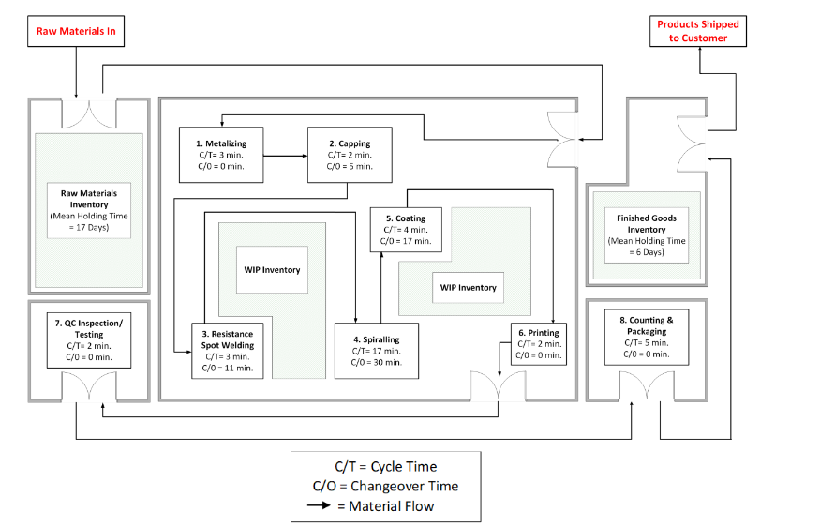
Figure 1 - PESC Plant Layout & Material Flow

Measure
The measurement section of the DMAIC approach enabled the collection data that provides various perspectives on the variables that could correlate with defect rates in a process. For this purpose, it is essential to collect the data of as many variables as possible, be them qualitive or quantitative. These variables include things such as:
- Time / Day / Month / Year
- Process Step
- Operator
- Team
- Machine Identification
- First Off Quality Inspection
- Internal Audit Results
- Defect Type
- Defect Quantity
- Defect Pattern (intermittent, after changeover, every 4th product etc.)
It is essential to audit the data logging processes regularly to avoid human error and intentional data manipulation. The process of collecting data can often be subjected to variation, the reason for which becomes apparent after the words of the famous statistician and SPC guru, Donald Wheeler, of which quoted:
“In the classroom, two plus two is always equal to exactly four. Yet when a manufacturer tries to lay down a two-micron film on a two-micron substrate, the result is seldom equal to exactly four microns. About the best that we can hope for is that the result will be four microns thick on the average. And this is the basic difference between numbers and data” (Wheeler, 2010).
Based on this statement, measurement system analysis (MSA) is an essential tool for ensuring the measurement processes are statistically in control. This is achieved by using Gauge R&R (Repeatability & Reproducibility) Studies to measure the variation between different measurement devices and operators. MSA measures two main variables, the accuracy of the data being collected and the precision.
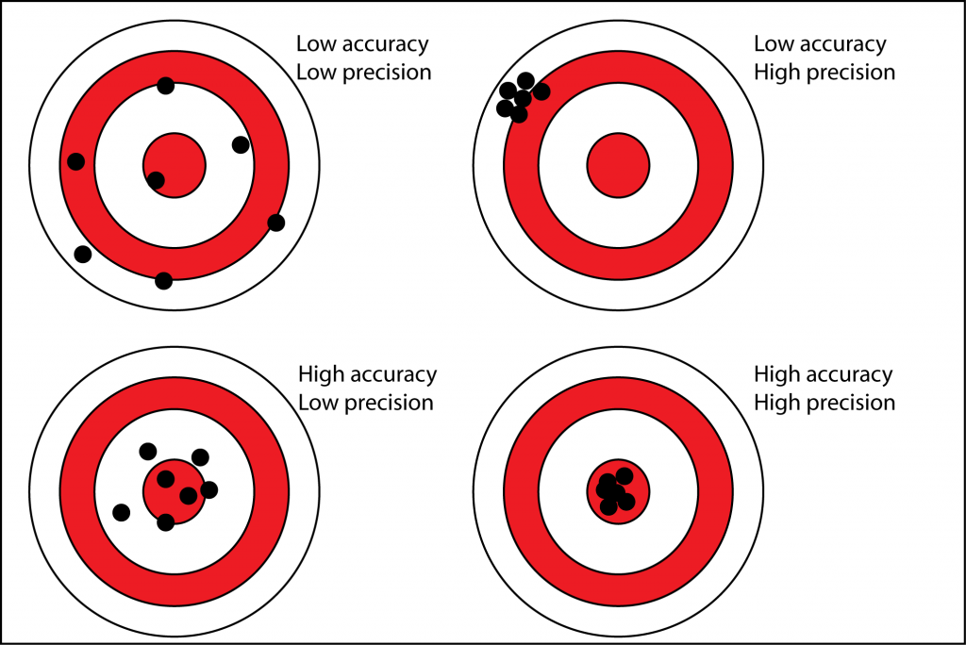
Figure 2 - Accuracy Vs Precision
(Davies, 2023)
Figure 2 demonstrates the commonly misinterpreted differences between accuracy and precision. Accuracy relates to the consistency in which data falls between a certain range. If a set of data has high accuracy with low precision (figure 2, bottom left) then the data is close in range but rarely falls directly on the target. If however, data is collected with high precision and low accuracy (figure 2, top right), the data collected will consistently be very close to the mean with a very tight range, however, may be very far from the target (actual value).
Often (although not always), poor accuracy is related to the calibration of the instrument being used. If the instrument is working correctly, however there is 0-offset in which the value of ‘0’ is reading for example ‘20’, the device may work perfectly but the data will consistently be 20 values out of place.

Analyse
Once the data has been collected, there are various tools that can be used to analyse it. Matlab is an excellent tool that can be used to calculate complex formulas for analysing large groups of data, such as completing correlation analysis to compare the correlation between two variables.
There are three main types of correlation analysis tools that can be used:
- Pearson’s correlation coefficient – Used to analyse linear variables such as the quantity of defects produced per hour on a machine and the time of day.
- Spearman’s Rank-Order Correlation – Often used to measure variables that commonly fit into a certain pattern, for example the number of defects per day and the number of changeovers per day.
- Kendall’s Tau Correlation – Determines the strength between two variables by assigning two variables a coefficient based on an x/y axis. The closer the value of the coefficient is to ‘0’, the more independent the variables are from each other.
(DX Adobe, 2021)
Figure 1 suggests there is plenty of room for improving the takt time in which it takes the raw materials to progress through the processes. Arene is a brilliant software for creating process flows capable of generating takt time by applying resources to the various stages of a process. Consider the spiralling process defined in figure 1 for example, currently a changeover takes 30 minutes which is the longest changeover on the manufacturing line, this means that every changeover takes at least 30 minutes to complete. The spiralling process involves a laser cutting the desired material from the metal film to achieve the correct resistance. Most of this changeover will be ensuring the correct settings are set on the laser cutter, aligning the new product with the laser cutter, and securing the correct clamps to hold the resistors as they rotate past the laser.
Most mature manufacturing operations that foster a six-sigma approach are well versed with SPC, a proactive tool set that monitors the variation in a process and filters out noise from the voice of the process, often via the use of control charts. There are various types of control charts, such as a chart of individuals, a moving average range chart and an X-bar chart. Each of these charts are suitable for different sets of data,
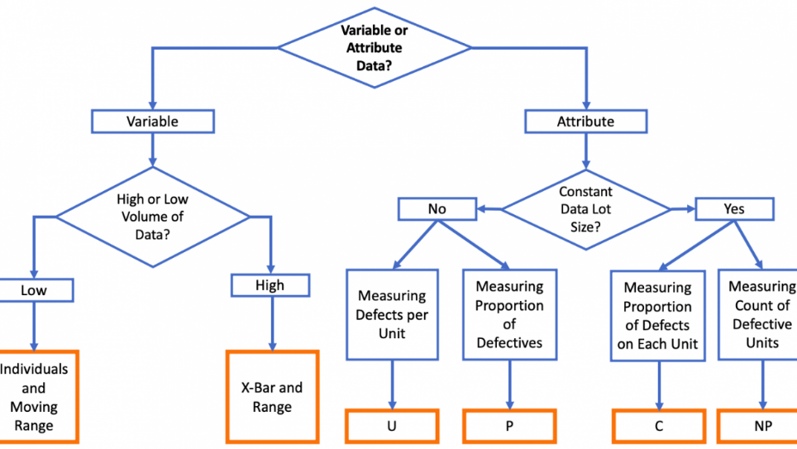
Figure 3 - Control Chart Type Flow Diagram
(Sensei, 2018)
Consider figure 3, when selecting the type of control chart to use it is first essential to consider whether the data is variable or attribute, also defined as qualitive and quantitative. Qualitive data refers to data that is counted in whole segments, whereas quantitative data is based within an infinite range.
A control chart filters common cause variation from special cause variation. Common cause variation is the natural variation of the process, it is imbedded into the standardization of the process and if everything goes well will always be there. Special cause variation, however, refers to variation of results produced by a process due to an unpredictable change in the standardization. This could be a tool breaking, a machine running on different settings, or a different material being used in manufacturing etc.
Processes can fall into 4 states, as defined by Donald Wheeler:
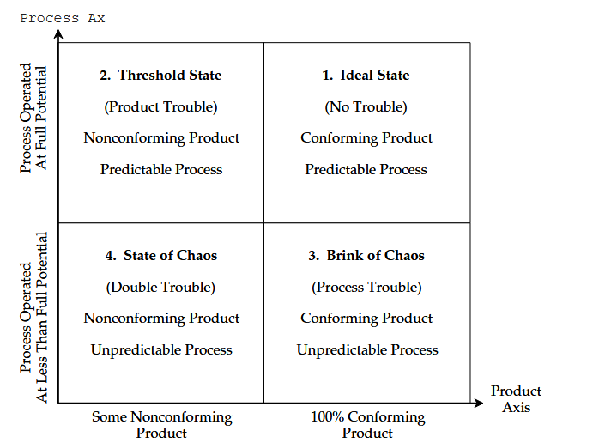
Figure 4 - The 4 States of Any Process
(D. Wheeler, 2009)
As described in figure 4, manufacturing plants always strive for the ideal state in which a process is predictable as defined by a control chart, and within the customers’ requirements. A process can be in statistical control but have a range exceeding the defined tolerance, this is described as the threshold state. The brink of chaos and state of chaos are defined so because the processes are not in statistical control, this means it is impossible to predict the outcome of products and assume they will fall within a certain range. The only way to improve the state of a process is to make a change to the standardization of the process.

Improve
Arguably the most important step of the DMAIC process is improve, where the work of defining, measuring, and analysing the problem is summarised into solutions. Six sigma projects tend to implement poke-yoke’s, a Japanese term that translates to ‘fool-proof’ in which a change is made to a process that eliminates an issue from occurring or implements a proactive detection such as a machine shutting down until a detected defect is manually extracted from the line (Nancy R. Tague, 2015).
As discussed above, figure 1 highlights the changeover time of the processes. A principle of lean manufacturing methodology initially developed by Taichi Ohno from Toyota features reducing waste by eliminating a surplus of inventory and improving the time it takes materials to pass through a production line to flow without building up in certain areas (Phogat, 2013). The mean raw material holding time is 17 days and the mean finished goods holding time is 6 days, this time is costing storage, down investment into materials not being used, and increases the likelihood of damage in storage. Currently one of the main reasons for adding the large product holding times is due to unpredictability such as machine downtime, which can be resolved with regular analysis of control charts.
Control charts as defined above can be a brilliant tool for detecting changes to a process, regular monitoring of control charts can result in detecting special causes variation before they can make a significant impact to manufacturing. There are systems such as SCADA (Supervisory Control and Data Acquisition) which can use live input sensors to populate data and control charts in real time, email notifications can even be set to send warnings to relevant stakeholders when a data range is breached.
Additionally, the SCADA system is compatible with various outputs such as actuators, alarms, and lights. When the data range of a test is breached, a circuit could be set to trigger in which the machine stops manufacturing, an alarm sounds until manually turned off, and a light flash for additional attention.
The above systems are ideal for automating improvement based on a trigger; however, a solid inspection is required that can yield reliable data compatible with the above proposals. Based on this, the following inspection would be an ideal implementation to work with the above fixes:
The spiralling process removes excess material to achieve the correct resistance, this means the weight of the material is correlated with the resistance of the product. An automated weighing process could be implemented to indicate if a resistor is faulty before it undergoes the final continuity test defined in figure 1 step 7. This test will be compatible with the SCADA system, to automatically populate control charts, improve the detection of the process by forcing operators to interfere when non-conforming products are measured, and alerting management of special cause variations present in a process in real time.

Control
The final step to the DMAIC process is the control process, in which the improvements from the previous step are standardized and implemented into the manufacturing process. This is achieved by updating key documents such as FMEA’s (Failure Mode and Effect Analysis), SWP (Standard Work Procedures), internal audit, operator check sheets and any other official documentation that specifies the nature of the manufacturing process.
Establishing control in a process is essential for assuring the work that went into improving a process remain indefinitely, and similar work is not completed in the future. Manufacturing plants often have a level of senior operators that hold an impressive knowledge of the manufacturing processes that are not documented, and when these operators stop working at the factory this knowledge is often lost followed by a rise in defects. Controlling a process is essential because it ensure that when different operators complete the job, there is as little variation as possible between them.
Additionally, to updating the documentation, the SCADA system will support as ongoing control over the processes too. The control chart will populate autonomously and send updates to management where necessary, additionally the operators are forced to react to non-conforming components.

Conclusions
It is clear the DMAIC structure is a powerful six sigma tool for problem solving, it holds the user accountable to ensure each step is reliant on the step prior, resulting in a well-structured solution being concluded.
The new inspection on figure 1 process 4 ensures special cause variation is detected within the first half of the process. The weighing method fed into a SCADA system also implements a detection poke-yoke that forces operators to respond and acknowledge non-conforming parts by stopping the machine and sounding an alarm. Additionally, the data being fed into a control chart enables special cause variation to be detect in real time, with this information being emailed directly to management.
With the above solution, unexpected downtime will decrease which will enable PESC to improve their just in time approach, by being less reliant on holding large amount of stock at various stages of the process. This results in PESC adopting more of a lean manufacturing mentality in an effort to reduce waste.

Bibliography
American Society for Quality. (2024). What is Six Sigma? American Society for Quality. https://asq.org/quality-resources/six-sigma
Davies, B. (2023, April 13). Precision and accuracy in glacial geology. Antarctic Glaciers. https://www.antarcticglaciers.org/glacial-geology/dating-glacial-sediments-2/precision-and-accuracy-glacial-geology/
DX Adobe. (2021, March 26). Correlation Analysis. Business Adobe. https://business.adobe.com/blog/basics/correlation-analysis
Indeed Editorial Team. (2023, March 31). How to write SMART goals in 6 steps (With tips and examples). Indeed. https://uk.indeed.com/career-advice/career-development/how-to-write-smart-goals
Nancy R. Tague. (2015). Quality Toolbox (Second Edition). ASQC Quality Press 1995.
Phogat, S. (2013). INTRODUCTION TO JIT: A REVIEW. International Journal of Latest Research in Science and Technology , 2(6), 97–101. https://www.mnkjournals.com/journal/ijlrst/pdf/temp/Volume_2_6/10238.pdf
Sensei. (2018, August 29). Control Charts. Lean Manufacturing. https://leanmanufacturing.online/control-charts/
Six Sigma Institute. (2018). Six Sigma DMAIC Problem Statement & Project Charter. Six Sigma Institute. https://www.sixsigma-institute.org/Six_Sigma_DMAIC_Process_Define_Phase_Six_Sigma_Project_Charter.php
Tanner, S. (2024, March 20). DMAIC Process: The 5 Phases of Lean Sigma You Must Know. Simplilearn. https://www.simplilearn.com/dmaic-process-article
Wheeler, D. (2009). Two Definitions of Trouble. Quality Digest Daily. https://www.spcpress.com/pdf/DJW203.pdf
Wheeler, D. J. (2010). Two Routes to Process Improvement. Quality Digest Daily, 209. https://www.spcpress.com/pdf/DJW209.pdf

