

Assignment Title- REWORK OF ORIGINAL SUBMISSION

Module Code: BMSW4002_BIRM

Student Name: Crista Grigore
Student ID: 2118246
Lecturer’s name:

Executive Summary
The report discussed the importance of effective teamwork and also discussed how effective teamwork can be developed. The report discussed Tuckman’s stages of team development and the grip model of teamwork. It further discussed the importance of team roles while discussing Belbin’s team roles theory. It further discussed the advantages of teamwork and made recommendations for the team Tom Jackson.

Table of Contents
Executive Summary 2
Introduction 4
How to Develop an Effective Team 5
Models of Team Development 5
Tuckman’s Model of Team Development 5
GRIP Model 7
Team Roles 8
Belbin’s Team Roles 8
Discussion 9
Advantages of Effective Team Working 9
Recommendations 10
Conclusion 11
References 12

Introduction
Effective teamwork depends on a lot more than talking to one another. In this way, every member of the team can learn about issues that might affect their responsibilities. In addition, it nurtures confidence, fosters companionship among members of the team, raises spirits, and keeps employees invested in their work. The importance of its advantages to the workplace is evident. This is why it's so essential for a company faces to foster an environment where employees feel at ease speaking to one another. The success of a team varies depending on its members' capacity to interact successfully with one another in hopes of exchanging ideas, completing tasks, as well as work together. The report shall discuss the importance of effective teamwork for the growth and development of members of the team and employees individually as well. It shall discuss the effective team roles of a successful team and use models and theories; it shall also identify teamwork barriers in the case of the team led by Tom Jackson which is working on opening large warehouses for Amazon in three major cities London, Paris, and Berlin.

How to Develop an Effective Team
Cooperation that produces an excellent output is an example of effective teamwork. Employees’ role on the team is comparable to that of an orchestra conductor in many respects. A strong commitment to teamwork is the basis for effective collaboration. One be part of a larger leadership team in which everyone is willing to take responsibility for their section's output, and employees also be willing to take responsibility for their own section's work. Regular interaction and collaboration with team members are vital to succeeding on any team, as is a firm belief in the value of team spirit. The following points can help in building an effective team.
- Constantly keep team cohesion in mind. Dedicate a fraction of team meetings to open conversations about how to address obstacles and identify growth opportunities. Team participants ought to be given opportunities to mingle and get to know one another in any way possible. Companions are more likely to help one another out and offer advice than strangers.
- Find out from the team members what they would most like to work on. Then, when chances for specialized positions present themselves, you can give them to team members with a genuine passion for the topic. This is an excellent way to recognise the hard work of your members of the team and provide them with possibilities for advancement in their professions.
- Think about the group dynamics and how your decision-making style will affect them. Be prepared for extended periods of deliberation if individuals decide that the team needs to reach a consensus before moving in a specific direction.

Models of Team Development

Tuckman’s Model of Team Development
According to Tuckman, as a team grows in expertise and maturity, relationships form, and the manager adopts a new strategic plan. They start by taking charge, then keep moving on to coaching, then participation, and finally representatives, until they're almost disengaged. The current leader can then move on to form a new group after the team has generated an alternate leader. Forming, Storming, Norming, Performing, and Adjourning are common ones for these phases of group development. Tuckman's model explains how, as a team grows in competence and self-awareness, its leadership style transitions from autocracy to a more democratic management style (Vaida, and Șerban, 2021).
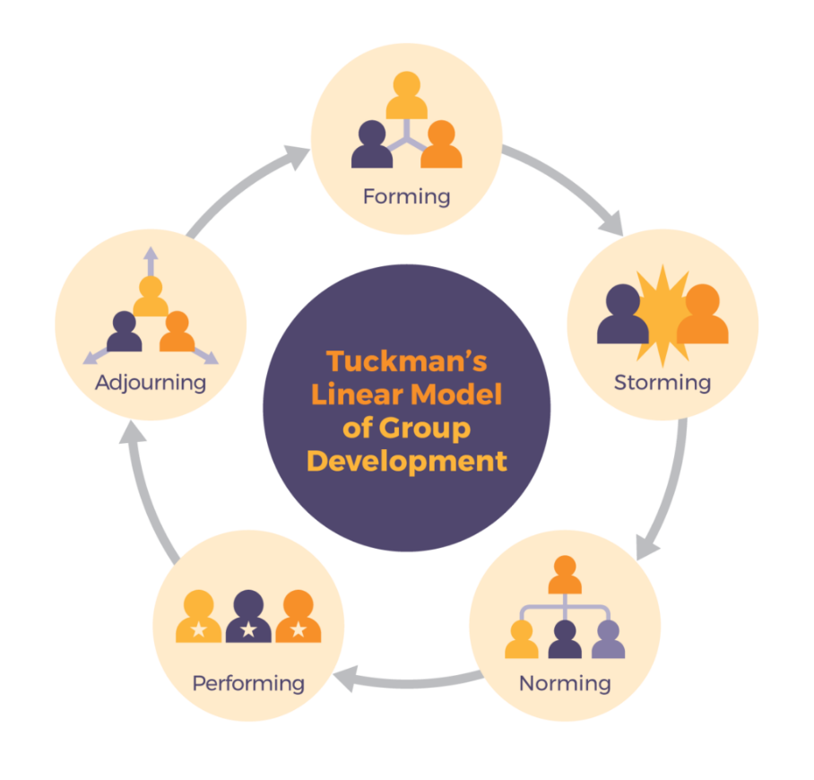
Figure 1 Tuckman’s Model of Team Development
(Source: https://pressbooks.bccampus.ca)
- Forming- The first phase of team structure entails formalising the group's foundational elements. The pressure to fit in causes members of the team to feel uncertain and cause conflicts to be avoided as much as possible. In most instances, team members would then look to their group leader, or a CORAL project guide, for guidance and advice.
- Storming- In the storming phase, participants begin to investigate the situation and challenge the status quo. When people on a team disclose their true selves and their favoured methods of working, they may come into conflict with each other. The teammates may now question your leadership skills or the relevance of the team's aim.
- Norming- After the storming stage the team moves into the norming stage. The team members resolve their differences and start to appreciate the talents and strengths of each other and start to respect the leader and acknowledge their superiority and knowledge (Natvig, and Stark, 2016).
- Performing- In the performing stage the entire team gives full of their potential with their hard work in structured processes and the team can achieve their goals efficiently and competently. This stage comes after the norming stage.
- Adjourning- All the teams reach this stage of Tuckman’s stage development theory naturally; at the adjourning stage the team is disbanded and all the team members are re-employed. The team members go back to their jobs and work. Usually, at this stage, the members are emotional to let the team go (Scherrer et al, 2016).

GRIP Model
The Grip model was developed by Richard Beckhard in 1972 and has been highly adapted in the sports field. The grip model outlines four components such as goals, roles, intrapersonal, and processes.
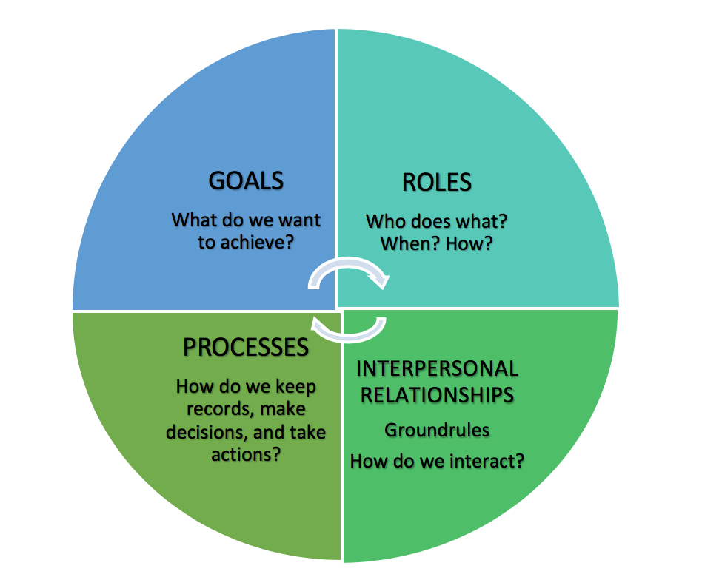
Figure 2: GRIP Model
(Source: https://pressbooks.bccampus.ca)
- Goals- For the goals, all the team members must carefully understand the goals, aims, and objectives of the team and what they want to achieve. All the members must be committed to the goals of the team as a whole and align their goals, establish trust as well as work hard toward achieving the goals and the desired outcome.
- Roles- The roles of each team member must be clarified and defined to know what part they are playing and they must be accountable and responsible for their role.
- Intrapersonal- Intrapersonal comprises trust among the team members, the team must have effective communication, coordination, and collaboration. The members must be empathetic towards each other and must be able to resolve conflicts on their own (De Cooman et al, 2016).
- Processes- Processes define how the system would work, the structure of the team, the decisions, and the hierarchy that would be followed.

Team Roles
A cohesive team is when individual employees in a company share a common identity or goals. The members remain united and work together. A cohesive team is motivated to accomplish a common goal, contribute to the success of the team, have respect for each other, have common goals and share the same culture and ideas and develop good relations. Team roles are extremely important as they clearly define the roles and responsibilities of each member which helps to avoid any confusion among the members and they can focus on completing their work and contribute toward reaching the goal. Team roles can be understood by Belbin’s team role model (Schippers, West, and Dawson, 2015).

Belbin’s Team Roles
Belbin has classified all nine team roles into three categories. The three categories are action, people, and though oriented. Each role under this model is linked to behaviour, weaknesses, and strengths. The report shall further discuss the nine team roles as defined by Belbin.
- Shaper- Shapers are team members who come under the category of challenging the team and motivating them to improve. As Belbin defined them, shapers are dynamic and creative, they are also extroverts who have good approaches to resolving an issue. They see obstacles as a challenge they need to overcome and are known for shaking things up in a team so that all the possibilities are considered (Rahmani et al, 2022).
- Implementer- Implementers are the ones who get all the task done. They believe in acting upon things and meeting targets. They are introverted disciplined people. Their strengths are that they work systematically and efficiently and are responsible for their tasks and are trusted by the leaders.
- Completer- They are the ones who check everything thoroughly when a task is completed. They ensure that the work is free of any errors or faults and pay attention to the tiniest detail. They are responsible team members who are accountable for delivering tasks on deadlines as well as described as perfectionists.
- Coordinator- They are responsible for guiding the team towards their objectives and are great listeners. Coordinators can recognize the talents and values of each team member as well as be responsible for delegating tasks to each of them.
- Team-worker- They have the role of supporting and motivating all the team members. They are diplomatic, perceptive, flexible, and good negotiators.
- Resource Investigator- They are inventive and creative and make connections and negotiate for resources on behalf of the entire team. They are known to be extroverted and outgoing.
- Plant- Their role is to generate new ideas and approaches for the team. They prosper on appreciation and do not take criticism well.
- Monitor Evaluator- Their role is to examine and evaluate the ideas given by planters by weighing the pros and cons.
- Specialist- they have specialised knowledge and information of a topic and work on tasks under their expertise.

Discussion

Advantages of Effective Team Working
- Builds Trust- For this purpose alone, it may be the best idea for companies to form teams. Members are more likely to rely on one another to reach a common goal when the team's achievement or failure could affect the whole team.
- It fosters Creativity- Collaboration between members of the team, attempting to draw on each student's abilities, is what makes working in a team so effective. This allows them to allocate their gives us an idea and produce more robust strategies. When people on a team can talk openly with one another, they are more likely to develop trust with one another, which in turn generates the generation of innovative approaches (Chiniara, and Bentein, 2018).
- Stronger team- It's possible that one team member has members who thrive at writing but who fumble when it involves speaking in public. If you want to broaden your team's set of skills and give both members a chance to grow, pair them with a person who's familiar in front of an audience.
- Manages Conflict-Resolution- Teams that regularly practice conflict resolution find much better answers to common problems. This is because disputes are inevitable in any team with members with different experiences and perspectives. Employees are unique in many ways, such as their personalities, work styles, and ethnic backgrounds. When disputes occur within a team, workers develop skills in conflict resolution, a skill essential for those who aspire to managerial positions (Ferreira et al, 2021).

Barriers faced In the Scenario
- Communication barriers- Tom Jackson is facing communication barriers within the team which initiated from the team formation that was constructed poorly.
- Motivational Barriers- Mihaela and Spencer, two members of the team are facing commitment issues toward the goal of the team due to a lack of motivation.
- Lack of Listening- Team members are facing issues with a lack of being heard. They feel their problems are not being heard which is causing other problems.

Recommendations
Problems related to an absence of respect and trust can be improved by encouraging more interaction, concentrated and, whenever possible, in-person interactions among people in different roles. Disputes between people of different worldviews can be prevented through the promotion of mutual understanding. by recognizing each teammate's unique psychological type, needs, power base, conflict tone, and stress quotient and trying to make an effort to learn from team members whose perspectives differ from the ones you have due to training, role, or cultural variables. Tom must effectively engage with all the team members individually to make a connection with them and address the issues they are facing. When the team members would feel like they are being heard they would also try to make an effort to improve (Schmutz, Meier, and Manser,2019).

Conclusion
In conclusion, it can be understood how important effective team working is. By dividing up duties and duties, teams can feel less pressured to rush through one work and instead focus on doing excellent work from beginning to end. The report discussed Tuckman’s theory of team development as well as the Grip model to understand the stages of team development. It further discussed the importance of a cohesive team and the necessity of team roles in every team. It discussed Belbin’s team roles theory and further discussed the advantages of effective team working and suggested recommendations to overcome the barriers of effective team working faced by the team of Tom Jackson in the case of Amazon.

References
- Chiniara, M. and Bentein, K., (2018). The servant leadership advantage: When perceiving low differentiation in leader-member relationship quality influences team cohesion, team task performance and service OCB. The Leadership Quarterly, 29(2), pp.333-345.
- De Cooman, R., Vantilborgh, T., Bal, M. and Lub, X., (2016). Creating inclusive teams through perceptions of supplementary and complementary person–team fit: examining the relationship between person–team fit and team effectiveness. Group & Organization Management, 41(3), pp.310-342.
- Ferreira, R., Pereira, R., Bianchi, I.S. and da Silva, M.M., (2021). Decision factors for remote work adoption: advantages, disadvantages, driving forces and challenges. Journal of Open Innovation: Technology, Market, and Complexity, 7(1), p.70.
- Natvig, D. and Stark, N.L., (2016). A project team analysis using Tuckman's model of small-group development. Journal of Nursing Education, 55(12), pp.675-681.
- Rahmani, F., Scott-Young, C., Tadayon, A. and van der Walt, J.D., (2022). Team composition in relational contracting (RC) in large infrastructure projects: a Belbin’s team roles model approach. Engineering, Construction and Architectural Management, 29(5), pp.2027-2046.
- Scherrer, J.L., Olcoń, K., Butterfield, A.K. and Kebede, W., (2016). Bringing experiential educational groups to the United States: an analysis of group development in an international travel and study program. Social Work Education, 35(6), pp.693-705.
- Schippers, M.C., West, M.A. and Dawson, J.F., (2015). Team reflexivity and innovation: The moderating role of team context. Journal of Management, 41(3), pp.769-788.
- Schmutz, J.B., Meier, L.L. and Manser, T., (2019). How effective is teamwork really? The relationship between teamwork and performance in healthcare teams: a systematic review and meta-analysis. BMJ open, 9(9), p.e028280.
- Vaida, S.E.B.A.S.T.I.A.N. and Șerban, D., (2021). Group Development Stages. A Brief Comparative Analysis of Various Models. Studia Universitatis Babes-Bolyai, Psychologia-Paedagogia, 66(1), pp.91-110.

