Student name: Parvaneh Safari
Student No: P108305
Module: Ecommerce
Level: 5
Lecturer: Sue Maw
Assignment: Build a prototype E-Commerce Website (Essay 2)

Content
Introduction………………………………………………………………………………1
Ecommerce-infrastructure……………………………………………………………....1
Building Ecommerce application………………………………………………………..2
Ecommerce monetary transaction evaluation..………………………………………...7
Marketing Metric Evaluation…………………………………………………………...9
Conclusion……………………………………………………………………………….10
References……………………………………………………………………………….11

Introduction
Solar energy has been looked upon as a serious source of freely available energy and the modern solar panels are designed to convert the heat from the sun to energy [1]. Eira Sol founded Sol R Energy Company three years ago. It was initially a family business taking on small domestic solar panel installation jobs. However, today it has grown to employ six additional full time staff and one part time office administrator. The initial admin procedures are very simple and have not kept up with the company growth. Therefore, most of the invoicing, stock control and scheduling is based on paper work and completed manually. Consequently, jobs mostly starts with delay and this result in a need for a professional invoicing system to be able to track payment as well.

This report will investigate the useful ways to support the needs of the growing business and to provide an ecommerce platform for the domestic services. It will help to find wider sales opportunities and customised business applications installation. A prototype of the ecommerce site will be built and the proposed solutions for Sol R Energy will be presented.

Ecommerce-infrastructure
Every business requires powerful infrastructure to support its operations and customers. This includes facilities, equipment and processes to support all functional area of the business. Thus, choosing the right infrastructure to match the business strategies is very important and enables the business to run efficiently [2].

The value proposition of Sol R Energy is to provide a high-level customer service and low price products. Therefore, the infrastructure to run this business should include processes to deliver quick and responsive services such as live chat and self-service tools for booking engineer.

Ecommerce is usually to maintain a high degree of flexibility to keep the costs low and react quickly to the competitive pressure and the market changes [3]. According to Traxler (2012) [3], the seven important infrastructures that businesses face is as follow: marketing, facilities, customer service, information technology, Fulfilment, finance and administration, and human resources. However, marketing is the most important infrastructure element for success.
Keeping visitors on the ecommerce site and compel them to buy from Sol R company is the job of marketing through website design, social media, merchandising and other form of marketing [4]. In addition, customer-management system will make all the activities easier and live chat during specified hours of operations can be very useful [5].

Nevertheless, choosing the right ecommerce platform is an important decision [6] and Sol R Energy decides to use a hosted service platform that is more turnkey and externally managed such as “Wix web builder” [7]. The company wants to focus on the sales, marketing, and customer service and will use outside services for vendor payment, payroll, and other basic accounting activities. This will allow them to maintain their business and stay consistent.

In addition, website builders let the business create a dynamic website without experience in coding or web design. Wix ecommerce software (Figure 1) help merchants develop an online shop, plus website design and maintain security [8].

[Fig 1]
Wix is free to use but if the business decides to have a site with a custom URL, they need to upgrade to a paid account [7]. The payments options range from the $4.08 to $24.92-per-month. The higher amount plan provides the company with unlimited bandwidth, 20 GB storage, shopping cart, and priority support [8].

Building Ecommerce application
Once it was determined that the business can benefit from an online presence, it is important to realise what functionality it should have to reach the business goals and what type of business they want to choose. Sol R energy has already decided to cover both business-to-customer and business-to-business types. A B2B website usually use the same underlying applications as other business websites [9].

Although, using a web builder platform simplifies the architecture of underlying applications, the site requirement need to be considered carefully. An electronic storefront must offer certain capabilities to buyers and to the merchants and the same tasks as the physical stores [10].

The business decided to have a unique logo and different webpages for introducing the business and carry out its different activities. Logo is a symbol that is designed by the organisation to identify its products [11]. The website menue includes homepage, solutions, products, commercial, about us, and contact page (Figure 2).


[Fig 2]

Home page is seen first and usually contains links to other part of the site [12]. In the homepage, it tries to introduce the business and the benefits of using “Sol R Energy” services (Figure 3).
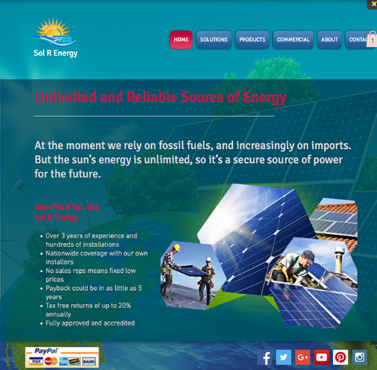
[Fig 3]
“Solution” page introduces new solutions for the energy problem that impact people’s life (figure 4). It explains how solar panel works with ability to play a video to show the procedure of the solar panels’ installations that can be very useful particularly for the people who are not aware of this solution.

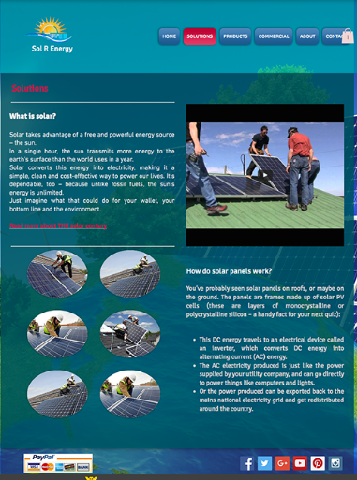
[Fig 4]

The first task of the website is the capability to present products and services and provides the customer with information about the products through the user interface [13] (figure 5). This information includes detailed product specifications, advertisements and products’ samples.

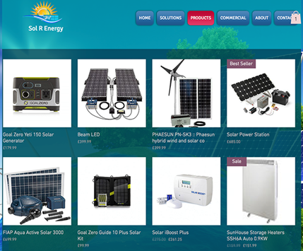
[Fig 5]

Second is the order entry function, allows the customer to check product availability, place an order and information about each order that has been added to the electronic shopping cart process (Figure 6) [14].

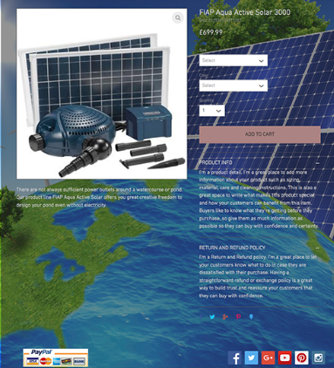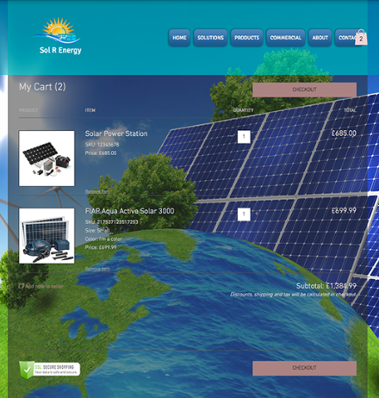

[Fig 6]

The next functionality refers to the ability of the electronic payment function; enabling the customers to pay for the order and complete transactions through PayPal checking service (Figure 7). This includes accepting different payment options such as credit cards and debit cards and producing invoice. The security here becomes very important and the function should provide the necessary security [15].
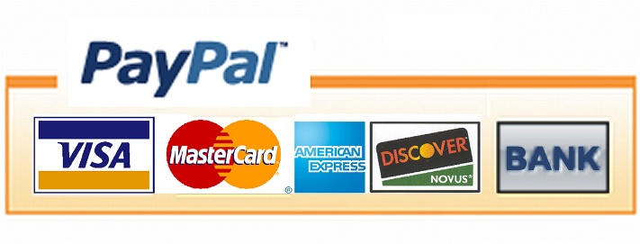
[Fig 7]

“About US” is the company profile that give information about how big is the company, when it was established and how it works (Fig 8).
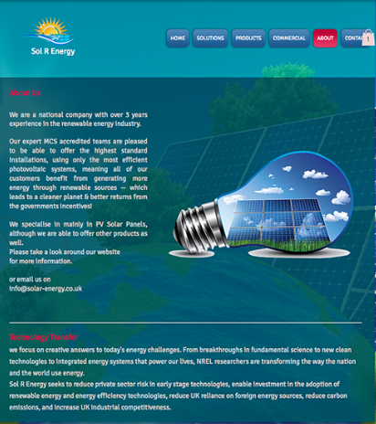

[Fig 8]

“Commercial” page providing information about commercial panel installation in Wales and provide option to get quote for householders and businesses [figure 9].

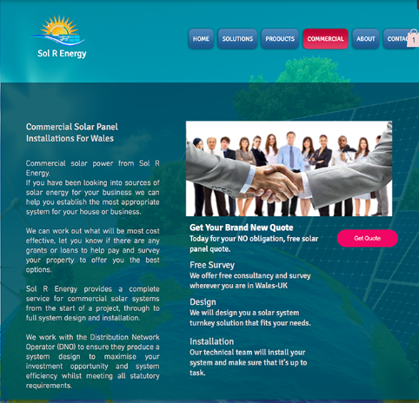
[Fig 9]
In addition, a customer service function to provide assistance to customers related to purchasing process is necessary [6]. The available options for customer service can be through call-free telephone numbers, email and chat rooms. The product support function also can be done through a good customer service for initial setup and installation, warranty, repair or troubleshooting and return policy (Figure 10).


[Fig 10]
Social media is transforming the way business is carried out; it is free and the best way to promote the business (figure 11). However, it is crucial to know how to capitalise the social media brands and turning “likes” into profit [23].


[Fig 11]

Ecommerce monetary transaction evaluation
In fact, electronic payment has revolutionised the business processes, help organisations to expand the market reach [15]. It is user friendly, less time consuming and more efficient than manual processing by reducing the business paper work, transaction costs and the labour cost [15, 16]. E-payment in an ecommerce site can be processed through different channels including credit cards, debit cards, E, Money, and electronic fund transfer (EFT) [16]. Credit card is the most popular mode of making the electronic Payments [17]. When a customer pays by the credit card, card issuer pays on behalf of the customer. The actors in credit card system are customer, merchant, card issuer, the merchant bank and the card brand for example visa or MasterCard [18].

When customer presents the credit card information to merchant site, the site should validates customers’ identity by asking for approval from the card brand company. A payment gateway acts as a middleman and allows merchants to securely pass the credit card information between merchant and the payment processor and also between the customer and the merchant [18]. The card brand company that a merchant uses to handle credit card transaction authenticates the credit card and pay the transaction by credit. It implements anti-fraud measures to protect both the merchant and the customer [16].

With a secure online payment system, customers experience a smooth and secure transaction when they shop online [15]. Every business can get a fast, affordable and reliable online payment process as the system will encrypt all the credit card data to make sure that it cannot be read by anyone else [15]. Some of the most common payment system includes “Authorize.Net, PayPal, Google checkout, and Amazon payment [19].

Authorize.Net is the most widely used payment gateway with over 300,000 merchants’ users. Many ecommerce platforms such as Volusion, X-cart, and Magneto are designed to accept easier the payments using “Authorize. Net” [18].

PayPal payment prompt the users to sign up and use the user existing account for sending payments. The company continues to gain popularity and is one of the best options for easily accepting electronic payments [19]. It is chosen as a safe way to use for electronic payments of “Sol R Energy “company. It also allows sending money through an email address that is a feature that only a few payment solutions provide [19, 15].

Google Checkout allows users to pay through an account connected to their Google profile and make the purchase process much simpler. Amazon payment also allows the user to receive and send money on the web.

Pricing and fees are different and are compared below (figure 11) [18]:

Payment services | Transaction fees | Monthly fees | Setup fees
Authorise.Net | $0.10 | $20 | $99
PayPal | 2/9% +$0.30 | None | None
Google Checkout | 2/9% +$0.30 | None | None
Amazon Payments | 2/9% +$0.30 | None | None

[Fig 11]

Marketing Metric Evaluation
Marketing metrics are numeric data about net sales, number of site visitors and other elements that allow marketers to evaluate their performance [21]. To track and improve the marketing effort, the business needs to know which metrics to track and analyse and how to do so. The best place to start, according to Cain (2012) [20], would be gathering data from the company website. This includes the number of individuals who visit the website (unique visitors) or specific pages during a certain period of time. If the page viewers are higher than unique visitors, it could be an indication that visitors engaged the contents because they are clicking around different pages [20].

The next metrics is “Search Engine Traffic”. It demonstrates the amount of traffic on the site though search engine, such as Google and Bing [20]. Bounce rate and Conversion rate are important; Bounce rate shows the percentage of visitors that come to the site and leave immediately, but conversion rate show the percentage of visitors that took a specific action in the site such as sign up for newsletter [21].

Another important metric is revenue, the marketer must measure how many click is lead to sale and made revenue [20].

Measuring all these metrics requires marketing software and CRM system; it allows creating standard reports and dashboards to track all the important measurement automatically [22]. Once the report created can stay up to date on all the metrics and allows skimming the information quickly and looking for any pop up issues [22].

Conclusion
There are many web builders landscape that offers approaches to developing websites, but Wix stands at the top of these sites. Wix is an easy and quick platform for prototyping and building actual website.
Pay pal was considered as a secure payment method for “Sol R Company”. PayPal is the most successful type of e-payment due to its policies and pricing that are transparent and easily understandable for everyone.
E-marketing also is very important, whether through social media, email marketing, and search engine optimization. Tracking marketing by CRM system is very useful, letting the business owner to evaluate all the important elements for better performance.

Reference
- Goetzberger A, Hoffmann VU. Photovoltaic solar energy generation. Springer Science & Business Media; 2005 Mar 29.
- Gray H, Sanzogni L. Technology leapfrogging in Thailand: Issues for the support of eCommerce infrastructure. The Electronic Journal of Information Systems in Developing Countries. 2004 Jan 1; 16.
- Traxler, D. 7 Key Ecommerce-infrastructure Decisions. 2012 May 18. Available at: http://www.practicalecommerce.com/articles/3545-7-Key-Ecommerce-Infrastructure-Decisions [Accessed 12/04/16]
- Gobe M. Emotional Branding, Revised Edition: The New Paradigm for Connecting Brands to People. Skyhorse Publishing, Inc.; 2010 Apr 27.
- Atkins CA, inventor; Proprietary Financial Products, Inc., assignee. System for the operation and management of one or more financial accounts through the use of a digital communication and computation system for exchange, investment and borrowing. United States patent US 5,875,437. 1999 Feb 23.
- Tan X, Yen DC, Fang X. Internet integrated customer relationship management: A key success factor for companies in the e-commerce arena. The Journal of Computer Information Systems. 2002 Apr 1;42(3):77.
- Muchmore, M. PC. Wix Review. Available at: http://www.pcmag.com/article2/0,2817,2461559,00.asp [Accessed 11/05/16]
- Bell MW. Build a Website for free. Que Publishing; 2012 Nov 13.
- Turban E, King D, Lee J, Viehland D. Chapter 19: Building E-Commerce Applications and Infrastructure. Electronic Commerce A Managerial Perspective. 2008:27.
- Nickerson R. An E-Commerce System Model. AMCIS 2002 Proceedings. 2002 Dec 31:47.
- Van den Bosch AL, De Jong MD, Elving WJ. How corporate visual identity supports reputation. Corporate Communications: An International Journal. 2005 Jun 1;10(2):108-16.
- Rouse, M. SearchSoa. Home page. 2005. Avilable at: http://searchsoa.techtarget.com/definition/home-page [Accessed 11/05/16]
- Zeithaml VA, Parasuraman A, Malhotra A. Service quality delivery through web sites: a critical review of extant knowledge. Journal of the academy of marketing science. 2002 Oct 1;30(4):362-75.
- Lohse GL, Spiller P. Electronic shopping. Communications of the ACM. 1998 Jul 1;41(7):81-7.
- Ecommerce-payment system. Tutorials point. Available at: http://www.tutorialspoint.com/e_commerce/e_commerce_payment_systems.htm
- Chandrasekar Subramaniam MJ. A study of the value and impact of B2B e-commerce: the case of web-based procurement. International Journal of Electronic Commerce. 2002 Jul 1;6(4):19-40.
- Sumanjeet S. Emergence of payment systems in the age of electronic commerce: The state of art. Global Journal of International Business Research. 2009 Jul 24;2(2).
- Meyer, R. 10 excellent online payment system. Available at: http://sixrevisions.com/tools/online-payment-systems/ [Accessed 20/04/16]
- Trautman LJ. E-Commerce and Electronic Payment System Risks: Lessons from PayPal.
- Cain, K. Measuring Marketing Effectiveness: 6 Metrics you need to track. Oct, 2012. Available at: http://contentmarketinginstitute.com/2012/10/measuring-marketing-effectiveness-metrics/ [Accessed 11/05/16]
- Boundless. Marketing performance metrics. Boundless marketing Jul.2015. Available at: https://www.boundless.com/marketing/textbooks/boundless-marketing-textbook/introduction-to-marketing-1/evaluating-marketing-performance-23/marketing-performance-metrics-134-7590/ [Accessed 12/05/16]
- Mirman, E. 12 critical marketing and Sales metrics you better be tracking. Oct. 2012, available at: http://blog.hubspot.com/blog/tabid/6307/bid/33659/12-Critical-Marketing-and-Sales-Metrics-You-BETTER-Be-Tracking.aspx#sm.01nm9kif19krdso10ir2jqw2q536r [Accessed 12/05/16]
- Qualman E. Socialnomics: How social media transforms the way we live and do business. John Wiley & Sons; 2010 Oct 7.

