Unit 2 Topic 3: Network society
Table of contents
Activity explainer 3
Section 1: Networks vs. hierarchies 5
Pre-industrial organisation 5
The Industrial Revolution 5
Bureaucratic hierarchy 5
Case Study: The Tacoma Bridge 6
Problems with hierarchies 7
Reflect (slide 7) 7
Black swan events 7
Alternatives to hierarchies 8
Case Study: Pioneers, Settlers and Planners 9
Networks and hierarchies coexisting 10
You have completed Section 1! 11
Section 2: The power of networks 12
Society’s balancing act 12
Exerting power 12
Maintaining power 13
The network society 13
The communication power of the web 14
You have completed Section 2 15
Section 3: Persuading the network society 16
Persuasion 16
Reflect (slide 20) 16
Networks of influence 17
Cohesive networks and Bridge networks 19
Case Study: COVID-19 vaccines 19
Reflect (slide 28) 20
You have completed Section 3 20
Before you go… 21
Unit 2 Topic 3 completed! 21
References 21

Activity explainer
As you work through this learning content you will be asked to undertake various types of learning activity to enhance and support your understanding of the material. It is important that you fully engage with these learning activities as the acquisition of information is only one part of the learning process – by being an active participant in your learning through these activities you will develop a deeper and richer understanding of the topics and concepts covered in the module.
Throughout the modules, you will also be provided with additional materials to deepen your understanding of the module topics. These are optional and can be found by selecting the Dive deeper button.
Whenever you encounter the following tasks and icons, it means you need to complete an activity.
- Check: Check tasks provide an opportunity for you to check how well you have understood the topic so far. Self-assessment is an important part of the learning process as it enables you to reinforce those concepts you understand well, and highlight any misconceptions and/or areas where you may need to do some further study.
- Network: Learning online shouldn’t be a solitary activity - being able to discuss, collaborate and compare your understanding with fellow learners through a Network task is a powerful tool in maximising your learning gains. Seeing that others have the same understanding as you can be a real confidence boost and reassure you that you are on the right track, and if others are interpreting things differently seeing things from a different perspective can be equally valuable.
- Reflect: You will often be asked to pause and consider ideas and concepts you have just learned, to allow the learning to “sink in” and start to think more widely about how it fits in with your discipline. Although Reflect tasks don’t usually require you to write anything, it’s important to take the time to think about the question asked and you can of course record your thoughts in your personal notes if you wish.
- Apply: These modules cover topics and skills that are valuable across all disciplines, however you will be able to understand, appreciate and benefit most by considering how the learning fits in with your academic discipline and your own beliefs and values. Apply tasks give you the opportunity to place the learning in a context that is relevant to you, and to link your learning with your real life goals.

Section 1: Networks vs. hierarchies
Upon completion of this section, you will be able to:
- Critique the bureaucratic approach to organisation.
- Describe how networks react to complex situations.
- Compare networks to hierarchal organisation.

Pre-industrial organisation
Back in the days of working on the land, as bizarre as it sounds, the particular skills people exhibited were rarely considered when they were employed to do a particular job. People were given opportunity simply because they were born into a role. Maybe they were from a particular societal group based on religion, race or gender. Or maybe they wore a particular school tie?
During this time, it was very difficult to change your prospects and progress through the societal hierarchy.

The Industrial Revolution
In the 18th-19th century, during what is known as the Industrial Revolution, workers moved into cities to work in factories and scientific management was born.

Bureaucratic hierarchy
A man called Max Weber realised for work to be done efficiently it needed to be structured in a particular way and he outlined rules to what is now known as a bureaucratic hierarchy.
Hierarchies such as these exist to this very day in many organisations that are administered by bureaucracy.
Society runs on bureaucratic hierarchies. This is what is known as a machine paradigm, like the one you learnt about in the motivation topic. In this context, you realised that people are not best treated as machines, and it is because of this that the hierarchy approach is flawed.
Of course, machines are great at producing copies of the same thing. Everyone knows what to do. Simple decisions can take at the top of the hierarchy and passed down. Progress and speed are measurable, and efforts are spent making the environment more predictable.
However, people cannot hope to cover every eventuality with machine thinking because, as you know, life is messy and unpredictable.
What happens if the environment is not as predictable as first thought?

Case Study: The Tacoma Bridge
This is an example of how a machine-like organisation thought it could defeat nature.
- Context: The Tacoma Narrows Bridge in the US state of Washington opened to traffic on 1st July 1940, and collapsed only four months later, on 7th November 1940. At the time it was the third longest suspension in the world.
- Design: The bridge had been designed to be the most flexible bridge ever constructed, and although it exceeded the standard ratios of length, depth and width, the engineers believed it was completely safe.
- Collapse: On the day of its collapse, the wind speed was about 40mph, and the deck started oscillating in an alternating twisting motion that gradually increased in amplitude until the deck tore apart.
- Investigation: Investigations following the incident revealed that the engineers had not properly considered the aerodynamic forces that were in play at the location during a period of strong winds. At the time of construction, such forces were not commonly taken into consideration by engineers and designers.

Problems with hierarchies
In the same way that the bridge collapsed because of an unpredictable wind, the old methodology of Weber’s bureaucracy simply can’t handle uncertainty caused by rapid change.
Hierarchies are a standard managerial process. Even when minimally bureaucratic, they are inherently risk-averse and resistant to change.

Political and cultural factors
Part of the problem is political: people are loathed to take chances without permission from superiors.
Part of the problem is cultural: people cling to their habits and fear loss of power and stature.
These are two essential elements yet discordant parts of hierarchies.

Key quote
'Part of the problem is that all hierarchies, with their specialised units, rules, and optimised processes, crave stability and default to doing what they already know how to do.' (Kotter, 2012)
But sometimes, situations are novel. This is because you have not seen a particular situation in which bureaucracies falter and fail.

Reflect (slide 7)
See Activities document.

Black swan events
Taleb (2007), in his book The Black Swan, tells of a time when everyone thought that all swans were white. But, when black swans were discovered in Australia, public opinion rapidly changed.
This story makes it clear that knowledge is only based on what you know at any one point in time.

The theory
The theory of black swan events is a metaphor that describes an event that come as a surprise, has a major effect, and is often inappropriately rationalised after the fact with the benefit of hindsight.
While the colour of a bird is not much of a problem to society, the rate of world complexity is increasing and so are extreme ‘black swan’ events. Examples include the First World War, stock market crashes and terrorist attacks.

Relying on incomplete theories
Such events seem to catch people by surprise because they rely on incomplete theories based on looking back at historical stories.
It is as though everyone is a turkey thinking they understand how nice farmers are for providing food and shelter. This is a reasonable assumption in November, but at Christmas, however, the turkey’s black swan event is fatal!
Hierarchies, it seems, cannot handle quick and large changes of direction. Like turning a big ship around, change in a hierarchy takes a lot of time and effort. Frankly, in some cases, it may not even be possible!

Alternatives to hierarchies
A network is another way of organising that is built to thrive in an ever-changing black swan infested world.
In the same way that nature does not have structure or hierarchy when it 'decides' where flowers bloom and deserts dry, networks too lack structure or any apparent organisation.

Organic organisations
To many people, this kind of environment might seem chaotic.
However, scratch below the surface, and there is organisation in this apparent madness. This is because nature is continuously adapting to the change as it happens, rather than relying on a model of the future it ‘understands’ from past events.
In business, you can see that start-ups operate in this way.
You also see it in the organic way that civilisations have spread across the planet. You can see it in all organic organisations.

Case Study: Pioneers, Settlers and Planners

Network
Adapting Robert X. Cringely's description of companies as Commandos, Infantry and Police in the book Accidental Empires, Simon Wardley takes the model of Pioneers, Settlers and Planners mentioned before and describes it as a network diagram.
For example, the pioneers of the American Wild West started out on their journeys without knowing their destination.

Explanation
They lived in an ever-changing world, discovering uncharted territory. They are followed by settlers that can take the concepts pioneers started to build and turn them into something sustainable. They turn the prototype into a product.
Settlers are followed by town planners that bring structure, scale and stability. All three are needed to be able to build a town, but we recognise that people are comfortable doing different types of jobs.

Analysis
Notice when we plot the relationships as a diagram there are significant differences to the shapes. Whereas the hierarchy is organised and vertical, the network is sprawling haphazardly and horizontally, connections do not have symmetry and to some can appear messy.
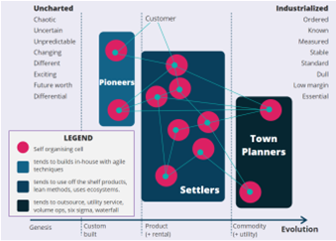

Conclusion
The distribution of power and information therefore is no longer controlled in traditional ‘vertical power structure’ but a network information is shared widely ‘horizontally’ and in a messy way.
While messy, the technological age we find ourselves in sees the distribution of information moves in a much simpler and faster way than in the past.

Networks and hierarchies coexisting
In practice, both the network and the hierarchy must coexist and work in harmony. You need to give people a chance to work in whatever way they can be at their best.

An effective hierarchy
As a member of society, you must deal with change and create innovation. You have to be able to survive.
However, you also need an effective hierarchy that can provide scale and promote stability.

You have completed Section 1!
You should now have gained some insight into the bureaucratic approach to organisation, how networks react to complex situations, and the comparison of networks and hierarchal organisations.

Section 2: The power of networks
Upon completion of this section, you will be able to:
- Articulate how society, state and business uses coercive and persuasive power to create action.
- Explain how society has evolved organisation to favour networked communication.

Society’s balancing act
According to Manuel Castell (2005), there is a perpetual balance with the state or business on one side and society on the other. For each side, power is dealt out and met with counter power that opposes it.
This is an endless journey that requires both sides to exert themselves to maintain order.

Exerting power
Power is exerted in two forms.
- Persuasion: Persuasion is used to convince by collaborative communication. Persuasion can occur in a variety of ways too, including mediation (particularly between civilians and military), advertisements, and laying out an argument and emphasising the positive benefits for that cause of action.
- Coercion: Coercion is used to convince the other by manipulation or force. Coercion often occurs through social pressure, e.g. parents controlling the behaviour of teenagers through threatening to withdraw time on their games console. Or, in some extreme cases, it may involve the use of physical force, e.g. prisoners of war being tortured for information.

Maintaining power
Castell (2005) argues history shows that for either side to maintain power, using coercion or manipulation requires far more energy than persuasion done via collaborative communication.
It follows that persuasion is also better done with networks rather than hierarchies. This means that a modern society is no longer in a situation where it can be simply coerced into compliance.

The network society
The idea of a network of social interactions and personal relationships is nothing new.
Society has organised itself in many ways in these forms for millennia, but the advent of the Internet has revolutionised the way society works.

The Internet
The Internet, as described above, is a black swan that has made a paradigm shift in the way information and ideas are communicated to society.
This has, in turn, been a challenge for the hierarchical society you will have been accustomed to.

Information
Hierarchies have been used to publishing information that is consumed by society in one direction, from the people with the power at the top to those at the bottom. For example, books are printed by publishers and television is made by broadcasters. Such mediums offer little ways for the community to interact.
However, in the current information age, ideas are now spread multi-directionally (up and down) using web-based technology.

The communication power of the web

Old ways of communication
Old ways of communication were limited by physical things like geography. For example, in the past people physically travelled to a location (a library) to read a book. Ideas transmitted by radio or television required you to be in range and in attendance at a certain time.
Old communication methods also meant ideas had to be consumed in the order the author intended or else awkwardly looked up in an index to find the page or video timestamp.

Modern communication
Castell’s (2009) paper suggests that modern communication offers the advantage of being able to blur the space and time in what he calls ‘space of flows’ or ‘timeless time’.
For example, in the 21st Century, a video gamer can explore an interactive virtual world and ‘meet’ people from the other side of the planet while using Google to efficiently appear knowledgeable on any subject known to mankind.
Such abilities mean that a citizen of the network society does not function by the same rules that have previously been used to manage the world.

Dive deeper
This lesson, the one you are reading here and now, is an example of Castell’s space of flows and timeless time! You are now consuming these ideas at a time and location of your choosing. This is more than likely a different time and space than any of your fellow students past and present.
- How does this affect your ability to learn?
- Who has the power in this new learning environment? Students or universities?
- How is this different to students from 20 years ago?

You have completed Section 2
You should now have identified how society, state and business uses coercive and persuasive power to create action; and how society has evolved organisation to favour networked communication.

Section 3: Persuading the network society
Upon completion of this section, you will be able to:
- Conclude which sort of networks are appropriate for creating change in society.
- Draw a conclusion as to why changemakers like Greta Thunberg are such powerful voices in global change.
- Devise approaches to orchestrate change in any organisation in the future.

Persuasion
Persuasion is part of all of our lives. You will find it in online ads, politicians’ speeches, government communications and so on.

Network society
In Daniel Pink’s ‘To Sell Is Human’, he identifies the seismic shift in persuasion that has occurred because of the network society.
Because humans operate within a transparent world, they can’t be manipulated by hierarchies that control information. When you are told anything these days, your reaction is usually to look it up on the Internet.

Selling the United Nations' goals
Sales is sometimes perceived as a negative word and might turn many people off.
However, as you have learnt, you live in a world where society has to be convinced of anything before it is believed - even the idea of peace and prosperity for people and the planet!

Reflect (slide 20)
See Activities document.

Networks of influence
In the article ‘The Network Secrets of Change Agents’ by Battilana and Casciaro (2013), it describes how the formal hierarchy at the NHS is eclipsed by the informal networks that operate throughout the organisation.
It seems that doctors, no matter how senior, cannot function without navigating the complex hospital politics. If they seek to persuade, they need the power of influential people in the network they supposedly control.
The power of formal hierarchies is shown to be eclipsed by the informal networks in this diagram.
An in-depth analysis of change initiatives at the UK’s National Health Service revealed that the likelihood of adoption often depended on characteristics of change agents’ networks of informal relationships, how central they were and the shape of the network map.
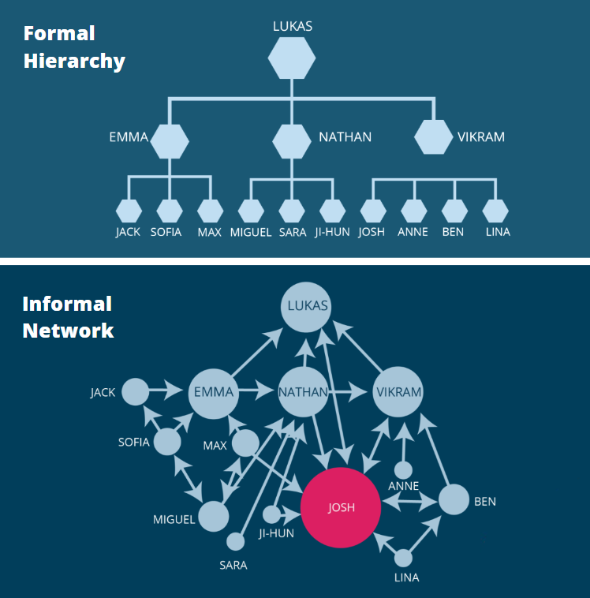

Formal Hierarchy
In the formal hierarchy of one unit in a large company, Lukas holds the most senior position, while Josh is at the bottom of the pyramid.

Informal Network
As the informal network diagram shows, many people seek Josh out for advice, making him more central to the network than Lukas and thus highly influential.

Cohesive networks and Bridge networks
If you were to draw a diagram of the connections that people informally keep, patterns emerge.

Cohesive networks
A cohesive network has the people connected to one another. Such a network is a sign of trust and mutual support, this is a way of facilitating communication and coordination.
Cohesive networks work well when the change is not particularly divergent. Here, the agent’s network will trust their intentions. Those who are harder to convince will be pressured by others in the network to cooperate because the change is not too disruptive.

Bridge networks
If the contacts are not connected to one another, a bridge network is formed. Such networks show a connection between disparate individuals and groups, giving Chris control over what, when, and how he communicates with them.
However, more dramatic transformations require a bridging approach; firstly, because unconnected resisters are less likely to form a coalition, and secondly, because the change agent can vary the timing and framing of messages for different contacts, highlighting issues that speak to individuals’ needs and goals.

Case Study: COVID-19 vaccines
In late 2020, COVID-19 vaccines became available and it was important for society to embrace taking these in order to stop the spread of the pandemic.
However, as you have looked at, hierarchies cannot simply ‘force’ people to become immunised. They must instead be persuaded.
A solution lies in looking at the network society and individuals who can act as cohesive and bridging influencers.
For example, many celebrities and politicians have spoken out in support of the vaccine and used their platforms to inform and persuade individuals.
The use of restrictions for non-vaccinated individuals, such as COVID passports, travel bans, etc. is another technique employed by the government to try and persuade people to get vaccinated.

Reflect (slide 28)
See Activities document.

You have completed Section 3
You should now have concluded which sort of networks are appropriate for creating change in society and devised some approaches to orchestrate change in any organisation in the future.

Before you go…
In this topic, you should have completed:
- Three Reflect activities where you thought of a failure of the hierarchical organisation, contemplated the United Nations' 17 goals for sustainable development, and reviewed three methods the government and NHS used to persuade people to get the vaccine.

Unit 2 Topic 3 completed!
You should now:
- Have compared networks to hierarchal organisation and described how networks react to complex situations
- Have identified how society has evolved organisation to favour networked communication.
- Have concluded which sort of networks are appropriate for creating change in society.

References
Battilana, J. and Casciaro, T. (2013) ‘The Network Secrets of Great Change Agents’. Harvard Business Review, 91, pp. 62 - 68.
Castells, M. (2005) The Network Society. Cheltenham: Edward Elgar.
Castells, M. (2009) Communication Power. Oxford: OUP.
Cringely, R. (1996) Accidental Empires. London: Penguin.
“Black and white photograph of Maximilian (Max) Weber” by Hacerahsen, used under (CC BY-SA 4.0) / Background removed from original. Available at: https://commons.wikimedia.org/wiki/File:Max_Weber_(Sociologist).jpg (Accessed: 23 September 2022)
Pink, D. (2018) To Sell Is Human. London: Canongate Books LTD.
Wardley, S. (2015) On Pioneers, Settlers, Town Planners and Theft [online] Blog.gardeviance.org. Available at: https://blog.gardeviance.org/2015/03/on-pioneers-settlers-town-planners-and.html (Accessed: 1 December 2020).

